**Air Canvas**

**Gaurav Boraste1, Ajay Vispute2, Sahil Gaikwad3, Prof.Puspendu Biswas4**

1,2,3Computer Engineering Student, S.M.E.S. Sanghavi College of Engineering, Nashik, India

4H.O.D, Computer Engineering Department, S.M.E.S. Sanghavi College of Engineering, Nashik, India

**ABSTRACT**

Writing in air has been one of the most fascinating and challenging research areas in field of image processing and pattern recognition in the recent years. It contributes immensely to the advancement of an automation process and can improve the interface between man and machine in numerous applications. Several research works have been focusing on new techniques and methods that would reduce the processing time while providing higher recognition accuracy. Object tracking is considered as an important task within the field of Computer Vision. The invention of faster computers, availability of inexpensive and good quality video cameras and demands of automated video analysis has given popularity to object tracking techniques. Generally, video analysis procedure has three major steps: firstly, detecting of the object, secondly tracking its movement from frame to frame and lastly analyzing the behavior of that object. For object tracking, four different issues are taken into account; selection of suitable object representation, feature selection for tracking, object detection and object tracking. In real world, Object tracking algorithms are the primarily part of different applications such as: automatic surveillance, video indexing and vehicle navigation etc. The project takes advantage of this gap and focuses on developing a motion-to-text converter that can potentially serve as software for intelligent wearable devices for writing from the air. This project is a reporter of occasional gestures. It will use computer vision to trace the path of the pen pointer. The generated text can also be used for various purposes, such as sending messages, emails, etc. It will be a powerful means of communication for the deaf. It is an effective communication method that reduces mobile and laptop usage by eliminating the need to write.

**Keywords:** Air Writing, Character Recognition, Object Detection, Real-Time Gesture Control System, Smart Wearable’s, Computer Vision. (5-6 Keywords, Font-Times New Roman, Font Size – 10).

1. **INTRODUCTION**

In the era of digital world, traditional art of writing is being replaced by digital art. Digital art refers to forms of expression and transmission of art form with digital form. Relying on modern science and technology is the distinctive characteristics of the digital manifestation. Traditional art refers to the art form which is created before the digital art. From the recipient to analyses, it cassis simply be divided into visual art, audio art, audio-visual art and audio- visual imaginary art, which includes literature, painting, sculpture, architecture, music, dance, drama and other works of art. Digital art and traditional art are interrelated and interdependent. Social development is not a people's will, but the needs of human life are the main driving force anyway. The same situation happens in art. In the present circumstances, digital art and traditional art are inclusive of the symbiotic state, so we need to systematically understand the basic knowledge of the form between digital art and traditional art. The traditional way includes pen and paper, chalk and board method of writing. The essential aim of digital art is of building hand gesture recognition system to write digitally. Digital art includes many ways of writing like by using keyboard, touch-screen surface, digital pen, stylus, using electronic hand gloves, etc. But in this system, we are using hand gesture recognition with the use of machine learning algorithm by using python programming, which creates natural interaction between man and machine. With the advancement in technology, the need of development of natural ‘human – computer interaction (HCI) systems to replace traditional systems is increasing rapidly. Earlier painting was done using either a mouse or touch pad which was quite stressful and hectic task. Even though we have touch screen laptops, they are expensive .Hand tracking more specifically pen pointer tracking technique is used as a tool of the computer acting as an external device similar to a keyboard and a mouse. It is used in various fields like Virtual Reality to sign language recognition. Air Canvas is a hands-free digital drawing canvas which utilizes camera to recognize and map the hand gestures. The user pen pointer is considered as the pen used to draw.The size of brush can be modified, also the pen colour can be changed by hovering pointer over built-in buttons. Computer vision techniques are used to draw different shapes. This system uses python language to built the code. Camera is used to track the pen pointer positions. Computer Vision built in methods are used to draw shapes on the canvas or the area provided. We can annotate or edit pdf of our choice by opening the required pdf and hovering over the area where we need to annotate or underline. We can also save the canvas work as image.

1. **METHODOLOGY**

The development of the Air Canvas application, involved training on various hand images to accurately identify finger positions. However, this method faced challenges such as the need for extensive data storage and occasional inaccuracies caused by background or skin color variations. Previous approaches relied on image processing with threshold values and extensive databases to address these issues. To address these limitations, our proposed system leverages the capabilities of Mediapipe. This system employs hand tracking through Mediapipe, which initially detects hand landmarks and then determines positions based on this data.

1. **DESIGN CONCEPT**



COLOR WINDOW DETECT

OUTPUT

WINDOW

COMPONENT

WINDOW

ADJUSTMENT WINDOW

VIDEO

INPUT WINDOW

**Figure 1:** UML Class Diagram

1. **RESULTS AND DISCUSSION**

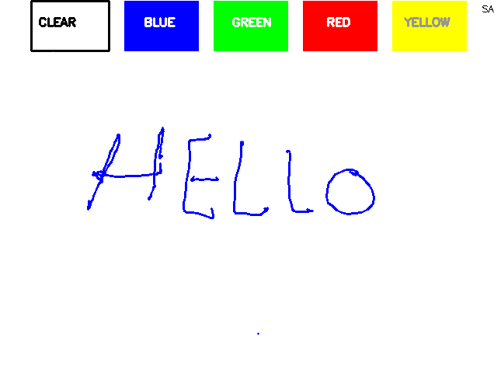

Figure:- Output

The content extracted from Air Canvas was accurate and of good quality after thorough proofreading and editing. OCR tools efficiently converted the content into editable text. The text was formatted appropriately, with a clear structure, font consistency, and visual elements enhancing readability. The printed document was of high quality, with crisp text and clear visual elements. The entire process from Air Canvas to paper publishing was completed efficiently, meeting the set deadlines. All legal considerations, including copyright and permissions, were meticulously adhered to. Environmental considerations were made by using eco-friendly printing practices and considering digital alternatives. Feedback from stakeholders was positive, with no major issues reported. The evaluation of the methodology showed that it was effective in achieving the objectivesThe accuracy and quality of the content were crucial for the success of the process. The OCR tools used were efficient, but human proofreading and editing were essential to ensure the final content's quality. Proper formatting and structuring significantly enhanced the document's readability. The methodology ensured that the text was clear, well-organized, and consistent, contributing to a positive reading experience. The high-quality publication positively impacted the document's reception. Proper binding methods and quality printing contributed to the document's professionalism and longevity. Adhering to the established timeline was crucial. The efficient completion of the process ensured timely availability of the published document, meeting the project's requirements and stakeholders' expectations. Ensuring legal and environmental compliance was essential. By adhering to copyright laws and eco-friendly practices, the project not only met legal obligations but also aligned with ethical standards. Feedback from stakeholders was encouraging, indicating that the methodology was effective. Continuous evaluation and feedback collection will be crucial for future improvements and iterations of the methodology.

1. **CONCLUSION**

We consider our project to be an overall success! With Air Canvas, we have achieved a hands- free drawing program that uses OpenCV to detect the user’s pen pointer. Colorful lines can be drawn wherever the user desires and the brush can even be modified. It is truly like drawing in the air! Of course, Air Canvas has many flaws that may be interesting areas of research in the future. The first is the issue of frame rate: image processing slowed down the camera feed and produced a cumbersome lag that impedes on the usability of the program. It would be best optimized with multicore functionality, which we attempted in this project. If the timing problems with queueing data between processes can be managed such that frame information is passed in order, perhaps Air Canvas can be upgraded to run authentically in real time. Moreover, we relied on open source OpenCV code for hand recognition, which had its own issues that we worked hard to circumvent.

.

1. **REFERENCES**
2. UKEssays. (November 2018). A Review Of Employee Management Systems Information Technology Essay. Retrieved from https:/[/www.ukessa](http://www.ukessays.com/essays/information-technology/a-review-of-employee-)y[s.com/essays/information-](http://www.ukessays.com/essays/information-technology/a-review-of-employee-) [technology/a-review-of-employee-](http://www.ukessays.com/essays/information-technology/a-review-of-employee-) management-systems-information-technology- essay.php?vref=1.
3. Ingui, S. (2012) as cited on 23 August 2012, Performance reviews and Employee management of employees – criteria for effectiveness, CBP Lawyers: http://www.cbp.

com.au/Publications/Performance-reviews-andperformance- management-of.

1. AITSL (2012) Australian Teacher Performance and Development Framework, August 2012 Australian Institute for Teaching and School Leadership Australia Ltd.
2. Tayler, C., Page, J., Deans, J., Gilley,T., Flottman R., & Young, S. (2009) A comprehensive approach towards excellence in ECEC teaching and learning, University of Melbourne, Melbourne
3. Cole, P. (2012) Aligning professional learning, Employee management and effective teaching, Centre for Strategic Education, Melbourne.
4. Baker, T. Dr. (2010) as cited on 15 November 2010, Don‟t discuss performance once a year, discuss it all year, HR Daily: [http://www.hrdaily.com.au/nl06_news_selected.](http://www.hrdaily.com.au/nl06_news_selected) php?selkey=1649.
5. Sytch, M. and DeRue D.S. (2010) as cited on 22 June 2010, Ditch performance reviews? How about learn to do them well? Harvard Business Review Blog Network: [http://blogs.](http://blogs/) hbr.org/2010/06/ditch-performance-reviews-ho