**Title:** “Evaluate the factor of block chain’s implementing in facilitating personalized and smart Insurance contracts at Aditya Birla Group”

1. **ABSTRACT**

This master's thesis investigates the use of blockchain technology and smart contract technology in privacy-conscious applications, with an emphasis on a blockchain-based healthcare plan that includes prescription medications. The thesis analyzes the digitization of prescription regimens and suggests a practical implementation strategy based on blockchain technology.

The smart contract system is designed to show how such an application may be constructed while also providing principles for designing a blockchain system. The essay also explores the suitability of several blockchain architectures for privacy-preserving applications. The research intends to assist decision-makers in understanding the potential advantages and hazards of blockchain technology in various businesses.

1. **INTRODUCTION**
   1. **Blockchain technology:**

Blockchain technology is a protected, transparent, and unchangeable electronic record system that stores transactions via a network of computers. It removes intermediaries, increasing efficiency in areas like banking, supply chain management, and healthcare. Blockchain's openness and immutability foster confidence among members, while its decentralized structure improves safety and adaptability to attacks from enemies.

* 1. **Smart Insurance Contract:**

Smart insurance contracts leverage blockchain technology and smart contract features to automate and execute policies, removing intermediaries and expediting claims processes. They ensure the openness, security, and consistency of policy terms and transactions. Real-time data verification enables precise risk assessment and individualized pricing. Smart insurance contracts promote efficiency, save costs, and build confidence between companies and policyholders.

* 1. **Aditya Birla Group:**

One of the Fortune 500's international conglomerates is the Aditya Birla Group. The Group, which employs over 120,000 people in 42 countries, is built on a strong foundation of generating value for stakeholders. Our firms have become global leaders in a range of industries, including metals, telecom, cement, carbon black, chemicals, textiles, and pulp and fiber, thanks to almost 70 years of ethical business practices. The Group's international operations, which span 36 nations in North and South America, Africa, and Asia, currently account for more than 50% of its sales.

1. **LITRETURE REVIEW**

The word "blockchain" describes an ongoing series of information-containing blocks that are built in compliance with strict legal requirements. According to **Peters and Panayi (2016)**, a blockchain can be compared to a chronological database or ledger that contains one or more transactions stored in blocks.

According to **Benton and Radziwill (2017)**, this trust is built decentralized, with blocks being added to the chain by consensus within the network. The fundamental feature of blockchain technology is its encryption, which makes it unchangeable once written. Distributed ledgers, which are independent of each other, are typically composed of many copies of block chains stored on different computer systems **(Kim &Laskowski, 2018).**

In order to increase transparency and traceability, a number of global industries have adopted and used blockchain technology, marking a technological advancement. Blockchain technology, so named because it can be understood as a chain of blocks connected with mathematically determined data via sophisticated algorithms, also known as cryptography, offers an open, decentralized platform for the development of a transparent, secure, and robust database **(Lipsey et al., 2005).**

This electronic ledger, which can be either private or public, uses a global peer-to-peer network to offer an accessible platform for the chronological recording of transactions. According to **Bordekar et al. (2019),** it facilitates distributed transactions, which lead to a series of transactions in which all parties have faith in the system.

Information technology adoption in the insurance industry has been hotly debated and investigated. It is anticipated that technologies such as Big Data, Blockchain, and Smart Contracts would fundamentally transform the insurance sector and improve everyone's quality of life **(Yu & Yen, 2018).**

1. **RESEARCH OBJECTIVE**

The goal of this study is to perform a detailed investigation of the variables impacting the use of blockchain technology in supporting tailored and smart insurance contracts within Aditya Birla Group operations. With the fast advancement of technology, particularly in the world of blockchain, there is an urgent need to analyze its possible influence on the insurance industry, particularly in the context of Aditya Birla Group's activities. This research will dive into the complexities of blockchain integration, investigating its multifarious ramifications on technological, operational, regulatory, and strategic levels.

Examining the potential benefits, challenges, and opportunities associated with the application of blockchain technology, particularly in the insurance sector; inside the Aditya Birla Group's organizational structure is the main objective of this study. The goal of this study is to clarify how blockchain technology may transform the insurance contract industry by enabling increased customisation and automation and tackling significant problems with efficiency, transparency, security, and customer experience.

This study intends to understand the fundamental mechanisms by which blockchain can optimize the procedures involved in insurance contract administration. Furthermore, it aims to identify the major drivers and challenges to the effective application of blockchain technologies in Aditya Birla Group's insurance business.

1. **RESEARCH METHODOLOGY**
   1. **Data Designing:**

This research report will employ a complete data design technique to evaluate blockchain technology's performance in supporting tailored and smart insurance contracts within the Aditya Birla Group. The research will include both quantitative and qualitative approaches, such as historical contract insurance data, blockchain deployment metrics, consumer comments, and expert perspectives. The quantitative research will assess how blockchain affects the efficiency, cost-effectiveness, and correctness of insurance contracts, while the qualitative findings will give insights for academics and industry practitioners.

* 1. **Data Collection:**

This research paper employs a mixed-methods approach to investigate the factors that influence blockchain deployment in Aditya Birla Group's customized and smart insurance contracts. Quantitative data will be collected from stakeholders via structured questionnaires, while historical data will be evaluated to determine the impact of blockchain adoption on operational efficiency and economic performance.

Semi-structured interviews will be used to collect qualitative data from important individuals who make decisions, specialists in the field, and blockchain technology professionals. The goal is to offer a thorough grasp of the problems, possibilities, and strategic considerations related to integrating blockchain technology into insurance operations.

1. **DATA ANALYSIS**
   1. **Survey questionnaires –**

With 38% of all projects in 2018, hyper ledger was utilized in the greatest percentage of initiatives. Once more, this occurs about two years after the late 2015 or early 2016 launch of hyper ledger. In 2014, the Agnostic group's projects made up the largest share of new projects; however, in later years, this number varied below 20%. Finally, in 2016, 2017, and 2018, TBC projects made up about 25–30% of all projects.

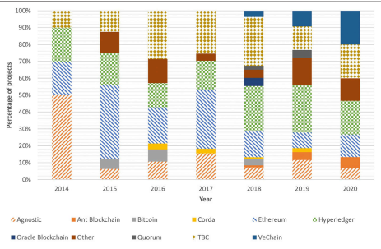

* 1. **Interview guides –**

The number of projects is displayed in figures according to the year of inception. 2018, with 57% of all projects released between 2017 and 2018, is the year with the highest number of initiatives created. Following 2018, there were fewer initiatives. Although the 2020 data is not yet full (it won't be until June), it already contains almost as many projects as in 2015. It turned out that no initiatives that were started in 2011 existed.

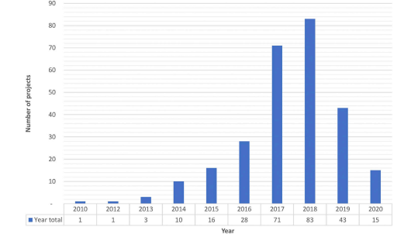

* 1. **Focus group discussion guides –**

The initiative statuses are shown in the figure based on the year of creation. Of the complete dataset, 67% of the projects are still in development, 10% are deemed inactive, and 23% are ready for the market. The projects that is most ready for the market date back to 2014, 2015, and 2017, making up 50%, 38%, and 31% of the total.

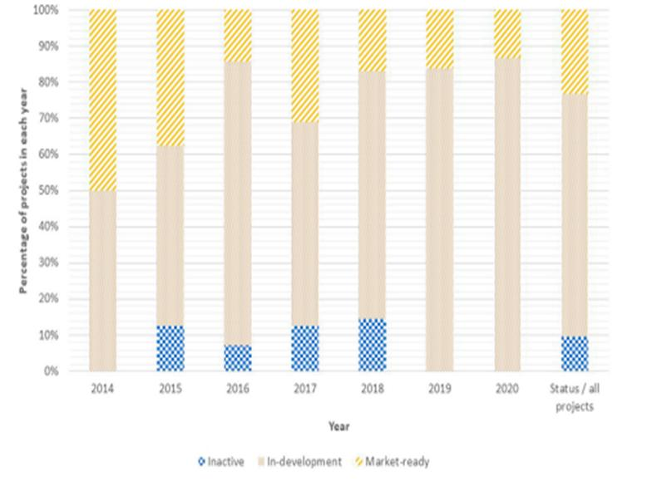

* 1. **Observation notes –**

As a result, 16% of projects with market-ready status fall into the TBC category. Only 2% of hyper ledger projects seem to be idle, while 47% are still in development and 36% are ready for launch. Of all Ethereum projects, 15% appear to be dormant, 21% appear to be ready for the market, and 50% appear to be in development.

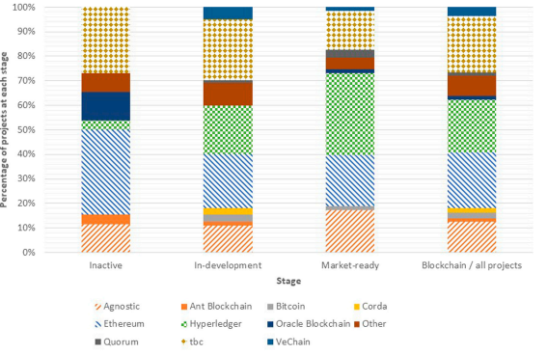

* 1. **Research articles, industry reports –**

Lastly, retail operations (7% of all projects) and the circular economy (8% of all projects) are the two least used application areas. Specifically, the UCL Centre for Blockchain Technologies' previous project identification work (2019) is the reason behind the renewed interest in the circular economy, which is essential to sustainability. Furthermore, retail operations, where blockchain technology and consumers collide, may be seen as a more risky growth sector, which could account for the lack of progress in this field.

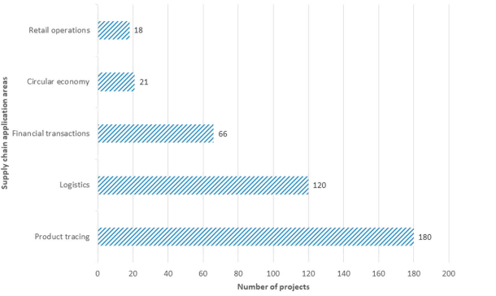

1. **RECOMMENDATION**

Finally, based on the findings of this research study assessing the factors driving blockchain deployment at Aditya Birla Group to facilitate tailored and smart insurance contracts, numerous recommendations arise.

First and foremost, Aditya Birla Group must continue to invest in blockchain technology infrastructure and personnel to support the successful adoption and continuous development of smart insurance contracts.

Second, developing engagement and collaborations with blockchain technology providers and industry peers may help to spread information and implement best practices.

Third, continual monitoring and evaluation of blockchain initiatives' performance indicators is required to discover areas for improvement and refinement.

Finally, proactive interaction with regulators and politicians may assist in navigating the developing regulatory landscape and creating a favourable atmosphere for blockchain innovation in insurance operations.

1. **CONCLUSION**

Finally, this research report studied the elements that influence Aditya Birla Group's use of blockchain technology to provide tailored and smart insurance contracts. Several major findings have emerged from a thorough review of the prospects, difficulties, and strategic considerations linked with blockchain implementation.

For starters, blockchain technology has the ability to completely transform insurance contract administration by increasing reliability, safety, and efficiency. The decentralized and unchangeable nature of blockchain allows Aditya Birla Group to simplify operations, automate jobs, and improve the entire customer experience.

In conclusion, the outcomes of this study highlight blockchain technology's disruptive influence on insurance contract administration at Aditya Birla Group. By embracing creativity, leveraging collaborations, and taking a forward-thinking attitude, Aditya Birla Group may establish itself as a leader in customized and smart insurance options, producing value for stakeholders and increasing competitiveness in the changing insurance market landscape.

1. **REFERENCES**

* “Estimated Size of the Global Insurance Market 2020, with Forecasts up until 2025,” 2020, <https://www.statista.com/statistics/1192960/forecast-global-insurance-market/>.
* “Bitcoin.org,” <https://bitcoin.org/bitcoin.pdf>.
* Government Office for Science, “Distributed ledger technology: beyond block chain,” in Government of United Kingdom, 2016, <https://www.gov.uk/government/news/distributed-ledger-technology-beyond-block-chain>.
* D. Mingxiao, M. Xiaofeng, Z. Zhe, W. Xiangwei, and C. Qijun, “A review on consensus algorithm of blockchain,” in Proceedings of the 2017 IEEE International Conference on Systems, Man, and Cybernetics (SMC), pp. 2567–2572, Banff, Canada, October 2017. <https://ieeexplore.ieee.org/abstract/document/7473060>