EV Charging and Monitoring System

# Om Chaudhari1, Minakshi Ahire2, Jay Jadhav3

1,2,3Student, Department of E&TC, MVP’s KBT College of Engineering, Nashik, Maharashtra, India.

# ABSTRACT

This system provides an efficient and user-friendly platform for EV owners to charge their vehicles while monitoring and optimizing their charging processes. This is charging monitoring system made for 2- wheeler electric vehicle which has rating of 3.3kw. the main purpose of the system is to measure the current, voltage for overlimit condition which has been done by the current transformer also the system has anti-theft detection that prevent the unauthorized usage. The system will start to charge the vehicle by authentication process and the access is given to the owner only. It allows operators to operate through RFID which ensures the authentication process and monitor the charging stations, ensuring their availability and performance with customized duration of charging according to customer.

**Keywords:** Electric Vehicles (EVs), Smart Adapter, Charging Infrastructure, Real-time Monitoring, Authentication, Monitoring System.

# INTRODUCTION

# As electric vehicles (EVs) continue to gain prominence in the automotive industry, the development of efficient and accessible charging infrastructure is important. The objective of this project is to design, develop, and evaluate a 3.3 kW electric vehicle charger for 2wheeler.This 3.3 kW charger aims to address the charging needs of EV. It's designed to be cost-effective, compact, and adaptable to various EV models. Moreover, it contributes to the broader goal of promoting cleaner and greener transportation options. The project interfacing involves the current transformer to analyze overcurrent and overvoltage, RFID system is used to authenticate the user to allow to charge their vehicle, Bluetooth is used to operate the system Wirelessly. All the output of current, voltage, charging duration etc. is displayed on LCD display. The design and implementation of the charger's electrical and electronic components, communication interfaces, and safety features. In summary, the Smart Adapter for Charging and Monitoring Electric Vehicles with Authentication represents a paradigm shift in EV charging technology. By combining advanced authentication mechanisms, real-time monitoring capabilities, and adaptive charging algorithms, the adapter offers a comprehensive solution to enhance security, efficiency, and user experience in the EV charging ecosystem. As electric mobility continues to evolve, the Smart Adapter stands poised to play a pivotal role in driving forward the transition towards a sustainable transportation future.

# RELATED WORK

“EV Charing and Monitoring System” this paper was published in IRJMETS in 2022 As electric vehicles (EVs) continue to gain prominence in the automotive industry, the development of efficient and accessible charging infrastructure is important. The objective of this project is to design, develop, and evaluate a 3.3 kw electric vehicle charger for 2wheeler. This 3.3 kw charger aims to address the charging needs of EV. It's designed to be cost-effective, compact, and adaptable to various EV models. Moreover, it contributes to the broader goal of promoting cleaner and greener transportation options. The project interfacing involves the current transformer to analyse overcurrent and overvoltage, RFID system is used to Authenticate the user to allow to charge their vehicle. All the output of current, voltage, charging duration etc is displayed on LCD display.The design and implementation of the charger's electrical and electronic components, communication interfaces. We're going to be ready to feed faves irrespective of where we are.[1]“Electric Vehicle Charging Infrastructure Development” by Cong Wu, Jianji Wang, Tianjin Chen, IEEE((2020)

This paper focuses on the development of electric vehicle (EV) charging infrastructure in the UK, which is a vital part of the delivering ultra-low-emission vehicle (ULEV) and will transition into low emission energy systems in the near future. Following a brief introduction to global landscape of EV and its infrastructure, this paper presents the EV development in the UK. It then unveils the government policy in recent years, charging equipment protocols or standards, and existing EV charging facilities. Circuit topologies of charging infrastructure are reviewed. Next, three important factors to be considered in a typical site, i. e., design, location and cost, are discussed in detail. Furthermore, the management and operation of charging infrastructure including different types of business models are summarized. Last but not least, challenges and future trends are discussed [2] “Commercial electric vehicle charging methods” by .Dr. UMIT K. TERZI, MDPI(2019) in Electric Vehicles (EVs) are rapidly becoming the forerunners of vehicle technology. First electric vehicles were overlooked because of not having adequate battery capacity and because of low efficiency of their electric motors. Developing semiconductor and battery technologies increased the interest in the EVs. Nevertheless, current batteries still have insufficient capacity. As a result of this, vehicles must be recharged at short distances (approximately 150 km). Due to scheduled departure and arrival times EVs appear to be more suitable for city buses rather than regular automobiles. Thanks to correct charging technology and the availability of renewable energy for electric buses, the cities have less noise and CO2 emissions. The energy consumption of internal combustion engines is higher than of the electric motors. In this paper, studies on the commercial electric vehicle charging methods will be reviewed and the plug-in charging processes will be described in detail. This study strives to answer the questions of how plug-in charging process communication has performed between the EV and Electric Vehicle Supply Equipment (EVSE) [3] “IoT Based Pet Feeder System” this was published in IJARIIE in 2018. Charging-station provides power supply for electric vehicles, which is a necessary and important energy supporting infrastructure for development and large-scale commercialization operation of electric. For the current charging-station management is overly dependent on high-cost devices such as industrial computer, this paper develops a charger field test device, which adopts STM32 as the data exchange interface between the host computer and charger. The charge data is sent to PC through STM32, and the monitoring system development is designed by LABVIEW. This method optimizes the decoding of message content, overcomes the defect of over reliance on high cost components, and strengthens the ability of bottom message collection, enhances the system intelligence. The communication is fast, reliable and has a good man-machine interface.[4] “EV charging station and monitoring using open charge point protocol” this paper was published in ijsrem in 2024. Electric vehicles (EVs) have gained significant popularity in recent years due to their environmental benefits and potential to reduce dependence on fossil fuels. As the adoption of EVs continues to increase, the efficient management and monitoring of charging stations become crucial to ensure reliable and seamless charging services. This abstract presents a solution for monitoring electric vehicle charging stations using the Open Charge Point Protocol (OCPP) in conjunction with NodeMCU and a web application. The proposed system utilizes the NodeMCU, an open-source IoT platform based on the ESP8266 Wi-Fi module, to connect and communicate with the EV charging stations. NodeMCU acts as a gateway between the charging stations and the web application, enabling real-time data collection and monitoring. OCPP, an open and widely accepted communication protocol for EV charging infrastructure, is employed to establish a standardized and interoperable communication link between the charging stations and the NodeMCU. The web application serves as the user interface for monitoring and managing the charging stations. It provides a comprehensive dashboard that displays real-time information such as charging station status, power consumption, charging history, and availability of charging ports. Users can access the web application from any device with internet connectivity, enabling remote monitoring and control of the charging stations. The system architecture ensures secure and reliable communication between the charging stations, NodeMCU, and the web application. Advanced encryption techniques are employed to protect sensitive data and prevent unauthorized access or tampering. By implementing this solution, electric vehicle charging station operators and administrators can effectively monitor and manage their charging infrastructure.

# METHODOLOGY

The project mainly consists of major components:

1. STM32 Controller
2. CT
3. MRFC522 RFID
4. SLA-12VDC RELAY
5. LCD 16×2

This paper presents the design and implementation of a charging station aimed at enhancing the charging process while ensuring authentication and monitoring functionalities. The proposed charging station integrates advanced technology to enable seamless communication between the EV, charging station, and utility grid. Overall, this System represents a significant advancement in EV charging technology, offering enhanced security, efficiency, and intelligence.

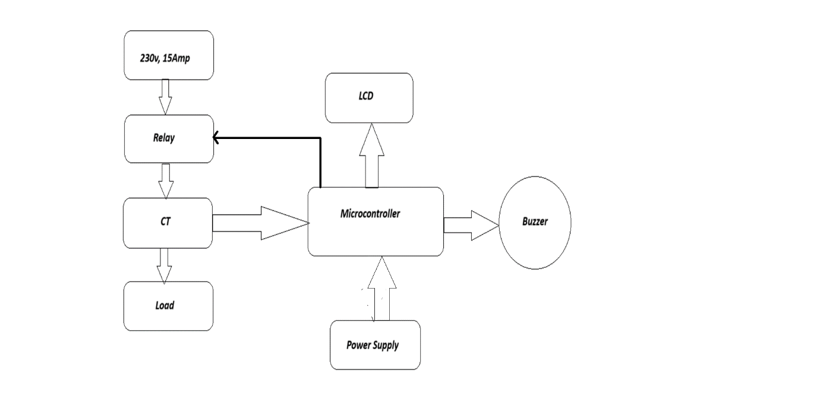



.

**Figure 1:** Block diagram of EV Charing and Monitoring System

* The STM32 this microcontroller is used for access the control in overall circuit. The role of microcontroller is to integrate the input of devices allowed such as RFID, Relay, Current transformer, LCD and Buzzer.
* The RC522 RFID Reader module is used to communicate with a microcontroller over Serial Peripheral Interface (SPI) communication protocol to provide authentication or secure charging of electric two-wheeler, so that only authorized user can charge their EV.
* when the microcontroller is power up the user set the duration of charging after it requires access through RFID to start the charging once RFID card is scanned.
* The relay will switched when the user is verified by scan the RFID then the 230V 15 amp applied to the output load through current transformer where user can plugged their on-board charger of the EV. CT analyze the current consuming by the output (on-board charger of the EV) to prevent the EV from overcurrent.

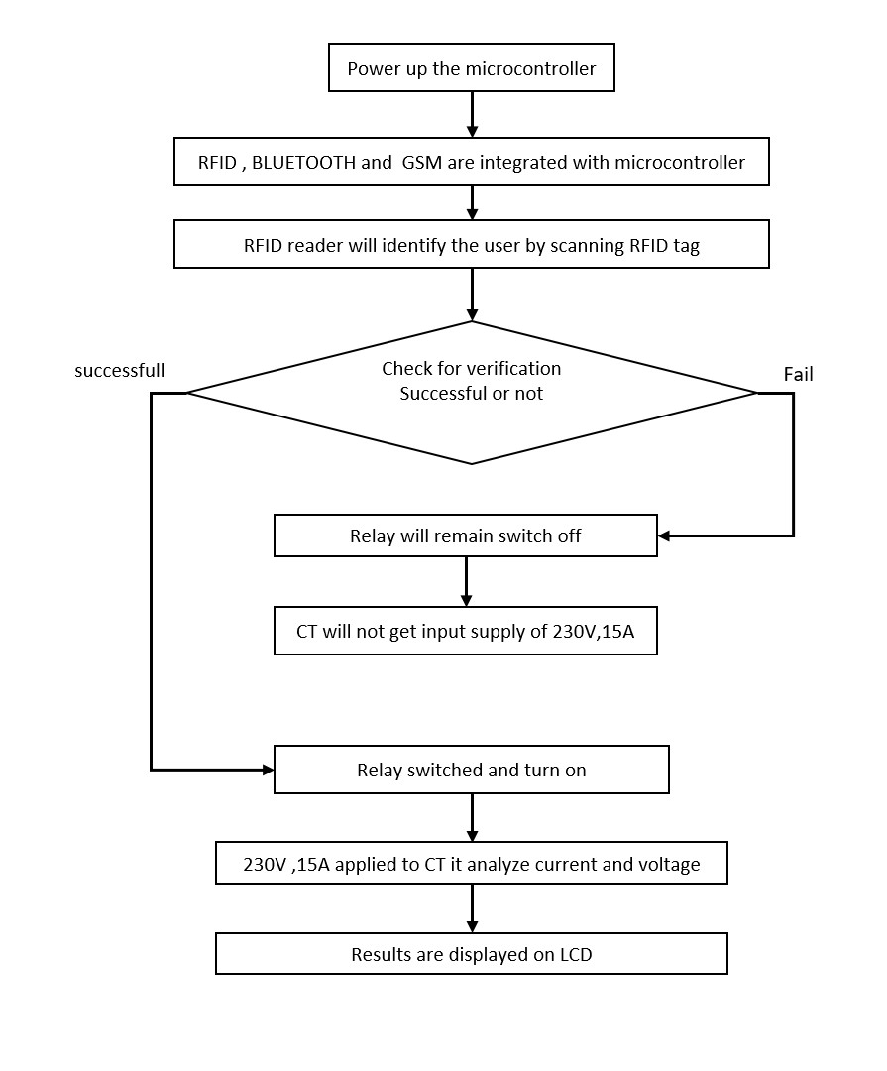

**Figure 2:** Flowchart of EV Charging and Monitoring System

# RESULTS AND DISCUSSION

After completing and testing the project we have observed these following results. As shown below

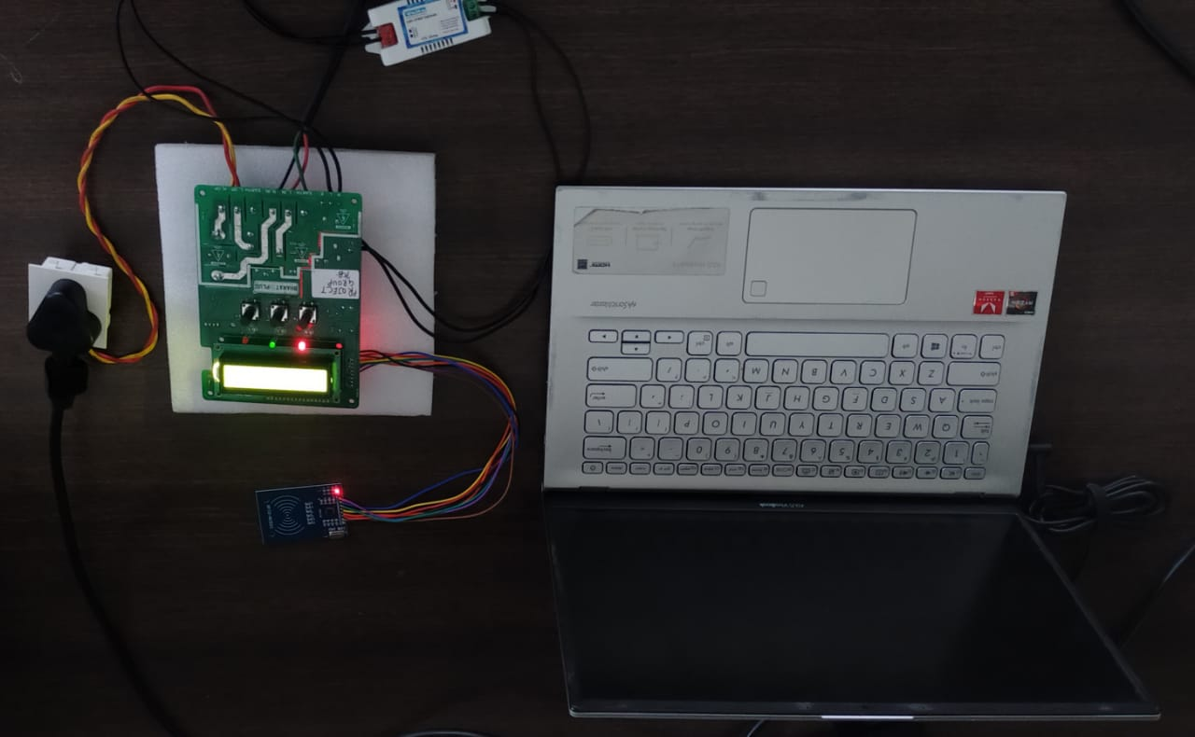

**Figure3:** Image of EV Charing and Monitoring Systems

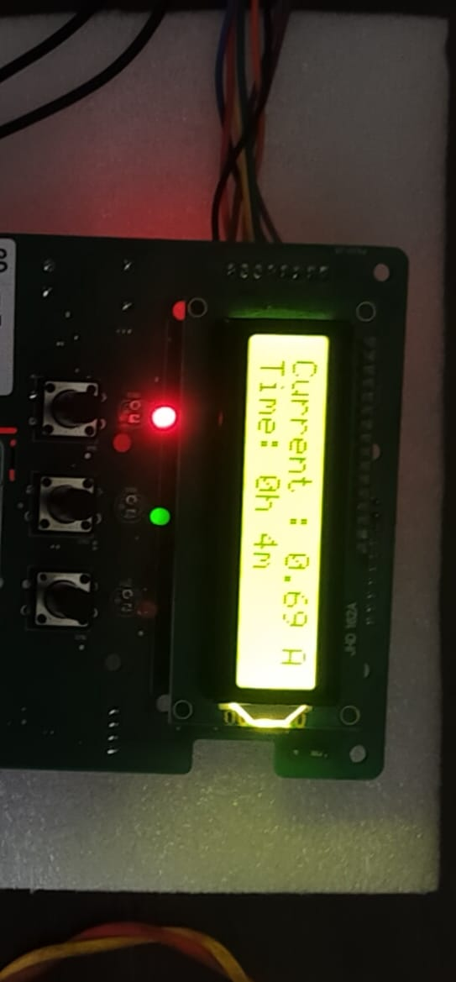

**Figure4:** image ofcurrent measuring of load

# CONCLUSION

# Electric vehicle charging and monitoring of by authentication this system of 3.3kw is made to analyze and monitor the charging of electric vehicle in such way that the system will identify the certain parameters which caused major effect on the battery of the electric vehicle.

# As in this project we are making the adapter of 3.3kw for the two- wheeler bikes and monitor for the over -charging, over current, over voltage through current transformer to prevent the battery from damage and also the anti-theft detection is there. first the owner verified by authentication process for the security purpose this is done by the RFID system then the vehicle will start to charge. after the monitoring and analyzing is done all the results will be displayed on the LCD such as continues monitored current and voltage, charging duration.

# REFERENCES

1. Development of rapid charging system for EV battery, International Journal of Recent Technology and Engineering (IJRTE), ISSN: 2277-3878, Volume-7, Issue-6S, March 2019.
2. International Electrotechnical Commission. (2014). IEC 61851-23. Electric vehicle conduction system  – Part 23  – D.C. electric vehicle charging station. Geneva: International .
3. Li, H., Zhang, W. S., Shi, J. Y., & Ma, X. Y. (2013). The sensing technologies in the electric vehicle charging and exchanging station. Applied Mechanics and Materials, 303–306, 1456–1459.
4. L. Xiaoguang, Z. Qionghua, H. Kui, S. Yuehong, “Battery management system for electric vehicles,” J.Huazhong Univ. Of Sci. & Tech. (Nature Science Edition). Vol. 35, No. 8, pp. 83-86, 2007.
5. S. A. Mathew, R. Prakash, and P. C. John “A smart wireless battery monitoring system for electric vehicles,” Int. Conf. Intel. Syst. Des. Appl. ISDA, pp. 189–193, 2012.