**ARDUINO FIRE FIGHTING ROBOT**

**Mr. Nagaraja Kumar1, Pannala Mounika2, Devarashetti Ramani3, Moodapalli Saketh4, Manda Sai Sujith5**

1Assistant Professor, Department of Computer Science and Engineering & CSE (IoT), ACE Engineering College, Hyderabad, Telangana, India

2,3,4,5IV B. Tech Students, Department of Computer Science and Engineering & CSE (IoT), ACE Engineering College, Hyderabad, Telangana, India

**----------------------------------------------***----------------------------------------------**

**ABSTARCT**

Fire incident is a disaster that can potentially cause the loss of life, property damage and permanent disability to the affected victim. Major fire accidents do occur in industries like nuclear power plants, petroleum refineries, gas tanks, chemical factories and other large-scale fire industries resulting in quite serious consequences. Thousands of people have lost their lives in such mishaps. Therefore, this project is enhanced to control fire through a robotic vehicle. With the advancement in the field of Robotics, human intervention is becoming less every day and robots are used widely for purpose of safety. In our day-to-day life fire accidents are very common and sometimes it becomes very difficult for fireman to save human life. In such case firefighting robot comes in picture.

This project aims in giving a technical solution to the mentioned problem. A robot is a mechanical design that is capable of carrying out a complex series of actions automatically, especially one programmable by a computer. The flame sensor detects the fire and gives the further signal to the extinguisher units to trigger the pump and spray the water. The whole system is programmed using an Arduino UNO board (ATmega328P microcontroller) which forms the brain of the system.

Keywords: DC motors, flame sensor, servo motor, motor driver, water pump, Arduino.

**1. INTRODUCTION**

The Firefighting Robot, driven by Arduino technology, stands as an innovative and effective response to fire emergencies. With its array of sensors, the robot can swiftly detect the presence of smoke and flames, enabling a rapid and accurate response. Equipped with a mechanism for dispensing water or foam, the robot extinguishes fires upon detection, minimizing the risk to human responders. Real-time data collection through the sensors ensures that the firefighting operations are not only swift but also tailored to the specific requirements of the situation.

The Arduino-based control system provides a powerful interface for remote operation and monitoring, adding an extra layer of safety to the firefighting process. This adaptability also makes the technology cost-effective and customizable, meeting the diverse needs of different firefighting scenarios. The compact design of the robot further enhances its accessibility, allowing it to navigate through confined spaces and reach areas that may be challenging for human responders.

Overall, the Firefighting Robot powered by Arduino is a testament to the synergy between cutting-edge technology and public safety. Its autonomous capabilities, real-time data processing, and remote control features make it a valuable asset in firefighting operations, demonstrating the continuous evolution and application of robotics in addressing critical challenges.

**2. LITERATURE SURVEY**

[1] Tawfiqur Rakib, M. A. Rashid Sarkar proposed a firefighting robot model which consists of a base platform made up of ‘Kerosene wood’, LM35 sensor for temperature detection, flame sensors to detect the fire and a water container of 1 litre capacity which is made up of a strong cardboard that makes it water resistant. The robot has two wheels for its movement.

[2] Saravanan P., Soni Ishawarya proposed a model which uses Atmega2560 micro-controller and in which the robot is divided into three basic units according to their functions which are as locomotive unit, fire detecting unit and extinguishing unit. The locomotive unit is used for the movement of the robot and to avoid the obstacles with the help of four IR and four ultrasonic sensors. The fire detecting unit is used to detect fire using LDR and temperature sensor. The extinguishing unit is used to extinguish the fire using water container and BLDC motor. The robot also have a Bluetooth module that is connected with the smartphones in order to navigate it in the proper direction.

[3] S. Jakthi Priyanka, R. Sangeetha proposed an android controlled firefighting robot which uses Arduino UNO R3. The robot consists of gas sensor for fire detection, gear motor and motor drive for the movement of robot, a Bluetooth module to connect the robot with the android device and to control the robot with the smartphone as well. Water pump and sprinkler is also used in this.

[4] Nagesh MS, Deepika T V, Stafford Michahial, Dr M Shivakumar proposed a fire extinguishing robot which employs DTMF (Dual Tone Multi Frequency Tones) technology for the navigation of the robot and uses a flame sensor for fire detection that is capable of sensing flame of the wavelength range 760 to 1100 nm and sensitivity varies from 10cm to 1.5feet.

[5] Sushrut Khajuria, Rakesh Johar, Varenyam Sharma, Abhideep Bhatti proposed an Arduino based fire fighter robot which consists of RF based remote operation to operate the robot and water pump. The robot is controlled by the user within a range of 7 metres. It also consists of a wireless camera which helps user to move  the robot in the required direction.

[6] Rolly Firefighter Robot by William Dubel, Hector Gongora, Kevin Bechtold, and Daisy Diaz. This firefighting robot is designed to search for a fire in a small floor plan of a house, extinguish the fire and then return to the front of the house. The navigation of the robot throughout the house is achieved by data provided by a line tracker and ultrasound transducers. The deployment of the extinguishing device is implemented with a custom arm controlled by servos.

[7] Khaled Sailan, Prof. Dr.-Ing. Klaus-Dieter Kuhnert, Simon Hardt proposed an obstacle avoidance robot named as Amphibious Autonomous Vehicle. In this robot, a fuzzy controller is used to avoid static obstacle in real time. It aims to guide the robot or vehicle along its path  avoiding all the obstacle that comes along the path.

**3. HARDWARE AND SOFTWARE REQUIREMENTS**

**3.1 HARDWARE REQUIREMENTS:**

* Arduino Uno

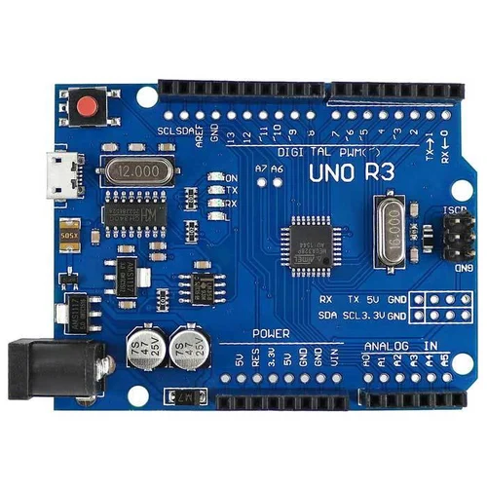

* GSM Module

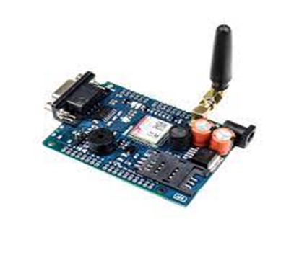

* Flame Sensor

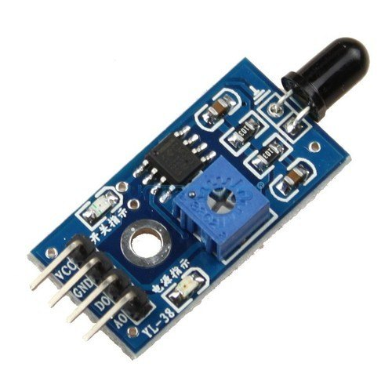

* L298NMotor Driver

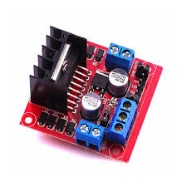

* Relay Module

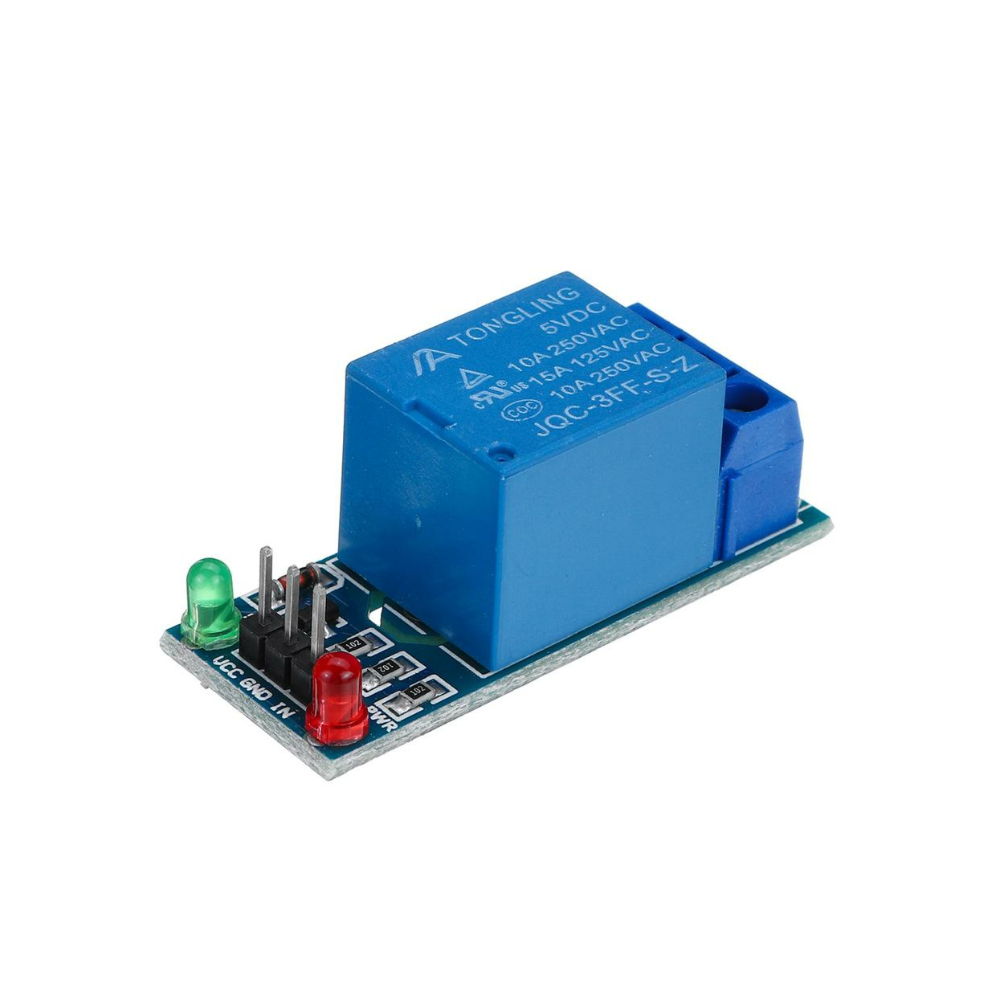

* Servo Motor

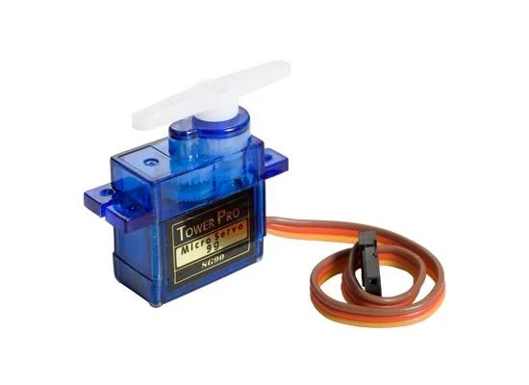

* Mini water pump

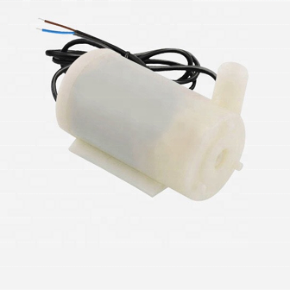

* 4-wheel BO motor

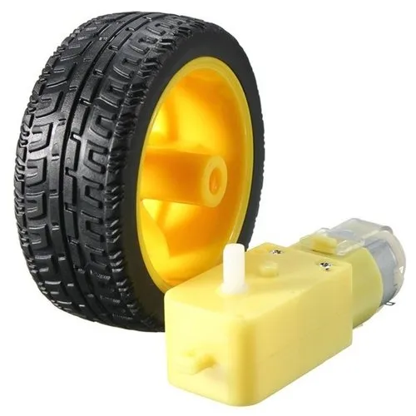

* 18650 Battery * 2

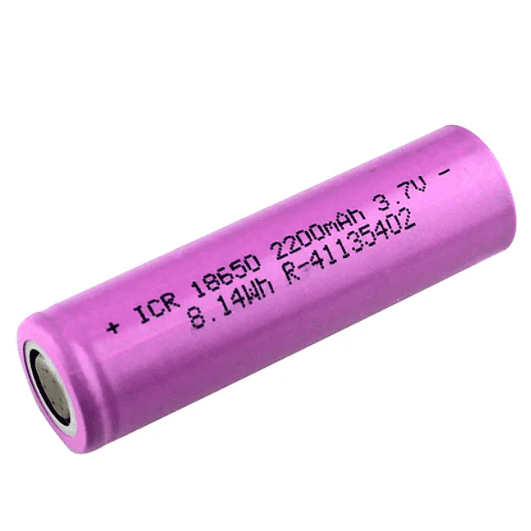

**3.2 SOFTWARE REQUIREMENTS**

* Arduino IDE

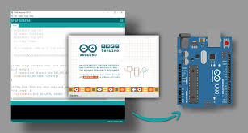

**4. IMPLEMENTATION OF OBJECTIVE**

**Chassis Assembly:** Build the physical structure of the robot using the chassis, wheels, and motors.

**Motor and Wheel Connection:** Connect the DC motors to the motor driver and then to the Arduino.

**Sensor Connections:** Connect the fire detection sensor and ultrasonic sensor to the Arduino.

**Water Pump and Nozzle Setup:** Connect the water pump to the Arduino and set up nozzles to spray water effectively.

**Programming:** Write the Arduino code to control the motors, read sensor data, and make decisions based on the input.

**Fire Detection Logic:** Implement a logic in your code to detect fire using the fire sensor.

**Obstacle Avoidance Logic:** Use data from the ultrasonic sensor to avoid obstacles.

**Firefighting Logic:** If fire is detected, activate the water pump and direct the robot towards the fire.

**Testing:** Test the robot in a controlled environment to ensure it responds appropriately to fire and obstacles.

**Refinement:** Refine and optimize your code and hardware based on testing results.

**5. OUTPUT SCREEN**

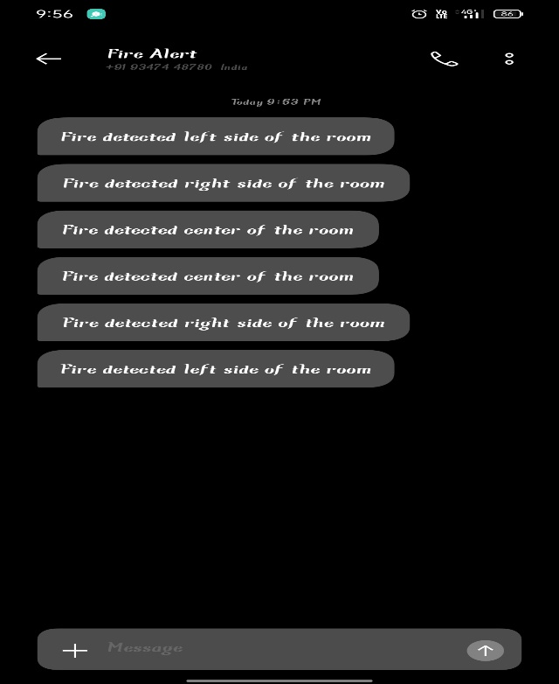

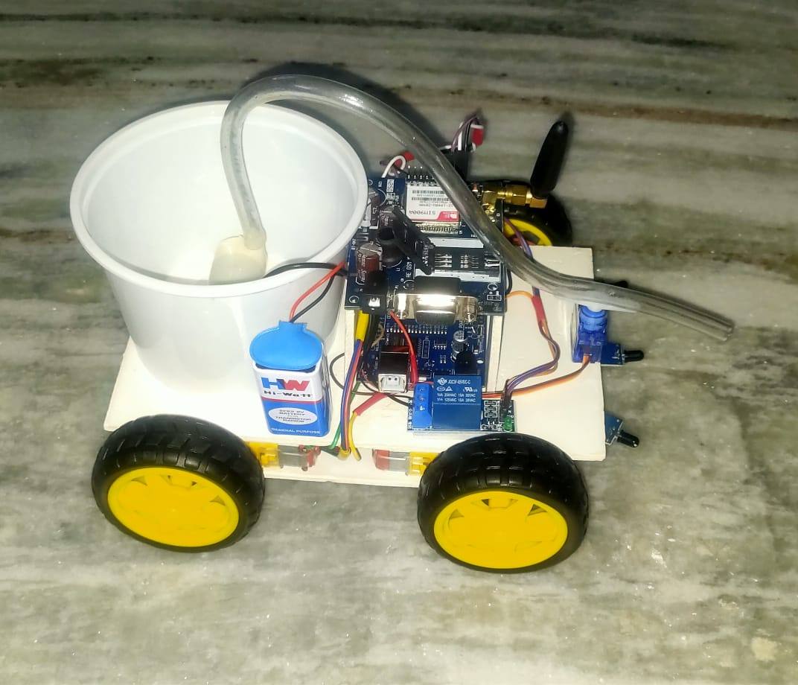

**6. CONCLUSION**

In conclusion, the Arduino-based fire-fighting robot integrated with a GSM module represents a technologically advanced and efficient solution for fire management. By combining the versatility of Arduino for autonomous fire detection and navigation with the real-time communication capabilities of the GSM module, the system offers a powerful tool for rapid response and remote monitoring. This innovative approach not only enhances the effectiveness of fire-fighting operations but also demonstrates the potential of combining open-source hardware with modern communication technology to address critical challenges in emergency response systems.

**7. FUTURE ENCHANCEMENT**

* Advanced Fire Detection Algorithms: Incorporating advanced algorithms, potentially based on machine learning, to improve the accuracy and speed of fire detection, enabling the robot to respond more effectively to various fire scenarios.
* Swarm Robotics: Exploring the implementation of swarm robotics, where multiple fire-fighting robots can work collaboratively to cover larger areas, share information, and coordinate efforts for more efficient and comprehensive fire response.
* Energy-Efficient Systems: Implementing energy-efficient technologies, such as optimized power management systems or the integration of alternative energy sources, to extend the operational duration of the robot and increase its autonomy during firefighting missions.
* Enhanced Communication Protocols: Investigating and adopting advanced communication protocols or technologies beyond GSM, such as 5G or low-latency communication systems, to ensure faster and more reliable data transmission for real-time remote monitoring and control.

**8. ACKNOWLEDGEMENT**

We would like to thank our guide Mr. Nagaraja Kumar and our project coordinator Mrs. P. Swaroopa for their continuous support and guidance. We are also extremely grateful to Dr.M.V.VIJAYA SARADHI, Head, Department of Computer Science and Engineering & CSE(IoT), ACE Engineering College for his support and invaluable time.

**9. REFERENCES**

[1] Rutuja Jadkar, Rutuja Wadekar, Shweta Khatade, Sayali Dugane, Prof.Dr.S.N. Kini, “A Survey on Fire Fighting Robot Controlled Using Android Application”, International Journal of Innovative Research in Science, Engineering and Technology [vol. 4], Issue 11, November 2015.

[2] University Malaysia Perlis, UNIMAP, “Fire Fighting Robot Competition, Theme & Rules”, 2009.

[3] Kristi Kosasih, E. Merry Sartika, M. Jimmy Hasugian, danMuliady, “The Intelligent Fire Fighting Tank Robot”, Electrical Engineering Journal Vol. 1, No. 1, October 2010.

[4] M. S. M. Hasimi, W. H. W. Zuha, Suhaidi Shafie, M. Hamiruce Marhaban Department of Electrical and Electronic, University Putra Malaysia “Fire Fighting Robot”, APSAEM2010, July 2010.

[5] Jayanth Suresh, M.S Electrical Engineering, Rochester Institute of technology New York, “Fire Fighting Robot”, International Conference on Computational Intelligence in Data Science (ICCIDS), June 2017.

[6] Ziliu ye, Fuwen Su, Qingyong Zhang, Lili Wan, Wuhan University of Technology, China, “Intelligent Fire-Fighting robot based on STM32”, 2019.

[7] Swati A. Deshmukh, Karishma A. Matte and Rashmi A. Pandhare, “Wireless Fire Fighting Robot”, International Journal For Research In Emerging Science and Technology.

[8] Ligang Chen, Qingdao Binhai University, “Design and Manufacture of Indoor Intelligent Fire Fighting Robot”, 2020.

[9] “Rolly Firefighter Robot”, William Dubel, Hector Gongora, Kevin Bechtold, and Daisy Diaz, Florida International University, Miami, 2003.

[10] Shang Gao, Zihan Zhao, Mohsin M. Jamali, University of Detroit Mercy, USA, “Vision and Infra-Red Sensor Based Fire Fighting Robot”,2018.

[11] Rohini More, Shrilekha Survase, Shubhangi Patil, Prof. S.D. Panchal 2017 “Firefighting wireless-controlled robot using 8051”.

[12] Hasan U. Zaman, Rakibol Islam Rakib, Md. Aowrongajab Uday, North South University, Bangladesh, “The Design of a Novel Multi-Purpose Fire Fighting Robot with Video Streaming Capability”, March2019.

[13] “Fire Protection Robot”, Viet Do, Ryan Norder, and Ryan Spraetz, Moscow

[14] S. Sridevi, G. Manikandan, J. Dhanasekar, P. Sengottuvel, Bharath University, India, “Design of Fire Fighting Robot”, International Journal of Innovative Research in Science, Engineering and Technology [vol. 3], Issue 11, November 2014