Formulation and evaluation of bhramakamal leaves powder. Department of pharmacognocy:Godavari Institute of pharmacy kolpa latur ,Pooja kharosekar pl aprajwal phad papradip waghmare

ABSTRACT: formulation of bhramakamal powder they prepared on natural extract on leaves of powder and they peppermint leaves are main exiplents are use on powder making on the product of powder preparation the powder preparation main constituents are ppeppermlnt leaves are extract it and they formed methanol for povvder making on bhramakamal leaves powder and ppeppermint leaves making methanol for mixing it they formulation formed this on process are used on the making the powder. they getting the 10 gm powder for 100 ml methanol are mixed it and to formed the product of powder formulation. powder is solld dosage form formed they making on natural prepared. this process main formed by the methanol preparation of 2 day on packed conditions on lab firstly getting on peppermint leaves half kg and mixing 100ml distilled water and this mixture 2days pack on container and after two days methanol formed . then yellow color shows methanol. and dryed leaves of bhramakamal tarturate it and powder formed.

KEY WORDS: The formulation and evaluation of bhramakamal leaves powder

INTRODUCTION: formulation and evaluation of bhramakamal leaves powder to prepare by the dry bhramakamal leaves, and peppermint leaves are wash it and tarturate this leaves for mortal and pestal using and they masticated leaves added 100ml water for 2days closed packed In containers and they after two day they show yellow color ,then this solution are filter it in filter paper then this solution are mixed in 10 gm of bhramakamal powder and methanol solution 100ml then this material are heat by 150 c temperature on 45 min in hot air oven. the material- are dryed it they creamy-color-shows-Thisis powder from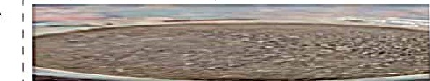

OBJECTIVES:

1) they powder are prepared in naturally.

2) they not show any toxic effects 

3) they not show any harmful effects.

4)this product prepared only natural leaves are used 5)they treatment of stomach pain, infection, cancer cell growth control, antimicrobial, antibiotics, antibacterial, antifungal, antiseptic, used.

6) this powder formulation check in evaluation test positive for ph is acidic, microscopic method positive.solubility test positive7) powder prepared they using naturally preapred methanol no any harm.

8) the powder are natural formulation for good health PLANT PROFILE:

Kingdom: Plan

EudicotsCIade:

AsteridsOrder:AsteraIesFamiIy:

AsteraceaeGenus:SaussureaSpecies:

S. obvallata

Binomial nameSaussurea obvallata

PANT PROFILE:

Kingdom:PlantaeClade:TracheophytesClade:AngiospermsClade:



MenthaSpecies:M. x piperitaBinomial nameMentha x piperitaMentha x odoraSalisb.Mentha * balsamea Willd.Mentha * banaticaHeinr.BraunMentha x braousiana PérardMentha * concinna PérardMentha x crispula Wender.Mentha x durandoana Malinv. ex Batt.Mentha x exaltata Heinr.BraunMentha x fraseri DruceMentha x glabra

Bellardi ex CollaMentha x glabrata VahlMentha xhercynica RÖhI. Mentha x heuffeIiiHeinr.BraunMentha x hircina HullMentha x hircina

J.FraserMentha x hirtescens Haw. ex

SpachMentha x hortensis Ten Mentha hortensis

EXCIPIENTSPROFILE:

lignans, flavonoids, steroids,glycosides, triterpenes, sesquiterpenesr lactones

EXIPIENTPROFILE.

menthol and menthone as well as severalother minor constituents, includingmenthofuran, 1,8-cineole, and limoneneAmerican peppermint contains 50-78% of methanol, while English peppermint oil has a methanol content of 60-70%. The

Japanese variety is the strongest with amethanol content of 85 chemical composition of the essential oil frompeppermint (Mentha x piperita L.) wasanalyzed by GC/FID and GC-MS. The mainconstituents were menthol (40.7%) and menthone (23.4%)

NEED.

The flowers, rhizomes and leaves are used for treat-ment of boneache, intestinal ailments, cough/cold and urinary tract problems. Thrhizomes in particular are used as antiseptic and for healing cuts an bruises 4-6

NEED:

Rich in Nutrients. Share on Pinterest. . -May Improve Irritable BowelSyndrome. ..May Help Relieve Indigestion. ...Could Improve BrainFunction. -May Decrease Breastfeeding Pain.

Subjectivelylmproves Cold Symptoms. May Mask Bad Breath. Easy to Addto Your Diet.

Rich in Nutrients. Share on Pinterest. May Improve Irritable

BowelSyndrome. May Help Relieve Indigestion. . Could Improve

BrainFunction. ...May Decrease Breastfeeding Pain

Subjectivelylmproves Cold Symptoms. . .May Mask Bad Breath

PIAN OFWORK.

1) collection of instrument 2) collection of raw materials, 3) time period checking work.

1. collection of proper data 
2. collection of information in deaily work on lab.6) properly used materials quality checking.
3. properly checking quantity of material use.
4. accuracy, identification rchecking.
5. data collection and point note out.
6. systematic study on project arranged

REVIEW OF LITERATURE.

l . Vieira RF

 Skorupa LA. Brazilian medicinal plants gene bank. Acta Hort.

1993,

330.51-8 2 Singhal S, Agarwal A Industrial utilization and promotion of medicinal plants in India. In: Chopra AK, Khanna DR, Prasad G, Malik DS, Bhutiani R, editors. Medicinal Plant: Conservation Cultivation and Utilization.

New Delhi:Daya Publishing House; 2007. p. 325-30

1. Rawat VS, Chandhok A. Medicinal plants used by tribes of Uttarakashi

District of Uttarakhand. Ind J Bot Res.

1. Semvval P
   * Kapoor T, Anthwal P
   * Thapliyal A. Pittosporum eriocarpum royal

(agni) endangered medicinal plant species of Uttarakhand and its conservation. Biotechnol Int.

1. Sharma AB. Global Medicinal Plants Demand May Touch $5 Trillion By 2050.

 EXTRACTION:

 Maceration. This is a very simple extraction method with thedisadvantage of long extraction time and low extraction efficiency. ...Percolation. ...Decoction. .Reflux extraction. . Soxhletextraction. ...Supercritical fluid extraction (SFE) Ultrasoundassisted extraction (UAE) Microwave assisted 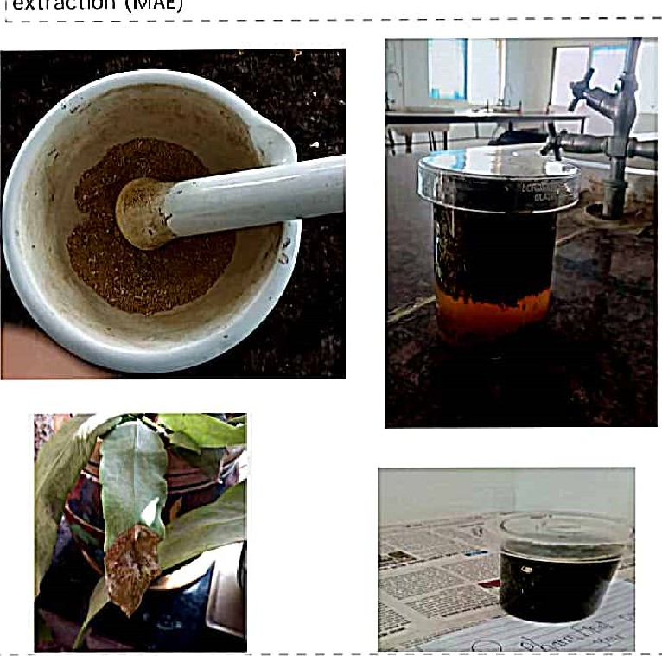extraction (MAE)

Maceration, This is a very simple extraction method with thedisadvantage of long extraction time and low extraction efficiency, ...Percolation. ...Decoction. ...Reflux extraction, . Soxhletextraction. ...Supercritical fluid extraction (SFE) Ultrasoundassisted extraction (UAE) ...Microwave assisted extraction (MA

FORMULATIONS:

FORMULATION OF METHANOL (NATURALLY) PEPPERMINT LEAVES: 1) step: getting peppermint half kg with freash peppermint leaves.

1. step: getting peppermint leaves are wash it and dry it sun rays.
2. step: then getting mortal and pestal for masticated the peppermint leaves.
3. getting beaker, measuring cylinder and petrideash for closed container.
4. step:masticated leaves added 100ml of water distilled. 6) then beaker are closed in petri deash and 2days closed this material.
5. step: After two days peppermint leaves are two layers shows andthen yellow colored formed menthol are filterate and methanol areformed and methanol are formed naturally.
6. step: getting filter paper

9)step: filter paper are placed in funnle and they formed

10)step: Filtered material or solution are yellow color formed 11) step: they 100 ml methanol solution formed diagram formulation:

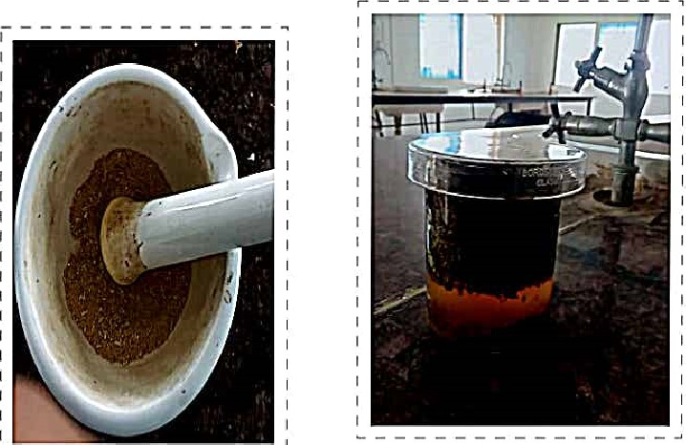

FORMULATION.

FORMULATION OF BHRAMAKAMAL DRY LEAVES POWDER:I) step getting dry leaves of bhramakamal.

2)step: getting mortal and pestal for masticated leaves.

3) step: masticated leaves are separate small partical,

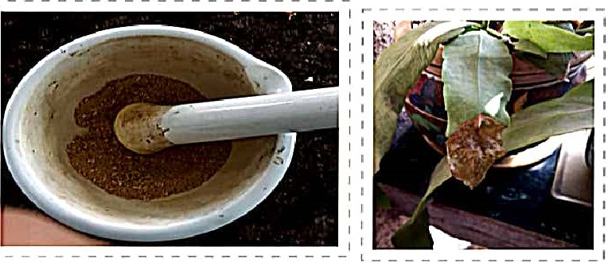

Powder bhramakamal leaves

FORMULATION OFBHRAMAKAMAL POWDER TO METHANOL

l)step:getting dry leaves of bhramakamal and they clean and properly dry.

1. step: getting mortal and pestal for the dryed leaves of bhramakamal masticated 
2. step : getting masticated leaves are used sieves 35 number smallpartical are separate out.
3. step: getting powder and measured this powder amount is 10 gm5) step: getting beaker they placed on powder on this beaker and

6)step: getting the water bath, hot air oven, stand rand beaker, petridesh by heating process.

1. step: they solution heating the hot air oven by 150c temperatureafter 45 min.
2. step : then shows creamy color powder are formed 

EVALUATIONMETHODS:

1) MICROSCOPIC METHOD: 1) step: getting lox microscope 2)getting slide ,glass,slide.

3)slide are applied on powder and applied on glas slide to checkedhleps the find out the impurities and also help quality assessmentsof help quality assessments of purity herbal powder. 4) step: checked microscopic method shows quality is better, purity is good and no any impurities are shows.

5) step: checked microscopic method shows quality is better 6) step: test report shows positive.

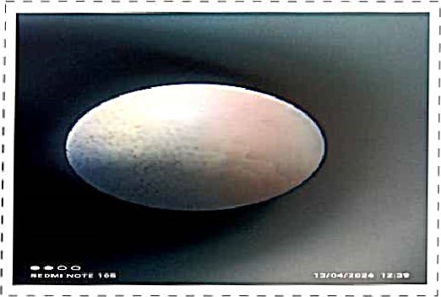

EVALUATIONMETHOD: 2)PH testing:

l)step: ph paper getting,

2) step: Iml of solution making of bhramakamal + methanol powderdistl.water added dissolved solution.

3)step: adding ph paper on this solutlon Imidia„tly shows red color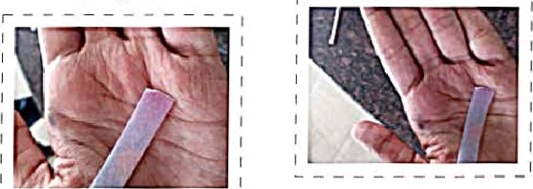

EVALUATIONMETHODS:

3)SOLUBILlTY TEAST:

1. step: getting powder added 2ml water.
2. 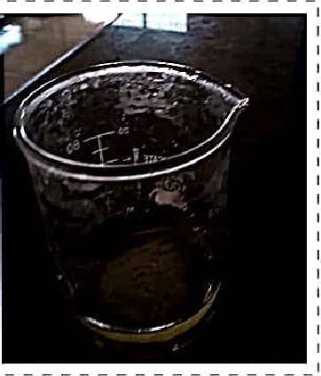step:they solution are made and shows small partical after 1 Omin they soluble. 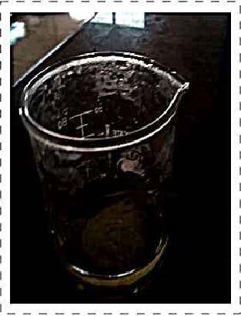

RESULT: formulation ofbhramakamal powder arenaturally preapred and shows no any harmful effects showsall evaluation test are positive effects shows.

CALCULATION:

(Percent yield of extract (%) cx/cyx100)P.Y extract ?

CX- bhramakamal leaves powder value

CY- formulation of methanol

CX = 7gm

# 70 ml

Pry extract = 7/ 100

( = 0.1*100

PY extract = 10%

CONCLUSION findings confirm the traditional claims and contribute in providingpromising baseline information for the pharmacological use of S.obvallata. Additional highly developed research is essential for isolation and identification of specific active components which are responsible for pharmacological properties of the plan. resultsof CC-MS analyses of methanolic leaf and flower extracts of

Saussurea obvallata showed the presence of 36 and 48 components, respectively based on separation of individual peaks through GC as per their retention time (Rt) and area per cent under individual peaks (Tables 3 & 4). The mass spectra of these compounds were matched with the spectra of known compounds listed in WILEY8.LlB and NIST08.LlB spectral databases/ libraries. Some of these components could not be identified by comparison using any of these libraries: such unidentified GC peaks numbered five (5: Rt: 9.1 13, 10.662, 10. 887, 19.407, and 22.337 min) in the flower extract and one (1 Rt.

15.552 min) in the leaf extract. Most of the components presented in the extracts of leaves and flowers have been already reported in respect of different biological activities namely, Curumene (for anticancer), Methyl acetate (for REFERENCE:

Vieira RF

Skorupa LA. Brazilian medicinal plants gene bank. Acta Hort.

Article Google Scholar

Singhal Si Agarwal A. Industrial utilization and promotion of medicinal plants in India. In: Chopra AK, Khanna DR, Prasad G, Malik DS, Bhutiani R, editors. Medicinal Plant: Conservation Cultivation and Utilization. New Delhi: Daya Publishing House, 2007. p. 325-30.

Rawat VS, Chandhok A. Medicinal plants used by tribes of Uttarakashi District of Uttarakhand. Ind J Bot Res.2009•5(3& 4):169-73.

Google Scholar

Semwal P

* Kapoor T, Anthwal P
* Thapliyal A. Pittosporum eriocarpum royal (agni) endangered medicinal plant species of

Uttarakhand and its conservation. Biotechnol Int.

25-30.

Google Scholar 

Sharma AB. Global Medicinal Plants Demand May Touch $5 Trillion By 2050. Indian Express 2004.

Pandey MM, Rastogi S, Rawat AKS. Saussurea costus: botanical chemical and pharmacological review of an ayurvedicmedicinal plant. J Ethnopharmacol. 2007;110:37990.

Article CAS PubMed Google Scholar

Chick WI, Zhu L, Yi T, Zhu GYr Gou et al, Saussurea involucrata: a review of the botany, phytochemistry andethnopharmacology of a rare traditional herbal medicine.

J Ethnopharmacol.

Article CAS Google Scholar

Fan JY, Chen HB, Zhu L, Chen HL, Zhao ZZ, Yi T. Saussurea medusa, source of the medicinal herb snow lotus: a review of itsbotany, phytochemistry, pharmacology and toxicology Phytochem Rev.

Article CAS Google Scholar

Chen QL, Chen xy, Zhu L, Chen HB, Ho HM, Yeung WP  et al, Review on Saussurea lanicepsr a potent medicinal plant known