**A Study on concrete with Silica Fume as a Partial Replacement to Cement**

**K. Akhil Babu* , P. Harish Manikanta\***

**P. Narendra Babu\***

**\***UG Students-Final Year, 1 Associate Professor

Department of Civil Engineering, NRI Institute of Technology, Agiripalli, India**.**

**Abstract:** The aim of this study is to evaluate the performance of Silica Fume an industrial by product as a admixture in concrete keeping in view the increasing market demand of cement which compel production of cement at large scale resulting in environmental problem and depletion of natural resources on one hand and rising prices on the other hand. To overcome these problem ideas developed to investigate the use of industrial by product/waste. The silica fume industrial by product found to be an attractive cementations material which is by product of smelting process in the silicon and ferrosilicon industry. The partial replacement of silica fume and its effects on concrete properties has been studies by adopting M-25, M-30, &M-35 concrete mix in this dissertation. The main parameter investigated in this study M-25 to M-35 concrete mix with partial replacement by silica fume with varying 0, 5,&10% by weight of cement The paper presents a detailed experimental study on compressive strength, and split tensile strength for 7 days and 28 days respectively. The results of experimental investigation indicates that the use of silica fume in concrete has increased the strength and durability at all age when compared to normal concrete. Hence the use of Silica Fume leads to reduction in cement quantity for construction purpose and its use should be promoted for better performance as well as for environmental sustainability.

**KEY WORDS:**  MicroSilica, Design Mix Concrete, Compressive Strength, Split Tensile Strength

1. **INTRODUCTION**

Concrete is mostly used as a construction as a construction material for any structure, for example, dams, roads, pavements, tanks, etc. A concrete mixture consists of cement, sand, coarse aggregate, and water. The process of selecting suitable ingredients for concrete and determining their relative amounts with the objective of producing a concrete of the required strength, durability, and workability as economically as possible is termed concrete mix design. In the concrete mix design, cement is the costliest material, so it should be replaced by any other cheap material. While replacing the cement, care should be taken to ensure that the strength of the concrete is not reduced. Micro silica, also known as silica fume or condensed silica fume, is a good replacement for cement in concrete mix design. The silica fume is a byproduct of silicon and ferrosilicon alloy production. It is an ultra-fine powder. Hence, when it is used in concrete to fill the spaces between the cement particles and between the cement paste matrix and aggregate particles, it acts as a filler and cementitious material. Hence, by using silica fume in concrete, the voids are also reduced. For the replacement of cement, generally cheaper materials are selected.

**2.LITERATURE REVIEW**

The research review is all about the partial replacement of silica fume by cement in concrete are elaborated in the followingliterature.

**Shanmugapriya and Uma (2013)**The study investigates the use of silica fume in high-performance concrete, a byproduct of the silicon and ferrosilicon industry.The optimal dosage of silica fume is 7.5% when used as a partial replacement of ordinary Portland cement, reducing cement quantity and promoting sustainability in the construction industry.

**Muhit et al (2013)** This paper explores the use of industrial byproducts like Silica Fume and Fly Ash as partial replacements for Ordinary Portland Cement (OPC) in High Performance Concrete (HPC).

**Srivastava et al (2014)** Experimental investigations show that the optimum dose of silica fume is 5% when used as part replacement for OPC, significantly increasing concrete's workability and strength.

**Hussain et al (2014)**Silica fume, an amorphous polymorph of silicon dioxide, can reduce cement content in concrete mixes and is an excellent pozzolanic material for high performance concrete. Nano technology is also a promising area of science, with the use of micro silica and nano silica as partial replacements of cement resulting in superior concrete composites.

**Hanumesh et al (2015)**Concrete is a crucial engineering material, and its properties can be altered by adding other materials. With increasing demand for prestressed concrete and high-rise buildings, there is a growing demand for concrete with higher compressive strength. Silica fume, a supplementary cementitious material, has been used to study its mechanical properties and evaluate the limit of cement replacement for M20 grade concrete.

**Jain et al (2015)**This paper discusses the effectiveness of silica fume in concrete, revealing that it improves both mechanical and durability. The study used compressive strength data from 4- to 6-year-old cores from field experiments using both silica-fume and non-silica fume concrete mixtures.

**Singh et al (2016)**This research review examines the compressive, flexural, and tensile strength testing of concrete incorporating silica fume as an optimum replacement for Portland cement. The non-metallic, non-hazardous silica fume is suitable for concrete mix.

**Gupta et al (2016)**A study investigates concrete with rubber fibers as partial replacements, evaluating compressive strength, density, water permeability, static and dynamic modulus of elasticity, and chloride diffusion. The study found that the compressive strength, static and dynamic modulus of elasticity decrease with the replacement level of fine aggregates.

**Khan ang Khan (2017)**A study found that a mixture of these materials increased concrete strength by up to 8.64%, tensile strength by 15%, and flexural strength by 7.08% at 28 days. The maximum strength was achieved by 30% cement replacement, and the strength decreased with higher content. SEM analysis confirmed the pozzolanic materials' role in hydration processes.

**Pedroetal (2017)**The study examines the impact of commercial densified silica fume and recycled concrete aggregates on high-performance concrete behaviour. Three concrete families were produced with varying amounts of silica fume, fly ash, and superplasticizer.

**Suryavanshi et al (2018)**The use of silica fume in cement concrete has been found to increase its strength and reduce costs. The addition of silica fume can be found in various percentages for various grades of concrete, including M20, M25, and M30.

**Imam et al (2018)**This paper reviews the use of Silica Fume (SF) as a mineral admixture in concrete, highlighting its significant enhancement in mechanical properties. The optimal percentage of SF replacement is 8-10% for compressive strength, with variations up to 12-15% for split tensile and flexure strength. The study also explores silica fume's impact on durability parameters like water absorption, permeability, sulphate attack, and chloride attack.

**Campos et al (2020)**A study aims to design a low-cement high-strength concrete (HSC) by partially replacing Portland cement with stone powder and silica fume. The design approach involves designing the paste and granular skeleton, with the most efficient paste being 64% Portland cement, 16% silica fume, and 20% stone powder.

**Nasr et al (2020)**Researchers have explored alternative techniques to reduce pollution and energy consumption in cement manufacturing. One such technique is replacing cement with supplementary materials like fly ash, slag, and silica fume. This study investigated the impact of silica fume on mortar properties in percentages of over 30%.

**Ibrahim et al (2021)**This study investigates the use of waste glass powder (WGP) as a partial replacement of cement weight in three types of concretes: ordinary concrete, silica fume concrete, and fly ash concrete.

**Ofuyatan et al (2021)**This study evaluates the properties of self-compacting concrete containing silica fumes as a partial cement replacement. The concrete showed improved flow-ability and compressive and flexural strength, but lower strength due to weak interfacial transition zones and mortar porosity. Rapid water absorption was observed after the first day, which tailed off over time.

**Ahmad et al (2022)**This paper examines the properties of self-compacting concrete (SCC) with silica fume (SF) substations. It uses slump flow, slump T50, L-box, and V-funnel tests to investigate filling and passing capabilities. Mechanical properties and durability characteristics were also examined.

**Amin et al (2022)**The paper introduces a new material, ferrosilicon alloy, as a partial substitute for cement in ultra high-performance concrete (UHPC). The material is used in mixtures with different cement replacement ratios and silica fume proportions.

**Tak, et al (2023)**The research explores the use of silica fume as a substitute for Portland cement in concrete to reduce carbon dioxide emissions. Tests were conducted on various silica fume concentrations, and the optimal percentage was determined to be 11%. The study found that silica fume enhanced the mechanical properties of concrete and was cost-effective.

**Hamada et al (2023)**The disposal of hazardous waste materials, such as Silica Fume (SF), has a negative environmental impact. However, recent research suggests reusing SF to produce high-strength concrete and ultra-high-performance concrete. SF positively influences flexural, tensile, and compressive strength, and improves pore size, increasing drying shrinkage. However, SF also negatively impacts workability and shrinkage of concrete.

**3.MATERIAL DESCRIPTION**

**3.1 CEMENT:**Cement Portland Pozzolana cement grade 53 is available in the market of UltraTech brand is used in this investigation, in according with IS: 269-2015. The security measures have been taken by putting it away in airtight containers to keep it away from atmospheric and monsoon moisture and humidity. The cement was tested for physical requirements in accordance with IS code IS: 12269-1987 and for chemical requirements in according with IS: 4032-1977.

|  |  |
| --- | --- |
| **Properties of Cement** |  |
| Normal Consistency % | 30 |
| Initial setting time (minutes) | 45 |
| Final setting time (minutes) | 360 |
| Compressive strength of cement | 55.5 MPa |
| Specific gravity of cement | 3.15 |

**3.2 FINE AGGREGATE:**The percentage passing is found in each sieve by using these IS sieves and those values satisfied the grading limit IS: 383-1970. The sieve analysis of fine aggregate is carried out by using different sizes of IS sieves, those are 10 mm, 4.75 mm, 2.36 mm, 1.18 mm, 600 – micron, 300 micron and 150 microns. From this experiment, the fineness modulus obtained is 4.22, so that sand is medium, and it comes under zone II. The concrete mixes are prepared by using clean dry river sand used as fine aggregate. The sand is free from clay, silt and organic impurities. It is 25 conformed to IS: 383-1970. Specific gravity of fine aggregate as per IS 2386 part-3 (1963) is 2.63.

|  |  |
| --- | --- |
| **Properties of Fine Aggregate** |  |
| Fineness modulus | 2.22 |
| Specific Gravity | 2.46 |
| Bulk Density (kg/m3) | 1675 |
| Water Absorption | 1.18 |

**3.3 COARSE AGGREGATE:**The sieve analysis of coarse aggregate is carried out by using different sizes of IS sieves, those are 20 mm, 16 mm, 12 mm, 10 mm, 4.75 mm and 2.36 mm. the cumulative percentage passing is found in each sieve by using these IS sieves and those values satisfied the grading limits (IS 383-1970) for12.5 mm size aggregate. Here in 100% of coarse aggregate, in that 65% of coarse aggregate of size 20mm has taken. Which is sieved from 20mm sieve and retained on 16mm sieve. And there mainly 35% of coarse aggregate taken as 10 mm size. Therefore, passing from 12.5 mm sieve and retained on10 mm IS sieve.

|  |  |
| --- | --- |
| **Properties of Coarse Aggregate** |  |
| Specific Gravity | 2.73 |
| Fineness Modulus | 7.16 |
| Bulk Density (KN/m3) | 1480 |
| Water Absorption | 0.48% |

**3.4 WATER:**Water is the most important ingredient of mortar as it actively participates in the chemical reaction with cement. Fresh water will be free from organic matter and only that should be used in mixing the mortar. The pH value should not be less than 6. Potable water as per IS 456 – 2000. As the quantity of water used in the mix increases, strength decreases, durability decreases, work ability increases, cohesion decreases and increases the quality and reliability. Potable water is used in the study for both mixing and curing.

**3.5 SILICA FUME :**Silica fume, also known as micro-silica, is a byproduct of producing silicon metal or ferrosilicon alloys. It is a fine, amorphous powder consisting of highly reactive silicon dioxide particles. Silica fume is commonly used as a supplementary cementitious material in concrete to improve strength, durability, and other properties. It fills the voids between cement particles, enhancing the packing density and reducing permeability.

|  |  |
| --- | --- |
| **Properties of Silica Fume** |  |
| Bulk Density (kg/m3) | 750-850 |
| Particle Shape | Irregular |
| Particle Size | >20 micron |
| Specific gravity | 2.90 |

**4. MIX PROPORTIONS**

Essentially, mix design involves selecting the appropriate materials and quantities to create a concrete mix that meets the desired specifications for strength and durability.

**4.1 M25 GRADE**

|  |  |
| --- | --- |
| Design grade of concrete | M25 |
| Standard deviation as per IS code | 4 N/mm2 |
| Target strength for 28 days | 31.6 N/mm^2 |
| Selected water/cement ratio | 0.5 |
| **Recommended mix Proportions quantities** | **Per cum** |
| Cement (kg) | 384 |
| Fine Aggregate (kg) | 632 |
| Coarse Aggregate (kg) | 1144 |
| Water (liters) | 192 |

**4.2 M30 GRADE**

|  |  |
| --- | --- |
| Design grade of concrete | M30 |
| Standard deviation as per IS code | 5 N/mm^2 |
| Target strength for 28 days | 38.25 N/mm^2 |
| Selected water/cement ratio | 0.47 |
| **Recommended mix Proportions quantities** | **Per cum** |
| Cement (kg) | 407 |
| Fine Aggregate (kg) | 616 |
| Coarse Aggregate (kg) | 1143 |
| Water (liters) | 192 |

**4.3 M35 GRADE**

|  |  |
| --- | --- |
| Design grade of concrete | M35 |
| Standard deviation as per IS code | 5 N/mm^2 |
| Target strength for 28 days | 43.25 N/mm^2 |
| Selected water/cement ratio | 0.45 |
| **Recommended mix Proportions quantities** | **Per cum** |
| Cement (kg) | 426 |
| Fine Aggregate (kg) | 604 |
| Coarse Aggregate (kg) | 1141 |
| Water (liters) | 192 |

**5. RESULTS**

**5.1 COMPRESSIVE STRENGTH**

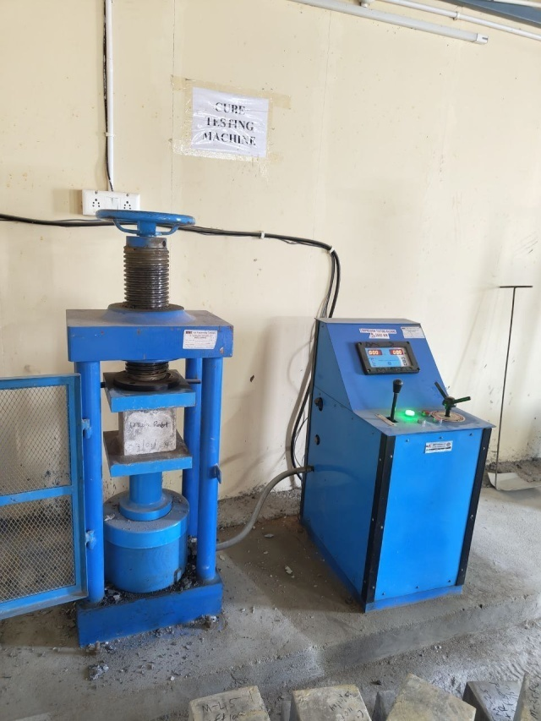

**Fig 1 : CUBE UNDER COMPRESSION TESTING MACHINE**

* **Compressive strength for M25 Grade**

|  |  |  |  |  |  |  |
| --- | --- | --- | --- | --- | --- | --- |
| Description | Normal RCC specimen | Average | 5% Replacement of Silica fume | Average | 10% Replacement of Silica fume | Average |
|  | 22.81 |  | 25.80 |  | 26.67 |  |
| 7 days | 22.70 | 22.72 | 25.65 | 25.65 | 27.98 | 27.56 |
|  | 22.65 |  | 25.50 |  | 28.03 |  |
|  | 26.90 |  | 29.73 |  | 33.79 |  |
| 14 days | 26.60 | 26.20 | 28.90 | 29.26 | 33.80 | 33.88 |
|  | 25 .10 |  | 29.65 |  | 34.05 |  |
|  | 31.48 |  | 37.34 |  | 39.75 |  |
| 28 days | 32.10 | 31.79 | 37.70 | 37.32 | 39.89 | 39.82 |
|  | 31.80 |  | 36.98 |  | 39.82 |  |

* **Compressive Strength for M30 Grade**

|  |  |  |  |  |  |  |
| --- | --- | --- | --- | --- | --- | --- |
| Description | Normal RCC specimen | Average | 5% Replacement of Silica fume | Average | 10% Replacement of Silica fume | Average |
|  | 30.12 |  | 32.33 |  | 32.44 |  |
| 7 days | 29.65 | 29.50 | 31.61 | 31.72 | 32.56 | 32.10 |
|  | 28.73 |  | 31.22 |  | 31.30 |  |
|  | 34.56 |  | 35.89 |  | 35.58 |  |
| 14 days | 34.05 | 33.58 | 36.44 | 35.83 | 36.32 | 36.03 |
|  | 32.13 |  | 35.16 |  | 36.19 |  |
|  | 39.34 |  | 43.56 |  | 45.02 |  |
| 28 days | 37.43 | 38.25 | 42.44 | 42.93 | 43.77 | 44.31 |
|  | 37.98 |  | 42.79 |  | 44.14 |  |

* **Compressive strength for M35 Grade**

|  |  |  |  |  |  |  |
| --- | --- | --- | --- | --- | --- | --- |
| Description | Normal RCC specimen | Average | 5% Replacement of Silica fume | Average | 10% Replacement of Silica fume | Average |
|  | 33.45 |  | 35.76 |  | 36.55 |  |
| 7 days | 32.35 | 33.18 | 36.00 | 35.5 | 35.48 | 36.42 |
|  | 33.74 |  | 34.74 |  | 37.23 |  |
|  | 35.67 |  | 40.74 |  | 44.12 |  |
| 14 days | 36.99 | 36.87 | 42.23 | 41.62 | 43.07 | 43.99 |
|  | 37.95 |  | 41.89 |  | 44.78 |  |
|  | 43.23 |  | 42.33 |  | 49.44 |  |
| 28 days | 44.46 | 43.25 | 43.99 | 43.68 | 49.50 | 49.02 |
|  | 42.06 |  | 44.72 |  | 48.12 |  |

* 1. **SPLIT TENSILE STRENGTH :**

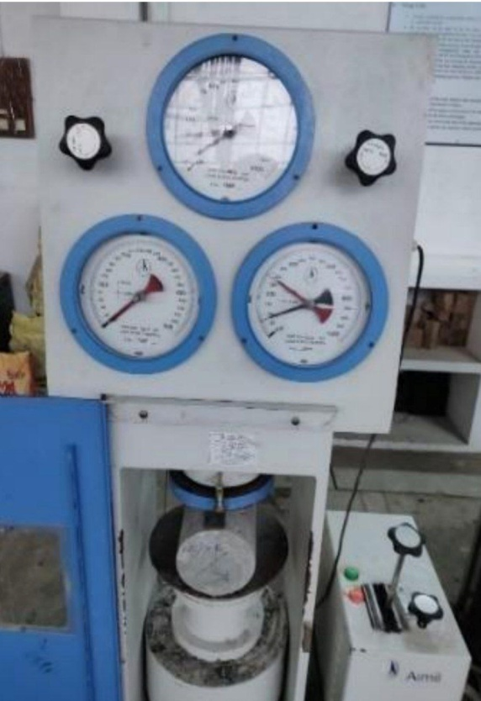

FIG 2 : CYLINDER UNDER SPLIT TENSILE STRENGTHING MACHINE

Split Tensile Strength for M25 Grade

|  |  |  |  |
| --- | --- | --- | --- |
| Description | 0% of Silica Fume | 5% of Silica Fume | 10% of Silica Fume |
| 7 days | 1.68 | 2.11 | 2.52 |
| 28 days | 2.89 | 4.05 | 4.28 |

* Split Tensile Strength for M30 Grade

|  |  |  |  |
| --- | --- | --- | --- |
| Description | 0% of Silica Fume | 5% of Silica Fume | 10% of Silica Fume |
| 7 days | 2.26 | 2.75 | 3.18 |
| 28 days | 3.58 | 4.68 | 4.93 |

* Split Tensile Strength for M35 Grade

|  |  |  |  |
| --- | --- | --- | --- |
| Description | 0% of Silica Fume | 5% of Silica Fume | 10% of Silica Fume |
| 7 days | 2.89 | 3.33 | 3.63 |
| 28 days | 4.18 | 5.36 | 5.64 |

**6. CONCLUSION :**

* High performance concrete produced by partial replacement of cement with silica fume in this study. The achievement of the present study obtained with the replacement of cement by 0%, 5%, and 10% silica fume The Compressive strength and split tensile strength test were observed for the mixes at the age of 7 days and 28 days. Thus high performance concrete obtained by replacement of cement up to 10% silica fume leads to increase in compressive strengthof concrete.
* The compressive strength mainly depend on percentage of silica fume. High performance concrete with silica fume can be effectively used in high rise building since high early strength is required with the reduced construction period. The percentage of increase in compressive strength is 11.77%, split tensile strength 25.88% at the age of 28 days by replacing partial replacement of cement with silica fume. The optimum percentage of partial replacement of cement with silica fume is 0% to 10% for compressive, split tensile strength of concrete.

**REFERENCES :**

1] M. S. Shetty “Concrete Technology”, 7th Edition, S. Chand & Company Limited.

2] M.L. Gambhir “Concrete Technology”, 5th Edition, Mc Graw Hill Education (India) Pvt Limited .

3] Neville, A. M., Properties of 1Concrete, Fourth Edition, Prentice Hall, Harlow, UK, pp.844, 1995.

4] Bhanja S., Sengupta B. (2002), “Investigations on the compressive strength of silica fume concrete using statistical methods”, Cement and Concrete Research 32 (2002) 1391 –1394.

5] Dilip Kumar Singha Roy, Amitava Sil,(2012) “Effect of Partial Replacement of Cement by Silica Fume on Hardened Concrete”, International Journal of Emerging Technology and Advanced Engineering, ISSN 2250-2459, Volume 2, Issue 8.

6] Ghutke S. Vishal, Bhandari S. Pranita,(2014), “Influence of silica fume on concrete”, IOSR Journal of Mechanical and Civil Engineering (IOSR-JMCE) e-ISSN: 2278-1684, p-ISSN: 2320- 334X PP 44-47.

7] IS: 456:2000, “Plain and Reinforced Concrete”, Code of Practice, Bureau of Indian Standards, New Delhi, 2000.

8] IS: 8112:2007, Specification for 43 Grade ordinary Portland cement, Bureauof Indian Standards, New Delhi. 2007.

9] IS: 2386 (Part v) -1963, Methods of test for aggregates for concrete, Bureau of Indian standards, New Delhi, India.

10] IS 10262: 1982 Recommended Guidelines for Concrete Mix Design .

11] Kennouche.S, Zerizer .A. Benmounah .A., Hami .B., Mahdad .M., Benouali .H. and Bedjou.S.,(2013),“Formulation and characterization of self-compacting concrete with silica fume”, Journal of Engineering and Technology Research, ISSN 2006-9790, Vol. 5(5).

12] Mohamed A. Heba (2011) “Effect of fly ash and silica fume on compressive strength of selfcompacting concrete under different curing conditions”, Ain Shams Engineering Journal (2011) 2, 79–86.

13] Shanmugapriya, T..,&Uma, R.N (2013). Experimental investigation on silica fume as partial replacement of cement in high performance concrete. The international journal of Engineering and Sciences, 2(5), 40-45.

14] Jain, A., & Pawade, P. Y. (2015). Characterstics of silica fume concrete. International journal computer applications, 975,8887.

15] Gupta, T., Chaudhary, S,., & Sharma,R.K. (2016). Mechanical and durability properties of waste rubber and fibber concrete eith and eithout of silica fume. Journal of cleaner of production 112,702-711

16] Pedro, D., De Brito, J., & Evngelista L, (2017). Evaluation of high-perfomance concrete with recycled aggregates. Use pf densifies silica fume as cement replacement. Construction and Building Materials, 147,803-814.

17] Imam, A., Kumar, V., & Srivastava, V. (2018). Review study towards effect of silica fume on the fresh and hardened properties of concrete. Advances in concrete construction, 6(2),145.

18] Ofuyatan, O. M., Adeniyi, A. G., & Ighalo, J.O. (2021). Evaluation of fresh and hardened properties of blended silics fume self-compacting concrete (SSC). Research on Engineering Structures and Materials, 7(2), 211-223.

19] Amin, M., Zeyad, A.M., Tayeh, B.A., & Agwa, I.S.(2022). Effect of ferrosilicon and silica fume on mechanical, durability, and microstructure characterstics of ultra high performance concrete. Construction and Building Materilas, 320,126233.

20] Tak, S., Gupta, P., Kumar, A., Sofi, A., & Yun, C.M. (2023). Effect of using silica fume as a partial replacement of cement in concrete. Materials Today; Proceedings.