BLIND POTTER: ULTRASONIC GPS

Prof. Sayali. B. Holkar Professor of Dept.

Information Technology Dr.J.J.Magdum college of Engineering,Jaysingpur Maharashtra, India

[sayalibholkar@gmail.com](mailto:sayalibholkar@gmail.com)

Pournima Pandurang Patil. Student of Dept.

Information Technology Dr. J. J. Magdum College of Engineering, Jaysingpur Maharashtra, India

[pournimap5401@gmail.com](mailto:pournimap5401@gmail.com)

Aishwarya Subhash Kale. Student of Dept.

Information Technology

Dr. J. J. Magdum College of Engineering, Jaysingpur Maharashtra, India

[aishwaryakale2019@gmail.com](mailto:aishwaryakale2019@gmail.com)

Neha Ulhas Khanaj.

Student of Dept. Information Technology

Dr. J. J. Magdum College of Engineering, Jaysingpur Maharashtra, India [nehakhanaj413@gmail.com](mailto:nehakhanaj413@gmail.com)

Shubhangi Rajesh Pujari. Student of Dept.

Information Technology Dr. J. J. Magdum College of Engineering, Jaysingpur Maharashtra, India

[pujarishubhangi46@gmail.com](mailto:pujarishubhangi46@gmail.com)

## Abstract: - The project leverages Raspberry Pi technology to create a navigation aid device for the visually impaired. This device integrates ultrasonic sensors for obstacle detection, facilitating accident prevention by issuing Bluetooth alerts upon obstacle detection. Additionally, gyro sensors enable free fall detection, triggering alerts sent via email to the blind individual's family members. The device utilizes GPS modules for live location tracking, with real-time latitude and longitude data stored in a Firebase database. This project demonstrates the utilization of Raspberry Pi in developing a comprehensive solution to enhance the mobility and safety of visually impaired individuals.

**Keyword: - Visually impaired, Ultrasonic sensors, Navigation aid, Bluetooth alerts, Gyro sensors, Free fall detection, GPS tracking, Firebase database.**

## I .INTRODUCTION

Visual impairment poses significant challenges to individuals' mobility and safety in their daily lives. According to the World Health Organization, approximately 285 million people worldwide suffer from visual impairment, with 39 million of them being completely blind. In response to this pressing issue, technological innovations have been developed to assist visually impaired individuals in navigating their surroundings more effectively and safely[1]. The project addresses this challenge by

proposing the development of a Raspberry Pi-based navigation aid device specifically designed for visually impaired individuals. The device incorporates ultrasonic sensors for obstacle detection, gyro sensors for free fall detection, and GPS modules for real-time location tracking. Additionally, the device utilizes Bluetooth technology to issue alerts to users upon detecting obstacles and to notify their family members in the event of a fall.

## II . LITERATURE SURVEY

In authors Smith et al. employs ultrasonic sensors, a widely used technology for obstacle detection. These sensors emit high-frequency sound waves and measure the time it takes for the waves to bounce back after hitting an object. By analysing these measurements, the system can accurately determine the distance to obstacles in the environment.

In authors: Jones et al. report that the. the project incorporates a speaker interface, which serves as the primary means of communication between the system and the visually impaired user. Through this speaker, the system provides real-time audio feedback, offering information about the surroundings, such as the presence of obstacles or landmarks. This is crucial for preventing accidents and ensuring the safety of the user. Simultaneously, the system is equipped to send a notification via

email to a predetermined contact, alerting them to the situation.

In authors: Patel et al. the project integrates a GPS module, allowing the visually impaired user to access precise location information. This enables them to share their whereabouts with family members or caregivers, providing an added layer of security and peace of mind. One of the key features of the project is its emphasis on accessibility. It is designed to be user-friendly and intuitive for visually impaired individuals, ensuring they can easily interact with and benefit from the system.

## PROPOSED METHODOLOGY AND DISCUSSION

**Problem Definition**

The project aims to address safety concerns for visually impaired individuals by developing a navigation aid device. This device integrates advanced sensors for obstacle detection and real- time location tracking, aiming to enhance users' mobility and independence. It emphasizes accessibility and inclusivity in technology design and seeks to create a comprehensive solution for the challenges faced by visually impaired individuals.

**Proposed Experience Work**

Our blind Potter: ultrasonic gps project using Raspberry Pi is based on real time data that is gathered by the variety of hardware such as gyro sensor, ultrasonic sensor, GPS module, Bluetooth connectivity will be seamlessly integrated. The project aims to create a comprehensive navigation aid device that prioritizes user preferences and accessibility standards, empowering visually impaired individuals to navigate confidently and independently.

**Description**

The "Blind Potter : Ultrasonic GPS" project is a pioneering initiative aimed at enhancing the mobility and safety of visually impaired individuals through the development of an advanced navigation aid device. This device integrates cutting-edge technologies, including ultrasonic sensors for obstacle detection and gyro sensors for free fall detection. By leveraging these sensors, the device provides real-time alerts and warnings of potential hazards, empowering users to navigate with confidence and independence in various environments.

Furthermore, the device incorporates GPS modules for precise real-time location tracking. Live location data, securely stored in a Firebase

database, enables efficient tracking and monitoring, as well as quick assistance in emergency situations. Through iterative prototyping, usability testing, and feedback iteration, the project ensures that the device meets the diverse needs and preferences of visually impaired individuals, resulting in a user- friendly, reliable, and comprehensive navigation aid solution.

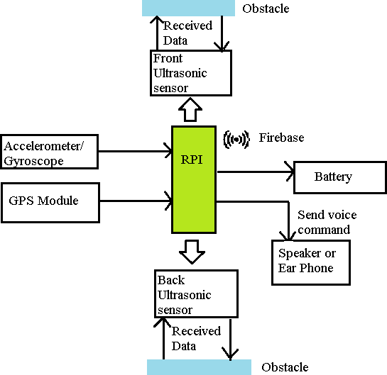

**Fig. system architecture**

# WORKING

## Detect the obstacle:

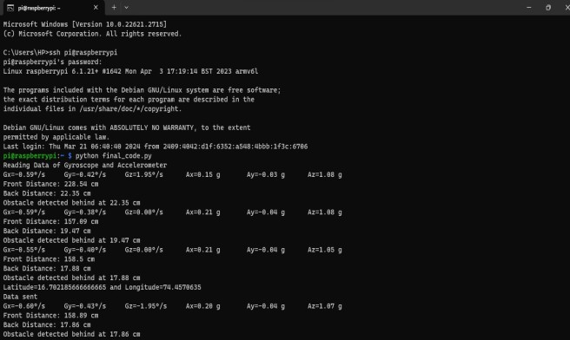

*Gyro and Acceleration Readings:* Display the readings from the gyro and acceleration sensors in the x, y, and z directions. These readings can indicate the orientation and movement of the user.

*Front and Back Obstacle Distances*: Display the distances to obstacles detected by the ultrasonic sensors in front and behind the user.

*Obstacle Detection Message*: If an obstacle is detected in front of the user, display a message indicating the obstacle and its distance.

## Navigation:

*GPS Data*: Display the latitude and longitude data obtained from the GPS module.

Since the GPS system was introduced there have been many attempts to integrate it into a navigation-assistance system for blind and visually impaired people[2].

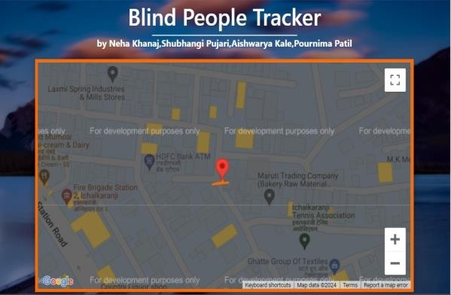

the device collects the user's GPS data, it prepares this data to be sent to Firebase. This data usually includes the latitude and longitude coordinates obtained from the GPS module.

## Database storage:

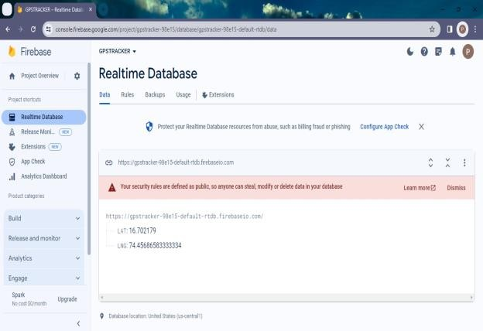

The website utilizes Firebase Realtime Database to store latitude and longitude data of visually impaired individuals. This data is retrieved using Firebase JavaScript SDK. Integrated with Google Maps JavaScript API, the website dynamically displays the user's location with markers and an orange polyline representing the path travelled. Real-time updates ensure the map reflects the latest location data, enhancing navigation assistance for the visually impaired.

## Free fall detection and Sending SMS:

Gyro sensor is used for free fall detection if there is any free fall detected by the sensor the

system is sending email notifications in case of accidents or emergencies

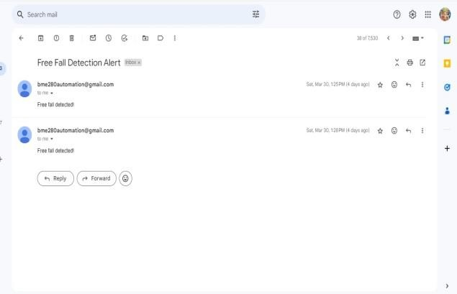

## Perspective view of system:

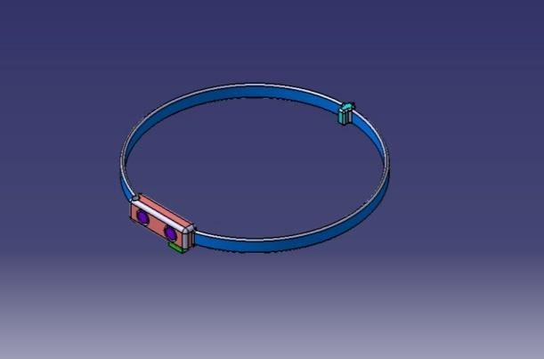

**Existing view of system:**

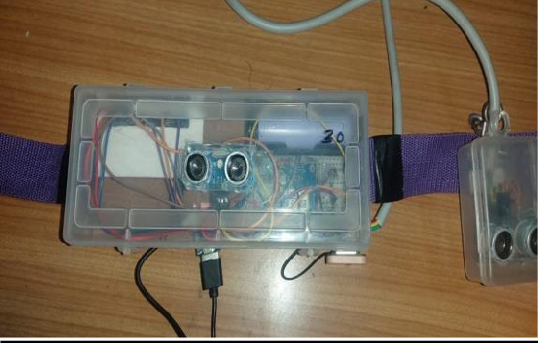

# Implementation

## Front and Back Obstacle Distances:

* 1. Connect ultrasonic sensors to the Raspberry Pi. Ultrasonic sensors typically require GPIO pins for triggering the sensor and receiving echo signals.
  2. Install any necessary libraries for interfacing with ultrasonic sensors on the Raspberry Pi. Libraries such as RPi.GPIO may be used for GPIO control.
  3. Write a Python script to control the ultrasonic sensors. Use the libraries to trigger the sensors, measure the time taken for echoes, and calculate distances to obstacles based on the measured time.
  4. Implement logic to compare measured distances with predefined thresholds to detect obstacles. If obstacles are detected, trigger appropriate actions such as displaying messages or emitting warning sounds.

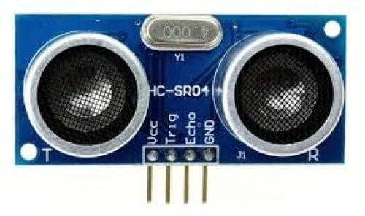

## Gyro and Acceleration Readings:

1. Connect the gyro and accelerometer sensors to the Raspberry Pi. These sensors typically communicate via I2C or SPI protocols, so ensure that the Raspberry Pi's GPIO pins are correctly connected to the sensors.
2. Install the necessary libraries and drivers for the gyro and accelerometer sensors on the Raspberry Pi. Popular libraries like smbus for I2C communication and specific sensor libraries may need to be installed.
3. Write a Python script to read data from the gyro and accelerometer sensors. Use the installed libraries to communicate with the sensors and retrieve sensor data.
4. Process the sensor data to obtain orientation and movement information. Combine data from the gyro and accelerometer sensors to calculate orientation angles and detect acceleration.
5. Display the sensor readings (orientation angles and acceleration) on an output device connected to the Raspberry Pi, such as an LCD display or through a web interface.

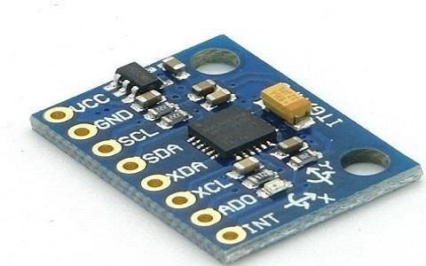

## Navigation:

1. Use a GPS module compatible with Raspberry Pi, such as the NEO-6M GPS module. Connect the GPS module to the Raspberry Pi's UART pins.
2. Install any necessary libraries for interfacing with the GPS module, such as gpsd.
3. Write a Python script to read GPS data from the module using the installed libraries. Retrieve latitude and longitude coordinates from the GPS data stream.
4. Implement logic to send GPS data to Firebase Realtime Database. Utilize Firebase's Python SDK to interact with the database and send location updates.
5. Integrate Google Maps JavaScript API with your website to visualize the user's location and path based on the data stored in Firebase.

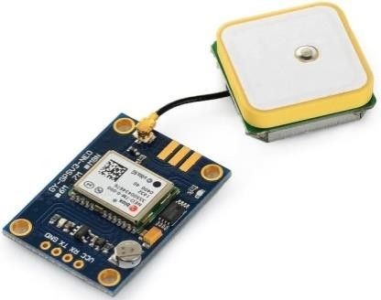

## Free fall detection and Sending SMS:

1. Modify the gyro sensor script to include free fall detection logic. Monitor gyro readings for sudden changes indicative of free falls.
2. Integrate email notification functionality into the Python script. Use libraries like smtplib to send email notifications when a free fall is detected.
3. Optionally, implement SMS sending functionality using services like Twilio. Utilize Twilio's Python SDK to send SMS alerts to designated contacts in case of emergencies.

## CONCLUSION

In conclusion, the Blind Potter Ultrasonic GPS project represents a significant leap forward in technology designed to empower visually impaired individuals. By seamlessly integrating ultrasonic sensors for obstacle detection, a speaker for clear auditory feedback, and a GPS module for precise location tracking, the system addresses critical challenges faced by the visually impaired in navigating their surroundings. The inclusion of accident detection capabilities and email alerts in the event of a fall or impact adds an essential layer of safety. Furthermore, enabling authorized family members to access real-time location data through a secure platform enhances the user's network of support

## FUTURE WORK

In the realm of future development for the Blind Potter Ultrasonic GPS project, several exciting possibilities emerge. First and foremost, refining the obstacle detection system stands as a crucial endeavor. Implementing advanced machine learning algorithms could significantly enhance the

system's capability to identify and categorize various types of obstacles, distinguishing between stationary objects and moving entities. Moreover, expanding the system's awareness to environmental factors like temperature, humidity, and ambient light could provide users with a more comprehensive understanding of their surroundings

## REFERENCES

1. Mariotti, S.P.; Pascolini, D. Global estimates of visual impairment: 2010. Br. J. Ophthalmol. 2012, 96, 614.
2. Meliones, A.; Sampson, D. Blind MuseumTourer: A System for Self-Guided Tours in Museums and Blind Indoor Navigation. Technologies 2018.
3. RCI1-00593 MANTO: Innovative Autonomous Blind Navigation Outdoor and Indoor and in Museums. Project Webpage.
4. Meliones, A.; Filios, C. BlindHelper: A Pedestrian Navigation System for Blinds and Visually Impaired. In Proceedings of the 9th ACM International Conference on Pervasive Technologies Related to Assistive Environments, Corfu, Greece, 29 June–1 July 2016. (best innovation paper).
5. Chumkamon, S.; Tuvaphanthaphiphat, P.; Keeratiwintakorn, P. A Blind Navigation System Using RFID for Indoor Environments. In Proceedings of the International Conference on Electrical Engineering/Electronics, Computer, Telecommunications and Information Technology (ECTI-CON 2008), Krabi, Thailand, 14–17 May 2008. [**Google Scholar**]
6. Giampaolo, E. A Passive-RFID Based Indoor Navigation System for Visually Impaired People. In Proceedings of the 2010 International Symposium on Applied Sciences in Biomedical and Communication Technologies (ISABEL), Rome, Italy, 7–10 November 2010. [[**Google Scholar**](https://scholar.google.com/scholar_lookup?title=A%2BPassive-RFID%2BBased%2BIndoor%2BNavigation%2BSystem%2Bfor%2BVisually%2BImpaired%2BPeople&conference=Proceedings%2Bof%2Bthe%2B2010%2BInternational%2BSymposium%2Bon%2BApplied%2BSciences%2Bin%2BBiomedical%2Band%2BCommunication%2BTechnologies%2B(ISABEL)&author=Giampaolo%2C%2BE.&publication_year=2010)]
7. Na, J. The Blind Interactive Guide System Using RFID-Based Indoor Positioning System. In Proceedings of the 2006 International Conference on Computers Helping People with Special Needs (ICCHP 2006) (LNCS 4061), Linz, Austria, 11–13 July 2006; pp. 1298–1305. [[**Google Scholar**](https://scholar.google.com/scholar_lookup?title=The%2BBlind%2BInteractive%2BGuide%2BSystem%2BUsing%2BRFID-Based%2BIndoor%2BPositioning%2BSystem&conference=Proceedings%2Bof%2Bthe%2B2006%2BInternational%2BConference%2Bon%2BComputers%2BHelping%2BPeople%2Bwith%2BSpecial%2BNeeds%2B(ICCHP%2B2006)%2B(LNCS%2B4061)&author=Na%2C%2BJ.&publication_year=2006&pages=1298%E2%80%931305)]
8. Kiers, M.; Kranjc, E.; Dornhofer, M.; Bischof, W. Evaluation and Improvements of an RFID Based Indoor Navigation System for Visually Impaired and Blind

People. In Proceedings of the International Conference on Indoor Positioning and Indoor Navigation, Guimaraes, Portugal, 21–23 September 2011. [[**Google Scholar**](https://scholar.google.com/scholar_lookup?title=Evaluation%2Band%2BImprovements%2Bof%2Ban%2BRFID%2BBased%2BIndoor%2BNavigation%2BSystem%2Bfor%2BVisually%2BImpaired%2Band%2BBlind%2BPeople&conference=Proceedings%2Bof%2Bthe%2BInternational%2BConference%2Bon%2BIndoor%2BPositioning%2Band%2BIndoor%2BNavigation&author=Kiers%2C%2BM.&author=Kranjc%2C%2BE.&author=Dornhofer%2C%2BM.&author=Bischof%2C%2BW.&publication_year=2011)]

1. Ganz, A.; Schafer, J.; Gandhi, S.; Puleo, E.; Wilson, C.; Robertson, M. PERCEPT Indoor Navigation System for the Blind and Visually Impaired: Architecture and Experimentation. *Int. J. Telemed. Appl.* **2012**, 894869. [**Google Scholar**] [[**CrossRef**](https://doi.org/10.1155/2012/894869)] [[**PubMed**](http://www.ncbi.nlm.nih.gov/pubmed/23316225)]
2. Faria, J.; Lopes, S.; Fernandes, H.; Martins, P.; Barroso, J. Electronic White Cane for Blind People Navigation Assistance. In Proceedings of the World Automation Congress, Kobe, Japan, 19–23 September 2010. [[**Google Scholar**](https://scholar.google.com/scholar_lookup?title=Electronic%2BWhite%2BCane%2Bfor%2BBlind%2BPeople%2BNavigation%2BAssistance&conference=Proceedings%2Bof%2Bthe%2BWorld%2BAutomation%2BCongress&author=Faria%2C%2BJ.&author=Lopes%2C%2BS.&author=Fernandes%2C%2BH.&author=Martins%2C%2BP.&author=Barroso%2C%2BJ.&publication_year=2010)]