Stress Management Therapist Application

1Akshay Talnikar, 2Yogesh Kale, 3Shreya Patil, 4S.M Patil

123UG Student, 4Proffesor

Department of Electronics and Telecommunications, Imperial College of Engineering and Research, Pune, India

**Abstract*:*** The stress management app outlined in this report serves as a holistic and user-centric solution for tackling the ever- increasing stress levels that plague modern life. Stress, often an unavoidable part of daily living, can manifest in various ways and affect different individuals uniquely. Recognizing this, the app adopts a personalized approach, allowing users to access tailored stress management tools based on their age or profession. One of the standout features of the app is the login page, which enables users to establish a personalized profile. This individualized approach sets the foundation for the app's effectiveness in addressing stress. By asking targeted questions, the app gains insights into the user's stress level and related factors, such as lifestyle and profession. This information is then used to offer highly specific recommendations for stress reduction techniques. The app, therefore, becomes a trusted companion on the journey to stress management, understanding the user's unique needs and tailoring its guidance accordingly.

# *Keywords* – login page, stress calculation , panic button, stress levels, stress management.

1. **Introduction**

“

Stress, a ubiquitous part of modern life, can exact a considerable toll on both our physical and mental well-being. Its repercussions span a spectrum of maladies, from stress and anxiety to sleep disturbances and persistent headaches. Coping with stress requires a diverse toolkit, including physical activity, relaxation techniques, and cognitive-behavioral therapy. In this era, technology is a valuable ally in the quest to address and alleviate stress, with a multitude of stress management applications readily accessible This document introduces the concept of a comprehensive stress management application, designed to offer users a multifaceted approach to stress control. The proposed app boasts an array of distinctive features, such as a secure login system, a stress level calculator, personalized activity recommendations based on stress levels, access to doctor recommendations and contact information, a supportive Telegram channel, and a panic button for immediate assistance during crises. One of the app's defining features is its unwavering commitment to user-friendliness and accessibility, catering to individuals of all technical backgrounds. To ensure its effectiveness, the application would undergo a rigorous evaluation process employing diverse techniques, including user surveys, focus groups, and A/B testing. This feedback loop would be instrumental in refining the app and enhancing its efficacy in assisting users in managing their stress levels

# PROBLEM STATEMENT

By addressing these needs and challenges, the stress management therapist application aims to democratize access to quality mental health support, promote early intervention, and foster a culture of self-care and resilience in the digital age.

# METHEDOLOGY

1. *Person Registration and Verification:* Broaden a person-friendly registration manner that collects crucial consumer information, such as username, email, and password. Implement a verification system to ensure the security and authenticity of person accounts, which might also encompass email verification or telephone verification.
2. *Strain level Calculator:* Design a strain assessment questionnaire that gathers consumer inputs related to temper, pressure triggers, and physical symptoms. Create an algorithm to calculate a strain degree primarily based on the person's inputs. Show the calculated pressure degree to the person at the side of an evidence.
3. *Interest primarily based on pressure degree:* Broaden an advice engine that indicates strain management activities tailor-made to the person's calculated stress level. Offer distinct information on each suggested activity, inclusive of instructions and blessings. Permit users to pick out and schedule activities from the recommendations

.

1. **BLOCK DIAGRAM**

┌───────────────────┐

│Mobile Device│

└───────────────────┘

│

▼

┌───────────────────┐

│Mobile App UI│

└───────────────────┘

│

▼

┌───────────────────┐

│Authentication│

└───────────────────┘

│

▼

┌───────────────────┐

└───────────────────┘

│

▼

┌───────────────────┐

│Activity Planner│

└───────────────────┘

│

▼

┌───────────────────┐

│Doctor Information│

└───────────────────┘

│

▼

┌───────────────────┐

│ Motivational│

│Quotes│

└───────────────────┘

│

▼

┌───────────────────┐

│Feedback &│

│Support │

└───────────────────┘

│

▼

┌───────────────────┐

│Panic Button│

└───────────────────┘

│Stress A**I**P**N**I│

**FIG :CONTROLLING MECHANISM OF STRESS MANAGEMENT**

1. **ALGORITHM**
   * STEP 1. User registration and profile creation
   * STEP 2. Initial assessment
   * STEP 3. Data analysis and personalization
   * STEP 4. Resource library
   * STEP 5. Interactive tools and exercises
   * STEP 6. Therapeutic interventions
   * STEP 7. Progress tracking and feedback
   * STEP 8. community support
   * STEP 9. Reminders and notifications

# RESULTS

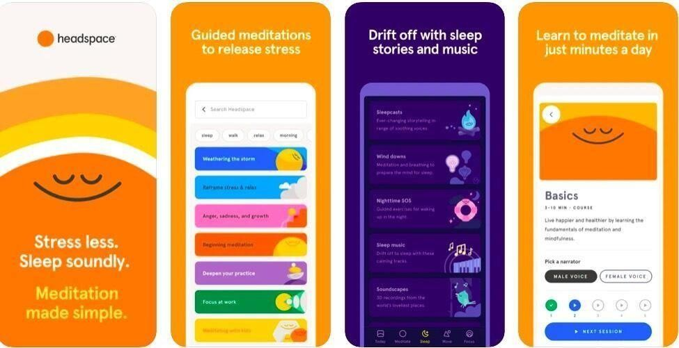

**Figure 1.** Headspace stress management app

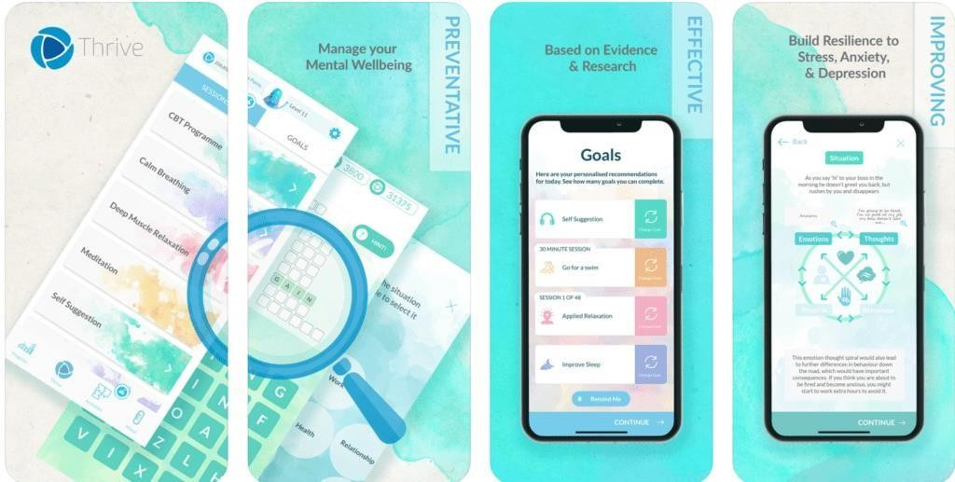

**Figure 2.** Thrive stress management app.

# CONCLUSION

In end, the stress management utility we have outlined, presenting the important thing functionalitiesof login and verification, stress degree calculator, hobby pointers, motivation, community engagement,access to medical doctor records, remarks, and a panic button, is a holistic answer designed to cope withthe developing demanding situations of stress in our lives. By supplying a relaxed login device and stringent verification, we prioritize user privacy and data security. The pressure stage calculator affordsa vital device for self-assessment, empowering customers with insights into their mental nicely-being. Personalized interest guidelines based on stress stages ensure that customers obtain realistic steerage tocope with their precise stressors. Motivational content material uplifts and evokes, fostering a fine mindset. Community engagement through committed Telegram channels encourages mutual support and the sharing of valuable pointers and experiences. Get entry to physician statistics connects customers with expert assist while wished, promoting universal nicely-being. User remarks, as a fundamental part of the machine, informs ongoing upgrades, ensuring the software remains user-centricand effective. In the end, the inclusion of a panic button underscores our commitment to consumer safety, imparting a lifeline in instances of disaster. This comprehensive pressure management utility, through its multifaceted method, seeks to empower people to lead healthier, greater balanced lives, manage stress efficaciously, and experience a heightened experience of nicely-being. It embodies an empathetic and person-centered solution, spotting the various desires and demanding situations we all face in each day lives.

.

# REFERENCES

1. Anagnostou M, Drigas A. mobile Applications for stress management .sci electron arch.2022 January 31;15(2):58-62
2. Khademian f, Aslani A, Bastani p. the effects of mobile apps on stress, anxiety and depression: overview of symmetric reviews. int J Technol assess health care. 2021;37(1): e4.
3. Bhargava D, Trivedi H. A case study of causes of stress and stress management among youth IRA -Int J Manag Soc Sci

.2018 July 18; 11(03): 108-17

1. Satpathy DI , Patnaik DB , Mitra MB . Stress Management Modalities in it sector .Int J Manag (IJM). 2014 January :5(1): 71-79.
2. Maryem B, Ikrame Y, Imane T, Chadya A, Mohamed B. “Stress-free” mobile app for Moroccan university students: “relaxation program” validation. In 2020 IEEE International Conference on Intelligent Systems and Computer Vision (ISCV). 2020 Jun 9; 1–5.
3. Boateng G, Kotz D. StressAware: An app for real-time stress monitoring on the amulet wearable platform. In 2016 IEEE MIT Undergraduate Research Technology Conference (URTC). 2016 Nov 4; 1–4.
4. Maryem B, Ikrame Y, Imane T, Chadya A, Mohamed B. “Stress-free” mobile app for Moroccan university students: “relaxation program” validation. In 2020 IEEE International Conference on Intelligent Systems and Computer Vision (ISCV). 2020 Jun 9; 1–5.
5. Drissi N, Ouhbi S, Idtissi MA, Ghogho M. Mobile apps for post traumatic stress disorder. In 2019 41st Annual International Conference of the IEEE Engineering in Medicine and Biology Society (EMBC). 2019 Jul 23; 4279–4282.