**MATERIAL OPTIMIZATION OF ATV GEAR SHIFTER CASING USING FINITE ELEMENT ANALYSIS**

**Shalender Singh Bhandari1, Prof. D.S. Chaudhari2**

1 P.G Scholar Mechanical Engineering, 2 Professor of Mechanical Engineering,

Gokhale Education Society's R. H. Sapat College of Engineering, Management Studies and Research,

Nashik (Maharashtra, Ind.)

**ABSTRACT**

In a transmission, the gear shift system is a part of extreme importance, being the responsible for controlling how and when the gear shifts occur. In sequential gear shifting systems, there are many design options that can be used for the development of such system. The current Concept deals with the Design and Modification of Sequential Gear Shifter for a three wheeler all-terrain vehicle. The gear shifters are generally made for Grey Cast Iron or ASI Mild Steel due to their salient features in the field of Ductility and Machinability. The material gives considerable strength but their increase in strength increase the weight of shifter Mechanism. Hence in this study, an attempt is made to replace the steel material with aluminum matrix composites so as to maintain or increase the strength with reduction in weight. The shifter is designed considering different loads acting on it as in Shear, bending and Sudden Loads.

**Keywords:** Gear Shifter, Material Optimization, Alloys of Aluminium

1. **INTRODUCTION**

The gear shifter allows the vehicle to be put into different gears on a manual transmission. In an automatic transmission, the gear shifter is known as a gear selector. The gear knob is the top of the gear shifter, and includes a shift pattern that guides the gear selection. The shift pattern indicates which way the gear shifter should be moved when selecting a certain gear. [1] The mechanism used for gear shifting is called synchronizer. The synchronizer consists of three rigid bodies; sleeve, ring and gear. [2]

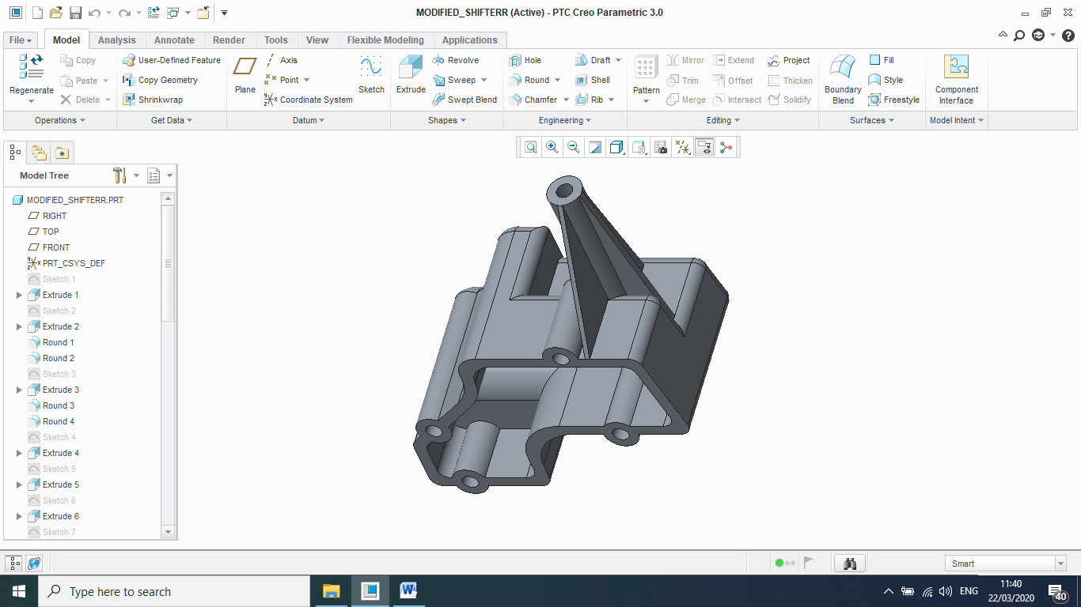

**Figure 1.** Drum Based Sequential Gear Shifter [2]

An all-terrain vehicle (ATV), also known as a quad, three-wheeler, four-track, four-wheeler, or quadricycle. In India, All terrain vehicles stand for the three wheelers which comprises of Auto Rickshaws, the Passenger seats Three Wheeler. Some of the Common Manufacturers of this kind of Vehicles are Bajaj, Mahindra and Mahindra, Piaggo Vehicles, Force Auto, TVS, Scooters India. A sequential manual transmission (or sequential manual gearbox) is a non-traditional type of [manual transmission](https://en.wikipedia.org/wiki/Manual_transmission) used on [motorcycles](https://en.wikipedia.org/wiki/Motorcycle) and high-performance cars for [auto racing](https://en.wikipedia.org/wiki/Auto_racing), where [gears](https://en.wikipedia.org/wiki/Gear) are selected in order, and direct access to specific gears is not possible. [2]

The different forces acting on the shifter casing are –

* Force due to sudden exhitation
* Force at the lever column
* Force at the base of the body
* Bending force at the base of the body

1. **MATERIAL PROPERTIES**

*2.1 FG150 Cast Iron:*

With the majority of the medium to large reducer housings being made of cast iron. FG150 is grey cast iron material which is specially used for casting purpose. For casting, there are many factors to be considering for better result such as material properties, mechanical properties, chemical composition, fluidity, boundary clearance, thermal properties etc. [12]. The current Gear shifter used is made of Grey Cast Iron FG150. It has excellent vibration damping capacity. It has high compressive strength, low tensile strength, self-damping, does not vibrate, high resistance to wear. [8] The Gear Shifter made of grey Cast Iron weighs 0.73 Kg.

**Table 1** Chemical Composition of Grey Cast Iron GF150 [8]

|  |  |  |  |  |  |  |
| --- | --- | --- | --- | --- | --- | --- |
| **Material** | **Carbon** | **Silicon** | **Manganese** | **Phosphorus** | **Sulphur** | **Iron** |
| **Contribution** | 2.5-3.8% | 1.2-2.8% | 0.4-1% | 0.15% | 0.10 | Bal. |

**Table 2.** Material Properties of Grey Cast Iron GF150 [18][8]

|  |  |
| --- | --- |
| **Parameter** | **Value** |
| Ultimate Tensile Strength | 160 MPa. |
| Yield Strength | 98 MPa. |
| Young’s Modulus | 180GPa. |
| Poisson Ratio | 0.29 |
| Density | 7800 Kg/m3 |

* 1. *Material Optimization using Aluminum Alloy:*

Currently, the materials that are used Gear shifter is FG150 and processed material of which possesses considerable strength but the implementation of these materials increases the unnecessary cost of the assembly as it is been famous for its heavy weight. Hence in order to obtain the same strength with considerable reduction in cost, it is necessary to optimize the material.

* Aluminum is resistant to corrosion and rust, holds up well to outdoor elements and lasts a lifetime. Although Cast iron is susceptible to rust and corrosion, its heavy weight makes durable.
* Aluminum alloys have been widely used in the Automotive and Aerospace industries as they can be heat-treated to enhance the superior properties of strength, workability, thermal ,electrical conductivity and corrosion resistance while maintaining low weight.
* Al Alloys are very light metal, with a high strength to weight ratio, most cost effective for equipment needing lighter weight than steel with equal strength.
* While steel is stronger per volume, more aluminum can be used to increase strength while still being lighter.

**Table 3.**  Material Properties of Al-Alloy [19] [4]

|  |  |  |
| --- | --- | --- |
| **Parameter** | **LM24** | **LM25** |
| Ultimate Tensile Strength | 180 MPa. | 190 MPa. |
| Yield Strength | 120 MPa. | 150 MPa. |
| Young’s Modulus | 71 GPa. | 71 GPa. |
| Poisson Ratio | 0.33 | 0.33 |
| Density | 2790 Kg/m3 | 2680 Kg/m3 |

1. **FINITE ELEMENT ANALYSIS :**

*3.1 Finite Element Ansys Settings and Constraints:*

The material is first prepared in creo software as shown in figure 1. The material is saved in IGES extension and then exported to Ansys software for further analysis procedures. The shifter is been modified. Now, it’s important to check the parameter of behaviour analysis of the shifter when it is subjected to same loading as it was subjected in case of old shifter made of FG150. Hence, it is now analyzed in Ansys software by changing the same parameter and adopting for the new modified shifter. The further loading conditions and simultaneous behaviour is been described as follows.

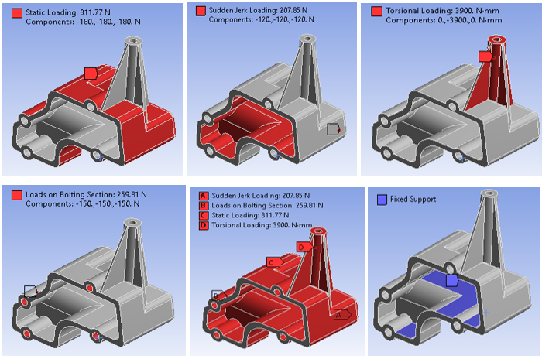

**Figure 2** Loading Constraints in Finite Element Analysis

* 1. *FEA of Gear Shifter made of FG150 :*

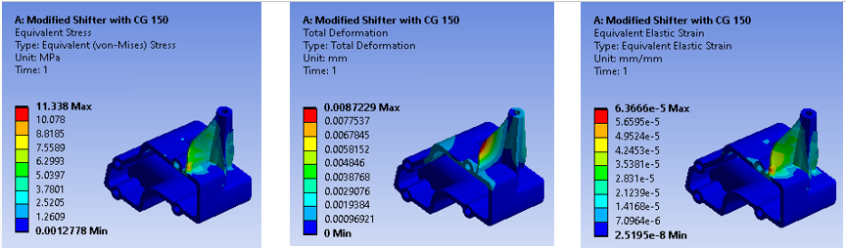

**Figure 3** Finite Element Analysis of Gear shifter made of FG150 for combined loading Effect

* 1. *FEA of Gear Shifter made of LM24 :*

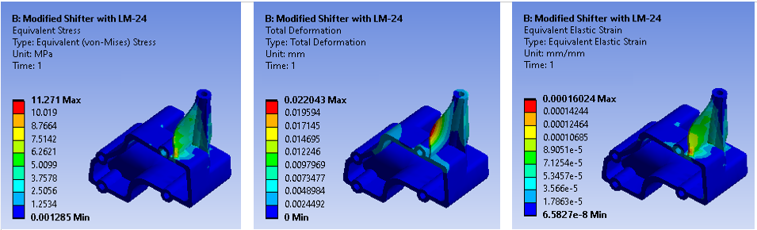

**Figure 4.** FEA for Combine Loading for Modified Shifter Mechanism for LM24

* 1. *FEA of Gear Shifter made of LM25 :*

**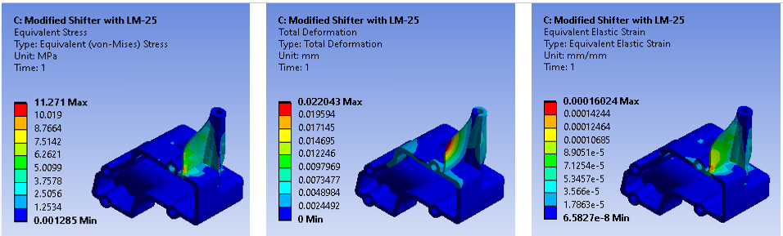***:*

**Figure 5.** FEA for Combine Loading for Modified Shifter Mechanism for LM25

1. **RESULT AND DISCUSSIONS :** 
   1. *Response Analysis of Equivalent Stress :*

**Table 3.** Result of FEA for Equivalent Stress Produced in MPa for Various Section

|  |  |  |  |
| --- | --- | --- | --- |
| **Section of Loading** | **FG150** | **LM24** | **LM25** |
| Static Loading | 0.831 | 0.826 | 0.83 |
| Sudden Loading | 0.643 | 0.642 | 0.65 |
| Torsional Loading | 11.5 | 11.44 | 11.44 |
| Bolting Section | 0.71 | 0.689 | 0.69 |
| Combine Loading | 11.3 | 11.27 | 11.27 |

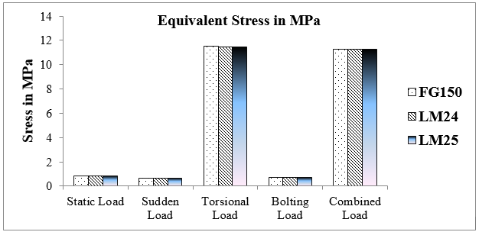

**Figure 6.** Response Analysis of Equivalent Stress Produced in Finite Element Analysis

For component subjected to combine loading the design constraint are of 9.9 MPa and the values determined for LM24 and LM25 are 11.44 respectively. In this the stress values just surpass the actual values in case of FG150. But as the values are under the permissible limit of tolerance, the material satisfies the criteria of combine loading constraint.

* 1. *Response Analysis of Deformation Produced :*

**Table 4.** Result of FEA for deformation Produced in mm for Various Sections

|  |  |  |  |
| --- | --- | --- | --- |
| **Section of Loading** | **FG150** | **LM24** | **LM25** |
| Static Loading | 0.00042 | 0.00111 | 0.0016 |
| Sudden Loading | 0.000258 | 0.00065 | 0.00065 |
| Torsional Loading | 0.00084 | 0.021 | 0.0202 |
| Bolting Section | 0.000411 | 0.001 | 0.0011 |
| Combine Loading | 0.0087 | 0.022 | 0.0223 |

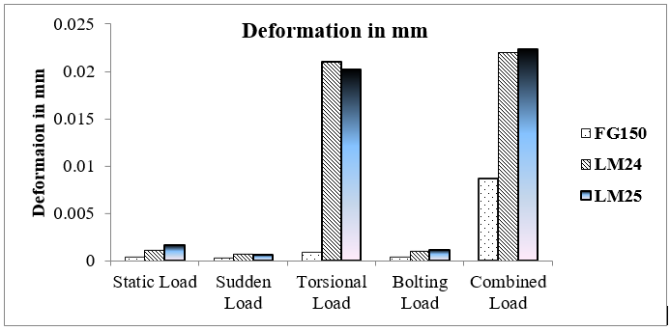

**Figure 6.** Response Analysis of Deformation Produced in Finite Element Analysis

From the above graph, it is seen that the deformation produced under different loading conditions for FG150 is similar as that of other materials. The deformation is maximum for LM24 but it is similar in case of LM25 material. The design constraints for deformation of optimized material slightly varies to larger range, but as the numbers are below the decimals of zero, hence can be neglected and we can say that the Aluminium Composites Satisfies the criteria for deformation.

1. **CONCLUSION :**

* The Load and Stress analysis have been studied and mathematical algorithm has been prepared to define the area and section of loading. Finite Element Modelling is performed in Ansys 2020 software to determine the simulation in stress, strain and deformation.
* The design constraints for strength of material is been defined in reference of FG150. Hence, in this case we can say that the optimized material of LM24 and LM25 satisfies the criteria for Strength.
* The Principal Stresses produced under different loading conditions for FG150 is similar as that of other materials. The stress for Aluminium composites is finding out to be slightly more than FG150 but as the values are very less in numbers and in decimals, hence the difference can be neglected.
* The deformation is similar for LM24 and LM25 and larger than the previous material of FG150. As the deformation exceeds just the range of constraints, hence we can say that the Aluminium Composites Satisfies the criteria for deformation.
* The implementation of LM24 and LM25 can provide the difference in the weight reduction can be up to 0.660 Kg. This weight reduction may further lead to the material and manufacturing cost of the component, which further leads to the actual selling cost of component.
* Overall, it can be concluded that, the alternative material of LM24 and LM25 can be used precisely for Gear shifter body.

1. **REFERENCES**

|  |  |
| --- | --- |
|  | Charnont Moolwan et.al. “Failure Analysis of a Two High Gearbox Shaft”, Social and Behavioural Sciences Symposium, 4th International Science, Social Science, Engineering and Energy Conference”, Volume 88 , Page 154 – 163, 2013. |
|  | Fabrícius Viana Maia, “Finite element analysis for estimation of internal loads in a shift drum system”, Sae Technical Paper Series, Copyright to SAE International, Volume 36, 2014. |
|  | Gabriel Figlie Macedo, “Test Procedure for Estimation of Internal Loads in a Sequential Gear Shift System”, Sae Technical Paper Series, Copyright to SAE International, Volume 36, 2013. |
|  | M. Mahesh Babu et.al., “Stress Analysis of Gearbox Casing Using ANSYS Workbench”, International Journal of Science and Research, Index Copernicus , 2013. |
|  | Y. Shivraj Narayan et.al., “Modeling and Core Cavity Preparation of Side Engine Cover of a Gear Box Casing Using Pro/E Software”, National Conference on Advances in Mechanical Engineering, 18th December 2010 |
|  | Ashwani Kumar et.al., “Dynamic Vibration Characteristics Analysis of Truck Transmission Gearbox Casing with Fixed Constraint of Vehicle Frame Based on FEA”, 12th Global Congress on Manufacturing and Management, Else Vier Publication by Procedia Engineering, Volume 97, Page 1107 – 1115, 2014. |
|  | Bhavin Gajjar, “Finite Element Analysis of Gearbox Housing”, IJSRD - International Journal for Scientific Research & Development, Volume 2, Issue 03, 2014. |
|  | Neeta T. Chavan et.al. “Analysis Of Gearbox Casing Using FEA”, International Journal of Engineering Research and General Science Volume 4, Issue 5, September-October, 2016. |
|  | Barathiraja K et.al. “Analysis of automotive transmission gearbox synchronizer wear due to torsional vibration and the parameters inﬂuencing wear reduction”, Journal of Engineering Failure Analysis, Science Direct - Else Vier Publication by Procedia Engineering, Volume 105, Page 427 – 443, 2019. |
|  | Rise Victoria et.al. ,”Optimal Speed and Gear Shift Control of Trucks, Journal of International Federation of Automatic Control, Science Direct - Else Vier Publication, Volume 52, Issue 5, 2019. |
|  | Miss Smita Pawar et.al. “Improvement in design of gearbox housing (Code No: MFO225DR) through static analysis”, CIKITUSI Journal for Multidisciplinary Research, A research Gate Publication, 09 May 2019. |
|  | Vasim Bashir Maner et.al. , “Design Analysis and Optimization for Foot Casing of Gearbox”, Proceedings of 3rd IRF International Conference, 10th May-2014. |
|  | Shivaprakash Y M et.al. “Experimental studies on grey cast iron reinforced aa6061 composite”, International Journal of Mechanical And Production Engineering, Volume- 4, Issue-3, Mar.-2016. |
|  | S.T. Mavhungu et.al. “Alumium Matrix Composites for Industrial use”, International Conference on Sustainable Material Processing and Manufacturing,Else Vier Publication. 2017. |
|  | Vaibhav Pimpalte, “Topology Optimization of Gears from Two Wheeler Gear Set Using Parametric Study”, IOSR Journal of Mechanical and Civil Engineering, Volume 14, Issue 1 Version 2, Jan. - Feb. 2017. |
|  | B. Mohammed Baba Rizwan, “Design and analysis of gear box casing with aluminum boron composite and characterization of mechanical properties on specimen”, 1st International Conference on Manufacturing, Material Science and Engineering. Journal of Materials Today: Proceedings, Vier Publication 2019. |
|  | Institute of Aeronautical Engineering, “Lab Manual for Strength of Material”, Department of Civil Engineering, Experiment No. 03, Page 23-27, Hyderabad, India. |