**NUMERICAL INVESTIGATION OF THRUST BEARING MADE OF BABBIT AND BRONZE METAL FOR CONTACT STRESS ANALYSIS AND WEAR DEFORMATION ANALYSIS**

**Amol S. Bhamare1, Prof. Dr. P.B. Nehe2**

1 P.G Scholar Mechanical Engineering, 2 Head of Mechanical Engineering

Gokhale Education Society's R. H. Sapat College of Engineering, Management Studies and Research,

Nashik (Maharashtra, Ind.)

**ABSTRACT**

The major components of Hydraulic Power Plant comprise of Pipe, Turbine and Draft tube followed by the respective electric generator. Hydropower is produced in three transitional stages of energy. First, kinetic energy is responsible for the flow of water from a higher to a lower level, such as commonly occurs in a river or dam. The turbine bearing plays equal vital role in functioning of turbine and efficiency of power plant. Bearing damage can occur for many reasons. Problems such as misalignment, unbalance, looseness and friction are all telegraphed through the bearing, sometimes leading to failure. Bearing life mainly depends upon the choice of bearing material, so it is important to select the bearing material correctly to service conditions and operating mode. The current material used in the bearing is Babbitt. Hence an attempt is made to study the wear rate investigation and contact stress analysis of Babbitt as well as bronze as a replacement. The model of bearing is first prepared in Creo Software and then exported to Ansys for further analysis process of Contact Stress Analysis and Wear Deformation analysis.

**Keywords:** Thrust Bearing, Wear Study, Contact Stress Analysis

1. **INTRODUCTION** 
   1. *Methods to Improve Efficiency of Turbine:*

The methods to improve the efficiency of the hydraulic turbine optimize the hydraulic turbine mechanism, optimize the configuration of the device and adjust the system operating parameters. Optimization of components such as blade thickness, duct profile and guide vane opening can also be performed. Optimizing the configuration device can replace a mechanical transmission with a hydraulic transmission to reduce energy loss and improve transmission efficiency.

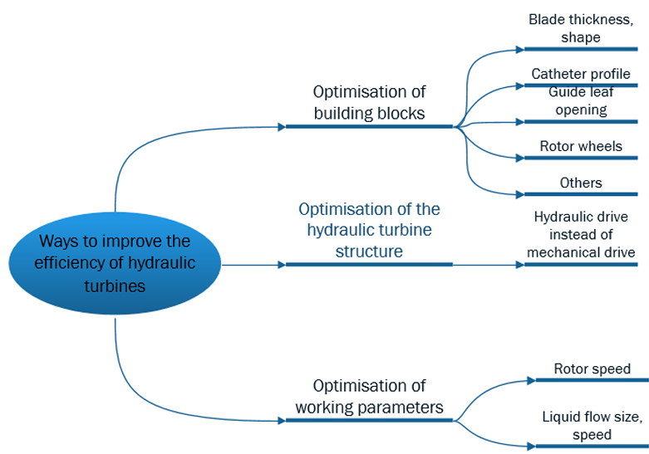

**Figure 1.** Efficiency of Hydraulic Turbine

Adjustment of the system operating parameters can maintain the hydraulic turbine operating condition in the high-efficiency zone. The mechanical gearbox is one of the most failure-prone turbine components and is also the most expensive to replace and repair; replacing mechanical gears with hydraulic drives can increase efficiency and save costs.

* 1. *Thrust Bearing :*

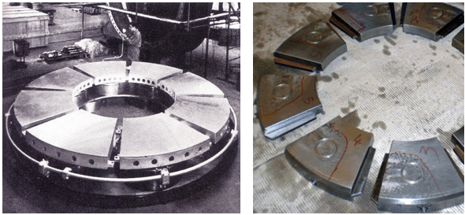

**Figure 2.** Hydro dynamic Thrust Bearing

The turbine-generator unit presents remarkable masses under rotation and considerable inertia forces, that increase if masses are not balanced, come into play. The runner may be subject to lateral forces due to the asymmetric flow that strikes it and the generator may be subject to magnetic pull. These forces associated to the weight of the rotating parts must be controlled by means of the bearings. in the case of horizontal machines, the main loads on the bearings are due to the weights that act in perpendicular with the machine shaft and the axial loads, also present, are smaller than those in the corresponding vertical unit because in this case there is no weight along the shaft. Making reference to a vertical unit, the axial loads are discharged by the thrust bearing and the radial ones by the guide bearings. The number of guide bearings depends on the type of turbine-generator unit and essentially by the length of the shaft line. In general, in vertical machines, the thrust bearings are positioned above the generator and often they are combined with one guide bearing.

1. **COMPUTER AIDED MODEL :**

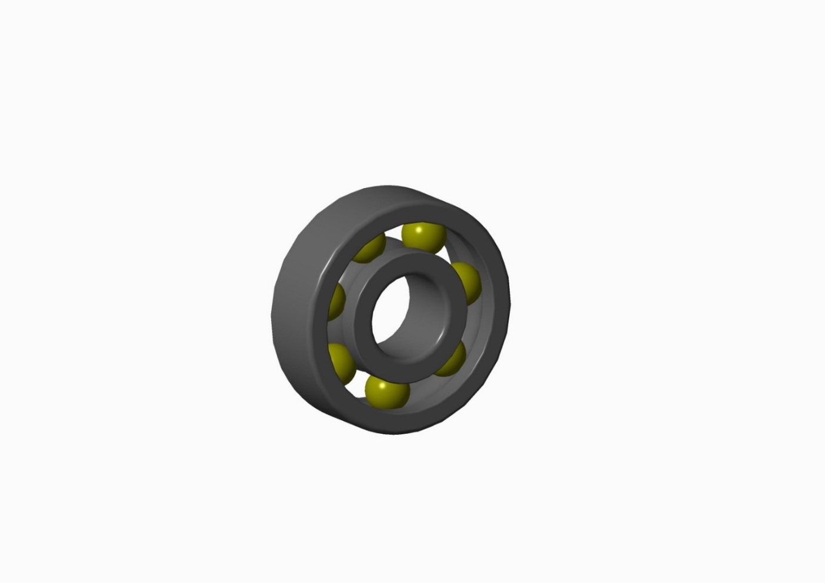

**Figure 3.** Creo Model of Bearing

Friction is bound to occur between the rotating shaft and the part that supports the rotation. Bearings are used between these two components. The bearings serve to reduce friction and allow for smoother rotation. This cuts down on the amount of energy consumption. The simulation is conditioned for small purpose turbine bearing. The properties of bearing is as shown in the figure.

**Table 1.** Functional Properties of Bearings

|  |  |
| --- | --- |
| **Parameter** | **Value** |
| Basic dynamic load rating C | 1190 KN |
| Basic static load ratingC0 | 540 KN |
| Fatigue load limit Pu | 228 KN |
| Reference speed | 38000 r/min |
| Limiting speed | 24000 r/min |
| Mass | 8.2 Kg |
| Calculation Factor F0 | 121.35 |

The model using the specifications from table 1, a solid model is prepared in creo software showing all the physical parameters in simulative conditions. Creo runs on Microsoft Windows and provides apps for 3D CAD parametric feature solid modeling, 3D direct modelling, 2D orthographic views, Finite Element Analysis and simulation, schematic design, technical illustrations, and viewing and visualization.

1. **Finite Element Analysis Setting :**

*3.1 Contact Stress Analysis Setting:*

In order to analysis the balls and the bearing under the effect of contact pressure, the model which is first prepared in creo software, is to be imported in Ansys. In order to export the model in Ansys, it has to be saved in IGES format which states that The Initial Graphics Exchange Specification (IGES)

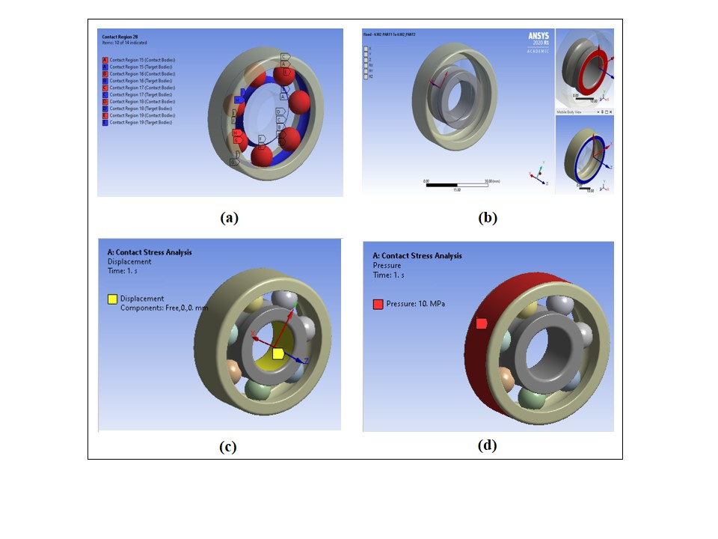

**Figure 4.** Ansys Setting of Contact Stress Analyses

In the current analysis, the different parts which are mating with other are the balls which are in contact with the inner race of bearings. The description of contact setting is described in the figure 4(a). A revolute joint takes the length of that shaft and prevents any bending or tilting of the shaft. If you have a single row of ball bearings at one end, that tends to allow bending and tilting of the shaft. You can change the joint type from Revolute to General and free up all Rotation as shown in figure 4(b). Free displacement is provided to the component for allowing it to rotate under the given revolute joint. In Ansys workbench every loads and supports have different applications shown in figure 4(c). Bearing pressure is a particular case of contact mechanics often occurring in cases where a convex surface (male cylinder or sphere) contacts a concave surface (female cylinder or sphere: bore or hemispherical cup) as shown in figure 4(d).

*3.2. Ansys Setting for Transient Structural Analysis:*

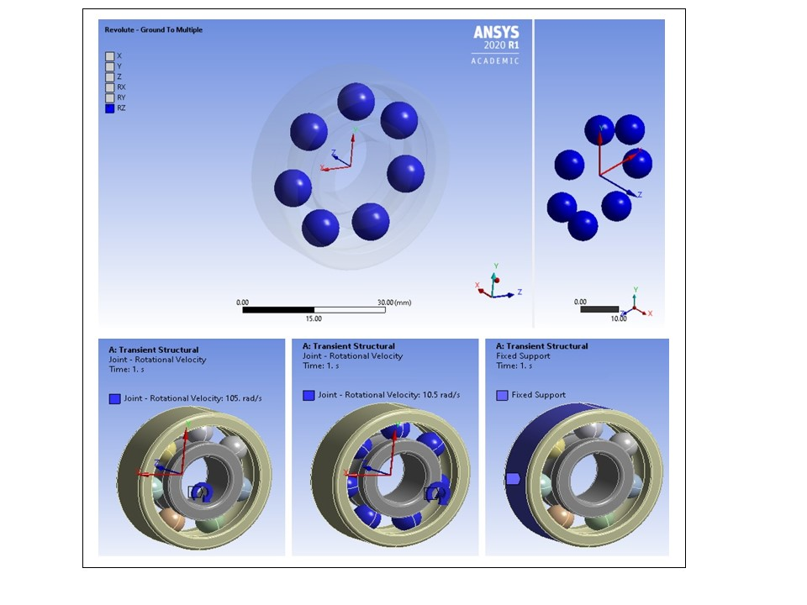

**Figure 5.** Ansys Setting of transient Structural Analysis

Ball or roller bearings are kinematic ally equivalent to simple revolute joints. This is a combination of revolute joints and has two rotational degrees of freedom. A revolute joint is usually made by having a pin or knuckle joint, through a rotary bearing. The radial acceleration is a function of the radius of the element from the axis and the rotational velocity. Hence in order to simulate the rotational speed, the velocity is given to inner portion of bearing where the shaft is fixed (Portion A in figure 5) and the balls which are self-rotation or rolling during the rotation of bearing (Portion B in figure 5). As it is circular velocity, hence the bearing which is running at 1000 Rpm, is been subjected to velocity of 105 rad/sec. It is assumed that, the angular velocity of balls is 1/10 part of the actual velocity, hence the balls are subjected with velocity of 10.5 rad/sec.

1. **RESULT AND DISCUSSIONS :**

*4.1 Response Analysis of Contact Stress Analysis:*

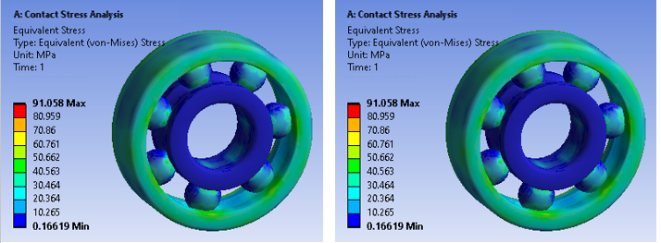

**Figure 6.** Contact Stress Analysis for Babbitt Material

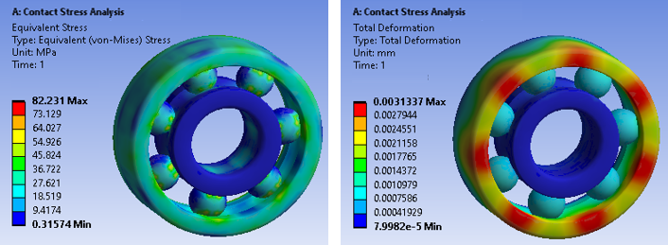

**Figure 7.** Contact Stress Analysis for Bronze Material

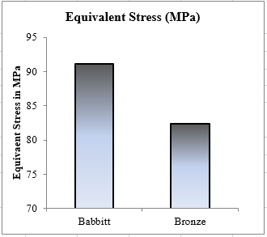 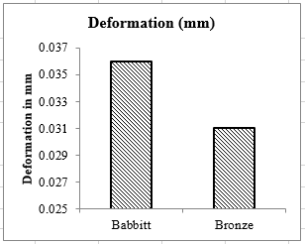

**Figure 8.** Response Analysis of material in Contact Stress Analysis

The Figure 6,7 and 8 , show the comparison of results that are determined for contact stress analysis. As we can see from the above Figure 8(a), for all the static loading conditions, the stress produced for all the materials is similar. Still, with the keen and accurate comparison, the stress obtained in the Bronze material is the lowest as per the Babbitt. As we can see from the above figure 8(b), for all the static loading conditions, the deformation produced for, the stress obtained in the Bronze material is the lowest as per the Babbitt. In both the results for contact stress, the deformation of Babbitt is obtained to be maximum.

* 1. *Response Analysis of Transient Structural Analysis :*

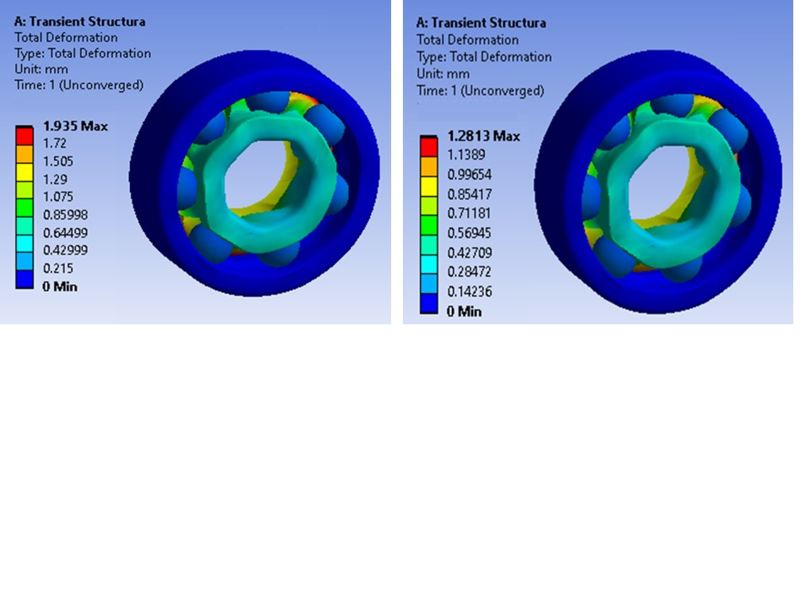

**Figure 9.** Wear Deformation Analysis for Babbit and Bronze Material

Figure 9 shows the deformation of material under the behaviour of 1000 RPM loading. The model of Bearing is developed which is imported in Ansys transient structural model for wear deformation analysis in simulation conditions. Under the simulation conditions, the wear rate is found to be maximum for Babbitt material and the Wear rate in Bronze found to be the lowest.

1. **CONCLUSIONS :**

* The numerical approach is done to calculate the results in more than one approach for contact stress distribution and wear deformation analysis.
* The deformation is measured by simulation and the wear volume is determined with help of mathematical equations.
* For Contact Stress and Wear deformation, the results of Bronze material were found to be least and better as that of Babbitt.
* While validation process, the difference in the results of experimental validation is found to be 2.5 %. Hence, if some simulation conditions are improvised, one can rely the simulation results also.
* In all the process, Bronze material shown the best possible results amongst all as that of other Babbitt material.
* A Successful approach is determined for determination of Frictional resistance for bronze materials. The attempt can be successfully implement in case of thrust bearings so as to increase the bearing life and weight.

1. **REFERENCES**
2. R. K. Tyagi, “Hydraulic Turbines and Effect of Different Parameters on output Power”, European Journal of Applied Engineering and Scientific Research, 2012.
3. Yunguang Ji, HaoSong Ji, Y, Song, H. Xue, Z, Li, Z, Tong, M.; Li, “A Review of the Efficiency Improvement of Hydraulic Turbines in Energy Recovery”, MDPI Journal of Processes, 2022.
4. Qi Zhao, “Research Developments of Aerostatic Thrust Bearings: A Review”, MDPI Journal of Applied Science, 2022.
5. Wodtke Michał, “Analysis Of A Hydrodynamic Thrust Bearing Using Multi – Physical Modeling Technique”, STLE Journal, 2016.
6. J. Bouyer a, , M. Wodtke, M. Fillon, “Experimental research on a hydrodynamic thrust bearing with hydrostatic lift pockets: Influence of lubrication modes on bearing performance”, Tribology International, 2022.
7. Hydrodynamiczne Łożyska Wzdłużne Z Polimerową Warstwą Ślizgową, “Hydrodynamic Thrust Bearings With Polymer Lining”, Tribologia, 2016.
8. Shrikant U. Gunjal, “A Study Of Bearing And Its Types”, International Journal of Advance Research In Science And Engineering, Vol. No.4, Special Issue (01), March 2015.
9. J W Cao, L M Zhaiz, B Guo, H M Lei, S H Ahn and Z W Wang, “Analysis on the thrust bearing lubrication in pumped storage unit based on fluid-solid-thermal interactions”, IOP Conf. Series: Earth and Environmental Science, 2021.
10. F. Dupuy, B. Bou-Saïd and M. Garcia ,” Tribological study of an aerodynamic thrust bearing in the supersonic regime”, IOP Conf. Series: Materials Science and Engineering, 2017.
11. J W Cao, “Analysis on the thrust bearing lubrication in pumped storage unit based on fluid-solid-thermal interactions”, Asia Symposium on Hydraulic Machinery and System, IOP Conf. Series: Earth and Environmental Science, 2021.
12. M A Mukutadze, A M Mukutadze and V V Vasilenko, “Simulation model of thrust bearing with a free-melting and porous coating of guide and slide surfaces”, IOP Conf. Series: Materials Science and Engineering, 2019.
13. H. Iliev, “Failure analysis of hydro-generator thrust bearing”, Journal of Wear, Elsevier Publicaion, 2019.
14. Vishnu Saini, Raja Sekhar Dondapati, Vijay Shankar, Abhinav Kumar, “Thermal Analysis on Thrust Pad Bearing with Non-Newtonian Lubricant”, International Journal of Engineering Research & Technology (IJERT), 2015.
15. Kittipong Boonlong and Puttha Jeenkour, “Experimental Study on Oil Pressures of Hydrodynamic Lubrication in Thrust Bearing Considering Circumferential V-Grooved Pad”, International Journal of Mechanical Engineering and Robotics Research Vol. 9, No. 3, March 2020.
16. Lyle Hyle, “A Handbook on Failure of Thrust Bearing”. 2015.