**WEAR RATE INVESTIGATION OF BIO-FIBER OF JUTE FIBER AND BANANA FIBER FOR CLUTCH PLATE MATERIAL**

**Anil Gangadharrao Kandulwar1, Prof. V.C. Kale2**

1 P.G Scholar Mechanical Engineering, 2 Professor in Mechanical Engineering

Gokhale Education Society's R. H. Sapat College of Engineering, Management Studies and Research,

Nashik (Maharashtra, Ind.)

**ABSTRACT**

A Clutch is a machine member used to connect the driving shaft to a driven shaft, so that the driven shaft may be started or stopped at will, without stopping the driving shaft. Hence the clutch is used for Power Transmission. In transmitting power from engine to gearbox, Clutch plate plays an important role. Hence in this concept we are design the clutch plate for wear and friction criteria. In this study, the bio-composite material is been tested under wear rate investigation. Currently the material which are observed are jute fiber and banana fiber. The materials of Banana and Jute fiber are prepared in pin format using Compression moulding technique and then been modified in size as respect to the pin testing apparatus. The wear testing is conducted on Pin on Disc Test up for determination of Frictional Force, Wear rate and wear volume. The material which is used for the plate is selected as Grey cast iron.

**Keywords:** Clutch Plate materials, Banana Fiber, Jute Fiber

1. **INTRODUCTION** 
   1. *Clutch Plate :*

A clutch mainly consists of two parts, i.e. friction plates and separator plates. These plates engage and disengage to transmit speed and torque. The transmitted torque is proportional to the overall friction coefficient of the clutch plates. The friction behaviour of clutch plates is critical for overall performance of the transmission and it depends on the sliding velocity, the normal pressure, the lubrication, the temperature and the surface topography of the clutch plates. It is necessary to investigate the effect of surface topography on the friction behaviour of the clutch plates [1].

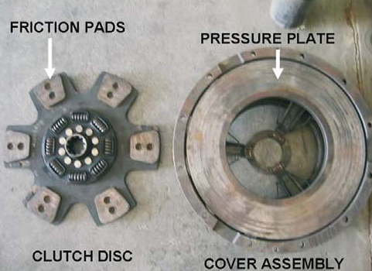

**Figure 1.** Automotive Clutch Plate

* 1. *General Materials Used for Clutch Plate :*
* Grey cast iron: The clutch disc is generally made from grey cast iron (FG 300). Because of its high heat and wear resistant but its cost is too high [2, 4].
* Sintered brass: The material is used as clutch plate material because of their resilience at high loads and high temperatures as well as their cost in comparison to alternative friction materials. The main disadvantage is that the sintered brass material is much softer as compared to the opposing hardened steel plates, as exposed by larger amount of deformation [2]
* Asbestos: In past, Asbestos was used as a clutch plate material due to its high heat resistance and good strength. Disadvantage of asbestos is that it will create lung cancer such as colon, throat and oesophageal cancer [3].
  1. *Failures in Clutch Plate :*

Clutch plate is one of main systems inside a vehicle,. Clutch system comprises of clutch plate and clutch facing, pressure plate, diaphragm spring and bearing. Hence the material of clutch plate should consist of following prime requirements.

* It must have high coefficient of friction
* It must resist wear effects such as scoring, galling and ablation
* It should resistant to the environment (moisture and dust)
* It should possess good thermal properties, good thermal conductivity, high heat capacity and with stand high temperature
* It should withstand high contact pressure [3]

The clutch engages the transmission gradually by allowing a firm quantity of slippage at the transmission input shaft. Though, the slipping mechanism in the clutch generates high heat energy due to friction. At high sliding velocity, excessive frictional heat energy is formed and it leads to high temperature rises, and this causes thermo mechanical problems such as deformations and instability which can lead to high wear, cracks and other mode of failure of the clutch disc component [3]

1. **MATERIALS AND METHODS :**

*2.1 Jute Fiber:*

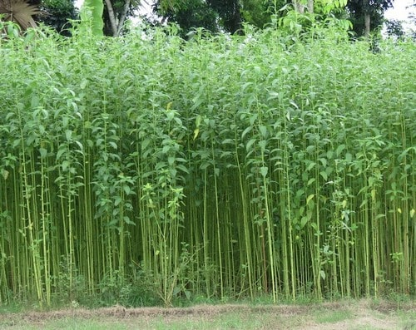 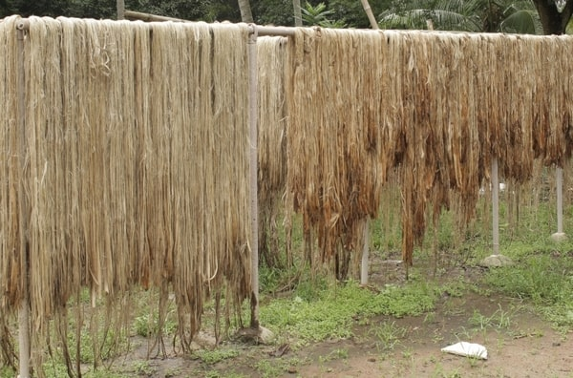

**Figure 2.** (a) Jute plants (b) Jute Fiber

Jute has several benefits as a natural fiber. It is biodegradable, making it environmentally friendly. It is also a renewable resource, as the jute plant can be regrown after it is harvested. Jute is also resistant to rotting and has natural fire retardant properties. It is a strong and durable fiber, making it suitable for use in the manufacture of heavy-duty products such as bags and ropes. In addition to its use in the textile industry, jute is also used in the production of paper, insulation materials, and biofuels. It is a versatile and sustainable resource that has the potential to play a significant role in a variety of industries.

*2.2 Banana Fiber :*

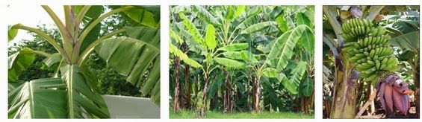

**Figure 3.** Banana Fiber Plant and Fruit

Banana fiber, a ligno-cellulosic fiber, obtained from the pseudo-stem of banana plant (Musa sepientum), is a bast fiber with relatively good mechanical properties. Banana plant is a large perennial herb with leaf sheaths that form pseudo stem. Its height can be 10-40 feet (3.0-12.2 meters) surrounding with 8-12 large leaves. The leaves are up to 9 feet long and 2 feet wide (2.7 meters and 0.61 meter). Banana plant is available throughout Thailand and Southeast Asian, India, Bangladesh, Indonesia, Malaysia, Philippines, Hawaii, and some Pacific islands. Banana fiber is very less cost available fiber in India. It is light in weight and easily achievable. Banana fiber is eco-friendly, non-toxic, biodegradable and odourless fiber. Banana fiber which is used for manufacturing of composite. Banana fiber is very light in weight and is used in fabrication of composites.

*2.3 Manufacturing Methods: Principle of Moulding Process:*

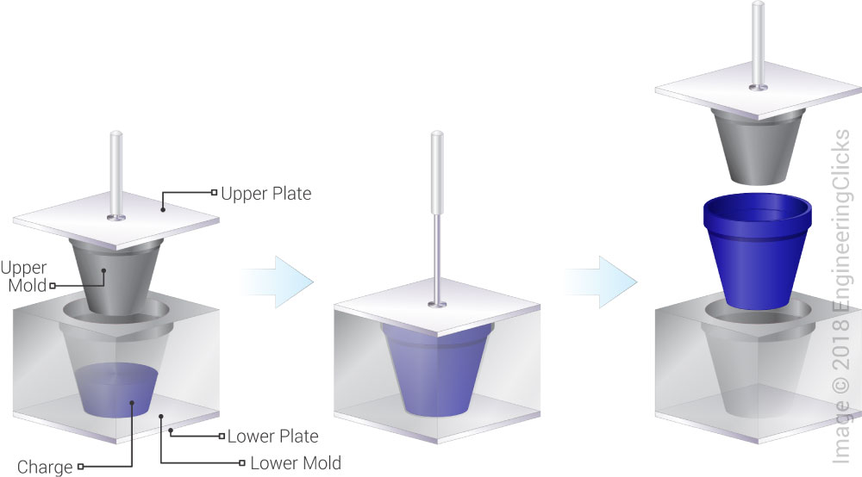

**Figure 4.** Compression Moulding Principle

Compression molding is the process of molding in which the fibers is placed into an open mold cavity. The mold is then closed with a top plug and compressed in order to have the material contact all areas of the mold. This process is able to produce parts with a wide array of lengths, thicknesses, and complexities. The objects it produces are also high in strength, making it an attractive process for a number of different industries. There are four main steps to the thermoset composite compression molding process:

1. A high strength, two part mould tool is created that exactly matches the dimensions required to produce the desired part.
2. The desired composite is pre-formed into the shape of the tool. Pre-forming is a crucial step that helps to improve the performance of the finished part.
3. The pre-formed part is inserted into the mold. The tool is then compressed under very high pressure, usually ranging from 800psi to 2000psi (depending on the thickness of the part and the type of material used).
4. The part is removed from the tool after the pressure is released. Any resin flash around the edges is also removed at this time.
5. **EXPERIMENTAL INVESTIGATIONS :**

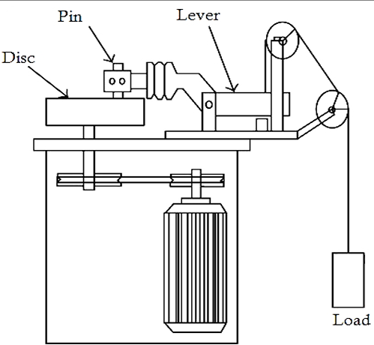

**Figure 5.** Pin on Disc Testing

Pin on disk wear testing is a method of characterizing the coefficient of friction, frictional force and rate of wear between two materials. As a particularly versatile method for testing wear resistance, pin on disk can be configured in multiple scenarios depending on the goals of your project. Pin on disk testing can simulate multiple wear modes, including unidirectional, bidirectional, omnidirectional and quasi-rotational wear. Our equipment allows us to test virtually any combination of materials to determine the effect of wear on a medical device. In this experiment, the test was conducted with the following parameters are Load, speed and distance. The Load has been considered just to verify the suitability of trials on the different composite materials. The Composites are lighter in weight hence considering the same point the load has been considered.

Hence Normal Force can be said as,

Normal Force (FN) = Load x 9.81 = 19.62 N

Disc Rotation (N) = 1000Rpm.

The Speed of the disc has been selected on the basis of regular speed of engine clutch. The Regular speed is about 1000-2000 Rpm. The Engagement speed is 2000 Rpm hence to ensure the safety, 1000 Rpm speed has been considered.

Sliding Velocity:

The Sliding Velocity can been given as,

VS= (πDsN)/(60*1000)

Where.

Ds = Sliding phase diameter = 100mm

Hence, VS = 5.23 m/s

1. **RESULT AND DISCUSSIONS :**

*4.1 Wear Volume:*

**Table 1** Results for Wear Volume

|  |  |  |  |  |
| --- | --- | --- | --- | --- |
| **No.** | **Material** | **Initial Weight W1(gm)** | **Final Weight W2**  **(gm)** | **Wear Volume**  **(mm3)** |
| 1. | Grey Cast Iron | 18.64 | 17.23 | 470 |
| 2. | Jute Fiber | 10.22 | 10.10 | 95 |
| 3. | Banana Fiber | 10.91 | 10.80 | 45.83 |

The above graph is determined by using results from chapter 3, section 3.2, and table 3.09. The wear Volume for Jute Fiber and Banana Fiber Fibre are comparatively low. Due their low density and good wear resistant property, the gives less wear out during the experimental test.

**Figure 6.** Wear Rate Comparison for all material

*4.2 Co-Efficient of Friction:*

The Figure 5.2, shows the behaviour of co-efficient of friction for different materials under different interval of time. The material showing shows the lower wear rate possess the coefficient of friction which slightly varies with respect to deeper wear testing. The Friction coefficient for Banana Fiber Fibre remains constant throughout the test, which shows that the wear behaviour will remain constant after a certain period of time. Figure 5.2 explains that, Coefficient of friction shown by Grey cast iron is consistent, quite obvious due to ferrous in nature as that of bio-fibres. As the time goes on increasing uptill 1800 sec, the co-efficient of friction goes on increasing. Hence after the timing of 1500 seconds, the material of jute and banana fiber is proved to slightly higher than that of grey cast iron.

**Table 2** Results for Co-efficient of Friction

|  |  |  |  |
| --- | --- | --- | --- |
| **Time (s)** | **Grey Cast Iron** | **Jute Fiber** | **Banana Fiber** |
| 300 | 0.201 | 0.13 | 0.133 |
| 600 | 0.159 | 0.189 | 0.154 |
| 900 | 0.154 | 0.247 | 0.199 |
| 1200 | 0.156 | 0.262 | 0.197 |
| 1500 | 0.172 | 0.269 | 0.202 |
| 1800 | 0.169 | 0.224 | 0.214 |

**Figure 7.** Co-efficient of Friction of Different Material

1. **CONCLUSIONS :**

* The Experimentation is done on different pins for material Grey Cast Iron, Jute and Banana Fibre.
* The Tribological Investigation for all the materials shows the result & calculations for wear Volume, Co-efficient of friction and Hardness Analysis.
* With respect to the Wear Volume, volume gradually decreased from material Grey Cast Iron, Jute Fiber and Banana Fiber. With respect to wear volume Jute and Banana fiber shows the best result.
* The co-efficient of friction is been calculated with respect to the experimental results of Frictional Force.
* The Least the value of Co-efficient of friction is determined from Banana Fiber.
* A Successful approach is determined for use of Composites as Clutch Plate Friction material.
* The friction linings of clutch plate are generally made of asbestos or casted iron material. Hence in this approach, a novel attempt is made to test the bio-fibres in tribological conditions.

1. **REFERENCES**
2. Qian Zou et.al., “Investigation of surface characteristics and tribological behavior of clutch plate materials”, Elsevier Publication, Wear 302, 2013.
3. Aravind Vadiraj “Engagement characteristics of a friction pad for  
   commercial vehicle clutch system”, Indian Academy of Sciences, Vol. 35, Part 5, pp. 585–595, October 2010.
4. A. Mr. Dattatray B. Jondhale, B. Prof. Vishnu S. Aher, “Experimental Evaluation of Clutch Plate Material by Tribological Properties Using Trobometer,” International Engineering Research Journal.
5. Miss Kaveri. S. Kadam, “Tribological Investigation of Ferodo Lining  
   Material Embedded with Copper and SiC particles For Clutch plate” International Engineering Research Journal Page No 1810-1816.
6. G.Kannan, K.Krishnamoorthy, K.Loheswaran, “Review on Different Materials Utilized in Clutch Plate,” South Asian Journal of Engineering and Technology Vol.2, No.23, Pg. 135 – 142 ,2016.
7. S. Gouse seema begum, A. Balaraju, “Design and Analysis of Friction Clutch Plate  
   using Ansys”, International Journal of Advanced Engineering Research and Science (IJAERS) , Vol-2, Issue-5, May- 2015.
8. Virendra kumar patel et.al. . “Review on Wear Analysis of Different Types of Clutch Material,” International Journal of Research in Advent Technology, Vol.3, No.11, November 2015.
9. Ravikiran M. Tate, “Design and Analysis of Clutch Plate for Automatic Single Plate Clutch”, IJSRD - International Journal for Scientific Research & Development, Vol. 3, Issue 09, 2015.
10. B. Nivas et.al. “Design and Analysis of Clutch Plate Using Steel Material [En – Gjs-400 -15steel]”, IOSR Journal of Dental and Medical Sciences (IOSR-JDMS), Volume 13, Issue 5, PP 76-78, May. 2014.
11. J Joy Mathavan and Amar Patnaik, “Analysis of wear properties of aluminium based journal bearing alloys with and without lubrication”, IOP Conf. Series: Materials Science and Engineering, 2016.
12. Sandip B. Chaudhari et.al. “Wear Analysis of Polytetrafluoroethylene (PTFE) and it’s  
    Composites under Wet Conditions”, IOSR Journal of Mechanical and Civil Engineering (IOSR-JMCE), Volume 8, Issue 2,Pg 07-18 Jul. - Aug. 2013.
13. K.C.Lathiya, et.al. “A Literature Review on Failure in Single Plate Clutch System”, IJSRD - International Journal for Scientific Research & Development, Vol. 2, Issue 10, 2014.
14. Mamta G. Pawar, Monarch K. Warambhe, Gautam R. Jodh, “Design and Analysis of Clutch Using Sintered Iron as a Friction Material, International Journal of Innovative Technology and Exploring Engineering (IJITEE), Volume-3, Issue-7, December 2013.
15. Zeyaullah Ansari, “Investigation of Stresses of Friction Clutch Plate on Different Material, International Journal of Innovative Research in Science, Engineering and Technology, Vol. 6, Issue 3, March 2017.
16. N. A. Barve, “Analysis of Single Plate Friction Clutch Using Finite Element Method”, International journal of advance scientific research and engineering trends, Volume 2, Issue 11, JUNE 2017 .