PARAMETRIC ANALYSIS OF HIGHRISE BUILDING WITH DIFFERENT LOCATIONS OF SHEAR WALL USING STAAD-PRO
¹Mr. Satyawan Dhobale, ²Mr. Sahil Pawar, ³Mr. Shailesh Shinde & ⁴Prof. Nitin Shelar
^{1to3}UG Student, Department of Civil Engineering, Yadavrao Tasgaonkar Institute Of Engineering & Technology, Mumbai University, Mumbai
⁴Assistant Professor & Head, Department of Civil Engineering, Yadavrao Tasgaonkar Institute Of Engineering & Technology, Mumbai University, Mumbai
Abstract:
The analysis and design phase of this project begins with the selection of a suitable building model, which is subjected to different loading scenarios in various geographical locations. STAAD-PRO, a renowned structural analysis and design software, is employed to simulate and assess the structural behavior of the high-rise building. The software allows for the detailed examination of the impact of shear wall locations on factors such as structural deformation, stress distribution, and overall stability. Throughout the project, an in-depth investigation into the effects of shear wall placement on the building's performance is conducted. The findings of this study will help engineers and architects make informed decisions regarding the optimal positioning of shear walls in high-rise buildings, ensuring that they meet both safety and aesthetic requirements. This research contributes to the field of structural engineering by providing valuable insights into the significance of shear walls in high-rise building design. It also demonstrates the capabilities of STAAD-PRO as a powerful tool for structural analysis and design. Ultimately, the project aims to enhance the efficiency and safety of high-rise structures, paving the way for innovative and sustainable architectural solutions in the construction industry.
Keywords: STAAD, RC frame building, shear wall, deformation, base shear
- Introduction
The global landscape of urbanization and population growth has ushered in an era of towering structures, with high-rise buildings becoming prominent features of our modern cities. These architectural marvels not only accommodate the ever-expanding urban population but also stand as symbols of progress and innovation. However, as these structures ascend to ever-greater heights, they face unique engineering challenges, particularly in ensuring structural stability and safety. One of the key elements in addressing these challenges is the strategic incorporation of shear walls within the building's design.
Shear walls are essential components in high-rise building construction, serving as the backbone of lateral load resistance. In a world increasingly susceptible to environmental forces such as wind and seismic activity, the proper placement and design of shear walls are vital to safeguard the structural integrity of these towering edifices. The location of shear walls significantly influences a building's response to lateral loads, affecting factors such as deflection, stress distribution, and overall stability.
This Bachelor of Engineering (BE) final year project embarks on a comprehensive exploration of the parametric analysis and design of high-rise buildings, focusing on the varied locations of shear walls, all of which is facilitated by the state-of-the-art STAAD-PRO software. The central objective of this study is to investigate how the placement of shear walls within the structure impacts its performance under different loading conditions, geographical locations, and architectural constraints.
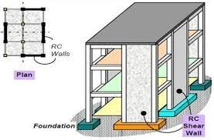
Fig.1.1: Location of shear wall in building
The analysis and design phase of this project will be guided by the principles of structural engineering, aiming to ensure that the high-rise building not only stands tall but also stands strong, resilient to the dynamic forces it may encounter throughout its lifespan. STAAD-PRO, a widely recognized and respected structural analysis and design software, will serve as the primary tool for simulating and evaluating the structural behavior of the building under various scenarios.

- LITERATURE REVIEW
A.B. Karnale and Dr.D.N. Shinde (2015) [1] "Study of Optimizing Configuration of Multi- Storey Building Subjected to Lateral Loads by Changing Shear Wall Location" Shear wall systems are one of the most commonly used lateral load resisting in high rise building. Shear wall has high in plane stiffness and strength which can be used to simultaneously resist large horizontal loads and support gravity loads.
A.Joshua Denial, S Sivakamasundari (2016) [2] Incorporation of shear wall has become inevitable in multi-storey building to resist lateral forces .It is very necessary to determine effective, efficient and ideal location of shear wall. In this paper, study of 25 storey building in zone V is presented with some preliminary investigation which is analysed by changing various position of shear wall with different shapes for determining parameters like bending moment, base shear and storey drift. This analysis is done by using standard package ETAB.
Ashish S. Agrawal et. al. (2012) [3] have worked on high rise steel framed building subjected to earthquake load to optimize the location of outrigger. The basic concept of this research work was to carry out the comparative study of results obtained for the lateral displacement and story drift by response spectrum and non-linear time history methods for optimum outrigger location.
Abbas Hangollahi et al. (2012) [4] In this investigation, 20 and 25 story models had been analysed by considering ground accelerations of several actual earthquakes in the past to study displacement and drift. Similarly by employing Non linear Dynamic Time History analysis optimum location of outrigger and belt truss was at story 14 and story 16 (i.e. 0.3 and 0.36 times the height of structure from top). So according to author it may be safe to claim that outrigger optimum location at real status should be located in upper level. einforced concrete (RC) buildings often have vertical plate-like RC walls called Shear Walls in addition to slabs, beams and columns.
Anil Baral et. al. (2015) [5] " Seismic Analysis of RC Framed Building for Different Position of Shear wall" Shear walls are incorporated in building to resist lateral Forces and support the gravity loads. RC shear wall has high in plane stiffness. Positioning of shear wall has influence on the overall behaviour of the building. For effective and efficient performance of building it is essential to position shear wall in an ideal location.
- METHODOLOGY
3.1 General
This chapter is including the method of the analysis of the building with re-entrant corners and the provision of the bracings and shear wall at different locations have been identified.
3.2 Modeling
The different models are modeled using STAAD-PRO as follows.
- Model-I: Multistoried Building without Shear Wall & Bracings
- Model-II: Multistoried Building with Bracings location-1
- Model-III: Multistoried Building with Shear wall location-1
- Model-IV: Multistoried Building with Shear wall - bracing location-1
- Model-V: Multistoried Building with Bracings location-2
- Model-VI: Multistoried Building with Shear wall location-2
- Model-VII: Multistoried Building with Shear wall-bracing location-2
- Model-VIII: Multistoried Building with Bracings location-3
- Model-IX: Multistoried Building with Shear wall location-3
- Model-X: Multistoried Building with Shear wall-bracings location-3
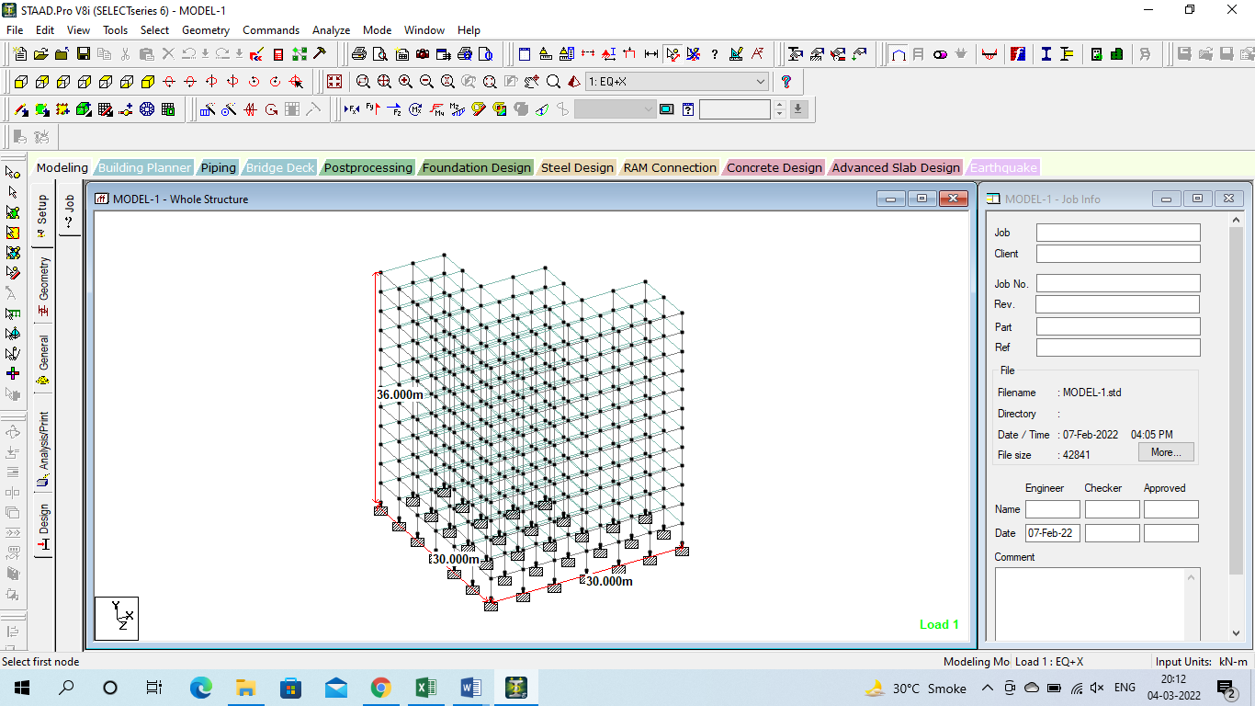
Figure 3.1: Elevation of model-I
The above figures is related to elevation of the model-I, the geometry once created using STAAD-PRO software, the elevation can be easily known.
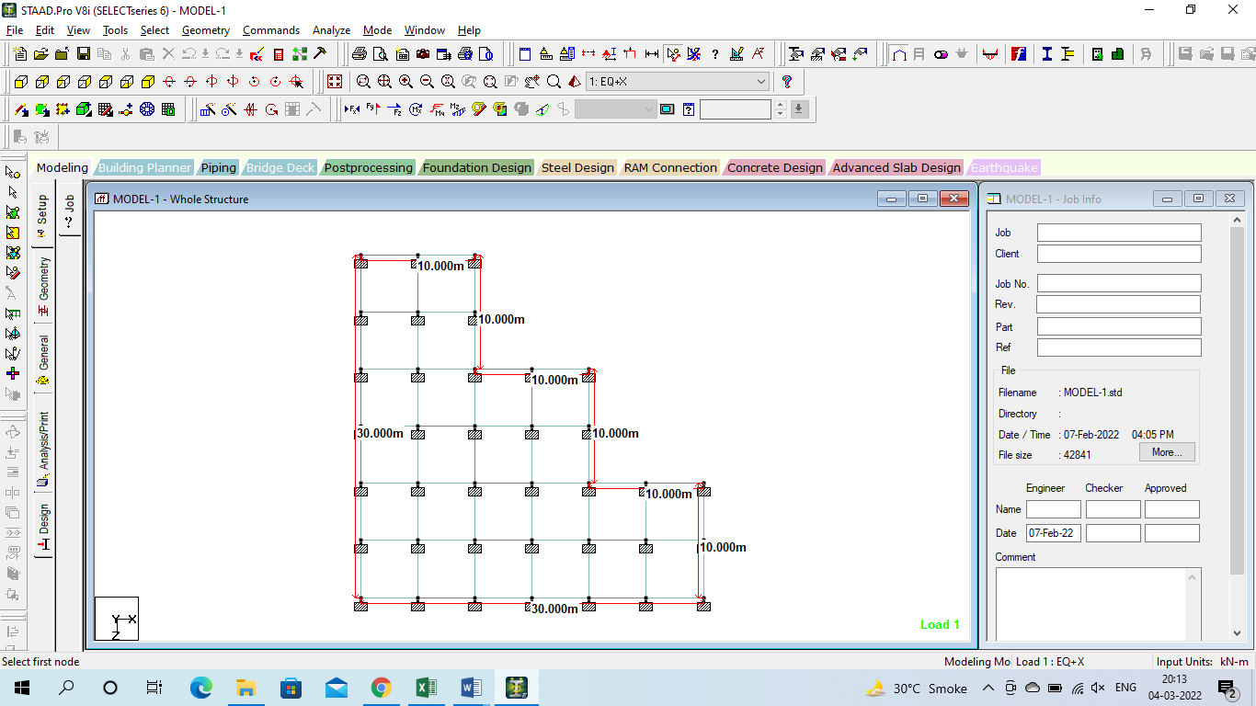
Figure 3.2: Plan of model-I
The above figures is related to plan of the model-I, the geometry once created using STAAD-PRO software, the plan can be easily known.

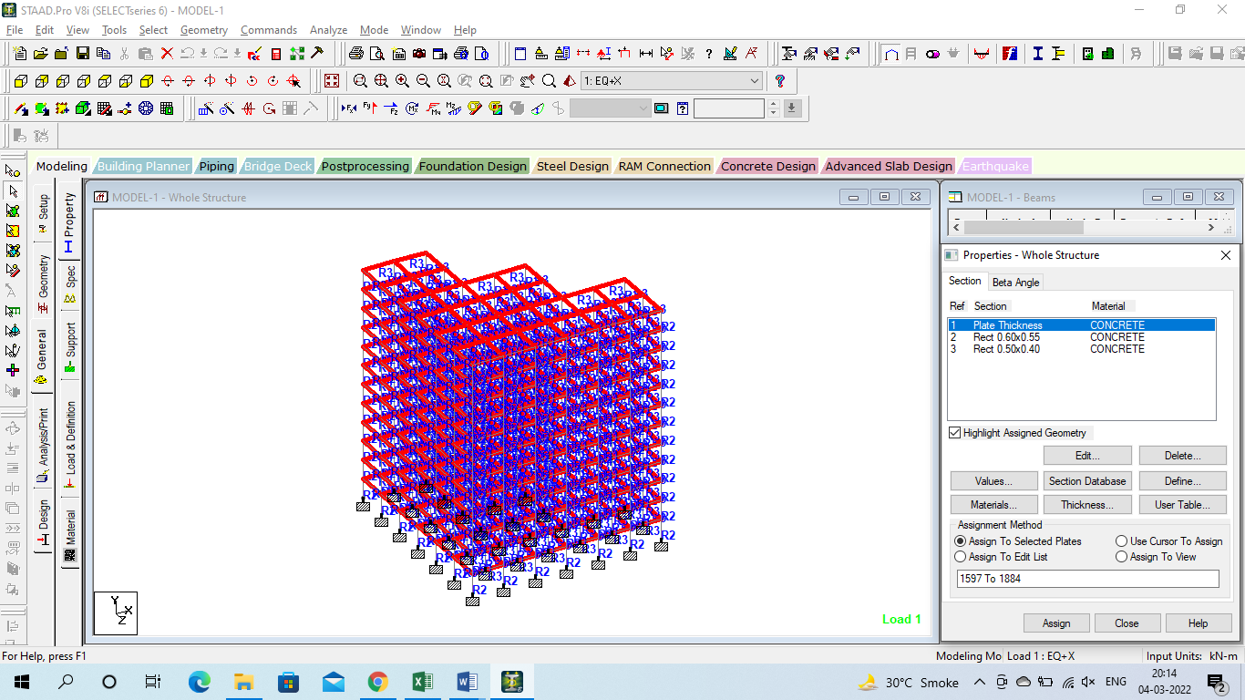
Figure 3.3: Properties assigned to model-I
The above figure is related to Properties assigned to model-I, after the geometry is created then the properties can be assigned to the model.
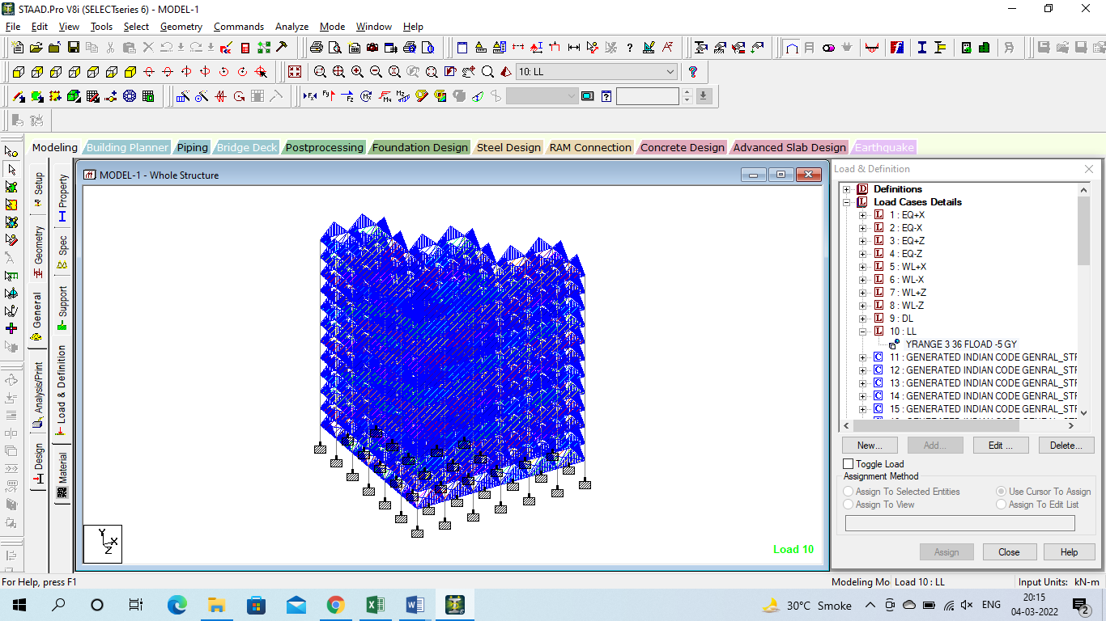
Figure 3.4: Loads assigned to model-I
The above figure is related to Loads assigned to model-I, after the geometry is created then the loads can be assigned to the model.
Figure 3.5: Loads assigned to model-I
The above figure is related to different loads assigned to model-I, after the geometry is created then the loads i.e. DL, LL, EQ loads can be assigned to the model.
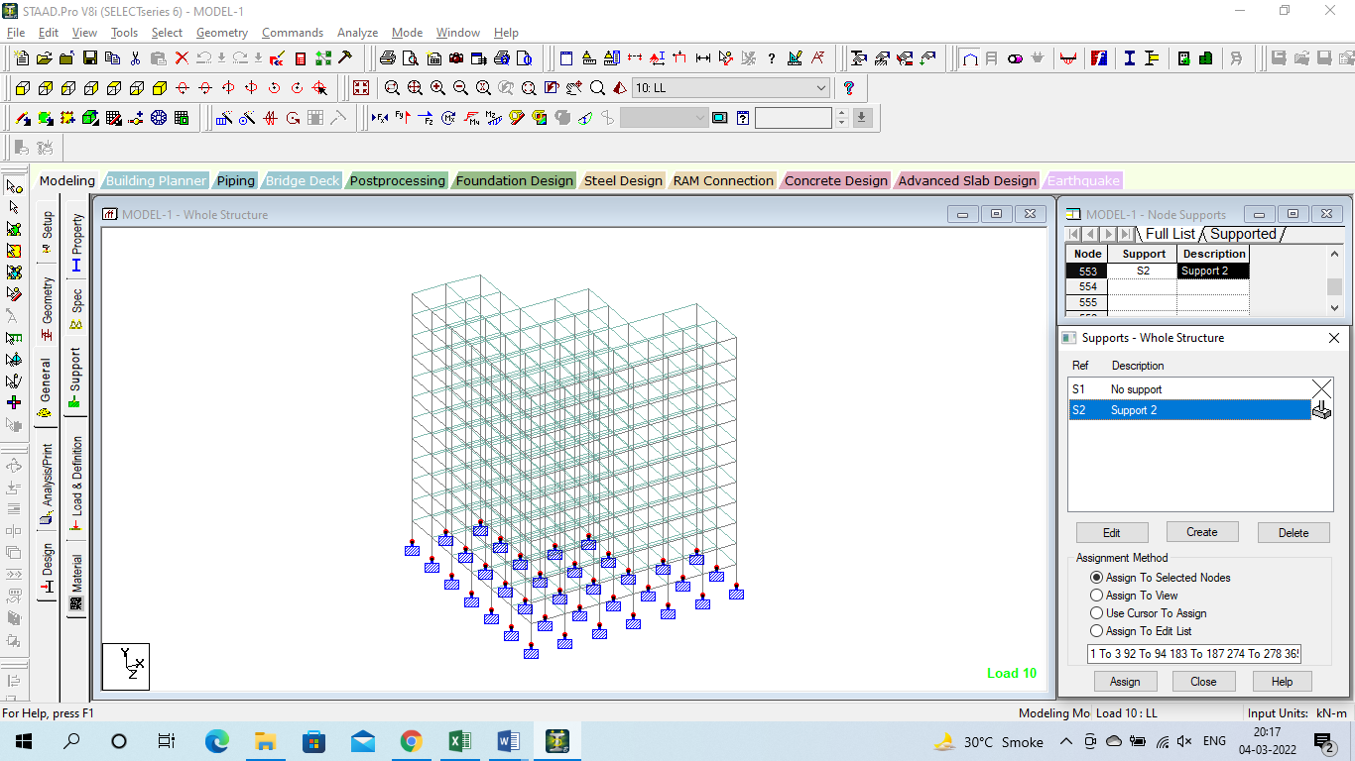
Figure 3.6: Supports assigned to model-I
The above figure is related to supports assigned to model-I, after the geometry is created then supports can be assigned to the model.

- RESULTS
The results obtained in terms of the displacement, reactions, beam forces and plate stresses for all the models.

Graph 4.1: Combined Horizontal (X) Displacement for all the models
The above graph is related to Combined Horizontal (X) Displacement for all the models, the horizontal displacement is maximum for the model-2 with the value of 165 mm.
Graph 4.2: Combined Horizontal (Z) Displacement for all the models
The above graph is related to Combined Horizontal (Z) Displacement for all the models, the horizontal displacement is maximum for the model-5 with the value of 171 mm.
Graph 4.3: Combined Vertical (Y) Displacement for all the models
The above graph is related to Combined Vertical (Y) Displacement for all the models, the Vertical (Y) displacement is maximum for the model-2 with the value of 21.7 mm.
Graph 4.4: Resultant Displacement for all the models
The above graph is related to Resultant Displacement for all the models, the Resultant Displacement is maximum for the model-5 with the value of 174 mm.
Graph 4.5: Combined Reactions (Horizontal-Fx) for all the models
The above graph is related to Combined Reactions (Horizontal-Fx) for all the models, the Combined Reactions (Horizontal-Fx) is maximum for the model-3 with the value of 3400 kN.
Graph 4.6: Combined Reactions (Horizontal-Fz) for all the models
The above graph is related to Combined Reactions (Horizontal-Fz) for all the models, the Combined Reactions (Horizontal-Fz) is maximum for the model-3 with the value of 3335 kN.
Graph 4.7: Combined Reactions (Vertical-Fy) for all the models
The above graph is related to Combined Reactions (Vertical-Fy) for all the models, the Combined Reactions (Vertical-Fy) is maximum for the model-3 with the value of 18197 kN.

- CONCLUSIONS
The following conclusions are drawn based on the present study.
- In terms of combined horizontal displacement (X), Model-2 exhibits the maximum displacement with a value of 165 mm. This indicates that Model-2 experiences the highest lateral movement among all the models considered.
- Similarly, for combined horizontal displacement (Z), Model-5 demonstrates the highest displacement of 171 mm. This suggests that Model-5 experiences significant horizontal movement in the Z-direction.
- Moving on to combined vertical displacement (Y), Model-2 exhibits the highest displacement with a value of 21.7 mm. This indicates that Model-2 experiences the most significant vertical movement compared to the other models.
- When considering the resultant displacement, which accounts for the combined effects in all directions, Model-5 exhibits the highest displacement of 174 mm. This implies that Model-5 experiences the most overall displacement among the analyzed models.
- Shifting focus to the combined reactions, Model-3 displays the maximum combined horizontal reaction (Fx) with a value of 3400 kN. This suggests that Model-3 experiences the highest resistance to horizontal forces.

REFERENCES
- A.B. Karnale and Dr.D.N. Shinde (2015), “Comparative Seismic Analysis of High Rise and Low Rise RCC Building with Shear Wall”, International Journal of Innovative Research in Science, Engineering and Technology, September 2015.
- A.Joshua Denial, S Sivakamasundari (2016), seismic vulnerability of building on the hill slope, international general of earth science and engineering volume 9, no.5, page 1892-199.
- A.S. Agrawal and S.D. Charkha (2012) 'study of Optimizing Configuration of Multi Story Building Subjected to Lateral Loads by Changing Shear Wall Location' proceedings of International conference on advances in architecture and civil engineering, volume 1 , pp 287-289.
- Abbas Haghollahi, Mohsen Besharat Ferdous and Mehdi Kasiri: "Optimization of outrigger locations in steel tall buildings subjected to earthquake loads", 15th world conference of earthquake engineering 2012.
- Anil Baral and Dr. S. K. Yajdani May-(2015); "Seismic Analysis of RC Framed Building for Different Position of Shear wall" International Journal of Innovative Research in Science, Engineering and Technology (An ISO 3297: 2007 Certified Organization) Vol. 4, Issue 5, May 2015
- Ankita Mishra, Kapil International journal of scientific & engineering research Volume 5 Issue VI, June 2017 IC Value: 45.98 ISSN: 2321-9653.
- Anshul Sud, Raghav Singh Shekhawat, Poonam Dhiman (2014) Best Placement of Shear Walls In an RCC Space Frame Based on Seismic Response-International Journal of Engineering Research and Applications (IJERA) ISSN: 2248-9622
- Anshumn. S, Dipendu Bhunia, Bhavin Rmjiyani (2011), “Solution of shear wall location in Multi-storey building.” International Journal of Civil Engineering Vol. 9, No.2Pages 493-506.
- Anuj Chandiwala (2012) 'Earthquake Analysis of Building Configuration with Different Position of Shear Wall' -International Journal of Emerging Technology and Advanced Engineering ISSN 2250-2459, ISO 9001:2008 Certified Journal, Volume 2, Issue 12.
- Anuj Chandiwala (2012), “Earthquake Analysis of Building Configuration with Different Position of Shear Wall”, International Journal of Emerging Technology and Advanced Engineering ISSN 2250-2459, ISO 9001:2008 Certified Journal, Volume 2, Issue 12, December 2012,

