**A PV SYSTEM BASED ON MAXIMUM POWER POINT TRACKIN USING PARTICLE SWARM OPTIMIZATION TECHNIQUE**

**VISWANADHAPALLI NAGA BABU**

VISWANADHAPALLI DHAMAKESH; THANNIRU VENKATA RAJYALAKSHMI; NAGABOYINA TEJA SIVANJANEYALU; MEKALA BALA NAGESWARARAO

**ABSTRACT:**

As we rely more on solar and wind power for electricity, increasing solar panel efficiency is critical. Maximum Power Point Tracking (MPPT), similar to Particle Swarm Optimization (PSO), improves this procedure. PSO outperformed MATLAB/Simulink, rapidly optimizing solar panel power output. While Perturb and Observe (P&O) and Incremental Conductance (INC) have limits, PSO consistently provided optimal performance, which is critical for managing escalating energy needs.

**INTRODUCTION:**

Over the last two decades, renewable energy, particularly solar electricity, has grown in popularity, with certain locations seeing up to 25% adoption. The government is spending considerably in solar energy installations. However, solar panels encounter efficiency issues owing to factors such as temperature and sunshine intensity. Maximum Power Point Tracking (MPPT) methods, including Particle Swarm Optimization (PSO), are utilized to improve panel performance. PSO was compared to established approaches such as Perturb and Observe (P&O) and Incremental Conductance utilizing MATLAB and SIMULINK simulations. PSO demonstrated exceptional performance in maximizing solar panel power generation under a variety of situations.

**Introduction to Maximum PowerPoint Tracking:**

MPPT improves solar panel efficiency by modifying operation to maximum energy extraction, which is critical because the panel's Maximum Power Point (MPP) fluctuates with temperature and sunlight intensity. MPPT is primarily used in PV solar systems to change load characteristics to changing circumstances, hence improving power transfer efficiency. MPPT is integrated into power converter systems, such as solar inverters, to guarantee effective voltage or current conversion for a variety of loads. Regardless of cost, MPPT controllers provide versatility in supporting various panel layouts. Finally, MPPT controllers improve solar panel performance, resulting in increased power output from solar systems.

**MPPT Implementation Control Techniques:**

MPPT guarantees that solar panels run at their greatest efficiency by tracking the Maximum electricity Point (MPP), which is the maximum point of electricity generation. This point fluctuates according on solar intensity and temperature. In this paper, we look at Particle Swarm Optimization (PSO) as an effective MPPT approach and compare it to Perturb & Observe (P&O) and Incremental Conductance (IncCond). Using a low-cost microcontroller, we intend to provide exact MPP tracking with little computing time. We'll go over solar cell fundamentals, mathematical models, and actual simulations in MATLAB before comparing PSO's performance to other tactics to determine the quickest and easiest MPP tracking technique.

**Components Required**

**Photovoltaic Systems:**

Photovoltaic systems, which are made up of several components, can be installed on their own or linked to the grid. Standalone systems make direct use of solar energy and may contain storage components such as batteries. Hybrid systems mix PV and other power sources. Power converters and storage units are examples of balance-of-system components, which have a substantial influence on system efficiency and cost.

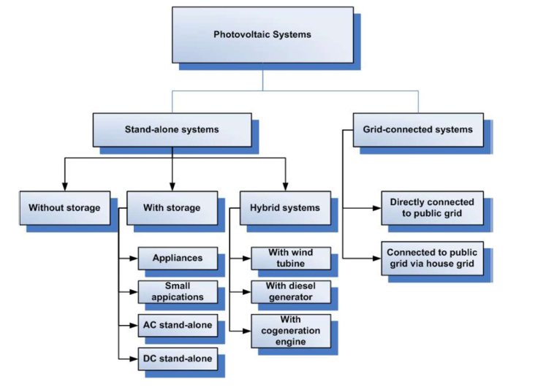  
**PV Cells:**

Photovoltaic cells turn light into electricity using a p-n junction. When photons strike the cell, they form electron-hole pairs, resulting in DC electricity. These cells are typically constructed of monocrystalline or polycrystalline silicon and shaped like tiny wafers. They behave similarly to diodes in the absence of light, according to the Shockley-Read equation. To obtain the required voltage and power levels, numerous cells are linked in series, usually in strings of 36 or 72 cells.

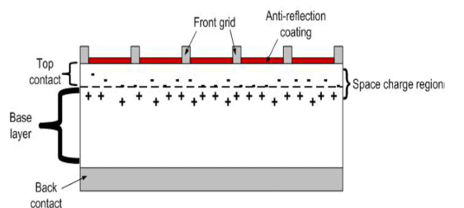

**PV array:**

PV cells turn light into energy via a connection between two materials, usually silicon. They function as diodes in the absence of light. Multiple cells are frequently linked in series to produce the requisite voltage.

**DC-DC converters:**

DC-DC converters are critical components in applications such as car lighting ballasts and solar energy systems. While boost converters theoretically provide substantial voltage increases, they have practical limitations owing to variables like as power switch characteristics and component resistance.

**Types of DC-DC Converters:**

Voltage manipulation separates DC-DC converters into three types: lowering, increasing, and both. The three primary varieties are Buck (Step-Down), Boost (Step-Up), and Buck-Boost (both).

* Buck converters effectively reduce voltage levels.
* Boost converters enhance voltage when input voltage is low.
* Buck-Boost converters alter voltage for diverse applications.
* Flyback converters offer electrical separation in low-power applications.
* Forward converters, like flyback converters, provide electrical separation for particular applications.

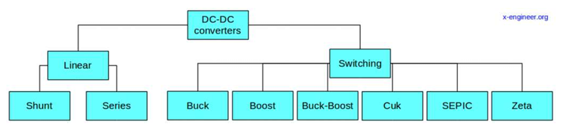

**Operating Principle:**

The Boost Converter uses inductor resistance to regulate current variations, ensuring that the output voltage surpasses the input voltage. When the circuit switch is closed, current flows through the inductor, which stores energy in a magnetic field. The switch operates as a short circuit, preventing current passage to the load. When the switch is opened, the circuit impedance increases, resulting in a current drop or voltage increase. The inductor functions as a voltage source, keeping current levels stable by increasing overall circuit voltage. Rapid cycling prevents the inductor from fully discharging. The load always gets a voltage greater than the input alone. When the switch is closed, the capacitor supplies energy, which is protected from over discharge by the blocking diode. This delivers energy to the capacitor. In contrast to a buck converter, the input current stays continuous.

**Voltage Source Converter:**

A Voltage Source Converter (VSC) or inverter converts direct current (DC) to alternating current (AC) while retaining unity power factor. It features two control loops: one to regulate the DC link voltage and another to manage the grid's active and reactive current components. In this project, the VSC takes a 500 V DC output from the boost converter and transforms it to 260 V AC.

**Component Ratings:**

* Solar Panel: The system consists of 66 strings of 5 SunPower SPR-305-WHT panels linked in series.
* DC-DC Converter: Operates at 5 kHz, accepts input at 273 V DC, and outputs at 500 V DC, always producing a greater output than the input.
* Inverter: Converts 500 V DC to 260 V AC with unity power factor.
* Harmonic Filtering: A 10-kVAR capacitor bank filters the harmonics generated by the Voltage Source Converter (VSC).

**Particle Swarm Optimization (PSO):**

Eberhart and Kennedy invented particle swarm optimization (PSO) in 1995, which is influenced by bird foraging behavior and fish schooling. It effectively solves search and optimization issues by keeping a swarm of particles that represent potential solutions. Each particle monitors its current position, velocity, and personal best position in the search space.

The PSO method adjusts particle locations and velocities using two essential positions: personal best (Pbest) and global best (Gbest). Pbest denotes the location with the greatest objective function value for each particle, whereas Gbest indicates the highest position value across all particles. The program employs these places to direct particle migration toward optimal solutions.

PSO's core design concept is inspired by evolutionary algorithms and artificial life theories. It uses a swarm mode to search huge solution areas and behaves cooperatively, akin to social animals. PSO adheres to the concepts of closeness, quality sensing, diversified response, stability, and adaptability, all of which are required for the development of swarm artificial life systems.

Current PSO research focuses on understanding the interaction processes, convergence qualities, and overall system development. Analyzing particle trajectories, convergence behavior, and system dynamics helps to improve PSO's performance for a variety of optimization tasks. The algorithm's stability and behavior under various settings are also being investigated.

**WORKING AND DESCRIPTION**

The solar panel's output is determined by temperature and sunshine intensity. In our project, we employ Maximum Power Point Tracking (MPPT) in conjunction with Particle Swarm Optimization (PSO) to maximize efficiency. Here is the process:

* The solar panel provides DC voltage of roughly 275V.
* The DC-DC boost converter boosts the voltage to 500V.
* The Voltage Source Converter (VSC) converts 500V DC to 260V AC while retaining unity power factor.
* A 10 KVAR capacitor filters out unwanted harmonics.

We tested under various sunshine situations. For example, at 1000 watts per square meter, we measured 100.5 kilowatts in 0.3 milliseconds. PSO outperformed other approaches in terms of consistent power generation.

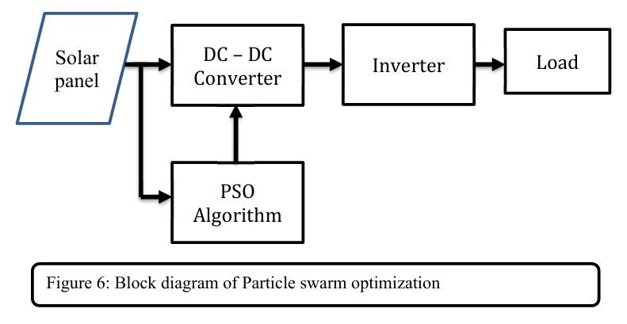

**MATLAB AND SIMULINK**

**MATLAB Introduction:**

MATLAB is a high-level programming language and environment that is used to create algorithms, analyze data, visualize results, and perform numerical calculations. It provides speedier answers to technical computer issues than standard languages such as C, C++, and FORTRAN.

MATLAB is widely used in a variety of applications, including signal processing, image processing, communications, control design, financial modeling, and computational research. It also includes supplementary toolkits for specific purposes.

It supports collaboration, interaction with other programs and languages, and the sharing of MATLAB algorithms and applications.

**SIMULINK Introduction:**

Simulink is a highly adaptable simulation and design tool for dynamic and embedded systems. It provides a graphical environment with customisable block libraries for creating and testing a wide range of systems, including communications, control, signal processing, and more. Additional add-ons broaden its capabilities to include new modeling domains and tools for design, implementation, and verification activities.

**SUB SYSTEMS**

Simulink enables complex systems to be represented by interconnected subsystems, all represented by a block diagram. Subsystems can be created using Simulink's Subsystem block and model manager, allowing for the creation of dynamic models with nested subsystems. Conditional subsystems can also be implemented, executing only when certain conditions are met.

**SIMULINK BLOCKS FOR THE SIMULATION:**

1. Three-phase source
2. in and out ports
3. subsystem
4. gain
5. scope
6. voltage and current measurements
7. distributed parameter line
8. Linear transformer

**System Data**

The system incorporates a PV array providing 100 kW at 1000 W/m² irradiance, a 5-kHz DC-DC boost converter raising voltage from 273 Vdc (PV voltage) to 500 Vdc, and a VSC converting 500 Vdc to 260 VAC while preserving a unity power factor. A 10-kvar capacitor bank filters VSC harmonics,

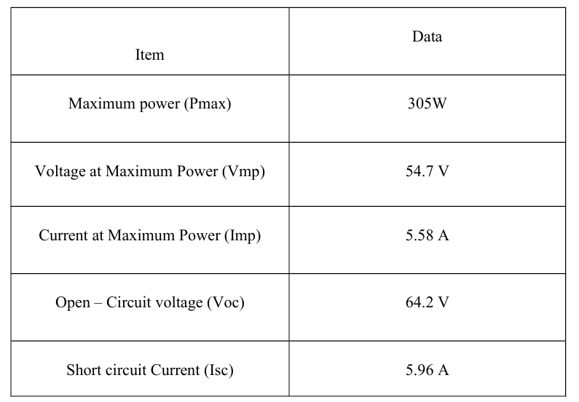

which are then routed through a three-phase 100-kVA 260V/25KV coupling transformer and into the utility grid. The PV array consists of 66 strings of 5 series-connected SunPower SPR-305-WHT modules, simulated with variable irradiance (kW/m²). The simulation in MATLAB/Simulink considers the array's I-V and P-V properties for various irradiance levels at a constant temperature of 25ºC. The MPPT controller employs the 'Perturb & Observe' approach and Incremental Conductance.

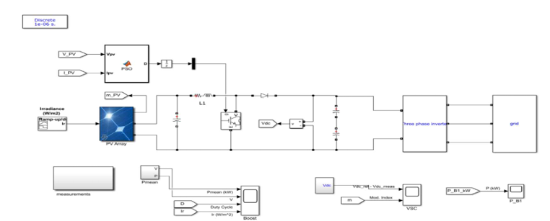

MATLAB connections for particle swarm optimization approach

**RESULTS**

**Simulation output results:**

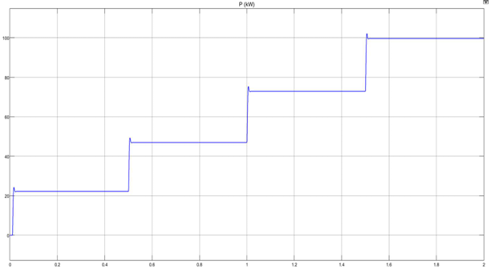 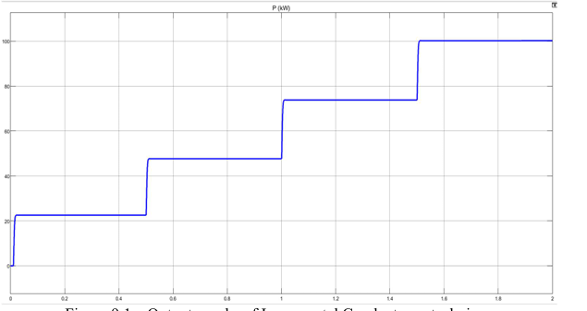

1. (2)

Output graphs of the perturbation and observation approach Output graphs of Incremental Conductance technique

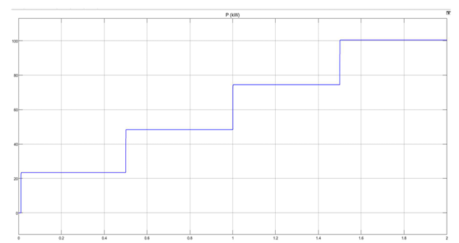Top of Form

**(3)** Output graphs of the particle swarm optimization approach

1. Result (1) The output of the Perturbation and Observation approach is displayed at different irradiances, with power (kW) plotted against time (ms). The graph depicts power gains at various irradiance levels.
2. Result (2) shows the output of the Incremental Conductance method at different irradiances, showing power (kW) vs time (ms). The graph depicts power increases at various irradiance levels.
3. Result (3) Shows the results of the Particle Swarm Optimization approach under various irradiance circumstances. The graph shows power (kW) versus time (ms), demonstrating power variations or increases as a function of irradiance levels.

**Comparison of P&O, IC, and P&O algorithms at different irradiances.**

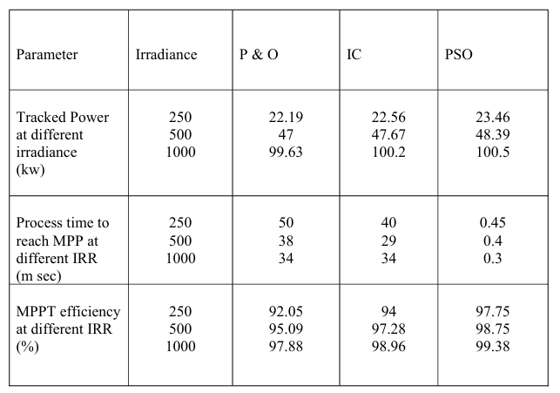

**Output graphs for Perturbation and observation technique:**

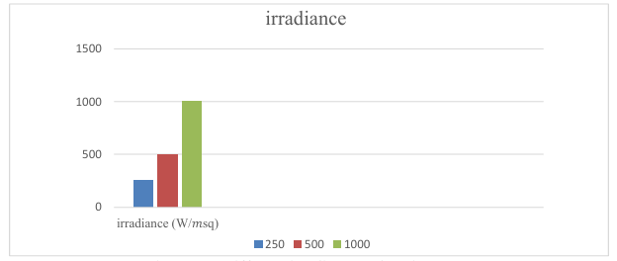 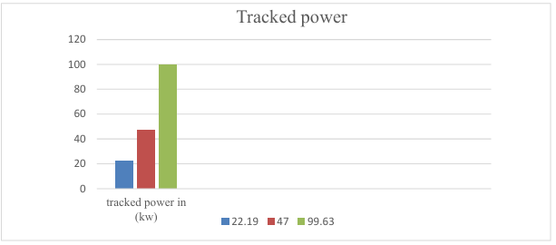

Different irradiation values in P and O. Tracked power under varied irradiance (P&O).

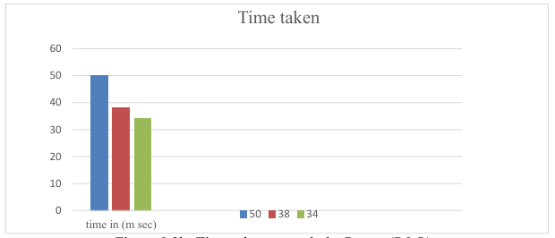

Time taken to monitor the power

**Output graphs for the particle swarm optimization technique:**

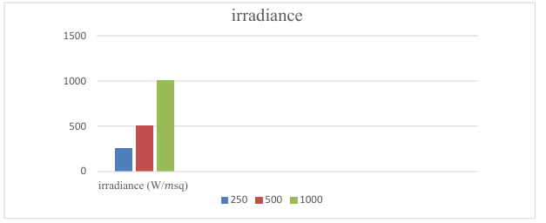 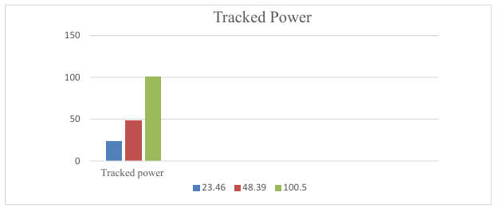

Different irradiation settings for the PSO method. Tracked power under varied irradiance (PSO).

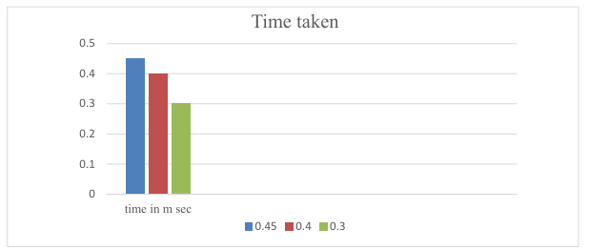

Time taken to monitor the power

**REFERENCES**

1. Eid A. Gouda is with the Department of Electrical Engineering, Faculty of Engineering, Mansoura University, 35516 Mansoura, Egypt (e-mail: eid.gouda@yahoo.fr)
2. Tianmeng Wei1 , Dongliang Liu1,2,a, and Chuanfeng Zhang1 1School of Automation Engineering, Hangzhou Dianzi University, Hangzhou, China 2Wolong ELectric Group Co.,Ltd, Shangyu, Chin
3. Vivek Nandan Lal, Student Member, IEEE Department of Electrical Engineering Indian Institute of Technology Kanpur, India vnlal@iitk.ac.in
4. M. Abdulkadir, A. H. M. Yatim, and S. T. Yusuf Department of Electrical Power Engineering, Faculty of Electrical Engineering, Universiti Teknologi Malaysia, 81310 Skudai, Johor Bahru, Malaysia.
5. Gazia Manzoor, Department of Electrical Engineering Chandigarh university Punjab, India (E-mail: [ergaziaqadri@gmail.com](mailto:ergaziaqadri@gmail.com).
6. The authors are with The College of Engineering, Design and Physical Sciences, Brunel University London, Uxbridge, Middlesex, UB8 3PH, U.K. (e-mail: Ramdan.Koad@Brunel.ac.uk ; azobaa@ieee.org; [aahmed@georgiasouthern.edu](mailto:aahmed@georgiasouthern.edu)).