**AUTOMATION OF PETROL BUNK MANAGEMENT USING PREPAID CARDS AND GSM COMMUNICATION**

**Dr .L .RAVI SRINIVAS**

V. ANITHANJALI DEVI | T. ANJAI SRI VENKAT | SK. LATHIF | V. J. S. SRINIVAS

**Abstract:**

At many gas stations today, there's a computer inside the pump that controls everything - from pumping fuel to showing the price. But, there's still a person who needs to collect money. Our idea is to get rid of this part by making the pump work all by itself. Every driver would have a special card, like a credit card, but for gas. You can put points on this card to pay for fuel. When you go to the pump, you swipe your card. The pump reads how much money is on your card and shows it on a screen. Then, you type in how much fuel you want, and the pump starts pumping. Once you've got what you need, it stops automatically. It can even send you a text message to let you know the transaction is complete. This system makes getting gas faster and means fewer people are needed to run the gas station.

**Introduction:**

In today's fast-paced world, running a successful gas station needs efficiency, safety, and making things easy for consumers. However, traditional methods of selling fuel and processing money can lead to delays and safety concerns. So we have a fresh idea: use high-tech solutions to improve gas station operations. To help things go more smoothly, we aim to use prepaid cards, SMS technologies, and smart control systems. With these modifications, we hope to speed up transactions, make things safer, and make consumers happy. Our approach revolves around a particular microprocessor known as the Arduino Uno. It regulates everything and communicates with all of the system's components to ensure that they function together seamlessly. We also utilize an expansion shield to add new features to the system is activated as necessary.

**The key components of our system are:**

* I2C LCD (liquid crystal display)
* GSM Module (such as SIM900A)
* Relay
* AC Pump

Our solution combines many components to make managing gas stations easier. Customers may easily pay for fuel using prepaid cards, which are similar to gift cards. Gas station workers can operate more efficiently and safely. We employ texting technology to complete transactions rapidly, and there is a screen that displays consumers what is going on while they pump gas.

**Problem Statement:**

Old-fashioned gas station systems often conduct transactions by hand, resulting in concerns such as delayed service, safety risks, and negative customer experiences. Some challenges gas station operators frequently face include:

* Manual Transaction Processing
* Security Risks
* Inconvenient Payment Methods.
* Lack of real-time monitoring
* limited transaction options.

Because of these issues, we really need a gas station system that operates autonomously. It should address these challenges, making things faster, safer, and better for customers.

**Project Objectives:**

The project's main purpose is to establish an autonomous gas station system. It will make use of prepaid cards and text messaging technologies. The goal is to achieve the following key things:

* Efficiency Enhancement
* Enhanced Security Measures
* Customer Convenience
* Real-time Monitoring and Reporting
* Integration with GSM Communication
* Scalability and adaptability
* Compliance and Standards Adherence: User training and support.

By achieving these objectives, the autonomous gas station system aims to totally transform how gas stations operate. It will make things faster, safer, and better for customers, resulting in higher overall business performance.

**Review of Existing Systems in Petroleum Bunk Management:**

Different gas station systems exist in a variety of forms and sizes, with some being more modern, expandable, and functional than others. Looking at these systems allows us to see what they excel at, where they could improve, and how they can grow. Here are a few varieties we frequently see.

* Manual System
* Semi-automated systems
* Integrated POS systems
* RFID-based systems
* Smart Fuel Dispensing System

Some systems utilize sensors, computer analysis, and smart learning algorithms to improve fuelling efficiency. They can identify issues, help things operate more smoothly, and save time. However, these sophisticated fuel systems are still relatively new, and they may require more testing to ensure that they perform as intended.

**Technologies utilized in similar projects:**

Other initiatives aiming to automate gas stations have employed various types of technology to accomplish their goals. They choose the technology that is most effective for their needs and makes things faster, safer, and better for their consumers. Some of the common technologies they employ include:

* Microcontrollers (e.g., Arduino, Raspberry Pi)
* RFID (Radio Frequency Identification)
* GSM (Global System for Mobile Communications)
* I2C LCD (Liquid Crystal Display)
* Relays
* Prepaid Card System
* Database Management System
* Web and Mobile Applications

Other initiatives have successfully used similar technology to automate gas station administration, improve operations, and make consumers happy. They select and combine the technology that best meets their needs, budget, and capabilities.

**Challenges and Limitations of Current Systems:**

* Manual Transaction Processing
* Security Risks
* Limited Payment Options inefficient inventory management
* Lack of real-time monitoring
* Technological Obsolescence
* Customer Experience
* Regulatory Compliance

**Block Diagram:**

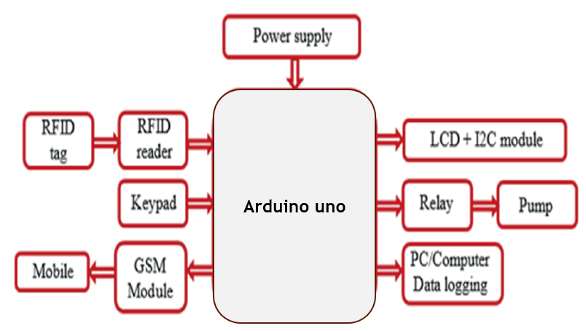

**Description of individual hardware components:**

**ARDUINO UNO**

The Arduino Uno is a popular tiny computer board that employs the ATmega328P processor. It is the main board in the Arduino system, and it is popular because it is simple to use and capable of a wide range of functions. Arduino Uno allows you to construct a wide range of electronics projects, from simple ones like generating a flashing light to more complex ones like developing smart gadgets that connect to the internet.

* Atmega328P Microcontroller
* Digital and Analog I/O Pins
* USB Interface
* Built-in LED and Reset Button
* Compatibility and expandability
* Open Source

Simply explained, the Arduino Uno is a versatile and simple little computer board that has enabled many people create amazing electronics projects. It's ideal for both beginners and specialists because it's simple to use, reasonably priced, and quite effective.

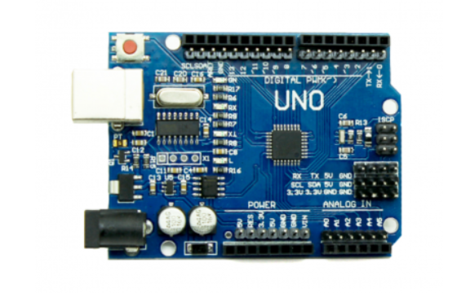

**RFID CARDS**

RFID cards are unique smart cards that have a chip and an antenna inside. They communicate with equipment known as RFID readers using radio waves, allowing them to send and receive data without touching anything. These cards are used in a variety of ways, including unlocking doors, paying for transportation, and keeping track of items at businesses. They are useful because they are quick, safe, and need no physical contact.

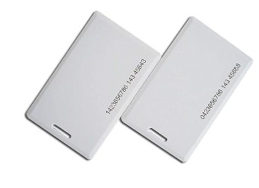

**RFID READER**

RFID readers are devices that communicate with RFID tags or cards without touching them. They use radio waves to communicate with RFID tags nearby. These readers are commonly used in systems for unlocking doors, keeping track of inventories, and coordinating transportation. They make it easier to discover and identify items or persons with tags.

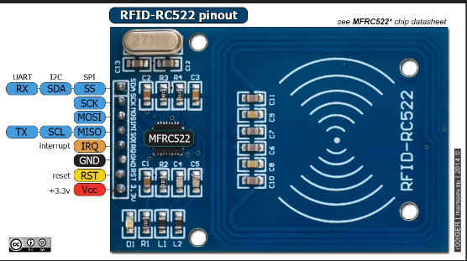

**GSM MODULE**

A GSM module is a tiny instrument that allows devices to communicate with mobile networks wirelessly. It includes a cellular modem, which allows devices to transmit and receive data, make calls, and send messages over cell phone networks. These modules are utilized in a variety of applications, including remote monitoring, IoT device operation, location security, vehicle tracking, mobile payment, environmental monitoring, and emergency message delivery. They are extremely significant because they keep objects connected in areas where traditional communication systems may not operate.

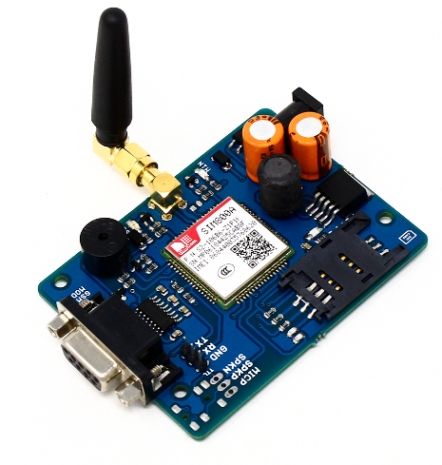

**RELY**

A relay functions similarly to an electrical switch. It is used to switch things on and off, such as lights or motors, by providing a tiny signal to the relay, which then allows a larger flow of electricity to power the device under control.

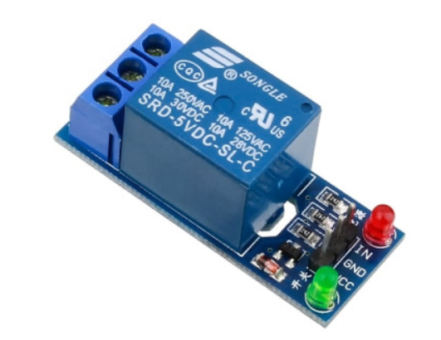

**LCD display with i2c**

An LCD with an I2C interface is a form of display screen that combines a standard LCD with a small adapter that connects it to a microcontroller, such as an Arduino. This configuration makes it easier to connect and control the LCD since it requires fewer cables. Instead of several cables, it just requires two: one for data transmission and one for timekeeping. It's useful for tasks that require a limited number of pins or when you want to keep things simple.

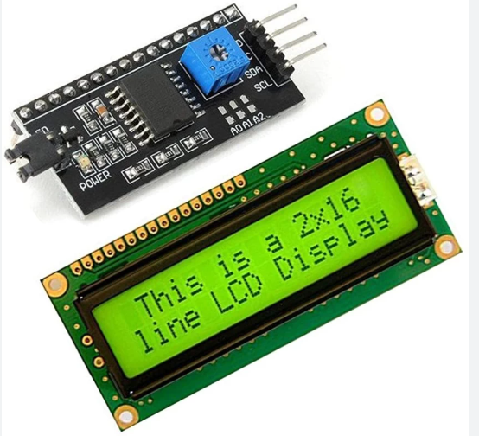

**AC PUMP**

An alternating current (AC) pump is powered by electricity that alternates directions. It is used for a variety of purposes, including moving water, managing building temperatures, doing factory duties, and watering crops on farms.

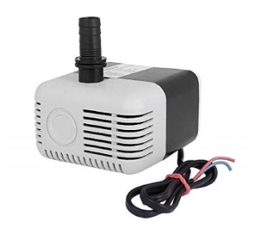

**ARDUINO IDE**

The Arduino IDE (Integrated Development Environment) is a computer application that allows you to write, compile, and submit code to Arduino microcontroller boards. It is meant to be simple to use, allowing both novices and specialists to work with it. Here are some crucial details concerning the Arduino IDE:

a) **Writing Area:** The Arduino IDE includes a location where you may create and edit code in the Arduino programming language. It helps by highlighting crucial areas, completing words for you, and providing additional coding tools.

b) **Coding and Sending:** Once you've written your code, you may prepare it for use in the Arduino IDE. It converts the code into a particular format that the Arduino board can comprehend, similar to translating it into a language that the board can read (known as firmware). The ready code may then be sent to the board via a USB cord.

**c) Board Selector:** The Arduino IDE includes a feature named Board Selector. It helps you decide the sort of Arduino board to use. This ensures that the IDE correctly sets up the code for your unique board.

d) **Library Selector:** Arduino libraries are pre-written pieces of code that offer additional functionality to your projects. The Arduino IDE's Library Selector allows you to conveniently search, add, and control these libraries.

e) **Message Viewer:** The Arduino IDE includes a tool called Message Viewer. It allows the Arduino board to communicate with a computer via USB connection. This is useful for troubleshooting difficulties in your projects by displaying messages and data from the Arduino board.

f) **Project Organizer:** In Arduino terminology, code files are referred to as "sketches." The Arduino IDE organizes these sketches into projects, making it easier to manage many code files and project settings all in one spot.

g**) Universal:** The Arduino IDE is compatible with Windows, macOS, and Linux computers. This means it may be used on a variety of machines, providing users with greater freedom.

h) **Useful Tool:** The Arduino IDE allows you to program Arduino boards for a variety of tasks, such as making lights flash or developing internet-connected smart gadgets. It's simple to use, and many people can help if you have any questions, making it ideal for both novices and specialists who work with Arduino.

**Programming language utilized:**

The Arduino IDE's language is based on Wiring, which is a simplified version of C and C++. It's designed to be simple for beginners to grasp while being powerful enough for experts. It contains fundamental principles, normal features found in C/C++, specific commands for communicating with hardware, extra code pieces for additional functions, and is compatible with all computer platforms.  
The Arduino IDE is compatible with Windows, macOS, and Linux, allowing you to utilize it on any computer. It's a useful tool for programming Arduino boards, allowing you to create a wide range of projects, from simple flashing lights to complex IoT devices. It's simple to use, and many of people can help if you get stuck, which is ideal for beginners.

**References**

1. Kulkarni amruta M. & Taware sachin S.―Embedded security system using RFID & GSM moduleǁ (international journal of computer technology & electronic engg.) Volume 2 (issue 1), page no. 164-168.
2. Christo ananth, g.Poncelina, M.Poolammal, S.Priyanka, M.Rakshana, praghash.K., “GSM based AMR”, international journal of advanced research in biology, ecology, science and technology (IJARBEST), volume 1,issue 4,july 2015, pp:26-28
3. kapse sagar sudhakar, abhale amol anil, kudake chetan ashok,shirsath shravan bhaskar. ―Automatic street light control systemǁ (international journal of emerging technology and advanced engineering) volume 3, issue 5, may 2013.
4. Aaron Smith, “Nearly half of American adults are Smartphone”, http://pewinternet.org/~/media/Files/Reports/2012/Smartph one%20ownership%202012.pdf, 2012.
5. Jithin V mohan, Minu Balan, Sharoon Thomas, and Lynn Mariette Mendonza, “Fleet Management System”, B.Tech Degree Thesis, College Of Engineering, Munnar, Idukki, Kerala, India, 2009.
6. Mohammad A. Al-Khedher, “Hybrid GPS-GSM Localization of Automobile Tracking System”, International Journal of Computer Science & Information Technology (IJCSIT) Vol 3, No 6, Dec 2011.
7. Saed Tarapiah, Shadi Atalla, and Rajaa AbuHania, "Smart On-Board Transportation Management System Using GPS/GSM/GPRS Technologies to Reduce Traffic Violation in Developing Countries", International Journal of Digital Information and Wireless Communications (IJDIWC) 3(4): 96-105, the Society of Digital Information and Wireless Communications, 2013 (ISSN: 2225-658X)