**IOT BASED FAULT DETECTION OF UNDERGROUND CABLES THROUGH MCU MODULE**

**R. Sujatha1, V. Harshavardhana Achari2, J. Sreeram3, G. Rajasekhar4,**

**B. Suresh5, K. Vijay Kumar6**

1Assistant Professor, Department of EEE, Santhiram Engineering College, Nandyal, A.P,

2,3,4,5,6UG Student Scholar, Department of EEE, Santhiram Engineering College, Nandyal, A.P

[sujatha.eee@srecnandyal.edu.in](mailto:sujatha.eee@srecnandyal.edu.in), [vadlaharshavardhanachari7@gmail.com](mailto:vadlaharshavardhanachari7@gmail.com)

**ABSTRACT**

In the downtowns, underground cables are utilized or maybe than of overhead transmission lines. For the most part soil cables are utilized in outside nations for control conveyance, at whatever point a blame happens in soil cables. It is difficult to carry out the particular spot of the blame. As India gotten to be unmistakable as a movement nation, civilized field is moreover boost day by day. The underground cables are beat beneath alike circumstances its utilizations are moreover growing since of its clear focal points such as lower transmission misfortunes, lower upkeep taken a toll and they are less helpless to the impacts of extreme climate. But it is having few issues as well like exorbitant establishment and discovery of blame region. As it is not clear it moves extreme to identify compel area of the blame. In this proposed work we are attempting to amend this issue by proposing a strategy which is great sufficient to the computerized world. In this paper we have utilized IOT based strategy with Google database for the blame location with the offer assistance of Hub MCU Wi-Fi Module. It is completely based on IOT. The precision and productivity of our proposed strategy is more as compare to the other procedures.

**Keyword:** ESP32, LEDs, Sensors, IOT, Blynk Application.

**1.INTRODUCTION**

Underground cables are imperative for control transmission and dissemination. In any case, flaws in these cables can be troublesome to find due to their buried nature. Conventional strategies include physically burrowing up areas of cable, which is time-consuming, costly, and disturbs benefit [1].

Control supply systems are developing ceaselessly and their unwavering quality getting more vital than ever. The complexity of the entire organize comprises various components that can come up short and hinder the control supply for conclusion client. For most of the around the world worked voltage and medium voltage dispersion lines, underground cables have been utilized for numerous decades. Underground tall voltage cables are utilized more and more since they are not affected by climate conditions, overwhelming rain, storm, snow and contamination [1]. Indeed, in spite of the fact that the Cable fabricating innovation is moving forward consistently; there are still impacts which may cause cable to come up short amid test and operation [8]. A cable in great condition and introduced accurately can final a lifetime of approximately 30 a long time. How ever cables can be effortlessly harmed by erroneous establishment or ineffectively executed jointing, whereas consequent third-party harm by respectful works such as trenching or check edging. The transmission line and system foundation expect a key portion in sharing faultlessly with clients. Investigate has appeared that 80% of client back interferer is since of organization disillusionments. It is fundamental to accumulate data on the transmission line to work on the constancy of the circulation. Directly, the movement system consolidates systems like the utilization and action of geographic information systems, meter substitution, taking care of, and examining. An component of this thought is that control workers or observe authorities can alter estimations like how much current gushing or any degree of voltage. The partition from control to buyers is divided into bunches. Here, the duty can be a centre or a gather head, unexpected upon the control utilized. Electrical cables are vital for the control system and have a tall bet of being gone after by the climate. Line imperfections brought around by harms like lightning, wind, falling vegetables, fog, and salt can't be obliged by individuals. A confirmation system is presented in the transmission system, which 2 illustrates an issue that separates the settled portion from the leftover portion of the system, which is hurt and hurting the equipment. Circulation and movement pipelines are the foremost interface that prompts the principal control supply line to conclusion clients. Transmission lines relate the station and the cargo put. Control plants are found in overabundance of 100 miles from the centre, so there is a tall probability that they will appear up on the transmission line. They should to be isolated rapidly as issues might exasperate the control system. Harm examination is a critical issue in quickly wiping out inadequacies in the movement of the control system, in reestablishing control quickly, or conceivably stopping it. The system subsequently sends any information to the dashboard [6]. It screens estimations like voltage and current at the same time and sends information electronically. The principal thought is to outfit clients with a reliable load of control; Build up quick and strong advancement in a reliable way, in this way working on the offer assistance of control buyers. It recognizes blemishes in the domestic of electrical and observe staff. When a botch has happened, the botch is made all the more absolutely to keep the cargo from being taken [8]. The primary work of the electrical transmission and conveyance frameworks is to transmit electrical vitality from the era unit to the buyers. By and large, when blame happens on transmission lines, recognizing blame is fundamental for electrical framework in arrange to clear blame some time recently it increments, if it does not clear the blame at that point, it may harm to the electrical framework. In spite of the fact that the underground cable framework gives higher unwavering quality than the overhead line framework, it is difficult to distinguish the blame area. The request for solid benefit has driven to the improvement of strategy of finding issues [9]. The cable issues are harm due the cable which influences a resistance in cable. If permitted to continue, this can lead to a voltage breakdown. As the cable blame location is the prepare of finding the occasional blame, a modified Hub MCU will show the exact computerized esteem of arrangement resistance voltage drop changed over by ADC in unit separate from the base station to blame area.

**2. LITERATURE SURVEY**

**IOT Based Display of Underground Cable Fault Distance Over Internet System:** Underground cables are inclined to a wide assortment of flaws due to underground conditions, wear and tear, rodents etc. Diagnosing blame source is troublesome and entire cable ought to be taken out from the ground to check and settle deficiencies. The venture work is intended to distinguish the area of blame in underground cable lines from the base station in km utilizing a PIC16F877A controller. To find a blame in the cable, the cable must be tried for deficiencies [12]. This model employments the straightforward concept of Ohms law. The current would change depending upon the length of blame of the cable. In the urban areas, the electrical cables run in underground instep of overhead lines. At whatever point the fault occurs in underground cable it is troublesome to identify the correct area of the blame for process of repairing that specific cable. The proposed framework finds the exact location of the blame. The model is modelled with a set of resistors representing cable length in km and blame creation is made by a set of switches at each known distance to cross check the exactness of the same. In case of blame, the voltage across series resistors changes appropriately, which is at that point encouraged to an ADC to create precise digital information to a modified PIC IC that assist shows blame area in distance [12]. The blame happening separate, stage, and time is shown on a 16X2 LCD interfaced with the microcontroller. IoT is utilized to show the data over Web utilizing the Wi-Fi module ESP8266.A webpage is made utilizing HTML coding and the information approximately event of blame is shown in a webpage.

**IOT Based Underground Cable Fault Detector:** Underground cable framework is a common hone taken after in urban regions. Whereas a fault happens due to numerous reasons in the cable, at a time of expelling or repairing process, there is trouble in finding the correct area of the fault. The system proposed in this framework is utilized to discover out the correct area of the blame and display it to the devoted site over web utilizing Wi-Fi module, giving earlier information to the authorized individual at another conclusion. Botch acknowledgment has been a significant objective for system engineers in both transmission and movement. Know the beginnings of mix-ups and troublesome work; Quick botch acknowledgment helps with safeguarding the fabric from hurt some time recently it is hurt. Adjacent components offer assistance to dispense with goofs in human help and to figure out where regular mistakes happen, thus reducing botch rates and shortening nourish times [1]. The system utilizes a microcontroller board to recognize transmission line blames and sends one to the Middle for watching utilizing an IoT contraption.

**Under Ground Cable Fault Detection Over IOT:** Underground cable framework is a common hone taken after in urban zones. Whereas a blame happens due to numerous reasons in the cable, at a time of expelling or repairing handle, there is trouble in finding the correct area of the blame. The framework proposed in this paper is utilized to discover out the correct area of the blame and show it to the devoted site over web utilizing wi-fi module, giving earlier data to the authorized individual at another conclusion [13].

**IOT Based Underground Cable Line Fault Detection:** IOT based underground cable line fault detection framework is supportive for discover out deficiencies and its location in exceptionally simple way. Underground cables have been widely used with the advancement of control framework grid. Underground cables are inclined to a wide assortment of flaws due to underground conditions, wear and tear, rodents. Detecting blame source is troublesome since whole line is to be dug in arrange to check blame at cable line. The repairmen know exactly which portion has blame and as it were that zone is to be burrowed to detect the blame source. In this way it spares a parcel of time, cash and allows to benefit underground cable lines quicker. We utilize IOT technology that permits the specialists to screen and check faults over web. The framework recognizes blame with the offer assistance of potential divider arrange laid over the cable. When a fault gets made in a cable line, a particular voltage gets generated as per the resistors arrange combination. This voltage is sensed by the microcontroller and is overhauled to the user. The data passed on to the client is the remove to which that voltage compares to. The microcontroller detects the blame cable line information and shows this information over LCD show, it exchanges this information over web to display online. Thing Speak to create the online framework that links with the framework to show the cable issues online [1].

**Existing System**

An assortment of innovations and tests are as of now accessible to assess underground cables but there is regularly small connection between the symptomatic comes about and the real degradation. The disappointments of underground control conveyance cables speak to a genuine risk to the unwavering quality of control foundation. Substitution must be done specifically since cable substitution is costly, being assessed at no less than hundred thousand dollars per kilometre of cable in region.

**Proposed System**

This framework speaks to that to compute the remove of the underground and overhead transmission cable from blame area to the base station utilizing Arduino. In this framework, a keen Innovation based blame location and area framework was utilized to enough and precisely demonstrate and find the correct spot where blame had happened [9]. This will guarantee a shorter reaction time for specialized team to correct these issues and in this way offer assistance spare transformers and other electrical gear from harm and fiascos. For underground cables (UC) blame discovery, we utilized Exchanging unit at each and each 10km of cable line [14]. If any blame accrues, we can effortlessly find the cable blame. It’s a troublesome errand to distinguish the Brief Circuit issues in underground cables in a fitting stage. By utilizing this framework, we can discover out correct blame area in specific stage of wire. Once deficiencies happen in the cable, with the offer assistance of small-scale controller and the show unit shows the correct blame area that happens in fitting stage of the cable to a devoted site with the offer assistance of IOT. If the blame happens at that point the individual loads will turn off, the reason is for ensuring it from harm.

**MICRO**

**CONTROLLER**

**LCD**

**LEDs**

**BUZZER**

**SWITCHES**

SS

**IOT**

**Figure 1: Block Diagram**

**LEDs (Light-Emitting Diodes):** The tall proficiency and directional nature of LEDs makes them perfect for numerous mechanical employments. LEDs are progressively common in road lights, stopping carport lighting, walkway and other open air region lighting, refrigerated case lighting, measured lighting, and errand lighting.

In the least difficult terms, a light-emitting diode (Driven) is a semiconductor gadget that transmits light when an electric current is passed through it. Light is created when the particles that carry the current (known as electrons and gaps) combine together inside the semiconductor fabric.

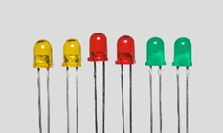

**Figure 2: Light-Emitting Diodes**

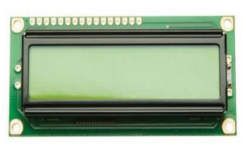**LCD:**After the show is set up and connected accurately, you can utilize commands like "clear show," "move cursor," and "type in character" to transmit content and other data to the show. More complex visualisations are too conceivable since the screen may be set to show user-defined characters or visuals.

**Figure 3: 16 X2 LCD Display**

**Buzzer:**A buzzer is an electronic signalling gadget that regularly produces a buzzing or beeping sound. It comprises of an electromechanical component called a transducer, which changes over electrical vitality into sound waves. When an electrical current passes through the buzzer, it causes the transducer to vibrate, creating the capable of being heard sound.

Buzzers can shift in plan and sound yield, with diverse sorts creating diverse tones, frequencies, and volumes. They can be dynamic (requiring a ceaseless electrical flag to create sound) or inactive (creating sound when a beat of power is connected). Generally, buzzers play a significant part in giving sound-related criticism and signalling in a wide extend of applications.

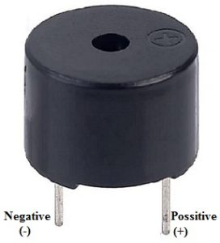

**Figure 4: Buzzer**

**Smoke Sensor:** A smoke sensor, moreover known as a smoke locator or smoke alert, is a gadget planned to distinguish smoke and caution tenants of a building to the nearness of a potential fire. It's a basic component of fire location and alert frameworks, giving early caution to offer assistance avoid property harm and spare lives. It's critical to note that smoke sensors are portion of a broader fire discovery and caution framework, which may incorporate extra components such as warm finders, control boards, and notice gadgets (such as strobe lights and voice cautions). These frameworks are ordinarily planned to comply with nearby fire security codes and directions.

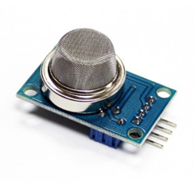

**Figure 5: Smoke Sensor**

**Fire Sensor:**A fire sensor, moreover known as a fire locator or fire caution sensor, is a gadget outlined to distinguish the nearness of fire or smoke and give an early caution to tenants of a building. Fire sensors are significant components of fire discovery and alert frameworks, making a difference to secure lives and property by cautioning individuals to potential fire hazards. Fire sensors are basic security gadgets in private, commercial, and mechanical settings, making a difference to distinguish fires at their most punctual stages and give convenient notices to tenants, permitting them to empty securely and minimizing harm to property.

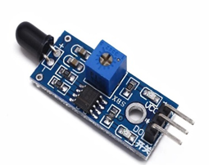

**Figure 6: Fire Sensor**

**3.FUNCTIONAL BLOCKS OF PROPOSED SYSTEM**

The ESP32 supports three types of I/O modes with each GPIO Pin: Digital, Analog and Internal Sensors.

**Analog:** Used to send/receive analog data using the following functions:

# examples based on Arduino IDE

analogRead();

analogWrite();

Digital: Used to send/receive digital data using the following functions:

# examples based on Arduino IDE

digitalRead();

digitalWrite();

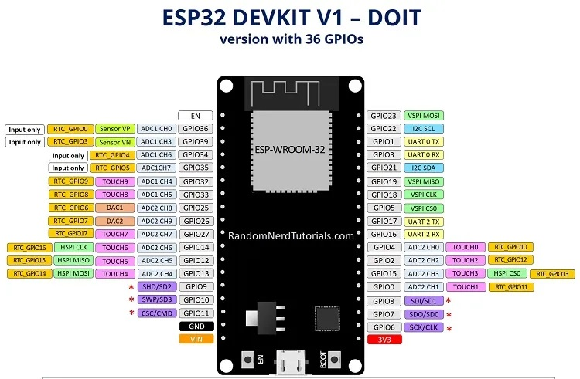

**Figure 7: Esp32 Board Guide**

The ESP32 Dev Kit C is a popular development board for the ESP32 microcontroller. Here's a breakdown of its key pin functionalities:

**Power:** Micro-USB: Gives control and programming interface through USB connection.

5V & 3.3V: These pins permit outside control supply. The onboard controller changes over 5V to 3.3V if needed.

Important Note: The ESP32 chip works at 3.3V. Never apply voltages surpassing 3.3V to any stick, as it can harm the chip.

**General Purpose Input/Output (GPIO) Pins:** 39 advanced pins: Out of these, 34 can be utilized as GPIOs for different functionalities like advanced input, yield, PWM (Beat Width Balance), SPI (Serial Fringe Interface), I2C (Inter-Integrated Circuit), and ADC (Analog-to-Digital Converter).

**D0 - D3, CMD, CLK:** These pins are saved for inside communication between the ESP32 and SPI streak memory. Maintain a strategic distance from utilizing them for outside connections.

**GPIO16 & GPIO17:** Accessibility depends on the particular ESP32 module on the board. They might be saved for inner utilize on ESP32-WROVER modules but are usable for common purposes on ESP32-WROOM and ESP32-SOLO-1 modules.

**Other Notable Pins:** Strapping pins (GPIO 0, 2, 4, 5, 12, 15) These pins are utilized to put the ESP32 into diverse modes like boot or blazing mode. The Dev Pack C ordinarily sets these pins naturally amid operation.

**4.HARDWARE EXPERIMENTAL RESULT**

**Under Normal Condition**

The figure 8 how’s is under normal condition. The fault will be occurring the buzzer is alert the sound and also displayed on the screen. In these conditions does not gives any faults so all the LEDs are off positions and also Buzzer is does not produced the beep sound of this conditions.

Here are two interfacing tabs that show on the screen of the smartphone. It shown blame conditions of cables and smoke rating and fire rating to alarm to casualty in a Blynk app.

**Cable 1 Fault Condition**

In the below figure 10 is fault occur the cable1. To give the fault by using the push button switch. The fault will be Occurs the cable1, the first LED is indicating the red colour light signal and also the Buzzer is produced the beep sound. The Remaining two cables are not occurring the faults. The cable 2 and cable 3 are normal condition. So, the remaining two LEDs are off position and the fault cable is displayed on the LCD screen. In LCD screen shows the alert signal and also shows the Blynk app.

**Cable 2 Fault Condition**

In the below figure 11 is fault occur the cable2. To give the fault by using the push button switch. The fault will be occurring the cable2, the second LED is indicating the red colour light signal and also the Buzzer is produced the beep sound. The Remaining two cables are not occurring the faults. The cable 1 and cable 3 are normal condition. So, the remaining two LEDs are off position and the fault cable is displayed on the LCD screen. In LCD screen shows the alert signal and also shows the Blynk app.

**Cable 3 Fault Condition**

In the below figure 12 is fault occur the cable3. To give the fault by using the push button switch. The fault will be occurring the cable3, the third LED is indicating the red colour light signal and also the Buzzer is produced the beep sound. The Remaining two cables are not occurring the faults. The cable 1 and cable 2 are normal condition. So, the remaining two LEDs are off position and the fault cable is displayed on the LCD screen. In LCD screen shows the alert signal and also shows the Blynk app.

**Cable 1 and Cable 2 Fault Condition**

In the below figure 13 is fault occur the cable1 and cable2. To give the fault by using the push button switches. The fault will be occurring the cable1 and cable2, the first and second LEDs is indicating the red colour light signals and also the Buzzer is produced the beep sound. The Remaining one cable is not occurring the fault. The cable3 is normal condition. So, the remaining one LED is off position and the fault cable is displayed on the LCD screen. In LCD screen shows the alert signal and also shows the Blynk app.

**Cable 1 and Cable 3 Fault Condition**

In the below figure 14 is fault occur the cable1 and cable3. To give the fault by using the push button switches. The fault will be occurring the cable1 and cable3, the first and third LEDs is indicating the red colour light signals and also the Buzzer is produced the beep sound. The Remaining one cable is not occurring the fault. The cable2 is normal condition. So, the remaining one LED is off position and the fault cable is displayed on the LCD screen. In LCD screen shows the alert signal and also shows the Blynk app.

**Cable 2 and Cable 3 Fault Condition**

In the below figure 15 is fault occur the cable2 and cable3. To give the fault by using the push button switches. The fault will be occurring the cable2 and cable3, the second and third LEDs is indicating the red colour light signals and also the Buzzer is produced the beep sound. The Remaining one cable is not occurring the fault. The cable1 is normal condition. So, the remaining one LED is off position and the fault cables is displayed on the LCD screen. In LCD screen shows the alert signal and also shows the Blynk app.

**Three Cables Are Faults at A Time**

In the below figure 9 is faults occur the Three cables at a time. To give the faults by using the push button switches. The fault will be occurring the three cables, the three LED is indicate the red colour light signals and also the Buzzer is produced the beep sound. The faults cable is displayed on the LCD screen. In LCD screen shows the alert signals and also shows the Blynk app.

****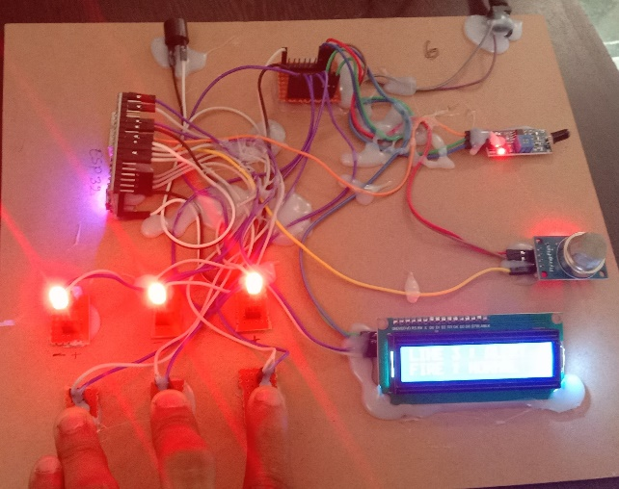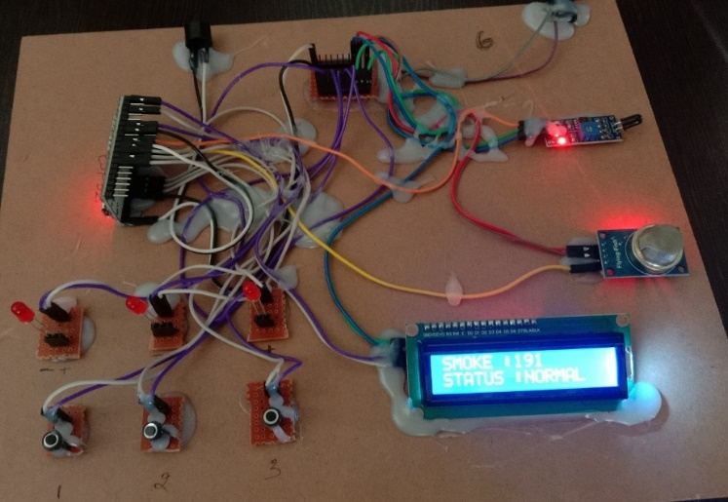

****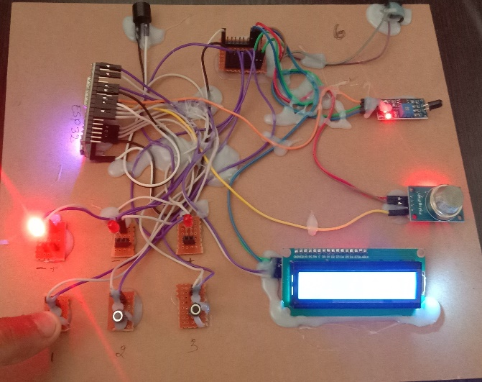 **Figure 8: Under normal condition Figure 9: *Three Cables Are Faults at A Time***

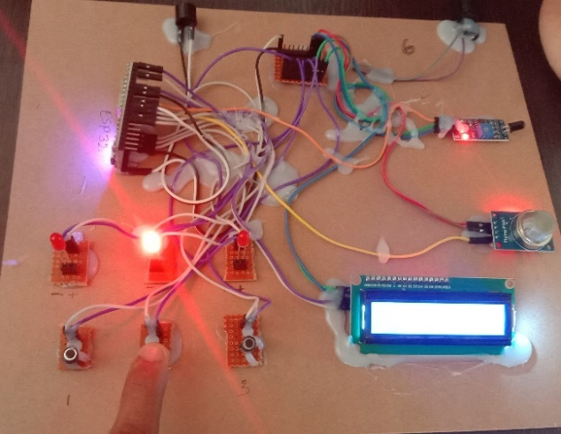

**Figure 10: Cable 1 Fault Condition Figure 11: Cable 2 Fault Condition**

****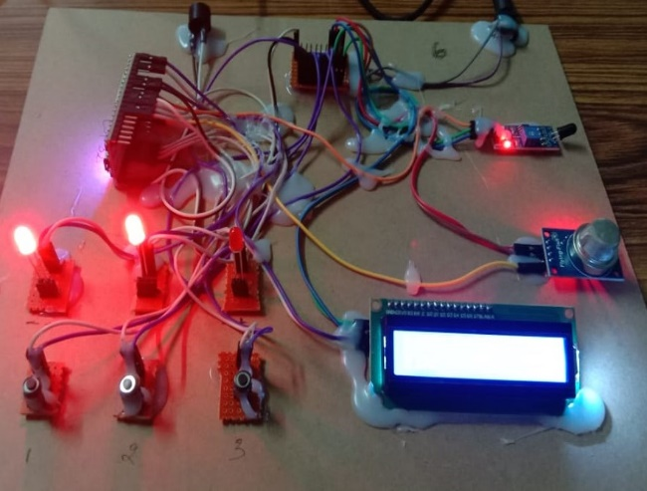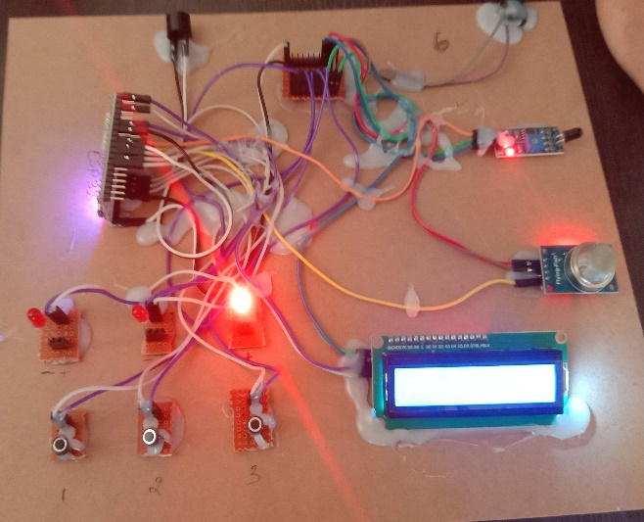

**Figure 12: Cable 3 Fault Condition Figure 13: Cable 1 and Cable 2 Fault Condition**

******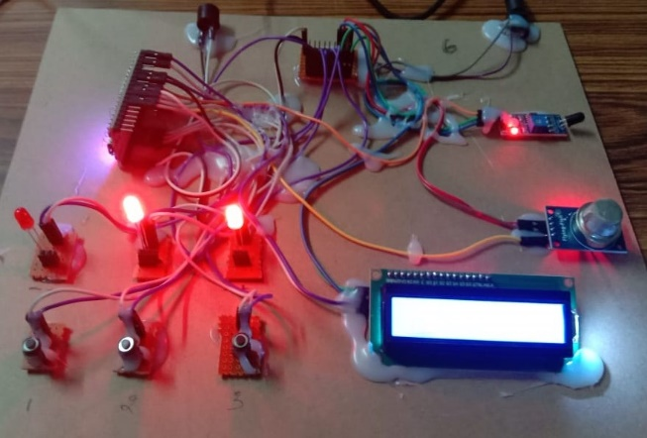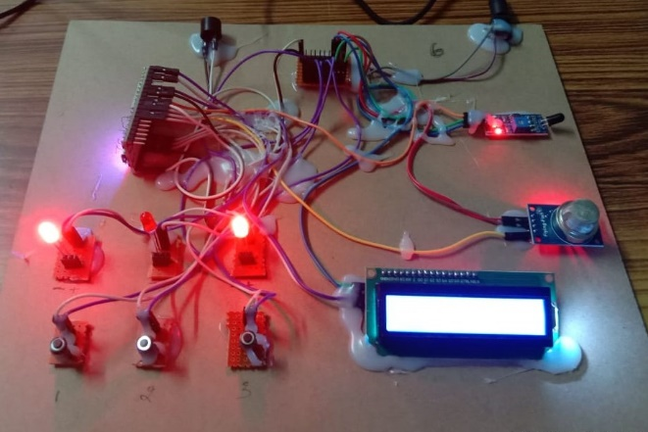**

**Figure 14: Cable 1 and Cable 3 Fault Condition Figure 15: Cable 2 and Cable 3 Fault Condition**

**5. BLYNK APPLICATION**

Firstly, introduce or download Blynk apps for Android or iOS at the Google Play Store or App Store. To interface with Arduino, the client needs to introduce the Blynk library in the library envelope of the Arduino IDE. After wrapping up the establishment, open the apps on the smartphone and make a unused account to login for a modern venture. For this venture, the equipment chosen is a Hub MCU, and the communication sort is WiFi ESP8266. There are five modes of show on the screen of the LCD, which too reflects on the screen of the keen phone utilizing the Blynk application. On the screen, it shown the blame conditions of the cables, and shown the fire and smoke location evaluations, to alarm the individual in charge. If cable1 is happen the blame, to appears the cable1 flag is shows on the Blynk app. If cable2 is happen the blame, to appears the cable2 flag is shows on the Blynk app. If cable3 is happen the blame, to appears the cable3 flag is demonstrates on the Blynk app. And too demonstrates the fire rating and smoke rating on the Blynk app.

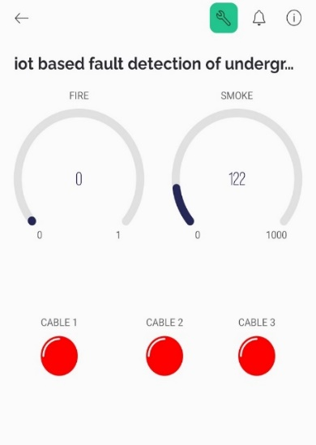

**Figure 16: Using Blynk App**

**6.CONCLUSION:**

In this chapter, we characterized IoT and distinguished common IoT layers. Moreover, we talked about a reference middleware engineering for IoT-based frameworks. This engineering has been proposed by Bandyopadhyay, S. et. al based on a think about on the existing middleware systems for IoT-based frameworks. To make and carry out assignment the officials in distinctive zones of the transport arrange by gathering sound information in the flexible and present-day businesses. The inspiration behind the thought is to donate a relentless movement of control from buyers to customers; Clearly and expeditiously cultivate steadfastness and recognize the hurt to the control, so do not cultivate the offer assistance for the control clients. Our movements might reflect the inadequate of the dam and the observe constrain. The inadequacy spot can be doubtlessly and accurately recognized after the issue happens, thwarting line theft in the load line. This article presents a way better approach for recognizing botches and appearing how they work. This article outlines the most perfect ways to work on web-based execution. The proposed program was broadly attempted utilizing independent generation models and fulfilled promising results. The impacts of different systems and necessities are inspected. Wide examination has appeared that pipelines can isolated between different sorts of inadequacies beneficially and quickly.

**7. REFERENCES**

[1] Ansa Sebastian, Anu Jacob, Angel Wilson, Ann Rija Paul J “IOT Based Underground Cable Line Fault Detection” Volume: 05 Issue: 03 | Mar-2018

[2] Dr.M. V. Subramanyam et al ‘Multiple Sensor Data Fusion Based Top-Down Embedded System for Automatic Plant Pot Watering Journal of Algebraic Statistics, e-ISSN: 1309-3452, Marmara University Istanbul University, Istanbul, Vol. 13, No. 1,PP: 884 – 891,2022, No.3.

[3] V.Jyothi, Dr.M. V. Subramanyam ―An Enhanced technique to improve the Network Lifetime of Cognitive Sensor Networks‘, International Journal of Wireless Personal Communications‘ pp. 12757 – 12763, May-2021 DOIhttps://doi.org/10.1007/s11277-021-08575-0 [SCI].

[4] V.Jyothi, Dr.M. V. Subramanyam ―An energy efficient fuzzy clustering-based congestion controlalgorithm for cognitive radio sensor networks‘, Wireless Networksl. Oct-2022. https://doi.org/10.1007/s11276-022-03143-1. SCI1.

[5] M.Yerri Veeresh, Dr.V.Nagabhaskar Reddy, Dr.R.Kiranmayi, Modeling and Analysis of Time Response Parameters of a PMSM-Based Electric Vehicle with PI and PID Controllers, in Engineering, Technology & Applied Science Research (Etasr), Issn: 2241-4487, Vol. 12, Issue. 6, December 2022, Pp.No. 9737-9741.

[6] V Ramanjaneyulu "Dtmf Based Irrigation Water Pump Control System" In International Journal Of Research Available At Https://Edupediapublications.Org/Journals P-Issn: 2348-6848 E-Issn: 2348-795x Volume 05 Issue 12 April 2018.

[7] R. Sujatha And N. V. S. Prasad, “Mppt Algorithms In Photovoltaics And Study Of Inc Methods By Using Matlab,” Vol. 5, No. 11, Pp. 23–29, 2018.

[8] S. Reddypogu, “Common Mode Voltage Reduction With Varying Dc Link Voltage In Indirect Matrix Converter By,” Vol. 06, No. 1, Pp. 320–328, 2019.

[9] Frolec, J. and Husak, M. (2010) ‘Wireless sensor system for overhead line ampacity monitoring’, in Proc. 2010 8th International Conference on Advanced Semiconductor Devices & Microsystems, Smolenice, Slovakia.

[10] Gungor, V. C. and Hancke, G. P. (2009) ‘Industrial wireless sensor networks: challenges, design principles, and technical approaches’, IEEE Trans. on Industrial Electronics, vol. 56, no. 10.

[11] Gungor, V. C., Lu, B. and Hancke, G. P. (2010) ‘Opportunities and challenges of wireless sensor networks in smart grid’, IEEE Trans. on Industrial Electronics, vol. 57, no. 10, pp. 3557–3564.

[12] Mr. N. Sampathraja,Dr. L. Ashok Kumar, Ms. V. Kirubalakshmi And Ms. C. Muthumaniyarasi, Mr. K. Vishnu Murthy “Iot Based Display Of Underground Cable Fault Distance Over Internet System”. Volume 8, Issue 8, August 2017, pp. 1299–1309, Article ID: IJMET_08_08_132

[13] Durgesh Pathak, Mithil Rathod, Sandeep Vishwakarma, Harindar Maurya, Mahalaxmi Palinje . “Under Ground Cable Fault Detection Over IOT” ISSN: 2278-0181 Published by, www.ijert.org ICIATE - 2017

[14] Ajaei, F. B., Sanaye-Pasand, M., Davarpanah, M., RezaeiZare, A. and Iravani, R. (2011) ‘Compensation of the current-transformer saturation effects for digital relays’, IEEE Trans. on Power Delivery, vol. 26, no. 4, pp. 2531– 2540.