FAKE PRODUCT DETECTION USING BLOCKCHAIN TECHNOLOGY

1Prasad Mane , 2Shivani Mane, 3Prof. Sayali Karmode

1Student, 2Student, 3Assosciate Professor

Department of Information Technology and Engineering

MGM Collage of Engineering and Technology, Navi Mumbai ,Maharashtra

***Abstract:***The manufacturing as well as marketing of counterfeit or duplicate products and goods leads to consequential financial, health and safety threat to end users. It also has adverse effect on the economic growth of original manufacturers and businesses through revenue loss, product defamation, downtime, replacement expenses, forcing many brands to spend money on fighting counterfeits, trust among business partners can also be at risk, stealing sales etc. To overcome and stop these crucial effects of counterfeiting, a blockchain based system is used in identification of original products and also detects duplicate products to ensure the identification of original goods. In this project, with massive emerging trends in wireless technology, QR (Quick Response) codes and barcodes provides a technique to cut down the practice of counterfeiting the products. The fake products are identified using camera scanner, where QR or barcode of the product or goods is linked to a blockchain to store product details and guaranteed unique code of each product stored as blocks in the database. If the code in product matches, the notification will be sent to the customer indicating the authenticity of the product and else if it does not match the code in database, a notification will be sent to customer indicating that product is fake or counterfeited and notification is also sent to manufacturer about the place of purchase if customer accepts the request made by the application. This approach to cut down counterfeit ensures that consumers won’t completely rely on merchants to determine if products are original or forged.

***Index Terms* - Blockchain, smart contracts,** **QR (Quick Response) code, anti- counterfeit.**

**I.INTRODUCTION**

Blockchain is a type of shared database that differs from a typical database in the waste in formation; blockchains store data in blocks linked together via cryptography .Different types of information can be stored on a blockchain, but the most common use for transactions has been as a ledger. In Bitcoin’s case, blockchain is decentralized so that no single person or group has control—instead, all users collectively retain control .Decentralized blockchains are immutable, which means that the data entered is irreversible. For Bitcoin, transactions are permanently recorded and viewable to anyone .

The global development of the product or branded product always comes with risk factors such as counterfeiting and duplication of product which in turn can affect the company name, reputation, revenue and customer satisfaction. The trading and marketing of counterfeit products is growing at high rates. It affects adversely on the sales, reputation, and profits of the companies and also do poses a fatal threat for the unsuspecting buyers. In order to ensure the identification and traceability of fake goods or products throughout the supply chain and to overcome this phenomenon, a fully functional blockchain system is proposed. Companies need to pay very low transaction fees and they don’t need to worry about the possibility of delivering counterfeit products to end-users. Because of fake products builder, original manufacturers face the biggest problems and huge losses in sense of brand damage as well as revenue loss. To find the originality of the product a functional blockchain technology can be used. Blockchain is a chained arrangement of recorded information that makes it difficult or impossible to modify or hack the framework. Once the product is stored on the network, hash code is generated for that product and it is possible to maintain all transaction records of the product as well as its current owner as a chain created for that product transactions. It will store all the transaction records as blocks in the blockchain. In the proposed system we are assigning a QR code or barcode generated for a particular product created by manufacturer along with all the details of the product. The end customer can scan that QR code to get all information about that product. After scanning the QR code or barcode on the product, the user can identify whether the product is real or fake.

# RESEARCH METHODOLOGY

Nowadays, with the rise of technology and markets the problem to differentiate with original and duplicate has also incurred a lot of damage to consumers, distributors, retailers and also manufacturers. Therefore, in order to combat this a blockchain based application fake product detector is proposed. This chapter briefs the design of the system including a full description of the function and user interface of the system. The goal is used to use the blockchain features to provide a convenient, accurate and low-cost product anti-counterfeiting solution. The system is a blockchain based android application used to detect counterfeit products on daily basis.

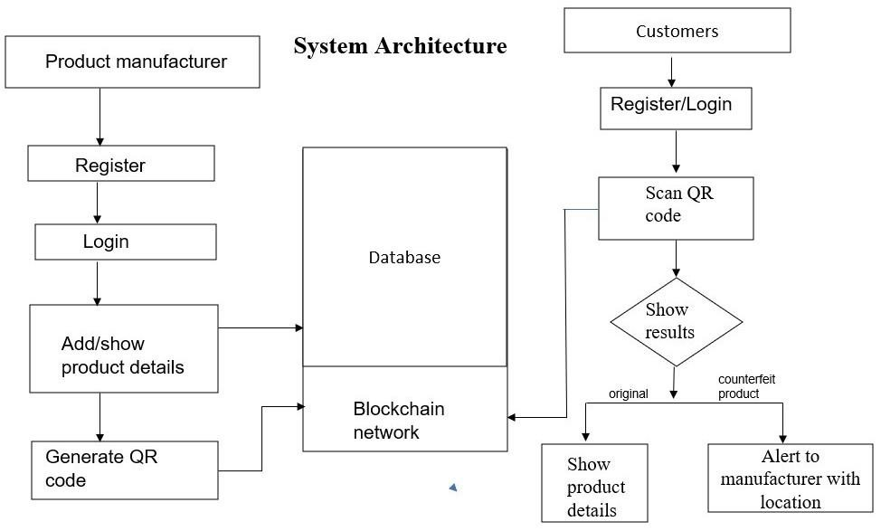

Fig: System Architecture The system consists of manufacturer and consumer part application:

MANUFACTURE END: The company after verification of mail Id for registration and authentication purpose. They can login to the system and add new product/item, upload the product details with system generated QR code which stores all the details of the products. Serializing the QR code is also advised for more security and to keep track of the product. The product details will be stored in database and QR code is made tamper proof using secure graphic technique which makes the QR code copy sensitive that is when copied it loses information and printed irreversibly.

CUSTOMER END: Customer has to register/login with email ID and password. After the completion of user authentication, the product initiates with scan button to scan QR code of the product. Here user is customer who wants to confirm whether the product is legit or not. The unique scanned code from the customer will be compared with the code produced by the manufacturer in blocks. Then the user will be notified with authenticity of the product. There is an option for customers to check product details like name, manufacturing year, price, total quality, quality of the product and also the details of manufacturer.

WORKING:

The system will detect counterfeit products using QR (Quick response) code, where QR code is chained to a specific product and linked to smart contracts to scan the code using smart phones or any device that scan. This will notify whether the products are original or fake.

A company after verification of mail Id and registration process will be given access to upload the product details with system generated QR code.

The product details include brand and product name with manufacturing year, price, total quantity, quality of the product and also the details of manufacturer. This will be stored in database(firebase) and QR code will be stored in decentralized block using Blockchain technology.

Each transaction of block will contain a unique QR code which cannot be reused by the manufacturer for different product. Manufacturer can make the tracing and identification process more secure and reliable by making use of serialized QR code with can show product information, engage customers and increase sales.

Customer has to register/login to the system before scanning the QR or barcode of the product.

After the completion of user authentication, the unique scanned code from the customer will be compared with the code produced by the manufacturer stored in blocks of smart contracts.

If code matches, then user will be notified that product is original with all its details and authentic certificate from database.

If code does not match, the user will be notified that product is fake which can prevent purchasing of falsified product and that may result in significant health or financial losses.

Even manufacturer can be benefitted if product is fake then the location of the user will be accessed with permission and alert will be sent to manufacturer who can take further legal actions on distributor, retailer and black-market manufacturer.

This ensures customers trust on merchants and increases the user’s satisfaction and also can save manufacturer time and money in fighting the defamation and sales because of forged manufacturers.

# OBJECTIVES :

# 

# Blockchain Integration: Implement integration with the Ethereum blockchain to store immutable records of product transactions and authenticity checks.

# Smart Contract Development: Develop Solidity smart contracts to define the logic for product registration, verification, and transaction tracking on the blockchain.

# MetaMask Integration: Utilize MetaMask, a browser extension, to enable secure user authentication and interaction with the Ethereum blockchain network.

# Front-End Development: Create a responsive and intuitive front-end interface using HTML, Sass, JavaScript, and React to allow users to easily interact with the application.

# User Authentication: Implement authentication mechanisms using MetaMask to ensure secure access to the DApp and protect user data and transactions.

# Product Registration & Verification: Enable manufacturers to register authentic products and consumers to verify product authenticity through the DApp interface.

# Styling and Design: Utilize CSS to design and style the front-end interface, ensuring a visually appealing and user-friendly experience for users interacting with the application.

# PROPOSED SYSTEM :

System is maintaining the status of ownership of the

product i.e., the manufacturer of the product, the

current owner of the product, and history of the

ownership, and a QR code.

Stage 1: Product Registration Process: Initially

manufacturer will be the first owner of the product.

So, the manufacturer will add the product to the

database of blockchain and add a QR code to the

product for adding new data of the product to its

blockchain

Stage 2: Distributor chains: In the next step

manufacturer will ship the product to the distributor.

When the distributor receives the product he will scan

the QR code and add a new chain about his details on

the network, product ownership, time Stamp, and

date.

Stage 3: Retailer chains: At this stage, the retailer

receives the product from the Distributor and scans

the QR code assigned to the product using a QR code

scanner, and will add a new chain of his owner details

of the product on the network

System is maintaining the status of ownership of the product i.e., the manufacturer of the product, the current owner of the product, and history of the ownership, and a QR code .Stage

1: Product Registration Process: Initially manufacturer will be the first owner of the product .So, the manufacturer will add the product to the database of blockchain and add a QR code to the product for adding new data of the product to its blockchain .

2: Distributor chains: In the next step manufacturer will ship the product to the distribute or. When the distributor receives the product he will scan the QR code and add a new chain about his details on the network, product ownership, time Stamp, and date

3: Retailer chains: At this stage, the retailer receives the product from the Distributor and scans the QR code assigned to the product using a QR codes canner, and will add a new chain of his owner details of the product on the network

4: End User: At the end of the chain, the customer will take the product, go to the website and upload the QR code over there, and the customer willable to get all detail about the product from the manufacturer to the last retailer. And after getting the details then it was his choice whether to buy the product or not.

# OUTPUTS :

# CUSTOMER END

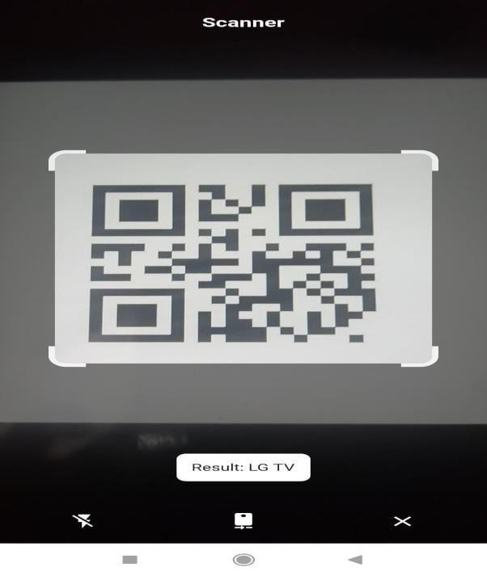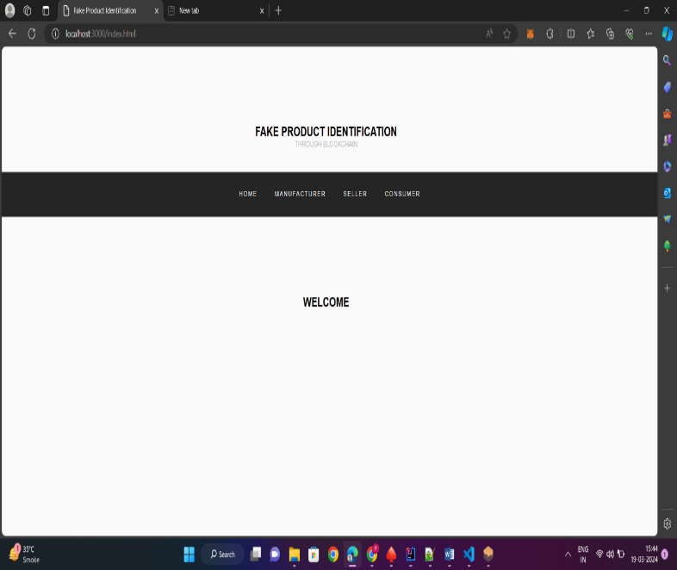

**Fig: Home Page Fig : Final Result**

**MANUFACTURER END :**

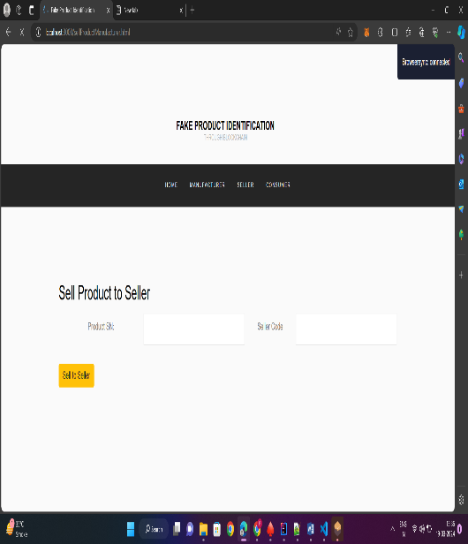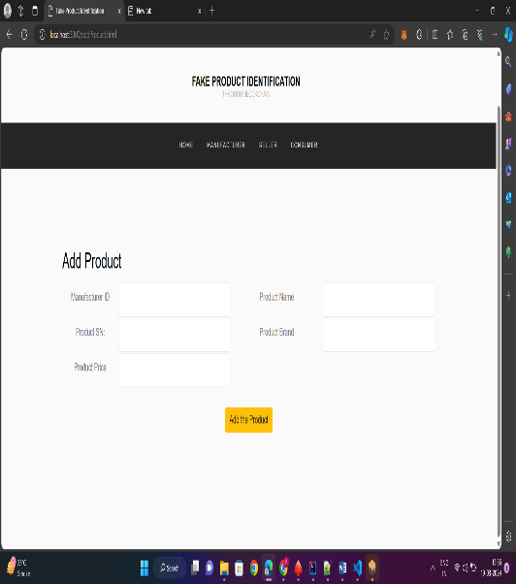

**Figure: Add Product Figure: Manufacture produc**t

Figure: QR code generator



**Figure: Generated QR code**

# ADVANTAGES OF PROPOSED SYSTEM :

# Accuracy: As we know that blockchain is distributed system so the database of the blockchain is distributed among the different nodes in the computer networks. This means that the user never comes to know from where the database of blockchain is coming This result in the least involvement of humans in this technology which leads to less human error thus resulting in less computational error by blockchain technology which leads to great accuracy.2. Cost Reductions: Blockchain is very beneficial for cost reductions in transactions because blockchain eliminates the involvement of third-party such as banks. For example, every time business owners accept payments using credit cards there will be a small cut in payment from the bank for providing the services. Still, blockchain does not have central authority so there will be no or minimal transaction fees.3. Decentralization: As we know from the above definition of blockchain that blockchain is a decentralized distributed system . so the blockchain database has many copies and is spread across the different computers in computer networks. Thus if we have to add a new block to the database then every computer has to add it to its blockchain to reflect the change. Thus, blockchain becomes more difficult to tamper with. Even if a hacker tried to make a change to the blockchain then only that copy is affected other remains the same. Thus decentralization property of blockchain helps in the security of data.4. Efficient Transactions: Blockchain transaction is decentralized and it is not conducted by some authority. As we know that authorities operate their transaction during working hours and if we start a transaction on Friday then it takes three days to complete the transaction which means till Monday but the blockchain run 24/7.And also blockchain completes the transaction in less than10 minutes. Blockchain also takes almost the same time to complete cross-border trades which if it is done by other authorities take longer time due to difference in time zones issue and many more reasons. Thus Blockchain provides an efficient mechanism for transactions.5. Transparency: Blockchain provides transparency as most of the blockchains are open-source software. So it will give us the functionality of reviewing the code, and gives suggestions to improve blockchain technology. Thus blockchain is completely transparent to the user. The Suggestions are going to implement only if the majority of network users agree.

# CONCLUSION AND FUTURE WORK:

The fully functional application can effectively reduce the threshold of the anti-counterfeiting of branded goods and provide the industries with limited financial resources and also easier approach to provide consumers with the trust and surety that they will not be purchasing unsusceptible counterfeited goods. Overall, this blockchain technology-based application can emerge as a life saver for the companies and provide a new system for trading, marking and purchasing which is more secure and user friendly.

The total cost of running on the Ethereum public chain is directly related to the code simplicity of the distributed applications. The future work of the system can be proof of code simplicity which can indirectly increase consumer’s trust because of distributed applications. It can be difficult on the manufacturer side to add all the details of the products manufactured so instead of manually adding the products details, data can be extracted using company’s API which can increase efficiency and manufacturer friendly.

QR code is not hackable but information in it can be copied or known to generate similarly QR code as well as print out of QR code works well to scan and retrieve information so in order to overcome this secure graphic QR code can be used that if when QR code is photocopied then it will lose information due to the ink smearing. These copy detection pattern or secure graphic is a digital image with optimal design to lose information when copied and it is printed irreversibly. Customer when found the product is counterfeited then system should able to show the same products but original from different sites with price differences to improve usability, efficiency and effectiveness of the system.

1. **REFERENCES**
2. S. Gore, S. Hamsa, S. Roychowdhury, G. Patil, S. Gore and S. Karmode, "Augmented Intelligence in Machine Learning for Cybersecurity: Enhancing Threat Detection and Human-Machine Collaboration," 2023 Second International Conference on Augmented Intelligence and Sustainable Systems (ICAISS), Trichy, India, 2023, pp. 638-644, doi: 10.1109/ICAISS58487.2023.10250514.
3. Layth Almahadeen, Renzon Daniel Cosme Pecho, Murugananth Gopal Raj, Nichenametla Rajesh, Zainab Mohammed Imneef, Sayali Karmode Yelpale, “Digital Investigation Forensic Model with P2P Timestamp Blockchain for Monitoring and Analysis” , Journal of Electrical System, Vol. 1, No 1, (2024): 09-17 ( DOI : https://doi.org/10.52783/jes.656)
4. Sayali Karmode, Security Challenges for IoT Based Applications & Solutions Using Fog Computing: A Survey, Journal of Journal of Cybersecurity and Information Management, Vol. 3 , No. 1 , (2020) : 21-28 (Doi : https://doi.org/10.54216/JCIM.030103)
5. M. S. K. Yelpale, “Security and privacy challenges in cloud computing: a review,” Journal of Cybersecurity and Information Management, vol. 4, no. 1, pp. 36–45, 2020.
6. View at: Google Scholar
7. Sayali Karmode Yelpale, “IOT Technology for Pandemic Situation”, NJITM, vol. 4, no. 2, pp. 25–27, Jan. 2022
8. https://mbajournals.in/index.php/JoITM/article/view/806.
9. Karmode, S. S., & Bhagat, V. B. (2017). DETECTION AND BLOCKING SOCIAL MEDIA MALICIOUS POSTS. International journal of modern trends in engineering and research, 4(5).
10. Kermode, S. S., & Bhagat, V. B. (2016). A Review: Detection and Blocking Social Media Malicious Posts. Int. J. Mod. Trends Eng. Res, 3(11), 130-136. doi: 10.21884/IJMTER.2016.3133.Q4M8O .
11. Prof. Bhushan B. Thakare, Prof. Sayali Karmode Yelpale, “Smart Home with Edge Computing”, International Journal of Interdisciplinary Innovative Research & Development (IJIIRD), Vol 6, 2021
12. https://ijiird.com/wp-content/uploads/CSE016-1.pdf
13. Sayali Karmode, “Blockchain Technology Security Issues and Concerns : A Review”, International Research Journal of Modernization in Engineering Technology and Science, Vol 6, Issue 03, March 2024
14. DOI : https://www.doi.org/10.56726/IRJMETS50249
15. Pranav Chavan, Harshraj Deshmukh, Aakash Dhotre, Aditya Gharat, Sayali Karmode, “Blockchain Democracy : Evaluating a Secure Voting System”, International Research Journal of Modernization in Engineering Technology and Science, Vol 6, Issue 03, March 2024
16. DOI : https://www.doi.org/10.56726/IRJMETS50478
17. B. J. Dange, Kaustubh Manikrao Gaikwad, H. E. Khodke, Santosh Gore, S. N. Gunjal, Kalyani Kadam, Sayali Karmode, “Machine Learning for Quantum Computing Bridging the Gap between AI and Quantum Algorithms”, Int J Intell Syst Appl Eng, vol. 12, no. 21s, pp. 600–605, Mar. 2024.
18. Eka Dyar Wahyuni and Arif Djunaidy, “Fake Review Detection from a Product Review Using Modified Method of Iterative Computation Product”, January 2016 Research Gate
19. M. C. Jayaprasanna, V. A. Soundharya, M. Suhana and S. Sujatha, "A Block Chain based Management System for Detecting Counterfeit Product in Supply Chain," 2021 Third International Conference on Intelligent Communication Technologies and Virtual Mobile Networks (ICICV), 2021, pp. 253-257
20. Singh, Shivam & Choudhary, Gaurav & Kumar, Shishir & Sihag, Vikas & Choudhary, Arjun. (2021). Counterfeited Product Identification in a Supply Chain using Blockchain Technology. 10.22667/ReBiCTE.2021.07.15.003.