Comparative Analysis of different size of water tank using IS code
¹JAI PENDE, ²ROHAN JAISWAL, ³KOMAL WAGHMARE & ⁴PROF. KARUNA AMBHORE
^{1to3}UG Student, Department of Civil Engineering, Yadavrao Tasgaonkar Institute Of Engineering & Technology, Mumbai University, Mumbai
⁴Assistant Professor, Department of Civil Engineering, Yadavrao Tasgaonkar Institute Of Engineering & Technology, Mumbai University, Mumbai
Abstract:
Water storage tanks are vital components of water supply systems, serving the essential role of storing and distributing potable water to meet the demands of communities, industries, and agriculture. The design and size of these tanks are critical factors that directly impact their structural integrity, safety, and cost-effectiveness. This study conducts a comparative analysis of water tanks of different sizes, employing the guidelines specified in the Indian Standard (IS) codes, particularly IS 3370, and utilizing STAAD-PRO software for structural analysis. This study investigates the structural behavior of three models of rectangular water tanks using STAAD-PRO software. The analysis focuses on key parameters such as displacement, reactions, beam forces, and plate stresses to understand the performance of these tanks under varying dimensions and loading conditions. The results reveal significant findings: higher-dimensional tanks exhibit maximum displacement and reactions due to increased surface area and load transfer to supports, while lower-dimensional tanks experience minimum beam forces and plate stresses owing to reduced weight and load distribution. These conclusions underscore the importance of dimension optimization and load management in designing resilient and efficient water tank structures. Understanding these structural behaviors is crucial for ensuring the stability, durability, and performance of such critical infrastructure elements.
Keywords: STAAD, multistory, seismic, displacement and shear wall
- Introduction
Water storage tanks serve as fundamental components of infrastructure, and their significance lies in their pivotal role in guaranteeing a consistent and dependable supply of clean drinking water for a variety of purposes, including domestic use, industrial processes, and agricultural irrigation. To ensure the effectiveness and reliability of these tanks, their size and design require meticulous planning and engineering, with a strong emphasis on adhering to safety and structural integrity standards.
- Role of Water Storage Tanks:
Water storage tanks are reservoirs designed to store and distribute potable water. They act as critical intermediaries between water sources, treatment facilities, and end-users. These tanks ensure that water is readily available, even during peak demand, and can serve as a buffer during times of water source scarcity, mechanical failures, or maintenance. This is vital for sustaining communities, industries, and agricultural activities.
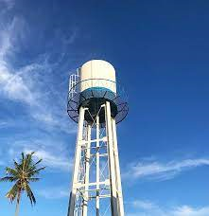
Figure 1.1: Elevated WaterTank

- Critical Consideration of Size and Design:
The size and design of water storage tanks are pivotal factors that demand careful attention. Various factors influence these choices, including population growth, water demand patterns, geographical location, and local climate conditions. Tank size must be determined to adequately meet the required water storage capacity without unnecessary excess. Overly large tanks can lead to excessive construction and maintenance costs.
- Safety and Structural Integrity Standards:
Water storage tanks must be designed and constructed to withstand a range of environmental and load conditions. Safety considerations are of utmost importance to prevent catastrophic failures, contamination, and risks to public health. Compliance with established standards and guidelines is essential. In India, the Indian Standard (IS) codes, particularly IS 3370, provide comprehensive specifications and design guidelines for water tank construction. These codes encompass structural safety, material requirements, and durability standards.

.
- LITERATURE REVIEW
Water storage tanks are indispensable components of water supply infrastructure worldwide. Their design, size, and adherence to safety standards are pivotal aspects in ensuring the reliable supply of potable water for various applications. This literature review explores key research and publications on water storage tanks, their design considerations, and the significance of the research.
According to the characteristics of the velocity and temperature fields, these shapes can be divided into three categories: shapes with sharp corners, those with hemispheres, and those with horizontal plane surface. Shapes with sharp corners have the highest degree of thermal stratification, whereas the shapes with horizontal plane surface possess the lowest. That of the shapes with hemispheres lies in between these two degrees. The thermal stratification of different shapes is determined by the flow at the bottom of the water tank and the heat transfer from the fluid to the environment (Yang et al., 2016).
Using the Ethiopian Building Code of Standards (EBCS 1995), the American Concrete Institute (ACI 350), the Euro code (EN 2004), and the Indian Standard codes (IS 3370), an elevated Intze water tank has been assessed and designed in this paper. The amount of concrete and reinforcement used in each code has also been compared. These constructions are particularly vulnerable to lateral loads brought on by wind and earthquakes because they have a big mass concentrated at the apex of a flimsy hold up framework. A variety of factors were taken into account when performing the design, including the impact of capacity, staging height, terrain type, and wind zone. The hoop stress and meridional thrust at diverse Intze tank parts are determined via membrane simulation analysis (Workeluel et al., 2023).
The design and construction methods used in reinforced concrete are influenced by the prevailing construction practices, physical properties of the material and climatic conditions. Before starting the design, the most appropriate type of tank installation and the correct assessment of loads are made, including the static balance of the structure, especially with regard to the overturning of overhanging elements. The work presented in the research work consists of a comparative analysis of the upper water tank in terms of shear force, bending moment and other parameters. From the results it is observed that the model-3 has the highest moment (kNm) as compared to the other models and have the maximum value of 170 kNm and the minimum value of 90 kNm for model-7 (Konde & Changhode, 2021).
.
- METHODOLOGY
This methodology ensures a systematic and comprehensive approach to the comparative analysis of water tanks, helping to determine the optimal tank size while adhering to relevant standards and ensuring structural integrity.
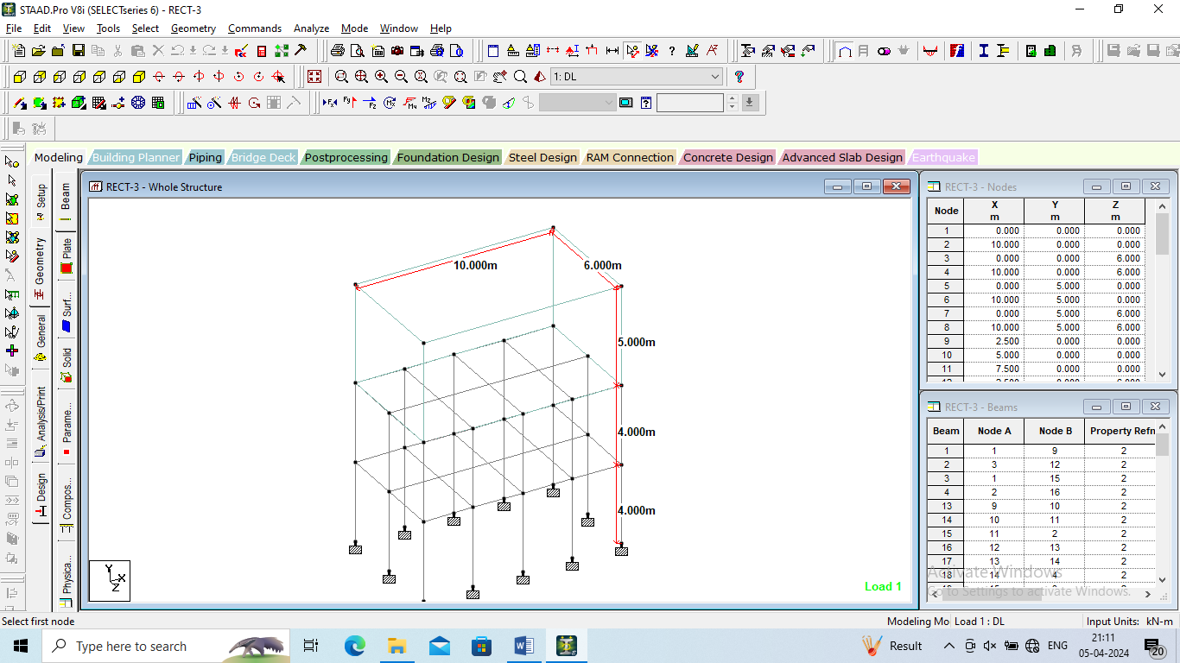
Figure 1: Geometry of the model-1

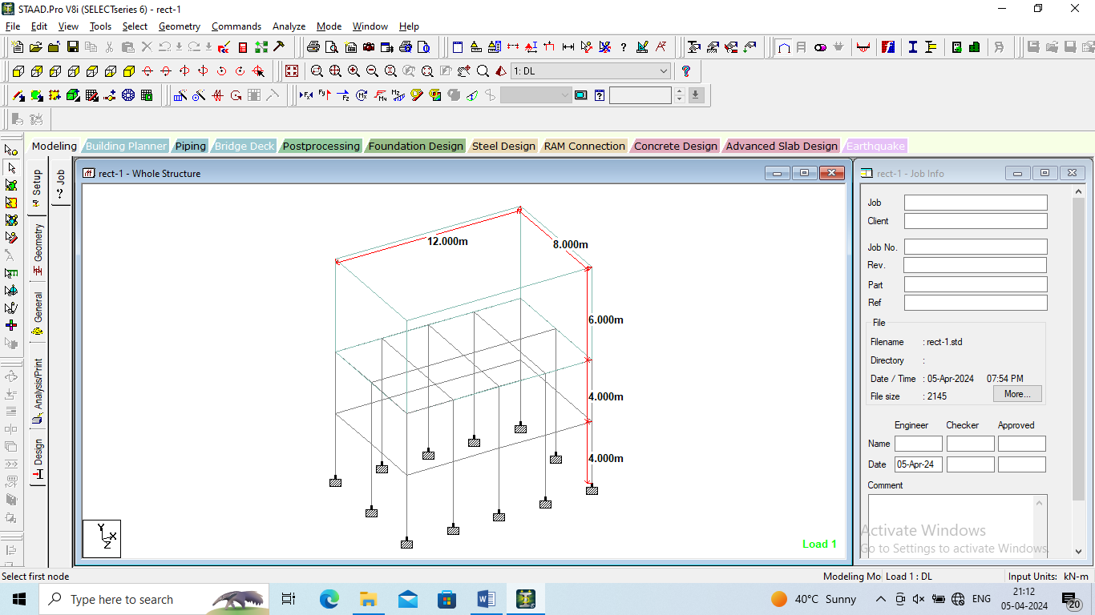
Figure 2: Geometry of the model-2

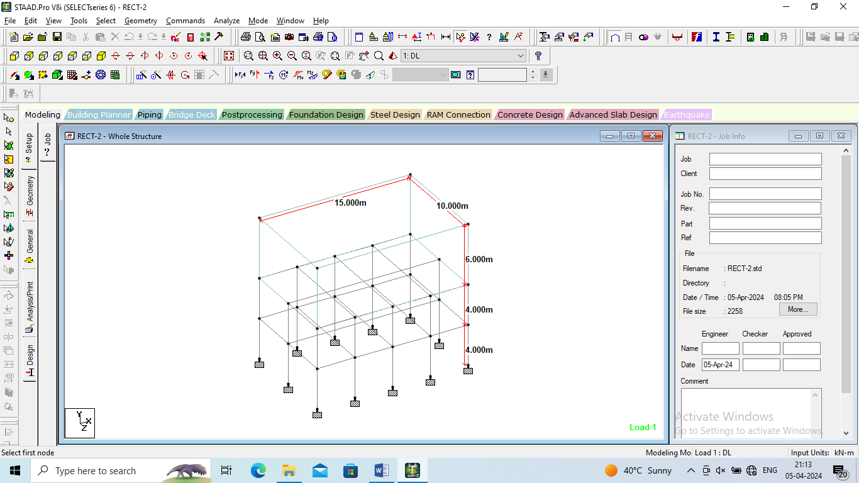
Figure 3: Geometry of the model-3

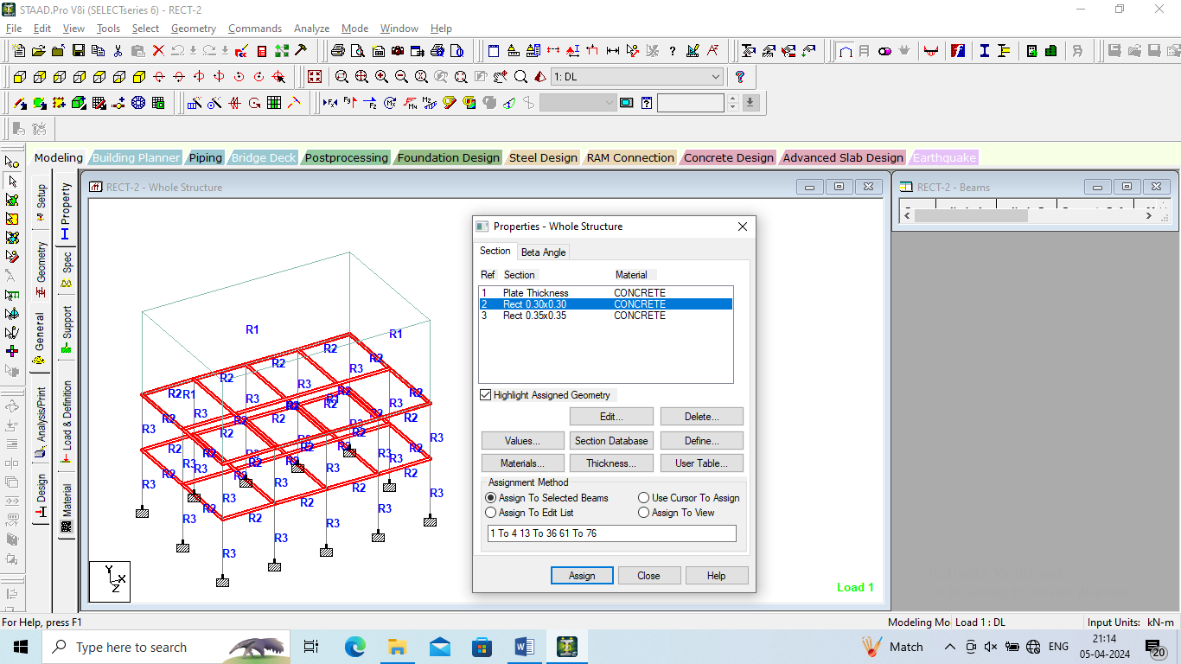
Figure 4: Property assigned to the model

- RESULTS
The results obtained in terms of the displacement, reactions, beam forces and plate stresses for all the models.
Figure 5: Displacement of all the models

Table 1: Reactions of all the models
 | Horizontal | Vertical | Horizontal | Moment
 | Fx kN | Fy kN | Fz kN | Mx kNm | My kNm | Mz kNm
MODEL-3 | 2.279 | 689.359 | 2.765 | 3.601 | 0.09 | 2.995
MODEL-1 | 3.126 | 1093.2 | 3.893 | 5.035 | 0.543 | 4.087
MODEL-2 | 4.723 | 1435.09 | 6.404 | 8.222 | 0.254 | 6.35

Figure 6: Horizontal Reactions of all the models

Figure 7: Vertical Reactions of all the models

Figure 8: Horizontal Reactions (Fz) of all the models

Table 2: Beam forces of all the models
 | Fx kN | Fy kN | Fz kN | Mx kNm | My kNm | Mz kNm
MODEL-1 | 699.055 | 19.023 | 6.146 | 2.55 | 19.374 | 32.134
MODEL-2 | 1101.71 | 19.502 | 9.844 | 3.115 | 30.219 | 36.304
MODEL-3 | 1439.99 | 16.602 | 19.525 | 5.17 | 58.466 | 39.917

Figure 9: Beam Forces (Fx) of all the models

Figure 10: Beam Forces & moment of all the models
Table 3: Plate stresses of all the models
 | Shear |  | Membrane |  | Bending Moment
 | SQX (local) N/mm2 | SQY (local) N/mm2 | SX (local) N/mm2 | SY (local) N/mm2 | Mx kNm/m | My kNm/m
MODEL-1 | 0.001 | 0.001 | 0.822 | 0.822 | 2.302 | 2.302
MODEL-2 | 0.001 | 0.001 | 1.225 | 1.13 | 2.871 | 2.871
MODEL-3 | 0.001 | 0.001 | 1.591 | 1.751 | 5.474 | 5.474

Figure 11: Plate stresses of all the models

Table 4: Principal stresses of all the models
 | Principal |  | Von Mis |  | Tresca
 | Top N/mm2 | Bottom N/mm2 | Top N/mm2 | Bottom N/mm2 | Top N/mm2 | Bottom N/mm2
MODEL-1 | 1.079 | 0.826 | 0.975 | 0.72 | 1.079 | 0.826
MODEL-2 | 1.502 | 1.119 | 1.338 | 1.026 | 1.502 | 1.173
MODEL-3 | 2.005 | 1.815 | 1.913 | 1.813 | 2.204 | 1.917

Figure 12: Principal stresses of all the models

Figure 13: Von Mis stresses of all the models

Figure 14: Tresca stresses of all the models

- CONCLUSIONS
The following conclusions are drawn based on the present study.
1. Displacement is found to be maximum for the model with higher dimensions:
- Displacement refers to the movement or deformation experienced by a structure under load. In this context, the model with higher dimensions likely experiences greater displacement because it has a larger surface area and volume, resulting in more material being subjected to deformation under the applied loads. Additionally, higher dimensions can lead to increased flexibility, causing more significant displacements compared to smaller tanks.
2. Reactions are maximum in case of water tank with higher dimensions:
- Reactions represent the forces exerted by the supports or foundations to counteract the applied loads and maintain equilibrium. For the water tank with higher dimensions, the increased weight and surface area result in larger loads being transferred to the supports, leading to higher reaction forces. This is consistent with the principle of static equilibrium, where the reactions must balance out the applied loads to prevent the structure from moving or collapsing.
3. Beam forces are minimum in case of water tank with lower dimensions:
- Beam forces refer to the internal forces (such as bending moments and shear forces) experienced by the structural members, such as beams, that support the water tank. When the tank has lower dimensions, the weight and load distribution are reduced, resulting in lower forces being transmitted through the beams. This can lead to reduced bending moments and shear forces in the beams, hence the minimum beam forces observed in the smaller tank model.

REFERENCES

- A.B. Karnale and Dr.D.N. Shinde (2015), “Comparative Seismic Analysis of High Rise and Low Rise RCC Building with Shear Wall”, International Journal of Innovative Research in Science, Engineering and Technology, September 2015.
- A.Joshua Denial, S Sivakamasundari (2016), seismic vulnerability of building on the hill slope, international general of earth science and engineering volume 9, no.5, page 1892-199.
- A.S. Agrawal and S.D. Charkha (2012) 'study of Optimizing Configuration of Multi Story Building Subjected to Lateral Loads by Changing Shear Wall Location' proceedings of International conference on advances in architecture and civil engineering, volume 1 , pp 287-289.
- Abbas Haghollahi, Mohsen Besharat Ferdous and Mehdi Kasiri: "Optimization of outrigger locations in steel tall buildings subjected to earthquake loads", 15th world conference of earthquake engineering 2012.
- Anil Baral and Dr. S. K. Yajdani May-(2015); "Seismic Analysis of RC Framed Building for Different Position of Shear wall" International Journal of Innovative Research in Science, Engineering and Technology (An ISO 3297: 2007 Certified Organization) Vol. 4, Issue 5, May 2015
- Ankita Mishra, Kapil International journal of scientific & engineering research Volume 5 Issue VI, June 2017 IC Value: 45.98 ISSN: 2321-9653.
- Anshul Sud, Raghav Singh Shekhawat, Poonam Dhiman (2014) Best Placement of Shear Walls In an RCC Space Frame Based on Seismic Response-International Journal of Engineering Research and Applications (IJERA) ISSN: 2248-9622
- Anshumn. S, Dipendu Bhunia, Bhavin Rmjiyani (2011), “Solution of shear wall location in Multi-storey building.” International Journal of Civil Engineering Vol. 9, No.2Pages 493-506.
- Anuj Chandiwala (2012) 'Earthquake Analysis of Building Configuration with Different Position of Shear Wall' -International Journal of Emerging Technology and Advanced Engineering ISSN 2250-2459, ISO 9001:2008 Certified Journal, Volume 2, Issue 12.
- Anuj Chandiwala (2012), “Earthquake Analysis of Building Configuration with Different Position of Shear Wall”, International Journal of Emerging Technology and Advanced Engineering ISSN 2250-2459, ISO 9001:2008 Certified Journal, Volume 2, Issue 12, December 2012,

