STRUCTURAL ANALYSIS AND DESIGN OF G+2 BUILDING USING STAAD-PRO SOFTWARE
¹Ms. Siddhi Kanekar, ²Mr. Shyam Tiwari, ³Mr. Rushikesh Meher & ⁴Prof. Nitin Shelar
^{1to3}UG Student, Department of Civil Engineering, Yadavrao Tasgaonkar Institute Of Engineering & Technology, Mumbai University, Mumbai
⁴Assistant Professor, Department of Civil Engineering, Yadavrao Tasgaonkar Institute Of Engineering & Technology, Mumbai University, Mumbai
Abstract:
The Structural Analysis and Design of a G+2 Building using STAAD-PRO Software is a comprehensive project undertaken in the final year of the Bachelor of Engineering program. This project aims to provide an in-depth understanding of the process involved in designing and analyzing multi-storey buildings, with a specific focus on a G+2 structure, utilizing state-of-the-art engineering software, STAAD-PRO. In the field of civil engineering, the structural design of buildings is a crucial aspect that ensures the safety, stability, and efficiency of structures. The G+2 building chosen as the subject of this project represents a typical low-rise residential or commercial building commonly found in urban environments. The project encompasses two main phases: structural analysis and structural design. In conclusion, the Structural Analysis and Design of a G+2 Building using STAAD-PRO Software project serves as an educational journey through the intricacies of structural engineering. It showcases the application of advanced software tools in addressing real-world engineering challenges while emphasizing the importance of safety, compliance with standards, and sustainable design principles in construction. The knowledge and skills gained through this project will be invaluable for aspiring civil engineers as they embark on their professional careers in the field of structural engineering.
Keywords: STAAD, multistory, seismic, displacement and shear wall
- Introduction
The construction industry is undeniably a driving force behind the development of our modern world. It shapes the skylines of our cities, provides shelter, and enables the infrastructure that supports our daily lives. At the heart of this industry lies structural design, a fundamental aspect that determines the stability, safety, and efficiency of any building or structure. The intricacies of structural design and analysis are pivotal in ensuring that structures can withstand the various forces and loads they may encounter during their lifespan.
Amid the ever-evolving technological landscape, structural engineers have an array of tools at their disposal to aid in the complex task of structural design and analysis. One such tool that has garnered widespread recognition and acclaim within the industry is STAAD-PRO software. This software has established itself as a powerful ally for structural engineers, significantly enhancing their ability to design and analyze complex structures with precision and efficiency.
In today's urban landscape, the demand for multi-storey buildings with open, column-free spaces has grown due to limited space, increasing population, and the desire for both aesthetic and functional features. To create such spaces, these buildings incorporate floating columns at one or more levels. However, this design presents significant challenges, particularly in seismic regions. During earthquakes, forces generated at different levels of a building must be efficiently transmitted to the ground through the most direct path. Any deviations or disruptions in this load transfer path can lead to poor building performance.
The earthquake response of a building is profoundly influenced by its overall shape, size, and geometry, as well as how it channels seismic forces to the ground. A notable example of the consequences of this design approach can be seen in the 2001 Bhuj earthquake in Gujarat, where many buildings featuring an open ground storey primarily intended for parking experienced severe damage or even collapsed.
The fundamental goals of any structural design are safety, serviceability and economy. Achieving these goals for design in seismic region is especially important and difficult to achieve. Uncertainty and unpredictability of when, where and how an earthquake event will strike a community increases the overall difficulty. In addition, lack of understanding and ability to estimate the performance of constructed facilities makes it difficult to achieve the above mentioned goals. In some cases, especially under strong earthquake excitations, these can cause the structural damage or even collapse of structure. For the structures that have high inherent or natural damping, the likelihood of damage will be decreased. However, for structures subjected to strong vibrations, the inherent damping in the structure is not sufficient to mitigate the structural response. In many situations, supplemental damping devices may be used to control the response of structure.
- LITERATURE REVIEW
Sreeshna K.S (2016) this paper deals with structural analysis and design of B+G+4 storied apartment building. The work was completed in three stages. The first stage was modelling and analysis of building and the second stage was to design the structural elements and the final was to detail the structural elements. In this project STAAD.Pro software is used for analysing the building. The IS:875 (Part 1) and (Part 2) were referred for dead load and live load. Design of structural elements like beam, column, slab, staircase, shear wall, retaining wall, pile foundation is done according to IS Codes.
Amar Hugar et al., (2016) has been discussed that the Computer Aided Design of Residential Building involves scrutiny of building using STAAD.Pro and a physical design of the structure. Traditional way of study shows tedious calculations and such tests is a timeconsuming task. Analysis are made quickly by using software’s. This project completely deals with scrutiny of the building using the software STAAD.Pro. Finally, the results are compared with physical calculations. The elements are created as per IS:456-2000.
Bandipati Anup et al., (2016) this paper deals with evaluate and plan a multi-storeyed building [G + 2 (3- dimensional frame)] adopting STAAD Pro. The technique used in STAAD.Pro is limit state technique. Initially they have created 2-D frames and cross checked with physical calculations. The exact result should be proved. We tested and created a G + 2 storey building [2-D Frame] instantly for all feasible load combinations. The work has been finished with some more multi-storeyed 2-Dimensional and 3- Dimensional frames beneath various load combinations
Aman et al., (2016) has discussed that the point of the structural engineer is to model a guarded structure. Then the structure is subjected to various types of loading. Mostly the loads put in on the building are considered as static. Finite part analysis that exhibit the result of dynamic load like wind result, earthquake result, etc. The work is conducted using STAAD.Pro software.
Madhurivassavai et al., (2016) he says that the most common problem country facing is the growing population. Because of the less availability of land, multi-storey building can be constructed to serve many people in limited area. Efficient modelling is performed using STAAD.Pro and AutoCAD. Manual International Journal of Pure and Applied Mathematics Special Issue 2798 calculations for more than four floor buildings are tedious and time consuming. STAAD.Pro provides us a quick, efficient and correct platform for analysing and coming up with structures.
Borugadda Raju et al., (2015) has been designed and analysed G+30 multi-storey building adopting STAAD.Pro in limit state methodology. STAAD.Pro contains an easy interface that permits the users to produce the mount and the load values and dimensions are inputted. The members are designed with reinforcement details for RCC frames. The analysis is completed for two dimensional frames and then it is done for more multi-storeyed 2-D and 3-D frames under various load combinations.
Anoop. A, (2016) has explained that the scope of the project is to provide a multi storied building of G+ 5 floors. Revit 2011 and Auto CAD 2014 software is used for developing 3-D models. The structure analysis and design are done using STAAD.Pro. The results are checked for selected members using limit state method of design as per IS 456-2000.
- SYSTEM DEVELOPMENT
- The methodology section of this project outlines the systematic approach taken to achieve the objectives of structurally analyzing and designing a G+2 building using STAAD-PRO software.
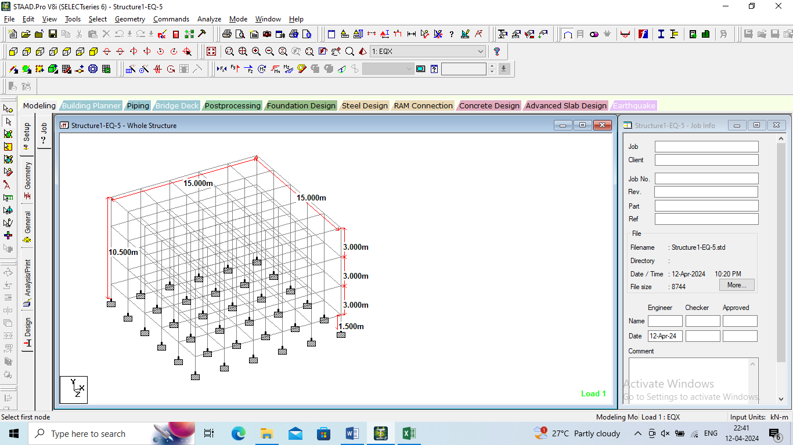
Figure 3.2: Geometry of the model

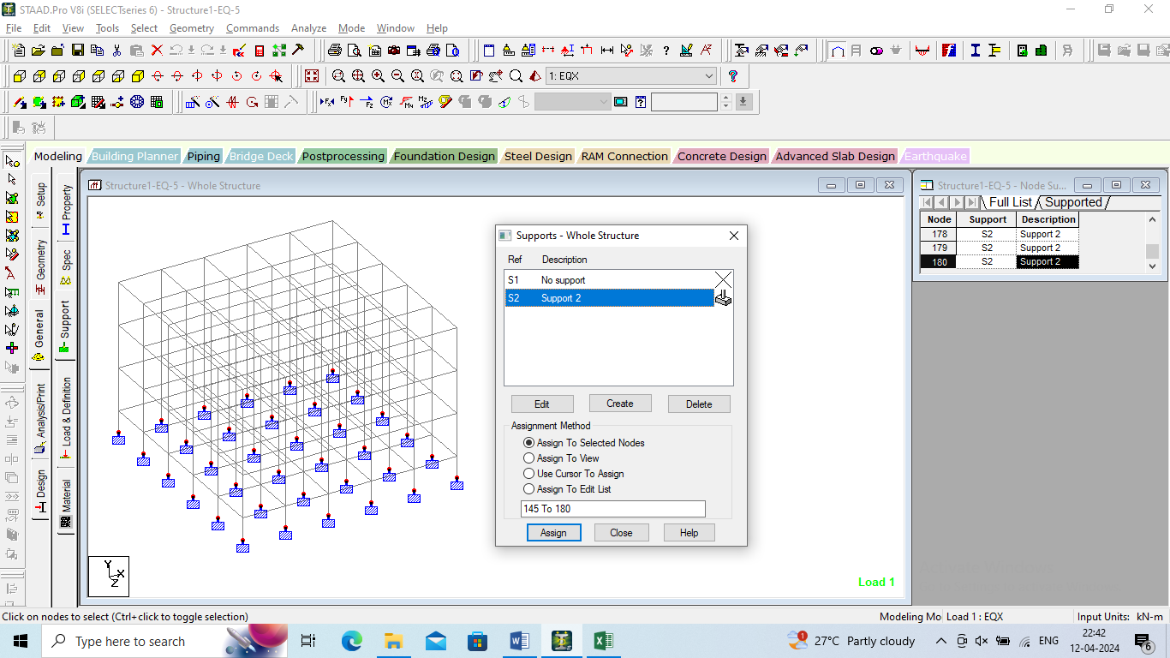
Figure 3.3: Supports assigned of the model

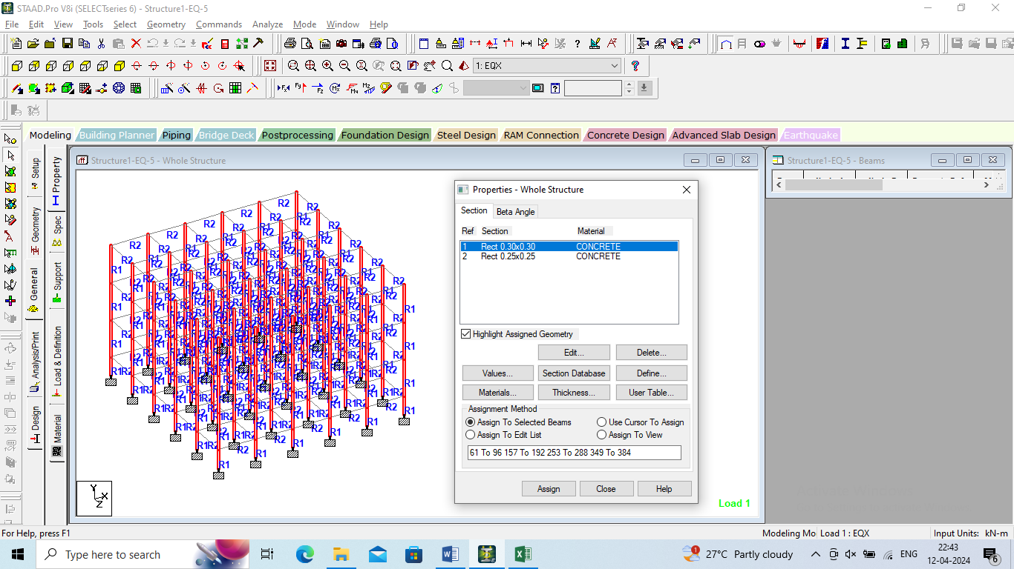
Figure 3.4: Properties assigned of the model

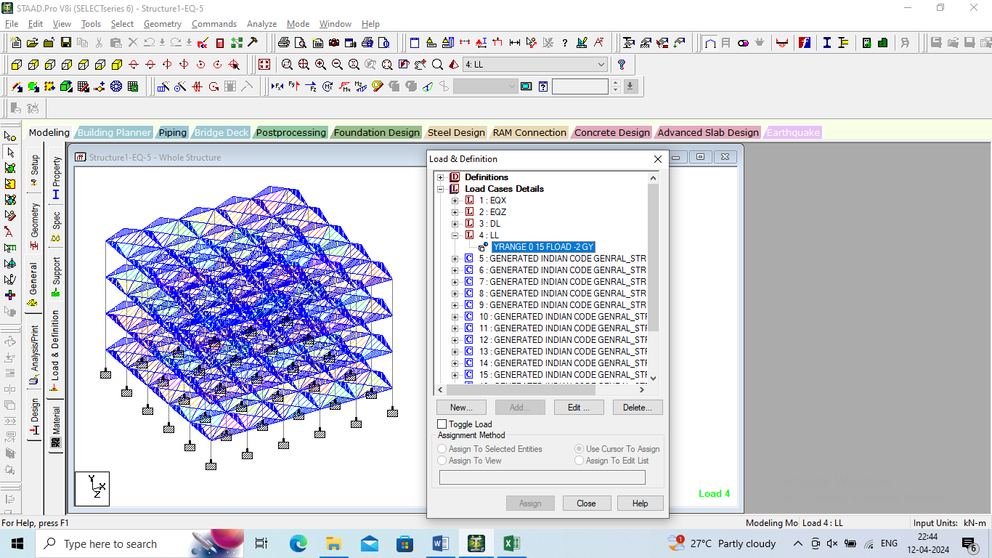
Figure 3.5: Loads assigned of the model

- PERFORMANCE ANALYSIS
The results obtained in terms of the displacement, reactions, beam forces and plate stresses for all the models.
Figure 4.1: Displacement of models

Figure 4.2: Horizontal Displacement of models

Figure 4.3: Vertical Displacement of models

Figure 4.4: Horizontal (Z) Displacement of models

Figure 4.5: Resultant Displacement of models

Table 4.14:Reactions of all the models
 | Horizontal | Vertical | Horizontal | Moment
 | Fx kN | Fy kN | Fz kN | Mx kNm | My kNm | Mz kNm
Model -1-EQ-2 | 4.426 | 276.555 | 4.426 | 3.64 | 0.006 | 3.64
Model -2-EQ-3 | 5.107 | 276.555 | 5.107 | 5.231 | 0.009 | 5.231
Model -3-EQ-4 | 6.016 | 276.555 | 6.016 | 7.391 | 0.013 | 7.391
Model -4-EQ-5 | 8.239 | 276.555 | 8.239 | 11.045 | 0.019 | 11.045

Figure 4.6: Reactions of models

Figure 4.7: Horizontal (Fz) Reactions of models

Figure 4.8: Moment (Mx) Reactions of models

Figure 4.9: Moment (Mz) Reactions of models

- CONCLUSIONS
The comprehensive analysis and design process conducted for the G+2 building using STAAD.Pro software have yielded valuable insights into the structural behavior, seismic response, and design adequacy of the structure. Through meticulous analysis of different seismic zones and adherence to design codes such as IS 456, key conclusions have been drawn regarding the building's structural performance and resilience.
1. Seismic Considerations: The analysis and design of the G+2 building using STAAD.Pro software revealed significant differences in structural responses across various seismic zones. Particularly, the model subjected to seismic Zone-V exhibited higher displacements, reactions, and beam forces compared to other zones. This underscores the critical importance of seismic considerations in structural design, especially in regions prone to high seismic activity.
2. Structural Vulnerability: The observed maximum displacements, reactions, and beam forces in the seismic Zone-V model indicate a higher structural vulnerability to seismic forces. This highlights the necessity for implementing robust seismic design measures, such as adequate lateral load-resisting systems, ductile detailing, and appropriate foundation design, to enhance the building's seismic performance and mitigate potential damage during seismic events.
3. Compliance with Design Codes: The design calculations performed as per IS 456 standards ensured compliance with the relevant design provisions and safety requirements. By adhering to the prescribed design methodologies and material specifications, the structural elements were adequately sized and reinforced to withstand the anticipated loads and environmental conditions.
REFERENCES

- Theory of Structures by ramamrutham for literature review on kani,s method
- Theory of structures by B.C.punmia for literature on moment distribution method.
- Reinforced concrete Structures by a.k. Jain and B.C. punmia for design of beams, columns and slab.
- Fundamentals of Reinforced concrete structure by N. c. Sinha.
- Sreeshna K.S, ‘Analysis and Design of an Apartment building’, IJISET - International Journal of Innovative Science, Engineering & Technology, Vol. 3 Issue 3, ISSN 2348 – 7968, March 2016.
- Amar Hugar, Sharanabasappa M Pujari, Beerappa G Pujari, Anaveerappa N Biradar, Gajendra, ‘Analysis and Design of a Commercial cum Residential Building by Using STAAD Pro’, International Research Journal of Engineering and Technology (IRJET), Volume: 03, Issue: 06, e-ISSN: 2395 -0056, p-ISSN: 2395-0072, June-2016.
- Bandipati Anup, Dr. Dumpa Venkateswarlu, ‘Comparison Between Manual Analysis and STAAD PRO. Analysis of Multi Storey Building’, International Journal of Research Sciences and Advanced Engineering, Volume 2, Issue 15, PP: 216 - 224, SEPTEMBER’ 2016.
- Aman, Manjunath Nalwadgi, Vishal T, Gajendra, ‘Analysis and design of multistorey building by usingSTAAD Pro’, International Research Journal of Engineering and Technology (IRJET), Volume: 03, Issue: 06, e-ISSN: 2395 -0056, p-ISSN: 2395-0072, June-2016.
- Madhurivassavai, V. Bhargavi, E.V. Raghava Rao, ‘Analysis and Design of Multistoried Building with G+8 Floors by Using Staadpro’, International Journal of Advanced Technology and Innovative Research’, Vol.08, Issue.02, ISSN 2348–2370, February-2016. 10.
- Borugadda Raju, Mr. R. Rattaiah, ‘Analysis AND Design of High-Rise Building (G+30) Using STAAD.PRO’, International Journal of Research Sciences and Advanced Engineering, Volume 2, Issue 12, PP: 50 - 54, OCT - DEC’ 2015.

