PHONE 4U WITH COMPARISON AND SENTIMENT ANALYSIS

*Prof.Mitrakshi Patil*1, Amey Dalvi*2, Swarali Potdar*3, Vaishnavi Wagh*4, Atharva Warge*5*

*\*1Faculty of Department of Information Technology, MGM College of Engineering and Technology, Navi Mumbai, Maharashtra.*

*\*2,3,4,5 Student of Department of Information Technology, MGM College of Engineering and Technology, Navi Mumbai, Maharashtra.*

|  |  |
| --- | --- |
| ***Abstract*- In today's technology-driven world, the choice of a smartphone is a pivotal decision, influencing our daily lives and routines. With unlimited range of phone models available, each boasting a unique set of features, specifications, and user experiences, consumers face the challenge of selecting the perfect device that aligns with their individual needs and preferences. Our project, "Phone4u with sentiment analysis," emerges as an innovative solution to simplify this decision-making process. This project merges technology and data analysis to serve two essential purposes:**  **Phone Comparison: Our platform offers users a convenient and comprehensive tool for comparing various smartphone models. This comparison encompasses an array of parameters, including hardware specifications, software capabilities, pricing, and expert reviews. Through this feature, consumers can obtain a great understanding of the available options, aiding them in selecting the phone that best suits their requirements and also according to their budget.**  **Sentiment Analysis: Acknowledging that user experiences extend beyond technical specifications, our project integrates Sentiment Analysis. Employing Natural Language Processing (NLP), we analyze and quantify the sentiments expressed in user reviews, comments, and discussions surrounding different phone models. This offers an authentic glimpse into the real-world experiences and user satisfaction levels associated with each phone.**  1.INTRODUCTION  1.1INTRODUCTION  The modern smartphone market is a dynamic and ever-evolving landscape, presenting consumers with an overwhelming array of choices in features, specifications, and brands. The challenge of selecting the perfect smartphone tailored to individual needs and preferences can be daunting due to the sheer diversity of. | **Chatbot: This project introduces an intelligent chatbot designed to assist users in the process of comparing and selecting smartphones. With the rapid evolution of mobile technology and the plethora of choices available in the market, users often face challenges in making informed decisions based on their preferences and requirements. The chatbot incorporates a database of diverse smartphone models, including specifications, features, user reviews, and expert opinions. Through dynamic conversations, users can input their priorities, such as camera quality, battery life, processing power, budget constraints, and more.**  **Slide show of video comparison: Embark on a visual journey through the cutting-edge world of smartphones with our dynamic slide show, "Unveiling the Ultimate Phone Showdown." This engaging presentation is designed to offer viewers a comprehensive overview of the latest and greatest smartphones available in the market. From flagship giants to budget-friendly contenders, we meticulously compare and contrast key features, performance metrics, and innovative technologies. The slide show unfolds with a captivating exploration of each phone's design, highlighting sleek aesthetics, ergonomic considerations, and durability factors. Dive into the realm of display technology as we dissect screen resolutions, refresh rates, and HDR capabilities, providing viewers with a vivid understanding of each device's visual prowess.**  available options. Addressing this complexity, our project, "Phone4u using sentiment analysis," emerges as a beacon of assistance in the smartphone selection journey.In an era dominated by technology and information, making informed decisions is paramount. |

|  |  |
| --- | --- |
| Taking our commitment to user empowerment a step further, Phone4u introduces an intelligent chatbot feature. This dynamic assistant engages users in personalized conversations, guiding them through the intricate maze of smartphone options. Leveraging artificial intelligence, the chatbot not only provides instant information on specifications and features but also considers individual preferences and usage patterns to offer tailored recommendations. Users can interact with the chatbot in a conversational manner, asking questions, seeking advice, and receiving real-time assistance in their decision-making process. The chatbot's knowledge extends beyond mere technical details, incorporating the sentiment analysis results to provide insights into user satisfaction and experiences with different phone models.  **1.2 PROBLEM STATEMENT**  The modern smartphone market is a vast and dynamic ecosystem characterized by a profusion of choices, each offering unique features, specifications, and user experiences. While this diversity is a testament to technological innovation, it poses a significant challenge for consumers seeking to make an informed decision about which phone best aligns with their individual preferences, choices and needs.The core problem at hand is the absence of a holistic and user-centric solution for comprehensively comparing smartphone models and understanding the user sentiment associated with these devices. Consumers are often confronted with the issues like availability of huge information, lack of decision making because of fragmented online reviews, lack of user experience and lots of fake reviews confused the individual to select right device for them. so the "Phone4u with sentiment analysis" project seeks to address this problems or challenges by providing user-friendly, comprehensive and data-driven solution. | **1.3 OBJECTIVE**  Our main objectives are:  Phone Comparison: We aim to provide a platform where users can effortlessly compare multiple smartphone models based on various parameters, including specifications, pricing, user ratings, and expert reviews and company name and budget. The comparison process will offer a holistic view of how different phones different from each other, enabling consumers to make a well-informed choice and help them in decision making process.  Sentiment Analysis: Understanding that the consumer experience is more than just numbers, we integrate Sentiment Analysis to analyze user reviews, feedback, and online conversations about different phone models. By employing NLP techniques, we extract and quantify the sentiments expressed in these texts, helping users comprehend the real-world user experiences and satisfaction levels associated with each phone. This technique will give the clearcut idea about the device they needed (according to their preferences) and the devices which are available.  Chatbot:This project introduces an intelligent chatbot designed to assist users in the process of comparing and selecting smartphones. With the rapid evolution of mobile technology and the plethora of choices available in the market, users often face challenges in making informed decisions based on their preferences and requirements.The chatbot incorporates a database of diverse smartphone models, including specifications, features, user reviews, and expert opinions. Through dynamic conversations, users can input their priorities, such as camera quality, battery life, processing power, budget constraints, and more. |

|  |  |
| --- | --- |
| 2.LITERATURE REVIEW  2.1 EXISTING SYSTEM  In existing system, we need to do the manual research by visiting multiple websites at a time, by reading user reviews form which they get confused. The decision-making process is depend on the brand loyalty, recommendation by friends and family and this things may not get align with users actual need. Also, there are limited comparison tools are available which focuses on the basic specifications and pricing. Most of the existing systems for phone comparison lack sentiment analysis capabilities.  2.2 PROPOSED SYSTEM  The proposed system, "Phone4u," is envisioned as a user-friendly web-based platform that aims to revolutionize smartphone decision-making through comprehensive phone comparison and sentiment analysis. Comprising three key modules, the Phone Comparison Module provides users with detailed specifications, features, and performance metrics for a diverse array of smartphones. The module boasts a user-friendly interface for effortless side-by-side comparisons and advanced filtering options, catering to individual preferences such as budget constraints, camera quality, and battery life considerations.  2.3 FESIBILITY STUDY  The feasibility study for the Phone Comparison and Sentiment Analysis with Chatbot project reveals a promising venture with substantial viability. The ever-expanding smartphone market and the increasing complexity of consumer choices create a demand for a comprehensive decision-making tool. The project addresses this need by integrating advanced technologies such as sentiment analysis and a chatbot, offering a | unique and valuable solution. Market analysis indicates a growing consumer base seeking informed choices in smartphone purchases.  The feasibility study to be conducted for this project involves:  • Technical Feasibility  • Operational Feasibility  • Economic Feasibility  **2.3.1 TECHNICAL FEASIBILITY**  The technical feasibility of a phone comparison sentiment analysis and chatbot project can be evaluated based on the available technologies and resources. For the sentiment analysis aspect, the project can leverage existing tools and algorithms to analyze user reviews and opinions on different phones. By utilizing machine learning techniques, sentiment can be categorized as positive, negative, or neutral. As for the chatbot, existing chatbot frameworks can be employed to create an interactive interface for users seeking information on phone comparisons.  **2.3.2 OPERATIONAL FEASIBILITY**  The operational feasibility of a phone comparison sentiment analysis and chatbot project refers to its practicality and effectiveness in real-world usage. In simpler terms, it assesses whether the project can be smoothly implemented and run without major obstacles. For this particular project, operational feasibility would involve evaluating whether the system can efficiently analyze sentiments related to phone comparisons and respond appropriately through a chatbot interface. It aims to ensure that the project is feasible from an operational standpoint, considering factors like user interaction, system performance, and overall functionality, without the need for advanced language understanding capabilities. |

|  |  |
| --- | --- |
| 2.3.3 ECONOMICAL FEASIBILITY  This project is evident through its potential to generate cost-effective solutions and enhance user engagement. By providing a platform for users to compare phones based on sentiment analysis, the project aims to streamline decision-making processes, potentially leading to increased sales and customer satisfaction. The integration of a chatbot further adds value by offering instant and efficient customer support, reducing the need for human intervention and lowering operational costs. As a result, the project demonstrates economic viability by offering a user-friendly service that can contribute to improved sales, customer experience, and operational efficiency.    3.MODULE DESCRIPTION  This project is composed of five main modules which also include sub modules:  1.Data retrieval: This module is responsible for gathering detailed information about various phones. It collects data such as specifications, features, and user reviews from reliable sources. The information is then organized for further analysis.  **2.Feature Extraction:** This module identifies and extracts key features from the collected phone data. It focuses on important aspects like camera quality, battery life, performance, and design. The goal is to create a structured dataset that can be used for comparison.  **3.Sentiment Analysis:** Sentiment analysis involves assessing the overall sentiment expressed in user reviews for each phone. This module uses a pre-built sentiment analysis model to determine whether reviews are positive, negative, or neutral. The output helps gauge user satisfaction with different phone models.  **4.Comparison Engine:** The comparison engine takes the extracted features and sentiment analysis results to create a comprehensive comparison between multiple phones. It generates easy-to-understand reports highlighting the strengths and weaknesses of each | phone, aiding users in making informed decisions.  **5.Chatbot Integration:** The chatbot module incorporates a simple and intuitive chatbot interface. Users can interact with the chatbot to ask questions, seek recommendations, and receive real-time information about phones. The chatbot uses predefined responses based on the analysis results to assist users effectively.  **4. SYSTEM DESIGN**  **4.1ALGORITHM**  In the first step we gather information about different phones, including specifications, features, and customer reviews. Create a dataset with details about each phone. Next, Identify key features of each phone, such as camera quality, battery life, display, etc. Create numerical representations or scores for these features.Then, Manually label the sentiment of customer reviews for each phone as positive, negative, or neutral based on the overall tone. This step helps train the model to understand sentiments. Clean and preprocess the data by removing irrelevant information, handling missing values, and converting text into numerical representations for analysis. Develop an algorithm to compare phones based on their feature scores. You can use weighted averages or other mathematical methods to calculate an overall comparison score.Create a sentiment analysis model using simple rules or basic machine learning techniques to predict the sentiment of new reviews. This could involve using features like the frequency of positive and negative words. Implement a chatbot that interacts with users. The chatbot can provide information about phones, ask users for their preferences, and use the comparison algorithm to recommend phones based on user requirements. |

|  |  |
| --- | --- |
| 4.2DATA FLOW DIAGRAM: |  |

**5.SYSTEM IMPLEMENTTATION:**

**5.1 SCREENSHOTS:**

Home page:

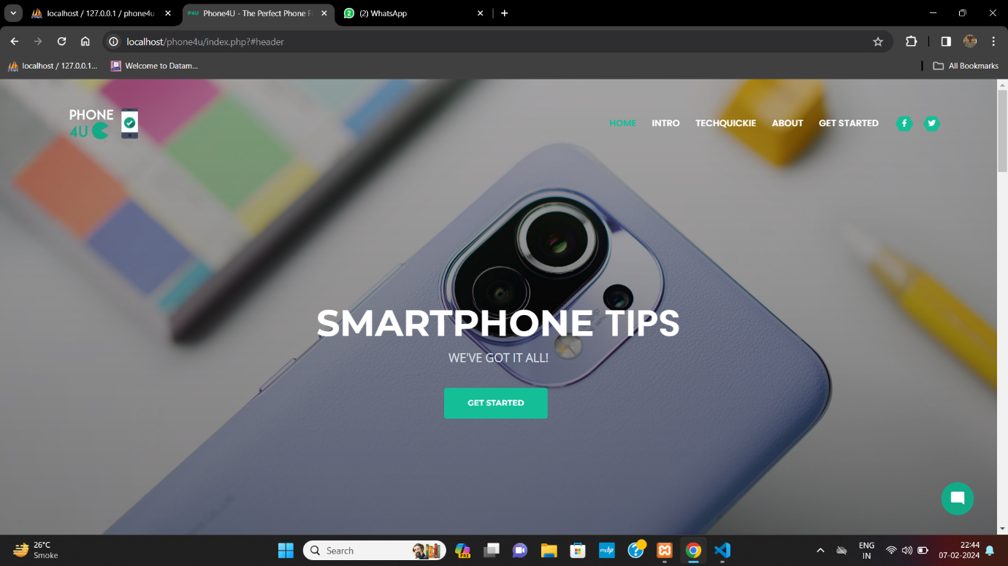

Intro page:

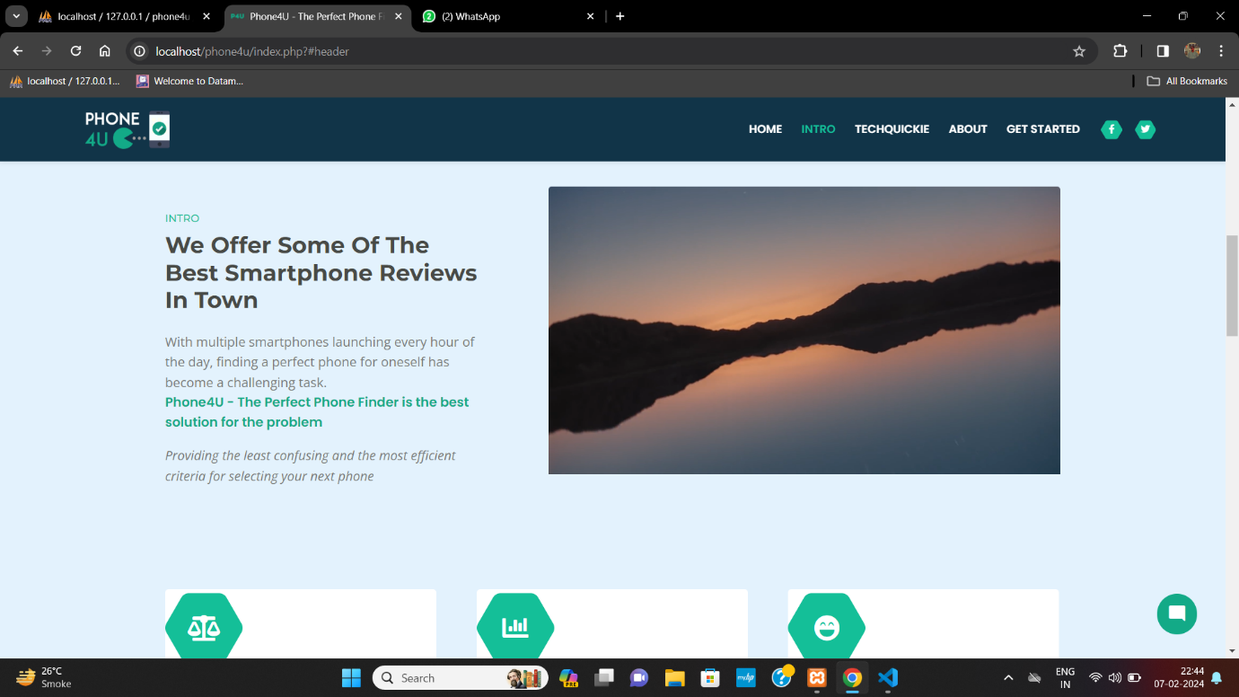

Tech news page:

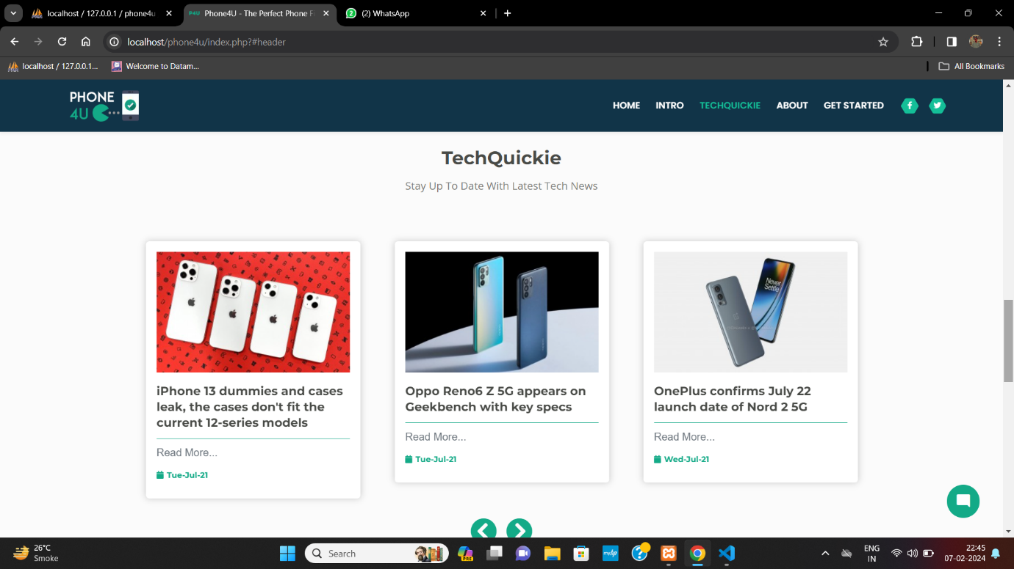

About page:

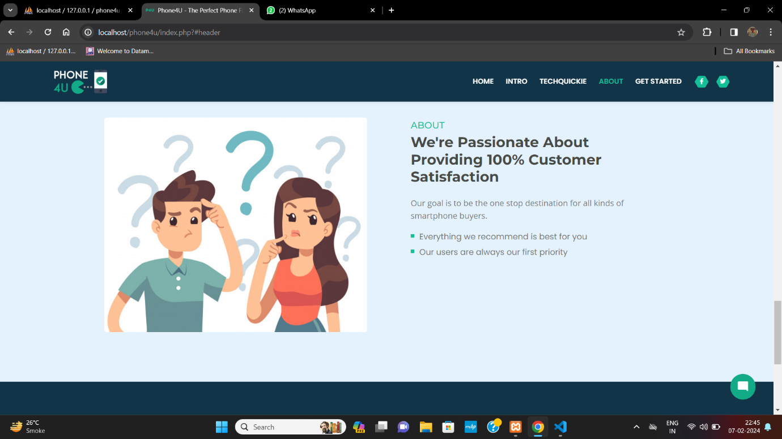

Preference page:

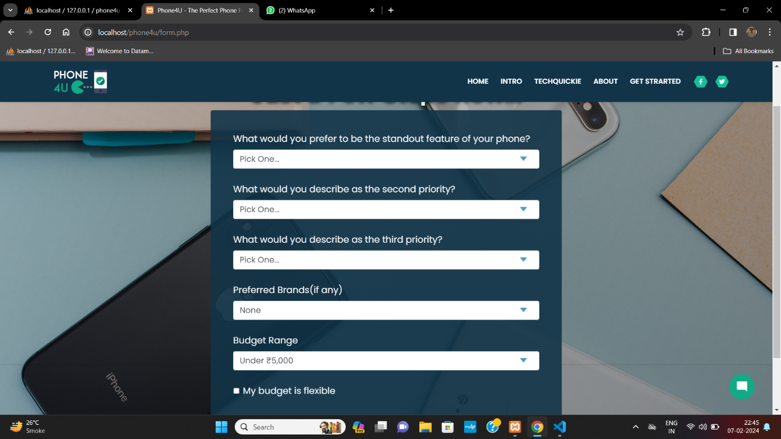

Comparison page:

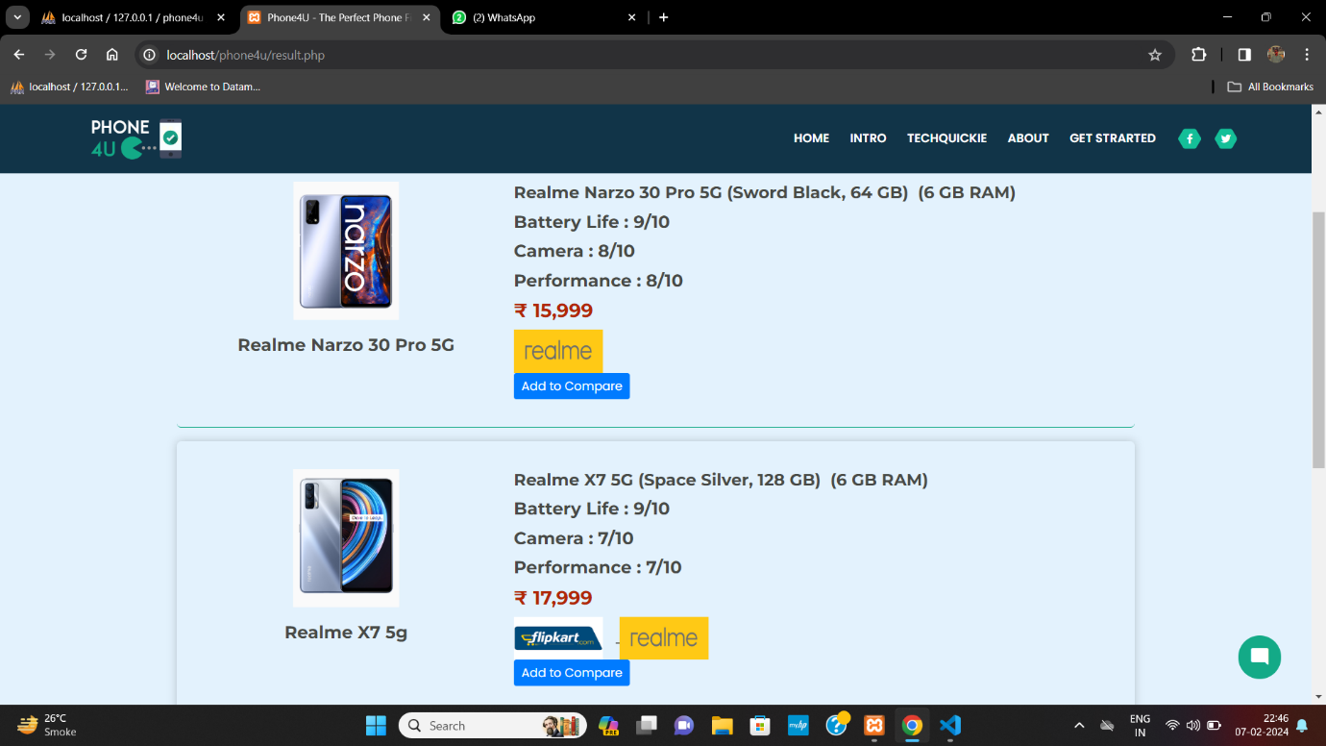

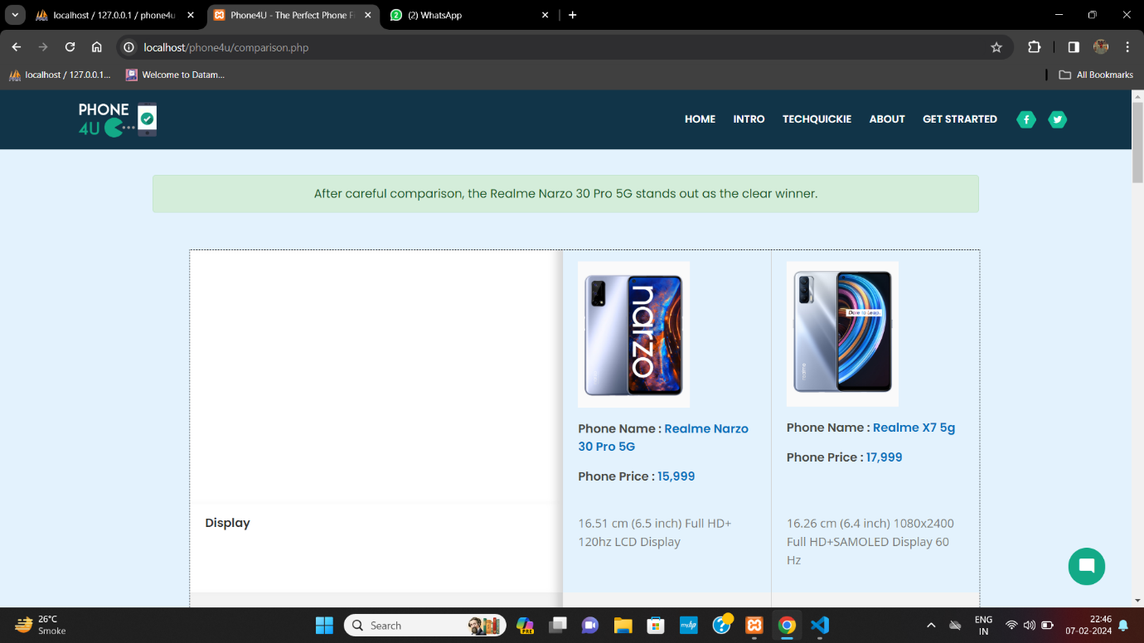

Chatbot:

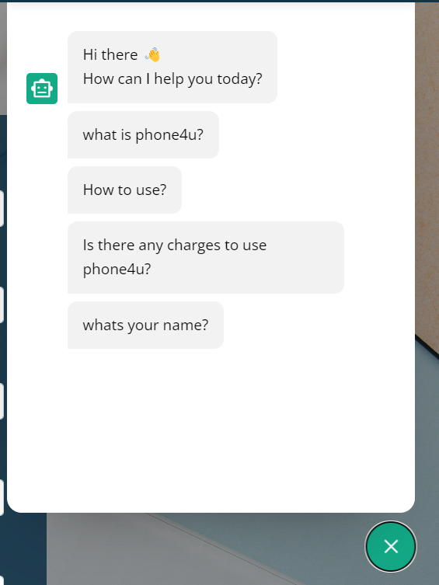

Sentiment analysis:

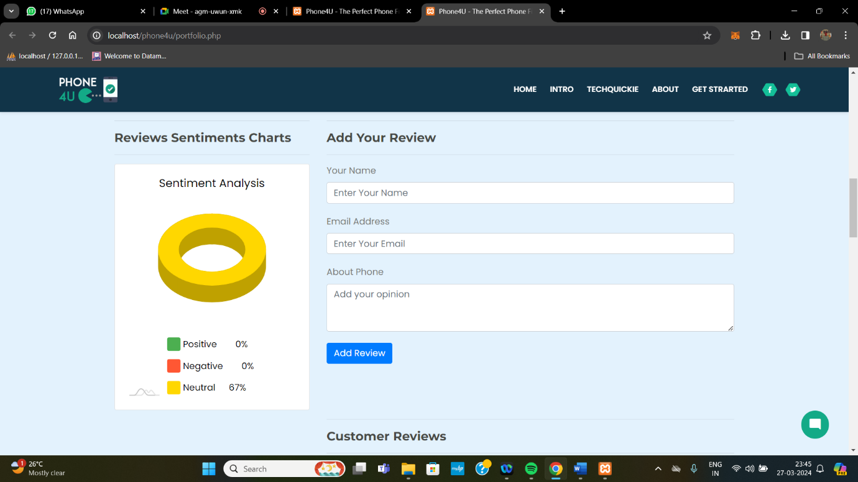

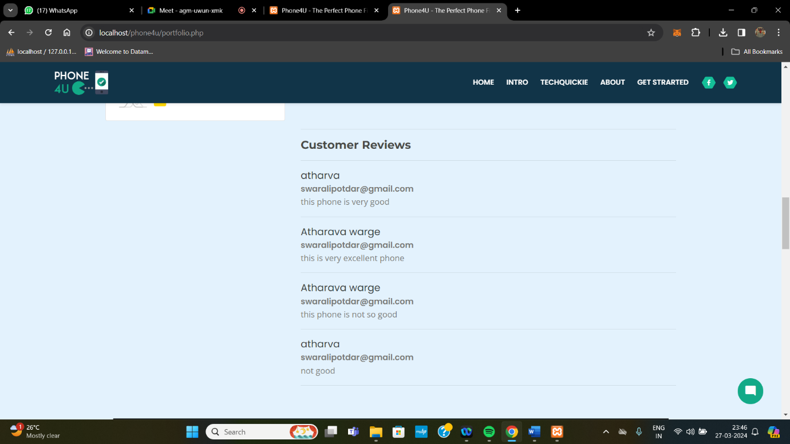

|  |  |
| --- | --- |
| **6.RESULTS ANALYSIS:**  The result analysis for the phone comparison sentiment analysis and chatbot project provides valuable insights into user preferences, sentiments, and interaction patterns. Through sentiment analysis of user reviews and discussions related to phone comparisons, we gain a deep understanding of how consumers perceive various phone models in the market. By employing natural language processing techniques, we can categorize sentiments expressed in reviews and discussions as positive, negative, or neutral, allowing us to gauge the overall sentiment towards each phone model.  Furthermore, the sentiment analysis can uncover specific features or aspects of phones that drive positive or negative sentiments among users. For instance, users might express enthusiasm about the camera quality of a particular phone while being critical of its battery life. These insights are invaluable for phone manufacturers to understand their strengths and weaknesses in comparison to competitors and to tailor their marketing strategies and product development efforts accordingly.  In addition to sentiment analysis, the chatbot component of the project provides another layer of understanding by engaging users in real-time conversations. By analyzing user inquiries, feedback, and preferences collected through the chatbot interactions, we can identify common user queries, pain points, and areas where users seek guidance or clarification during the phone comparison process. This information can inform the improvement of the chatbot's conversational capabilities and content, ensuring a more effective and engaging user experience.  Overall, the result analysis of the phone comparison sentiment analysis and chatbot project offers comprehensive insights into consumer perceptions, preferences, and behavior in the context of phone purchasing decisions. By leveraging these insights, businesses can make informed decisions to enhance their products, services, and customer interactions, ultimately driving greater satisfaction and loyalty among consumers.  Top of Form | **7.CONCLUSION:**  The phone comparison sentiment analysis and chatbot project effectively addressed the need for providing users with intuitive and effective information about different phone models their types and their features. Through careful design and implementation, the project successfully executed user-friendly interfaces and intuitive navigation, enabling users to easily compare various phone specifications and features with pie chart and videos. By utilizing sentiment analysis techniques, the project allowed users to see public opinions and sentiments surrounding different phone models, enhancing their decision-making process. Moreover, the integration of a chatbot feature provided users with instant access to relevant information and support, further enhancing the overall user experience.  **8.REFERENCES:**  Cheng, S. W., Chen, M. C., & Yang, C. S. (2015). Mobile phone selection criteria and preferences: Exploring the differences between early and late adopters. Telematics and Informatics, 32(2), 333-342. [1]  Chittayasothorn, S., & Awa, K. (2019). A Comprehensive Model for Evaluating Smartphone Quality Attributes. Journal of Engineering Research, 7(5), 39-52. [2]  Pang, B., & Lee, L. (2008). Opinion Mining and Sentiment Analysis. Foundations and Trends® in Information Retrieval, 2(1–2), 1-135. [3]  Liu, B. (2012). Sentiment Analysis and Opinion Mining. Synthesis Lectures on Human LanguageTechnologies, 5(1), 1-167. [4]  Serban, I. V., Sordoni, A., Lowe, R., Charlin, L., Pineau, J., Courville, A., & Bengio, Y. (2017). A hierarchical latent variable encoder-decoder model for generating dialogues. arXiv preprint arXiv:1605.06069. [5]  Bordes, A., Boureau, Y. L., & Weston, J. (2017). Learning End-to-End Goal-Oriented Dialog. arXiv preprint arXiv:1605.07683. [6] |