**DESIGN OF AN AGRICULTURAL PICKING ROBOT BASED ON ARDUINO**

**V. RAMANJANEYULU1, L. SRIKANTH2, P. NAGA DIVAKAR REDDY3,**

**B. HUSSIAN4, I. PAVAN KUMAR REDDY5, P. MALLIKARJUNA6**

1Assistant Professor, Department of EEE, Santhiram Engineering College, Nandyal, A.P,

2,3,4,5,6UG Student Scholar, Department of EEE, Santhiram Engineering College, Nandyal, A.P

[ramanjaneyulu.eee@srecnandyal.edu.in](mailto:ramanjaneyulu.eee@srecnandyal.edu.in), [srikanthlukkani123@gmail.com](mailto:srikanthlukkani123@gmail.com)

**ABSTRACT**

Agri bot is a gadget that makes complex tasks easy to perform by making use of software programs. It substitutes the convectional techniques to perform similar tasks with more efficiency. Affixing automation in agriculture has helped create various advancements to the industry, it saves farmer’s time and money. By making use of Bluetooth medium of an android smartphone the agricultural robot can be monitored. The sensors interfaced with microcontroller and motors designs the entire calculation process, monitoring and processing. Usually, people are careless to water the plants on their gardens and rooftops daily, this part explains an in complex and appealing automatic plant watering system which can be built by ourselves in just few hours, by making use of an IR sensor, automatic plant watering system is created, which is based on raspberry and raspberry pi. These agribots can be used for harvesting pesticide spraying, controlling weed and many other applications.

**1.INTRODUCTION**

Agribusiness should adapt to the sector's ongoing transition toward new generation and uses. There were a whole lot of research carried out on writing. Most out-of-the-regular pursuits endorse employing an offset off sensor association to accumulate info from numerous sensors concurrently even as transmitting facts to a far-flung social event. The acquired information by and large famous the remarkable homemade pieces. If you want to enhance crop yield, you can't handily check the regular locations. For a ramification of motives, maintaining a continually high level of certification is not financially viable. Consequently, robots need to be utilized in agriculture to cope with these difficulties. To reap such targets, it's miles important to create a hierarchical structure that allows for the control of all of the elements impacting the capability at every level. Commonplace kinds of manufacturing automation are not used, although this is for superb motives. Studies is regularly conducted but not constantly disseminated to farmers so we can appreciate the monetary blessings of the product. This newsletter is based in a revised textual content submitted on February eleven, 2019, and it focuses on strategies for creating prosperous agribusinesses. Research scholar Kranthi, that Madala, branch of ECM, KLEF, Vaddeswaram, Guntur, A.P, India. KLEF (Deemed to be institution) ECM partner Professor Dr. NarendraBabuTatini of Vaddeswaram, Guntur, A.P, India. Soil, environmental alternate, water tool, plant fabric, and alimentary framework are all monitored the use of persistent statistics in given mobile devices and web get right of entry to. A recreation-converting innovation is at the horizon (Precision Farming - PA). Growing a web of things software employing a degree/module deal method and open motion on programming can reduce development costs and increase infrastructure potential. Far flung sensory machines (WSN) are being an increasing number of utilised to create globally, selection-making structures which might be enormously long lasting in an incident that different signs fail. Results may additionally keep up a crucial distinction from advancement wastes and increase yields by way of decreasing ambiguity about the locations and collected that demand incredibly straightforward systems. In India, most people of farm system [9] is outdated even earlier than it hits the cabinets. Protecting the integrity and great of revolutionary objects is in which IOT[1] use has the maximum innovative capability. Robotics has the capability to improve productiveness, precision, and adaptableness in agribusiness. As such, the project will serve as a case have a look at in how the net of things (IOT), decentralised management, and anticipated burrowing for neurological devices, together with an internet-primarily based interface, can be used to create the proper farm as a method of connection and exercise.

Business sensors for systems aimed for agriculture and its irrigation [8] are very luxurious, making it not possible for smaller farmers to implement this form of machine on their farms. However, producers are presently providing low-cost sensors that may be related to nodes to put into effect low-cost structures for irrigation management and agriculture tracking [9]. Moreover, due to the interest in low-fee sensors for tracking agriculture and water, new low-fee sensors are being proposed in researches which includes a leaf water strain monitoring sensor, a multi-stage soil moisture sensor made from copper earrings located along a percent pipe, a water salinity monitoring sensor made with copper coils or a water turbidity sensor made with coloured and infrared led emitters and receptors.

Due to the latest advances in sensors for the implementation of irrigation systems [10] for agriculture and the evolution of WSN and IOT technologies that may be applied inside the improvement of those structures, we gift a survey aimed at summarizing the cutting-edge country of the art regarding clever irrigation systems. On this survey, we're going to offer an overview of the kingdom of the research concerning irrigation structures. We are able to decide the parameters that are monitored in irrigation systems concerning water amount and nice, soil characteristics, climate conditions, and fertilizer utilization. We are able to provide an outline of the most applied nodes and wireless technologies [1] hired to put in force WSN and IOT based clever irrigation systems. Ultimately, we can talk the demanding situations and the first-rate practices for the implementation of sensor-based [2][3] totally irrigation systems.

Other authors have carried out studies with a focal point on irrigation systems [11], water management [4] or precision agriculture systems. But, the opposite available surveys on clever irrigation systems analyzed quite some papers and therefore do no longer offer an in-intensity evaluation of the kingdom of the art regarding irrigation structures [12]. Others are centered on specific aspects concerning irrigation along with software program for irrigation systems, pivot-middle unique irrigation structures or irrigation structures for greenhouses. Lastly, there are surveys that focus on precision agriculture, crop tracking and the agro-business and environmental fields of agriculture that comment on irrigation agriculture. In this survey, we offer an outline of the contemporary advances in irrigation structures and the applied sensors and actuators. Furthermore, we offer discuss the maximum applied nodes and the wireless technologies employed for the communique and transmission of the records collected through the sensors. This manner, with this work we cope with the modern gap in literature with a survey that offers a top-level view of IoT-based totally smart irrigation structures [13].

Consequently, low food manufacturing impacts each the population and the economic system. In 2002, the monsoon season produced the least amount of precipitation within the closing 130 years. That ended in a loss of rice production because of the dearth of sparkling water. To determine the drought due to anomalies in floor water, the Standardized Precipitation Evapotranspiration Index (SPEI) turned into applied. These indexes and the information collected from sensors that monitor the surroundings, the soil and the water [5] can be applied to decide the present-day state of the water and the opportunity of masking all of the freshwater needs. Countries with higher finances are already implementing structures for water control and water reuse aiming to optimize water usage and reduce the environmental impact as a result of using terrific amounts of water [6][7]. However, a few nations may additionally find those solutions to be high-priced.

**2. LITERATURE SURVEY**

S.Muthunpandian et al. created a mechanized strategy to empower consistent checking of farmland. The innovation controls the sum of water sent to the cultivate, permitting for critical investment funds. The water system framework may advantage from the overhauled technology [1].

Taking into account the regularity of water deficiency, Joaquin Gutierrez et al. [2] appeared how to plan a computerized water system framework that essentially cuts water utilization. They demonstrated they may reuse most of their water, and they set up a framework to tackle sun-oriented vitality to cut their vitality bills. The keen phone was utilized to get and examine online sensor data.

Mohan an et al. [3] carefully track information all through the entire cultivating prepare. Utilizing GSM-powered finders based on ATMEL miniaturized scale controllers, the framework screens temperature and pH levels in wind turbines and water. After that, an Arduino-based Web of Things framework is built up, though a Raspberry pi-based checking arrangement is ideal when working with a huge number of devices.

A Raspberry Pi-powered water system framework was appeared by Michael G. Johnson [4]. Do-it-yourself media, security, and computerization ventures built on the Raspberry Pi. Raspberry Pi framework improvement is more energizing in challenging settings [10]. This study's overarching objective is to make an Internet-of-Things (IOT)-based framework for data-driven computerized cultivating. The Raspberry Pi gives a Web of Things (IOT) arrangement that combines equipment and the cloud for recording collect information in genuine time. Keen sensors and a progressed administration framework collect information on dampness levels and track how they change in reaction to temperature varieties. The system's exactness has been updated so that ranchers may use it, and cloud computing has been included. There incorporates a rundown and conclusion, a dialog of the test information, a unique, a framework and equipment plan, a proposed calculation, and an abstract.

The area's receptivity to novel concepts and strategies makes it a vital target for the advancement of the agrarian segment. Inquire about in the field of agribusiness is very wide. In arrange to collect information from a wide assortment of sensors broadcasting at certain times and conveying it to a removed party through strategies [11], an inaccessible sensor setup is required for most imperative events. The information gives subtle elements on the most regularly experienced viewpoints of thorough estimation. Confirming the trademark components is vital to accomplishing most extreme edit surrender. Various impediments essentially reduce the advantage. As a result, these challenges must be figured in all through the improvement of robotization.

The distinctive unused angles affecting the precision of each estimation require an expansion of a framework that takes into account the ideal strategy to oversee the existing reaction for each such weight. In most cases, producers turn to rambles en masse as a arrangement to particular issues. It sees overwhelming utilization in scholastic circles but is at times advertised to ranchers as a beneficial venture [12]. As savvy buildings proceed to create, the Web of Things (IOT) is examined as a having a place and serve computer to screen soil, found trade, water frame, plant, and a dinner save framework, and to give a non-discourage caution in predominant versatile gadgets and an online entry. Open-source computer program may offer assistance us diminish improvement costs and keep the framework sensible, and the proposed brilliant agrarian (Accuracy Agri - Dad) IOT framework may be utilized as a part/module agreeable strategy.

Situated distant absent in arrange to make dependable frameworks that can be sent against a wide extend of dangers, WSNs are getting to be more well known. Diminishing advancement squanders and expanding collect generation by means of the utilize of institutionalized information [13] on the ground and accumulates with choice totally reliable structures. Most of India's rural yield ruins some time recently it can be sold. When working in an IOT environment, engineers have got to to apparatuses and strategies never some time recently conceivable for keeping tabs on how their items are holding up in real-world utilize. The efficiency, homogeneity, and flexibility of corporate preparing programs all advantage from mechanization. We will be able to move our center from specialized issues to social and relaxation interests as a result of the expansion of IOT gadgets, conveyed compute, and an on-demand, outright interface for shrewd contraptions.

**Existing Method**

Farming is the most vital division of Indian Economy. Indian farming segment accounts for 18 per cent of India's net household item (GDP) and gives work to 50% of the nation’s workforce. Water system is characterized as “Artificially providing & methodicallly separating of water for agribusiness & cultivation in arrange to get higher or subjectively way better generation. In India most of the water system frameworks are not computerized. These procedures are supplanted with semi-automated and robotized procedures. The accessible procedures are like terraced water system, dribble water system and sprinkler framework. The worldwide water system is categorized by expanded request for higher rural efficiency, destitute execution and diminished accessibility of water for farming.

**Proposed Method**

The proposed framework comprises of wheeled versatile robots i.e. Ace and Slave hub, as appeared in Fig. 1. The ace robot is prepared with all sensors can explore autonomously in field. It has moreover the capability of recognizing weeds by utilizing onboard picture dealing with single board computer Raspberry Pi. The ace robot is dependable of arrangement of convenient inaccessible sensor organize through NRF Convention. It has capacity to obtain the channel physically. The other salves/robots can connect the organize by choosing same recurrence channel. In this way joining the framework, the slave robot sends the sensor information to ace hub. Both the robots are prepared with temperature, dampness, smoke and gas sensors to screen the climate and ultrasonic sensors to distinguish deterrents and move independently. The ace hub collects data from partitioned sensor hubs and at that point employments the Hub MCU module to exchange the gathered data to IOT.

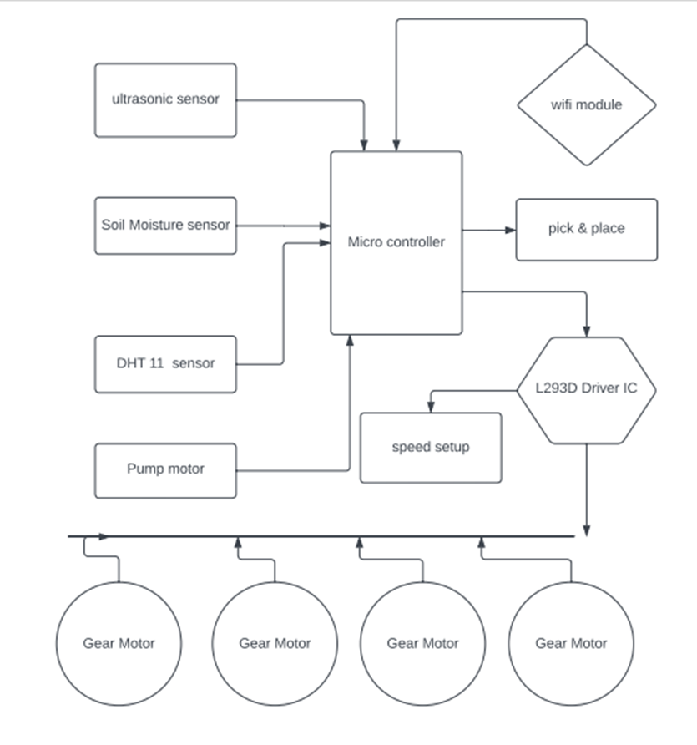

**Figure 1: Block Diagram**

**Ultrasonic sensor:** An ultrasonic sensor is a gadget that employments sound waves to identify the nearness, remove, or vicinity of objects. It works by emanating high-frequency sound waves that are over the capable of being heard extend for people. These sound waves travel through the discuss and bounce off any objects in their way. The sensor at that point recognizes the reflected sound waves and measures the time it took for them to return. By knowing the speed of sound, the sensor can at that point calculate the remove to the protest.

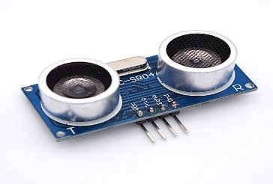

**Figure 2: Ultrasonic Sensor**

**Soil Sensor:**A little charge is put on the anodes and electrical resistance through the sensor is measured. As water is utilized by plants or as the soil dampness diminishes, water is drawn from the sensor and resistance increments. Alternately, as soil dampness increments, resistance diminishes

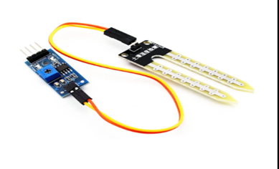

**Figure 3: Soil Sensor**

**Dth 11 Sensor:** The Web of Things (IOT) was utilized in shrewd farming for the reason of deciding soil temperature and dampness, which is fundamental for edit development. The utilize on sensors, rambles, for satellites in trim checking permits for the distinguishing proof of issue ranges and the observing of edit wellbeing. All sorts of information, counting trim wellbeing, mugginess, precipitation, temperature, and more, are included in edit observing frameworks.

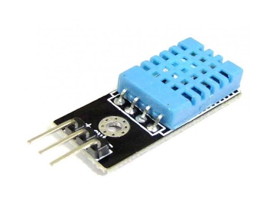

**Figure 4: Dth 11 Sensor**

**Servo Motor:**A servo engine is a rotating actuator that permits for exact control of precise position. It comprises of a standard electric engine coupled to a sensor for position criticism. This input component separates servo engines from standard DC engines, which offer less exact speed control.

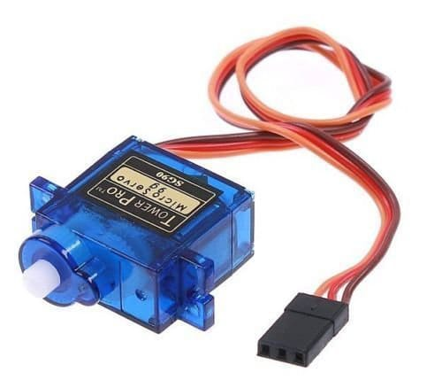

**Figure 5: Servo Motor**

**3v Relay Module:**This capability is especially useful in scenarios where a little control flag from a microcontroller needs to switch higher streams. In pith, a hand-off module amplifies this control flag, empowering it to oversee more significant electrical loads.

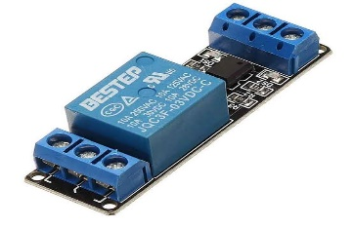

**Figure 6: 3v Relay Module**

**Pump:**A pump is a machine that moves liquids (fluids or gasses) by mechanical activity. It basically takes vitality from an exterior source and changes over it into water powered vitality to thrust, drag, or circulate liquids. Here's a breakdown of how pumps work in general.As the engine turns the impeller, it makes a low-pressure zone in the center, sucking liquid in through the gulf. The turning movement flings the liquid outwards due to centrifugal constrain (think water flying off a turning tire). A volute casing at that point channels this high-velocity liquid and changes over its speed into expanded weight, pushing it out of the pump.

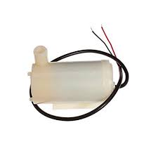

**Figure 7: Pump**

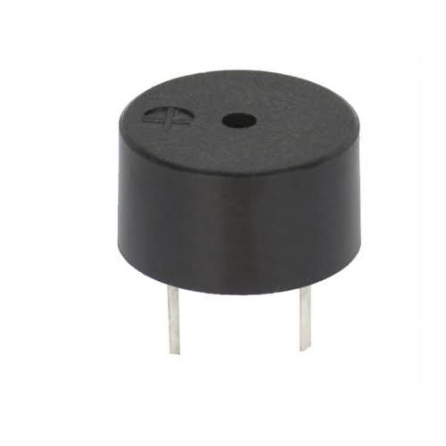**Buzzer:**A buzzer or beeper is a sound signaling gadget, which may be mechanical, electromechanical, or piezoelectric (piezo for brief). Normal employments of buzzers and beepers include alarm gadgets, clocks, prepare and affirmation of client input such as a mouse trap or keystroke.What is a Buzzer? A sound signaling gadget like a beeper or buzzer may be electromechanical or piezoelectric or mechanical sort. The fundamental work of this is to change over the flag from sound to sound. By and large, it is fueled through DC voltage and utilized in clocks, alert gadgets, printers, alerts, computers, etc.

**Figure 8: Buzzer**

**L293D Driver IC:**The L293D is a well-known 16-pin coordinates circuit (IC) that acts as a double H-bridge driver, particularly planned to control two DC motors.The center usefulness lies in its two coordinates H-bridges. An H-bridge is an electronic circuit that permits you to control the course of current stream through a DC motor. By giving particular computerized signals to the input and empower pins, you can control the heading and actuation of each engine associated to the L293D's yields. The IC basically acts as a interpreter between the computerized control signals from your microcontroller and the control required to drive the DC engines.

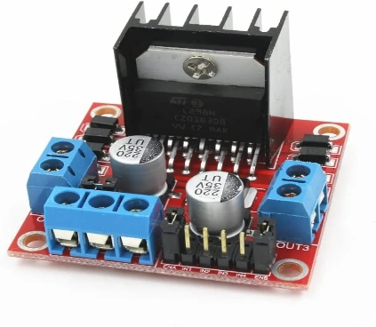

**Figure 9: L293D Driver IC**

**Power Bank Module:**A control bank module is a circuit board that shapes the center of a control bank. It's basically a pre-built and compact gathering containing the basic electronic components to change over control and oversee the chargeng handle sand Driven sign module and a assurance module.

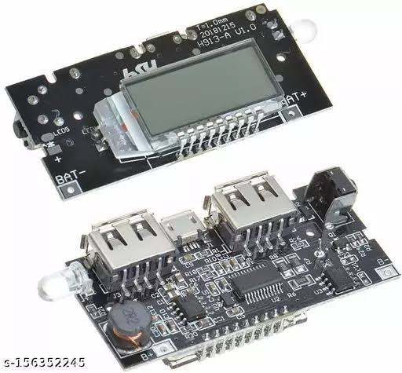

**Figure 10: Power Bank Module**

**Rechargeable Battery:**A rechargeable battery, moreover known as a auxiliary cell or capacity battery, is an electrochemical gadget that you can more than once charge and release. Not at all like expendable batteries, which are tossed absent after utilize, rechargeable batteries offer a more feasible and cost-effective arrangement for fueling electronic gadgets.

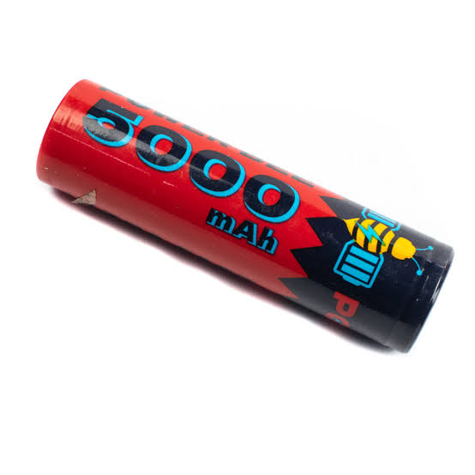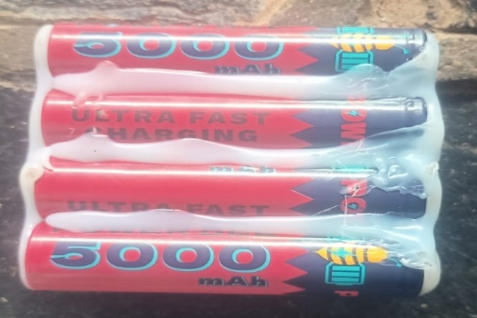

**Figure 11: Rechargeable Battery**

**Core Less DC Motor:**A coreless DC engine is a sort of lasting magnet DC engine that varies from conventional DC engines by missing a press center in its rotor. This plan offers a few points of interest, making them well-suited for particular applications.Similar to conventional DC engines, brushes and a commutator are utilized to control current stream in the rotor windings. By exchanging the extremity of the current in the windings, the attractive field of the rotor is always realigned with the stator's changeless magnets, making a constrain that pivots the shaft.

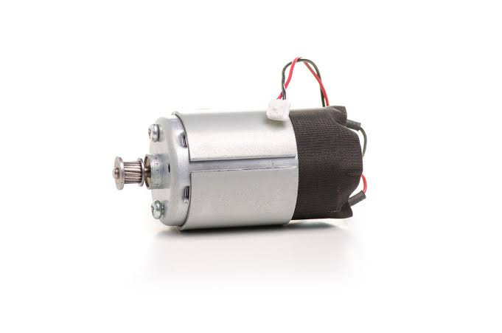

**Figure 12: Core Less DC Motor**

**3.FUNCTIONAL BLOCKS OF PROPOSED SYSTEM**

The ESP32 supports three types of I/O modes with each GPIO Pin: Digital, Analog and Internal Sensors.

**Analog:** Used to send/receive analog data using the following functions:

# examples based on Arduino IDE

analogRead();

analogWrite();

Digital: Used to send/receive digital data using the following functions:

# examples based on Arduino IDE

digitalRead();

digitalWrite();

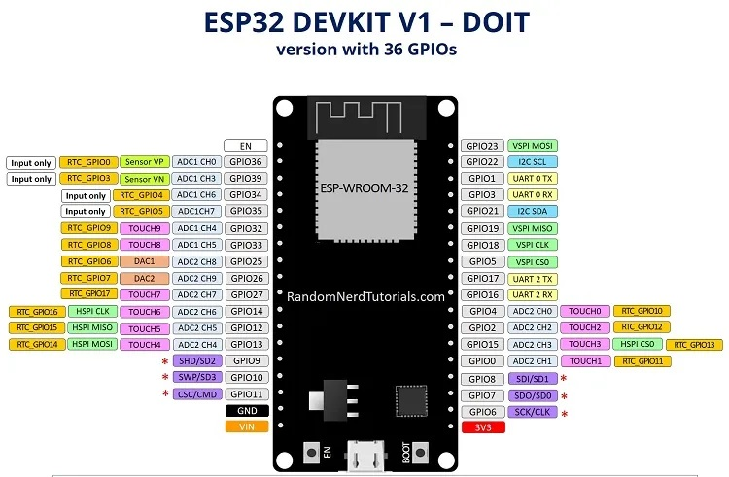

**Figure 13: Esp32 Board Guide**

The ESP32 Dev Kit C is a popular development board for the ESP32 microcontroller. Here's a breakdown of its key pin functionalities:

**Power:** Micro-USB: Provides power and programming interface through USB connection.

5V & 3.3V: These pins allow external power supply. The onboard regulator converts 5V to 3.3V if needed.

Important Note: The ESP32 chip operates at 3.3V. Never apply voltages exceeding 3.3V to any pin, as it can damage the chip.

**General Purpose Input/Output (GPIO) Pins:**39 digital pins: Out of these, 34 can be used as GPIOs for various functionalities like digital input, output, PWM (Pulse Width Modulation), SPI (Serial Peripheral Interface), I2C (Inter-Integrated Circuit), and ADC (Analog-to-Digital Converter).

**D0 - D3, CMD, CLK:** These pins are reserved for internal communication between the ESP32 and SPI flash memory. Avoid using them for external connections.

**GPIO16 & GPIO17:** Availability depends on the specific ESP32 module on the board. They might be reserved for internal use on ESP32-WROVER modules but are usable for general purposes on ESP32-WROOM and ESP32-SOLO-1 modules.

**Other Notable Pins:** Strapping pins (GPIO 0, 2, 4, 5, 12, 15) These pins are used to put the ESP32 into different modes like boot or flashing mode. The Dev Kit C usually sets these pins automatically during operation.

**4.HARDWARE EXPERIMENTAL RESULT**

Arduino Board is the brain of the robot, responsible for processing sensor data, controlling motors, and making decisions based on the program. Motor Driver Module An interface between the Arduino and the motors. It amplifies the control signals from the Arduino to drive the robot's movement.Gripper Mechanism is used for the picking it can be a simple gripper design using servos or solenoids to grasp fruits. A sturdy frame is built to hold all the components and provide structural support for the robot. The material selection (metal, wood) depends on the robot's weight and desired sturdiness.

**Under Working Condition**

The below fig 14 shows the agricultural picking robot it is to move the Forword, backword, left, right and digger with the help of blink app. The above robot we place some sensor they are ultrasonic sensor to find the distance between the object to robot and indicate to user. The Dth 11 sensor is to find the temperature and humidity of field and display in the blink app. Soil moisture sensor uses capacitance to measure dielectric permittivity of the surrounding medium. The pump is start with the help of blink app. The blink app shows the all information about the field. The below fig 6.3 shows the working of pump to place the pump in the water with the help of picking robot. The pump to start with the help of blink IOT app. The below fig 16 shows the soil moisture in the field. The soil moisture is to place in the field and the soil 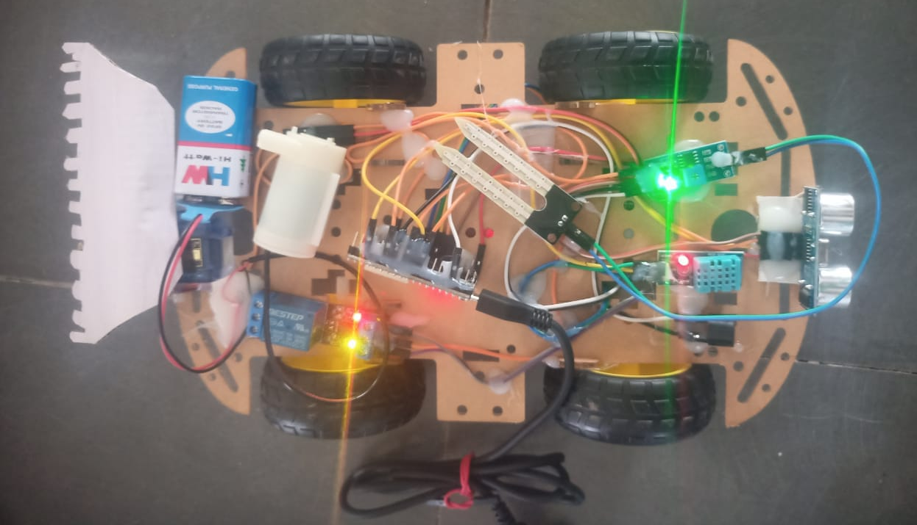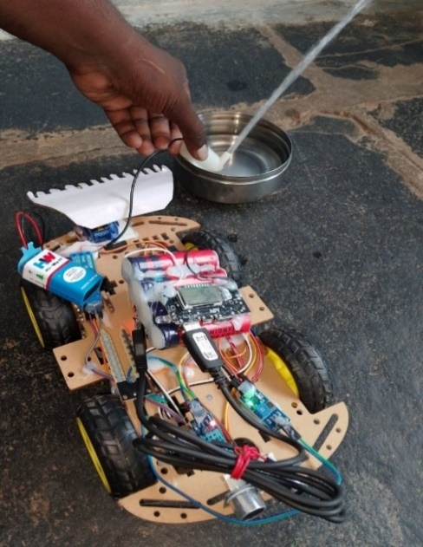percentage is display in the blink IOT app.

**Figure 14: Under Working Condition Figure 15: working of pump**

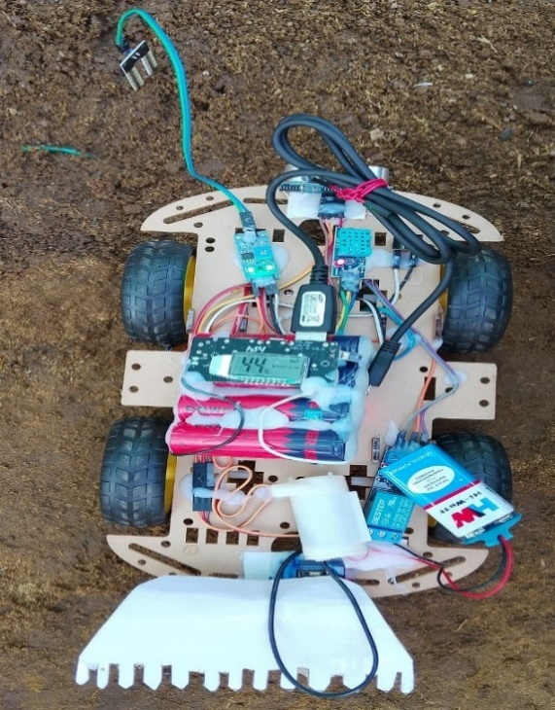

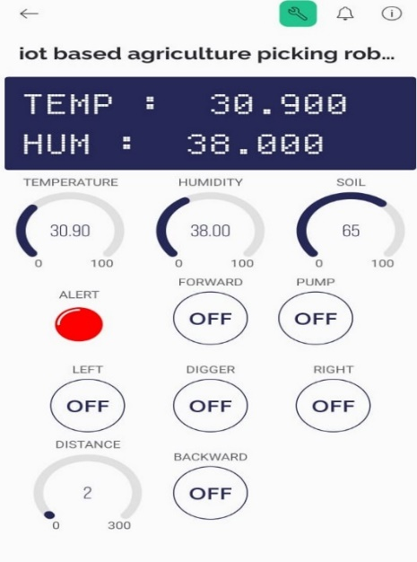

**Figure 16: To Check the Soil in The Field Figure 17: Blink Application**

**5.CONCLUSION:**

Water is fundamental for profitable cultivating. Without crops, a nation cannot make noteworthy financial or social picks up. In arrange to develop arrive that a agriculturist must always screen it, watering as it were when essential and depleting any standing water that may be destructive to the soil and crops. When it comes to cutting edge cultivating, nothing beats the productivity of our Keen Water system + water system systems. Our strategy is an update over other strategies that as it were splashed the edit without collecting; it leverages the Web of Things concept to inundate plants by measuring the dampness in the ground and depleting any abundance water from themes utilizing sensors and Arduino. Gear utilized in this strategy permits agriculturists to pick up extra understanding into their areas. Less work will be required to keep up the edit and deplete abundance water beneath this conspire, sparing time as well as assets.

**REFERENCES**

[1] J.Sofiapriyadarshani&,Dr.M.V.Subramanyam ‘Emperor Penguinoptimized User Association Scheme For Mmwave Wireless Communication’ Wireless Personal Communications. An International Journal,Issn 0929-6212 Doi 10.1007/S11277-020-07269-3.

[2] Dr.M. V. Subramanyam et al ‘Multiple Sensor Data Fusion Based Top-Down Embedded System for Automatic Plant Pot Watering Journal of Algebraic Statistics, e-ISSN: 1309-3452, Marmara University Istanbul University, Istanbul, Vol. 13, No. 1,PP: 884 – 891,2022, No.3.

[3] Saraswati, B. Alekya himabindu, Dr. M. V. Subramanyam “Multiple Sensor Data Fusion Based Top-Down Embedded System for Automatic Plant Pot Watering” Journal of Algebraic Statistics Volume 13, No. 1, 2022, p. 884 – 891.

[4] M. Y. Veeresh, V. N. B. Reddy, and R. Kiranmayi, “Range Estimation of Battery Electric Vehicle by Mathematical Modelling of Battery’ s Depth-of-Discharge,” no. 6, pp. 3987–3992, 2019, doi: 10.35940/ijeat.F8800.088619

[5] Dr.K.Rajasekhar Reddy "Simulation of a Matrix Converter Fed Induction Motor" in International journal of Research science and Management (IJRSM) ( ISSN: 2349-5197, PP- 51-59,Volume-2, Isuue-9, August 2015).

[6] V. Ramanjaneyulu "DTMF Based Irrigation Water Pump Control System" in International Journal of Research Available at https://edupediapublications.org/journals p-ISSN: 2348-6848 e-ISSN: 2348-795X Volume 05 Issue 12 April 2018

[7] David Chaparro, MerceVall-llossera, Maria Piles, Adriano Camps, ChristophR¨udiger and Ramon Riera-Tatch, "Predicting the Extent of Wildfires Using Remotely Sensed Soil Moisture and Temperature Trends", IEEE journal of selected topics in applied earth observations and remote sensing, VOL. 9, NO. 6, June 2016.

[8] Aravind Anil et al., “Project HARITHA - An Automated Irrigation System for Home Gardens”, 2012 [6] JunjinRuan, Peng Liao, Chen Dong., "The Design and Research on IntelligentFertigation System", 2015 7th International Conference on Intelligent Human-Machine Systems and Cybernetics.

[9] Santoshkumar and Udaykumar R.Y, "Development of WSN System for Precision Agriculture", IEEE Sponsored 2nd International Conference on Innovations in Information Embedded and Communication SystemsICIIECS’15.

[10] SabrineKhrij , Dhouha El Houssaini, Mohamed WassimJmal, Christian Viehweger, Mohamed Abid, OlfaKanoun, "Precision irrigation based on wireless sensor network", IET Science, Measurement and Technology,Jan 2014

[11] David Chaparro, MerceVall-llossera, Maria Piles, Adriano Camps, ChristophR¨udiger and Ramon Riera-Tatch, "Predicting the Extent of Wildfires Using Remotely Sensed Soil Moisture and Temperature Trends", IEEE journal of selected topics in applied earth observations and remote sensing, VOL. 9, NO. 6, June 2016.

[12] G.nisha, J.megala, “wireless sensor network based automated irrigation and crop field monitoring system”, sixth international conference on advanced computing (icoac), 2014.

[13] Nelson Sales and ArturArsenio," Wireless Sensor and Actuator System for Smart Irrigation on the Cloud", In Agricultural Communications Documentation Center, 2015