Review Paper On

“Digital ATM For Medicine”

1Vedant Bhendkar, 2Vedanshu Thakare, 3Mamta Kushwaha, 4Revati Hujwant, 5Ishita Bhilavekar,

6Chetan Tembhare, 7Rakesh Gharat.

1,2,3,4,5,6Students, Electronics Engineering,

7HOD, Electronics Engineering,

Dr. Panjabrao Deshmukh Polytechnic, Amravati, Maharashtra, India.

**ABSTRACT: -** This paper presents the design and implementation of a Digital ATM for Medicine aimed at providing access to essential medications in remote or underserved areas where traditional medical stores are not readily available. The Digital ATM for Medicine is designed to operate 24/7, storing various types of medications such as painkillers, cold, cough, fever, and dizziness relievers, and dispensing them according to user requirements.

Keywords: - Arduino, RFID Module, Servo Motors.

# INTRODUCTION

The Digital ATM for Medicines represents a groundbreaking solution to medication management, combining cutting-edge technology with user-centric design principles. At its heart lies the Arduino microcontroller, a versatile and programmable device that serves as the brain of the operation, orchestrating the entire medication dispensing process. The RFID module, integrated seamlessly into the system, adds a layer of connectivity and accessibility, enabling users to interact with the Digital ATM remotely using their mobile phones. This interaction can include tasks such as requesting medication refills, adjusting dosage schedules, or receiving reminders about upcoming doses. The medication storage system within the Digital ATM is designed with precision and security in mind, with electronically controlled compartments ensuring accurate dispensing according to the user's prescription. The system can accommodate various types of medications and dosage schedules, providing flexibility to meet the diverse needs of users. Additionally, the storage system incorporates safety features to prevent unauthorized access or tampering,

ensuring the integrity of the medication supply. The user-friendly interface enhances the overall experience of interacting with the Digital ATM, allowing users to input their medication schedules, view their dispensing history, and receive notifications about their medication regimen. One of the key benefits of the Digital ATM is its ability to improve medication adher- ence by automating the dispensing process and providing timely reminders, helping users stay on track with their medication schedule, leading to better health outcomes and reduced risks of complications associated with missed doses or incorrect medication administration. Moreover, the Digital ATM offers peace of mind to caregiv- ers and healthcare providers, allowing them to oversee the medication adherence of their loved ones from afar and intervene proactively if any issues arise, ensuring the well-being of the user.

# LITERATURE REVIEW

By integrating an Arduino microcontroller and incorporating a RFID module for communication, the automatic medicine vending machine system undergoes a significant transformation in terms of operation and connectivity. The ATmega168 microcontroller, a central component in the system, governs the functionality of various peripherals and components. By integrating an Arduino board into this setup, the system gains new capabilities and functionalities, allowing for enhanced control and communication.

[1]. The Paper provides an overview of an "Automatic Medicine Vending Machine". Users can interact with the machine via a webpage where they can select medicine, confirm the order, and make pay- ments. The project's goal is to provide medical ser- vices in rural and remote areas and has various po- tential applications in shopping malls, railway sta- tions, and healthcare settings.

[2]. The study of the paper explains the existing prob- lems faced by society, such as the lack of availa- bility of medicines, especially during the night or in remote and rural areas. It also mentions the con- cept of General Sale List (GSL) medicines that may be sold or supplied from a vending machine. The focus is on addressing the critical issue of providing access to medicines to people in need, which the document suggests can be tackled by an innovative vending machine that dispenses medi- cines 24x7. The project aims to provide a solution to deliver Over The Counter (OTC) drugs, pain- killers, and first aid products, making it very use- ful to society, particularly in emergency situa- tions. If you need more specific details or addi- tional information, feel free to ask!

[3].In today's landscape, automated vending machines have become ubiquitous due to their ability to streamline tasks and enhance efficiency across vari- ous sectors. This work introduces a novel self- service medication dispenser, akin to traditional vending machines but tailored specifically for dis- pensing medicines. Operating on a coin-operated basis, this device aims to provide users with easy access to a diverse range of medications. It accepts coin denominations, such as Rs.1, Rs.2, and Rs. 5, in any order, offering convenience and flexibility to customers. The core objective of this system lies in promoting responsible medication usage and miti- gating environmental impact by incorporating fea- tures such as precise dosage control and waste re- duction mechanisms. By leveraging a medication control valve, the system ensures accurate dispens- ing while minimizing the risk of medication waste and environmental degradation.

customers. The core objective of this system lies in promoting responsible medication usage and mitigating environmental impact by incorporat- ing features such as precise dosage control and waste reduction mechanisms. By leveraging a medication control valve, the system ensures accurate dispensing while minimizing the risk of medication waste and environmental degradation.

[4].In recent years, there has been a proliferation of vending machines offering an array of product options and customizable selections. These machines span various categories, including snacks, chocolates, foods, and beverages such as glucose water. Additionally, there has been a notable emergence of liquid dispensing vending machines catering to diverse consumer preferences. These advancements in vending technology aim to cater to the evolving needs and preferences of consumers across different demographics.

One significant objective of these vending machines is to address the issue of altered water usage, particularly in regions lacking access to pharmacists or traditional healthcare facilities. By providing convenient access to essential medications and healthcare products, these vending machines play a crucial role in raising awareness and promoting responsible usage of medications, including liquid formulations. They serve as accessible and reliable sources of healthcare essentials for individuals residing in underserved areas, thereby contributing to im- proved health outcomes and well-being within communities.

[5].The quick expansion of the Internet of Things (IoT) and machine learning transforms the world of humans into a smart one. Smart sensors help to make people's lives easier and advanced. In this paper we used different sensors for different applications like level sensor, temperature sensor, and Arduino to do this functions.

# METHODOLOGY

Developing a medicine vending machine utilizing RFID and Arduino technologies involves several key steps. Initially, the hardware components, in- cluding Arduino microcontrollers and RFID mod- ules, are assembled and integrated into the vending machine framework. Arduino serves as the central control unit, managing the interaction between the user interface, medication dispensing mechanism, and RFID module.

Next, the software programming for Arduino is developed to facilitate various functionalities, such as user input processing, medication inventory management, and communication with the RFID module. The program also includes algorithms for dispensing medications based on user requests and ensuring the security of the vending machine system.

Simultaneously, the RFID module is configured to enable communication between the vending machine and users' mobile devices. This involves setting up SMS-based commands for users to interact with the vending machine, such as requesting specific medica- tions or checking medication availability.

Furthermore, the medication dispensing mechanism is designed and integrated into the vending machine, ensuring accurate and secure dispensing of medications based on user requests. Extensive testing and validation procedures are conducted to verify the functionality, reliability, and security of the medicine vending machine. This includes testing the interaction between Arduino and RFID modules, validating med- ication dispensing accuracy, and assessing the respon- siveness of the user interface. Iterative refinements are made based on the test results to optimize the perfor- mance and usability of the vending machine system. Overall, the methodology encompasses hardware inte- gration, software development, communication setup, mechanism design, and rigorous testing to en- sure the successful implementation of a medicine vending machine using RFID and Arduino. technolo- gies.

Circuit Diagram:-

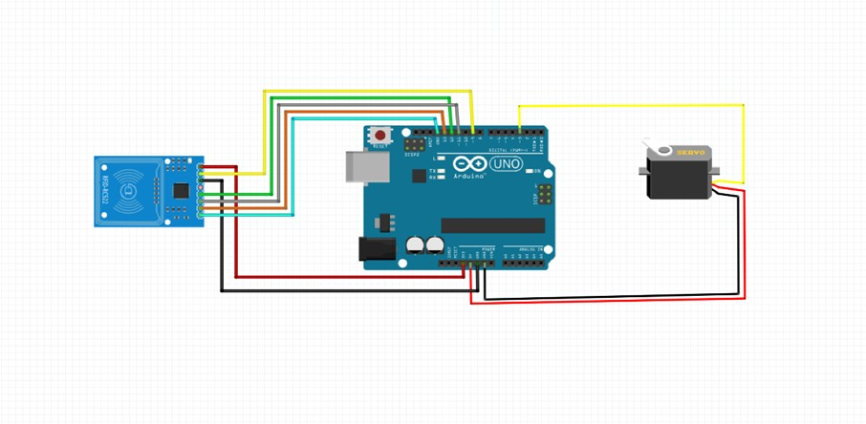

Fig no.1 Connections of Digital ATM for Medicine

# HARDWARE REQUIREMENT

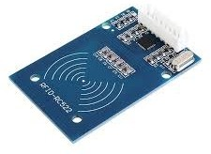

Fig no.2 RFID

RFID (Radio-Frequency Identification) is a technolo- gy that uses electromagnetic fields to automatically identify and track tags attached to objects. An RFID system consists of three main components: a tag or transponder, a reader or interrogator, and an antenna. The tag contains a microchip that stores data and an antenna to communicate with the reader.

The reader emits radio waves to communicate with the tag and read its data. RFID tags can be active, passive, or semi-passive. Active tags have their pow- er source and can transmit signals over longer dis- tances. Passive tags rely on the reader's electromag- netic field to power them and have a shorter read range. Semi-passive tags also rely on the reader for power but have a battery to power their internal cir- cuitry. RFID systems operate at different frequen- cies, including low-frequency (LF), high-frequency (HF), and ultra-high-frequency (UHF). Each fre- quency has its advantages and is suitable for different applications.

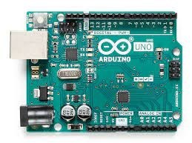 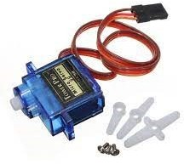

Fig no.3 Arduino UNO

Arduino Uno, a versatile microcontroller board based on the ATmega328P chip, serves as the cornerstone of a medicine vending machine's functionality. With its robust capabilities, Arduino Uno handles a multitude of tasks essential for the smooth operation of the vending system. Acting as the central nervous system, Arduino Uno interfaces with user input devices, such as buttons or touchscreens, to interpret commands for medication selection and dispensing. Furthermore, it efficiently manages the inventory of medications stored within the machine, keeping track of quantities and updating stock levels in real-time. Arduino Uno also takes charge of controlling the dispensing mechanism, ensuring pre- cise and accurate delivery of medications according to prescribed dosages. Additionally, it facilitates communication with the RFID module, enabling re- mote interaction with the vending machine via SMS or calls. Through this communication channel, users can request medications, check availability, or receive im- portant notifications regarding their medication regi- men. Moreover, Arduino Uno implements robust security measures to safeguard the vending machine, incorporating authentication protocols to prevent unauthorized access and ensure the integrity of the system. In essence, Arduino Uno's pivotal role in orchestrating the various components and functions of the medicine vending machine ensures re- liable operation and seamless user experience, ulti- mately contributing to improved accessibility and man- agement of essential medications.

Fig no.4 Servo Motor

Within the framework of a medicine vending machine, the servo motor emerges as a critical component, pivotal in the precise dispensing of medications to users. Operated by the Arduino Uno microcontroller, the servo motor serves as the driving force behind the mechanical dispensing mechanism. Its primary function lies in executing controlled rotational movements to activate the mechanism responsible for releasing medications from their allocated compartments. Through precise instructions from Arduino Uno, the servo motor rotates to predetermined angles or positions, ensuring accurate dosage and quantity of medications dispensed with each transaction. This precision not only minimizes the risk of errors but also enhances user confidence in the vending machine's reliability. Furthermore, the servo motor's adjustable parameters, programmable through Arduino Uno, enable customization to accommodate various medication types and dosag- es, thus expanding the machine's versatility. Renowned for their durability and efficiency, servo motors uphold consistent performance even during prolonged operation, making them a dependable choice for continuous dispensing tasks. Moreover, their low power consumption aligns well with the energy-efficient demands of modern vending machine setups. In essence, the servo motor's role in the medicine vending machine exemplifies its indispensability, facilitating precise and reliable medication dispensing that ensures user satisfaction and safety.

# CONCLUSIONS

In Conclusion, the Digital ATM for Medicines is an innovative solution designed to revolutionize medication management. By leveraging Arduino microcontrollers and RFID modules, this system offers remote interaction, real-time monitoring, and secure dispensing of medications. Its user-friendly interface and customizable features empower users to manage their medication schedules effectively, leading to improved adherence and better health outcomes. With automated dispensing, robust security measures, and remote management capabilities, the Digital ATM for Medicines represents a significant step forward in patient-centric healthcare delivery.

# REFERENCES

[1]. Abhijeet Bhande, Aniket Tambe, Falguni Nim- kar, Mr. Prabhu Reddy AUTOMATIC MEDI- CINE VENDING MACHINE,Volume:03/

Issue:05/May-2021

[2]. Malashree.G, Ubaidulla, Shilpa, Divya U, ATM (All Time Medicine) Counter For Medicine Self-Dispensing, Volume VI, Issue VS, May 2017 | ISSN 2278-2540

[3]. Raviraja K, Pavan R, Sanjay P, Srikanth D, Kiran Kumar T,Anytime Medicine Vending Machine, Journal of Communication Engineer- ing and Its Innovations Volume 5 Issue 2

[4]. Teerapong Boonlar, Online Checking System for Drinking Quality of Drinking Water Vend- ing Machine, International Conference on Sig- nal - Image Technology & Internet -Based Sys- tems (SITIS), 2019

[5]. Praveen Kumar; Shailaja Singh; Manu Choudhary; K. Singh, Solar Powered Medic Vending Machine, IEEE 2020

[6]. Sasikala G, Kuldip sing Rajput, Sarfaraz Hussain and Aastha Shrivastava, real time em- bedded based water vending machine, Asian Journal of Science and Technology, December 2014