**EFFECT OF DIFFERENT SOIL CONDITIONS ON THE DESIGN OF FOUNDATIONS FOR LARGE BUILDINGS**

***Ranjeet Ravindra Tanpure1, Akshay Vilas Gulve2, Sumit Sitaram Ghorpade3, Suyas Changdev Pokale5,* *Prof. Shinde P.B5***

1,2,3,4 Student, Department Of Civil Engineering Vidya Niketan College of Engineering, Bota. 422602

5Lecturer, Department Of Civil Engineering, Vidya Niketan College Of Engineering, Bota. 422602

**ABSTRACT**

Above the past two decades, there has been a significant rise in the construction of tall structures over 150m in height, with an almost exponential development rate. Numerous similar structures have been built throughout the Middle East and Asia, and many more are proposed or now under development. Buildings over 300m in height are posing new engineering difficulties, especially in terms of structural and geotechnical design. Wind analysis is critical when it comes to big structures. Geotechnical engineers, in particular, are progressively abandoning empirical techniques in favour of state-of-the-art methods when designing foundations for super-tall structures. Numerous studies have investigated the structural behaviour of tall structures with SSI by taking into account a variety of factors such as foundation type, soil conditions, lateral stresses, and the ratio of the flexural stiffness of the beam and column. Very few studies on the soil-structure interaction of tall structures in clayey soil conditions, especially in Indian seismic zones, have been conducted. In zone III, a G+18-story rectangular structure with a 3 m floor-to-floor height was assessed using the Etabs software. The selected plan is rectangular in shape. The structure has been evaluated for static and dynamic wind and seismic forces. Structures have been developed for use in circumstances of hard, medium, and soft soil.

***Keywords: soil conditions, foundations, large buildings, ETABS.***

# I. Introduction

## 1.1 General

Indian population is estimated at 1,282,390,303 as of 2015 and India has become second most populous country in the world. Vertical growth of built environment is unavoidable for providing shelter and workspace for them. Dynamic analysis of tall buildings with all considered safety factors has become a challenge for Civil Engineers. Earthquake resistant tall buildings behaving well in all type of soil conditions, especially in soft soils are necessary to be constructed. Wind analysis is also important in case of tall buildings.

## 1.2 Tall Buildings

The last two decades have seen a remarkable increase in construction of tall buildings in excess of 150m in height, and an almost exponential rate of growth. A significant number of these buildings have been constructed in the Middle East and Asia, and many more are either planned or already under construction. “Super-tall” buildings in excess of 300m in height are presenting new challenges to engineers, particularly in relation to structural and geotechnical design. Wind analysis is important in case of tall buildings. Figure 1 shows the significant growth in the number of such buildings either constructed. Many of the traditional design methods cannot be applied with any confidence since they require extrapolation well beyond the realms of prior experience, and accordingly, structural and geotechnical designers are being forced to utilize more sophisticated methods of analysis and design. In particular, geotechnical engineers involved in the design of foundations for super-tall buildings are increasingly leaving behind empirical methods and are employing state-of-the art methods.

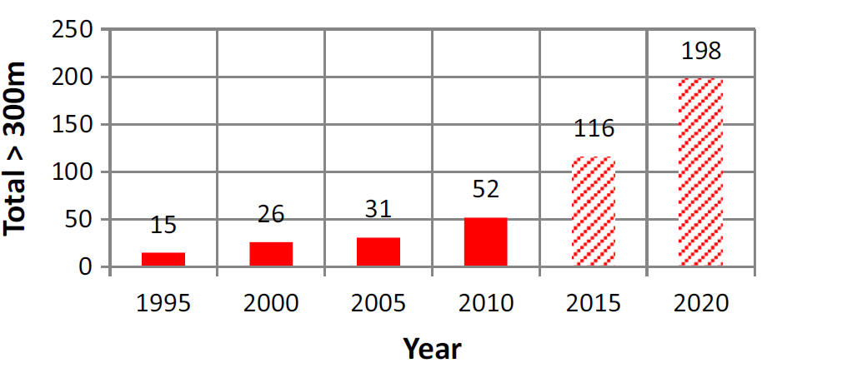

#### Fig 1: Total number of buildings in excess of 300 m tall.

The investigations have been carried out by many researchers on the structural behaviour of tall buildings with SSI (Soil Structure Interaction) by considering many parameters like foundation type, soil conditions, lateral forces, ratio of flexural stiffness of beam and column etc. Very few investigations have been carried out on soil-structure interaction of tall buildings under clayey soil conditions, particularly in Indian seismic zones. The objective of the study is to investigate behavior of Tall building in terrain category 2 under wind loading having different soil conditions such as Hard, Medium and Soft soil.

# II. Literature Review

## The Research Carried out by various researchers is provided below: -

The summary of all the literature through standard publications and conference papers have summarized below in effective manner.

* **K. Vishnu Haritha, Dr.I. Yamini Srivalli [1]** In this paper equivalent static method is used for analysis of wind loads on buildings with different aspect ratios. The aspect ratio can be varied by changing number of bays. Aspect ratio 1, 2, 3 were considered for present study. The analysis is carried out using ETAB.
* **B. Dean Kumar and B.L.P. Swami [2**] In this paper the present work, the Gust Effectiveness Factor Method is used, which is more realistic particularly for computing the wind loads on flexible tall slender structures and tall building towers. In this paper frames of different heights are analysed and studied.
* **Yin Zhou and Ahsan Kareem [3]** In this paper “Gust loading factors for design applications” Wind loads on structures under the buffeting action of wind gusts have been treated traditionally by the “gust loading factor” (GLF) method in most major codes and standards around the world. The equivalent static wind loading used for design is equal to the mean wind force multiplied by the GLF. Although the traditional GLF method can ensure an accurate estimation of the displacement response, it fails to provide a reliable estimate of some other response components. In order to overcome this shortcoming, a more realistic procedure for design loads is proposed in this paper.
* **Wakchaure M. R., Gawali Sayali [4]** In this paper the gust effectiveness factor method takes into account the dynamic properties of the structure, the wind-structure interactions and then determines the wind loads as equivalent static loads. Wind loads are determined based on gust effectiveness factor method. The critical gust loads for design are determined. After the application of calculated wind loads to the building models prepared in finite element software package ETAB’s 13.1.1v. Having different shapes are compared in various aspects such as storey displacements, storey drifts, storey shear, axial forces in column etc. Based on the results, conclusions are drawn showing the effectiveness of different shapes of the structure under the effect of wind loads.
* **Mohammed Asim Ahmed, Moid Amir, Savita Komur, Vaijainath Halhalli [5]** In this paper presents displacement occur in different storey due to wind in different terrain category. Three models are analysing using ETABS 2015 package. Present works provides a good source of information about variation in deflection as height of model changes and percentage change in deflection of same model in different terrain category.

## Research gap

The existing literature review on the analysis and design of foundations for large buildings under wind and seismic loads reveals significant insights into structural responses. The current body of work tends to overlook the variability in soil properties and lacks a comprehensive exploration of how diverse soil conditions influence foundation design. While some studies touch upon soil-structure interaction, there is a need for more in-depth investigations that specifically address the dynamic behavior of tall buildings in relation to varying soil types. Moreover, geographical specificity is often overlooked, and there is a dearth of research considering the unique soil compositions in different regions. Integrating advanced analytical tools and refining design codes to incorporate soil-specific parameters are also areas that require further exploration. Additionally, there is a research gap in validating numerical models against real-world data to enhance the accuracy of predictions. Bridging these gaps would contribute to a more holistic understanding, offering valuable insights for professionals involved in the construction and safety of large buildings.

# III. Methodology

Following is flowchart of work for Project: -

#### Fig 2: Flowchart.

A study involving dynamic effect of wind load on RC buildings and study the behavior of the buildings. The methodology worked out to achieve the mentioned objectives is as follows: -

* + 1. Compilation of relevant research data from national and international journals, research papers web source, text books, reference books etc to get acquainted with past research.
    2. Identification of scope of further research in the high rise buildings subjected to wind effects.
    3. Define the scope of specimen for research like height, plan size of building, input parameters from IS code, Material specifications, member specifications etc.
    4. The E-TABS software is used to develop 3D model and to carry out the analysis. The lateral loads to be applied on the buildings are based on the Indian standard IS-875-Part 3: 2015.
    5. Comparison of results which have significant effects on foundation design of tall building varies as per soil conditions and preparation of discussion summary.
    6. Result and discussions.
    7. Conclusion will be drawn based on the result of analysis.

# IV. Problem Statement

In this project, a G+18-storey structure of a rectangular building with 3 m floor to floor height has been analysed Non-Linear Dynamic Analysis of Multi-storey R.C.C Buildings using ETAB software in zones III. The plan selected is Rectangular in shape. The structure has been analysed for both static and dynamic wind and earthquake forces. Hard, Medium and soft soil condition has been selected for the structure.

# V. MODELLING

## 5.1 Prepare Model in ETABS

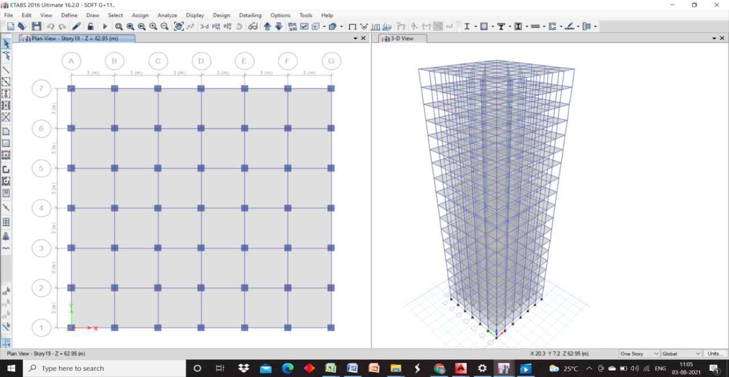

Fig 3: Prepare modeling in ETABS.

## 5.2 Software Development 3D FEM Model High Rise Structure Having Different Soil Conditions

Table 1: Models.

|  |  |
| --- | --- |
| MODEL 1 | G+18 IN SOFT SOIL |
| MODEL 2 | G+18 IN MEDIUM SOIL |
| MODEL 3 | G+18 IN HARD SOIL |

# VI. RESULT AND DISCUSSION

## 6.1 Introduction

In this project, a G+18-storey structure of a rectangular building with 3 m floor to floor height has been analysed Non-Linear Dynamic Analysis of Multi-storey R.C.C Buildings using ETABS software in zones III. The plan selected is Rectangular in shape. The structure has been analysed for both static and dynamic wind and earthquake forces. Hard, Medium and soft soil condition has been selected for the structure. The finite element method (FEM) is a widely used method for numerically solving [differential equations](https://en.wikipedia.org/wiki/Differential_equation) arising in engineering and [mathematical modelling](https://en.wikipedia.org/wiki/Mathematical_models).

* **Storey Displacement**

## 6.2 G+18: - Storey Displacements for Symmetric in Plan Building Resting on Soft Soil, Medium Soil and Hard Soil in X –Direction

Graph 1:G+18: Storey Displacement -X.

Above graph.6.1. describes the results of storey displacement-X of G+18, as we see in the graph, maximum results of displacement value are for soft soil. Storey displacement value for hard soil is in between 0-110, Storey displacement value for medium soil is in between 0-150, and Storey displacement value for soft soil is in between 0-220.

* **Design Reactions: -**

Graph 2: G+18: Design Reaction.

Above graph.6.3. Describes the results of Design Reaction of G+18, as we see in the graph, maximum results of Design Reaction value is for soft soil. Design Reaction value for Hard soil is 1993 KN, Design Reaction value for medium soil is 2152 KN, and Design Reaction value for soft soil is 2580 KN.

* **Storey Drift: -**

## 6.3 G+18: Storey Drift

Graph 3: G+18: Storey Drift-X

Above graph.6.4. describes the results of storey Drift-X of G+18, as we see in the graph, maximum results of storey drift value are for soft soil. Storey displacement value for Hard soil is in between 0-3, Storey displacement value for medium soil is in between 0-4, and Storey displacement value for soft soil is in between 0-5.

* **Base Shear**

## 6.4 G+18:- Base Shear for A symmetric in plan building on Soft Soil, Medium Soil and Hard Soil for X-direction

**Graph 4: G+18: Base Shear- X.**

Above graph.6.6. describes the results of storey displacement-Y of G+18, as we see in the graph, maximum results of displacement value are for soft soil. Storey displacement value for Hard soil is in between 0-6500, Storey displacement value for medium soil is in between 0-8500, and Storey displacement value for soft soil is in between 0-10500.

# CONCLUSION

## 7.1 Conclusion

The study as a whole may prove useful in formulating design guidelines for seismic design of building frames incorporating the effect of soil flexibility. In this study, the effects of wind and SSI are analyzed for typical multi-story building resting Using the ETABS programmed; a G+18-storey rectangular building with a 3 m floor-to-floor height was evaluated in zone III. Rectangular is the form of the chosen plan. Static and dynamic wind and seismic forces have been analyzed for the structure for different soil conditions, the different soil conditions are directly affect the design parameters of the foundation such as length width depth and reinforcement of the foundations, it also affect the displacement and storey drift of the structure. The all conclusion is concluding from the following parameters

* The findings of storey Displacement-X of G+18, as seen in the graph; the highest displacement value is for soft soil. Hard soil has a storey displacement value of 0-110, medium soil has a storey displacement value of 0-150, and soft soil has a storey displacement value of 0-220.
* The findings of storey displacement-Y of G+18, as seen in the graph; the highest displacement value is for soft soil. Hard soil has a storey displacement value of 0-110, medium soil has a storey displacement value of 0-150, and soft soil has a storey displacement value of 0-220.
* The findings of Design Reaction of G+18, and as we can see from the graph, the highest Design Reaction value is for soft soil. Hard soil has a design reaction value of 1993 KN, medium soil has a design reaction value of 2152 KN, and soft soil has a design reaction value of 2580 KN.
* The results of storey Drift-X of G+18, as we see in the graph, maximum results of storey drift value are for soft soil. Storey displacement value for Hard soil is in between 0-3, Storey displacement value for medium soil is in between 0-4, and Storey displacement value for soft soil is in between 0-5.
* The results of storey displacement-Y of G+18, as we see in the graph, maximum results of displacement value are for soft soil. Storey displacement value for Hard soil is in between 0-3, Storey displacement value for medium soil is in between 0-4, and Storey displacement value for soft soil is in between 0-5.
* The results of storey displacement-Y of G+18, as we see in the graph, maximum results of displacement value are for soft soil. Storey displacement value for Hard soil is in between 0-6500, Storey displacement value for medium soil is in between 0-8500, and Storey displacement value for soft soil is in between 0-10500.
* The results of storey displacement-Y of G+18, as we see in the graph, maximum results of displacement value are for soft soil. Storey displacement value for Hard soil is in between 0-6500, Storey displacement value for medium soil is in between 0-8500, and Storey displacement value for soft soil is in between 0-10500.

# References

1. K. Vishnu Haritha, Dr.I. Yamini Srivalli (2013**) “Effect of Wind on Tall Building Frames - Influence of Aspect Ratio”**. International Journal of Research in Civil Engineering, Architecture & Design Volume 1, Issue 1, July-September, 2013, pp. 01-06, © IASTER 2013 ISSN Online: 2347-2855, Print: 2347-8284
2. B. Dean Kumar and B.L.P. Swami (2010) **“Wind effects on tall building frames-influence of dynamic parameters”** Indian Journal of Science and Technology Vol. 3 No. 5 (May 2010) ISSN: 0974- 6846
3. Yin Zhou and Ahsan Kareem (1999**) “Gust loading factors for design applications”** J. Struct. Div., ASCE, 93(ST3), 11-34.
4. Wakchaure M. R., Gawali Sayali (2015) **“Effects of Shape on Wind Forces of High-Rise Buildings Using Gust Factor Approach”** International Journal of Science, Engineering and Technology Research (IJSETR), Volume 4, Issue 8, August 2015.
5. Mohammed Asim Ahmed, Moid Amir, Savita Komur, Vaijainath Halhalli (2015**) “Effect of wind load on tall buildings in different terrain category”** IJRET: International Journal of Research in Engineering and Technology.