**REVIEW PAPER ON STUDY ON MULTI-MODAL TRANSPORTATION SYSTEM**

***Vivek kumar giri1*, Shivani2***

*1Student, 2Assistant Professor*

*Sat Priya Group of Institutions, Rohtak*

***\*Corresponding Author***

***E-mail Id:-girivivek1993@gmail.com***

***ABSTRACT***

With international trade becoming a giant a part of the worlds economic activity, the demand permanently freight transportation systems has grown substantially. the acceptable use of transportation is an integral a part of the availability chains effectiveness. Therefore, the continual economic globalization, the growing demand for speed-to-market product delivery, and therefore the must manage global supply chains more effectively, has led to the sustained increase in demand towards multimodal transportation systems (MTS). MTS play a necessary role in corporations competing in global markets within the 21st century. In transportation, the effectiveness and efficiency of the full system depends upon the interconnectivity of its elements. Because disruptions within the supply chain are costly, this research will observe improving the efficiency of MTS by observing disruptions that have a negative impact on the weather that compose the system. Although past research classifies disruptions in MTS as: congestion, demand fluctuations, time delays, capacity limits, scheduling and, connectivity between the various modes, limited research address the connection between these failures and therefore the system.

Top of Form

Bottom of Form

This research presents a Systems Dynamics (SD) approach to model MTS, which will let us iterate and mitigate a system to be able to forecast scenarios and meaningful hypothesis of a systems behavior over time. The SD model will aid to identify and understand those major elements and disruptions that altogether impact the efficiency of the MTS. The model will help determine how the disruptive factors of the supply chain are related to the efficiency of the system and will suggest decision- making strategies that will improve MTS performance over time being able to enhance customer satisfaction.

***Keywords:-*** *steel fiber reinforced concrete (SFRC), steel fiber, flexural strength, compression strength, split tensile strength*

**INTRODUCTION**

An efiicient transport system is very important in an industrialized society if trying to compete in global markets in the 21st century. Even before Thomas Friedman suggested that the world was flat in 2002, the worldwide phenomenon of globalization, brought by modern communication and the Internet; had inevitably already encouraged a rapid pace of change towards consciously opening cross-border links in international trade and finance. Supply chanining,out sourcing and trade globalization, , had changed the world permanently . With international trade becoming a big part of the worlds economic activity, good freight transportation systems grew substantially and became even more significant in any supply chains success.

The movement of freight from one location to another as it goes from the beginning of the supply chain to the customer suggested through the transportation . Five modes of transportation, each with advantages and disadvantages, carry freight in the U.S.: water, air, rail, road and pipeline. Transport through water is the least expensive mode but is also the slowest and although carries bulk cargo, has limited destinations.Transportation of cargo through air in limited quantities but fast and to a limited number of destinations. Rail transport is able to carry rather fast, large quantities of cargo over long land routes for a low value but to limited destinations. Road transport moves cargo in limited quantities but virtually to any destination. And, pipeline transport is limited to large and predictable demand of liquids and gases at a high-fixed cost and has limited destinations. For further details on the characteristics of the different modes.

The appropriate use of transportation is an integral part of the supply chains effectiveness. For that reason, the continuous economic globalization, the growing.

Table 1.1: Comparison of india Domestic Transportation Mode

Comparison of U.S. Domestic Transportation Modes

Motor Rail Air Water Pipeline

|  |  |  |  |  |  |
| --- | --- | --- | --- | --- | --- |
| Economic Characteristics | | | | | |
| Cost | Moderate | Low | High | Low | Low |
| Market Coverage | Point-to-point | Terminal-to-terminal | Terminal-to-terminal | Terminal-to-terminal | Terminal-to-terminal |
| Degree of Competition (Number of Competitors) | Many | Moderate | Moderate | Few | Few |
| Predominant Traffic | All Types | Low-moderate value | High Value | Low value | Low value |
| Moderate-high density | Low-moderate density | High density | High density |
| Average Length of Haul | Short to Long | Medium to Long | Medium to Long | Medium to Long | Medium to Long |
| Equipment Capacity (tons) | 10 to 25 | 50 to 12,000 | 5 to 125 | 1,000 to 60,000 | 30,000 to 2,500,000 |
| Service Characteristics |  |  |  |  |  |
| Speed (time-in-transit) | Moderate | Slow | Fast | Slow | Slow |
| Availability | High | Moderate | Moderate | Low | Low |
| Consistency (Delivery time variability) | High Consistency | Moderate Consistency | High Consistency | Low-moderate Consistency | High Consistency |
| Loss and Damage | Low | Moderate-High | Low | Low-Moderate | Low |
| Flexibility (Adjustment to shipper’s needs) | High | Moderate | Low-Moderate | Low | Low |

demand for speed-to-market product delivery, and wish to manage global supply chains more effectively, has led to the sustained increase in demand towards mul- timodal transportation systems (MTS). Multimodal transit refers to the modal coordination or integrated use of two or more modes of transportation for delivering freight from origin to destination in an exceedingly seamlessly linked and efficiently coordinated flow. MTS has grown considerably within the last decades making it an important constituent of the entire global distribution process.

How a nations economic strength and competitive- ness depend on an sustainable , efficient and secure freight transportation system has been shown in historica pattern. international freight trade grew by over 20 times, resulting that the economy of india is increasing 10 times over that period of time . That transportation activity denoted more than 10 percent of the gross domestic product (GDP) . This results in 325 pounds of freight moved daily for every citizen of the india and the volume is expected to double by 2035 . In todays globalized.

Table : Top Commodities

|  |  |  |  |  |
| --- | --- | --- | --- | --- |
| Tons (millions) | |  | Value ($ millions) | |
| Total | (P) 19,326 |  | Total | (P) 13,120 |
| Coal n.e.c.1 | 2,687 |  | Machinery | 1,866 |
| Gravel | 2,048 | Electronics | 948 |
| Cereal Grains | 1,330 | Mixed Freight | 944 |
| Crude Petroleum | 1,284 | Motorized Vehicles | 855 |
| Coal | 1,261 | Coal n.e.c.1 | 729 |
| Nonmetal min.prods.2 | 1,138 | Textiles/leather | 545 |
| Gasoline | 1,090 | Pharmaceuticals | 519 |
| Waste/Scrap | 926 | Unknown | 458 |
| Fuel Oils | 560 | Chemical Prods. | 444 |
| Natural sands | 557 | Misc. mfg. prods. | 411 |

World, multimodal transportation forms the backbone of world trade. Therefore, because the demand for mts grows and becomes more significant to logistics and efficient sup- ply chain, there's need of heightening the importance of multimodal transportation systems, understanding its elements and therefore the thanks to manage them effectively. In order to manage mts effectively a profound understanding of the sys- tem must happen. The carrirs and shippers and also the modes of transport are the foremost players or elements within the multi modal tansport system network are people who generate the demand for transportation, and carriers, people who supply the transportation services for moving the demand. The interactions of these elements constituting the mts, their individual behaviors, and also the cause-and-effect that they have on each other, determine the performance of multimodal transportation systems.

illustrates the multi-mode transportation network, which is represented as a collection of nodes and links. Transportation of freight originates and ends at nodes and travels on links. The figure also shows how for several modes of transportation, infrastructure like ports, roads, waterways, and airports are required to exist in both, at the nodes and links. within the figure example, loaded containers leave the ship- pers facilities by truck to a rail yard, where they're merged into a train and sent to a different rail yard. Trucks are used again to move those containers from that rail yard to the ocean container terminal. And then, containers after relocated into the ship, are transported to a port, from where they leave by either air or train to their final destinations.

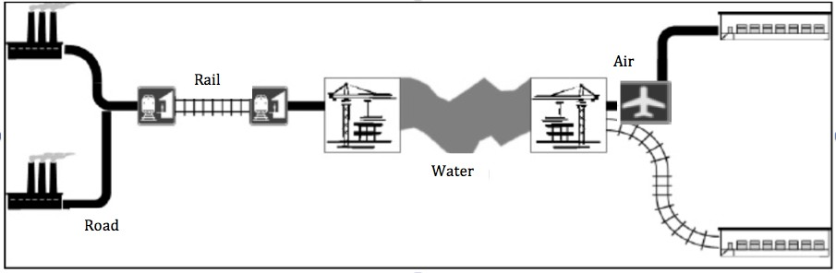

Figure 1.1: A Multimodal Transportation System-Network

Although there are five modes of transportation, this research will only con- sider the four major modes of transportation, which are: road, rail, air and water. a strong analysis of the mixture of all the modes and connections and elements that participate within the system will occur so as to grasp the impact towards the efficiency of the MTS, which is critical for sustaining a vibrant economy. A breakdown of the MTS elements that constitute the system and affect one another because are somehow interrelated to every other by the various means of transportation utilized to maneuver freight from one location to a different within the supply chain.

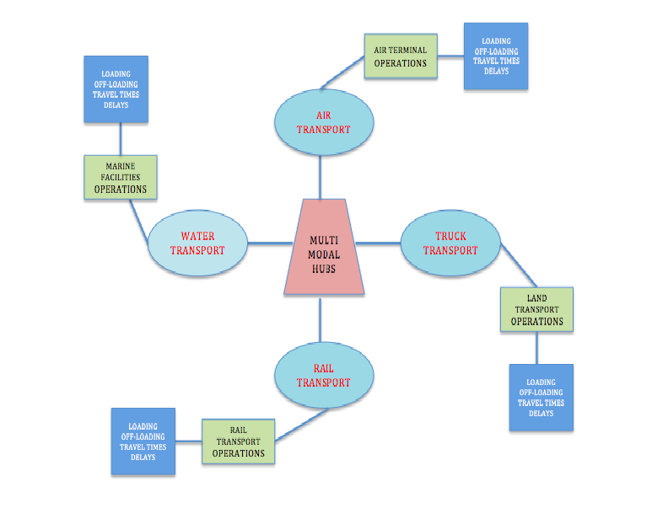

The lower-level network is employed to access the higher-level network. the standard of the lower-level network thus determines the standard of the higher-level network. Furthermore, since there are travellers using both network levels, the standard of the higher-level network influences the patronage of the lower network. These additional relationships make the multilevel transport network design problem even more complicated than the single-level transport network design problem. the main target of the literature on single-level unimodal transport network doesn't mean that no attention is paid to other transport services. In project PI , for example, both private and public modes are considered simultaneously, however, still as separate modes. In many studies within which the demand is assumed to be addicted to the standard of the services offered, mode-choice is employed to explain this relationship, usually the selection between private car and conveyance services. the assorted transport services are, again, analyzed as separate modes.

**LITERATURE REVIEW**

As globalization has expanded, supply chain resiliency has decreased making supply chain systems more complex and interdependent. it's become a policy of the indian Government to encourage and promote the event of multimodal transportations systems within the india so on move freight in an efficient maner interruption in any a component of the supply chain affects the whole supply chain network. Disruptions are stochastic events that interrupt the traditional operations of a multi- modal system as an example, the congestion that happens within the road transport will consequently have a negative impact on the rail transport scheduling. the vulnerabilities of supply chains thanks to these disruptions has become significant. Therefore, interest in understanding so on extend the efficiency and effectiveness of transportation systems. Freight transportation systems have grown, making supply chains success more complex because of factors such as: higher flows, longer distances, and therefore the utilization of various modes of transport; amongst other factors. a worldwide supply chain network is exposed to a range of risks, including supply disruption, supply delays, demand fluctuations, price fluctuations, and exchange-rate fluctua- tions . Underestimating risks in global supply chains may result in really painful outcomes.

Hence, if appropriate mitigation plan aren't in situ, these risks can significantly hurt the provision chain performance. For suitable mitigation strategies, it's critical for global supply chains to remember of the relevant risk factors that has to be considered when designing a decent supply chain network.

**CONCLUSIONS AND FUTURE WORK**

A system may be a set of things working together as parts of a mechanism or an inter connected network. Many methodologies exist so as to specific mathematically, logically and symbolically the connection between the entities or objects of interest within the system and analyze them. The challenge arises when the system may be a complex one. A system is taken into account complex when it's composed from relatively many mu- tually related parts which are hard to explain or understand and in most cases possesses random behavior. System dynamics provides the building blocks necessary to construct models that help within the understanding of complex real- world systems and their behavior over time. System dynamics may be a useful methodology within the understanding of complex systems like those encountered in todays transportation systems. during this research a SD simulation model was built with the target of analyzing the MTS efficiency and the way its constituents affect it over a specific period of your time.

The utilization of Systems Dynamics methodology to understand how disrup- tions affect the efficiency of the Multimodal Transportation System was a positive one. An advantage to this computer simulation built, is that it not only mimicked, explained and predicted the behavior of the real system over a desired period of time, but also, it tracked the implications of complex relationships and their dynamic con- sequences within the system when testing different scenarios aimed at altering the MTSs efficiency behavior in a desired way.

A variety of multimodal combinations are possible. the primary simulation run was the truck-rail multimodal combination of transport modes. the primary run is what's referred to as the pure state because it allows seeing the pure behavior of the system, which is that close representation to the real-life scenario. This pure statewas then used as a reference for analyzing how the behavior of the system changes over time within the various scenarios. within the truck-rail pure state it absolutely was observed how congestion and shipment rate increased over time and even the MTS efficiency increased. The interesting a part of performing different policy scenarios was to know how of these disruptions are interrelated and affect one another, and consequently affect the efficiency of the MTS.

**REFERENCES**

Abbas, K. A. (1990). The use of system dynamics in modelling transportation systems with respect to new cities in Egypt. System, 90-17.

Beamon, B. M. (1998). Supply chain design and analysis: Models and methods.International journal of production economics, 55 (3), 281–294.

Banerjee, S., Banerjee, A., Burton, J., & Bistline, W. (2001). Controlled partial ship- ments in two-echelon supply chain networks: a simulation study. International Journal of Production Economics, 71 (13), 91 - 100.

Banerjee, A., Burton, J., & Banerjee, S. (2003). A simulation study of lateral ship- ments in single supplier, multiple buyers supply chain networks. International Journal of Production Economics, 8182 (0), 103 - 114.

Bontekoning, Y., Macharis, C., & Trip, J. (2004). Is a new applied transportation research field emerging? a review of intermodal rail–truck freight transport literature. Transportation Research Part A: Policy and Practice, 38 (1), 1–34.

Bektas, T., & Crainic, T. (2007). A brief overview of intermodal transportation.