Enhancing Road Safety through Automated Pothole Detection

N Dyuthi Reddy J Buvann E Sree Harsha Supervisor: Mrs. G. Swapna, Assistant Professor

**ABSTRACT**

Potholes are a major cause of accidents and injuries on the road, and there is a growing need for new technologies to improve road safety. Object detection using deep learning is a promising new approach that can be used to identify potholes. In this project, we will develop a system for road safety implementation using object detection in deep learning. The system will use a camera to capture images of the road, and a deep learning model will be used to detect objects such as potholes, depth, and size. The system will then be able to generate alerts if it detects any of

KEYWORDS: Video analytics, Object Detection, deep learning, Road safety, Pothole detection, accident prevention.

**INTRODUCTION**

Potholes are a major cause of accidents and injuries on roads, and there is a growing need for new technologies to improve road safety. Object detection using deep learning is a promising new approach that can be used to identify potholes. In this project, we will develop a system for road safety implementation using object detection in deep learning. The system will use a camera to capture images of the road, and a deep learning model will be used to detect objects such as potholes, depth, and size. The system will then be able to generate alerts if it detects any of the objects. The system will be

the objects and also evaluates based on the data set of images from real-world environments. We will measure the accuracy of the system in detecting objects and hazards and we will also evaluate the system's ability to generate timely alerts. The results of this project will demonstrate the feasibility of using object detection in deep learning for road safety implementation. The system has the potential to significantly improve safety on roads by reducing the number of accidents and injuries.

evaluated on a dataset of images from real-world environments potholes are caused

by a variety of factors, including weather, traffic, and poor road construction. Potholes can be a significant hazard to drivers, cyclists, and pedestrians. They can cause damage to vehicles, and lead to accidents. Traditional methods of pothole detection, such as manual inspection and visual surveys, are time-consuming and labor-intensive. They can also be inaccurate, especially in large or remote areas. In recent years, however, there has been a growing interest in using technology to improve pothole detection. Potholes are those annoying holes

and bumps you find on roads. They happen because roads get old and damaged, and cars driving over them make things worse. Potholes can be small or big, but they're always a problem for drivers and walkers. Fixing potholes is essential to keep roads safe and save people from car damage. Nowadays, we use advanced technology to find and repair potholes, which helps make our roads better these are like little craters on

the road, caused by things like rain, ice, and lots of traffic. They can make driving bumpy and even damage cars. Finding and fixing potholes is a big job for cities and towns because it keeps the roads safe for everyone. Thanks to modern technology, we now have better ways to spot and repair these pesky road holes quickly, making our journeys smoother and safer.

**LITERATURE SURVEY**

1. An Author has developed a project called An Intelligent Pothole Detection and Alert System Using IoT and Machine Learning that leverages the Internet of Things (IoT) and Machine Learning to revolutionize road safety. This system employs sensors and cameras to detect potholes in real time, allowing for immediate alerts to authorities and drivers, thus enhancing safety and enabling timely road repairs. Advantages include proactive hazard mitigation, reduced accidents, and efficient road maintenance. However, challenges such as initial setup costs and sensor maintenance must be addressed for widespread adoption.
2. An Author has developed a project for object detection using Yolv3 The system is robust to changes in the environment, such as the appearance of objects and the lighting conditions. The system is easy to deploy. However, challenges such as The system

not suitable for all road safety applications, such as the system may not be able to detect small objects or objects that are moving quickly.

1. An Author has developed a project Particle Swarm Optimization-Based SVM for Classification of Cable Surface Defects of the Cable-Stayed Bridges Utilizing PSO with SVM improves defect classification accuracy by optimizing parameters and offers automated tuning for efficiency. It enhances robustness to noisy data and efficiently explores parameters while maintaining interpretability, making it a practical solution for ensuring cable-stayed bridge safety and maintenance. It is complex implementation, computational intensity, Hyperparameter Sensitivity

are dispatched at regular intervals to inspect and repair roads, including filling potholes. However, this approach may not be

**EXISTING SYSTEM**

The existing system for pothole detection and maintenance typically relies on a combination of manual inspections, citizen reports, and limited technology integration. Here's a breakdown of the key components of the current system:

1. Manual Inspections: Municipalities and transportation agencies often conduct periodic manual inspections of roads. Trained personnel visually examine road surfaces to identify and assess the condition of potholes and other road defects. This traditional approach is time-consuming and may not be as efficient in identifying all potholes, especially in large road networks.
2. Citizen Reporting: Many cities and towns rely on citizens to report potholes. Residents can contact local authorities through various channels, such as phone calls, emails, or dedicated mobile apps, to report the location and size of potholes they encounter. Citizen reporting plays a crucial role in alerting authorities to the presence of potholes that may not have been detected through routine inspections.
3. Road Maintenance Schedules: Some regions follow predetermined road maintenance schedules. Maintenance crews

responsive to newly formed potholes that can pose immediate risks to road users.

1. Patch and Repair: When a pothole is identified, road maintenance teams are dispatched to patch and repair it. This typically involves filling the hole with asphalt or other suitable materials. The quality and durability of repairs can vary based on the available resources and expertise.
2. Technology Integration (Emerging): While technology for pothole detection was not as widespread in 2021, there were emerging initiatives. Some cities started experimenting with sensors and cameras mounted on vehicles or stationary positions to monitor road conditions. These sensors could detect anomalies in the road surface and automatically trigger alerts for pothole repair.
3. Crowdsourcing Apps: Crowdsourcing apps and websites allowed residents to report potholes and road defects, contributing to more timely repairs. These platforms often included features for submitting photos and geolocation data to aid maintenance crews.

It's important to note that the adoption of advanced technologies like machine learning, AI, and IoT for real-time pothole detection and automated repair scheduling.

**PROPOSED SYSTEM**

The proposed system is to use YOLOv8 to develop a video analytics system for road safety that is specifically designed to address the challenges of road safety. The system will be trained on a large dataset of videos that are representative of the types of environments and objects that will be encountered on roads.

The proposed solution would have several benefits, including:

Improved accuracy: YOLOv8 is very accurate in a variety of applications. This means that the proposed system would be able to detect objects more accurately than current solutions.

Increased safety: A more accurate video analytics system would be able to detect potential hazards more quickly and accurately. This would help to prevent accidents and injuries.

Reduced costs: A more accurate system would require less human intervention. This would reduce the costs associated with monitoring and managing road safety.

The proposed system will be implemented in three phases:

Phase 1: Data collection and preparation: A large dataset of videos will be collected and prepared for training the YOLOv8 model. The dataset will be representative of the types of environments and objects that will be encountered in industrial settings.

Phase 2: Model training: The YOLOv8 model will be trained on the prepared dataset. The model will be tuned to optimize accuracy and performance.

Phase 3: System deployment: The trained YOLOv8 model will be deployed in a video analytics system for industrial safety. The system will be tested and evaluated to ensure that it meets the desired performance requirements.

**SOFTWARE REQUIREMENTS**

The software requirements are always subject to change when it comes to the extent of the accuracy the user desires or the flexibility in which the deployment is needed. This project can be made by using the following software

and hardware which are enough for students’ purposes in the industry or market.

Hardware: The system could be tested using a variety of hardware platforms, such as IP cameras and computers.

Software: The system could be tested using a variety of software frameworks, such as TensorFlow, PyTorch, and OpenCV.

Data: The system is trained and tested on a dataset of over 10000 images and videos

that are representative of the real-world conditions in which the system will be deployed. The dataset should include images and videos of potholes, as well as images and videos of different types of potholes.

**PURPOSE AND SCOPE**

The purpose of this research project is to address the critical issue of road safety by developing and implementing an innovative system for pothole detection and hazard alerting. Specifically, the objectives of this work include:

Utilizing deep learning techniques to enhance the accuracy of pothole identification on road surfaces.

Expanding the system's functionality to assess pothole depth and size, providing comprehensive hazard information.

Developing a real-time alerting mechanism that promptly notifies relevant parties, including drivers and authorities, upon pothole detection.

Evaluating the system's performance using a dataset of real-world road images, measuring accuracy and timely alert generation.

We'll focus on creating a smart system to find potholes on roads and warn drivers about them. The project includes taking pictures of roads with cameras, teaching a computer to recognize potholes using deep learning, and making sure it can quickly alert people when it finds one. We'll test how well the system works using real road pictures and ensure it respects privacy rules. We'll also explore working with local authorities and make the system user-friendly, affordable, and ready for future improvements.

the pressing issue of road safety. Our primary objective is to create a smart system that can accurately identify and promptly

**OVERALL DESCRIPTION**

Our initiative is at the forefront of leveraging cutting-edge technology to tackle the

warn individuals about the presence of potholes on road surfaces. This proactive approach aims to significantly diminish road accidents and enhance overall safety for all travelers. To achieve this, we rely on a combination of state-of-the-art cameras and robust machine-learning techniques. These cameras are strategically placed along roadways to continuously monitor the road surface. The machine learning algorithms we employ play a pivotal role in recognizing potholes, determining their depth and size, and transmitting real-time alerts to relevant authorities or road users. This holistic approach ensures that we not only identify potholes but also assess their severity, aiding in prioritizing repair efforts

**PARAMETERS IMPROVEMENT**

Accuracy of Detection: Improve the accuracy of Pothole detection by fine-tuning the YOLOv8 model and optimizing hyperparameters.

Real-time Processing Speed: Optimize the model for real-time processing to minimize latency in detecting individual potholes.

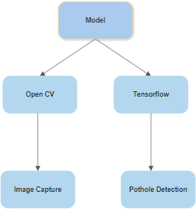

Utilize hardware acceleration (e.g., GPUs or TPUs) to speed up inference.

Safety Compliance: Improving object detection for pothole identification can enhance road safety compliance and reduce accidents and injuries.

Scalability and Camera Support: Design the system to support the camera, enabling monitoring of larger areas or different entry points.

Deployment Flexibility: Make the system adaptable for deployment in various settings, including public spaces, and workplaces.

**MATHEMATIC CALCULATION PARAMETER VALUES**

Bounding Box Coordinates: Formula: (x, y, width, height)

Intersection over Union (IoU): Formula: IoU = (Area of Intersection) / (Area of Union)

Mean Average Precision (mAP): Formula: mAP = (1 / N) * Σ Precision at Recall_i

Precision: Formula: Precision = (True Positives) / (True Positives + False Positives)

**IMPLEMENTATION**

The implementation of the project has been carried out in a step-by-step manner. A detailed description of each module is given below and it is followed by an introduction to the technologies used in implementing the project.

SYSTEM ARCHITECTURE AND METHODOLOGY

The Ultralytics and yolv8 modules were used to develop the project's code in Python. In this work, the modules that will be used for additional input and output operations are initially loaded. This project makes use of the libraries- OpenCV, and yolv8, which must be loaded. The primary camera provides the video inputs. Now that TensorFlow is being used to identify the video as input from the

Recall (Sensitivity): Formula: Recall = (True Positives) / (True Positives + False Negatives)

F1-Score (Harmonic Mean of Precision and Recall):Formula: F1-Score = 2 * (Precision * Recall) / (Precision + Recall)

Training Loss (e.g., YOLO Loss):Formula: Loss = λ_coord * (Σ |x - x̂| + |y - ŷ|) + λ_coord * (Σ |√w

- √ŵ| + |√h - √ĥ|) + (Σ |C - Ĉ|) + λ_noobj * (Σ

|conf - conf|̂ )

Learning Rate Scheduling (e.g., Step Decay):Formula: lr_new = lr_initial * (lr_decay_rate ^ (epoch / lr_decay_step))

presentation. The input processing must then be completed by converting the input image to a predicted image. Then it's your turn to specify the pothole and yolv8 is used to modify the required output of this operation. In this process, the presentation is managed by the pothole. The yolo library for the Python programming language is necessary for computing. It contains several components, including:

-An efficient array of N dimensions

-Tools for C integration and object detection

connected layers which function to predict probability and coordinates.

System Architecture

DETECTING POTHOLE BY YOLV8

**Object detection** is an activity that aims to gain an understanding of the classification, concept estimation, and location of objects in an image. As one of the basic computer vision problems, object detection can provide valuable information for semantic understanding of images and videos, and is associated with many applications, including image classification.

**Artificial Intelligence** is a simulation of human intelligence that is modeled in a machine and programmed to be able to think like humans. It is a technology that requires data to be used as knowledge so that the intelligence made can be even better so that it can continue to grow and learn from previous mistakes. Artificial intelligence can do self-correction is because artificial intelligence designed to learn from the mistakes that have been experienced. Artificial intelligence is one of the following four factors, namely: acting humanly, thinking humanly, thinking rationally, and acting rationally.

**Machine learning** can be defined as computer applications and mathematical algorithms adopted using learning that comes from data and produces predictions in the future. The learning process in question is an attempt to acquire intelligence through two stages, including training and testing.

**You Only Look Once** (YOLO) is an algorithm for object detection based on Convolutional Neural Network. In the YOLO architecture, 24 convolutional layers function to get features from the image. Then followed by 2

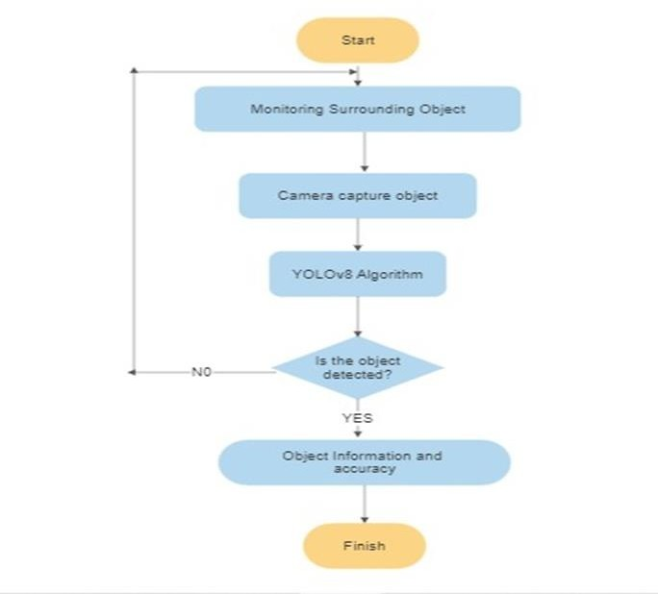

**Tensorflow** is a software library or library that is open source or open, and free for machine learning. It is used for many things but focuses more on training and inference of deep neural. Its library is a library based on dataflow and programming. It is a computational framework for building machine learning models. It provides a variety of toolkits that allow you to build models at your preferred level of abstraction and run graphics on multiple hardware platforms, including CPU, GPU, and TPU.

**You Only Look Once YOLOv8** is an innovative object detection algorithm known for its simplicity and efficiency. Unlike its predecessors, YOLOv8 combines the strengths of various YOLO versions, resulting in a robust and versatile model. Its unique feature lies in its ability to handle multi-scale object detection

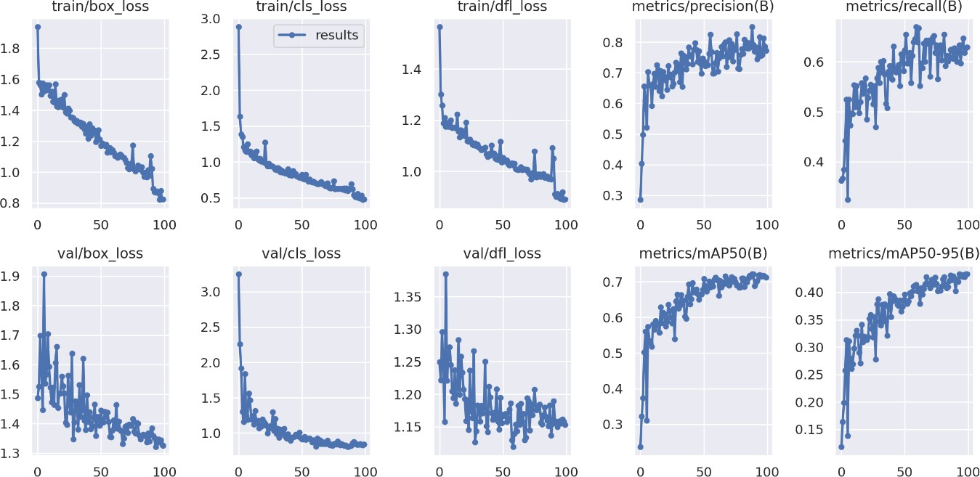without extensive computational resources. YOLOv8 achieves high accuracy by employing a single-pass architecture that directly predicts

bounding boxes and class probabilities, making it a preferred choice for real-time applications.

**SAMPLE CODE**

# Pip install method (recommended)

!pip install ultralytics==8.0.20 from IPython import display display.clear_output()

import ultralytics ultralytics.checks()

from ultralytics import YOLO

from IPython.display import display, Image

%cd /content/drive/MyDrive/Pothole.v1- raw.yolov8

lo task=detect mode=train model=yolov8s.pt data= data.yaml epochs=100 imgsz=224 plots=True

from google.colab import drive drive.mount('/content/drive')

Image(filename='runs/detect/train/confusion_ matrix.png', !yowidth=600)

Image(filename='runs/detect/train/val_batch0_ pred.jpg', width=600)

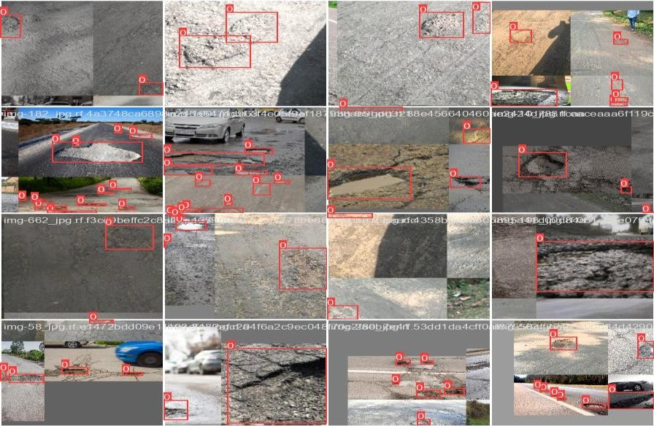

**Results(test data)**

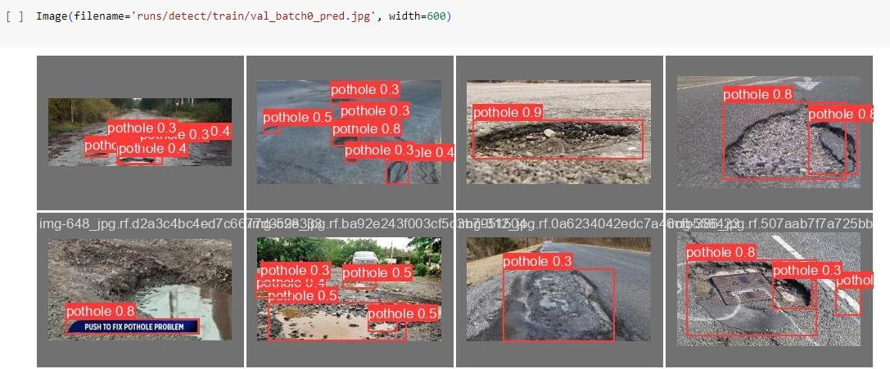

**The final result of the detection the pothole and region of interset**

**CONCLUSION**

In the final analysis, our project has demonstrated how deep learning-based object identification has the potential to change the field of vehicular safety. We have developed a useful system that can significantly reduce accidents and injuries by extending detection beyond potholes, improving real-time alerts, and emphasizing affordability. Collaboration with municipalities and robust case studies underline the real-world impact of our technology. As we move forward, the path to safer roads becomes clearer, promising a future with fewer accidents and safer journeys for all.

In conclusion, utilizing the YOLO v8 algorithm for pothole detection in video analysis offers an efficient, accurate, and dynamic solution to monitor and address road surface issues. The resulting Region of Interest (ROI) within the video frames provides a clear visual representation of detected potholes, aiding in the maintenance and safety of road networks. This technology holds significant potential for enhancing road infrastructure management and ensuring smoother and safer travel for all road users

**FUTURE ENHANCEMENT**

Integrate AI-based object detection for not only potholes but also various road hazards like debris or animals. Implement real-time alerts and a user-friendly interface, offering immediate safety benefits for drivers. Explore cost-effective hardware options to ensure affordability and scalability, making it accessible in diverse regions. Collaborate with municipalities for seamless integration into existing traffic management systems. Conduct case studies to demonstrate significant reductions in accidents and injuries, emphasizing the practical impact of the technology. It should focus on making pothole detection and maintenance more efficient, proactive, and responsive to evolving road conditions. These improvements can contribute to safer and more reliable road networks

**BIBLIOGRAPHY**

1. Research Gate, Google
2. Amel Ali Alhussan, Doaa Sami Khafaga, El-Sayed M. El-Kenawy, Abdelhameed Ibrahim Marwa Metwally Eid Abdelaziz A. Abdelhamid Date of Publication: 05 August 2022 INSPEC Accession Number: 21970489 DOI:10.1109/ACCESS.2022.3196660
3. Xinke Li Yongcai Guo Yongming Li Date of Publication: 23 December 2019 Electronic ISSN: 2169-3536 INSPEC Accession

Number: 19442450 INSPEC Accession Number: 19442450 DOI: 10.1109/ACCESS.2019.2961755

1. Abhishek Kumar; Chakrapani; Dhruba Jyoti Kalita; Vibhav Prakash Singh 2nd International Conference on Data, Engineering and Applications (IDEA) DOI: 10.1109/IDEA49133.2020,28-29 Feb. 2020
2. Surekha Arjapure; D.R. Kalbande, International Conference on Communication information and Computing Technology (ICCICT) DOI: 10.1109/ICCICT50803.2021 25-27 June 2021
3. Alessio Gagliardi; V. Staderini; S. Saponara Date of Publication: 14 June 2022 Electronic ISSN: 2169-3536 INSPEC Accession Number: 21799310 DOI: 10.1109/ACCESS.2022.3183116
4. Dong Chen; Nengcheng Chen; Xiang Zhang; Yuhang Guan Date of Publication: 19 August 2022 INSPEC Accession Number: 22014136 DOI:

10.1109/JSTARS.2022.3200147

1. Amita Dhiman; Reinhard Klette INSPEC Accession Number: 19950625 DOI: 10.1109/TITS.2019.2931297
2. Dong Chen; Nengcheng Chen; Xiang Zhang; Yuhang Guan Date of Publication: 19 August 2022 INSPEC Accession Number: 22014136 DOI:

10.1109/JSTARS.2022.3200147 Publisher: IEEE

1. Faria Kalim; Jaehoon Paul Jeong; Muhammad U. Ilyas Date of Publication: 08 September 2016 Electronic ISSN: 2169-3536 INSPEC Accession Number: 16568326 DOI: 10.1109/ACCESS.2016.2607719 Publisher: IEEE.

[11]E. Salari; G. Bao Published in: 2011 IEEE INTERNATIONAL CONFERENCE ON ELECTRO/INFORMATION

TECHNOLOGY Date of Conference: 15-17 May 2011 INSPEC Accession Number: 12178472 DOI: 10.1109/EIT.2011.5978575