**RAIN-DRIP AUTOMATIC WATER IRRIGATION SYSTEM**

# **Shivani Bire*1, Mayuri Choudhari*2, Samiksha Petkar*3, Maithili Bhoyar*4, Nutan Dhande*5, Abhishek K Singh*6**

*1,2,3,4Student, Department Of Computer Engineering, Agnihotri College Of Engineering, Wardha, India.

*5,6Assistant Professor, Dept. Of Computer Engineering, Agnihotri College Of Engg., Wardha, India.

**ABSTRACT**

Water scarcity is a critical global issue, and efficient water management in agriculture is essential to ensure food security and conserve water resources. This abstract provides an overview of an Internet of Things (IoT)- based water irrigation system designed to address these challenges. The IoT-based water irrigation system leverages cutting-edge technology to enhance the precision and efficiency of water usage in agricultural practices. The system comprises a network of interconnected sensors, actuators, and controllers that monitor and manage the irrigation process. Key components include soil moisture sensors, weather stations, and automated valves. The system's operation begins with soil moisture sensors that continually measure soil moisture levels. These sensors transmit data to a central controller, which processes the information and makes real-time decisions regarding when, where, and how much water to distribute. The controller takes into account the specific crop's water requirements, weather conditions, and historical data to optimize irrigation scheduling.

**Keywords:** Arduino Uno, Smart Irrigation, IOT Smart System, Planting Using IT, Smart.

**INTRODUCTION**

Irrigation is the process of giving water to plants for their growth and development. Traditional agricultural systems require huge amounts of money for on-site irrigation power. In this, we will study the smart technique of irrigation, Automatic Plant Watering System. It is used to detect the moisture from the pots, in what amount it is present, its percentage etc. We will get this whole data and by Arduino we can get all the information regarding the water supply. Using this data, we can determine the amount of water to be supplied to a variety of crops based on Plant’s seasonal requirements.

Irrigation is a critical component of modern agriculture, enabling efficient water management for crop cultivation. Traditionally, irrigation systems have relied on manual or timer-based methods, which often result in inefficient water usage and resource wastage. To address these challenges, the integration of Internet of Things (IoT) technology into irrigation systems has become increasingly popular. IoT-based irrigation systems offer a smart and data-driven approach to optimize water usage, enhance crop yields, and conserve resources.

The raising population, the agricultural production is needed. The irrigated agriculture has been an extremely important source which increases the production and its value.

Now a days people wants to look their work from anywhere in manner of digital devices such as smartphone and tablet or laptop. These things are done easily by using Internet of thing (IoT).

This presentation on “Rain-drip automatic water irrigation system“ is for to create and IOT based irrigation mechanism which makes the pumping motor ON and OFF on detecting the available moisture content and sufficient water level.

The data through IOT platform has to be passed and this results overcoming of labour intensive work and also controls the water management system.

Here we use hardware and software components for all this process.

OBJECTIVE

1. To use IoT sensors and data analysis to ensure that the irrigation system only provides water when and where it is needed. This prevents overwatering, which can lead to water wastage and soil erosion.
2. To monitor soil moisture levels, weather conditions, and other environmental parameters in real-time. This data is used to schedule irrigation cycles intelligently, minimizing the use of water and energy resources.
3. To automate the operation of the irrigation system, reducing the need for manual intervention and allowing for remote monitoring and control via a smartphone or computer.
4. To reduce water and energy bills by optimizing irrigation, which can lead to cost savings for farmers and homeowners.
5. To enhance crop health and yield by ensuring that plants receive the right amount of water at the right time. This can result in better agricultural productivity.
6. To provide an easy-to-use interface for users to monitor and adjust irrigation settings as needed, ensuring that the system is user-friendly and accessible.
7. **METHODOLOGY**

The methodology of an IoT-based irrigation system involves a systematic approach to design, implement, and manage a smart irrigation system that relies on Internet of Things (IoT) technology. This method can be broken down into several key steps:

* System Design and Planning: Begin by defining the objectives of the IoT-based irrigation system. Determine the specific crops to be irrigated, the environmental conditions, and the desired level of automation. Consider the types of sensors and actuators needed.
* Sensor Deployment: Install various sensors, including soil moisture sensors, weather sensors, and humidity sensors, in the agricultural field. These sensors will collect real-time data about soil moisture levels and environmental conditions.
* Connectivity Setup: Choose the appropriate wireless connectivity technology, such as Wi-Fi, LoRa, or cellular networks, to connect the sensors to a central control system. Ensure a reliable and robust network infrastructure for data transmission.
* 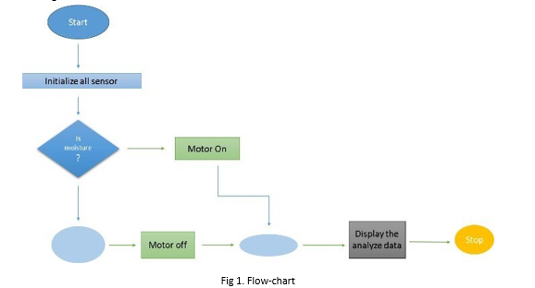Central Control System: Develop or select a central control system, which can be a cloud-based platform or an on-premises controller. This system receives data from sensors and processes it. It should have the capability to store data and run algorithms for decision-making.

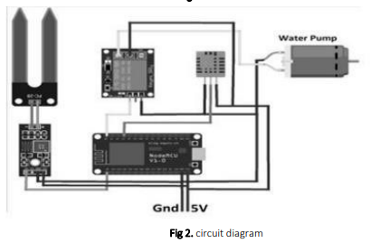

1. **PROPOSED SYSTEM**
2. **Water Source:** Identify the water source for irrigation, which could be a well, a river, a pond, or a municipal water supply. Ensure the source provides a reliable and sufficient quantity of water for irrigation needs.
3. **Pumping System:** If the water source is not pressurized or if the irrigation area requires water to be pumped over distances or to higher elevations, you'll need a pumping system. This might include pumps, pipes, and fittings to transport water from the source to the irrigation area.
4. **Distribution System:** Design the distribution system to evenly distribute water across the irrigation area. This could involve pipes, valves, and sprinklers or drip emitters. Drip irrigation systems are efficient for conserving water and are suitable for various types of crops.
5. **Control System:** Implement a control system to manage when and how much water is delivered to the plants. This could include timers, sensors, and controllers. For example, soil moisture sensors can measure the moisture content of the soil and activate irrigation only when necessary, optimizing water usage.
6. **Filtration and Treatment:** Depending on the water source, filtration and treatment may be necessary to remove sediment, debris, or contaminants that could clog irrigation equipment or harm plants. Filters, sedimentation tanks, and chemical treatments may be required.
7. **Monitoring and Maintenance:** Incorporate monitoring systems to track the performance of the irrigation system and detect any issues such as leaks or malfunctions. Regular maintenance, including cleaning filters, checking for leaks, and adjusting settings, is essential for optimal system performance.
8. **Automation and Remote Control (Optional):** For larger or more complex systems, consider incorporating automation and remote control capabilities. This allows for remote monitoring and adjustment of the irrigation system, enhancing efficiency and convenience.
9. **Energy Source:** Ensure there's a reliable power source for any pumps, sensors, or controllers used in the system. This could be grid electricity, solar power, or a backup generator.
10. **Safety Measures:** Implement safety measures to prevent accidents and protect the integrity of the system. This could include proper installation of electrical components, fencing or barriers around water sources, and emergency shutoff valves.
11. **Regulatory Compliance:** Be aware of any local regulations or permits required for installing and operating an irrigation system, especially if it involves diverting water from natural sources or using certain chemicals for treatment.
12. **RESULTS AND DISCUSSION**

IoT-based irrigation systems offer numerous benefits, including efficient water usage, improved crop yields, and reduced labor costs. By integrating sensors, actuators, and connectivity technologies, these systems can monitor soil moisture levels, weather conditions, and plant health in real-time. This data allows for precise control over irrigation scheduling and water delivery, optimizing resources and minimizing waste.IoT-based irrigation systems find applications across various sectors, primarily in agriculture but also in landscaping, urban gardening, and environmental monitoring.

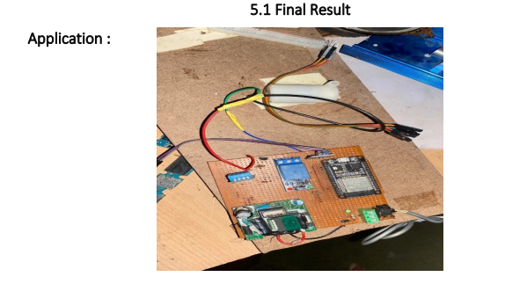 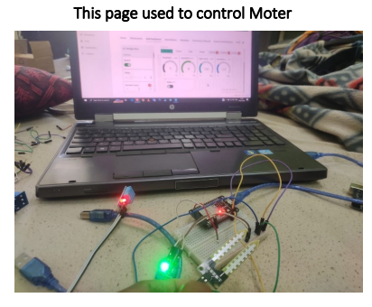

**Fig. IoT- device fig. Starting Process**

1. **CONCLUSION**

Water is life and it is important to save water. Without water not only humans, but also other living organisms won’t exist. In today’s world where pollution, water wastage are at all-time high it becomes extremely necessary to have clean water and to save it. Thus, Smart Irrigation System helps in doing. So, it gives live readings of moisture content in soil and can then be irrigated automatically or manually.

**REFERENCES**

1. Intelligent and Smart Irrigation System using edge computing and IOT, M. Safdar Munir, Imran Sarwar Bajwa, Amna Ashraf, Waheed Anwar,and Rubina Rashid, Research article, open access, Article ID 6691571, algorithm for KNN, 2021.
2. An overview of smart irrigation systems using IoT, Khaled Obaideen,Bashria A.A. Yousef, Maryam Nooman AlMallahi, Yong Chai Tan, Montaser Mahmoud, Hadi Jaber, Mohamad Ramadan, Energy Nexus Volume 7,100124, SDGs greenhouse gas emissions, 2022.
3. An overview of smart irrigation systems using IoT, Khaled Obaideen,Bashria A.A. Yousef, Maryam Nooman AlMallahi, Yong Chai Tan, Montaser Mahmoud, Hadi Jaber, Mohamad Ramadan, Energy Nexus Volume 7,100124, SDGs greenhouse gas emissions, 2022.
4. Smart Irrigation System using IoT, M Gayathri, D Arun Shunmugam, A Ishwariya, IJIRMPS | Volume 9, Issue 3, ISSN: 2349- 7300, temperature sensor, humidity sensor, and soil moisture sensor, 2021.
5. Smart Irrigation for Crop Management Using IoT, Mohamed Fazil, Rohan S, Ashritha C, Nagesh Shetty, Ramalingam H M, International Journal of Multidisciplinary Research and Analysis ISSN(print): 2643- 9840, ISSN(online): 2643-9875 Volume 05, NPK algorithm used, 2022.
6. Smart Irrigation System using IOT, Meghana Gupta Arakere, Avik Seal and Tejomurthula Bhuvana Teja, Asian Journal of Science and Technology, Vol. 10, Issue, 06, pp.9756-9768, connecting MQTT box to NodeMCU, 2019.
7. Application of IoT and Cloud Computing in Automation of Agriculture Irrigation, Khongdet Phasinam, Thanwamas Kassanuk, Priyanka P. Shinde, Chetan M. Thakar, Dilip Kumar Sharma, Md. Khaja Mohiddinand Abdul Wahab Rahmani, Hindawi Journal of Food Quality Volume 2022, Article ID 8285969, machine learning algorithm, 2022.