­­

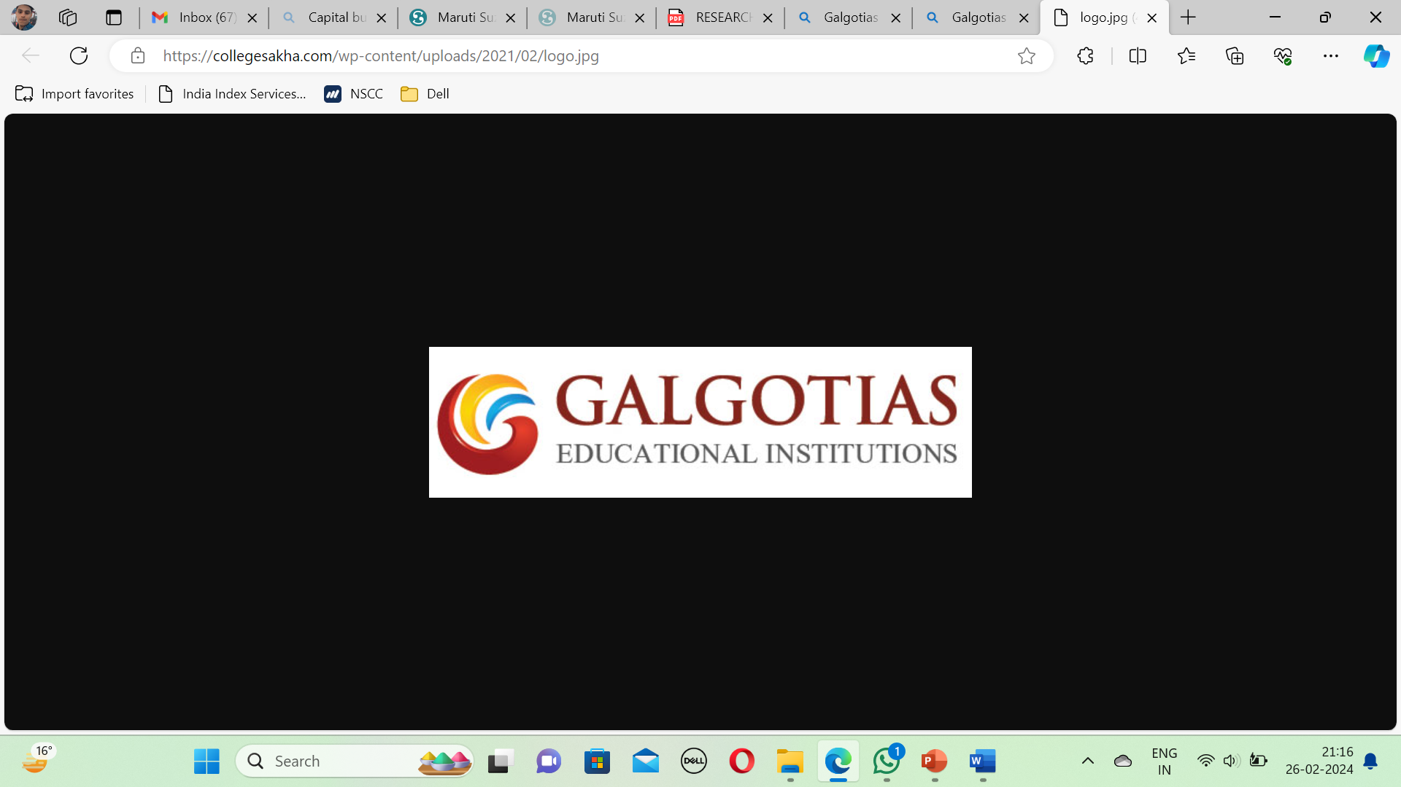

**RESEARCH PAPER**

Project –

**The Importance of Insurance In India**

**(HDFC ERGO LIFE INSURANCE)**

Submitted By –

**YASH YADAV**

**Admission no. 21GSOB1110053**

**SEM – VI**

**Section – 9 BBA(BFSI)**

**Submitted To: DR. PRATIKSHA JHA**

**DECLARATION**

I, Yash Yadav do here project work on the topic health Insurance , it is submitted by me in partial fulfilment of requirement for the award of Bachelor’s Degree in Business Administration, Galgotia’s University, Greater Noida, Uttar Pradesh.

Date:

Signature:

**CONTENTS**

|  |  |
| --- | --- |
| Topic | Page no. |
| Abstract | 1 |
| Introduction | 2 |
| Significance of Insurance | 3-7 |
| How Insurance works | 8-10 |
| Factors affect Insurance | 11-16 |
| Need for Insurance | 17 |
| ICICI Prudential Life Insurance | 18-19 |
| SWOT Analysis | 19-21 |
| Features and benefits of ICICI | 22 |
| SBI v/s ICICI | 23 |
| Feedback | 24 |
| Financial performance | 25-28 |
| ICICI using VPI technology | 29-34 |
| Methodology | 35 - 36 |
| Result of the survey | 37 - 40 |
| Bibliography | 41 |
| Conclusion | 42 |

**ABSTRACT**

Insurance must be a top priority for all nations, affluent or poor, as it is a worldwide issue. The private healthcare industry in India is very significant. Most allopathic medical professionals either work for private hospitals or even more favour private practise. In India, there are three different types of healthcare systems: formal, unofficial, and public. In the uncontrolled setting of the informal healthcare system, there is no oversight of the service providers, the recipients of services, or the costs of those services. A health investment is a human resource development investment. One of the main drivers of the general insurance sector's expansion in India is health insurance. From the standpoint of the overall growth of the general insurance industry, this sector's growth is crucial. The study offers insight into the health insurance market's performance in India.

The objective of this study has been to:

1. To study health insurance coverage in India

2. To list health insurance companies in India

3. To find out health insurance premium earned and claims and management expenses paid.

This paper's sole support comes from secondary data. The National Family Health Survey India Report, the Annual Report of the Insurance Regulatory and Development Authority of India, the Handbook on Indian Insurance Statistics, the Vital Statistics Division, books, journals, RBI bulletins, theses, and websites; and the Directorate of Economics and Statistics are some examples of the statistics-related sources. The analysis demonstrates that the cost of health insurance rose from Rs.1910 crores in 2006–2007 to Rs. 33011 crores in 2018–2019. The number of claims incurred, however, increased from Rs. 3349 crores to Rs. 40076 crores over the same time period when combined with commission and administrative costs. As a result, underwriting loss results from the claims and administrative expenses being combined to be greater than the health insurance premium generated over the course of the study.

Keywords: healthcare financing, health insurance, premium, claims incurred, administrative expenses**.**

**INTRODUCTION**

The concept of insurance provides a sense of comfort and protection against the dangers of financial loss, because what is uncertain for one person may be predictable for many. Thanks to health insurance, treatment costs and illness complaints are reduced.  
Health insurance has proven to be the best cost-sharing system by increasing resources and dividing the cost of health care between rich and poor, old and young, healthy and unhealthy.  
Since medical costs are often unpredictable, health insurance can be used to cover most of the costs. Everyone needs therapy at some point in life. Therefore, the best option is health insurance.  
Current health insurance is a special type of insurance that uses variable risk as one of the cost strategies in paying medical bills. It is no longer a type of insurance that covers health risks. It functions as a social insurance payment to pay for health care for almost everyone (Mariner, 2015).  
Serious illnesses and injuries are unpredictable and can increase costs. Major disasters can occur at any time (Amutha, D., 2021). The importance of insurance goes beyond its primary role of risk distribution, which is to reduce the risk of contamination (Amutha, D., 2014).  
Because they have little control over the situation, all patients generally rely on their doctor's advice for help. TRUE. Only insurance cost-sharing strategies can support financial and personal problems (Newhouse et al., 1997).  
The scope and coverage of health plans and the fees they pay doctors have a huge impact on the current healthcare system (Amutha, D., 2022). Health insurance is the ability to pay for healthcare and with its help one can reform the healthcare system (Mariner, 2010)..

**MEANING OF INSURANCE:-**

Insurance is a contractual agreement between two parties, namely the insurer and the insured. The main concept of insurance is risk sharing, that is, many insurers come together and form a fund group by paying premiums. This money will be used to pay the injured people. The basic elements of insurance include the policy itself, premiums, coverage, and deductibles.

**SIGNIFICANCE OF INSURANCE**

**Importance of Insurance**In today's world, insurance is necessary to ensure financial security, manage unforeseen risks, promote business stability, promote peace, encourage behavior, and facilitate long-term planning. Its importance cannot be overstated because it is the foundation of personal and health.  
  
**Risk Management**:  
Insurance helps individuals and businesses transfer money that may be lost to insurance companies. By paying a small premium, insured people can protect themselves against financial losses in case of accident, illness, natural disaster or liability.  
  
**Loss** **Prevention:**Insurance provides a type of insurance that helps reduce the financial impact of unexpected events on a person or organization. Without insurance, people can face serious financial problems or even unexpected losses due to events such as natural disasters, property damage or liability.

**Promotes stability**:  
Insurance promotes economic stability by spreading the risk of loss among multiple policyholders. This risk sharing helps protect individuals and businesses from financial losses and ensures that the costs associated with unforeseen events are more equitably distributed across society.  
  
**Promoting Entrepreneurship:**  
Insurance provides individuals and businesses with the confidence to invest in assets, conduct business, or engage in other productive activities without fear of losing everything in the event of a disaster. This encourages business growth and innovation by reducing the perceived risks associated with these experiments. > This sense of security is invaluable and can improve overall health and quality of life.

**Laws and Regulations:**  
Most of the time, insurance is required by law or regulation. Tradition. For example, most jurisdictions require auto insurance to protect the financial consequences of an accident, and employers are required to provide employees with other insurance benefits for workers injured on the job. Complying with these rules ensures that individuals and businesses can meet their legal obligations and avoid fines or liability

**Longterm planning:**

Insurance allows individuals and businesses to plan for the future with confidence, knowing they are protected. against unexpected losses. Whether you're saving for retirement, investing in a business, or buying a home, insurance can provide a foundation for financial security that creates long-**term goals**.

**Term Life Insurance Plans**:

 Term life insurance plans provide a fixed amount of money to your loved ones in exchange for regular payments in case an adverse event occurs during the policy period.  
  
**Health insurance:** health insurance provides coverage to the policyholder for medical treatment, surgery, hospitalization, etc. Reimburses or pays a fixed amount to the client for medical expenses incurred due to injury/illness including.  
  
**Annuity Plan**:

 An annuity plan is a type of retirement plan that provides you with payments in exchange for capital. Simply put, you pay premiums to the life insurance company and your money comes back to you either immediately or later as regular income. Life insurance companies deposit your money and return the benefits to you as payment.  
  
**Unit Linked Insurance Plan (ULIP**):

Unit linked insurance plan ensures that investment and insurance are covered under the same policy. A portion of your premium is invested in the equity/debt/equity of your choice and the other is used to protect your loved ones from the income generated.

**Advantages**  
  
**Savings Plan**: Savings plan allows you to create risk-free savings and protect your family's financial interests in your absence.  
  
**Car Insurance**: Car insurance can help you pay bills if you are injured in a car accident or damage someone else's home and pay for medical expenses if your car is stolen, broken into, or damaged. In case of natural disasters, your vehicle can be repaired or replaced.  
In addition to paying for car accidents and damages out of pocket, people also pay annual premiums to car insurance companies. The company then pays all or most of the costs associated with the car accident or other damage to the car. How does insurance work?  
A variety of insurance policies are available to suit different needs, and both individuals and businesses can benefit from an insurance provider. Despite the price, I am satisfied. Most personal insurance policies include auto insurance, health insurance, homeowners insurance, and life insurance, and most people in the United States have at least one of these policies; Auto insurance is regulated by state law.  
  
  
Businesses purchase health insurance policies based on their specific risks. For example, a fast-food restaurant policy will cover injuries caused to employees while operating equipment such as deep plates. Medical malpractice insurance covers liability resulting from a doctor's negligence or malpractice. Hiring a data custodian can help a company manage the rights of its employees. Additionally, state laws may allow businesses to purchase insurance.

**Life Insurance Content**  
  
**Policy:** Policy of the insurer (person or organization eligible for insurance) and the insured (insurance company). Outlines terms, conditions, coverage limitations and fees.  
  
**Premium:** It is the amount paid by the insured to the insurance company in return for coverage. Payments can be made at various times, such as monthly, quarterly or annually.  
  
**Coverage**: Indicates the risks or conditions that the insurance policy protects. Coverage may include things like damages, liability, medical expenses, or loss of income.  
  
**Deductible:** The amount of insurance money that must be paid out of pocket before the policy comes into force. In general, policies with higher deductibles have lower premiums.  
  
**Policy Limit**: It is the maximum amount that the insurance company will pay for damage. This can be a one-time limit or a total limit for a certain period of time.  
  
**Compensation process**: The process of making an accident claim an

 receiving damage compensation from your insurance company. This usually involves reporting the loss and providing evidence to the insurance company.  
  
**Insurance**: The process by which an insurance company evaluates the risk of insuring a person or entity and determines the appropriate premium. This includes verifying factors such as age, health, driving record or ownership. Events Related to Life Insurance 

There are many factors that affect life insurance: –  
  
**Age:** Children generally pay lower premiums because they are considered to have a lower risk of death.  
  
**Insurance Type:** Comprehensive insurance is more expensive than liability insurance.  
  
**Gende**r: Historically, women paid lower life insurance premiums than men because they lived longer.  
  
**Health:** Your current health, medical history, and lifestyle (such as smoking) can affect your premiums. Healthier people often get lower prices.  
  
  
**Legal Policy**: Term life insurance is associated with lower premiums compared to fixed term life insurance.

**Promotes stability**:  
Insurance promotes economic stability by spreading the risk of loss among multiple policyholders. This risk sharing helps protect individuals and businesses from financial losses and ensures that the costs associated with unforeseen events are more equitably distributed across society.  
  
**Promoting Entrepreneurship:**Insurance provides individuals and businesses with the confidence to invest in assets, conduct business, or engage in other productive activities without fear of losing everything in the event of a disaster. This encourages business growth and innovation by reducing the perceived risks associated with these experiments. > This sense of security is invaluable and can improve overall health and quality of life.

**Laws and Regulations:**

Most of the time, insurance is required by law or regulation. Tradition. For example, most jurisdictions require auto insurance to protect the financial consequences of an accident, and employers are required to provide employees with other insurance benefits for workers injured on the job. Complying with these rules ensures that individuals and businesses can meet their legal obligations and avoid fines or liability  
  
**Long-term planning**

Insurance allows individuals and businesses to plan for the future with confidence, knowing they are protected. against unexpected losses. Whether you're saving for retirement, investing in a business, or buying a home, insurance can provide a foundation for financial security that creates long-term goals.

**Term Life Insurance Plan**s: Term life insurance plans provide a fixed amount of money to your loved ones in exchange for regular payments in case an adverse event occurs during the policy period.  
  
**Health insurance**: health insurance provides coverage to the policyholder for medical treatment, surgery, hospitalization, etc. Reimburses or pays a fixed amount to the client for medical expenses incurred due to injury/illness including.  
  
**Annuity Plan**: An annuity plan is a type of retirement plan that provides you with payments in exchange for capital. Simply put, you pay premiums to the life insurance company and your money comes back to you either immediately or later as regular income. Life insurance companies deposit your money and return the benefits to you as payment.  
  
**Unit Linked Insurance Plan (ULIP):**Unit linked insurance plan ensures that investment and insurance are covered under the same policy. A portion of your premium is invested in the equity/debt/equity of your choice and the other is used to protect your loved ones from the income generated.

**ADVANTAGES**  
  
**Savings Plan**: Savings plan allows you to create risk-free savings and protect your family's financial interests in your absence.  
  
**Car Insurance**: Car insurance can help you pay bills if you are injured in a car accident or damage someone else's home and pay for medical expenses if your car is stolen, broken into, or damaged. In case of natural disasters, your vehicle can be repaired or replaced.  
In addition to paying for car accidents and damages out of pocket, people also pay annual premiums to car insurance companies. The company then pays all or most of the costs associated with the car accident or other damage to the car. How does insurance work?  
  
A variety of insurance policies are available to suit different needs, and both individuals and businesses can benefit from an insurance provider. Despite the price, I am satisfied. Most personal insurance policies include auto insurance, health insurance, homeowners insurance, and life insurance, and most people in the United States have at least one of these policies; Auto insurance is regulated by state law.  
  
Businesses purchase health insurance policies based on their specific risks. For example, a fast-food restaurant policy will cover injuries caused to employees while operating equipment such as deep plates. Medical malpractice insurancecovers liability resulting from a doctor's negligence or malpractice. Hiring a data custodian can help a company manage the rights of its employees. Additionally, state laws may allow businesses to purchase insurance.  
  
 **Life Insurance Content**  
Policy: Policy of the insurer (person or organization eligible for insurance) and the insured (insurance company). Outlines terms, conditions, coverage limitations and fees.  
  
**Premium**: It is the amount paid by the insured to the insurance company in return for coverage. Payments can be made at various times, such as monthly, quarterly or annually.  
  
**Coverage**: Indicates the risks or conditions that the insurance policy protects. Coverage may include things like damages, liability, medical expenses, or loss of income.  
  
**Deductible:** The amount of insurance money that must be paid out of pocket before the policy comes into force. In general, policies with higher deductibles have lower premiums.  
  
**Policy Limit**: It is the maximum amount that the insurance company will pay for damage. This can be a one-time limit or a total limit for a certain period of time.  
  
  
  
**Compensation process**: The process of making an accident claim and receiving damage compensation from your insurance company. This usually involves reporting the loss and providing evidence to the insurance company.  
  
**Insurance**: The process by which an insurance company evaluates the risk of insuring a person or entity and determines the appropriate premium. This includes verifying factors such as age, health, driving record or ownership. Related Events About Life Insurance  
  
There are many factors that affect life insurance:  
  
Age: Children generally pay lower premiums because their risk of death is thought to be lower.  
  
Insurance Type: Comprehensive insurance is more expensive than liability insurance.  
  
Gender: Historically, women's life insurance premiums have been lower than men's due to their longer life expectancy.  
  
Health: Your current health, medical history, and lifestyle (such as smoking) can affect your premiums. Healthier people often get lower prices.  
  
  
Legal Policy: Term life insurance is associated with lower premiums compared to fixed term life insurance.

**HDFC ERGO LIFE INSURANCE**

**Company Profile:**

HDFC Ergo Life Insurance Company is a joint venture between HDFC Bank, one of India's leading financial services companies, and Prudential plc, a global financial services group headquartered in the United Kingdom. Total capital infusion is Rs. 37.72 billion USD, of which HDFC Bank owns 74% and Prudential plc 26%.  
  
They started operations in December 2000 after receiving approval from the Insurance Regulatory Development Authority (IRDA). Today, our national team has more than 954 branches, 1,015 micro offices and more than 296,000 consultants; and there are 21 bancassurance cooperatives. hdfc Prudential is the first life insurance company in India to receive Fitch Ratings' AAA (Ind) national insurance rating. HDFC Ergo Life Insurance has been named India's most trusted life insurance company for three consecutive years in Business Times - AC Nielsen ORG Marg's 'Most Trusted Brand' survey. As our distribution network, products and customer base continue to grow, we will continue to continually evolve our commitment to providing global financial solutions to our customers across India.  
  
  
HDFC Bank Limited is India's largest private bank. As of March 31, 2008, HDFC Bank is India's second largest bank with total assets of US$ 121 billion. HDFC Bank's subsidiaries include India's largest private insurance company and its largest securities, mutual funds and equity institutions. HDFC Bank currently operates in 19 countries, including India.  
  
  
**SWOT**

Analysis of HDFC Ergo Life Insurance  
  
**Strengths:**

 HDFC Ergo Life Insurance is India's leading financial institution.  
Financial security will lead to prenatal care.  
Incentive and incentive programs provided by the compn  
We are primarily responsible for quality service.  
It has a comprehensive database of corporate customers, retail customers, HDFC corporate customers and bank accounts

.  
Largest paid

up capital deposit in IRDA among candidates.  
There is a training program for all HDFC Ergo Life Insurance employees.  
  
  
**Weaknesses:**

Targets are set too high for financial advisors and salespeople in the industry. Many competitors in the market offer similar products, albeit with different prices and products. Regulation fees that are too high create problems for advisors. There are also concerns about the stability of risk associated with financial transactions.  
  
**Timeline:**  
Health insurance and retirement planning represent a significant business estimated at $15 billion. We have a great idea to expand our collaboration with company representatives, including brokerage representatives all over India. He increased the sales of the business very well by taking advantage of the company's strong brand. It also focuses on attracting more customers by putting products ahead of their needs and preferences.  
  
And: "Bajaj and Birla Sun Life have competitive plans with low premiums. But many people are not aware of the various segments in the insurance industry. While insurance companies can be a significant threat, there can also be potential problems that may arise from new businessmen. Moreover, changes in IRDA rules will also affect the business environment.  
  
  
  
**Definitions and Benefits of HDFC Ergo Life Insurance**  
  
**Lowest cost:** HDFC Ergo Life Insurance offers competitive prices, making it an affordable option for affordable individuals looking for attractive options For affordable insurance for.  
  
**Affordable**: HDFC Ergo Life Insurance offers plans with low premium coverage, allowing policyholders to save money and save on out-of-pocket expenses for medical treatment.  
  
**Comprehensive Life Insurance**: HDFC Ergo Life Insurance offers premium coverage of up to 99 years to ensure the financial security of the insured, even if he is not in his family.  
  
 **Comprehensive disease protection**: HDFC Ergo Life Insurance provides comprehensive protection to beneficiaries by covering 35 major diseases such as cancer, heart diseases and kidney failure. Policyholders diagnosed with a terminal illness can benefit from 100% coverage.  
  
**High Policy**: HDFC Ergo Life Insurance reached a 97.84% assurance rate for the 2019-2020 financial year, ensuring that payments were made on time and correctly, ensuring that the customer did not have any problems with his request.  
  
**Tax Savings**: Policyholders can enjoy tax benefits under Sections 80C and 10 (10D) on premiums and benefits received; This makes HDFC Ergo Life Insurance an excellent option for tax planning.

**HDFC** v/s **SBI**

|  |  |  |
| --- | --- | --- |
| **Parameter** | HDFC Ergo Life Insurance | **SBI Life** |
| **Claim Settlement Ratio** | **9**7.90% | 93.09% |
| **Solvency Ratio** | **2**.07 | 2.15 |
| **Availability** | **O**nline/offline | Online/Offline |
| **Life Cover** | **U**p to 99 years | Up to 99 years |
| **Riders** | **A**vailable | **Available** |
| **Number of Branches Available** | **9**47 | **514** |
| **Premium Payment Term** | **R**egular pay , single pay and limited pay | Regular Pay, Single Pay, Limited Pay |
| **Premium Payment Mode** | **Y**early/Half-yearly /Quarterly/Monthly | Yearly/Half-yearly/ Quarterly/ Monthly |
| **Entry Age** | **18 to 65 years** | 18 to 65 years |
| **Death Benefit** | **yes** | Yes |
| **Maturity Benefit** | **yes** | Yes |
| **E-services** | Buying policy, renewal, update information, premium payments and claim settlement | Buying policy, renewal, update information, and claim settlement |
| **Plans Available** | Term, ULIP, Savings, Retirement, Group, Health, Rural Plans | Protection, ULIP, Savings, Retirement, Group, Wealth Creation, Money Back Plans |

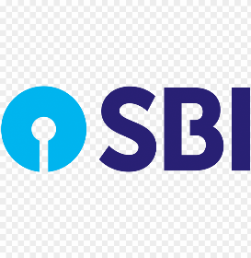

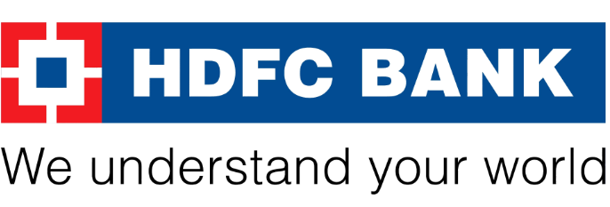

**Feedback From People on HDFC**

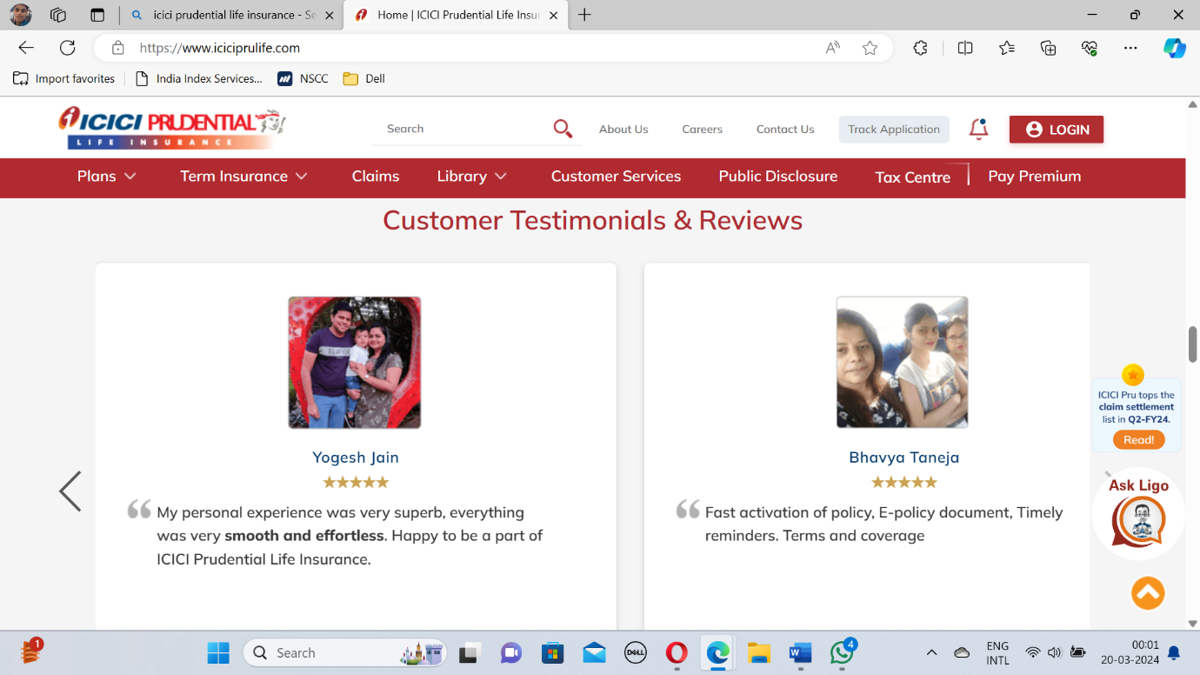

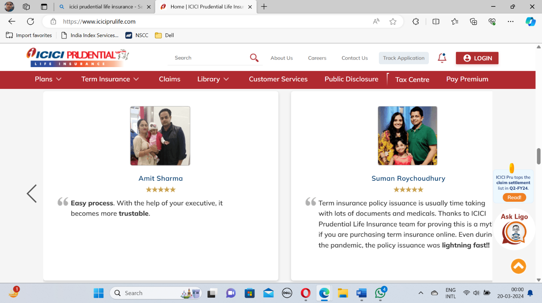

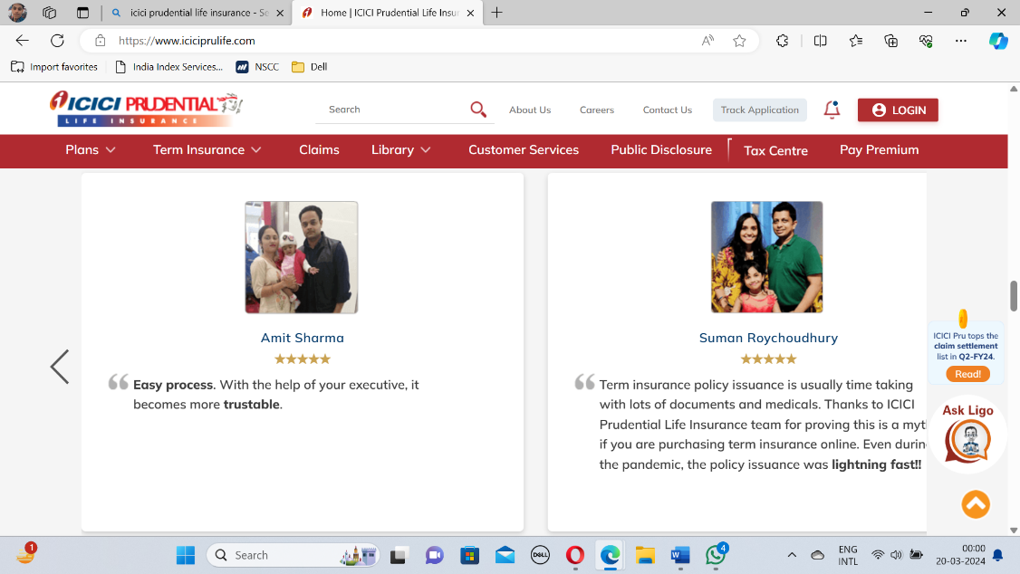**Financial Performance**

**HDFC Ergo Life Insurance:**  
Profit after tax (PAT) increased by 17.9% to €6.79 billion.  
The value of the new business (VNB) reached 14.51 billion euros and the profit of VNB was 26.7%.  
Conservation sector sales increased by 55.9% annually.  
The total annual value equivalents (APE) is 54.3 billion US dollars.  
Retail New Business Insured (NBSA) annual value equivalent (APE) totals $54.3 billion.  
Retail New Business Insurance (NBSA) grew 43.7% year-on-year, reaching $1.6 trillion in the first nine months of fiscal 2024.  
Total insurance coverage increased by 17.3% compared to fiscal year 2024, reaching $32.3 trillion. As of December 31, 2023.  
As of December 31, 2023, 13th month sustainability is 87.4%.  
As of December 31, 2023, assets under management (AUM) increased 13.8% year-on-year to $2.9 trillion.



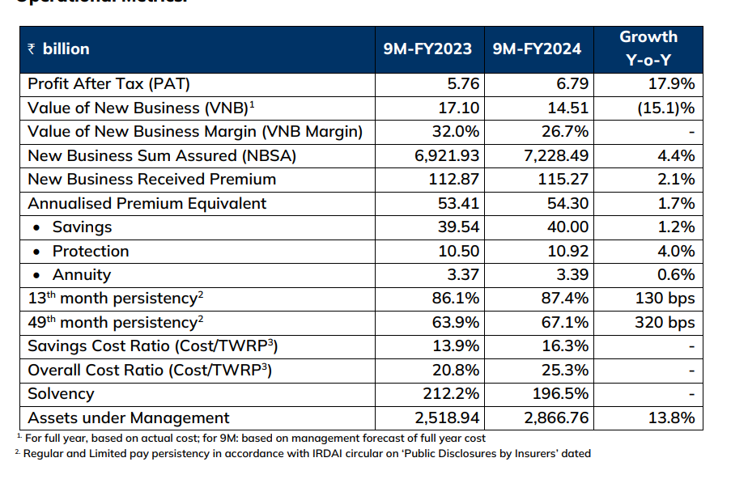

**HDFC ERGO LIFE INSURANCE IN CAPITAL MARKET**

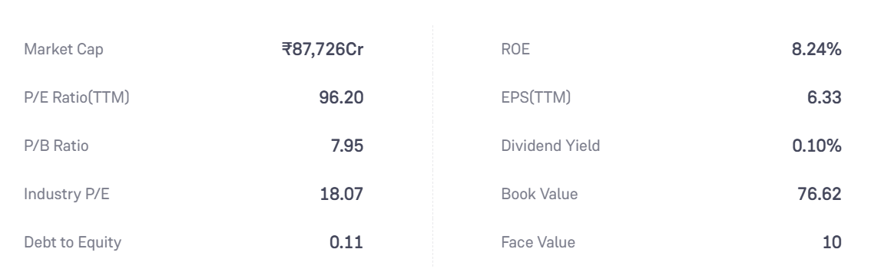



HDFC Ergo Life Insurance reported a strong growth of 17.9% in 9month profit after tax (PAT) to $6.79 billion for FY24. At the same time, the value of new business (VNB) reached $14.51 billion, and the margin of VNB was 26.7%.  
  
The company attributes its success to its strategy of offering quality products to its customers at competitive prices; This strategy led to a 26.5% and 17.3% increase in protection and annuity stores, respectively, in the third quarter. fiscal 2024. %. More importantly, new market insurance business (NBSA) fell 43.7% year-on-year to 1.6 trillion in Sep 24. In addition, as of December 31, 2023, total insurance premiums increased by 17.3% annually to 32.3 trillion, affecting customers' trust in company resources to solve problems.  
  
The company uses advanced working methods to increase the durability of each group, and the 13th and 49th month durability rate increased to 87.4% and 67.1%, respectively, on December 31, 2023. Profit after tax ( PAT) of HDFC Ergo Life Insurance increased by 17.9% to 6.79 billion in 9 months of FY24. At the same time, the value of new business (VNB) reached $14.51 billion, and the margin of VNB was 26.7%.  
  
The company attributes its success to its strategy of providing customers with quality products at competitive prices and has delivered significant growth in its protection and annuity stores, which increased by 26.5% and 17.3% respectively in the third quarter. fiscal 2024. %. More importantly, new market insurance business (NBSA) fell 43.7% year-on-year to 1.6 trillion in Sep 24. In addition, as of December 31, 2023, total insurance premiums increased by 17.3% annually to 32.3 trillion, affecting customers' trust in company resources to solve problems.  
  
Using advanced models to improve the performance of the entire line, the company achieved durability rates of 87.4% and 67.1% in the 13th and 49th months, respectively, as of December 31, 2023.

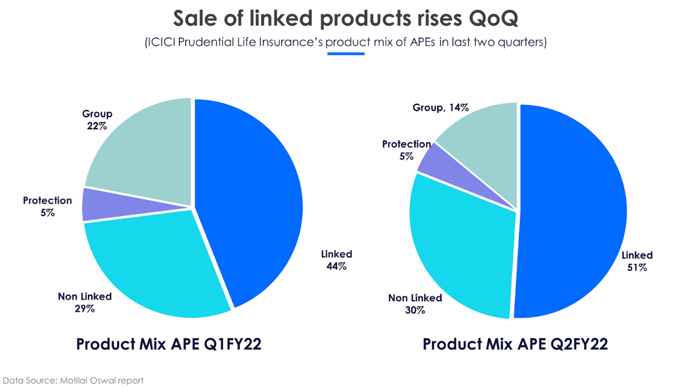



**HDFC Ergo Life Insurance**: Efficiently manage thousands of documents using Vision API.  
  
The insurance industry in India has undergone significant changes recently due to the integration of new technologies. HDFC Ergo Life Insurance is a recognized player in the industry and is actively participating in this change. Alpesh Karnik, senior vice president, IT, ICICI Life Insurance Company, agrees that data is on the rise and mobile usage has increased significantly across India. Around 60% of customer interactions are now said to occur via mobile phones, which is a significant change from the previous model.  
  
In addition, consumer expectations have increased due to increased access to information and digital services. Alpesh stated that consumers are increasingly aware of the importance of investment insurance and are therefore more proactive in purchasing insurance. But customers also want a fast and seamless process. HDFC Ergo Life Insurance is aware of this change and needs to improve efficiency. Therefore, the company chose to adjust its innovation and opt for Google Cloud services to meet the changing needs of customers  
  
  
Improving customer service through Google Cloud innovation  
  
HDFC Ergo Life Insurance uses technology to facilitate the entry of customer information Aiming to complete the process faster and do better. However, despite these efforts, some solutions still require manual intervention for document approval. For customers awaiting confirmation or update notification, this can result in delays of up to five to six hours, or even up to the next business day.  
  
HDFC Ergo Life Insurance has partnered with Google Cloud Premier Partner Searce to adopt innovative solutions using Artificial Intelligence and Machine Learning (ML) technology. The company revolutionized data processing by integrating Searce Recognic, powered by Google Cloud. Consider using Cloud Vision's optical character recognition (OCR) capabilities to read, understand, and analyze data at scale. This achievement allows organizations that process large amounts of data to effectively digitize data, ensuring accuracy and measurement.  
  
Through this strategic partnership and use of technology, ICICI Prudential Life Insurance has improved customer experience by enabling fast data. processing and approvals, thereby reducing waiting times and enhancing overall efficiency.

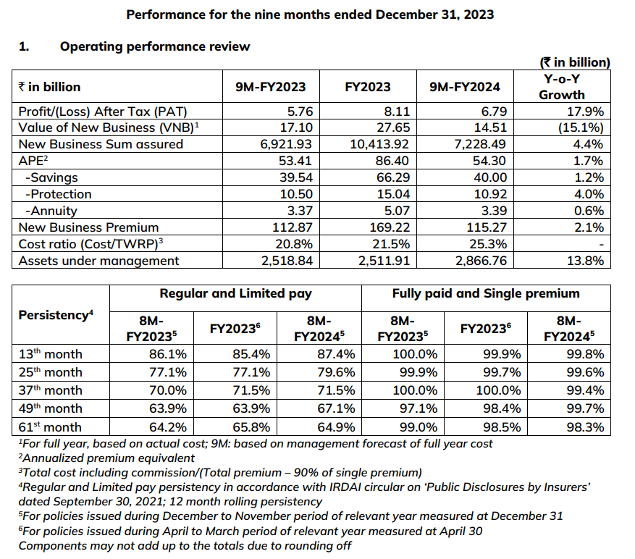

**New business value**

New business value increased by 2.1% annually, from 112.87 billion in September 2023 to 115.27 billion in September 2024.  
  
**Product Structure**

The company has many products in various categories such as savings. (linked and unlinked), annuities and protection to meet the specific needs of their clients. The company manages diversified products in 2024; The contribution of APE's 9 million mutual funds, unaffiliated funds, hedge funds, annuities and mutual funds is 43.1%, 26.9%, 20.1%, 6.2% and 3.7%, respectively. . < br>Protection APE increased by 4.0% year on year, from €10.5 billion in the nine months of fiscal 2023 to €10.92 billion in September 2024. It increased by 55.9% annually, from 2.2 billion euros in the nine months of 2024. Fiscal year 2023 increased to €3.43 billion in September 2024. As a result, retail insurance activity increased by 43.7% year on year, from €1,140.62 billion in the nine months of FY23 to €1,639.49 billion in FY24. Overall, new insurance business increased by 4.4% year on year, from €6,921.93 billion in the nine months of fiscal 2023 to €7,228.49 billion in the nine months of fiscal 2024. < br>  
Savings APE (excluding trade) increased 1.2% year over year, from $39.54 billion in the nine months of fiscal 2023 to $40 billion in September 2024.  
  
The risk of each group has increased, which shows the company's commitment to the development of good business. Month 13 exposure increased from 86.1% of FY 2023 8 million to 87.4% of FY 2024 8 million. The 49-month retention rate also increased from 63.9% in FY2023 to 67.1% in FY24.  
  
In September 2024, the total cost of ownership (TWRP) compared to operating and operating savings is 16.3% and 25.3% respectively. In recent years the company has invested to create future growth.

**HDFC ERGO PROCEDURE**

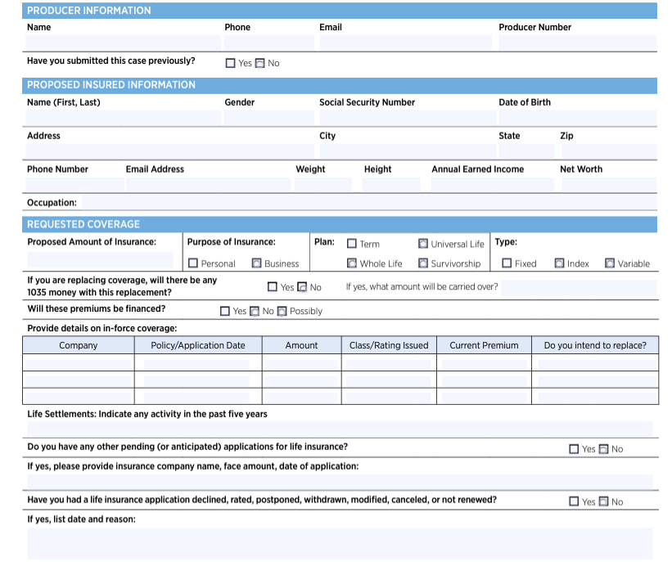

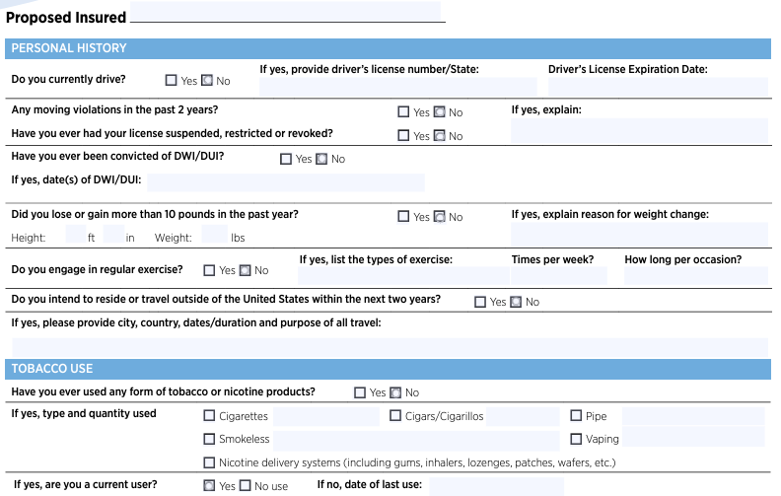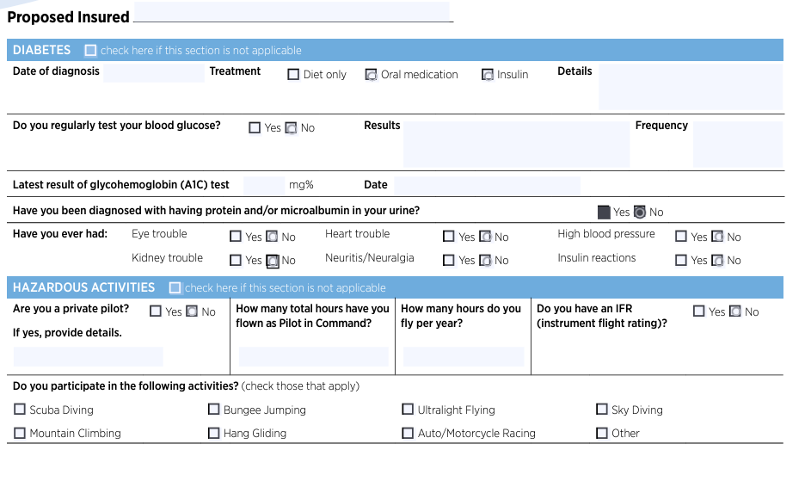

**APPENDIX**

1. The concept of insurance involves a transfer of

A. liability.

B. needs.

C ownership.

D. risk.

2. Rakesh recently bought a health insurance policy and a personal accident policy. What main section(s) of the insurance market do these products normally fall into?

A Life insurance in both cases

B. Life insurance for health and non-life insurance for personal accident.

C. Non-life insurance in both cases.

D. Non-life insurance for health and life insurance for personal accident.

3. The main role of an underwriter in a non-life insurance company is normally to

A. assess the acceptability of particular risks.

B. certify a loss when claims are submitted

C. design the structure of the products to be offered.

D. negotiate with the industry regulator.

4. Akshat is a relatively cautious person. In insurance terms, this will normally increase the likelihood that he will

A be considered an above average insurance risk

B. be considered a below average insurance isk

C. require insurance cover.

5.Do you think that insurance is necessary for any individual?

1. YES

2. NO

6. Do you know that insurance aims at covering risk and also a means of investment?

1. YES

2. NO

7. Are you aware that many private life insurance companies are providing life insurance coverage to the people apart from LIC of India?

1. YES

2. NO

8. Do you think that SBI Life Insurance Company is a government owned company like LIC of India?

1. YES

2. NO

9. Where do you invest your saving?

1. Life insurance company

3. Bank deposit

5. Mutual fund

10. Do you feel that the premiums paid in private life insurance companies are safe?

1. YES

2. NO

11. Do you think that the safety of the investments made in life insurance companies shall be protected by the regulatory body, i.e. IRDA.

1. YES

2. NO

**BIBLIOGRAPHY**

**The Economic Times (10,18 June)**

**INSURANCE HAND BOOK**

**FACT SHEET AND STATEMENT**

[**WWW. HDFC BANK  .COM**](http://www.bslmf.com)

[**WWW.MONEYCONTROL.COM**](http://www.moneycontrol.com)

[**WWW.AMFIINDIA.COM**](http://www.amfiindia.com)

[**WWW.ONLINERESEARCHONLINE.COM**](http://www.onlineresearch.com)

**WWW.HDFCERGOLIFE.COM**

**CONCLUSION**

HDFC, a prominent financial institution in India, has built a robust brand identity through years of dedicated service. Renowned for its pioneering products, customer-centric ethos, and technological prowess, HDFC has garnered the trust and loyalty of millions of clients. Its unwavering commitment to excellence, integrity, and transparency has been instrumental in cementing its esteemed reputation within the banking and financial services landscape.

The unique services offered by HDFC set it apart from its competitors, making it the preferred choice for a vast number of customers.

In summary, insurance plays a crucial role in risk management and financial security amidst today's uncertainties. HDFC, with its solid brand reputation, innovative strategies, and transformative influence on the banking sector, exemplifies the significance of prioritizing customers, embracing technology, and upholding ethical standards to drive positive change and promote financial inclusivity. As the banking and insurance industries continue to evolve, HDFC tradition of excellence and innovation is poised to continue shaping the future of financial services.