**Research Paper on:**

**CYBER SECURITY RISK MANAGEMENT IN SMALL BUSINESS**

By: Shanya Saxena

2024

# Abstract:

Cybersecurity risk management is a critical concern for small businesses in today's digital age. With the increasing frequency and sophistication of cyber threats, small businesses face significant challenges in protecting their sensitive data, financial assets, and reputations. This master's thesis explores the intricacies of cybersecurity risk management within the context of small businesses, aiming to provide insights and recommendations for enhancing their cyber resilience. The research delves into the theoretical frameworks, practical methodologies, and best practices associated with identifying, assessing, and mitigating cybersecurity risks in small business environments. Drawing upon a comprehensive review of literature, case studies, and industry reports, the thesis examines the unique cybersecurity threat landscape for small businesses, including common vulnerabilities, emerging threats, and regulatory requirements. Furthermore, it investigates the role of cybersecurity awareness, employee training, incident response planning, and budget allocation in building effective cybersecurity defences. Through the analysis of real-world examples and best practices, the thesis offers actionable recommendations for small businesses to strengthen their cybersecurity posture and minimize the impact of cyber incidents. By addressing these key areas, this research contributes to the advancement of knowledge in cybersecurity risk management and provides valuable insights for small business owners, policymakers, and practitioners striving to safeguard their digital assets in an increasingly interconnected world.

# Research Objectives

* To assess the level of familiarity with cyber security risk management concepts among small business owners and employees, as indicated by their responses to the questionnaire.
* To analyze the extent to which small businesses have implemented cyber security measures based on their responses regarding the implementation of such measures in their organizations.
* To examine the frequency of conducting risk assessments for cyber security in small businesses and identify any patterns or trends in their approach to risk assessment.
* To identify the factors influencing decision-making processes regarding cyber security investments in small businesses, including budget constraints, regulatory compliance requirements, and perceived threat levels.
* To determine the primary cyber security threats that concern small businesses the most, as indicated by their responses regarding the threats they perceive as most significant.
* To investigate the criteria used by small businesses to prioritize cyber security initiatives within their organizations, such as potential impact, likelihood of occurrence, regulatory requirements, and available resources.
* To assess the presence of dedicated teams or personnel responsible for cyber security in small businesses and examine their roles and responsibilities.
* To explore the methods used by small businesses to stay updated about emerging cyber security threats, including industry publications, cyber security conferences, online forums, and internal training sessions.
* To identify the challenges faced by small businesses in implementing effective cyber security measures, including a lack of skilled personnel, limited budget/resources, lack of awareness among employees, and the complexity of technology.
* To examine the incidence of cyber security incidents experienced by small businesses in the past year and analyze their responses regarding incident detection, response time, impact on business operations, and compliance with industry standards.
* To assess the presence of formal incident response plans in small businesses and examine their effectiveness in mitigating cyber security incidents.
* To investigate the methods used by small businesses to ensure data protection and privacy compliance, including encryption of sensitive data, access control mechanisms, regular data backups, and compliance audits.
* To analyze the extent to which small businesses involve external vendors or consultants in their cyber security efforts and identify the reasons behind such involvement.
* To examine the prioritization of cyber security in the overall business strategy of small businesses and assess its integration into their strategic planning processes.

# Introduction

Small businesses are increasingly becoming targets of cyberattacks due to their limited resources, making them vulnerable to various cybersecurity threats. As the digital landscape evolves, the importance of effective cybersecurity risk management for small businesses cannot be overstated. This introduction provides an overview of cybersecurity risk management within the context of small businesses, highlighting the significance of addressing cybersecurity threats proactively.

In today's interconnected world, small businesses are leveraging digital technologies to enhance efficiency, expand their customer base, and stay competitive. However, with these opportunities come inherent risks. Cybersecurity threats such as malware, phishing attacks, ransomware, and data breaches pose significant challenges to the confidentiality, integrity, and availability of small business data and systems. Moreover, the financial and reputational consequences of cyber incidents can be devastating for small businesses, often leading to loss of revenue, customer trust, and even business closure.

Cybersecurity risk management involves identifying, assessing, and mitigating risks to safeguard the organization's assets and operations from potential cyber threats. While large enterprises often have dedicated cybersecurity teams and substantial budgets for risk management initiatives, small businesses face unique challenges in this regard. Limited financial resources, lack of expertise, and inadequate awareness of cybersecurity risks make it challenging for small businesses to implement robust cybersecurity measures.

Despite these challenges, the need for effective cybersecurity risk management in small businesses cannot be ignored. The evolving threat landscape and increasing regulatory requirements necessitate proactive measures to protect sensitive information, critical systems, and business continuity. By prioritizing cybersecurity and adopting a risk-based approach, small businesses can strengthen their resilience against cyber threats and minimize the likelihood and impact of security incidents.

This master's thesis aims to explore the complexities of cybersecurity risk management in small businesses, examining various strategies, best practices, and challenges faced by organizations in mitigating cyber risks. By understanding the unique needs and constraints of small businesses, this research seeks to provide insights and recommendations for improving cybersecurity posture and fostering a culture of security awareness in the small business community. Through interdisciplinary research and practical insights, this thesis endeavours to contribute to the advancement of cybersecurity risk management practices tailored to the specific needs and constraints of small businesses.

## Overview of Cybersecurity Threats and Challenges

In today's digital age, small businesses face an ever-growing array of cybersecurity threats and challenges that can jeopardize their operations, reputation, and financial stability. These threats are diverse, sophisticated, and constantly evolving, posing significant risks to the confidentiality, integrity, and availability of sensitive information and critical systems. Understanding the landscape of cybersecurity threats is paramount for small business owners and managers as they strive to protect their organizations from potential harm.

One of the most pervasive cybersecurity threats facing small businesses is malware, including viruses, ransomware, and phishing attacks. These malicious software programs are designed to infiltrate systems, steal sensitive data, or extort money from victims, often through deceptive tactics or exploiting vulnerabilities in software and networks. With limited resources and expertise, small businesses are particularly vulnerable to malware attacks, which can result in costly data breaches, operational disruptions, and reputational damage.

Another significant challenge for small businesses is the prevalence of social engineering attacks, whereby cybercriminals manipulate individuals into divulging confidential information or performing actions that compromise security. These tactics may involve impersonating trusted entities, such as employees, customers, or vendors, through email, phone calls, or social media, exploiting human psychology and trust to gain unauthorized access to systems or data.

## Importance of cybersecurity for small businesses

The importance of cybersecurity for small businesses cannot be overstated in today's digital landscape. As technology continues to advance, small businesses increasingly rely on digital systems and online platforms to conduct their operations, store sensitive data, and communicate with customers. However, this increased connectivity also brings about heightened risks, making cybersecurity a critical priority for small businesses.

First and foremost, small businesses are prime targets for cyberattacks. Unlike large corporations with robust cybersecurity measures in place, small businesses often lack the resources and expertise to defend against sophisticated cyber threats. Hackers are well aware of this vulnerability and frequently target small businesses as easy prey. A successful cyberattack can have devastating consequences for a small business, including financial losses, reputational damage, and even the risk of bankruptcy.

Moreover, small businesses are custodians of valuable data, including customer information, financial records, and intellectual property. A breach of this data not only compromises the privacy and security of customers but also exposes the business to legal liabilities and regulatory fines. With data breaches becoming increasingly common and costly, small businesses must prioritize cybersecurity to safeguard their assets and maintain trust with their stakeholders.

## Definition and scope of cybersecurity risk management

The "Definition and scope of cybersecurity risk management" section in the master thesis on "Cyber Security Risk Management in Small Businesses" provides a foundational understanding of the concepts and boundaries within which the study operates.

Cybersecurity risk management encompasses the systematic identification, assessment, prioritization, and mitigation of potential threats and vulnerabilities that may compromise the confidentiality, integrity, and availability of digital assets and information within an organization. In the context of small businesses, cybersecurity risk management involves tailoring these processes to address the unique challenges and constraints faced by smaller-scale enterprises.

The scope of cybersecurity risk management extends across various dimensions, including technological, organizational, and regulatory aspects. It involves not only safeguarding digital systems and networks but also managing human factors, such as employee awareness and training, to mitigate the risk of insider threats and social engineering attacks. Furthermore, effective cybersecurity risk management requires alignment with relevant laws, regulations, and industry standards, ensuring compliance and accountability.

Within small businesses, the scope of cybersecurity risk management may be influenced by factors such as limited resources, expertise, and budget constraints. Therefore, the approach to risk management should be pragmatic and tailored to the specific needs and capabilities of small enterprises. This may involve prioritizing critical assets, adopting cost-effective security measures, and leveraging external resources, such as managed security services or collaborative networks, to enhance cybersecurity posture.

# Risk Assessment in Small Businesses

Risk assessment is a critical component of cyber security risk management for small businesses. It involves identifying potential threats, assessing vulnerabilities, and determining the likelihood and impact of cyber-attacks. This process helps small businesses understand their cyber security posture and prioritize actions to mitigate risks effectively. Here's a detailed overview of the risk assessment process tailored to small businesses:

## Identifying Assets and Vulnerabilities:

1. Asset Identification
2. Vulnerability Assessment
3. Asset Classification
4. Threat Identification

## Conducting Risk Assessments Tailored to Small Businesses:

1. Risk Identification
2. Risk Quantification
3. Risk Evaluation
4. Risk Documentation

## Prioritizing Cybersecurity Risks Based on Business Impact:

1. Business Impact Analysis
2. Risk Prioritization
3. Risk Treatment Planning
4. Continuous Monitoring

# Research Design and Methodology

## Research Design

This study investigates the landscape of cyber security risk management in small businesses. The data collection process involves the administration of a structured questionnaire via Google Forms. The questionnaire comprises 17 questions covering various aspects related to cyber security risk management practices, challenges, and strategies adopted by small businesses.

The research design for studying "Cyber Security Risk Management in Small Businesses" involved collecting data through a Google Form, with approximately 95 responses gathered. The questionnaire was structured to gather insights on various aspects related to cyber security practices and perceptions within small businesses.

Participants were asked to provide demographic information, including gender and age group, to understand the composition of the sample. Educational qualification was also captured to gauge the level of educational attainment among respondents.

To assess the familiarity with cyber security risk management concepts, participants were asked to self-assess their familiarity level. Subsequently, their implementation of cyber security measures in their organizations was explored, along with the frequency of conducting risk assessments.

The questionnaire delved into the factors influencing decision-making processes regarding cyber security investments, such as budget constraints, regulatory compliance requirements, and perceived threat levels. Participants were also prompted to identify the cyber security threats that concerned them the most.

### Sampling Approach:

The sample for this study consists of small business owners, managers, or decision-makers who are directly involved in or responsible for cyber security measures within their organizations. The sampling method employed is convenience sampling, whereby respondents are selected based on accessibility and willingness to participate in the study.

### Data Collection Instrument:

The questionnaire utilized in this study is designed to gather both qualitative and quantitative data. It includes multiple-choice questions, Likert scale items, and open-ended questions to capture a comprehensive understanding of participants' perceptions and experiences regarding cyber security risk management.

## Methodology

### Data Collection:

The data for this study was collected through an online survey administered via Google Forms. The survey aimed to gather insights into the cyber security risk management practices and perceptions of small businesses. A total of approximately 95 responses were collected from small business owners and professionals.

### Sampling:

The sampling technique employed for this study was convenience sampling. Participants were recruited through various channels, including social media platforms, professional networks, and email invitations. The survey was distributed to individuals who were involved in the management or decision-making processes related to cyber security within their respective organizations.

### Questionnaire Design:

The questionnaire consisted of 17 structured questions designed to elicit information on various aspects of cyber security risk management. The questions covered demographics, familiarity with cyber security concepts, implementation of cyber security measures, risk assessment practices, decision-making factors, threat perceptions, prioritization of initiatives, resource allocation, incident response capabilities, data protection measures, and engagement with external vendors. The response options provided multiple choices, Likert scales, and open-ended fields to capture a comprehensive range of perspectives.

### Data Analysis:

Quantitative data analysis techniques were employed to analyze the survey responses. Descriptive statistics such as frequencies, percentages, means, and standard deviations were calculated to summarize the demographic characteristics of the respondents and their responses to the survey questions. Cross-tabulations and chi-square tests were conducted to examine relationships between different variables, such as demographic factors and cyber security practices. Additionally, thematic analysis was performed on qualitative responses to identify recurring themes and insights related to challenges, priorities, and strategies in cyber security risk management.

### Ethical Considerations:

The survey protocol adhered to ethical guidelines for research involving human subjects. Participants were informed about the purpose of the study, voluntary nature of participation, confidentiality of their responses, and their right to withdraw at any time. Informed consent was obtained from all participants before they proceeded to complete the survey. Measures were taken to ensure the anonymity and privacy of the respondents, and data confidentiality was maintained throughout the research process.

### Limitations:

While efforts were made to obtain a diverse sample of small businesses, the convenience sampling method may limit the generalizability of the findings to a broader population. Additionally, self-reported data from survey responses are subject to potential biases such as social desirability bias and recall bias. Despite these limitations, the study provides valuable insights into the current state of cyber security risk management practices among small businesses and serves as a foundation for further research in this area.

# Data Analysis and Interpretation

1. Age group:

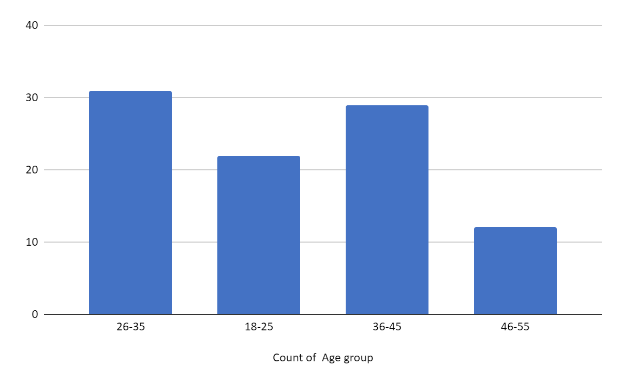

1. What is your familiarity with cyber security risk management concepts?

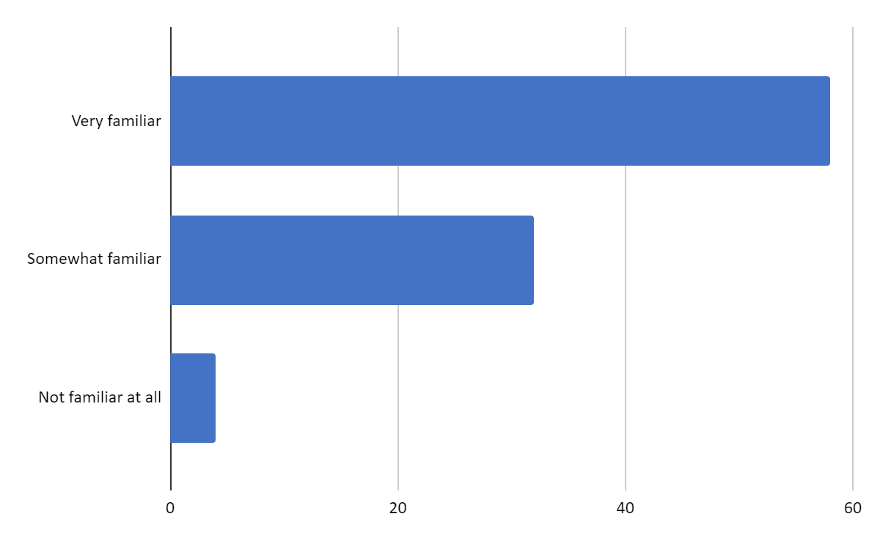

1. Do you have a dedicated team or personnel responsible for cyber security?

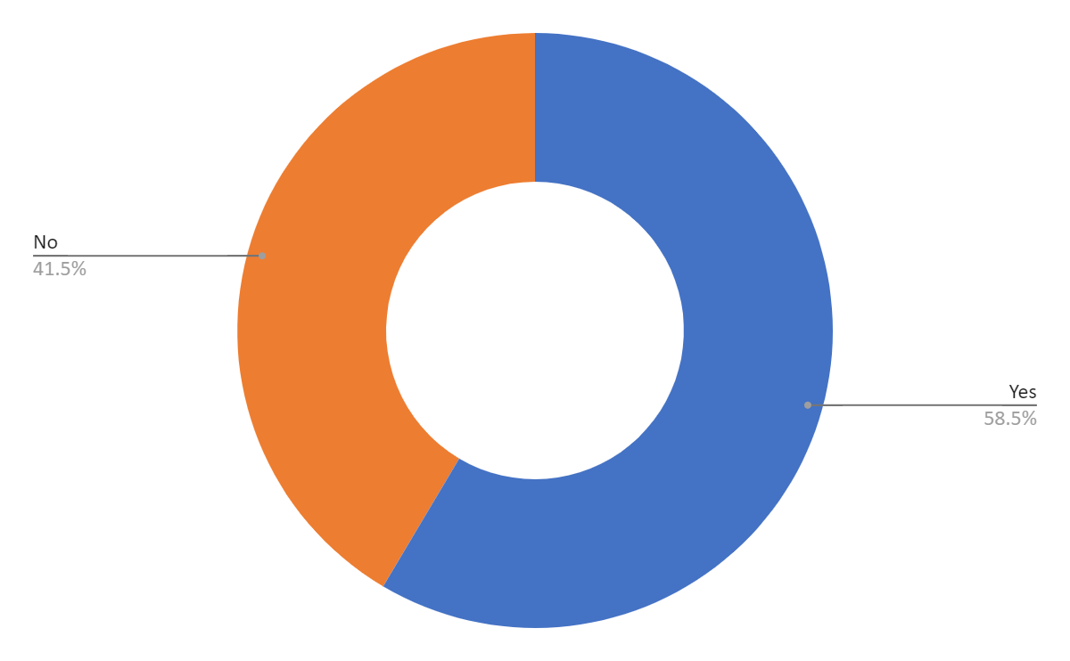

# Limitation

* **Sample Size and Representation**: The limitation of sample size could impact the generalizability of the findings. With only around 95 responses collected, the sample may not fully represent the diverse landscape of small businesses engaged in cyber security risk management. Moreover, if the respondents are not a true reflection of the population of interest, it could introduce bias into the analysis.
* **Self-Reporting Bias:** Since the data was collected through a Google form, there's a possibility of self-reporting bias. Respondents may have provided answers that they perceive as socially desirable or aligned with what they believe the researcher wants to hear, rather than their actual experiences or practices. This can skew the results and undermine the reliability of the findings.
* **Limited Scope of Questionnaire:** The questionnaire may not encompass all relevant aspects of cyber security risk management in small businesses. Certain nuances or critical factors could have been overlooked, leading to an incomplete understanding of the subject matter. This limitation could restrict the depth of analysis and hinder the ability to draw comprehensive conclusions.
* **Response Bias:** Depending on the clarity and wording of the questions, respondents may interpret them differently, leading to response bias. Additionally, respondents may skip questions or provide incomplete or inaccurate information, further compromising the validity of the data. Addressing response bias requires careful design and piloting of the questionnaire to ensure clarity and relevance.
* **Time Sensitivity:** The responses collected through the Google form may be time-sensitive, reflecting the cyber security landscape and practices at a specific point in time. As cyber threats evolve rapidly, the relevance and applicability of the findings may diminish over time. It's essential to acknowledge this limitation and interpret the results within the context of when the data was collected.

# Conclusion:

The responses gathered through the Google form shed light on the current state of cyber security risk management in small businesses. With approximately 95 participants providing insights into their perceptions, practices, and challenges, several key conclusions emerge.

Firstly, it's evident that while there's a diverse range of familiarity with cyber security risk management concepts, a significant portion of respondents acknowledge the importance of these concepts. However, a notable proportion also indicates a lack of familiarity, indicating a potential gap in understanding that needs to be addressed.

Secondly, the implementation of cyber security measures varies among small businesses, with some having extensive measures in place while others are still in the process of adopting them. This underscores the need for tailored approaches to address the specific needs and challenges faced by each organization.

Thirdly, the frequency of conducting risk assessments for cyber security appears to vary widely, with a significant portion either conducting them irregularly or not at all. This highlights a potential area for improvement in terms of establishing regular assessment practices to proactively identify and mitigate risks.

Fourthly, budget constraints, regulatory compliance requirements, and perceived threat levels are identified as significant factors influencing decision-making regarding cyber security investments. This indicates the multifaceted nature of considerations that businesses must navigate when prioritizing their cyber security initiatives.

Fifthly, the prevalence of cyber security threats such as phishing attacks, ransomware, insider threats, and Distributed Denial of Service (DDoS) attacks underscores the diverse and evolving nature of cyber threats faced by small businesses. This necessitates a holistic approach to cyber security that addresses various threat vectors effectively.

Sixthly, challenges such as a lack of skilled personnel, limited budgets/resources, lack of awareness among employees, and the complexity of technology are commonly cited obstacles in implementing effective cyber security measures. Addressing these challenges requires concerted efforts and potentially leveraging external expertise and resources.

Finally, the importance of having formal incident response plans, ensuring data protection and privacy compliance, and integrating cyber security into the overall business strategy is emphasized as essential components of a robust cyber security posture.

# Recommendations

Based on the data collected from the questionnaire, here are recommendations for small businesses regarding cyber security risk management:

* **Increase Awareness and Training:** Since many respondents indicated varying degrees of familiarity with cyber security concepts, it's crucial to invest in training programs to educate employees about potential risks and best practices for prevention. This could include regular workshops, online courses, or internal training sessions.
* **Implement Regular Risk Assessments:** A significant portion of respondents reported conducting risk assessments irregularly or not at all. It's essential for businesses to establish a structured approach to regularly assess their cyber security risks. This could involve quarterly or annual assessments to identify vulnerabilities and prioritize mitigation efforts.
* **Prioritize Investments Based on Impact and Likelihood:** When making decisions about cyber security investments, consider factors such as potential impact on the business and the likelihood of occurrence. This ensures that limited resources are allocated effectively to address the most significant threats.
* **Develop an Incident Response Plan:** Despite the importance of incident response planning, a notable portion of respondents reported not having a formal plan in place. Businesses should develop comprehensive incident response plans that outline procedures for detecting, responding to, and recovering from cyber security incidents.