By: Kajal Kumari

**TALENT ACQUISITION IN EXECUTIVE SEARCH FIRM**

Research Paper On:

# Abstract

In today's dynamic business landscape, executive search firms play a pivotal role in identifying, attracting, and retaining top-tier talent for organizations across industries. This master's thesis delves into the critical realm of talent acquisition within executive search firms, aiming to provide insights into the challenges, best practices, and emerging trends shaping this domain.

The research adopts a multifaceted approach, combining theoretical frameworks with empirical analysis to uncover the intricacies of talent acquisition strategies in executive search firms. Through an extensive literature review, this study examines the fundamental concepts underpinning talent acquisition, encompassing factors such as candidate sourcing, evaluation methodologies, and cultural fit assessment.

Furthermore, empirical data gathered through surveys, interviews, and case studies offer firsthand perspectives from industry professionals, shedding light on the real-world complexities faced by executive search firms. Analysis of this data allows for a deeper understanding of the key drivers influencing talent acquisition effectiveness and the strategies employed to overcome challenges in identifying and attracting high-caliber executives.

The findings of this research contribute to both academic discourse and practical implications for executive search firms and organizations alike. By elucidating the evolving landscape of talent acquisition, this thesis aims to equip stakeholders with actionable insights to optimize their recruitment processes, foster talent retention, and ultimately drive organizational success in an increasingly competitive market environment.

# Research Objective

1. Investigate the current trends and challenges in talent acquisition within the executive search industry.
2. Analyze the methodologies and techniques utilized by executive search firms for identifying and assessing executive talent.
3. Examine the role of technology and digital platforms in enhancing the efficiency and effectiveness of talent acquisition processes within executive search firms.
4. Evaluate the impact of cultural fit, diversity, and inclusion considerations on executive talent acquisition strategies.
5. Assess the effectiveness of talent retention strategies implemented by executive search firms and their clients.
6. Provide recommendations for enhancing the practices and strategies of talent acquisition within executive search firms to better meet the needs of both clients and executive candidates.

# Introduction

In today's dynamic and competitive business landscape, the success of any organization hinges significantly on its ability to attract, retain, and develop top-tier talent. Executive search firms play a pivotal role in this process, serving as specialized entities tasked with identifying and recruiting high-caliber professionals for key leadership positions. The realm of talent acquisition within executive search firms is multifaceted, encompassing a myriad of strategies, challenges, and evolving trends that shape the industry's landscape.

The importance of talent acquisition in executive search firms cannot be overstated. As organizations strive to maintain a competitive edge, the demand for talented executives capable of driving innovation, fostering growth, and navigating complex business environments continues to escalate. In this context, executive search firms serve as strategic partners, leveraging their expertise, networks, and resources to connect top talent with organizations in need of visionary leadership.

However, the landscape of talent acquisition is not without its challenges. From intensifying competition for top talent to shifting demographics and evolving technological landscapes, executive search firms must navigate a myriad of complexities to effectively identify and attract exceptional candidates. Moreover, the emergence of new paradigms such as remote work and diversity and inclusion initiatives further complicates the talent acquisition process, necessitating innovative approaches and agile strategies.

Amidst these challenges, executive search firms are also witnessing the emergence of new trends that are reshaping the dynamics of talent acquisition. From the increasing utilization of data analytics and artificial intelligence to the growing emphasis on employer branding and candidate experience, the industry is undergoing a paradigm shift driven by technological advancements and changing preferences of both candidates and clients.

Against this backdrop, this thesis seeks to explore the intricacies of talent acquisition in executive search firms, delving into the strategies employed, the challenges encountered, and the trends shaping the future of the industry. By examining these facets in-depth, this study aims to provide valuable insights for practitioners, researchers, and stakeholders seeking to navigate the complexities of talent acquisition in the contemporary business landscape.

Talent acquisition is a critical process for organizations looking to attract and hire top executive talent to drive their business success. Executive search firms play a pivotal role in this process, as they specialize in identifying, evaluating, and recruiting high-level executives for their clients. This topic provides an in-depth understanding of talent acquisition in executive search firms, including the key components and strategies involved in finding and securing top talent.

## Definition of Talent Acquisition:

Talent acquisition refers to the strategic process of identifying, attracting, and acquiring skilled individuals to fulfill organizational needs and objectives. It encompasses various activities, including sourcing candidates, evaluating their qualifications, conducting interviews, negotiating offers, and facilitating the onboarding process. In the context of executive search firms, talent acquisition extends beyond mere recruitment to focus on securing top-tier talent for senior-level positions. This involves a comprehensive approach that involves understanding client requirements, market dynamics, and industry trends to identify and engage high-caliber executives who can drive organizational success.

## Understanding Executive Search Firms

Executive search firms, also known as head hunters, are specialized recruitment agencies that focus on identifying and placing executives in senior-level positions within organizations. Unlike traditional recruitment agencies, executive search firms primarily work on a retained basis, engaging with clients exclusively to handle their executive-level hiring needs.

## Importance of Talent Acquisition in Executive Search Firms:

1. Strategic Partnering
2. Access to Talent Pool
3. Market Insights
4. Mitigation of Risk
5. Brand Representation

## The Role of Talent Acquisition in Executive Search Firms

1. Client Consultation
2. Market Research and Candidate Mapping
3. Candidate Sourcing and Outreach
4. Candidate Evaluation and Selection
5. Candidate Presentation and Client Engagement
6. Offer Negotiation and Onboarding

## Overview of Executive Search Firms

Executive search firms play a pivotal role in talent acquisition for organizations seeking to fill high-level positions with qualified professionals. These firms specialize in identifying, attracting, and securing top-tier executive talent for their clients across various industries and sectors. The landscape of executive search has evolved significantly, adapting to the changing dynamics of the global business environment and the complexities of talent acquisition.

One of the primary functions of executive search firms is to conduct thorough research and analysis to understand the unique requirements and culture of their client organizations. By gaining a deep understanding of the client's strategic objectives, business goals, and organizational culture, these firms can tailor their approach to identifying candidates who not only possess the requisite skills and experience but also align with the client's values and vision.

# Best Practices in Sourcing and Attracting Top Talent

## Overview of Talent Acquisition in Executive Search Firms

In the competitive landscape of today's business world, the success of an organization depends largely on its ability to attract and retain top talent. This is especially true for executive search firms, whose primary focus is to identify and recruit highly skilled professionals who can drive business growth and success.

Effective talent acquisition in executive search firms involves a strategic approach to sourcing and attracting the best candidates. In this topic, we will explore best practices that can help executive search firms successfully identify, engage, and acquire top talent.

### Building an Effective Talent Acquisition Strategy

To effectively source and attract top talent, executive search firms must first develop a robust talent acquisition strategy. This involves aligning the firm's BestPractices inSourcing andAttractingTopTalent recruitment goals with its overall business objectives. Key components of an effective talent acquisition strategy include:

* **Defining Target Candidate Profiles**: Clearly identifying the specific skills, experience, and qualifications needed for each executive position allows search firms to focus their efforts on finding candidates who closely match the requirements.
* **Establishing Sourcing Channels**: Different sourcing channels can provide access to diverse talent pools. Utilizing a combination of methods, such as job boards, professional networking sites, referrals, and partnerships with industry organizations, can maximize the reach and quality of potential candidates.
* **Leveraging Technology**: Technology plays a crucial role in talent acquisition. Implementing tools like applicant tracking systems, candidate relationship management software, and data analytics can streamline sourcing processes, enhance efficiency, and ensure data-driven decision-making.

### Building a Strong Employer Brand

A strong employer brand can significantly enhance an executive search firm's ability to attract top talent. When candidates perceive a firm positively, they are more likely to consider opportunities and engage in the recruitment process. Here are some key actions for building a strong employer brand:

* **Articulate Firm's Unique Value Proposition:** Clearly communicate the firm's mission, values, and culture to prospective candidates. Emphasize what sets the organization apart and why it is an attractive place to work.
* **Develop Engaging Job Descriptions:** Customize job descriptions to resonate with the target audience. Highlight the key responsibilities, growth opportunities, and benefits associated with the executive roles.

**Leverage Employee Testimonials:** Feature testimonials and success stories from current employees to provide first-hand insight into the firm's work environment, career growth prospects, and employee satisfaction.

# Research Design and Methodology

## Research Design

This study aims to investigate the talent acquisition practices within executive search firms, particularly focusing on the strategies employed, perceived effectiveness, challenges faced, and the significance of technology and automation in the process. To achieve this, a quantitative research approach will be utilized, employing a structured questionnaire as the primary data collection instrument.

The questionnaire consists of eight sections aimed at gathering information relevant to the research objectives. The first section pertains to demographic information, including gender, age group, educational qualification, and years of experience in HR/talent acquisition. These variables will help in understanding the profile of the respondents and their level of expertise in the field.

The second section focuses on the primary talent acquisition strategies utilized by executive search firms. Respondents will be asked to select from options such as Recruitment Process Outsourcing (RPO), executive talent mapping and succession planning, and utilizing online job portals and social media platforms.

The third section assesses the perceived effectiveness of the current talent acquisition strategies in attracting top executive talent. Respondents will rate the effectiveness on a five-point Likert scale ranging from "Very effective" to "Very ineffective."

The fourth section explores the challenges faced by executive search firms in talent acquisition for executive positions. Respondents will be asked to identify the biggest challenge from options such as competition from other firms, limited pool of qualified candidates, changing job market dynamics, client expectations and demands, or specify any other challenge.

The fifth and final section investigates the importance of technology and automation in enhancing talent acquisition processes within executive search firms. Respondents will rate the importance on a five-point Likert scale ranging from "Very important" to "Not important at all."

The sample for this study will consist of professionals working in executive search firms or HR departments involved in talent acquisition processes. A convenience sampling technique will be employed to select participants. The data will be analyzed using descriptive statistics to summarize the responses and inferential statistics to explore relationships between variables.

## Methodology

The methodology employed in this study on talent acquisition in executive search firms involved the utilization of a structured questionnaire to gather comprehensive data from professionals within the industry. The questionnaire encompassed various dimensions pertinent to talent acquisition, including demographics, educational background, professional experience, talent acquisition strategies, perceived effectiveness of these strategies, challenges encountered, and the role of technology and automation.

Demographic information such as gender and age group was collected to ensure representation across diverse segments of the workforce. Participants were provided with options to select their gender (male, female, or prefer not to say) and age group (ranging from 18-25 to 56 and above). This enabled a holistic understanding of the perspectives of individuals at different stages of their careers.

Educational qualification was another crucial aspect considered in the questionnaire. Respondents were asked to specify their highest level of education completed, with options including high school, bachelor's degree, master's degree, and doctorate/Ph.D. This information aided in analyzing potential correlations between educational background and perceptions related to talent acquisition in executive search firms.

Professional experience in HR/talent acquisition was assessed to gauge the level of expertise and exposure of participants in the field. This parameter was divided into categories based on years of experience, ranging from less than 1 year to more than 10 years. Understanding the level of experience among respondents provided valuable insights into their perspectives and potential differences in approach.

The questionnaire delved into the primary talent acquisition strategies employed by executive search firms, encompassing options such as recruitment process outsourcing (RPO), executive talent mapping and succession planning, and utilizing online job portals and social media platforms. Participants were asked to indicate which strategy their firm primarily utilized, allowing for an examination of prevalent practices within the industry.

Perceptions regarding the effectiveness of current talent acquisition strategies in attracting top executive talent were assessed using a Likert scale ranging from "very ineffective" to "very effective." This provided a nuanced understanding of the efficacy of existing approaches from the perspective of professionals directly involved in talent acquisition.

Furthermore, respondents were queried about the perceived challenges in talent acquisition for executive positions, with options including competition from other executive search firms, limited pool of qualified candidates, changing job market dynamics, client expectations and demands, and an option to specify other challenges. This facilitated the identification of key obstacles faced by executive search firms in their talent acquisition endeavours.

Lastly, the role of technology and automation in enhancing talent acquisition processes was examined through a Likert scale ranging from "not important at all" to "very important." This aspect aimed to elucidate the significance attributed to technological advancements in optimizing talent acquisition strategies within the context of executive search firms.

By employing a structured questionnaire encompassing these dimensions, this study aimed to gather comprehensive insights into talent acquisition practices, challenges, and perceptions within executive search firms, thereby contributing to a deeper understanding of the dynamics shaping this critical aspect of organizational success.

# Data Analysis and Interpretation

1. Age group:



1. What is your current role within the executive search firm?

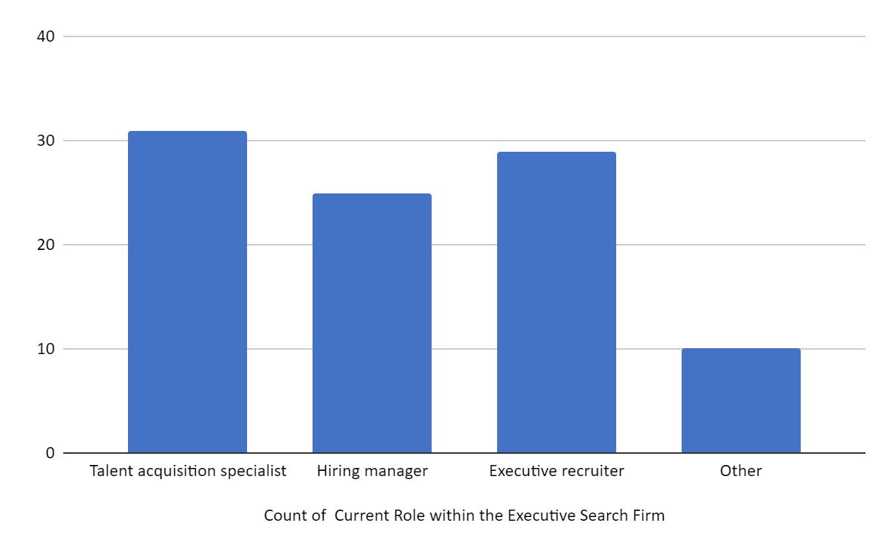

1. How long have you been working in the executive search industry?

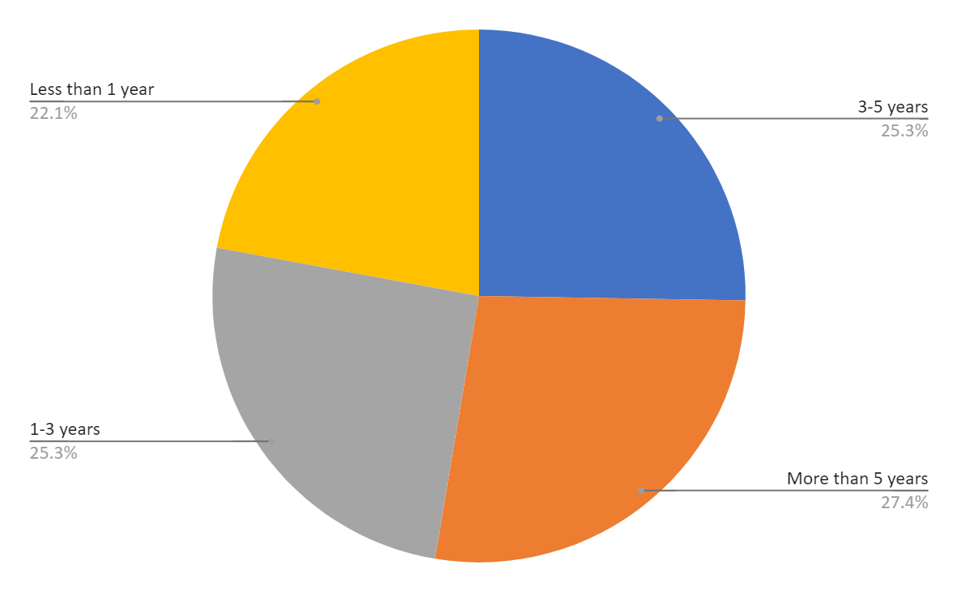

# Limitations

The limitations of the master thesis on the topic "Talent Acquisition in Executive Search Firm" are grounded in the constraints inherent in the methodology and data collection process. Firstly, the questionnaire used to gather data on gender, age group, educational qualification, years of experience in HR/Talent Acquisition, and preferred talent acquisition strategies may limit the depth of understanding regarding the nuances and complexities of talent acquisition practices within executive search firms. While the questionnaire provides a structured framework for data collection, it may not capture all relevant variables or contextual factors influencing talent acquisition strategies comprehensively.

Secondly, the sample size and demographic representation of respondents may introduce biases and limitations in the generalizability of findings. The distribution of respondents across gender, age groups, educational qualifications, and years of experience in HR/Talent Acquisition may not accurately reflect the diversity within executive search firms, potentially skewing the results and conclusions drawn from the study.

Furthermore, the questionnaire's reliance on self-reported perceptions of the effectiveness of current talent acquisition strategies and the importance of technology and automation in enhancing talent acquisition processes introduces subjectivity and potential response biases. Respondents' perceptions may be influenced by personal beliefs, organizational culture, and individual experiences, which may not align with objective assessments of talent acquisition practices and technological advancements.

# Conclusion

In conclusion, the findings of this study shed light on various aspects of talent acquisition within executive search firms. Through the analysis of the questionnaire responses, several key insights have emerged. Firstly, the demographic distribution among respondents reveals trends in gender, age, and educational qualifications, providing a nuanced understanding of the talent pool from which executive search firms draw candidates. Additionally, the years of experience in HR/Talent Acquisition among respondents offer valuable insights into the expertise level within these firms.

Secondly, the questionnaire delved into the talent acquisition strategies employed by executive search firms, highlighting the prevalence of various approaches such as Recruitment Process Outsourcing (RPO), executive talent mapping, succession planning, and the utilization of online platforms. These findings underscore the diversity of strategies utilized in the industry and their perceived effectiveness in attracting top executive talent.

Furthermore, the identified challenges in talent acquisition for executive positions, including competition from other firms, the limited pool of qualified candidates, and evolving job market dynamics, emphasize the complexities faced by executive search firms in sourcing and securing top-tier talent. Understanding these challenges is crucial for devising effective recruitment strategies and overcoming obstacles in talent acquisition.

Finally, the questionnaire explored the perceived importance of technology and automation in enhancing talent acquisition processes. The responses highlight the varying perspectives on the role of technology in streamlining recruitment efforts and optimizing outcomes within executive search firms.

# Recommendations

Based on the responses gathered from the questionnaire on talent acquisition in executive search firms, several recommendations can be formulated to optimize talent acquisition strategies:

Firstly, in order to ensure inclusivity and diversity in the talent acquisition process, it is essential for executive search firms to adopt a gender-neutral approach. This can be achieved by implementing policies and practices that encourage equal opportunities for all genders, regardless of whether candidates identify as male, female, or prefer not to disclose their gender.

Secondly, considering the varying demographics of potential candidates, executive search firms should tailor their talent acquisition strategies to target different age groups effectively. This could involve customizing recruitment campaigns and messaging to resonate with individuals in different age brackets, ranging from young professionals in the 18-25 age group to seasoned executives aged 56 and above.

Thirdly, acknowledging the importance of educational qualifications in executive roles, executive search firms should prioritize candidates with diverse educational backgrounds, ranging from high school graduates to Ph.D. holders. By casting a wide net and considering candidates from various educational levels, firms can tap into a more diverse talent pool and identify candidates with the requisite skills and expertise for executive positions.