Water Vending Machine

## 1Pratham Gedam, 2Nikhil Golait, 3 Akshad Gulhane, 4Devesh Mulani and 5Vaibhav Gawali.

6R.M. Gharat

## 1,2,3,4,5Students, Electronics Engineering.

6Lecturer/HOD, Electronics Engineering,

## Dr. Panjabrao Deshmukh Polytechnic, Amravati, Maharashtra, India.

### *Abstract: -*

### These devices represent an important step in the effort to provide sustainable, simple access to clean drinking water. This brief overview highlights their role in addressing environmental concerns, increasing health, and moving consumer behaviour toward sustainability through an analysis of their goals, functionality, and impact. Water vending machines offer an affordable answer to the problems of plastic waste and contaminated water by guaranteeing the supply of high-quality filtered water and serving as a convenient alternative to single-use plastic bottles. The abstract's conclusion highlights how water vending machines could change public hydration behaviours and promote a more sustainable and health-conscious mindset.

***Keywords—Water Vending Machine; Water Quality Standard; database; AI; IoT; NodeMCU.***

# INTRODUCTION

The water vending machine represents a significant advancement in ensuring accessible and clean drinking water for communities. This innovative technology addresses the global challenge of water scarcity by providing a convenient and cost-effective solution. Operating much like traditional vending machines, these units dispense water in predetermined quantities after payment. The system incorporates advanced filtration mechanisms to guarantee the purity and safety of the dispensed water.

By strategically placing these machines in urban and rural areas, communities gain immediate access to a reliable source of potable water, minimizing the reliance on traditional water supply infrastructure. This approach not only promotes public health by offering clean drinking water but also reduces the environmental impact associated with single-use plastic bottles. Additionally, the financial and logistical burden of transporting bottled water over long distances is alleviated.

The water vending machine emerges as a sustainable and practical solution, aligning with the broader global efforts to ensure water security and equitable access to this vital resource. for the quality of drinking water. This can lead to illnesses such as dysentery, typhoid, and hepatitis. Contaminated water can lead to illnesses such as typhoid, dysentery, and food poisoning. Today's consumers are more accustomed to using vending machines that dispense water, and this type of product has become more popular.

# LITERATURE REVIEW

1. The Water vending machine provides Safe and Clean Drinking Water to the people at low price. It also reduces the dependence of citizens on packaged drinking water which otherwise is an expensive option, especially for those living in rural areas.To reduce the rate of water borne diseases in poor people who cannot afford water purifier and to make environment free From excessive plastic bottles.
2. The system is using a controller that has a ESP8266 controller chip, it is main controller in the system. Another microcontroller is being used in this machine i.e., Arduino mega. the module is used to detect coins i.e., ESP32 CAM module.
3. The quick expansion of the Internet of Things (IoT) and machine learning transforms the world of humans into a smart one. Smart sensors help to make people's lives easier and advanced. In this paper we used different sensors for different applications like level sensor, temperature sensor, and Arduino to do this.
4. Water vending machines have gained significance as a convenient and accessible source of clean drinking water. These machines typically operate on a coin or card system, providing users with a specified amount of water for a set price. In the literature, the focus on water vending machines revolves around their role in addressing water scarcity and promoting public health. Studies highlight their potential to offer a reliable supply of safe drinking water in areas with limited access to clean water sources.
5. Researchers also explore the socio-economic impact of water vending machines, examining their affordability and impact on local communities. Concerns regarding water quality, machine maintenance, and regulatory frameworks are also addressed. Overall, the literature underscores the potential of water vending machines as a viable solution for improving water accessibility and quality in various settings, with ongoing discussions on optimizing their efficiency and ensuring equitable distribution.
6. The setup of a digital system to provide the drinking water from water vending machine is the goal of this project.the System is designed to research and develop a system that

safety and Improve quality of drinking water. The four main elements used by the system for evaluation are pH, water temperature, level measurement and coin detection.

Many vending machines featuring a variety of product options and number selections have been produced in the last few years. They can be separated into categories such as snack, chocolate, food, and glucose water dispensers, among many other types of liquid dispensing vending machines. The main goal is to raise awareness of alteration usage of water among those who reside in areas without access to pharmacists. One key aspect of water vending machines is their role in providing convenient access to clean drinking water, especially in regions facing water scarcity or contamination issues. Studies have shown that these machines can serve as a reliable and decentralized source of safe drinking water, offering a practical alternative to traditional water sources that may be unreliable or compromised

# METHODOLOGY

1. **Principle of System**

A water vending machine integrated with two sensors Along with the smartphone. One sensor for taking Environmental temperature, that will analyze the temperature In the environment and then according to the read value from The sensor it generates a notification to the user how much Water user needs to be consumed in that day. The second Sensor is to measure weight. It will take the weight of the Water bottle in the water vending machine. Even though there are few Sensors available these days which we can attach inside the Water bottle, we chose this weight measuring sensor, because Users will reluctant to use water if the sensor is inside the Water bottle by thinking about health issues come through an Electronic device

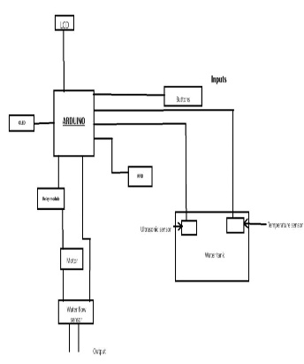 Figure a. Block Diagram of Water Vending Machine

Types of components we in water vending machine that are: - 1). ESP8266 controller, 2). Arduino mega, 3). LCD Display, 4). 4x4 Matrix Keyboard, , 5). Temperature sensor, 6). Motor. 7). Power Supply.

**Working**

**-** In the block diagram of Water vending machine the first’ block is coin when the user needs a water then he/she use a coin to get a water as per his requirements so that’s why the coin is used. Then the touch screen input is used .

**Temperature sensor**

This Temperature sensor is used to measure the temperature around what we prepared for example we Build a water vending machine, and this machine is where we can apply like a railway station so what is temperature around the railway station can we apply the water vending machine, so it is used to read the temperature of environment.

Temperature sensor is measured air temperature liquid or the temperature of solid matter.

Temperature sensors are versatile devices used in a wide range of applications to measure temperature accurately and reliably. Understanding the characteristics and considerations of different types of temperature sensors is crucial for selecting the most suitable sensor for a specific application and ensuring optimal performance and functionality.

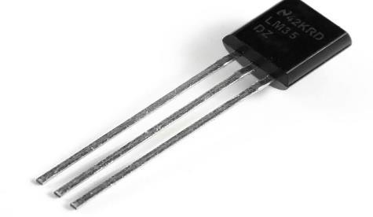

Figure b. Temperature sensor.(LM35)

**RFID sensor**

RFID sensors can efficiently work for water vending machines by assigning each customer a unique RFID tag linked to their account or payment method. When a customer approaches the vending machine, they can simply scan their RFID tag, which triggers the machine to dispense water accordingly. This system ensures secure transactions and eliminates the need for cash or cards, making the process more convenient for customers.

Additionally, RFID technology can track usage patterns and inventory levels, enabling vendors to manage their stock efficiently and provide timely refills. Moreover, RFID sensors are durable and can withstand the conditions typically encountered in outdoor environments where water vending machines are often installed. Overall, integrating RFID sensors enhances the functionality, security, and user experience of water vending machines.

# 

# Figure c. RFID sensor(MFRC522)

# Water flow sensor

# A water flow sensor is a device that measures the rate of water flow in a pipe or system. It typically consists of a mechanism to detect the movement of water, such as a paddle wheel or turbine, and a sensor to convert this movement into electrical signals. These signals are then processed to determine the flow rate, which can be displayed on a digital readout or used for control purposes in various applications, including industrial processes, irrigation systems, and plumbing. Water flow sensors are crucial for monitoring and managing water usage efficiently and detecting leaks or abnormal flow patterns.

# . Figure d. water flow sensor.

There are several types of water flow sensors available, including turbine, magnetic, ultrasonic, and paddlewheel sensors. Each type operates on different principles, such as measuring the rotational speed of a turbine or the changes in a magnetic field caused by flowing water.

**Relay module**

A relay module is an electromechanical or solid-state

device used to control high-power circuits with low-power signals. It consists of an input side (control circuit) and an output side (switched circuit). The input side typically includes a coil driven by a control signal (e.g., from a microcontroller), activating an electromagnet that closes or opens the relay's contacts on the output side

. This action allows the relay to control devices like lights, motors, or other appliances safely and efficiently. Relay modules come in various types based on load requirements and switching mechanisms. Solid-state relays (SSRs) use semiconductors for switching, offering faster response times and longer lifespans compared to traditional electromechanical relays. When selecting a relay module, consider factors such as voltage and current ratings, contact type (normally open or normally closed), and compatibility with control signals. Relay modules are integral to automation, IoT projects, and prototyping where interfacing with high-power devices is necessary.

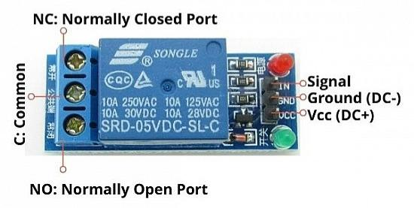

Figure e. Relay module

**Arduino IDE**

Arduino IDE (Integrated Development Environment) is a software program used to write, compile, and upload code to Arduino boards. A program for Arduino hardware may be written in any programming language with compilers that produce binary machine code for the target processor. Atmel provides a development environment for their 8-bit AVR and 32-bit ARM Cortex-M based microcontrollers: AVR Studio (older) and Atmel Studio



# Figure f. Arduino IDE

**IV. Future Enhancement**

As an added advantage in this paper, we can add the feature that we will get hot water or cold water according to the change in season and requirement. For this purpose, we can attach temperature control device like water heater or cooler with secondary tank and also some arrangements to maintain the temperature of water at required level in the tank. In addition to this, it is possible to use solar panel

to provide power supply to this machine so that the power is saved by this machine. It will be the added advantage for this machine that it will work in the absence of electricity. Thus, the establishment of this machine will be possible in remote sensing areas where the water crises. Thus, this machine will be more eco-friendly.

The coin discriminator it is possible to make note to coin exchanger, so that customer can be able to get water and exchange with note We can also add the IVR in the system so as to help people understand the instructions clearly and increase the reliability of machine .

**V. Acknowledgement**

We would like to express our sincere thanks to all those who have contributed to the development and implementation of the water vending machine project.

To begin with, we extend our appreciation to our team members whose dedication and expertise were instrumental in designing, building, and testing the water vending machine prototype. Their innovative ideas and tireless efforts have brought this project to fruition.

Last but not least, we would like to thank our Teachers, and colleagues for their unwavering support and encouragement throughout this journey. Their patience, understanding, and encouragement have been a constant source of motivation.

**VI. Actual Circuit**

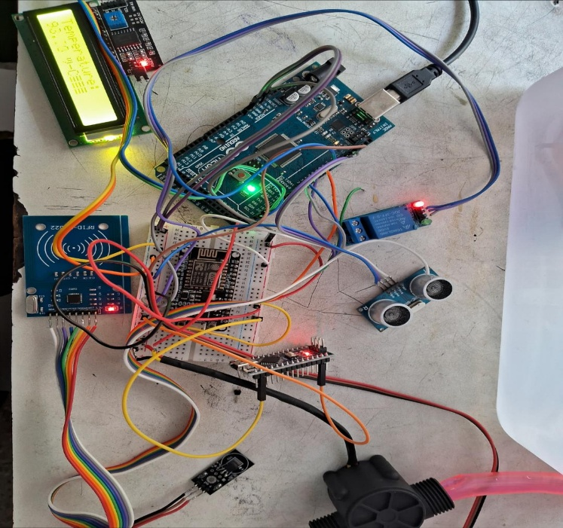

Figure g. Actual Circuit

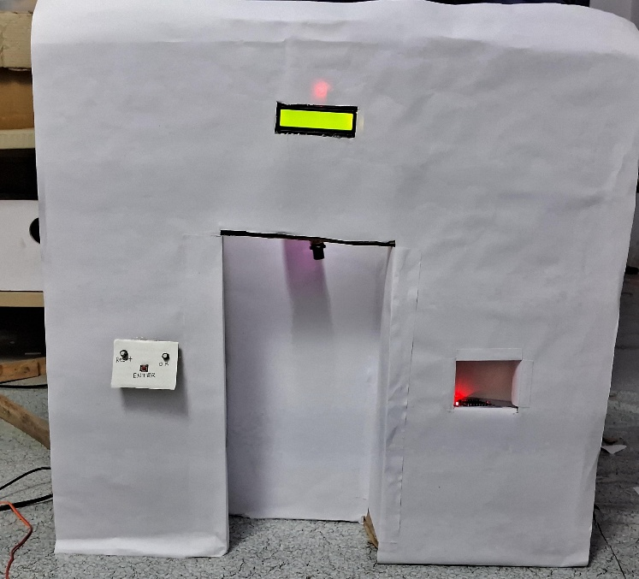

Figure h. Model of water vending machine

**VII. Conclusions :-**

Drinking Water Vending Machine aimed to

1. Water vending machines are more than simply useful utilities; they are essential answers to several problems, such as promoting sustainable development more broadly, reducing plastic pollution, and simplifying access to clean drinking water.
2. Water vending machines guarantee that everyone has access to clean drinking water, meeting the basic human need for hydration regardless of time or place, using their wide deployment.
3. Water vending machines considerably reduce our dependence on plastic and help reduce the negative impacts of plastic pollution, protecting marine life and ecosystems by offering a sustainable substitute for single-use plastic bottles.

**VIII. References**

[1] Teerapong Boonlar, Online Checking System for Drinking Quality of Drinking Water Vending Machine,

International Conference on Sign al Image Technology & Internet-Based Systems (SITIS), 2019.

[2] Amali Gunasinghe and Janani Tharmaseelan, Smart Water Dispenser, author profiles for this

publication

at: https://www.researchgate.net/publication/34883 2527, April 2019.

[3] N H Hashim and H M Yusop, Drinking Water Quality of Water Vending Machines in Parit Raja, Batu

Pahat, Johor, IOP publishing, 2016.

[4] Sasikala G, Kuldip sing Rajput, Sarfaraz Hussain and Aastha Shrivastava, real time embedded based

water vending machine, Asian Journal of Science and Technology, December 2014.

[5] Chin Jung Haung and Fa Ta Tsai, Research and development of a Practical Water Dispenser, IEEE, 2017.

[6] Praveen Kumar; Shailaja Singh; Manu Choudhary; K. Singh, Solar Powered Medic Vending Machine,

IEEE 2020.

[7] Zhang Jianbo; Yin Qun; Yin Meisu, Design of vending machine based on PLC, I