STRUCTURAL ANALYSIS OF BATTERY BRACKET FOR E VEHICLE
¹ MR. PRASHANT U. THORAT, ² Dr. S. H. KADHANE

¹Student, ME (Design Engineering) Dept. of Mechanical Engineering, SVPM'SCOE, Baramati
²Professor, ME (Design Engineering) Dept. of Mechanical Engineering, SVPM'SCOE, Baramati

Abstract: Ensuring the security and sturdiness of battery brackets in electric cars (EVs) is integral to guard battery packs and maintain reliable performance. Impact testing is integral for evaluating the structural integrity and crashworthiness of these brackets beneath more than a few scenarios. This summary outlines lookup on have an impact on trying out for EV battery brackets, focusing on experimental tests, numerical simulations, and finite component analysis.

Researchers have studied the influence overall performance of battery brackets under most loads, analyzing exceptional situations which includes frontal collisions, facet impacts, and high-speed loading. They've examined bracket responses in terms of von Mises stress, deformation, and equivalent stress to understand failure modes, deformation characteristics, and electricity absorption capacity.

Keywords: E Vehicle, Battery bracket, FEA, structural analysis

- INTRODUCTION
The security and crashworthiness of electric automobiles (EVs) are integral factors in their design and development. A key thing that performs a indispensable role in defending the battery gadget for the duration of influences is the battery bracket. Conducting crash checks on battery brackets is critical to consider their structural integrity, electricity absorption capabilities, and ordinary performance beneath severe impact conditions. The battery bracket is a crucial structural aspect that secures and supports the battery pack inside an electric powered vehicle. During a crash, this bracket is subjected to high forces, accelerations, and deformations. Its capacity to stand up to these forces and defend the battery gadget is essential for occupant safety and to prevent manageable hazards such as thermal runaway or harm to the battery cells.

Crash checks simulate real-world crash situations to verify how battery brackets behave at some stage in influence events. These exams involve subjecting the bracket to controlled influences that mimic extraordinary crash modes like frontal, side, or rear collisions. Through these tests, engineers can evaluate the bracket's crashworthiness, deformation characteristics, failure modes, and its capability to defend the battery system. The insights received from crash checking out are integral for guiding format upgrades and optimization strategies to decorate the security and crashworthiness of battery brackets in electric powered vehicles.

Furthermore, crash check information is used to validate and refine laptop simulations and analytical models. This allows engineers to predict and optimize the performance of battery brackets in the course of crash activities greater accurately.
- LITERATURE REVIEW
In this study, Adarsha et al.[1] focus on the design of a battery box specifically for buses. The research likely addresses the challenges associated with integrating and securing battery packs within the context of larger commercial vehicles like buses. By detailing the design process and considerations for this specific application, the study provides insights into the structural requirements and crashworthiness considerations for battery brackets in larger vehicles. The work may include experimental or numerical analyses to optimize the battery box design for safety and efficiency.
Sutar, Mansuri, and Ambesange [2] explore the design of an integrated battery mounting tray tailored for commercial vehicles. This research likely delves into the challenges of accommodating large battery packs in heavy-duty vehicles while ensuring robust structural support and crash performance. The study may involve a combination of design optimization, finite element analysis (FEA), and physical testing to validate the effectiveness of the integrated battery mounting tray. Insights from this work can contribute to enhancing the crashworthiness and safety of battery brackets in commercial EVs.
Lamb, Kim, and Kurzawski's [3] work likely focuses on testing procedures and analysis methodologies related to impact propagation and mitigation strategies. While the direct link to battery brackets may not be explicit, this research could provide valuable insights into general impact analysis techniques applicable to EV components, including battery brackets. Understanding propagation of forces and mitigation strategies is crucial for optimizing the crashworthiness of battery mounting systems in electric vehicles.
Belingardi and Scattina[4] likely discuss the challenges and solutions associated with integrating battery packs into the underbody structure of battery electric vehicles (BEVs). While the primary focus might be on overall vehicle structure integration, the study likely addresses specific considerations for battery brackets and mounting systems. Insights from this research can inform the development of robust and efficient battery brackets that optimize vehicle safety, weight distribution, and crash performance.

- OBJECTIVES
- Evaluate the structural strength and rigidity of EV battery brackets under various loading conditions, including static and dynamic loads.
- Enhance the crash performance of battery brackets by analyzing deformation characteristics, stress distribution, and energy absorption capabilities during impact events.
- Verify compliance with design specifications and industry standards to ensure that battery brackets can withstand realistic operating and crash scenarios.
- Identify potential failure modes such as buckling, yielding, or cracking under different loading conditions to guide design improvements.

IV. MATERIAL SELECTION AND PROPERTIES
4.1 Composite Material
Composite materials are engineered materials composed of a combination of two or more distinct elements that, when mixed together, create a new material with unique properties that surpass those of the individual components. Composites typically consist of a reinforcement material, such as fibers, combined with a matrix material, often in liquid form. The reinforcement fibers enhance the strength and stiffness of the composite, while the matrix material binds the fibers together to form a solid structure. This synergistic combination results in a composite material with improved mechanical properties tailored to specific applications.

- FINITE ELEMENT ANALYSIS
Finite Element Method is a numerical procedure for solving continuum mechanics of problem with accuracy acceptable to engineers.
6.1 Post-processing of Structural Analysis
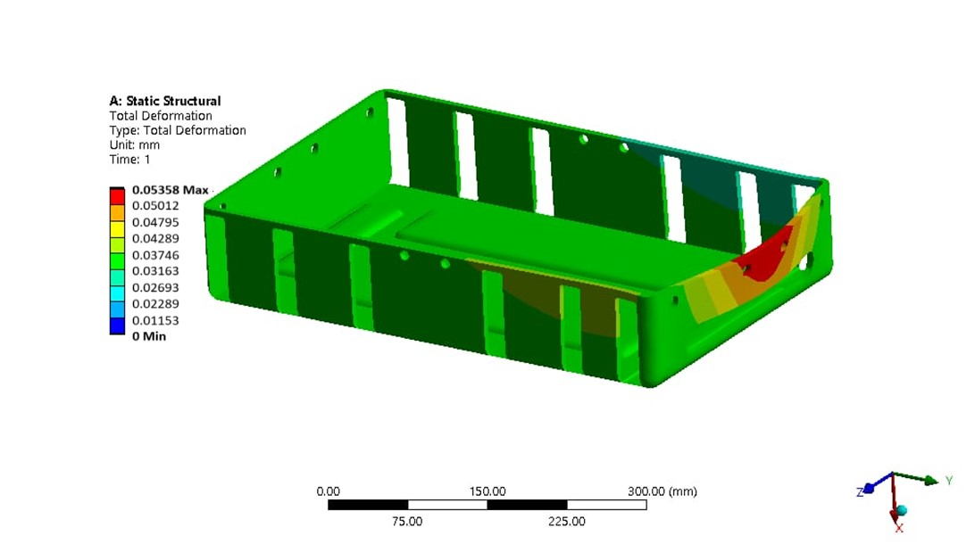
Figure 6.1: Total deformation contour plot for battery bracket
The maximum deformation shown by the battery Bracket design is 0.05358 mm.
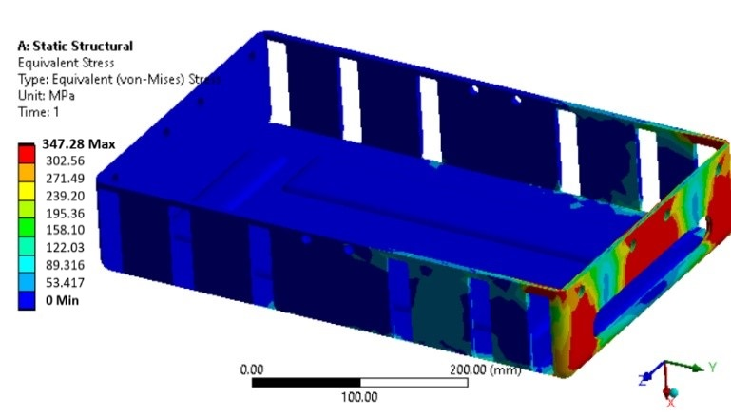
Figure 6.2: Von-Mises stress contour plot for battery bracket
The maximum equivalent stress observed in the battery bracket is 347.28 MPa.
The yield strength of the material is 385 MPa. According to the results, the von-Mises stress 347.28 MPa is less but nearer to the yield strength of the material.
6.2 Summary (From Finite Element Analysis)
The analysis reveals that the battery bracket experiences the highest stresses, correlating directly with observed field failures. A comparison is made between the maximum total deformation and equivalent stress values of the original battery bracket design and modified designs. The table below illustrates this comparison across different battery bracket designs using Finite Element Analysis (FEA).
Table 6.1: FEA Results
Sr.No | Description | Deformation (mm) | Von-Mises Stress (Mpa)
1 | Battery bracket | 0.05358 | 347.28

The stress levels in the proposed bracket are found to be minimal. This feasible bracket design is selected for manufacturing, and subsequent experimental results are compared with the findings from the finite element analysis (FEA) study.

V. EXPERIMENTAL RESULTS AND DISCUSSIONS

A) Testing of Bracket on UTM
An experimental study was conducted to investigate how the use of composite materials affects the load-bearing capacity of the bracket. The experimental setup for this test is illustrated in Figure 6.1. A Universal Testing Machine with a capacity of 10 tonnes was employed for conducting these tests.
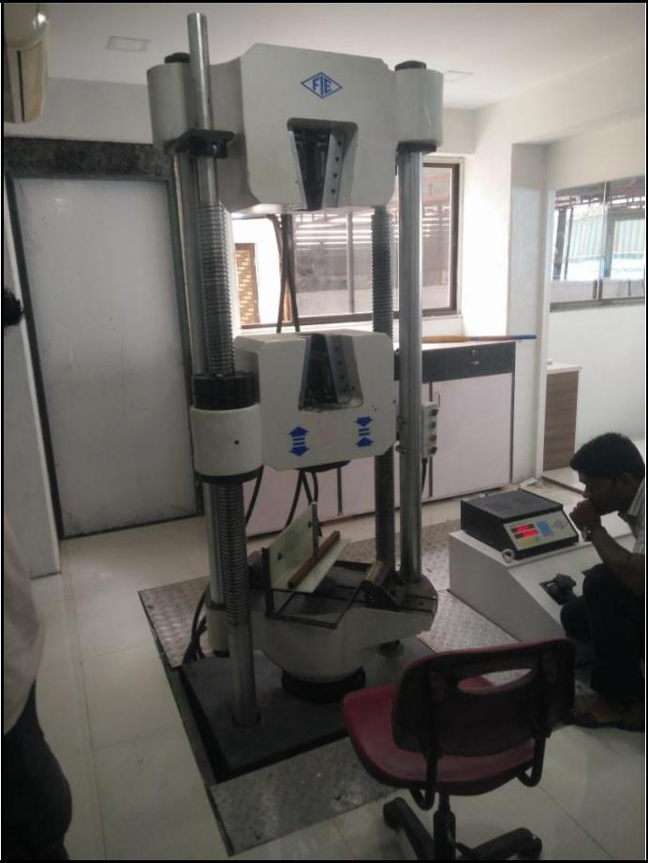

Figure 5.1 Test setup for battery bracket
Table 6.1: Experimental Results
Sr.No | Description | Deformation (mm) | Von-Mises Stress (Mpa)
1 | Battery bracket | 0.05185 | 342.19

- CONCLUSION
- The modified FEA design of the bracket exhibits minimal deformation, measuring 0.053 mm, while experimental testing shows a deformation of 0.051 mm.
- Similarly, the Von-Mises stress in the modified bracket design is minimized at 347.28 MPa in the FEA analysis and 342.19 MPa in experimental testing.
- These results indicate that the modified battery bracket design is highly suitable and feasible for the current application, both from a design and manufacturing perspective.

Table 7.1. FEA & Experimental Results Summary
Test | FEA Results | Experimental Results
Deformation (mm) | 0.05358 | 347.28
Von-Mises Stress (Mpa) | 0.05185 | 342.19
% Error | 3.35% | 1.48%

REFERENCES
[1] Mrs. Jostna Ingale and Prof. A. B. Dighewar, “Design and Optimization of Car Battery Tray”, International Journal of Research in Advent Technology, Vol.5, No.2, February 2017, 2321-9637.H.
[2] Shashank Arora and Ajay Kapoor, “Mechanical Design and Packaging of Battery Packs for Electric Vehicles”, Green Energy and Technology, 2018, 10.1007/978-3-319-69950-9_8.
[3] Shashank Arora, Ajay Kapoor and Weixiang Shen, “Application of Robust Design Methodology to Battery Packs for Electric Vehicles: Identification of Critical Technical Requirements for Modular Architecture”, Batteries 4(3):30,2018, 10.3390/batteries4030030.
[4] Nengsheng Bao; Rongjiang Zhao, “Design Optimization of Battery Holder for Electric Vehicle”, IEEE, 2018, 10.1109/CMAME.2018.8592441.

[5] Bhushan A. Bhaye, Kunal M. Chandorkar, Pankaj B. Doiphode, Sonali S. Koli and Rohit G. Ramteke, “Design and Implementation of Electric Vehicle” , International Research Journal of Engineering and Technology, Volume: 05 Issue: 10 | Oct 2018.
[6] Adarsha*, Sunil Bhat and S. Rakesh, “Design of a bus battery box”, Adarsha Journal of Engineering Research and Application, 2 Vol. 9,Issue 5 (Series -I) May 2019, pp 27-32.
[7] Pritesh Sutar, Arif Mansuri and Arvind Ambesange, “DESIGN OF INTEGRATED BATTERY MOUNTING TRAY FOR COMMERCIAL VEHICLE”, Vol-7 Issue-3 2021.
[8] Joshua Lamb, Jinyong Kim and Andrew Kurzawski, “Propagation Mitigation Testing Procedures, Modeling, and Analysis”, Affiliation: Sandia National Laboratories”, 2022, DOT HS 813 230.
[9] Giovanni Belingardi and Alessandro Scattina, " Battery Pack and Underbody: Integration in the Structure Design for Battery Electric Vehicles—Challenges and Solutions”, MDPI,2023, 5(2), 498-514.

