**EXPERIMENTAL ANALYSIS OF TWO WHEELER DISC BRAKE BY USING CERAMIC MATRIX COMPOSITE MATERIAL**

**Mr. Kanawade Sachin1, Prof. Prof. P. B. Dengale2**

1Student, M.E., Mechanical Engineering, SVCOET, Junnar, Pune, Maharashtra, India

2Professor, Mechanical Engineering, SVCOET, Junnar, Pune, Maharashtra, India

**ABSTRACT**

This abstract presents the experimental analysis of a disc brake system using a dedicated test rig to assess its performance characteristics under different operating conditions. The study focuses on evaluating the braking efficiency, thermal behavior, and wear patterns of the disc brake through comprehensive experimental tests. The experimental setup involves a specially designed test rig capable of simulating realistic braking conditions. The test rig allows for controlled application of braking forces and monitoring of critical parameters such as brake temperature, braking torque, and wear debris generation. Various test scenarios are conducted to investigate the influence of factors like braking pressure, speed, and material composition on the brake's performance.

Key experimental measurements include temperature distribution across the disc surface using thermocouples, torque measurements using strain gauges, and wear analysis through visual inspections and post-test measurements. Data acquisition and analysis techniques are employed to interpret experimental results and draw meaningful conclusions. The outcomes of this experimental analysis provide valuable insights into the dynamic behavior and performance limitations of the disc brake system, offering practical implications for optimizing brake design and operational parameters. This abstract outlines the methodology and objectives of the experimental study, emphasizing its significance in advancing the understanding of disc brake performance through empirical investigations.

**Keywords:** Finite Element Analysis, Disc brake, Material optimization comparative analysis..

1. **INTRODUCTION**

A brake is a mechanism used to observe synthetic frictional resistance to a shifting laptop part, with the aim of halting the machine's motion. In this process, brakes soak up both the kinetic power of the shifting part or the doable electricity launched through objects being lowered via units like hoists or elevators. The power absorbed by brakes is dissipated as warmness into the surroundings.

**Brake Design Considerations:**

Brakes have to provide adequate stopping electricity to halt a car within a minimal distance for the duration of emergencies.They need to permit the driver precise manipulate over the vehicle throughout braking, stopping skidding.Brakes must keep regular effectiveness even with extended or constant use (anti-fade characteristics).They ought to show right resistance to put on over time.

1. **OBJECTIVES**

* Develop a disc brake design capable of withstanding the structural load experienced during braking.
* Conduct a comparative analysis of the structural strength between two distinct disc brake designs and an established existing model.
* Identify the design with superior strength for implementation in disc brake applications.
* Utilize CATIA to model the current disc brake design.
* Employ ANSYS for structural analysis to assess the performance and strength of the disc brake designs.

1. **METHODOLOGY**

Methodology used in the failure analysis and design of the disc brake is as follow

1. Cad Model Creation
2. Mesh Generation
3. Material Properties
4. Boundary Conditions
5. Loading Conditions
6. Structural Analysis
7. Comparison Of Results

**4. EXPERIMENTAL ANALYSIS**

**Experimental Equipments:**

The experimental setup included a load frame supported by two robust structures. A load cell, serving as a force transducer, was utilized to measure applied loads. The machine was equipped with an output device, featuring a computer interface for result interpretation and analysis, contrasting with older models that employed dial or digital displays. The test rig was conditioned at a standard temperature of 23°C. Fixtures were used to securely position the test rig. Strain gauges were employed to measure the strain values of the test specimen under applied loads.

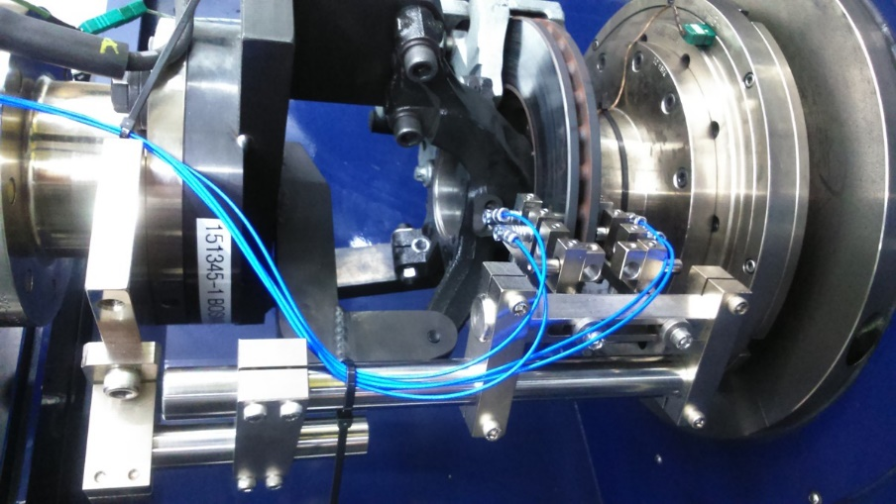

Fig 4.1: Experimental setup

The experimental procedure involved testing a specimen comprising baseline and proposed models. The baseline specimen was securely positioned within fixtures equipped with an extensometer and strain gauges to monitor strain and stress. Emulating real-world conditions, a wheel was rotated to simulate the maximum speed of a bike, followed by the application of sudden brakes using levers to create dynamic stress. The extensometer tracked changes in specimen length while a braking load versus deflection curve was recorded. Additionally, stress versus strain values were captured using a strain gauge meter. A second specimen underwent similar tests with comparable braking loads, allowing for a comparative analysis of stress, strain, and failure observations between the baseline and proposed models, culminating in a comprehensive documentation of results for further analysis.

**4.5 Summary (Experimental)**

The analysis of the results indicates that the baseline model exhibits the highest stress levels, which correlate closely with observed field failures. An Experimental Analysis was conducted to compare maximum total deformation and equivalent stress values across different disc designs. The table below illustrates the comparative analysis among the various disc designs.

**Table 4.1: Experimental Results**

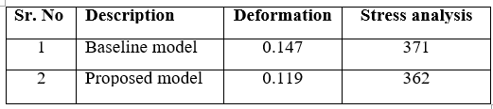

The proposed disc design is feasible and carried forward for manufacturing and compared the experimental results with finite element study.

**5. CONCLUSION**

The comparative study of different disc brake designs has led to the following conclusions:

* The proposed disc design exhibits less deformation compared to the baseline model.
* The von-Mises stress in the proposed disc design is lower than that in the baseline model design.
* Therefore, based on design and manufacturing considerations, the proposed disc design is deemed the most suitable and feasible for the current application.

**REFERENCES**

1. Anderson A. E. And Knapp R. A., Hot Spotting in Automotive Friction System Wear, vol. 135, page 319-337, (1990).
2. Barber J. R., Contact Problems Involving a Cooled Punch, J. Elasticity, vol. 8, page 409-423, (1978).
3. Brilla J., Laplace Transform and New Mathematical Theory of Visco elasticity, vol. 32, page 187-195, (1997).
4. Burton R. A., Thermal Deformation in Frictionally Heated Contact, Wear, vol. 59, page 1-20, (1980).
5. Flouet A. And Dubourg M.C., Non axis symmetric effect three dimensional Analyses of a Brake, ASME J. Tribology, vol. 116, page 401-407. (1994).
6. Kennedy F. E., et. al., Improved Techniques for Finite Element Analysis of Sliding Surface Temperatures. Westbury House page 138-150, (1984).
7. Manjunath T. V. And Dr. Suresh P. M., (2013 Dec), Structural and Thermal Analysis of Rotor Disc of Disc Brake,[Online].Available: https://www.ijirset.com/upload/2013/december/51A_Structural.pdf
8. Pigozzi G. And Ceretto E., Combined Thermal and Mechanical Analysis of Truck Brakes, Conference Innovation and Reliability in Automotive Design and Testing, Vol. 2, page 921-933, (1992).