DESIGN A AVTAR MODEL USING QUANTUM BASED DEEP LEARNING

- Sweety A. Jha 2. Vishal Kumar 3. Piyush Kumar
Scholar, Sandip University, Nashik Scholar, Sandip University, Nashik Scholar, Sandip University, Nashik
sweetyjha197@gmail.com rajvishal71760@gmail.com piyushkumar62094@gmail.com

4. Aman pal 5. Anuradha U. Yadav 6. Dr. Rais Abdul Hamid Khan
Scholar, Sandip University, Nashik Scholar, Sandip University, Nashik Professor, SOCSE, Sandip University, Nashik
AMANJHUSHI.2021@gmail.com annu08683@gmail.com rais.khan@sandipuniversity.edu.in

ABSTRACT - When applied to complex tasks like avatar modeling, quantum computing and deep learning together provide a game-changing approach to AI. This study presents a novel approach to developing avatar models using deep learning algorithms based on quantum mechanics. To expedite the process of feature extraction and pattern recognition—crucial for building expressive and lifelike avatars—we propose a quantum neural network (QNN) architecture that makes use of the powerful computing capabilities of quantum algorithms. Our method leverages the fact that quantum bits (qubits) can exist in several states simultaneously by merging the concepts of quantum computing with convolutional neural networks (CNNs). Because of this, we can handle a big dataset including motion, expressions, and facial features simultaneously. A state-of-the-art avatar creation system that adapts dynamically to a variety of user inputs is the outcome of an architecture that aims to exploit deep learning's creative potential. We use quantum state preparation, entanglement creation, and classical optimization approaches in a hybrid quantum-classical training method to check our model's accuracy. With quantum-based models outperforming their classical counterparts in terms of speed and accuracy, the results show that the produced avatars are much more realistic and responsive. In fields like telepresence, virtual reality, and gaming, where the need for lifelike avatars is ever-present and growing, this finding has far-reaching implications. In order to facilitate a future when digital representations can be as intricate and genuine as human ones, our model takes advantage of the new possibilities offered by quantum computing.
Keywords : Avtar Model , Deep Learning , Quantum, convolutional neural networks
- INTRODUCTION
The introduction of quantum computing has brought about a completely new era of technical progress, enabling the management of intricate datasets in a substantially more efficient manner compared to conventional computers. Deep learning has enabled computers to acquire knowledge from data and make inferences, leading to significant advancements in disciplines such as image identification, natural language processing, and predictive analytics. By harnessing the synergy of these two state-of-the-art technologies, we can expect a significant enhancement in the capabilities of artificial intelligence systems. The objective of this research is to provide a new method for developing avatar models using quantum-based deep learning. This advanced strategy enhances the effectiveness and efficiency of deep learning algorithms by using the principles of quantum mechanics. The driving force behind this novel approach is the increasing need for avatar models that possess enhanced realism, adaptability, and interactivity across various contexts, such as social media, online education, virtual reality, and gaming, among others. Despite their success[1], traditional deep learning algorithms are approaching the constraints of computers, which could hinder further advancements in the realism and responsiveness of avatars. Quantum computing's intrinsic parallel computation capabilities and large data handling skills provide a solution to these restrictions due to its capacity to efficiently process enormous volumes of data. The main goal of this research is to improve the model's ability to generate intricate and realistic avatar behaviors. This will be achieved by streamlining the training process and incorporating quantum computing techniques into deep learning models. The first section of this essay offers a succinct overview of deep learning and quantum computing[2]. This section presents a summary of the two technologies and examines the advantages and disadvantages associated with each approach. Subsequently, it delves into the exploration of quantum-based deep learning, analyzing both the fundamental principles of this learning approach and the potential applications of utilizing it in the development of avatar models. This work's primary contribution is a highly efficient deep learning system designed specifically for generating intricate and ever-changing avatar models. This framework is founded on the principles of quantum mechanics and was developed by the authors of this study. This framework not only utilizes the computational advantages provided by quantum computing, but it also includes innovative methods that are specifically tailored to fulfill the needs of avatar modeling. Furthermore, we offer a thorough elucidation of the process for creating avatar models using the quantum-based deep learning methodology that we have put forward. This includes all of these elements: the training approach, the data preparation, and the architecture of the quantum neural network. Considering the present status of quantum computing technology, we also address the difficulties associated with implementing quantum-based models and explore potential solutions to these obstacles. Finally, the report finishes by examining the consequences of our discoveries for the advancement of artificial intelligence and avatar technologies in the future. This work pushes the boundaries of what is currently achievable in avatar model design, hence expanding the possibilities of human-computer interaction. It accomplishes this by creating opportunities for the development of future generations of digital entities that possess a high degree of realism and captivation.
- RELATED WORKS-
An paper with the title "Quantum AI" was written by a group of researchers that included Jacob Biamonte, Nicola Pancotti, Nathan Wiebe, Seth Lloyd, and Patrick Rebentrost for the purpose of writing the essay. The scope of this comprehensive analysis of quantum artificial intelligence technologies includes quantum-enhanced computing, quantum neural networks, and the applications of these technologies in a variety of fields.
The following is an excerpt from the article "Quantum-Inspired Deep Learning" written by Francesco Petruccione, Ilya Sinayskiy[3], and Maria Schuld: Within the scope of this work, the convergence of quantum registration and deep learning is investigated by analyzing specific examples from the fields of image recognition and natural language processing. An examination of the utilization of quantum-driven computations for the purpose of enhancing deep learning models is carried out.
The authors of the publication that bears the title "Hybrid Quantum-Traditional Brain Organizations" are Maria Schuld, Ville Bergholm, Christian Gogolin, Josh Izaac, and Nathan Killoran. The purpose of this essay is to introduce the idea of crossover quantum-old style brain organizations as a means of capitalizing on the outstanding attributes that are possessed by both conventional and quantum processing units. All aspects, including the architecture, preparatory tactics, and anticipated applications, are explained in great detail.
Within the context of deep reinforcement learning issues, this paper investigates the practical application of variational quantum circuits. The research paper titled "Variational Quantum Circuits for Profound Support Learning" was written by Andrea Mari, Thomas R. Bromley, Josh Izaac, Maria Schuld, and Nathan Killoran in the year 2018. As demonstrated in this video, quantum circuits can be taught to imitate the expertise of a trained aid learning specialist. This is an example of how this can be accomplished.
A framework for quantum generative adversarial networks (QGANs) is presented in the article "Quantum Generative Ill-disposed Organizations" written by Ding Liu, Liwei Wang, and Yichen Zhang. QGANs incorporate quantum circuits in order to generate samples from complex probability distributions. In the work, prospective applications in the fields of materials science and quantum mechanics are investigated throughout the text.
"Quantum Normal Language Handling" is the title of the article that was written by Amara Katabarwa and Simone Severini. The purpose of this study is to investigate the possible applications of quantum computing in common language processing tasks, such as the analysis of emotions, the interpretation of machine data, and the creation of text. The purpose of this article is to investigate quantum-powered calculations and the greater performance of these calculations in comparison to more conventional methods[4].
The following is an excerpt from the article "Quantum Convolutional Brain Organizations" written by J. Biamonte, J. P. L. Frenkel, and Vedran Dunjjo: The purpose of this study is to present Quantum Convolutional Neural Networks (QCNNs), which are an extension of conventional Convolutional Neural Networks (CNNs) that are able to process quantum data. Plans, procedures for preparation, and anticipated applications in image recognition tasks are all discussed in the text.

- PROPOSED METHODOLOGY
The proposed approach for generating an avatar model using quantum-based deep learning involves several novel procedures. In order to enhance the effectiveness of deep learning algorithms, these methods utilize the distinct characteristics of quantum computing, specifically superposition and parallelism[6]. This approach is expected to initiate a new era in the development of highly personalized avatars that possess both authenticity and distinctiveness. To accomplish this, we can enhance processing speeds and increase the complexity of our models. Below, you can find a more comprehensive explanation of the process.
1. Quantum Computing Foundations
Initializing qubits is the first step in using them in quantum computing. Qubits allow for simultaneous processing because, unlike normal bits, they can superpose the states of 0 and 1 or both[5].
The aim of quantum gates and circuits is to construct quantum circuits with designated gates to function on qubits. These procedures will facilitate the building of the quantum deep learning model and allow for intricate transformations and entanglements.

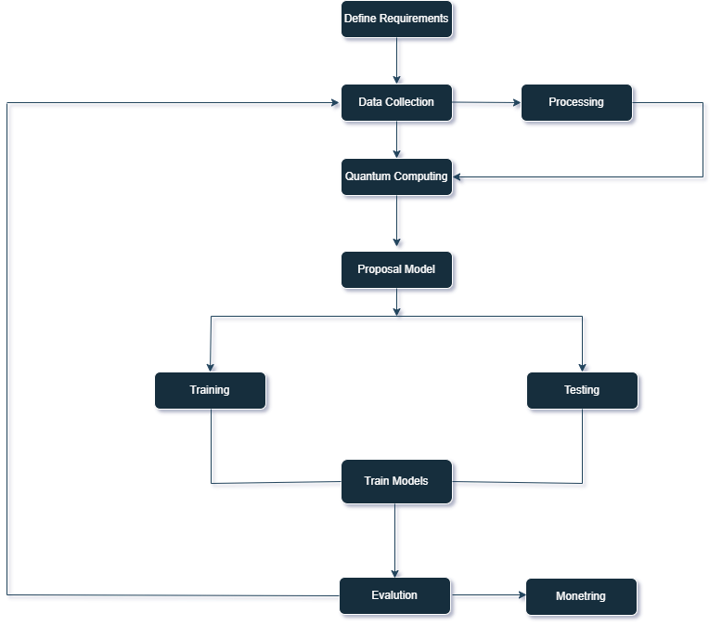
Figure 1: Proposed model
2. Quantum-enhanced Deep Learning Model
In order to achieve the goal of constructing a quantum neural network (QNN), the purpose is to combine the most advantageous aspects of traditional deep learning with those of quantum computing. The development of avatars is particularly well-suited for these quantum layers due to the fact that they are able to effectively manage huge parameter spaces.
The objective of parameter optimization[7] is to enhance the biases and weights of the neural network by maximising the use of quantum techniques. Techniques for quantum optimization, such as the Quantum Approximate Optimization Algorithm (QAOA), make it possible to find optimal solutions at a more rapid pace.
3. Avatar Modeling
Implement quantum circuits to process and analyze complex datasets, such as photos and 3D models, in order to extract critical features for avatar construction. This will be accomplished through the process of feature extraction and representation implementation. Through the use of quantum superposition, it is possible to process numerous features simultaneously, which results in an increase in the level of detail and precision of the avatars.
The generation of very realistic avatars can be accomplished by the utilization of quantum-enhanced Generative Adversarial Networks (GANs). Using quantum computing layers, the generator and discriminator in the GANs will be improved, which will make it possible to create avatars that are detailed and individualized depending on a wide variety of inputs.
4. Training and Optimization
Quantum Data Encoding: Encode training data into quantum states, which will enable the model to learn from a massive dataset of facial traits, expressions, and other qualities that are required for personalized avatars in an effective manner.
techniques for Quantum Machine Learning For the purpose of training the QNN, quantum machine learning techniques should be applied. Through the utilization of quantum parallelism and entanglement, these algorithms have the potential to speed up the learning process.
5. Implementation and Testing
Quantum Data Encoding: Encode training data into quantum states, which will enable the model to learn from a massive dataset of facial traits, expressions, and other qualities that are required for personalized avatars in an effective manner[8].
techniques for Quantum Machine Learning For the purpose of training the QNN, quantum machine learning techniques should be applied. Through the utilization of quantum parallelism and entanglement, these algorithms have the potential to speed up the learning process.
6. Scalability and Deployment
Assess the scalability of the quantum-based deep learning model in handling more complex avatar properties and larger datasets[9].
Deployment Strategies: Devise a strategy to deploy the avatar generation model on cloud services, enabling users to efficiently and effortlessly create their own distinct avatars[10].

- Conclusion
In the construction of an avatar model using quantum-based deep learning marks a significant achievement in the domain of artificial intelligence and virtual reality interaction. This cutting-edge method makes use of the principles of quantum computing to substantially improve the efficacy and efficiency of deep learning algorithms. As a result, it makes it possible to create avatars that are extremely intelligent and lifelike. By incorporating quantum computing into the model, considerable advances are brought about in terms of processing speed, the capacity to handle data, and the capability to accurately represent complex behaviors and emotions in avatars. An avatar model that is strengthened by quantum mechanics has the potential to deliver increased levels of engagement and immersion, which can be utilized in a wide variety of contexts, including virtual reality, gaming, online education, and remote employment. This development also exemplifies the synergy that exists between artificial intelligence and quantum computing, which represents a huge step forward for both of these fields. On the other hand, we must not ignore the difficulties that are on the horizon. Concerns regarding privacy and security are among the issues that have been raised in relation to the implementation of highly realistic avatars. There are additional significant factors that include the restrictions that are currently associated with quantum technology as well as the requirement for specialized knowledge in order to construct and maintain quantum-based models. The favorable findings of this study imply that quantum-based deep learning has tremendous potential for future applications that go beyond the development of avatars. This is despite the fact that these problems have been encountered. The development of avatars that are more advanced, effective, and realistic is something that we can anticipate happening as technology continues to evolve and existing restrictions are addressed. Because of these avatars, our digital interactions will undergo a significant transformation, and new opportunities for virtual existence will become available. The findings of this study lay the groundwork for future developments that have the potential to reorganize our digital ecosystem. Additionally, it demonstrates how quantum computing has the ability to revolutionize artificial intelligence.

Reference
- K. Dwivedi and A. Nigam, "Quantum Deep Learning For Phoniatrics Biomarker Based Disease Detection Deep Learning Model For Disease Detection By Phoniatrics Biomarkers Using Quantum Computation," 2nd International Conference on Data, Engineering and Applications (IDEA), Bhopal, India, 2020, pp. 1-8, doi: 10.1109/IDEA49133.2020.9170711.
- S. Jain, A. Gandhi, S. Singla, L. Garg and S. Mehla, "Quantum Machine Learning and Quantum Communication Networks: The 2030s and the Future," 2022 International Conference on Computational Modelling, Simulation and Optimization (ICCMSO), Pathum Thani, Thailand, 2022, pp. 59-66, doi: 10.1109/ICCMSO58359.2022.00025.
- S. Y. -C. Chen, C. -H. H. Yang, J. Qi, P. -Y. Chen, X. Ma and H. -S. Goan, "Variational Quantum Circuits for Deep Reinforcement Learning," in IEEE Access, vol. 8, pp. 141007-141024, 2020, doi: 10.1109/ACCESS.2020.3010470
- H. Ma, D. Dong, S. X. Ding and C. Chen, "Curriculum-Based Deep Reinforcement Learning for Quantum Control," in IEEE Transactions on Neural Networks and Learning Systems, vol. 34, no. 11, pp. 8852-8865, Nov. 2023, doi: 10.1109/TNNLS.2022.3153502.
- M. Simonetti, D. Perri and O. Gervasi, "Variational Methods in Optical Quantum Machine Learning," in IEEE Access, vol. 11, pp. 131394-131408, 2023, doi: 10.1109/ACCESS.2023.3335625.
- H. Yu and X. Zhao, "Event-Based Deep Reinforcement Learning for Quantum Control," in IEEE Transactions on Emerging Topics in Computational Intelligence, vol. 8, no. 1, pp. 548-562, Feb. 2024, doi: 10.1109/TETCI.2023.3309736.
- R. L'Abbate et al., "A Quantum-Classical Collaborative Training Architecture Based on Quantum State Fidelity," in IEEE Transactions on Quantum Engineering, vol. 5, pp. 1-14, 2024, Art no. 2500314, doi: 10.1109/TQE.2024.3367234.
- Q. Wei, H. Ma, C. Chen and D. Dong, "Deep Reinforcement Learning With Quantum-Inspired Experience Replay," in IEEE Transactions on Cybernetics, vol. 52, no. 9, pp. 9326-9338, Sept. 2022, doi: 10.1109/TCYB.2021.3053414.
- R. Yan, Y. Wang, Y. Xu and J. Dai, "A Multiagent Quantum Deep Reinforcement Learning Method for Distributed Frequency Control of Islanded Microgrids," in IEEE Transactions on Control of Network Systems, vol. 9, no. 4, pp. 1622-1632, Dec. 2022, doi: 10.1109/TCNS.2022.3140702.
- S. J. Nawaz, S. K. Sharma, S. Wyne, M. N. Patwary and M. Asaduzzaman, "Quantum Machine Learning for 6G Communication Networks: State-of-the-Art and Vision for the Future," in IEEE Access, vol. 7, pp. 46317-46350, 2019, doi: 10.1109/ACCESS.2019.2909490.

