VIRTUAL MOUSE CONTROLLED BY EYE MOVEMENTS

# Vignann Sai*1, Asif Mohammed*2, Tushar*3,Tejeswar*4, Venkatesulu*5, Rangaswamy*6

*1,2,3,4,5 Students, Computer Science & Engineering, Sri Venkateswara Institute of Technology, Anantapur, Andhra Pradesh.

*6 HOD, Associate Professor, Computer Science & Engineering, Sri Venkateswara Institute of Technology, Anantapur, Andhra Pradesh.

# ABSTRACT

Many persons with neurological disorders or those who have been paralyzed by an accident are unable to use computers for everyday chores like sending and receiving messages, browsing the internet, or watching their favorite TV shows or movies. It was found through a recent research study that because eyeballs move naturally when interacting with computing equipment, they are a fantastic candidate for ubiquitous computing.

The ability to utilize computers again for these patients may be possible by utilizing the underlying information from eye movements. In order to do this, we suggest an entirely eye-controlled mouse system. The goal of this effort is to create a free, open-source, general eye-mouse control system that can accurately track eye movements and let users conduct activities that are associated with particular eye motions or gestures using a computer webcam. It recognizes the user's pupil on their face and then monitors its movement. For the user to feel comfortable using it like other everyday devices, it must be accurate in real-time.

**Keywords:**EyeMouse, Webcam, Harr cascade, Mediapipe, PyautoGUI, OpenCV.

# INTRODUCTION

Fundamentally paralyzing diseases like paraplegia, which renders a person unable to move from the neck down, are becoming more common in today's society. In the majority of OECD (Organization for Economic Co- operation and Development) nations, women are more likely than men to experience disability. Their eyes are the only organ that can produce various actions. 518 million persons out of a population of 7 billion reported having a disability in the 2011 Census. Around 10% (or 650 million) of the world's population, as of February 7, 2018, has a disability.

Many people with Amyotrophic lateral sclerosis (ALS) or those who are paralyzed are unable to perform routine daily tasks on computers. Even when it comes to eating, they require assistance from someone else to feed them. For their daily tasks, these people require assistance. At the moment, people with impairments frequently type on keyboards by

holding long sticks in their mouths. The method we offer will enable people with disabilities to lead independent lives. They will have the opportunity to amuse themselves, mingle with others, and live their lives.

The development of innovative and cutting-edge HCI techniques is accelerating. Human eyes contain a wealth of information that can be collected and applied in a variety of ways (i.e. interacting with Computers). Eye movement exhibits a person's area of interest. The goal of tracking eye motions is to monitor human eye movements. By recording eye movements and using them as control signals, direct interaction with interfaces can be made possible without the need for a mouse.

Digital instruments have been interacted with using existing computer input devices such a mouse, keyboard, and other types of input devices. These computer input devices cannot be used independently by people with impairments. In this project, a computer input device that can only be operated with the eyes is created for wearable computers and those with disabilities. Additionally, such data might be utilized to generate the appropriate outputs for operating a computer, such as moving wheelchairs or commercially available robotic equipment like the robotic arm, to enable these patients to feed themselves. They will become physically capable as a result, and they will become valuable contributors to society. The goal of this project is to investigate and enhance potential uses for the eye gesture tracking technology.

Especially those fields that can aid physically handicapped people in using computers and programmable controlled equipment. As a result, these people could still handle their obligations, enhance the quality of their lives, and carry on with their daily activities—often without the need for assistance. The majority of eye tracking technologies used today track the pupil in real time using video. We used the same methodology and technologies and enhanced them to create a system that is more reliable and precise. Laptop with python 3.9 is used and the sensor used is laptops camera for taking input, tracking pupil of eye, and eye movements. The python modules or packages helped us a lot and the work done is simple when these are used.

# Existing System

* In the existing system the detection of Iris of the eye is done using Matlab and controls the cursor.
* In Matlab it is difficult to predict the Centroid of the eye so we go for OpenCV in Python, which is of low cost and which also provide very high accuracy.
* This Matlab system also need special equipment for only this purpose like separate computer, webcam, flashlight etc.
* Which leads to very expensive and also more time taking.

# Disadvantages

* Less Accuracy
* Can’t use a regular camera
* High cost
* Require special equipment’s

# Proposed System

* In our proposed system the cursor movement of the computer is controlled by eye movements using OpenCV, MediaPipe, PyautoGUI.
* Camera detects the eye ball movements which can be processed by OpenCV, by this the cursor can be controlled.
* To “pick out” any key, the user seems at the key for an exact period of time and to “press” any key, the user just blink the eye.

# Advantages

* High Accuracy
* Can use regular camera or laptop’s camera
* Low cost
* No need of any special equipment’s

# Performance Metrics

* **Accuracy :** Measures how precisely the eye mouse can track eye movements and translate them into cursor movements on the screen. It’s usually expressed as a percentage of accurate cursor placements
* **Latency :** Refers to the delay between the eye movements and the corresponding cursor movements on the screen. Lower latency is desirable for real – time interaction and
* **Precision :** Similar to accuracy but focuses on the consistency and reliability of cursor placements. It evaluates how closely the cursor follows the user’s eye movements over time
* **Robustness :** Indicates how well the eye mouse performs under various conditions, such as different lighting environments, user eye conditions, or distractions. A robust eye mouse maintains its accuracy and precision regardless of external factors.
* **Cost –** effectiveness : Considers the overall value proposition of the eye mouse, including its price relative to its features, performance, durability, and support services. A cost – effective eye mouse provides a balance between affordability and quality.
* **Compatibility :** Assesses the compatibility of the eye mouse with different operating systems, software applications, and hardware configurations. Seamless integration with existing systems enhances usability and versatility.
* **Customization options :** Examines the availability of customization options for adjusting sensitivity, cursor speed, click activation methods, and other settings according to user preferences and needs.
* **Ease of calibration :** Evaluates how easy it is to set up and calibrate the eye mouse for individual users. A simple and efficient calibration process enhances user experience and adoption.

# System Requirements

### Software Requirements :

* + OS : Windows 10
  + Language : Python
  + IDLE : Python 3.9, Pycharm
  + Packages : OpenCV, PyautoGUI, MediaPipe

### Hardware Requirements :

* + System : Laptop or Desktop with camera
  + Hard Disk : 10 GB
  + RAM : 2 GB (Onwards)

precise control.

# LITERATURE SURVEY

The literature was examined in order to address the objectives, comprehend the study topic, concentrate on the research questions, organize the data collection strategy, define the words, and correctly identify the framework. Understanding the study field that involves eye detection and mouse cursor movement was the most crucial challenge.

As we read through the literature, we noticed that the emphasis was on how to create a system that can satisfy the demands of people who are physically challenged and that system should be very simple to grasp.

The "sixth sense" technology, developed by a team at MIT, promises to improve human-computer interaction by utilizing hand and eye gestures. The entire system can be mounted on the user's helmet so that it can be used anywhere in the world and projected onto flat surfaces (like walls). The issue is that it doesn't generate a system that can communicate with other compatible devices or offer improved aid and accessibility to the impaired.

An eye tracking algorithm based on the Hough transform was created in 2018. This method can identify a person's face and eyes. It recognizes the user's face and eyes using a webcam. Matlab is the system's foundation. The real-time tracking and time- speed problems in this system are the problem. The system is relatively sluggish and requires an expensive, high-quality computer system to function effectively.

A pupil center coordinate detection method was first introduced in 2015. The webcam in this system use Hough Transform Techniques to identify a person's pupil. The problem with this approach is that it is not real-time and takes a long time. It takes a long time to capture the body first, then the face, the eyes, and ultimately the pupil. A face and eye-controlled system based on MATLAB was created in 2014. The mouse is moved by moving the eyes and face on a webcam. The problem with this technology is that it only functions within a few centimeters of the source. A method based on pictogram selection was created in 2013 and used an eye tracking technology. It makes the system dependable by utilizing a variety of eye- tracking approaches. The problem with this technology is that it won't function if any liquid is found in the eyes. When women apply eyeliner or mascara to their eyes, for example, the system malfunctions. Human eyes use a two-lens system housed in a liquid called vitreous humour to project light waves from various objects in the outside world onto the retina.

In order to accommodate very precise color vision, the fovea is densely packed with cones, with around 161,900 per square millimeter. We can see from the structure of a retinal exterior that just a small region

of ourvisual field can be resolved in high resolution.

# METHODOLOGY

It relates to the field of Human-Computer Interaction (HCI) and demonstrates how a low-cost eye tracking solution can be created for patients with disabilities by enhancing current open source frameworks used for Computer Vision and HCI. The system model and overview are shown in Fig.

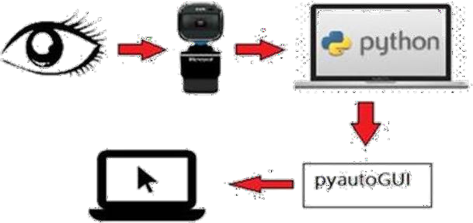

**Figure:** Block Diagram

The System prototype uses camera input to identify and track the user's pupil in real-time. Computers or microcontrollers can use this "tracking" information to perform a variety of tasks. One of these tasks is to track the pupil-movement and then store that tracked eye movement to control a computer's mouse pointer, allowing someone with a disability like, say, Amyotrophic Lateral Sclerosis, to use it to communicate with others.

It comes with a high resolution web camera that is strategically placed, as well as an open-platform software module that is simple to install and is compatible with all current laptops and desktop computers. This system can be viewed as a seamless movement between the concept, design, and proof of concept phases. It involves implementing portions of research papers and collaborating with the open- source community to design and create a prototype, all while making sure that only open-source, affordable, easily accessible, and commercially off the shelf (COTS) items are used.

# MODELING

Python was used to design the mouse system, and the following Python modules were imported to make the system operate.

* MediaPipe offers cross - platform, customizable ML solutions for live media.
* OpenCV is a collection of programming tools with a real-time computer vision major focus.
* PyautoGUI is a cross-platform GUI automation module allows you to automate computer by controlling the mouse as well as performing simple picture recognition.

## Use Case Diagram

Use case diagram indicates that the system completes the subsequent stages.

1) Software is active.

1. Turn on the laptop's webcam and display a picture of a person.
2. Face detection is carried out.
3. The system recognizes a person by their eyes.
4. After performing the aforementioned action, perform the subsequent procedure.
5. The system then uses a laptop's webcam to recognize eyes and a face.
6. We discovered that a person can now control the mouse cursor with eye movements. The computer's home screen displays the progress of the core.

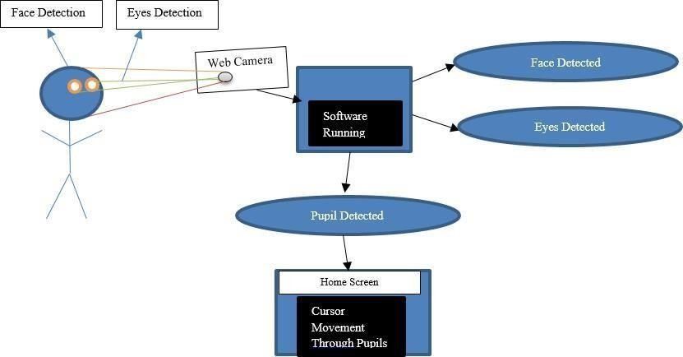

**Figure:** System Use Case Diagram

## Activity Diagram

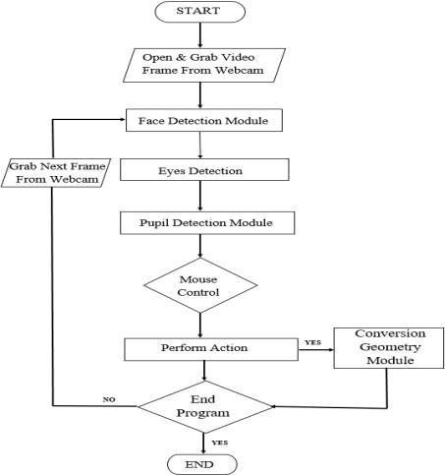

**Figure**: Activity Diagram

Figure depicts the system's operation. The Eye Mouse software has the following phases from beginning to end.

1. Switch on the webcam and record some footage.
2. The system takes a step and finds the face.
3. The system detects the presence of eyes.
4. The mechanism locates the pupil of the eye.
5. The system will find the eyes and carry out geometric translations using only the image of the user's face from the webcam.
6. The mouse control function recognizes a gesture, moves the mouse cursor, and translates the coordinates to the user's screen.

## System Sequence Diagram

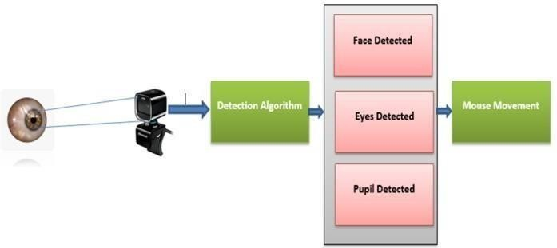

**Figure:** Sequence Diagram

The user's interactions with the system are depicted in Fig. in order. The six fundamental modules of our system are elaborated in Fig.'s system sequence diagram. Using detection techniques, the system uses the webcam to identify a person's pupil in the first module. The machine then finds the face. The mechanism then finds and seizes the eyes. The machine then finds the pupils. The system begins moving the mouse cursor in the last module by monitoring pupil movement.

# IMPLEMENTATION

Using Python, an image is created. First, it opens the camera and starts taking video. It then selects a frame and changes it to a gray scale image because it converts images to binary form, making it easy to find things. The face is detected using Haar-cascade. Haar- cascade detects items from other photos after training on many positive and negative images. It will crop the frame and pass it on for additional processing after detecting the face. The Haar-cascade algorithm will detect eyeballs and trim the frame.

Eye-cascade : The Haar cascade recognizes eyes. A numpy-supported four-variable array gives us x, y, w, and h all at once. The camera detects eyeballs from x and y; w is the width, and h is the height. These variables construct a rectangle around the eye and crop the image, as seen in Fig. The rectangle begins at x and finishes at x+w horizontally and y and y+h vertically.

Because both eyes move simultaneously, tracking can be done by looking at just one eye's motions. This program selects the user's left eye for clicking anything and right eye for moving the mouse cursor. It crops this picture by drawing a box/ellipse shape around eye.

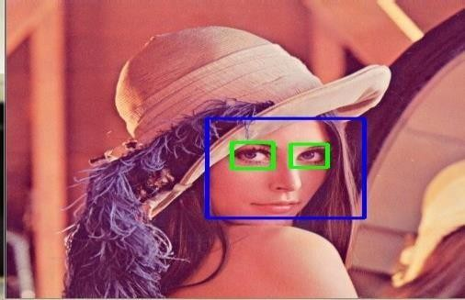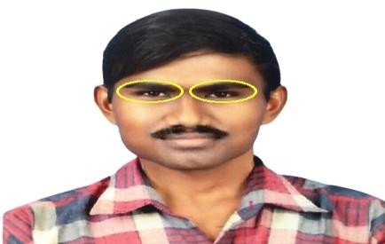

**Figure:** Output Of The System

Fig. shows output. For further processing, the application will blur the little image. It then finds, then draw a circle around the pupil. Sometimes the camera sees black rings around the eyes as pupils.

The technology detects circular dark patches in the rectangle's center to fix this. The camera will only track the eye's pupil this way. Define x and y using PyAutoGUI for cursor movement. y moves the mouse vertically, x horizontally. Both of them start with a random value, so when the code runs, the mouse starts moving. Check the gap between two frames to detect eye movement. Human eyes move somewhat. To fix this, the eye is considered motionless if its position difference is less than 5 pixels. If the eye's horizontal location is larger than5 pixels and its vertical position is less than 5 pixels, it's travelling horizontally. The eye moves diagonally if its horizontal and vertical positions differ by more than 5 pixels. The mouse cursor moves vertically, horizontally, and diagonally when we move our eyes.

## Harr-cascade Algorithm:

The system performs two tasks in this algorithm. Determine the person's face and eyes the face-cascade function is shown in Fig.

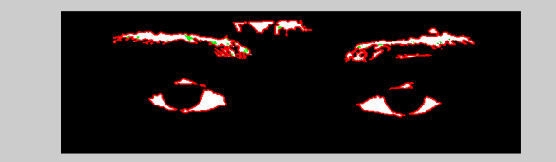

**Figure:** Face-Cascade

Face-cascade is used to initially identify the user's face in an image. It crops the image and run scan around the face for later processing. The user's eyes are picked up from the image once the face has been extracted. as depicted in Fig. below

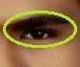

**Figure:** Eye-Cascade

# CONCLUSION

This device seeks to provide a low-cost eye-mouse that will enable the user to control a computer system's mouse cursor. The system is simple to use and cost-effective, relying just on a laptop camera and Python programming language software modules. With the help of this project the desire of any person, whether he is normally abled or not doesn’t matter. This system is easy and can be used in any system or laptops. Finally, we point out that the project can be used in a variety of environmental settings with just minor adjustments to the brightness and contrast needed to retain its durability. This is a remarkable accomplishment for such a cheap eye-tracking technology.

# REFERENCES

1. “The Mind's Eye: Cognitive and Applied Aspects of Eye Movement Research” by Charlie Ware and HenryMikaelian (1987)
2. Schmidt, Jochsen, Vogt and Nieman "Calibration–free hand–eye calibration: a structure–from–motion approach." Pattern Recognition. Springer Berlin Heidelberg, 2005. 67-74.) (2005)
3. PUPIL: constructing the space of visual attention. Diss. Massachusetts Institute of Technology, 2012.) Kassner, Phillip, and Patera (2012)
4. “An image-based eye controlled assistive system for paralytic patients” https://ieeexplore.ieee.org/document/80665 49/ (2017)
5. OpenCV (n.d) [online] Available At: <http://opencv.org/>[Accessed 5Jan 2018]
6. “Introduction PyautoGUI” [online] Available At <http://pyautogui.readthedocs.io/en/latest/intr> oduction.html [Accessed 10 Jan 2018]
7. Li Cuimei, Qi Zhiliang, Jia Nan, The Human face detection algorithm via Haar cascade classifier combined with three additional classifiers” https://ieeexplore.ieee.org/document/82658 63/ (23.1.2018)
8. Disabled persons Ratio [online] Available At: https://www.disabled- world.com/disability/statistics/(Accessed 2 Jan 2018)