The Impact of Social Media on Mental Health: A Comparative Study of Adolescents in Urban and Rural Communities

**Manish kumar, Dr. VISHAL SHRIVASTAVA2, Dr. AKHIL PANDEY3, MS. MEGHA RATHORE4**

1B.TECH. Scholar, 2,3Professor, 4Assistant Professor

Computer Science & Engineering

Arya College of Engineering & I.T. India, Jaipur

mehramanish023@gmail.com,  [vishalshrivastava.cs@aryacollege.in](mailto:2vishalshrivastava.cs@aryacollege.in), [akhil@aryacollege.in](mailto:akhil@aryacollege.in), [rathore.megha@gmail.com](mailto:4rathore.megha@gmail.com)

**Abstract*:*** *This paper explores the impact of social media on the mental health of adolescents in urban and rural communities. The researchers explore how geographical settings shape social media use and its consequences for mental well-being. Initial findings indicate that, while social media is prevalent among adolescents in both areas, urban youth exhibit higher engagement and greater susceptibility to negative mental health outcomes. The paper contributes to the ongoing discourse on digital well-being, emphasizing the need for targeted interventions to foster a healthier approach to social media among adolescents.*

**Keywords:** Adolescents, Digital Well-being, Mental Health, Social Media, Urban and Rural Environments

## INTRODUCTION

In recent times, social media has fundamentally transformed the way young people connect and share information. Adolescents, who heavily engage with social media, find themselves profoundly affected by this digital shift, using these platforms for communication, self-expression, and staying informed about news and entertainment. While social media has become as integral to our lives as blood is to our bodies, it has also introduced unforeseen challenges, particularly for teenagers. Excessive social media use has been linked to rudeness, difficulty sleeping, forgetfulness, and the inadvertent sharing of inappropriate content without parental awareness (Osama, Mohammad, 2015).

The term "social media" encompasses any platform facilitating online interaction, gaining popularity as a means of entertainment and communication. Parents must grasp the dynamics of these platforms, as not all of them contribute positively to the well-being of children and teenagers. Pediatricians, as experts in children's health, play a pivotal role in guiding families to understand and use social media responsibly. They advise parents to actively monitor potential issues, including cyberbullying, experiences of "Facebook depression," inappropriate messages, and exposure to unsuitable content (O'Keeffe et al., 2011). This underscores the significance of addressing the specific challenges associated with various social media platforms and emphasizes the role of healthcare professionals in ensuring the healthy use of these platforms among young individuals.

Numerous studies have explored how extensive social media use can impact individuals' self-perception and mental health. This is particularly relevant for teenagers, a demographic undergoing crucial emotional and mental development. Concerns arise from the fact that, while

social media offers novel avenues for expression and connection, it may expose young individuals to risks such as cyberbullying, unhealthy comparisons, privacy breaches, and sleep disturbances.

Despite the existing body of research on this topic, there is still much unknown about how social media uniquely affects the mental health of teenagers in diverse geographical settings. The location of teenagers' residences, whether in bustling urban environments or tranquil rural areas, can significantly influence their social media use, access to technology, and online interactions. Urban settings, characterized by advanced technology, offer more opportunities for social media engagement but may also pose increased risks. Conversely, rural areas, with limited digital options, may either shield teenagers from some negative influences of social media or present distinct challenges.

## CONCEPTUAL FRAMEWORK

The researchers use the diagram model that describes the entire flow of the article which outlines the key variables and their relationships, providing a clear structure for understanding the study's focus on the impact of social media on the mental health of adolescents in urban and rural communities. The researchers focus on three key components: the independent variable, the moderating variable, and the dependent variables. See Figure 1.0

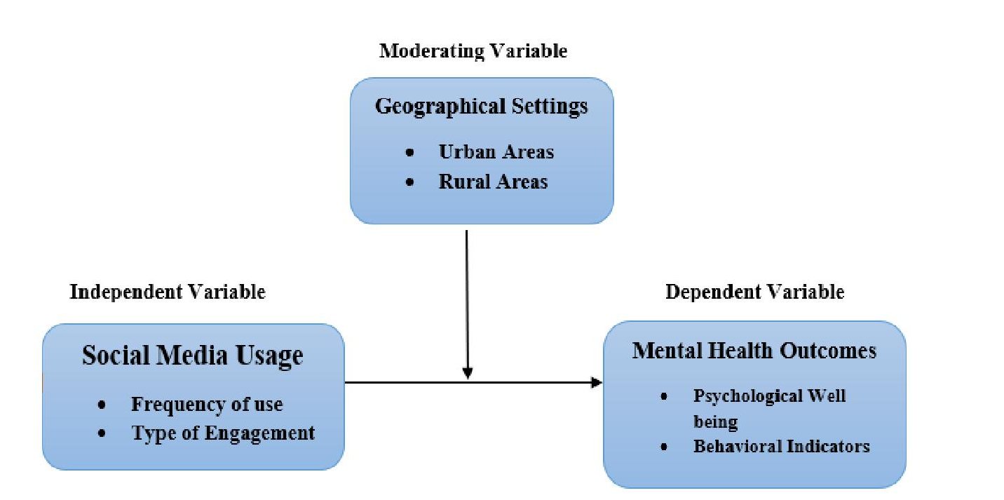

## Social Media Usage (Independent Variable)

Frequency and Type of Engagement The researchers are delving into how often teenagers use social media (frequency) and the diverse ways in which they engage with it (type of engagement). This independent variable serves as the catalyst, influencing the subsequent experiences and outcomes in the study.

## Geographical Setting (Moderating Variable)

Urban and Rural Environments The geographical setting, whether urban or rural, acts as a moderating variable. It shapes and influences the relationship between social media usage patterns and mental health outcomes among teenagers. The specific nature of social media

Psychological Well-being: Explores emotional states such as self-esteem, anxiety, depression, and loneliness. Behavioral Indicators: Observe actions resulting from social media experiences, such as rudeness, sleepdisturbances, and forgetfulness.

The researchers hypothesize that the geographical setting (urban or rural) moderates the relationship between the independent variable (social media usage) and dependent variables (psychological well-being and behavioral indicators) among teenagers. They anticipate that the unique nature of social media engagement, influenced by the surrounding environment, will yield varying impacts on well-being. For instance, teenagers in urban settings, characterized by increased connectivity and diverse online experiences, may face different mental health challenges compared to their counterparts in rural areas with limited digital options. This study aims to clarify these interconnected relationships, providing subtle insights to guide teenagers in cultivating healthy social media habits within the contextual nuances of their living environment.

## Objectives

This study aims to unravel the dynamics of social media's impact on adolescents by pursuing the following objectives:

* To Understand Social Media Habits: This aims to comprehend the frequency and types of social media engagement among teenagers, investigating their patterns of checking, posting, and chatting.
* To Examine Geographical Influences: The research endeavors to explore the impact of geographical settings, distinguishing between urban and rural environments, on teenagers' social media experiences.
* To Study Impact on Well-being Both Positive and Negative: The study aims to explore the diverse effects, both positive and negative, of social media on the psychological well-being of teenagers. This investigation includes an examination of associations with self-esteem, anxiety, depression, and feelings of loneliness.
* To Observe Behavioral Effects: This study aims to observe and analyze observable behaviors linked to social media usage, such as rudeness, sleep disturbances, and forgetfulness.
* To Evaluate Geographical Moderation: The research aims to evaluate how the geographical setting moderates the relationship between social media usage patterns and mental health outcomes among teenagers.
* To Provide Practical Advice: In light of the findings, this study aspires to provide practical insights and recommendations for teenagers to cultivate healthy social media habits, considering the nuances of their geographical context.

These objectives collectively form a comprehensive research framework to contribute a nuanced understanding of the interconnected relationships between social media usage, geographical settings, and mental health outcomes among adolescents, ultimately guiding future interventions and policies for responsible social media practices.

## METHODOLOGY

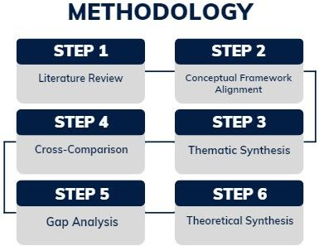In this chapter, the researchers employ a comprehensive Synthesis Methodology to systematically investigate the intricate relationship between social media usage, geographical settings, and the mental health outcomes of adolescents in urban and rural communities. This methodological approach is integral to developing a robust foundation for this paper's comparative study, encompassing six interconnected steps. See Figure 1.1

Figure 1.1 Metho

## Synthesis Methodology

The research endeavors to comprehensively understand the complex relationship between social media usage, geographical settings, and the mental health outcomes of adolescents. The following steps outline the Synthesis Methodology employed in this study:

Literature Review: The research initiation involves an exhaustive Literature Review, serving as the cornerstone for understanding existing insights into the interplay of social media and adolescent mental health. By identifying and categorizing relevant studies, we gain a holistic perspective on the subject, laying the groundwork for subsequent steps. Conceptual Framework Alignment: Building upon the insights garnered from the literature, the researchers proceed to Conceptual Framework Alignment. This step involves the evaluation of existing frameworks, modification to suit this paper’s unique focus, and the integration of key variables, emphasizing social media usage patterns, geographical settings, and mental health outcomes.

Cross-Comparison: The synthesis process then unfolds into a Cross-Comparison of studies focusing on urban and rural communities. By conducting a comparative analysis, the researchers identify commonalities, differences, and trends in social media usage and mental health outcomes among adolescents in diverse settings. This step ensures a nuanced understanding of the contextual factors influencing this paper.

Thematic Synthesis: Thematic Synthesis follows, aiming to extract and categorize key themes related to social media usage and mental health. Through a coding system, the researchers analyze the literature, facilitating the identification of patterns and trends. This step is crucial in distilling meaningful insights that inform the research questions and study design.

Gap Analysis: The synthesis methodology proceeds to Gap Analysis, where researchers scrutinize the existing literature to identify knowledge gaps. By pinpointing areas lacking comprehensive exploration, researchers justify the need for this paper and emphasize the significance of a comparative study focusing on both urban and rural environments.

Theoretical Synthesis: The final step involves Theoretical Synthesis, integrating relevant psychological and sociological theories. This step aids in explaining the mechanisms through which social media influences adolescent mental health. The refined conceptual framework, enriched by theoretical insights, positions this study to unravel the complexities of the relationship between social media, geography, and mental well-being.

This interconnected Synthesis Methodology guides the research from the initial exploration of literature to the formulation of a refined conceptual framework, ensuring a comprehensive understanding of the research landscape. As each step informs the next, this methodological approach enhances the coherence and depth of this study, setting the stage for nuanced insights into the impact of social media on the mental health of adolescents in diverse geographical settings.

## RESULTS AND DISCUSSION

This chapter presents the findings and discussions from a comparative study aimed at understanding the impact of social media on the mental health of adolescents in urban and rural communities. Through an intricate synthesis methodology, this research uncovers the multifaceted ways in which geographical settings shape social media use and its consequences for adolescents' mental well-being. The results delineate distinct patterns of social media engagement and their psychological and behavioral repercussions, offering insights into the differential impacts across urban and rural contexts.

## Results

**A. Social Media Usage Patterns**

The study reveals significant differences in social media engagement between urban and rural adolescents. Urban youth reported higher frequencies of social media use, with a diverse array of platforms at their disposal. This group demonstrated a tendency towards more extensive and varied engagement, including content creation, interactive communication, and information seeking.

certain social media platforms over scientific databases and e-books for content creation and additional educational purposes. See Table 1.0 for the types of social media and resources

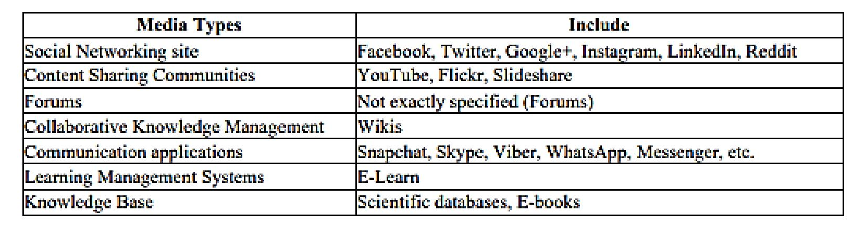Table 1.0 Types of Social Media and Resources

n contrast, adolescents in rural areas exhibited more constrained patterns of social media use, primarily due to limited internet accessibility and lesser exposure to a wide range of social media platforms. Their engagement was predominantly passive, such as viewing content without much interaction or content creation. See Figure 1.1 and Figure 1.2

According to the researcher’s observations, in rural areas, adolescents demonstrate distinct social media usage patterns, with a focus on communication (35%), entertainment (40%), studying (15%), and a relatively lower emphasis on

socializing (10%). These patterns reflect he unique dynamics of rural settings, influenced by factors such as limited

internet access and a potentially more close-knit community (see Figure 1.1).

Communication (35%): In rural areas, where physical distances may be greater, social media

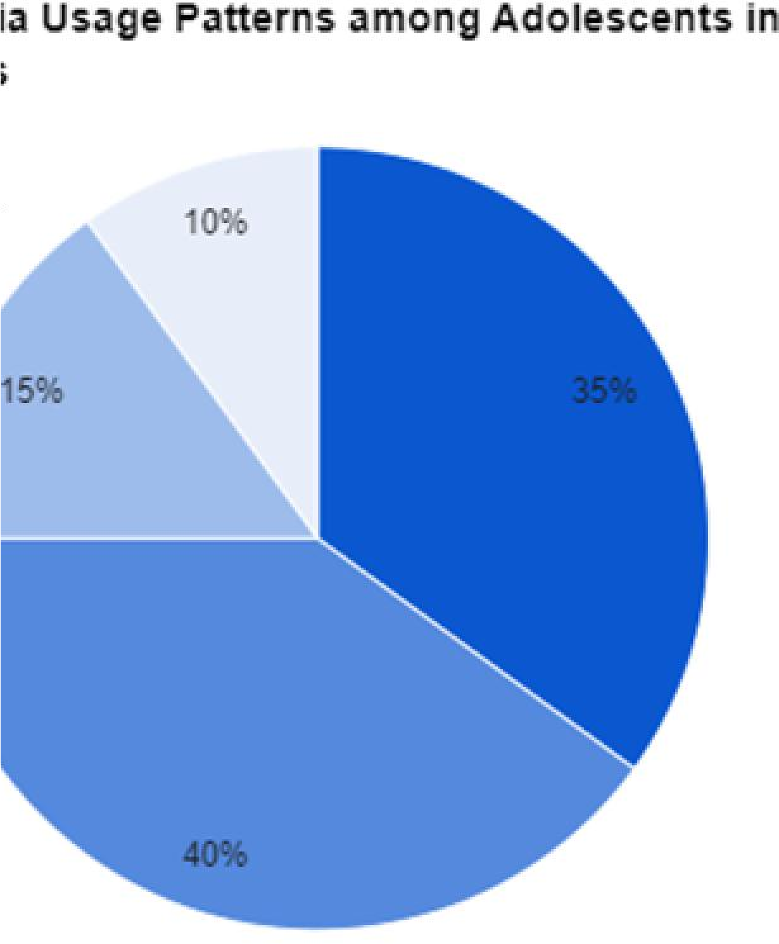

Socializing

Communication

Studying

Entertainment

becomes a crucial tool for communication. Adolescents rely on platforms to connect with friends and family, compensating for the challenges posed by geographic distances.

Entertainment (40%): Similar to their urban counterparts, rural adolescents use social media as a primary source of entertainment. The wide variety of content and I

with traditional media outlets like newspapers, television, and radio decreasing coverage in rural regions, social media has become a vital substitute for distributing essential information.

Figure 1.2 Social Media Usage Patterns among Adolescents in Urban Areas

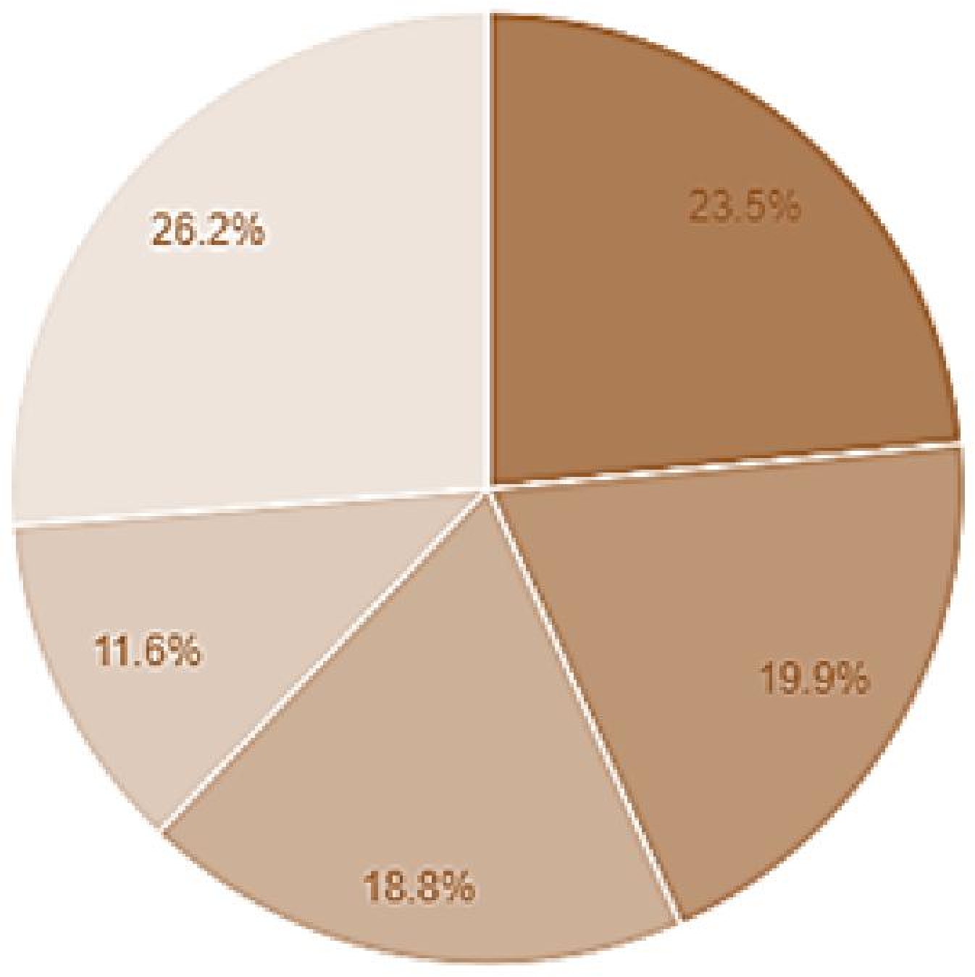

Entertainmen

Communicatio

Studying

Information

Socializing

According to the Researcher's observation of this digital age the distribution of social media usage patterns among adolescents in urban areas (see Figure 1.2), with a significant emphasis on entertainment, communication, information, socializing, and studying, reflects the multifaceted role of social media in the lives of young individuals nowadays. Each of these categories serves a distinct function in their daily routines and social interactions, influenced by the urban environment's characteristics, such as high connectivity, accessibility to technology, and diverse societal dynamics. Below is an explanation for each usage pattern:

Entertainment (26.2%): Urban areas typically offer faster and more reliable internet access, allowing for seamless streaming of videos, music, and games. Adolescents in these settings may turn to social media platforms as primary sources of entertainment due to the wide range of content available at their fingertips. This reflects the high engagement with platforms that deliver instant gratification and leisure activities, satisfying their need for entertainment.

Communication (23.5%): Social media serves as a crucial communication tool, enabling instant messaging, video calls, and the sharing of news and updates among peers. The urban lifestyle, often fast-paced and hectic, may make online platforms more convenient for keeping in touch with friends and family. This percentage underscores the importance of social media in maintaining relationships and facilitating interactions in an environment where physical meet-ups might be challenging due to distance or time constraints.

Information (19.9%): Adolescents in urban settings use social media as a significant source of information, including news, educational content, and global events. The accessibility to a vast array of information sources allows urban youths to stay informed and connected to the world. This reliance on social media for information reflects the shift from traditional media to digital platforms among younger generations.

Socializing (18.8%): While similar to communication, socializing specifically refers to the use of social media for engaging in communities, participating in discussions, and making new friends. Urban adolescents might find social media platforms particularly appealing for exploring their identities and finding communities with shared interests. This socializing aspect is crucial for emotional and social development, offering a sense of belonging and engagement in a broader social network.

## Comparison between Rural and Urban Social Media Usage Patterns

Communication and Entertainment: Both rural and urban adolescents prioritize communication and entertainment on social media. However, the percentages may differ, reflecting variations in internet accessibility, lifestyle, and preferences.

Studying: While studying is a notable category in both settings, urban adolescents exhibit a higher percentage (11.6%) compared to rural ones (15%). This could be attributed to differences in educational resources and opportunities between urban and rural environments.

Socializing: Rural adolescents allocate a smaller percentage to socializing compared to their urban counterparts (18.8%). This may indicate that in rural areas, social connections are more commonly formed within the local community rather than online.

Overall, the differences in social media usage patterns between rural and urban adolescents underscore the impact of geographical context on preferences and needs. According to a 2023 journal article on enhancing literacy in rural villages through social media, it highlights the potential of social media to boost literacy in rural regions. However, it acknowledges challenges like insufficient digital literacy and the prevalence of misinformation (Andri Irawan, 2023). Rural usage reflects a balance between communication, entertainment, and studying, with a notable emphasis on maintaining connections within the community. Urban usage, on the other hand, tends to have a higher focus on studying and socializing, possibly influenced by the broader and more digitally connected urban environment.

## Geographical Influences on Social Media Use and Mental Health

Sri K. Rambabu (2021) surveyed the impact of social media networks on youth, particularly adolescents who are prolific users of new technologies. Various studies have highlighted the significant time adolescents spend on social media platforms and their susceptibility to its negative effects. The COVID-19 pandemic further intensified the use of social media, especially with the transition to online classes due to restrictions on physical movement. Jelenchick's study on youth found no conclusive link between social media use and depression. Mustafa Koc highlighted excessive dependence and anxiety as predictors of Facebook addiction. Gabre and Kumar observed increased stress levels and loss of control among undergraduates using Facebook. Depression risk factors include computer use and television viewing (de Wit et al., 2011). O'Dell noted feelings of depression and loneliness associated with Facebook use among students. O'Keeffe, Clarke-Pearson, and the Council on Communications and Media (2011) coined "Facebook Depression," connecting excessive social media time to depression symptoms in youth. This resurgence in electronic device usage among children and youth has reignited the debate on its consequences for both Urban and Rural Environments.

Urban Environment:High Connectivity and Diverse Interactions: Urban adolescents' exposure to a vast spectrum of online content and interactions was associated with increased reports of anxiety and depression. The high connectivity facilitated constant social comparison, cyberbullying incidents, and sleep disturbances, directly impacting their psychological well-being.

Rural Environment:Limited Connectivity and Distinct Challenges:

## sychological Well-being and Behavioral Indicators

The positive influence of Facebook usage on academic performance has been highlighted in studies such as Tuan (2013). Numerous research endeavors, including Wood et al. (2014), have identified the constructive impacts of social media and networking on language and reading skills. Additionally, social networking and media offer valuable tools for innovative teaching approaches, facilitating effective student engagement. Empirical studies, exemplified by Ito et al. (2009), recommend that educators adopt and integrate social media into educational practices.

The comparative analysis highlights a nuanced picture of mental health outcomes shaped by social media.

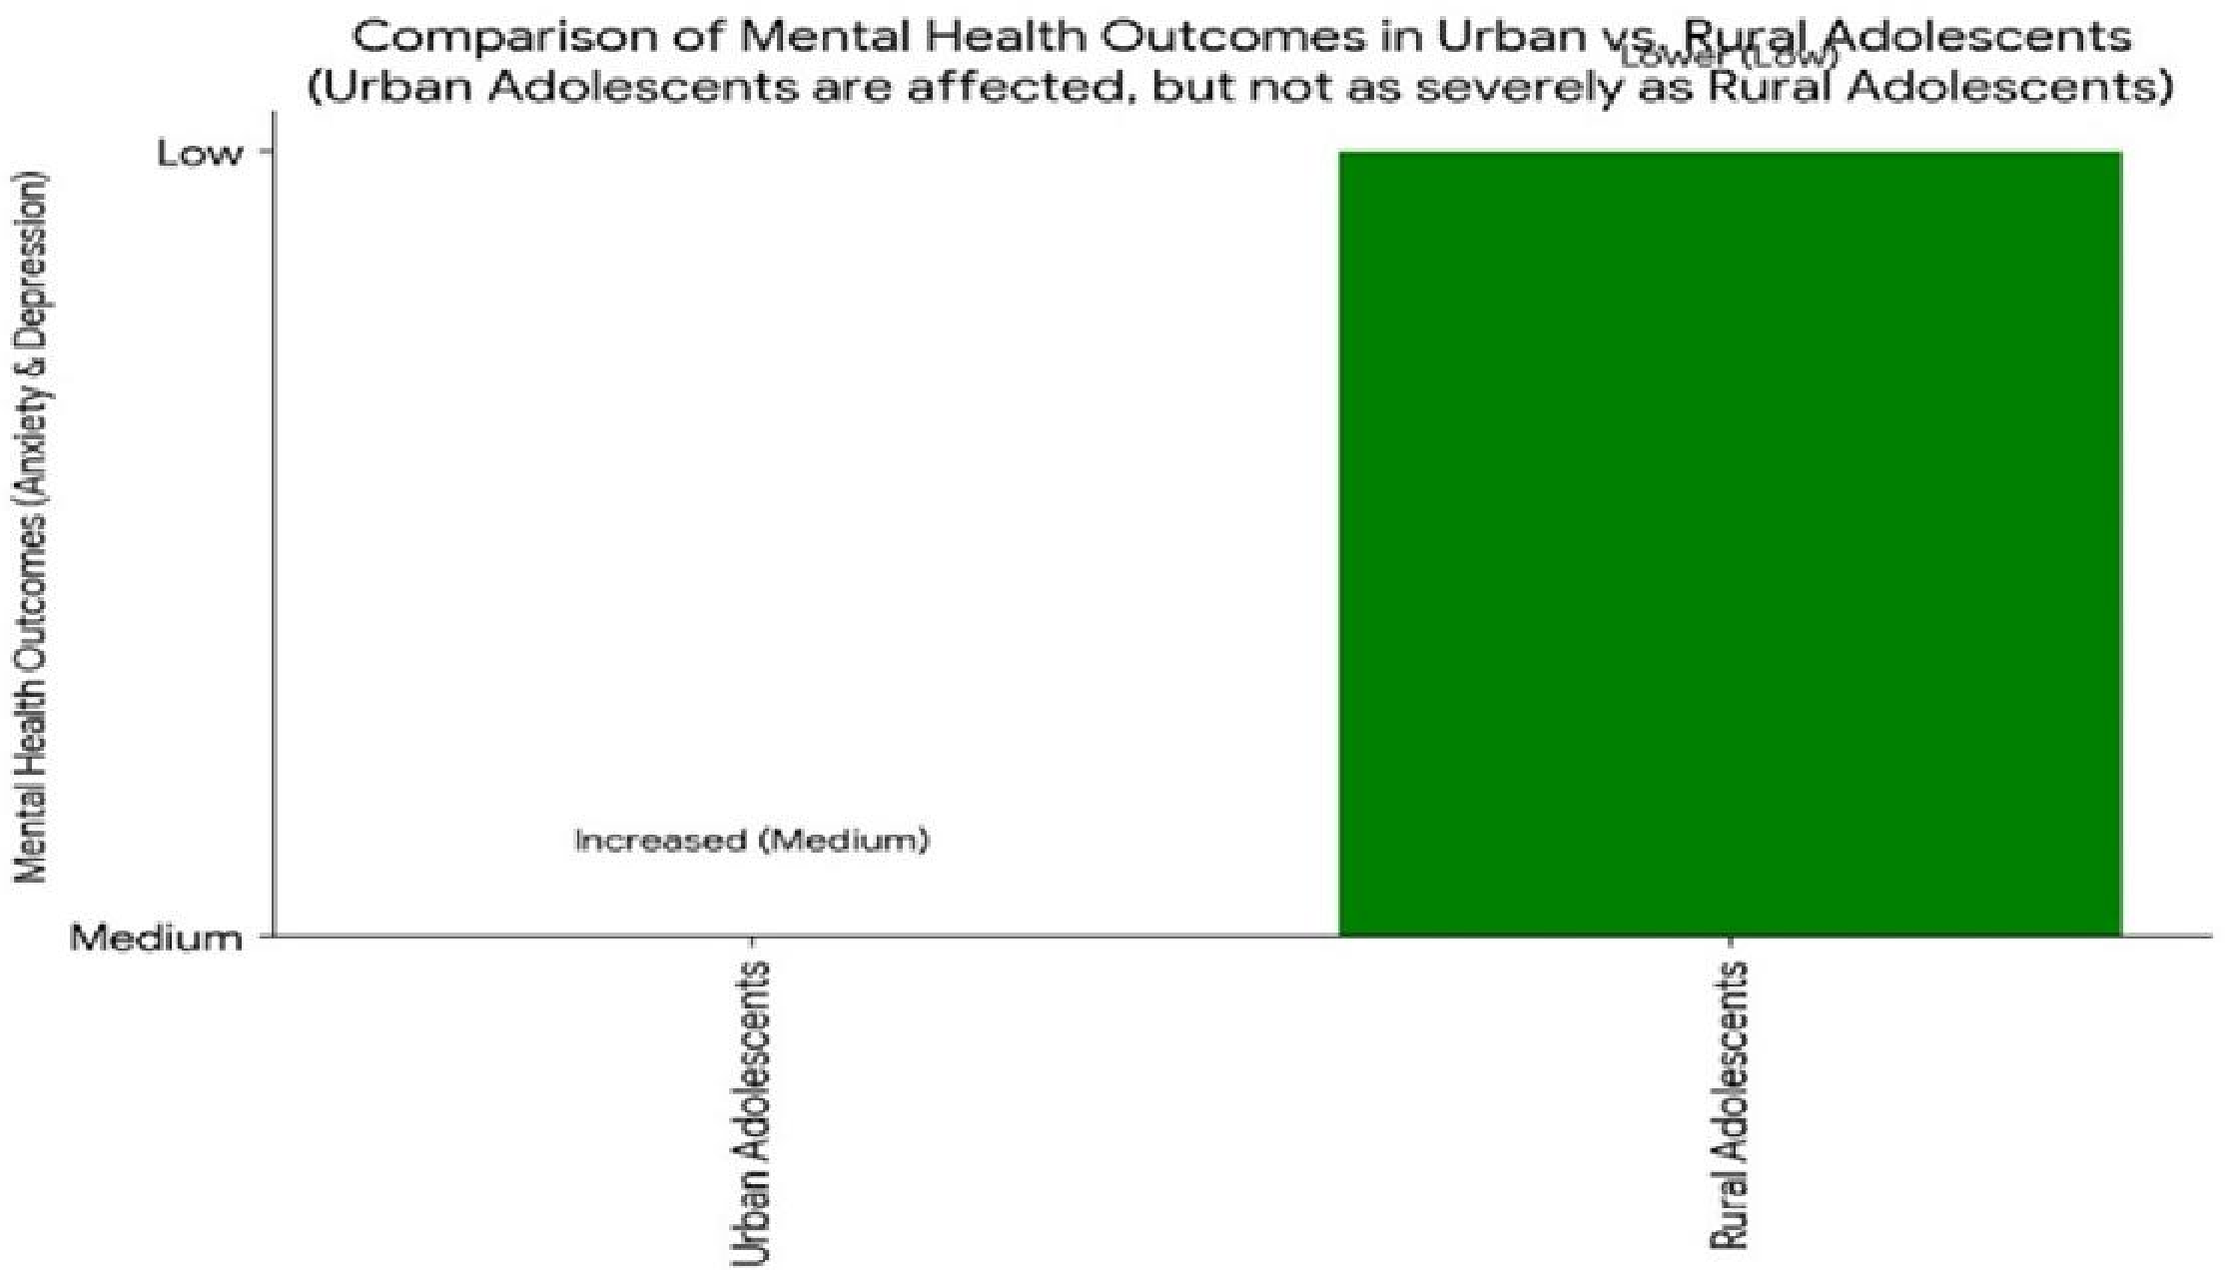

Figure 1.3 Comparison of Mental Health Outcomes in Urban Vs. Rural Area

Urban Adolescents: Displayed heightened vulnerability to negative mental health outcomes, including increased levels of anxiety, depression, and sleep disturbances. The intensity of social media engagement and the ensuing exposure to harmful content and cyberbullying were significant contributors.

Rural Adolescents: Reported lower levels of anxiety and depression related to social media use but highlighted issues related to social isolation and decreased self-esteem, driven by limited access and engagement with social media.

Gipson et al. (2015) highlighted that the adolescent phase is critical for youths' psychological well-being and emotional prosperity. However, they noted a lack of information on how individuals perceive their health and maintain their well- being during this stage. According to Zhang et al. (2015), social media platforms facilitate communication and social connections. Contrarily, Brooks (2015) demonstrated that increased social media usage among youth often leads to trouble, unhappiness, and boredom. Amedie (2015) asserted that social media contributes to anxiety and depression in young people, particularly when users compare their lives to seemingly happier and more affluent peers. Additionally, Clarke, Kuosmanen, and Barry (2015) contended that social media amplifies the emotional experiences of young people.

## Discussion

This research underscores the complex interplay between social media usage, geographical location, and adolescent mental health. The differential experiences and outcomes observed in urban versus rural settings highlight the importance of contextualizing social media's impacts within specific environmental frameworks.

Urban Context: The findings suggest that interventions in urban areas should focus on educating adolescents about healthy social media habits, promoting digital literacy, and providing resources to cope with cyberbullying and social comparison.

Rural Context: For rural adolescents, efforts might better target increasing safe and meaningful social media engagement opportunities, combating isolation, and fostering a sense of community online.

This study explores the multifaceted impact of social media on the mental well-being of young individuals, particularly focusing on aggressive behaviors, excessive usage patterns, and associated risks. Pater and Mynatt (2017) highlight the contribution of social media to aggressive and unsafe behavior, posing potential risks to the mental health of young people. Parmar (2017) observes that contemporary youth dedicate a significant amount of time to various social devices, engaging with platforms like WhatsApp, YouTube, Facebook, Instagram, and Twitter. This excessive usage has been strongly linked to increased depressive symptoms (Shensa et al., 2017). While acknowledging the significance of social media in youths' lives, Thornicroft et al. (2016) emphasize the potential risks, especially concerning cyberbullying.

Baroness Greenfield and Dr. Himanshu Tyagi underscore the challenges posed by excessive internet use among children, affecting offline concentration and real-life priorities, including education. The study asserts both positive and negative impacts of social media on academic achievements in urban and rural areas.

Additionally, Miller et al. (2016) note the small positive effects of social media on the younger generation, emphasizing its role in altering communication and socialization methods. However, they caution against the risks associated with spending excessive time in online society, posing potential dangers to emotional health. Len-Ríos et al. (2016) highlight the frequent use of social media for social networking, noting its impact on the mental health of adolescents.

## CONCLUSIONS AND RECOMMENDATIONS

The researcher concludes that this study extensively explores the interplay between social media usage patterns among adolescents, their geographical contexts (urban and rural), and the subsequent effects on mental well-being. The investigation uncovers diverse engagement patterns in urban and rural areas, shaped by factors like connectivity, social dynamics, and educational access. Social media emerges as a multifaceted tool, influencing entertainment, communication, information-seeking, socialization, and studying.

Geographical moderation proves pivotal in influencing these patterns, with urban settings offering heightened connectivity and diverse experiences, while rural environments present unique challenges and opportunities. The need for a nuanced understanding of these geographical nuances becomes apparent, emphasizing the importance of tailored interventions and policies.

## Recommendations

This study finds no notable difference in social media usage patterns between urban and rural youth. It highlights the importance of social media for academic and career-related information, stressing parental supervision. Caution is urged against sharing personal data and establishing online connections.

Parental Support: Provide educational resources and workshops for parents, particularly in rural areas, to aid them in comprehending and overseeing their children's social media activities. Encourage open dialogue between parents and adolescents about online experiences.

Incorporate Well-being in Education: Integrate digital well-being education into the school curriculum, focusing on responsible social media use and addressing potential mental health impacts. Foster a supportive environment that promotes positive online behaviors.

Community Awareness: Launch community-based awareness programs, engaging local leaders and influencers, to educate both urban and rural communities about the potential advantages and risks linked to adolescent social media use.

Policy Formulation: Collaborate with educational institutions, healthcare professionals, and policymakers to devise comprehensive policies addressing the distinct challenges posed by social media in diverse geographical settings. Consider the unique needs of both urban and rural populations.

## ACKNOWLEDGEMENT

The successful completion of this study on social media usage patterns among adolescents in urban and rural areas is attributed to the collective efforts of the researchers involved. The researcher’s heartfelt gratitude goes out to the participants who generously shared their experiences, insights, and perspectives, significantly enhancing the depth of this paper.

The researcher would like to thank the academic and research communities for providing a robust foundation through existing literature and methodologies. Special thanks to their peers, mentors, and colleagues for their valuable support and guidance, which played a pivotal role in shaping the trajectory of this research endeavor.

This paper stands as a collaborative effort, and the researcher acknowledges the collective contributions that have made it possible. Each voice, whether through participation, guidance, or encouragement, has significantly enriched the overall narrative of this research.

Thank you to all who have been instrumental in this journey

## REFERENCES

**[1].** Learning (Online), 14(5), 108-121. https://doi.org/10.3991/ijet.v14i05.9720

**[2].** American Psychological Association (APA). (2011). Social networking's good and bad impacts on kids **[3].** Amedie, J. (2015). The Impact of Social Media on Society. Advanced Writing: Pop Culture Intersections

**[4].** Becker Digital. (2023). Rural Communities. Retrieved from https://[www.becker-digital.com/blog/rural-](http://www.becker-digital.com/blog/rural-) social-media-strategy

**[5].** Clarke, A. M., Kuosmanen, T., & Barry, M. M. (2015). A systematic review of online youth mental health promotion and prevention interventions. Journal of youth and adolescence, 44(1), 90-113.

**[6].** Deogade, S. C., et al. (2018). Adverse health effects and unhealthy behaviors among dental undergraduates surfing social networking sites. Ind Psychiatry J, 26, 207-14.