ReactJS: A JavaScript Library for Development of Responsive and Single-Page Websites
AJAY KUMAR SHARMA¹, Dr. VISHAL SHRIVASTAVA², Dr. AKHIL PANDEY³
¹B.TECH. Scholar, ^{2,3}Professor,
Computer Science & Engineering
Arya College of Engineering & I.T. India, Jaipur.
¹asharma7507@gmail.com , ²vishalshrivastava.cs@aryacollege.in,³akhil@aryacollege.in

Abstract

ReactJS, a JavaScript library developed by Facebook, has emerged as a leading technology for building user interfaces in modern web applications. Its component-based architecture, virtual DOM, and declarative syntax have revolutionized the way developers approach front-end development. This paper explores the fundamental concepts of ReactJS, including its core principles, key features, and benefits. It delves into the advantages of using ReactJS for building interactive and scalable web applications, discussing topics such as reusability, performance optimization, and ecosystem support. Additionally, this paper examines real-world use cases and provides insights into best practices for leveraging ReactJS effectively in software development projects. Through a comprehensive analysis, this research aims to provide a thorough understanding of ReactJS and its significance in the realm of web development.

Introduction

In the ever-evolving landscape of web development, creating dynamic and responsive user interfaces is paramount for engaging user experiences. ReactJS, an open-source JavaScript library maintained by Facebook, has emerged as a cornerstone technology in this pursuit. ReactJS offers developers a powerful toolkit for building interactive web applications with speed, efficiency, and scalability.

This introduction sets the stage for exploring ReactJS by highlighting its significance in modern web development. It outlines the goals of the paper, which include examining the core principles and features of ReactJS, exploring its advantages, and providing insights into its practical application through real-world examples and best practices. As we delve deeper into ReactJS, we uncover how its component-based architecture, virtual DOM, and declarative syntax empower developers to create rich and dynamic user interfaces with ease.

Through this exploration, we aim to provide readers with a comprehensive understanding of ReactJS and its role in shaping the future of web development. By the end of this paper, readers will have gained valuable insights into how ReactJS can revolutionize their approach to building web applications and enhancing user experiences.

Background and Context: Provide a brief overview of the evolution of web development technologies leading up to the emergence of ReactJS. This could include the challenges faced by developers with traditional approaches and the need for more efficient solutions.

Rise of Component-Based Architecture: Discuss the shift towards component-based architecture in web development and how ReactJS epitomizes this approach. Highlight the benefits of componentization, such as reusability, maintainability, and scalability.

Impact on Industry: Describe the impact ReactJS has had on the web development industry, including its widespread adoption by major companies and the developer community. Mention notable success stories or case studies where ReactJS has been instrumental in achieving significant outcomes.

Ecosystem and Community Support: Highlight the vibrant ecosystem surrounding ReactJS, including the abundance of third-party libraries, tools, and resources available to developers. Emphasize the active community support through forums, documentation, and online tutorials.

Performance and Scalability: Discuss how ReactJS addresses performance challenges in web applications through features like the virtual DOM and efficient rendering strategies. Explain how its architecture enables the building of scalable applications capable of handling complex user interfaces and large datasets.

Cross-Platform Capabilities: Touch upon ReactJS's versatility in enabling development across different platforms, including web, mobile, and desktop. Mention frameworks like React Native for mobile development and Electron for desktop applications.

Continuous Evolution: Acknowledge ReactJS's commitment to innovation and continuous improvement through regular updates and new features. Highlight the importance of staying up-to-date with the latest advancements in ReactJS for leveraging its full potential in web development projects.

Methodology

Literature Review: A thorough review of existing literature, including academic papers, articles, documentation, and online resources related to ReactJS, is conducted to establish a foundational understanding of the subject matter. This literature review helps identify key concepts, best practices, and emerging trends in ReactJS development.

Documentation Analysis: The official documentation provided by the ReactJS team is analyzed in detail to understand the core principles, features, and API specifications of the library. This analysis serves as a primary source of information for elucidating ReactJS's fundamental concepts and usage guidelines.

Case Studies: Real-world case studies and examples of ReactJS implementation in diverse web development projects are examined to gain insights into its practical application and effectiveness. These case studies provide valuable context and illustrate the benefits of using ReactJS in different scenarios.

Interviews and Surveys: Interviews with ReactJS developers and stakeholders, as well as surveys conducted within the developer community, are utilized to gather firsthand experiences, opinions, and insights regarding the usage, challenges, and advantages of ReactJS. These qualitative data collection methods offer valuable perspectives from practitioners in the field.

Experimental Analysis: Experimental studies and performance evaluations are conducted to assess the efficiency, scalability, and performance characteristics of ReactJS in comparison to alternative frameworks or libraries. This experimental analysis involves benchmarking, profiling, and testing methodologies to quantify ReactJS's capabilities and identify areas for optimization.

Best Practices and Guidelines: A synthesis of best practices, guidelines, and recommendations for ReactJS development is derived from the findings of the literature review, documentation analysis, case studies, and interviews. These best practices serve as actionable insights for developers aiming to leverage ReactJS effectively in their projects.

Feature of ReactJS

Component-Based Architecture: ReactJS is based on a component-based architecture, where UIs are composed of reusable and independent components. This modular approach promotes code reusability, maintainability, and scalability, allowing developers to build complex interfaces more efficiently.

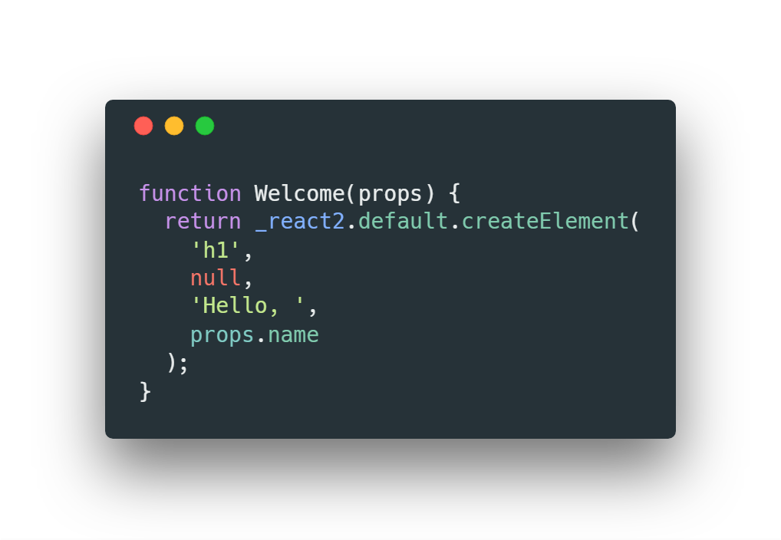

Figure – Syntax of a Component of ReactJS

Virtual DOM (Document Object Model): ReactJS uses a virtual DOM to represent the UI in memory, which is a lightweight copy of the actual DOM. When changes are made to the UI, React reconciles the virtual DOM with the real DOM, minimizing the number of DOM manipulations and improving performance.

Declarative Syntax: ReactJS uses a declarative syntax to describe how the UI should look based on the application state. Developers can simply declare what they want the UI to look like, and React takes care of updating the DOM to match the desired state, simplifying the development process and making code more predictable and easier to understand.

JSX (JavaScript XML): JSX is a syntax extension for JavaScript that allows developers to write HTML-like code within JavaScript files. JSX makes it easier to create React elements and compose components, blurring the line between markup and logic and facilitating the creation of complex UIs in a more intuitive manner.

Unidirectional Data Flow: React follows a unidirectional data flow pattern, where data flows down the component hierarchy from parent to child components. This makes it easier to understand how data changes propagate through the application and helps prevent unexpected side effects, making applications more predictable and easier to debug.

Reusable Components: React encourages the creation of reusable components that encapsulate specific UI functionality. These components can be composed together to build complex UIs, promoting code reuse and modularization and simplifying maintenance and updates.

Future of ReactJS

Continued Growth and adoption: ReactJS is likely to continue its growth trajectory, with more developers and companies adopting it for web development projects. Its popularity is supported by its robust ecosystem, active community, and backing from Facebook.

Enhancement in performance and Optimization: ReactJS is likely to undergo further optimizations to improve performance, particularly in areas such as rendering speed and memory management. Efforts may focus on minimizing bundle sizes, enhancing virtual DOM efficiency, and optimizing re-renders.

Expansion of Ecosystem and Tooling: The ReactJS ecosystem is expected to expand further, with the introduction of new libraries, tools, and frameworks that complement and extend React's capabilities. This includes tools for state management, routing, testing, and server-side rendering.

Integration with Emerging Technologies: ReactJS is likely to integrate with emerging technologies and trends in web development, such as serverless architecture, progressive web apps (PWAs), and micro-frontends. Integration with technologies like Web Assembly may also open up new possibilities for performance optimization.

Focus on Developer Experience: There may be a continued focus on improving the developer experience with ReactJS, including enhancements to developer tools, documentation, and learning resources. Efforts to streamline development workflows and reduce boilerplate code are also expected to continue.

Accessibility and Inclusivity: ReactJS is likely to place greater emphasis on accessibility and inclusivity, with efforts to make it easier for developers to create web applications that are accessible to users with disabilities. This may include built-in accessibility features and tooling for testing and auditing accessibility.

Evolution of Component-Based Architecture: The concept of component-based architecture, which ReactJS popularized, is expected to evolve further. This may involve advancements in component composition, interoperability between different component libraries and frameworks, and standardization of component APIs.

Adaption to New Browser Features: ReactJS is likely to adapt to new features and capabilities introduced by modern web browsers, such as support for new JavaScript language features, improvements in browser performance, and APIs for handling device capabilities.

Conclusion

In conclusion, ReactJS stands as a pivotal technology in modern web development, offering a powerful toolkit for building dynamic and interactive user interfaces. Through its component-based architecture, virtual DOM, declarative syntax, and other key features, ReactJS has revolutionized the way developers approach front-end development, enabling them to create complex UIs with greater efficiency, scalability, and maintainability.

Throughout this research paper, we have explored the fundamental concepts of ReactJS, delving into its core principles, key features, and benefits. We have examined the significance of ReactJS in the web development landscape, discussing its impact on industry practices, its widespread adoption by developers and companies, and its vibrant ecosystem of libraries, tools, and resources.

Furthermore, we have explored real-world use cases and best practices for leveraging ReactJS effectively in software development projects. From building reusable components to optimizing performance and integrating with emerging technologies, ReactJS offers developers a flexible and versatile platform for creating cutting-edge web applications that meet the demands of today's users.

Looking ahead, ReactJS is poised to continue its growth and evolution, adapting to emerging trends and technologies while maintaining its commitment to simplicity, performance, and developer experience. As web development continues to evolve, ReactJS will remain at the forefront, empowering developers to push the boundaries of what is possible and deliver exceptional user experiences on the web.

In summary, ReactJS represents not only a technology but also a paradigm shift in how we approach web development. With its focus on modularity, efficiency, and innovation, ReactJS has cemented its place as a cornerstone of modern web development, shaping the future of the web for years to come.

References

React Documentation. Retrieved from: https://reactjs.org/docs/getting-started.html

ReactJS GitHub Repository. Retrieved from: https://github.com/facebook/react

Reactiflux Community. Retrieved from: https://www.reactiflux.com/

Reactiflux Discord Server. Retrieved from: https://discord.gg/0ZcbPKXt5bZjGY5n

React subreddit. Retrieved from: https://www.reddit.com/r/reactjs/

Reactiflux Twitter. Retrieved from: https://twitter.com/reactiflux

Reactiflux GitHub Organization. Retrieved from: https://github.com/reactiflux

