“MARKETING STRATEGY OF APOLLO TYRES”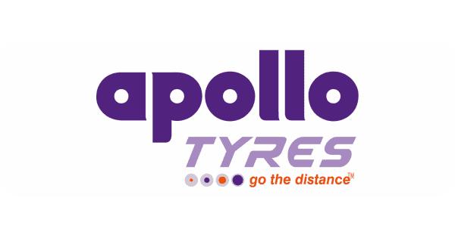

* Raushan Kumar

Student of BBA (Marketing & Automobiles Mgt.)

Galgotias University

Abstract:

One of the top tyre manufacturers in the world, Apollo Tyres focuses in producing and supplying a large selection of tyres for cars, trucks, motorbikes and bicycles. Apollo Tyres is well-known for its dedication to quality, innovation, and customer satisfaction and has a significant market share in both home and foreign markets. The purpose of this abstract is to give a summary of the salient features of Apollo Tyres, such as its background, range of products, market share, and core values. Apollo Tyres Ltd. was established as a public limited company in India on September 28, 1972, and on October 24, 1972, it was granted a certificate of commencement of business.[9] Raunaq Singh, Mathew T. Marattukalam, Jacob Thomas, Bharat Steel Tubes, Ltd., Raunaq International Pvt. Ltd., and Raunaq & Co. Pvt. Ltd. all pushed the business.[10] The firm launched its first public offering of equity shares in 1975[11]. Its first manufacturing unit, Perambra unit, in Thrissur, Kerala, India, was put into operation in 1977[1], and its second plant, at Limda, Gujarat, India,[1], was put into operation in 1991. In 1995, the business purchased Premier Tyres Limited, establishing its third facility in Kochi, Kerala, India.[12] It opened a new facility in Chennai, Tamil Nadu, India, in 2008,2009.

Introduction:

One of the top tyre producers in the world, Apollo Tyres Limited provides a wide selection of excellent tyres for a variety of cars. Since its founding in 1972, Apollo Tyres has developed into a reputable company with a global reach into more than 100 nations.

The business is renowned for its dedication to sustainability, innovation, and technology. Apollo Tyres places a high priority on research and development, allowing them to create tyres that offer better performance and safety in addition to being long-lasting and dependable.

Tyres for a variety of vehicles, such as automobiles, SUVs, lorries, buses, and motorbikes, are manufactured by Apollo Tyres. Summer tyres, winter tyres, all-season tyres, and specialty tyres for various uses and terrains are all part of their product line.

Apollo Tyres engages in a number of community and corporate social responsibility projects in addition to producing tyres. They place a high priority on sustainable practices and have taken a number of steps to reduce their negative effects on the environment, including recycling programmes and environmentally friendly production techniques.

Apollo Tyres guarantees that their products are delivered to consumers all over the world through an extensive global network of manufacturing facilities and distribution channels. They have a good reputation in the tyre sector thanks to their significant emphasis on customer satisfaction and ongoing improvement.

In conclusion, Apollo Tyres is a well-known tyre producer distinguished by its creative and environmentally friendly methods. The business remains a major force in the world tyre market thanks to its wide selection of premium tyres and dedication to client satisfaction.

SWOT Analysis of Apollo Tyres:

Strengths:

1. Strong Global Presence: Apollo Tyres has a wide distribution network and a strong presence in over 100 countries, enabling them to reach a diverse customer base around the world.

2. Quality and Innovation: The company is known for its high-quality tires that are durable, reliable, and deliver superior performance. They have a strong focus on research and development, enabling them to constantly innovate and introduce new products.

3. Diverse Product Portfolio: Apollo Tyres offers a wide range of tires for various vehicles and applications, catering to the needs of different customer segments. This diversification helps them tap into different markets and customer preferences.

4. Strong Manufacturing Capabilities: The company has a global network of technologically advanced manufacturing facilities, ensuring a consistent supply of high-quality tires.

Weakness:

1. Reliance on Raw resources: The production of tyres at Apollo Tyres is heavily reliant on natural rubber and other raw resources. Due to this reliance, the business is subject to changes in price, problems with supply, and geopolitical concerns when procuring these resources. Any interruption in the supply chain could have an effect on output and raise expenses for the business.

2. Limited Brand Awareness: When it comes to brand recognition and awareness, Apollo Tyres still trails some of the more well-known tyre manufacturers, even with their strong worldwide presence. Because of this, it may be difficult for the business to compete with well-known brands, especially in developed countries where consumer loyalty and trust are important factors.

Opportunities:

1. Expanding Automotive sector: Particularly in emerging regions, the global automotive sector is growing steadily. Apollo Tyres now has the chance to enhance sales volumes and broaden its market presence. By enhancing relationships with Original Equipment Manufacturers (OEMs) and concentrating on product development to satisfy the particular needs of various vehicle segments, the company can take advantage of this.

2. Growing Need for High-Performance Tyres: As technology advances and customer tastes move to prioritise safety and performance, there is an increasing need for high-performance tyres. Apollo Tyres may take advantage of this chance by funding R&D to create cutting-edge tyre solutions that will appeal to customers who value performance. By providing an extensive selection of premium, high-performing tyres, the business may increase its market share.

Threats:

Wars of price

fierce rivalry between domestic and foreign brands

less expensive technologies

Price and raw material volatility due to India's lower-than-demand production of rubber.

Government policies on import and export taxes, taxes imposed on the auto industry, and the country's economic status all have an impact on how many cars are sold.

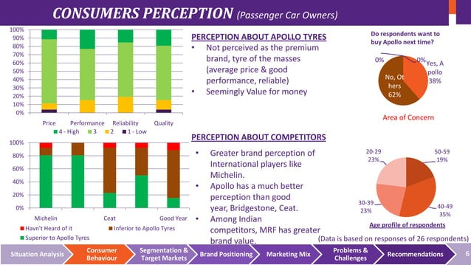

Conclusion:

As a brand, Apollo Tyres has a distinctive journey to success. When it comes to engaging its audience with creative and instructive ads, the company is staying true to its core values. With the advent of digital technology, the brand's most successful marketing strategy is to offer devoted services. Additionally, their marketing approaches are getting better.

Apollo Tyres has participated in numerous CSR initiatives addressing issues like HIV, Clean India, etc. In an effort to raise awareness about HIV, they hand out leaflets to drivers and offer testing, counselling, and treatment at their health centres. In order to raise awareness of HIV, they also conducted street dramas, musical dance performances, one-on-one interactions, workshops, and peer educators. For the past eleven years, this project has been in operation. Their goal is to leave a lasting impression.

The Apollo Tyres Foundation developed SPARSH, and Apollo Tyres endorses the Clean India initiative. The acronym for Segregating Waste, Practice Composting, Raising Awareness, Reuse-Recycle-Reduce is SPARSH, which stands for Safe Sanitation.

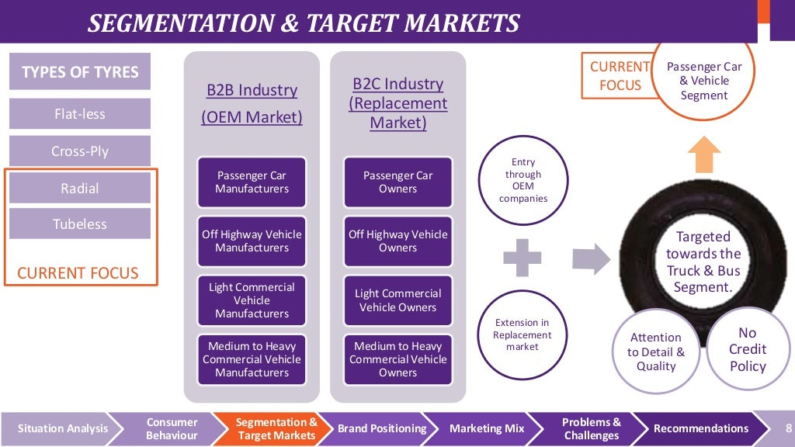

REFERENCES:

[Apollo Tyres Marketing Strategy & Marketing Mix (4Ps) | MBA Skool](https://www.mbaskool.com/marketing-mix/products/16968-apollo-tyres.html)

www.thehindubusinessline.com