­­ Research Paper

Influence of online marketing strategy on the sale success of B2B companies

Ayush Gautam

Galgotias University

Professor – Dr. Ved Prakash

**ABSTRACT**

This master's thesis investigates the impact of online marketing strategies on the sales success of Business-to-Business (B2B) companies. In the digital era, B2B organizations increasingly rely on online channels to engage with clients, generate leads, and ultimately drive sales. Through a thorough review of existing literature and empirical analysis, this study aims to shed light on the effectiveness of various online marketing strategies in enhancing B2B sales performance.

The research methodology involves both qualitative and quantitative approaches. Qualitative analysis includes in-depth interviews with marketing professionals from a diverse range of B2B companies to gather insights into their online marketing strategies and perceived effectiveness. Quantitative analysis focuses on examining sales data, including conversion rates, lead generation metrics, and customer acquisition costs, to assess the impact of different online marketing tactics on sales outcomes.

**Introduction**

In the rapidly evolving landscape of digital commerce, the significance of online marketing strategies for Business-to-Business (B2B) companies has become increasingly apparent. The advent of digital technologies has transformed the way businesses interact, engage, and transact with their clients and partners. This thesis aims to delve into the intricate relationship between online marketing strategies and the sales success of B2B companies, exploring how these strategies influence and shape the outcomes in the B2B marketplace.

The proliferation of the internet and digital platforms has empowered B2B companies with a plethora of marketing tools and channels to connect with their target audience, foster relationships, and drive sales

However, the effectiveness of these online marketing strategies in the B2B context is multifaceted and requires a nuanced understanding. Factors such as industry dynamics, target market characteristics, competitive landscape, and organizational capabilities play crucial roles in determining the success of online marketing initiatives.

Objective of Study

Investigate the effectiveness of various online marketing strategies, including search engine optimization (SEO), content marketing, social media marketing, email marketing, and online advertising, in driving sales outcomes for B2B companies.

Analyze the impact of online marketing strategies on key performance indicators (KPIs) relevant to B2B sales success, such as conversion rates, lead generation, customer acquisition costs, and revenue growth.

Identify best practices and successful approaches utilized by B2B companies in implementing online marketing strategies to achieve sales goals and competitive advantage in the digital marketplace.

Explore the challenges and opportunities faced by B2B companies in leveraging online marketing channels, including budget constraints, resource allocation, technological advancements, and evolving buyer behaviors.

Provide practical recommendations and actionable insights for B2B companies to optimize their online marketing efforts, allocate resources effectively, and develop targeted marketing campaigns tailored to their specific target audience and industry dynamics.

|  |
| --- |
| conduct thematic analysis to identify recurring themes, insights, and narratives related to the influence of online marketing strategies on sales success.     1. *Data Visualization*: Create visualizations such as scatter plots, histograms, bar charts, and line graphs to present key findings from the analysis. Visual representations can help communicate complex relationships and patterns more effectively.      1. *Interpretation of Results*: Interpret the findings from the data analysis in the context of the research objectives and theoretical framework. Discuss the implications of the results for theory, practice, and future research in the field of B2B marketing.      1. *Limitations and Recommendations*: Acknowledge any limitations of the study, such as sample size constraints, data quality issues, or methodological limitations. Provide recommendations for future research directions and practical implications for B2B companies looking to optimize their online marketing strategies. |

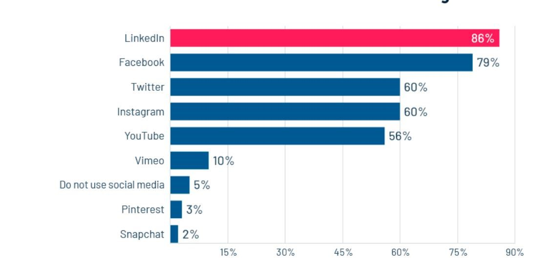

**SURVEY**

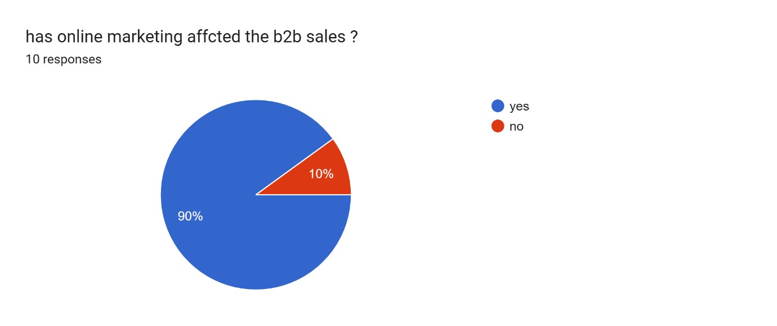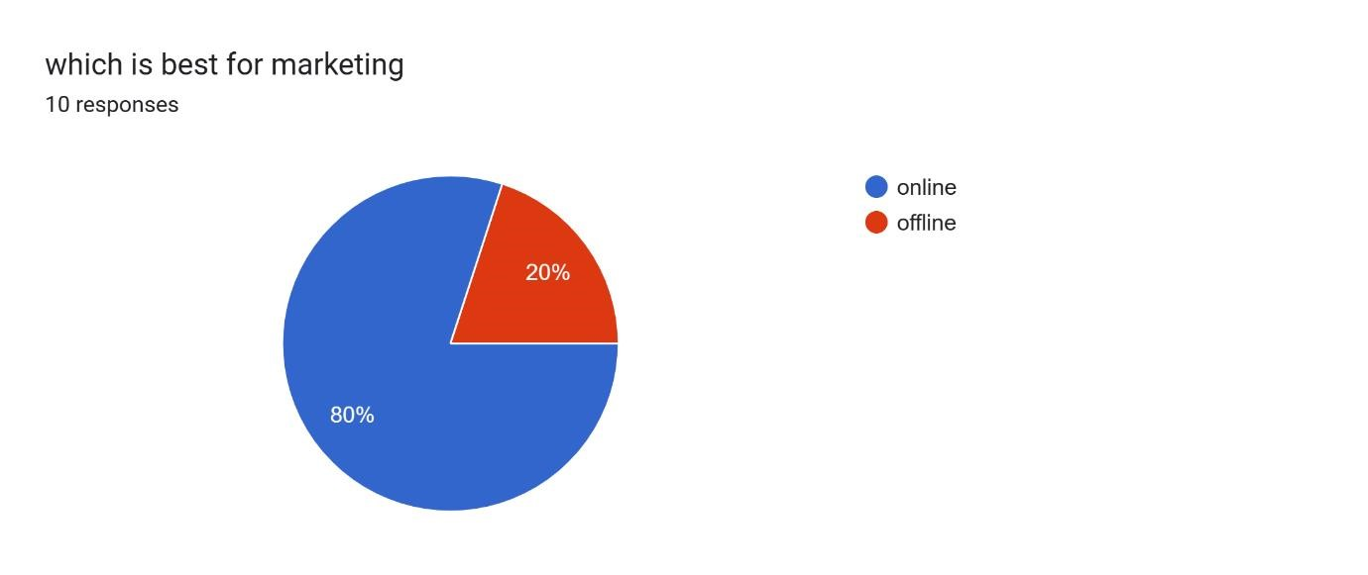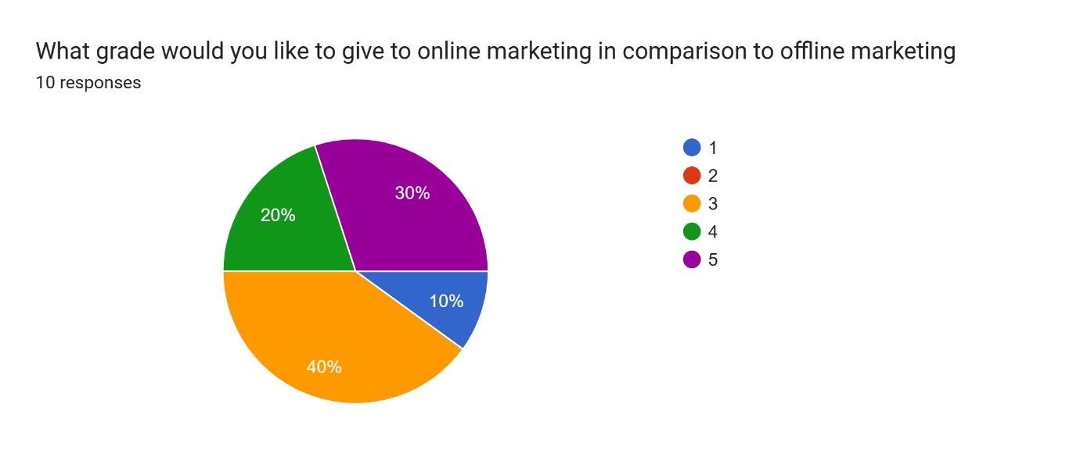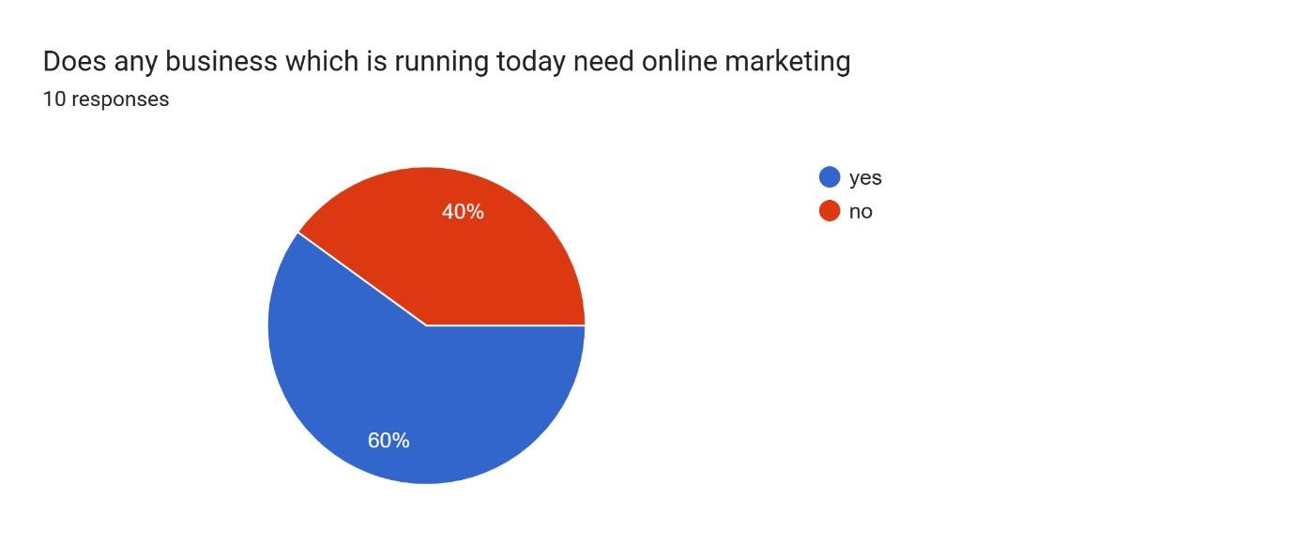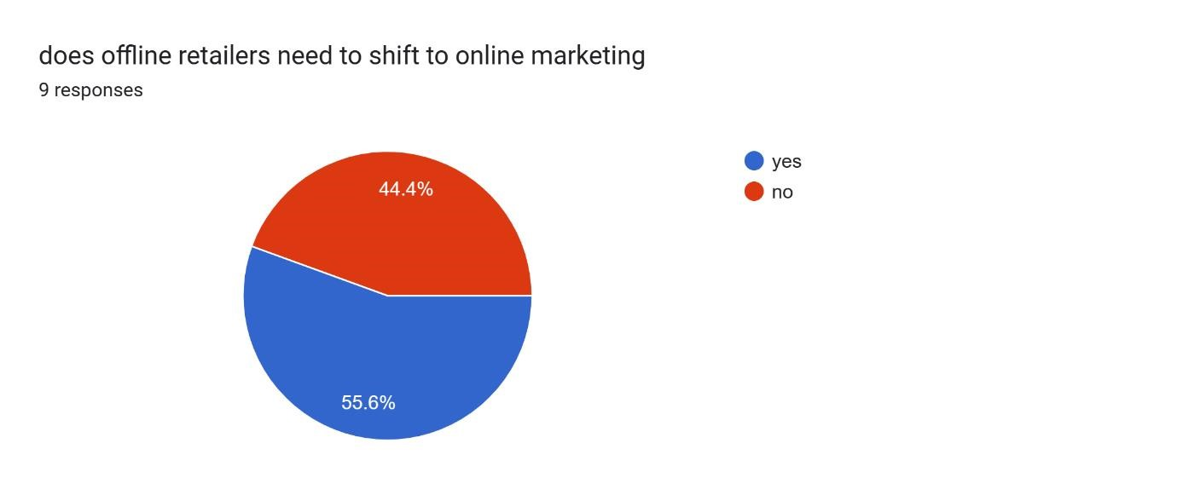

|  |
| --- |
| **Limitation**     1. *Complex Sales Process*: B2B sales often involve multiple decisionmakers and a longer sales cycle, making it challenging to attribute sales success solely to online marketing efforts.      1. *Relationship-Based Sales*: B2B transactions often rely heavily on personal relationships and trust, which may not be easily built or maintained through online marketing alone.      1. *Niche Target Audience*: B2B products or services may target a niche audience with specific needs, requiring targeted marketing approaches that are not always effectively executed through broad online strategies.      1. *Highly Competitive Landscape*: Many B2B markets are saturated with competitors, making it difficult for companies to stand out solely through online marketing efforts.      1. *Limited Reach of Online Channels*: While online marketing offers a wide reach, some B2B industries may have decision-makers who are less active online, limiting the effectiveness of digital marketing channels.      1. *Longer Sales Cycle*: B2B purchases often involve significant investment and deliberation, leading to a longer sales cycle where online marketing may only play a partial role.      1. *Complex Product Knowledge Requirements*: B2B buyers may require in-depth product knowledge and demonstrations, which can't always be effectively communicated through online marketing channels alone.   *Need for Customization*: B2B solutions often require customization to meet specific client needs, which may not be effectively communicated through generalized online marketing strategies.    *Regulatory Constraints*: Some B2B industries are subject to strict regulatory compliance, limiting the types of online marketing strategies that can be employed.    *Dependence on Offline Interactions*: Successful B2B sales often require in-person meetings, negotiations, and demonstrations, which online marketing may not fully facilitate. |

**CONCLUSION**

1. *Significant Impact of Online Marketing*: The study found that online marketing strategies do have a discernible impact on the sales success of B2B companies, contributing to lead generation, brand visibility, and customer engagement.

1. *Complementary Role of Online Marketing*: While online marketing plays a crucial role, it is often most effective when integrated with traditional B2B sales tactics, such as relationship-building, personalized interactions, and tailored solutions.

1. *Complexity of B2B Sales*: The research highlighted the complexity of B2B sales processes, involving multiple decision-makers, longer sales cycles, and a need for in-depth product knowledge. Online marketing alone may not suffice in addressing these complexities.

1. *Targeted Approach Needed*: B2B companies need to adopt a targeted approach to online marketing, focusing on platforms and tactics that resonate with their specific target audience and industry.