**IOT BASED MUSHROOM FARMING**

**Latha P H1, Priyanka S2, Divya D H3, Lipika V4**

1HOD, ISE, SAIT, Bengaluru, Karnataka, India

2ISE, SAIT, Bengaluru, Karnataka, India

3ISE, SAIT, Bengaluru, Karnataka, India

4ISE, SAIT, Bengaluru, Karnataka, India

**ABSTRACT (Font-Times New Roman, Bold, Font Size -12)**

Agriculture assumes a pivotal role in every nation, offering a crucial avenue to alleviate extreme poverty and sustain a burgeoning population. The integration of modern agricultural technologies, notably the Internet of Things (IoT), has proven to outperform traditional methods by substantially boosting productivity and efficiency. This research study delves into mushroom cultivation, recognized for its nutritional richness and emerging as a supplementary income source. In the current investigation, emphasis is placed on an IoT-based mushroom farming, employing a fully controlled environment setup. The monitoring of the mushroom crop involves the incorporation of various sensors, such as the DHT11 for tracking temperature and humidity, the MQ135 for monitoring CO2 levels, and soil moisture sensors. To regulate temperature and humidity automatically, a mechanism involving a water pump and exhaust fan is employed, ensuring an optimal growth environment for the mushrooms. Notably, the entire system is powered by solar energy, and its operations are wirelessly monitored through the external server. The executed work serves as a tangible demonstration of the application of IoT in advancing agricultural practices. It goes beyond conventional methods, contributing to improved food security while simultaneously offering a sustainable source of income for farmers.

**Keywords:** IoT, humidity, temperature, CO2, mushrooms

1. **INTRODUCTION**

Edible mushrooms stand as innovative biotechnological creations, playing a crucial role in converting various lingo cellulosic agro-wastes into valuable protein sources. The cultivation of mushrooms is a cost-effective process characterized by its eco-friendly practices and reliance on advanced technology. This approach involves utilizing local farm wastes as the primary raw material, contributing to a sustainable and resource-efficient production method.

Mushrooms, often referred to as "vegetable meat," not only address human food requirements but also offer significant pharmaceutical and medical applications. These fungi serve as unique umami-flavored additions to culinary dishes, with their fruiting bodies being central to the process. Over thousands of years, mushrooms have been consumed and employed for their health benefits, boasting low calorie and fat content, high fiber, and protein levels. Additionally, mushrooms are recognized for their low cholesterol content and the presence of significance, 20 being commercially cultivated, and 5 reaching industrial-scale production. Notably, the white button mushroom stands out as the most widely cultivated crop, contributing to almost 40 percent of the global mushroom production glutamate, an amino acid imparting a savory, meaty flavor to various dishes. sThe diversity of mushroom species is extensive, with approximately 2000 known varieties. However, only about 80 species are subjected to experimental cultivation, with around 40 gaining economic significance, 20 being commercially cultivated, and 5 reaching industrial-scale production. Notably, the white button mushroom stands out as the most widely cultivated crop, contributing to almost 40 percent of the global mushroom production.

1. **METHODOLOGY**

Mushroom cultivation encompasses a series of methods and steps to establish optimal conditions for mushroom growth. A prevalent approach involves cultivating mushrooms on a substrate, which functions as the growth medium. The process can be outlined as follows:

1. Selecting Mushroom Species: Opt for a mushroom species suitable for cultivation, such as Agaricus bisporus (button mushrooms), Pleurotus ostreatus (oyster mushrooms), or Lentinula edodes (shiitake mushrooms).
2. Preparing Substrate :The substrate, the medium for mushroom growth, typically consists of materials like straw, wood chips, sawdust, or a blend of these. Sterilize or pasteurize the substrate to eliminate potential competitors.
3. Inoculation: Introduce mushroom spawn, which is mycelium cultivated on a nutrient-rich medium, to the substrate. The spawn acts as the "seed" for mushroom cultivation.
4. Incubation: Place the inoculated substrate in a controlled environment with optimal temperature and humidity, facilitating the growth of mycelium. This incubation stage spans several weeks.
5. Colonization: Permit the mycelium to thoroughly colonize the substrate, creating a network throughout this phase.
6. Casing (optional): Some mushroom species benefit from a casing layer, a non-nutritive material like peat moss or vermiculite, applied to the colonized substrate to encourage the development of mushroom fruiting bodies.
7. Fruiting Conditions: Initiate fruiting conditions by adjusting temperature, humidity, and light. Specific conditions are essential for the initiation of fruiting body formation.
8. Harvesting: Harvest mature mushrooms when they attain the desired size, typically by cutting them at the base of the stem.
9. Spore Printing (optional): Optionally, collect spores from mature mushrooms if you wish to preserve and reproduce the mushroom strain. Spores are microscopic reproductive cells.
10. Cleanup and Reuse: After harvesting, consider reusing the substrate for subsequent crops. It may require sterilization or pasteurization to eliminate contaminants.
11. **MODELING AND ANALYSIS**

## **Figure 2** : Architecture diagram

Mushroom cultivation encompasses a series of methods and steps to establish optimal conditions for mushroom growth. A prevalent approach involves cultivating mushrooms on a substrate, which functions as the growth medium. The process can be outlined as follows:

1.**Selecting Mushroom Species:** Opt for a mushroom species suitable for cultivation, such as Agaricus bisporus (button mushrooms), Pleurotus ostreatus (oyster mushrooms), or Lentinula edodes (shiitake mushrooms).

2.**Preparing Substrate** :The substrate, the medium for mushroom growth, typically consists of materials like straw, wood chips, sawdust, or a blend of these. Sterilize or pasteurize the substrate to eliminate potential competitors.

3.**Inoculation**: Introduce mushroom spawn, which is mycelium cultivated on a nutrient-rich medium, to the substrate. The spawn acts as the "seed" for mushroom cultivation.

4.**Incubation:** Place the inoculated substrate in a controlled environment with optimal temperature and humidity, facilitating the growth of mycelium. This incubation stage spans several weeks.

5.**Colonization**: Permit the mycelium to thoroughly colonize the substrate, creating a network throughout this phase.

6.**Casing (optional):** Some mushroom species benefit from a casing layer, a non-nutritive material like peat moss or vermiculite, applied to the colonized substrate to encourage the development of mushroom fruiting bodies.

7.**Fruiting Conditions**: Initiate fruiting conditions by adjusting temperature, humidity, and light. Specific conditions are essential for the initiation of fruiting body formation.

8**.Harvesting:** Harvest mature mushrooms when they attain the desired size, typically by cutting them at the base of the stem.

9.**Spore Printing (optional):** Optionally, collect spores from mature mushrooms if you wish to preserve and reproduce the mushroom strain. Spores are microscopic reproductive cells.

10.**Cleanup and Reuse:** After harvesting, consider reusing the substrate for subsequent crops. It may require sterilization or pasteurization to eliminate contaminants.

1. **RESULTS AND DISCUSSION**

Experimental Setup:

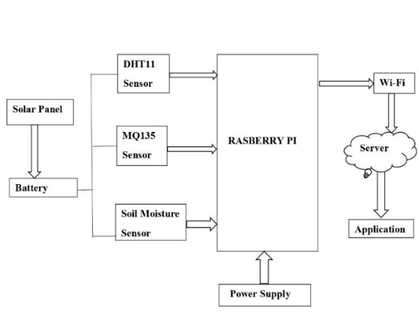

# **Figure 3**: Block diagram of setup

To maintain required environmental conditions such as temperature, humidity, CO2 etc. The circuitry With IoT platform adopted is shown in fig.2. While the complete experimental setup for button mushroom production is shown in fig.3.The production of button mushroom takes around 23 days with various stages as presented in section-3.

The basic environmental parameters, the temperature and humidity are monitored by DHT11 sensor. The required temperature and humidity values are setup into the system and are monitored continuously. Due to variation in weather conditions, if the value exceeds above or below predefined condition then an automated exhaust fan system and water pumping mechanism is adopted in order to maintain a constant temperature and humidity condition. In the present cultivation, the temperature is maintained between 200C to 280C, humidity between 55% to 70% and CO2 level at 2%. These parameters are maintained using WSN (Wireless Sensor Network), controlled and monitored using ESP32 microcontroller that maintains the sensor data and also uploads the data to Blynk IoT cloud through API token and virtual pins. This access token or authentication token, is a unique string of characters used to authenticate a person or machine, which adds an extra layer of protection and control over a person, who has access to the API resources.

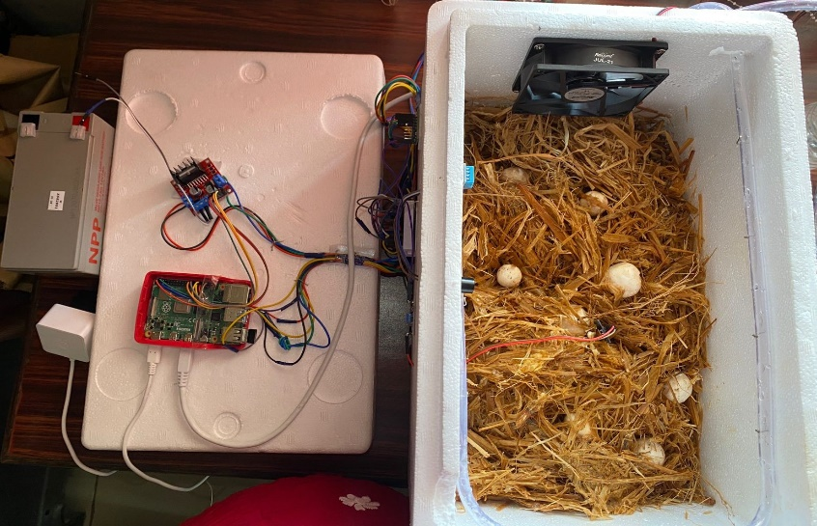

**Figure 4**: Setup of the IOT mushroom farming

First, the system connects to Wi-Fi and displays a welcome message on the LCD. It then periodically checks the temperature, humidity, soil moisture level, and gas level. If all parameters are within the normal range, the system pauses for 1 second. However, if any sensor value exceeds the threshold, the system sends data to the user through the Blynk IoT application. The user can monitor the parameters and control the exhaust fan and water pump accordingly. Additionally, the system includes an onboard buzzer that alerts the user to abnormal weather conditions.

The system is equipped with a range of sensors, including the DHT11 for temperature and humidity monitoring, MQ135 for CO2 gas monitoring and soil moisture sensors for monitoring soil moisture levels. All of these sensors work in tandem and transmit data to the ESP32 microcontroller, which monitors the environmental conditions of the mushroom cultivation area. If any abnormal conditions arise, the ESP32 sends notifications to the user via the Blynk IoT platform. Additionally, the system controls temperature and humidity levels by utilizing an exhaust fan and water pump mechanism. The sensors data are shown in the Blynk application as shown in figure 4. Based on the requirement the system turns on the exhaust fan and switch on the motor. The graphical recordings of various parameters variation are shown in figure 5, 6, 7 and 8 respectively. This automated system develops saves time and efforts of farmer in mushroom production.

1. **CONCLUSION**

The integration of IoT technology into solar-powered mushroom farming presents a promising solution for sustainable agriculture. By leveraging IoT sensors and monitoring systems, farmers can optimize environmental conditions, such as temperature, humidity, and AQI, to maximize mushroom yield while minimizing resource consumption. This approach not only increases efficiency and productivity but also reduces reliance on traditional energy sources contributing to environmental sustainability. Furthermore, IOT-based monitoring allows for real-time data analysis and remote management, enabling farmers to make informed decisions and respond promptly to changing conditions. IoT in solar-powered mushroom farming represents a significant step towards achieving a more sustainable and efficient agricultural system.

# FUTURE SCOPE

# 1.Research on New Mushroom Varieties.

# 2. Long-Term Sustainability Planning.

# 3.Waste Management Solutions .

1. **REFERENCES**

# [1] Carrera, D. M (2002), “Current development of mushroom biotechnology in Latin America,” published in Micologia Aplicada International, vol.14, no: 2, pp 61-74.

# [2] Sa´nchez, C. (2004), “Modern aspects of mushroom culture technology,” published in, applied microbiology and …...biotechnology, vol. 64, no: 2, pp 756-762.

# [3] Dias, E. S.(2010) “Mushroom cultivation in Brazil: challenges and potential for growth.” published in Cieˆnciae Agrotecnologia, vol.34, pp. 795-803.

# [4] Chioza, A., Ohga, S. (2014), “Cultivated Mushrooms in Malawi: A Look at the Present Situation,” published in Advances in Microbiology, vol. 4,p. 6-11.

# [5] Frenila, J. B., Silvela, O. V., (2015) Paglinawan, A. C. “Novel approach to urban farming: A case study of a solar-powered automated mushroom cultivation in a plastic box,” In 2015 IEEE Region 10 Humanitarian Technology Conference (R10-HTC), 015, pp. 1-6.

[6] Adhitya, R. Y., Ramadhan, M. A., Kautsar, S., Rinanto, N., Sarena, S. T., Munadhif, I.. Soe prijanto, A.(2016) “Comparison methods of Fuzzy Logic Control and Feed Forward Neural Network in automatic operating temperature and humidity control system (Oyster Mushroom Farm House) using microcontroller,” In 2016 International Symposium on Electronics and Smart Devices (ISESD), (pp. 168-173

[7] Lu, C. P., Cai, Z. H., Lin, Y. S. (2017)“Research and development of a fuzzy control system of greenhouse microclimate for button mushroom, “In 2017 International Conference on Orange Technologies (ICOT), 2017, pp. 192-196.

[8] Higgins, C., Margot, H., Warnquist, S., Obeysekare, E., Mehta, K. (2017), “Mushroom cultivation in the developing world: A comparison of cultivation technologies.” In 2017IEEE Global Humanitarian Technology Conference (GHTC), pp. 1-7.

[9] Mat, I., Kassim, M. R. M., Harun, A. N., Yusoff, I. M. (2017), “Environment control for smart mushroom house,” In 2017 IEEE Conference on Open Systems (ICOS),pp. 38-42.

[10] Ibrahim, N. H. N., Mat, I., Harun, A. N., Witjaksono, G. (2018) “IR 4.0 using IoT and LORAWAN to accelerate Lentinula Edodes growth,” In 2018 2nd International Conference on Smart Sensors and Application(ICSSA), pp.28-32.

[11] Hongpo, W., Hong, Z.(2018), “Study on precise mushroom cultivation based on feedback perception,” In 2018 IEEE 3rd International Conference on Cloud Computing and Big Data Analysis (ICCCBDA) 2018, pp. 506-510.

[12] R. c. Janapati, C. Balaswamy and K. Soundararajan, "Enhanced mechanism for localization in Wireless Sensor Networks using PSO assisted Extended Kalman Filter Algorithm (PSO-EKF)," 2015 International Conference on Communication, Information & Computing Technology (ICCICT), Mumbai, India, 2015, pp. 1-6, doi: 10.1109/ICCICT.2015.7045686..

[13] Nasution, T. H., Yasir, M., Soeharwinto, S.(2019), “Designing an IoT system for monitoring and controlling temperature and humidity in mushroom cultivation fields,” In 2019 International Conference on Electrical Engineering and Computer Science (ICECOS), pp. 326- 331.

[14] Ariffin, M. A. M., Ramli, M. I., Amin, M. N. M., Ismail, M., Zainol,Z., Ahmad, N. D., Jamil, N. (2020), “Automatic climate control for mushroom cultivation using IoT approach,” In 2020 IEEE 10th International Conference on System Engineering and Technology (ICSET), pp. 123-128.

[15] R. Janapati, C. Balaswamy and K. Soundararajan, "Enhancement of localized routing using CDPSO in WSN," 2018 Conference on Signal Processing And Communication Engineering Systems (SPACES), Vijayawada, India, 2018, pp. 16-19, doi: 10.1109/SPACES.2018.8316306..

# [16] Jia, B., Yang, S., Yu, T. (2020) “Research on three picking arm avoidance algorithms for agaricus mushroom picking robot,” In 2020 IEEE International Conference on Advances in Electrical Engineering and Computer Applications (AEECA) , pp. 325-328.

# [17] Munshi, N. A., Dar, G. H., Ghani, M. Y., Kauser, S., Mughal, N. (2010), “Button mushroom cultivation,” Communication and Publication Centre SKUAST, 2010, pp. 1-28.

# [18] Sharma, K. “Mushroom: Cultivation and processing, (2018) “Int. J. of Food Processing Technology, vol.5(2), pp. 9-12.