Live Streaming Website Using WebRTC and RTMP

**Shubham Kirve , Ronak Waghela , Kunal More , Tejas Prasade Prof. Mitrakshi Patil**

Mahatma Gandhi Mission’s College of Engineering and Technology

(Affiliated to University of Mumbai and Approved by, AICTE, New Delhi.) Plot No. 1, 2, Sion - Panvel Expressway, Sector 18, Kamothe, Navi Mumbai, Maharashtra410209 Website : [www.mgmmumbai.ac.in](http://www.mgmmumbai.ac.in/)

Department of Information Technology

# ABSTRACT

In the ever-evolving landscape of communication media, video streaming has emerged as a vital means of bridging geographical divides. However, challenges such as bandwidth limitations, network congestion, energy efficiency, cost, and reliability loom large. This study provides a comprehensive comparison of the Real-Time Messaging Protocol (RTMP) and Web Real-Time Communication (WebRTC), with a focus on their applications in video and game streaming. The objective is to evaluate their influence on streaming quality of service, including connection establishment and stream reception times. The findings underscore the enhanced performance of WebRTC, offering promising prospects for video and game streaming in overcoming these challenges.

**KEYWORDS:** WEBRTC, RTMP, VIDEO STREAMING

# INTRODUCTION

In an era where connectivity has become the lifeblood of modern communication, the evolution of multimedia streaming technologies has revolutionized the way we engage with digital content. Among these technologies, video streaming has emerged as a transformative force, enabling real-time communication and content distribution across the globe. The increasing prevalence of video streaming has not only altered the dynamics of entertainment but has also extended its reach into various sectors, including education, business, and gaming. Within this landscape, two prominent protocols have emerged as stalwarts in facilitating real-time video streaming: the Real-Time Messaging Protocol (RTMP) and the Web Real-Time Communication (WebRTC). Their utilization extends beyond conventional video streaming, transcending into the realm of game streaming, where low latency and robust performance are paramount.

Game streaming, a subset of the broader video streaming domain, has garnered significant attention as it enables players to broadcast their gameplay, engage with audiences in real-time, and build thriving online communities. As the demand for high-quality, low- latency game streaming experiences continues to surge, the choice of underlying protocols becomes pivotal. In this review paper, we embark on a comprehensive exploration of the RTMP and WebRTC protocols, dissecting their capabilities, strengths, and weaknesses in the context of video and game streaming. This work aims to unravel the intricacies of these protocols, focusing on their roles in delivering quality of service (QoS) in real-time streaming scenarios. In the sections that follow, we will delve into a comparative analysis of RTMP and WebRTC, examining their performance, reliability, and efficiency in transmitting both video and game content. Additionally, we will scrutinize their impact on critical factors such as connection establishment times, stream reception, and stream packet delay. By the end of this review, we hope to offer insights into the potential advancements these protocols bring to the world of live streaming, particularly in the context of game streaming, where minimal delay and optimal performance are paramount.

As we embark on this journey, it is important to recognize the transformative power of these protocols and their potential to shape the future of live streaming experiences, redefining the way we connect, engage, and entertain in a digitally interconnected world.

# LITERATURE REVIEW

This literature survey navigates the intricate landscape of existing systems in the realm of live streaming, shedding light on their significance and interplay with our project's core elements. We embark on a journey of discovery, exploring traditional streaming solutions, the transformative emergence of Web Real-Time Communication (WebRTC), the ascent of interactive

live streaming platforms, the creative facets of overlays and interactions, and the profound influence of user- generated content and gaming streams. Security considerations form a pivotal part of this exploration, underlining the importance of safeguarding data within the live streaming ecosystem. This survey offers a contextual framework, paving the way for a deeper understanding of the dynamic intersection of WebRTC and RTMP in our live streaming project.

**Conventional Streaming Solutions** : We initiate our examination by acknowledging the historical significance of protocols like RTMP, which have traditionally underpinned the landscape of live video streaming. These tried-and-true solutions, known for their low-latency attributes, have been instrumental in enabling real-time multimedia communication. However, we must recognize that the rapid evolution of technology has brought forth new challenges, prompting the exploration of innovative alternatives.

* + Peer-to-Peer (P2P) Connections: An Earlier Approach before the dominance of centralized servers, P2P connections played a pivotal role in the landscape of live video streaming. Here are the key aspects:
  + P2P Streaming Clients communicated directly, bypassing intermediaries. Video segments were shared among peers without relying on central servers.
  + Challenges:

▫ Coordination: Efficient data exchange among peers required sophisticated algorithms to manage connections dynamically.

▫ Security: P2P raised concerns, particularly regarding copyrighted content distribution.

▫ Dynamic Topology: Nodes joined and left dynamically, impacting network stability.

**The Rise of WebRTC**: Our exploration takes a significant turn as we delve into the rise of WebRTC, an open-source framework engineered to facilitate real- time communication. A defining feature of ebRTC is its seamless integration into web browsers, obviating the need for users to install external plugins. This inherent adaptability across a spectrum of devices and browsers positions WebRTC as a transformative force in the live streaming arena.

**Interactive Live Streaming Platforms**: The digital landscape has witnessed a transformative shift with the rise of interactive live streaming platforms. Industry giants like Twitch, YouTube Live, and Facebook Live

have redefined content consumption. These platforms, fueled by technologies like WebRTC, offer immersive, socially-engaging experiences. Audiences actively participate, connecting with content creators in real time. As our project embraces WebRTC and other modern protocols, it contributes to this dynamic era of interactive live streaming, where immediacy and engagement take center stage.

**Creative Enhancements and Interaction:** Within the live streaming landscape, we underscore the significance of creative enhancements that enable content creators to overlay text onto their live streams. These features serve as a hallmark of modern live streaming platforms, adding a layer of creativity and interactivity that enhances the viewer experience. Notably, these features are deeply aligned with the core objectives of our live streaming project.

**Building Upon Legacy and Innovation:** Our project embraces the legacy of RTMP and the pioneering spirit of P2P connections. We aim to create a modern live streaming platform that leverages WebRTC, WebSocket, and adaptive streaming techniques

# SYSTEM IMPLEMENTATION

Media Server: Set up a media server to handle video and audio streams. This server is responsible for managing the streaming process, encoding and decoding video, and distributing the streams to viewers.

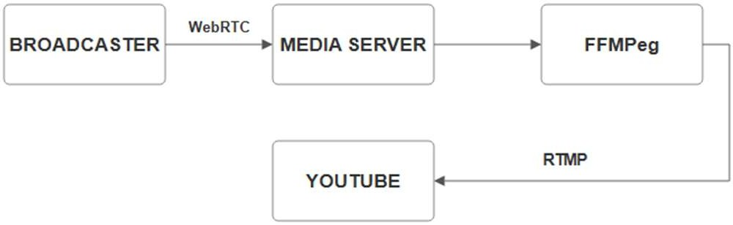

* + Web Application: Develop a web-based interface for both streamers and viewers. Streamers can initiate broadcasts and customize their streams, while viewers can access and interact with the live content.
  + Encoding and Decoding: Implement encoding and decoding mechanisms to compress and decompress video and audio data for efficient transmission.
  + Live Streaming Features: Enable streamers to start and stop live broadcasts.
  + Provide viewers with real-time access to live streams
  + Filters and Canvas: Include filters and

special effects and canvas that streamers can apply to their live video feeds for creative and entertainment purposes.

* + Latency Optimization: Optimize the system for low-latency streaming, ensuring minimal delay between the live event and viewer reception.

# CONCLUSION

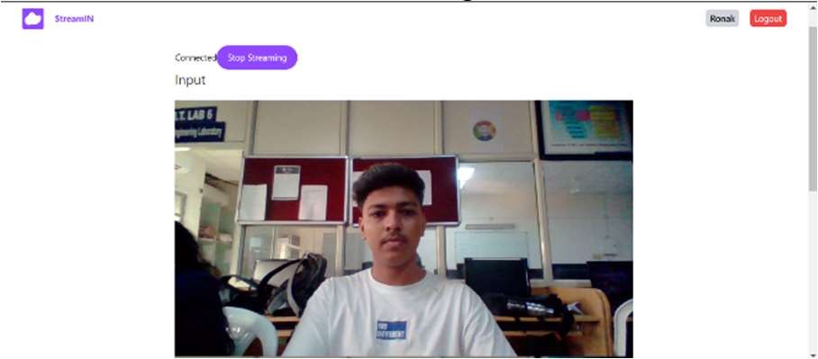our project effectively merges WebRTC and RTMP, highlighting WebRTC's strengths in low-latency streaming, cross-platform compatibility, and security.Interactive features enrich user engagement, while overcoming challenges fuels future scalability and integration with new technologies. With gratitude for collaborative efforts, our project signifies innovation in live streaming, poised for ongoing advancements and unwavering commitment to excellence in this ever-evolving domain.

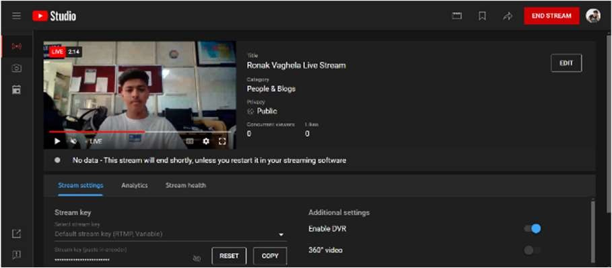

# REFERENCES

Varma, M., Yarnagula, H. K., & Tamarapalli, V. (2017). WebRTC-based peer assisted framework for HTTP live streaming. 2017 9th International Conference on Communication Systems and Networks (COMSNETS). doi:10.1109–

/comsnets.2017.7945420

Rhinow, F., Veloso, P. P., Puyelo, C., Barrett, S., & Nuallain, E. O. (2014). P2P live video streaming in WebRTC. 2014 World Congress on Computer Applications and Information Systems (WCCAIS). doi:10.1109/wccais.2014.6916588

Diallo, B.; Ouamri, A.; Keche, M. A Hybrid Approach for WebRTC Video Streaming on Resource-Constrained

Devices. Electronics 2023, 12, 3775.

https://doi.org/10.3390/electronics12183775

T. Stockhammer, “Dynamic adaptive streaming over HTTP - standards and design principles,” in Proceedings of the Second Annual ACM Conference on Multimedia Systems, ser. MMSys ’11. New York, NY, USA: ACM, 2011