# PNEUMATIC PUNCHING AND FEEDING SYSTEM

# Mr. S. K. Aher1, Mr. Sumit Sanjay Bharpure2, Mr. Abhijit Ramdas Wagh3,

# Mr. Ritesh Mahendra Pimpre4, Mr. Kaivlya Shravan Ambhore5

1Professor, Mechanical Engineering, Sandip Foundation's Sandip Polytechnic, Nashik, Maharashtra, India. 2,3,4,5Student, Mechanical Engineering, Sandip Foundation's Sandip Polytechnic, Nashik, Maharashtra, India.

# ABSTRACT

Pneumatic drilling / punching and feeding machines are precision machines designed to speed up the drilling / punching process while increasing feed and area. The system includes pneumatic actuators, sensors and a programmable logic controller (PLC) that control the flow of compressed air to operate the punching mechanism and control the product. The process begins with material being feed into the system, sensors detecting the material and sending a signal to the PLC to start the stamping sequence. The punching machine is powered by compressed air and makes drilling / punches in the product according to predefined requirements. Food products also ensure stability, correct movement of the equipment and maintaining a good relationship with the drilling / punching . Thanks to effective pneumatic control and sensor feedback, the system provides high performance, reliability and flexibility for a variety of industries requiring precision drilling/ punching and handling equipment.

1. **INTRODUCTION**

Pneumatic drilling / punching and feeding machines are complex products that rely on compressed air to power their different products. The basis of this is that the cylinder converts the capacity of compressed air into mechanical work to operate the drilling /punching machine accurately and powerfully. The machine is designed to cut, shape, drill or punching materials accurately and quickly. To complete the drilling / punching process, the feeding system controls the movement of the materials to ensure they are in the correct position during the drilling / punchign process. These systems often use pneumatic valves to control the flow of compressed air and the connection between components. Sensors play a key role in determining the position of the product, while actuators respond accordingly to adjust the feeding process to maintain performance. Overall, pneumatic punching and feeding systems help improve product design and quality products throughout the manufacturing process by providing a reliable and efficient solution for industrial applications requiring highspeed punching and precision part

# METHODOLOGY

The underneath drift chart indicates the sequential operation/steps that will be accomplished throughout the task.

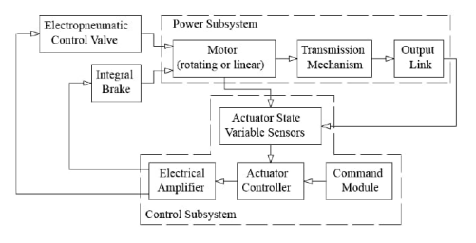

# MODELING AND ANALYSIS

# 

**Fig.1.** Pneumatic **Fig.2.** Solinoid valve.

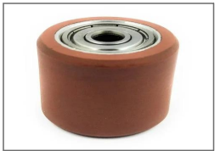 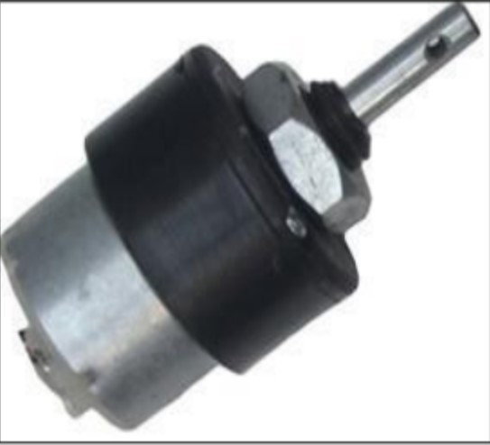

**Fig.3.** Roller **Fig.4.** DC Motors.

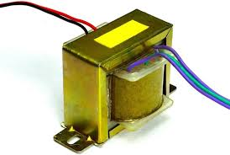 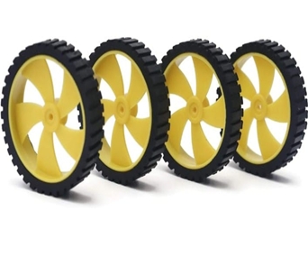

**Fig.5.** Transformer **Fig.6.** Wheel

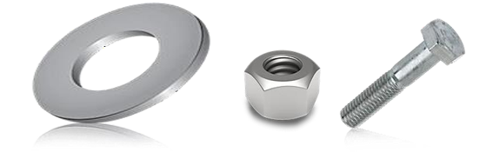

**Fig.7.** Washer. **Fig.8.** Nut and Bolt

Pneumatic drilling/ punching and feeding machines involve the use of compressed air to power the drilling machine and facilitate feeding. The system usually consists of components such as cylinders, valves, actuators and sensors that all work together to ensure stamping and product quality. Modeling and analysis of these systems; Examines issues such as high demand, long cycle times, cycle times and food quality. Features such as pneumatic system design, material selection and control strategies are carefully reviewed to ensure reliability, accuracy and efficiency while minimizing energy consumption and maintenance. Through design and analysis, engineers aim to achieve high-quality and cost-effective solutions according to the specific requirements of drilling / punching and feeding applications.

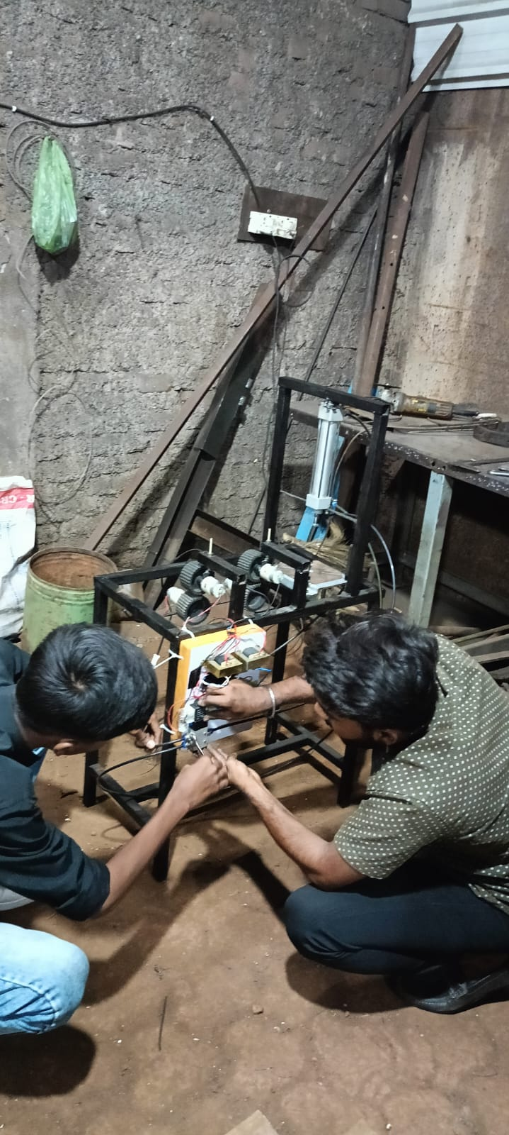

# RESULTS AND DISCUSSION

# 

**Advantages:**

Pneumatic drilling / punching and feeding machine has many advantages:

1 Using compressed air as the power source, efficient and easy to operate, simple structure and minimal maintenance.

2. Less noise than traditional power press, it can save power consumption and reduce production cost.

3. Adjustable height, speed, stroke, pressure and stamping time according to different products or mould.

4. Equipped with anti-rotation guide bar, guide plate, high precision, can adapt to high-speed precision blanking.

5. Use both hands control or pedal mode to ensure the safety of operators.

6. With microcomputer control system, the mode can be manual, semi-automatic and automatic.

7.The heating mould,temperature control and pressure sensor can be optional.

8. The structure is simple and adopts pneumatic technology, so that an air compressor can be used for the work of multiple pneumatic punching machines, which can be more energy saving than electric punch.

# CONCLUSION

# In summary, pneumatic punching / drilling and feeding technology provides great benefits for the stamping industry and product processing process. Using the power of compressed air, the system does a good job of punching /drilling while keeping the product consistent. Its design can be easily integrated into the production line, increasing flexibility and scalability. Additionally, pneumatic systems have very low maintenance and reliability, increasing productivity and reducing downtime. Pneumatic punching and feeding technology provides precision, reliability and versatility to establish a reliable foundation, optimize operations and increase productivity in today's manufacturing facilities.

# REFERENCES

1. Suraj V Bhosalel, “Design and Fabrication of Pneumatic Sheet Metal Cutting Machine”, International Journal of Magazine of Engineering, Technology,Volume 7, Issue 8-7, Pg 177-289.
2. A.S. Aditya Polapragadal, “Pneumatic Auto Feed Punching and Riveting Machine Journal of Pneumatic punching and technology, Volume 1, Issue 7, 2012, Pg 6-10.
3. Ms anita v. hase “Mechanically Operated Automation System”, Journal of automatically Operated system and its Technology, Volume 5 2015,Issue 5, Pg 69-75.
4. Puneet Isarka “Design and development of pneumatic punching machine”, Journal of Pneumatic systems, Volume 4,Issue 11,2017,Pg 25-36.
5. S.p avadhani “Design and Analysis of Blanking and Piercing of die punch”, International Journal for blanking and Piercing technology, Volume 4 ,2017,Issue 05, pg 56-65.
6. P.Goyal, studied on “Design of pneumatically controlled small scale punching machine”, Journal of Pneumatics Science and Technology, Volume 4, 2015 Pg 199-208