EVCS-Chargepoint: Streamlining EV charging discovery, booking and payment
Md. Arshan Shaikh  Computer Engineering  Pillai HOC College Of Engineering and Technology  Rasayani, India  mohammadas20comp@student.mes.ac.in | Dakshata Thakare  Computer Engineering  Pillai HOC College Of Engineering and Technology  Rasayani, India  dakshatapt20comp@student.mes.ac.in | Rohit Udamale  Computer Engineering  Pillai HOC College Of Engineering and Technology  Rasayani, India  rohitlu20comp@student.mes.ac.in | Prof. Sagar Yeshwantrao  Computer Engineering  Pillai HOC College Of Engineering and Technology  Rasayani, India  sagaryeshwantrao@mes.ac.in

Abstract— Over the past century, vehicles primarily reliant on fuels such as petrol and diesel have been extensively used. This heavy reliance on these fuels has resulted in a significant decrease in their availability and has contributed to pollution. However, with advancements in the automobile industry, Electric Vehicles (EVs) have been introduced. EVs do not rely on natural fuels like crude oil; instead, they use electricity as their power source, making a substantial contribution to reducing pollution. One of the greatest advantages of EVs is that they can be charged at home. Nevertheless, there is an issue with charging infrastructure, especially when owners are outside their neighborhoods and require immediate charging solutions. The 'EVCS-Chargepoint' application has been developed to address this issue. It assists users in locating the nearest charging station, booking a charging slot, and making payment for the services. This application is versatile and can be used by owners of all types of vehicles, ranging from motorcycles and light motor vehicles (LMVs) to heavy motor vehicles (HMVs). A significant advantage of this project is that it offers additional services like battery swapping and battery delivery. In situations where there is a rush at the charging station, vehicle owners can opt for battery swapping, which quickly provides them with the required charge. Additionally, if a vehicle's battery is completely depleted, the owner can utilize the urgent battery delivery service. It's important to note that the availability of these facilities may depend on the individual charging station's offerings. This project involves two main stakeholders: the customer/vehicle owner and the charging station owner.
Keywords— Charging infrastructure, pollution reduction, battery swapping, charging station locator.

Introduction
In the 19th century, the automobile industry began with the development of the first car by Carl Benz. For approximately 125 years, the industry relied on crude oils such as petrol and diesel for commuting, but the emissions from these fuels significantly contributed to global warming. Additionally, the extensive use of these oils led to their scarcity.
In the 21st century, heightened awareness of the environmental issues caused by petroleum prompted significant changes in the industry. Vehicles running on natural gases like CNG and LPG emerged as alternatives. However, these gases have drawbacks, such as lower power yield.
The trend toward electric vehicles (EVs) gained momentum worldwide as they offer solutions to pollution control and fuel conservation. This trend has also taken root in India. While the electric vehicle charging infrastructure is well-developed in many parts of the world, it is still evolving in India due to its recent development.
One of the main advantages of EVs is the ability to charge them at home or in offices. However, this poses a challenge when traveling to distant locations. The scarcity of charging stations in India, coupled with the increasing number of electric vehicles, exacerbates this issue. Moreover, the rise in production of electric motorcycles in India presents a different charging structure requirement compared to Light Motor Vehicles (LMVs) and Heavy Motor Vehicles (HMVs). The lack of standardized charging cables at charging stations further complicates the situation, hindering EV users.
To address these challenges, a charging station locator application is needed to enhance connectivity. Such an application should facilitate finding stations, booking slots, and making payments. It should provide users with information about nearby charging stations, the availability of different charging cables, and other relevant details.

Related work
1) As per Monica Sharma [1], user location tracking is the most important requirement of an application. Buying a GPS device is not necessary, as a location-based API can suffice.

2) According to Efthymiou D., Chrysostomou K., Morfoulaki M., and Aifantopoulou G. [2], genetic algorithms are used to build an EV station locator structure, which is open source and can be freely used.

3) According to Sumit S. Muddalkar, Nishant S. Chaturkar, Khushal D. Ingole, Shreyash B. Wadaskar, and Rahul B. Lanjewar [3], the application will be developed in such a manner that users and charging station workers will be able to use it conveniently.

4) In accordance with A. M. Qadir and P. Cooper [4], the application utilizes various tools and technologies such as Flutter, Firebase, and Node.js. The application can be used on both Android and iOS devices.

5) As per J. C. Ferreira, V. Monteiro, J. L. Afonso, and A. Silva [5], a study was conducted on the Electrical Market (EM) to gain insights into the production of electricity, aiming to enhance the importing and exporting of energy systems.

6) As per the study by R. George, S. Vaidyanathan, and K. Deepa [6], a database management system (DBMS) is utilized for slot booking at a station.

7) According to Joshi, Aashish Somaiya, K. Hariram, Arni Hussain, and Mubashir [7], the solution involves utilizing public energy and solar panels for the easy charging of vehicles.

8) As per the study by Ferreira, Joao Monteiro, Vitor Afonso, J.L. Silva, and Antonio [8], the system explores the field of Electrical Markets (EM) concerning electric production to find the best conditions for commercializing electrical energy.

9) According to Zhang, Yuxi Qiu, Zheyong Gao, Pengbing Jiang, and Shihao [9], the solution includes a set coverage model and a distance satisfaction function.

10) As per the study by Bayram, I. Safak Bayhan, and Sertac [10], stochastic location facility theory, which utilizes queuing and other probabilistic approaches, is presented.

Methodology
In recent years, the number of EV users has surged and is projected to continue rising over the next decade and beyond. With this increase in EV adoption, there is a growing demand for EV charging stations. Users should be able to locate these stations, book slots in advance, and make payments seamlessly. Therefore, this study aims to develop an application using the Flutter programming language, with the goal of minimizing both time and distance required for vehicles to reach the nearest charging station. Firstly, upon opening the application, the user must create an account and fill in all the required information. The map interface within the application is constructed using the Google Maps API, powered by Google. This map aids in locating nearby stations, and by selecting a preferred station, users can access detailed information about it. This information encompasses the types of charging cables available and their current availability. Additionally, it provides details about nearby amenities for entertainment or other purposes while the vehicle is charging. The universal charging cable types include CCS1 DC connector, CCS2 DC connector, and AC type-2 connector. If a user's vehicle lacks sufficient charge to reach a station, facilities such as battery swapping and battery delivery are also available. This process is initiated by sending the user's last known location, as per the map, to the station. Furthermore, users will receive notifications regarding various activities such as payment, slot booking, etc. The payment can be made via debit or credit card or through the Razorpay interface. The user can pay the required amount at any time, whether it is before, during, or after the charging process.


Fig 1. CCS1 and CCS2 type chargers

Proposed system
After Having a public EV charging station solves numerous problems, such as providing a source of charging while traveling abroad and offering a source of income and employment opportunities. Unfortunately, there is a scarcity of charging stations because the field of Electric Vehicles is relatively new, and building a proper infrastructure may take time. All these facts present an opportunity to build an integrated application that provides several features to help users find a charging station more efficiently. Therefore, we have embarked on this idea to create a proper application to address this problem. The most basic feature of this application is a map that can locate the station and the user, built with the help of the Google Maps API. Based on the location found on the map of the station, the application presents information to the user regarding the station, such as slot availability, nearby entertainment areas, and other relevant information. The data regarding the charging stations and nearby areas is collected from various websites and databases, with querying and searching capabilities on the database.

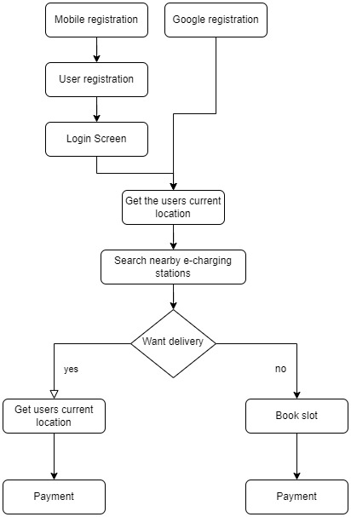
Fig 2. Flowchart

The UI of the application is designed to be user-friendly, allowing any user to navigate the platform easily. The first step a user should take when using the application is to create an account on the platform. The application might request some personal information from the users, which they have to fill in. After creating an account, the user must log in to their specific account, after which they will be redirected to the home page containing a map neighbouring the user’s location. This map will also display the charging stations present in that area. Importantly, the user needs to grant location access to the application so it can track the user’s location. The user then has to select the preferred station, after which information related to the station is shown to the user, and based on this information, they can book a slot. Additionally, in case of emergencies such as depleted charging, the user can also choose amenities like emergency battery delivery and battery exchange. However, for this feature to be provided, the application needs to collect the last known location of the user. Finally, after availing the service, the user can pay the charges directly from the application. The payment confirmation will then be sent to the EV charging station worker.

Implementation
A The discussed application utilizes various tools and technologies such as the Flutter programming language, Firebase as the database, Google Maps for the map interface, and Razorpay for payment processing. Android Studio serves as the Integrated Development Environment (IDE) for building Android applications. The Flutter programming language used in the application is coded on Android Studio due to its features like the Android emulator. The Android emulator is employed to test the implementation's progress as it demonstrates how the application will appear on different types of mobile devices. Firebase offers numerous services that assist users in building and scaling applications easily. It is a service platform provided by Google. In this application, Firebase is utilized to provide a database for storing details regarding the station and nearby areas.

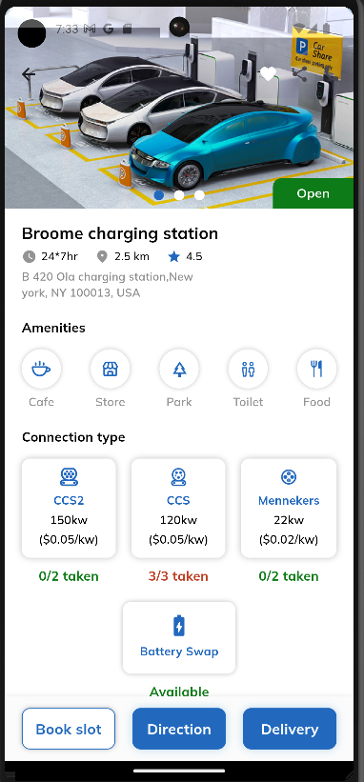
Fig 3. Station details

The aforementioned tools and technologies contribute to building a comprehensive and feature-rich application. By using Flutter and Google Maps, the UI of the application is elegant and easy to understand and use. Briefly describing the account creation process – it requires information such as name, phone number, and email address. After creating and logging into the account, the user is directed to the home page containing a large map locating the user and nearby stations. Upon selecting the preferred station, the user can view details such as information regarding the station and its picture, nearby entertainment areas like cafes, restaurants, etc.
The most crucial feature of the application is the map, which aids drivers in locating the charging station. As mentioned earlier, Google Maps API is utilized to provide the interface for the application's map. The reason for using Google Maps API is that it offers a comprehensive interface, making it easy for users to navigate the application, and it is also straightforward to implement as a developer. Razorpay provides a payment gateway for the application, serving as a payment solution for businesses. It offers amenities such as payment processing, payment gateway integration, subscription billing, and digital wallet solutions. The application includes both Razorpay gateway and payment through credit/debit cards. The inclusion of Razorpay in the application is mainly because not all users may carry credit/debit cards, and it provides faster and more secure payment processing.

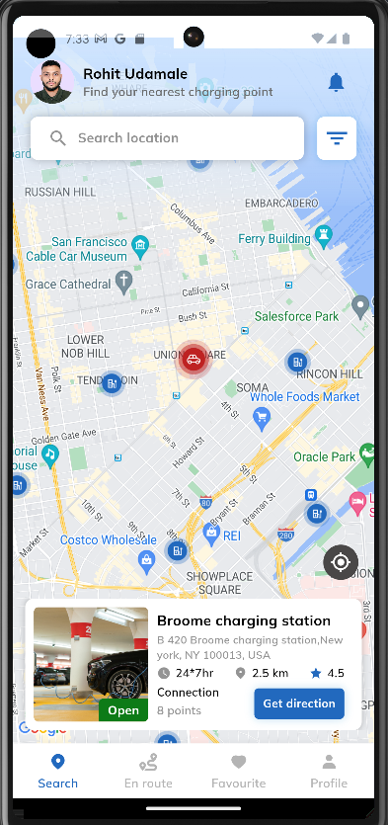
Fig 4. Map interface of the application

Furthermore, the availability of charging cables is displayed, with each cable type differentiated. Additionally, the availability of features such as battery delivery and swapping is indicated, and the option to show directions to the station is provided. This page also facilitates slot booking, and users can provide ratings and reviews based on their experience at the station.
The application caters to drivers of various types of vehicles, including Motorcycles, Light Motor Vehicles (LMVs), and Heavy Motor Vehicles (HMVs). The battery capacity of electric motorcycles ranges from 3 kWh to 20 kWh, with a charging time of 30 minutes for fast charging and several hours for standard charging. For LMVs, the battery capacity ranges from 20 kWh to 100 kWh, and the charging time depends on the level of charging. Level 1 charging takes about 8 to 20 hours, Level 2 charging requires 4 to 12 hours, and Level 3 (DC fast charging) can charge the vehicle in approximately half an hour to an hour.
Regarding HMVs, the battery capacity ranges from 100 kWh to 1000 kWh, and charging follows a similar level-based system as LMVs. However, Level 1 charging is not applicable due to its extended duration, which may take several days to fully charge a vehicle. Additionally, for battery swapping and delivery services, charging stations must provide these features for users to access them. Primarily, the last known location of the vehicle is utilized if the station worker is unable to determine the live location. After availing the services, users must pay the charges and can provide their feedback on the charging station.

Futurescope
The future changes or additions in this application will depend solely on how the infrastructure of electric charging stations develops. However, one thing certain for the future is that the number of electric vehicles and their charging stations will increase, making applications like this much needed. Additionally, due to advancements in technological fields such as artificial intelligence and data science, it will become easier to understand various unseen patterns related to this field. Specifically for our application, we plan to implement the addition of a vendor-side interface. This will allow station owners and workers to add their information and connect directly with users through the application. Moreover, we aim to introduce the delivery of different types of batteries, such as those for home appliances. The use of this application is expected to flourish, as similar integrated platforms have not yet been developed. As the number of electric vehicle users continues to increase, and considering that this trend has only just begun, there is great potential for growth and adoption of such applications.

Conclusion
In conclusion, the application provides main features such as locating an EV charging station, booking a slot at the station, and completing the payment. Other secondary features include locating nearby entertainment areas, battery swapping, and battery delivery. Our application offers an integrated platform, encompassing the fundamental requirements of such applications as well as introducing some new features that have the potential to reshape the charging infrastructure. The application is user-friendly, time-saving, and built on reliable data. Moreover, it will facilitate smooth and efficient progress in the charging of users' vehicles. Importantly, it will contribute significantly to the growth of the EV industry by providing a platform for it to thrive.

Acknowledgment
First and foremost, we extend our sincere gratitude to all those who have contributed to this research project. Your dedication, insights, and collaboration have been instrumental in shaping our work. We would like to express our heartfelt appreciation to Prof. Sagar Yeshwantrao for his invaluable support and guidance throughout the project. Furthermore, we would like to acknowledge our Head of Department, Prof. Rohini Bhosale, and the entire Computer Engineering department for their unwavering support, providing ideas, opportunities, and resources that made this research possible.
We are also deeply grateful to our peers and mentors for their contributions of various ideas, feedback, and insights throughout the research and project, which have been invaluable in helping us to successfully complete this endeavor.

References

- Monika Sharma , Department of Computer Science, Banasthali Univer sity Jaipur,India (June 2015). Location tracking using Google Geoloca tion API IJSTE Volume 1, Issue 11 . J. Clerk Maxwell, A Treatise on Electricity and Magnetism, 3rd ed., vol. 2. Oxford: Clarendon, 1892, pp.68–73.
- Efthymiou, D., Chrysostomou, K., Morfoulaki, M., Aifantopoulou, G. (2017). Electric vehicles charging infrastructure location: a ge netic algorithm approach. European Transport Research Review, 9(2). doi:10.1007/s12544-017-0239-7
- Sumit S. Muddalkar , Nishant S. Chaturkar , Khushal D. Ingole , Shreyash B. Wadaskar , Rahul B. Lanjewar. April 2022. Electric Vehicle Charging Station Finding App, IJARSCT Volume 2, Issue 2, DOI: 10.48175/IJARSCT-3359
- GPS-Based Mobile Cross Platform Cargo Tracking System with Web Based Application. A M Qadir, P.Cooper.
- J. C. Ferreira, V. Monteiro, J. L. Afonso and A. Silva, ”Smart electric vehicle charging system,” 2011 IEEE Intelligent Vehicles Symposium (IV), 2011, pp. 758-763, doi: 10.1109/IVS.2011.5940579.
- R. George, S. Vaidyanathan and K. Deepa, ”Ev Charging Station Locator With Slot Booking System,” 2019 2nd International Conference on Power and Embedded Drive Control (ICPEDC), 2019, pp. 342-348, doi: 10.1109/ICPEDC47771.2019.9036610.
- Joshi, Aashish Somaiya, K Hariram, Arni Hussain, Mubashir. (2021). Electric Vehicle Charging Station. International Journal of Scien tific Research in Science, Engineering and Technology. 122-128. 10.32628/IJSRSET218429.
- Ferreira, Joao Monteiro, Vitor Afonso, J.L. Silva, Antonio. (2011). Smart ˜ electric vehicle charging system. 758 - 763. 10.1109/IVS.2011.5940579.
- Zhang, Yuxi Qiu, Zheyong Gao, Pengbing Jiang, Shihao. (2018). Lo cation model of electric vehicle charging stations. Journal of Physics: Conference Series. 1053. 012058. 10.1088/1742-6596/1053/1/012058.
- Bayram, I. Safak Bayhan, Sertac. (2020). Location Analysis of Electric Vehicle Charging Stations for Maximum Capacity and Coverage. 409- 414. 10.1109/CPE-POWERENG48600.2020.9161639.
- Akhil Raj Kizhakkan, Dr. Akshay Kumar Rathore, Dr. Anjali Awasthi “Review of Electric Vehicle Charging Station Location Planning.” 2019 IEEE Transportation Electrification Conference (ITEC-India) 2020 IEEE 10.1109/ITEC-India 48457.2019.ITECINDIA 2019-226.
- Stefan Meisenbacher, Karl Schwenk, Johannes Galenzowski, Simon Waczowicz, Ralf Mikut, Veit Hagenmeyer “Stefan Meisenbacher, Karl Schwenk, Johannes Galenzowski, Simon Waczowicz, Ralf Mikut, Veit Hagenmeyer.” 2021 9th International Conference on Smart Grid and Clean Energy Technologies (ICSGCE) | 2021 IEEE | DOI: 10.1109/ICSGCE52779.2021.9621604.
- Muhammad Shahid Mastoi a, Shenxian Zhuang a, Hafiz Mudassir Munir b, Malik Haris c, Mannan Hassana, Muhammad Usman a, Syed Sabir Hussain Bukhari b, Jong-Suk Ro “An in-depth analysis of electric vehicle charging station infrastructure, policy implications, and future trends 2022”.
- Swati Jadhav, Sidhesh Marne, Soham Phadke, Tilak Solunke, Tanmayee Suryawanshi ”EV Sahayak: Android Assistance App for Electric Vehicle.” 2023 International Conference on Signal Processing, Computation, Electronics, Power and Telecommunication (IConSCEPT) | 2023 IEEE | DOI: 10.1109/IConSCEPT57958.2023.10170158.
- Sumit S. Muddalkar , Nishant S. Chaturkar , Khushal D. Ingole ,Shreyash B. Wadaskar , Rahul B. Lanjewar “Electric Vehicle Charging Station Finding App” 023 IEEE 8th International Conference for Convergence in Technology (I2CT) | 2023 IEEE | DOI: 10.1109/I2CT57861.2023.10126148.
- Syarifah Muthia Putri. Mochamad Ashari, Endroyono, Heri Suryoatmojo “EV Charging Scheduling with Genetic Algorithm as Intermittent PV Mitigation in Centralized Residential Charging Stations.” 2023 International Seminar on Intelligent Technology and Its Applications (ISITIA) | 2023 IEEE | DOI: 10.1109/ISITIA59021.2023.10221086.

