**“Design of Multipurpose Indexer: A multi role job handling device”**

**Mr. H. N. Ranadive1, Mr. V. S. Patil2, Mr. A. R. Sawant3, Mr. T. B. chole4, Prof. K. J. Burle5**

***1, 2,3,4 Engineering students, 5 Project Guide***

*Department of Mechanical Engineering, Annasaheb Dange College of Engineering & Technology, Ashta, Maharashtra, India*

---------------------------------------------------------------------***---------------------------------------------------------------------

**Abstract –**This research describes a multi-purpose indexer design that enables precise positioning and indexing of workpieces for machining operations on both horizontal and vertical axes. The design leverages the versatility of multi-purpose indexers to accommodate various workpiece sizes, shapes, and weights, eliminating the need for dedicated machines for each orientation. This translates to space and cost savings in manufacturing environments. The indexer can be integrated into automated production lines or used as a standalone unit, providing flexibility in production setups. By automating workpiece positioning and indexing, the design minimizes human error, improves machining precision. This automation also enhances workflow efficiency by reducing setup times and increasing overall productivity. Safety is also prioritized with reduced manual handling risks. The multi-purpose indexer design contributes to improved product quality, reduced production costs, and a competitive advantage in modern manufacturing.

Key Words: Indexer, Machining Process, Indexing system.

**1.INTRODUCTION**

Modern manufacturing demands both precision and efficiency. In order to address this difficulty, this research introduces a unique multi-purpose indexer design that can accurately position and index workpieces on both the horizontal and vertical axes. This design accommodates a broad range of workpiece sizes, shapes, and weights, building on the inherent adaptability of multi-purpose indexers and removing the need for separate machines for each orientation. This results in better use of available space and less money spent. The unparalleled flexibility of the modular design is offered. Multi-axis movement makes complex tasks easier to perform, while automation reduces human error and improves machining precision. This results in more efficient processes with shorter setup times and higher output all around. Ultimately, this multi-purpose indexer design promises improved product quality, reduced production costs, and a sustainable competitive edge in today's dynamic manufacturing landscape

**2. LITERATURE REVIEW**

***Zheng (2018)*** proposed a reconfigurable indexing spindle for multi-tasking machines. This spindle allows quick tool and workpiece changes, boosting efficiency and reducing setup times. Successful tests validate its performance, making it a promising solution for enhanced productivity and versatility in industrial settings [1].

***Kumar, P. (2017)***designed and built an indexing head, detailing materials and engineering principles. They highlighted its ability for milling, drilling, and grinding. Validation tests confirmed accuracy, repeatability, and efficiency, making it a valuable asset for multi-purpose machines and boosting manufacturing capabilities across industries [2].

***Park, S. J (2016)***described an indexing system design for multi-tasking machines. The focus was on the design approach and engineering principles used to create a versatile and adaptable system that can handle various tools and workpieces. Testing confirmed accuracy, repeatability, and stability during machining. The research suggests potential cost savings and productivity gains through this indexing system, contributing valuable knowledge to precision engineering and manufacturing[3].

***Ghoreishi, M (2015)***studied details the design process and engineering considerations for a reconfigurable indexing fixture. The focus is on its adaptability to diverse workpiece shapes and sizes, highlighting its potential for various machining applications. Experimental validation confirms the fixture's accuracy and repeatability. The research suggests benefits like increased efficiency, reduced production time, and improved overall productivity in manufacturing when implemented in multi-purpose machines[4].

***Lu and Chang (2014)*** described the design and build of a multi-function indexing head for CNC machines. They detail the mechanisms enabling various machining operations. Successful experiments confirm accuracy and repeatability. The research highlights the benefits of this versatile tool for CNC machining, including increased productivity and cost-efficiency. This contributes valuable knowledge to mechanical engineering and manufacturing technology [5].

***Xu and Chen (2021)*** investigated the use of finite element analysis (FEA) to optimize the structural design of a multi-axis indexing mechanism. They analyzed stress distribution to identify and mitigate potential weak points that could lead to failure during precision machining. This research likely aimed to improve the indexer's stiffness, durability, and overall performance, contributing to more reliable and efficient machining processes[6].

***Fangyan Zheng et al.(2016)*** explored the synthesis of indexing mechanisms using non-circular gears for precise motion control. Various design techniques were discussed, underscoring their potential applications across engineering disciplines. The study highlighted benefits like reduced backlash and enhanced accuracy, advocating for non-circular gears' integration into advanced indexing systems[7].

***Giorgio Figliolini et al. (2006)*** introduced the pure-rolling cam-equivalent of the Geneva mechanism as a novel alternative to oscillating cams. Their proposed synthesis method employs pure-rolling cams, aiming for reduced friction and improved mechanical efficiency. The study's insights offer potential advancements in motion control and automation systems, promising enhanced performance and decreased wear[8].

***Liu (2020)*** analyzed materials for indexer components, focusing on rotary tables and spindles, aiming to improve stiffness and mitigate thermal deformation during machining. Through material investigation, they sought enhanced mechanical properties, reduced thermal expansion, and improved dimensional stability, likely providing valuable insights for optimizing indexer component design in precision machining operations[9].

***Lee and Kim (2019)*** introduced a hybrid indexer incorporating rotational and linear motions, enabling five-axis machining. This enhanced flexibility facilitated intricate operations on complex workpieces, improving surface finish and reducing setup times. The research highlighted the hybrid indexer's potential for advanced machining applications, promising increased efficiency and precision across industries [10].

**3. Problem Statement**

This research aims to address this limitation by developing a multi-purpose indexer that precisely positions and indexes workpieces on both axes. This design will accommodate various workpiece characteristics, eliminating the need for multiple machines. The key challenge lies in creating a cost-effective and modular design that ensures precision, repeatability, and efficient automation for diverse machining applications. This innovative indexer promises to improve product quality, reduce production costs, and enhance overall manufacturing competitiveness.

**4. Design and Calculation**

4.1 Power Calculation

To calculate the mass moment of inertia

* + 1. **Roller**

Assume,

m = 300 gm = 0.3 kg

l = 480 mm = 0.48 m

r = 29 mm = 0.29 m

∴ Ix = m × (3r2 + h2)

∴ Ix =× (3 × 0.292 + 0.482)

**Ix =0.01206 kg/m2** ……..(for 1 roller)

**Ix =0.08447 kg/m2** ……..(for 7 roller)

**Ix =0.1689 kg/m2** ……..(for total roller)

Centre shifting –

Iroller= Icen + A × d2

Iroller= 0.168 + [0.0368 × 0.242]

**Iroller= 0.17103 m4**

* + 1. **Rod**

Assume,

m = 200 gm = 0.2 kg

l = 775 mm = 0.775 m Ix = × ml2

Ix = × 0.2 × 0.7752

**Ix =0.01001 kg.m2** ……(for 1 rod)

**Ix =0.03003 kg.m2** …….(for 1 rod)

Centre sifting –

Irod= Icen + A × d2

Irod= 0.03003 + (0.9424 × 0.3752)

**Irod= 0.1625 m4**

* + 1. **Resting Pad**

Consider as L-Section

For rectangle 1:

A1 = 5 × 20 = 100 mm2

X1 = = 2.5 mm

Y1 = = 10 mm

For rectangle 2:

A2 = 15 × 5 = 75 mm2

X2 = = 7.5 mm

Y2 = = 2.5 mm

=

=

**= 4.64 mm**

Ixx = Ixx1 + Ixx2

Ixx1 = AG1 + Ah2

Ixx1 =

∴ Ixx1 = + (5 20) (10 – 6.78)2

∴ **Ixx1 = 4370.17 mm4**

Now for 2nd rectangle

Ixx2 = AG2 + Ah2

Ixx2 =

∴ Ixx2 = + (18 2.5) (6.78 – 2.5)2

∴ **Ixx2 = 847.76 mm4**

Now total moment inertia in X-direction,

Ixx = 4370.17 + 847.76

**Ixx= 5217.9355 mm4**

Now Centre sifting –

A = A1 + A2

A = 100 + 75

A = 175 m2

Ipad= Icen + A × d2

∴Ipad= 5.2179 + (0.175 + 0.3752)

∴**Ipad= 5.2425 m4**

* + 1. **Job**

Consider as a rectangle section,

For X-direction,

Ixx =

∴Ixx=

∴**Ixx = 2293.338*106 mm4**

For Y-direction

Iyy =

∴Iyy =

∴**Iyy = 6.1633*106 mm4**

NowCentre sifting,

A = 400 $x$ 430

∴ A = 172000 mm2

∴ A = 172 m2

∴Ijob= Icen + A × d2

∴Ijob= [ (2.2933 106 ) + (172 2152 ) ]

∴**Ijob= 10.244 *106  m4**

**Now Total Moment of Inertia,**

I = Iroller + Irod +Ipad + Ijob

**∴**I = 0.17103 + 0.1625 + 5.2425 + ( 10.244 106 )

∴**I = 10.2440 106 m4**

Now,

Torque (T) = I × α

Assume,

N = 0.25 rev/min

t = 5 sec

$ω_{1}$ = 0

$$α=\frac{ω_{2}-ω_{1}}{t}$$

$ω_{2}=\frac{2πN}{60}$ = 0.02 rad/sec

α =

**α = 4 × 10-3 rad/sec2**

∴ T = (10.2440×106) × (4 × 10-3)

∴**T = 40976.0223 Nm**

Now Power,

KW = $\frac{2πM_{t}N}{60000}$

∴ KW = $\frac{2π ×40976.0223 ×0.25 }{60000}$

∴**Power = 1.07 KW**

Therefore, Based on power calculation we select the **1 HP** motor.

**4.2 COMPONENTS OF INDEXER**

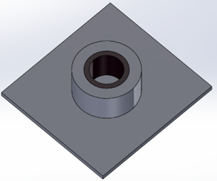**4.2.1. Base of Indexer**

Fig.4.2.1 Base of Indexer

In order to achieve our objective of creating an indexer capable of handling any workpiece or job, a crucial feature we have integrated is the ability for the indexer to rotate about the vertical axis. To accomplish this, a specialized bearing arrangement has been meticulously attached to the base plate of the indexer. This innovative design enhancement ensures seamless rotation around the vertical axis, thereby significantly expanding the indexer's operational capabilities. By incorporating this pivotal feature, we have effectively elevated the versatility and adaptability of the indexer, empowering it to efficiently accommodate diverse workpieces and perform a wide array of machining tasks with precision and ease. The integration of the bearing arrangement onto the base plate not only facilitates smooth rotation but also enhances the stability and reliability of the entire system during operation. This strategic design choice underscores our commitment to delivering a robust and versatile solution that meets the evolving needs of modern manufacturing processes.

**4.2.2 Drive System of indexer**

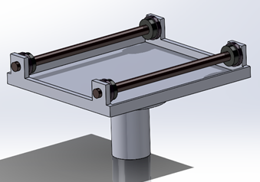

Fig.4.2.2. Drive System of indexer

The indexer's drive system starts with a carefully chosen electric motor that delivers the perfect amount of torque and speed for the job. A sturdy steel center shaft, precisely machined for smooth rotation, connects to the motor. High-quality bearings support the shaft on both ends, while meticulously crafted rollers mounted at each end provide contact points for the crankcase cylinder. A coupling ensures smooth power transfer between the motor and shaft, and a control system allows for precise adjustments to speed, direction, and indexing. Safety features like position sensors, overload protection, and emergency stops are crucial to protect both the machine and operator. The control system enables precise adjustments to rotational speed, direction, and indexing increments based on specific requirements. Safety features, including position sensors, overload protection, and emergency stop mechanisms, are integrated to preserve machinery and ensure operator safety. Regular maintenance, including inspections, proper lubrication, and monitoring wear indicators, is essential for optimal performance and longevity of the drive system.

**4.2.3. Indexer Body**

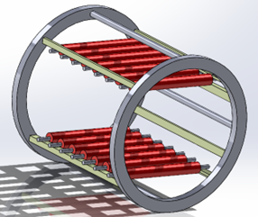

Fig.4.2.3. Indexer Body

The indexer body of our specialized indexer machine, which is in charge of rotating job or workpiece. The indexer body is the primary structural support for the whole system, and it was made with durability and accuracy in mind. Its main job is to hold the job or workpiece firmly in place and make sure it rotates smoothly. With painstaking attention to detail, the body is constructed with a series of perfectly crafted rollers that operate as contact points for the job or workpiece. The indexer body's adaptability to various workpiece or job sizes and configurations allows for a wide range of application possibilities. Its design takes into account the particular needs of the indexing operation, and the placement of the rollers maximizes the workpiece or job's stability and balance while it rotates. Additionally, the body has characteristics that make it simple to load and unload workpiece or jobs. All things considered, the indexer body is the fundamental component of our indexer machine, guaranteeing accurate, steady, and effective manipulation of workpiece or jobs.

**5. CAD Model Design**

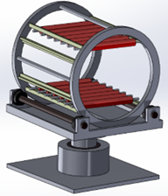

Fig.5.1. CAD Model

The CAD model showcases a complete indexer assembly designed for precise positioning and work piece rotation on both horizontal and vertical axes. The foundation is a sturdy base plate that likely incorporates a mechanism for vertical rotation. This mechanism is not entirely visible in the image.

Mounted on the base plate is the drive system, which appears to consist of rigid rails supported by bearings. These rails facilitate the horizontal rotation of the indexer body. The body itself sits on top of the rails and contains a central platform with rollers. These rollers allow for smooth insertion and positioning of the workpiece. Overall, this design offers a versatile solution for Indexing workpieces during machining operations. The combination of vertical and horizontal rotation capabilities along with the roller-equipped platform streamlines workpiece handling and orientation changes.

**6. Analysis of Indexer**

The analysis of the indexer involved evaluating various parameters such as stress, strain, and total deformation under different conditions including variations in size, shape, and weight of the workpiece. The results of this analysis were thoroughly discussed to understand the performance of the indexer across different scenarios. The stress analysis focused on identifying areas of high stress concentration within the indexer components, ensuring that they can withstand the mechanical loads exerted during operation. Similarly, strain analysis helped assess the material's deformation under applied loads, providing insights into potential areas of weakness or fatigue. Moreover, total deformation analysis allowed for understanding how the indexer components responded to external forces, including the effects of weight distribution and dynamic loading. By analysing these parameters across different workpiece characteristics, the study aimed to optimize the indexer's design for enhanced performance and durability in diverse machining applications.

**6.1. Considering the weight of job as 190 kg**

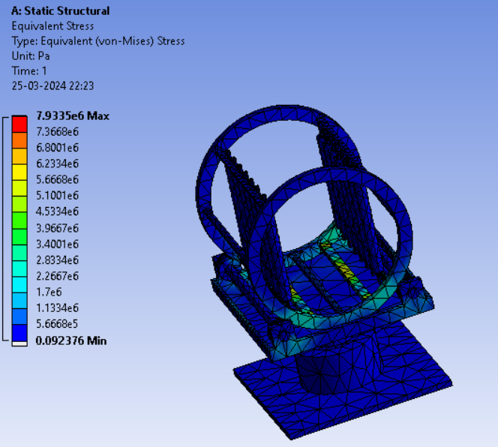**6.1.1. The Equivalent Stress**

Fig.6.1.1. Stress Analysis of Indexer

**6.1.2. The Equivalent Elastic Strain**

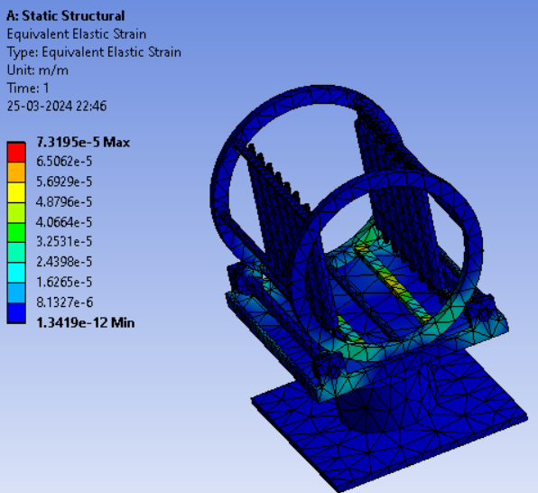

Fig.6.1.2. Elastic Strain Analysis of Indexer

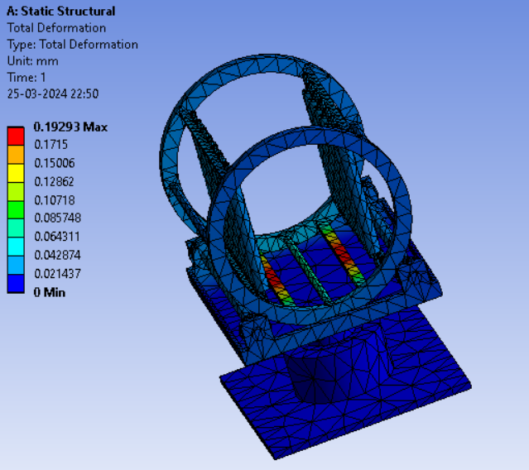**6.1.3. The Total Deformation**

Fig.6.1.3. Total Deformation of Indexer

**6.2. Considering the weight of job as 150 kg**

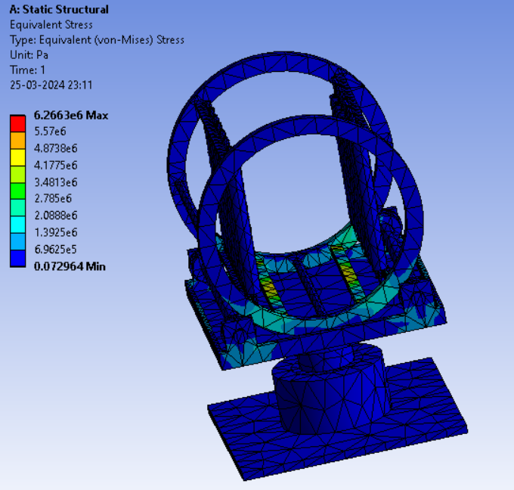**6.2.1. The Equivalent Stress**

Fig.6.2.1 Stress Analysis of Indexer

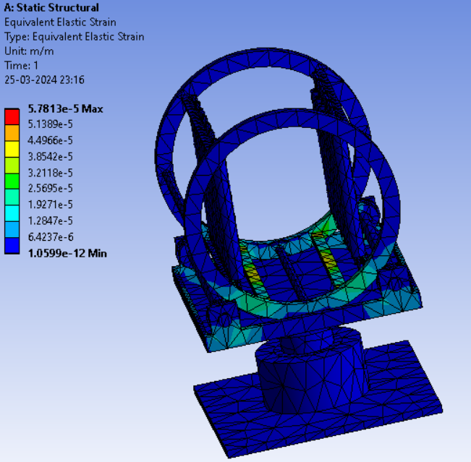**6.2.2. The Equivalent Elastic Strain**

Fig.6.2.2 Elastic Strain Analysis of Indexer

**6.2.3. The Total Deformation**

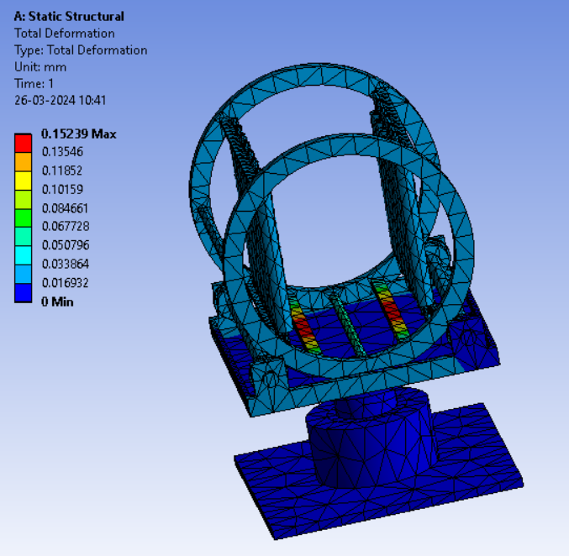

Fig.6.2.3. Total Deformation of Indexer

**6.3. Considering the weight of job as 225 kg**

**6.3.1. The Equivalent Stress**

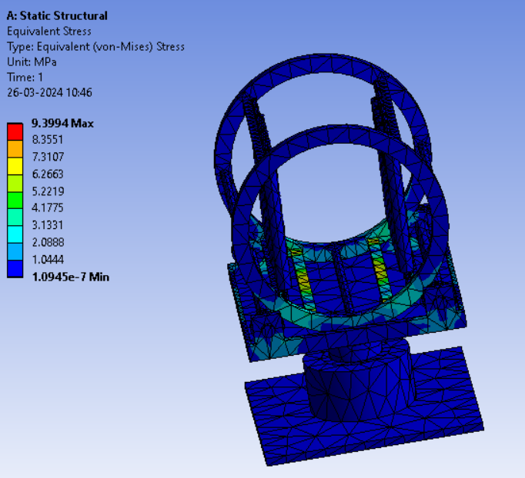

Fig.6.3.1 Stress Analysis of Indexer

**6.3.2. The Equivalent Elastic Strain**

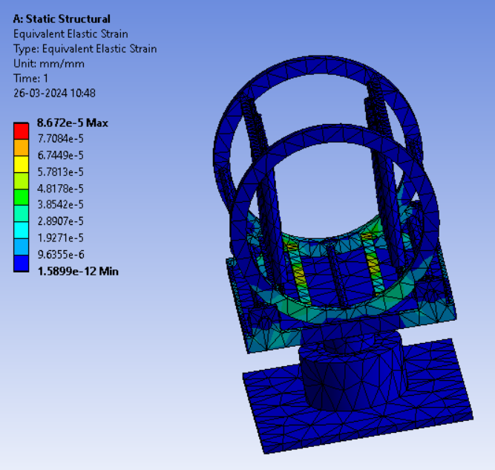

Fig.6.3.2 Elastic Strain Analysis of Indexer

**6.3.3. The Total Deformation**

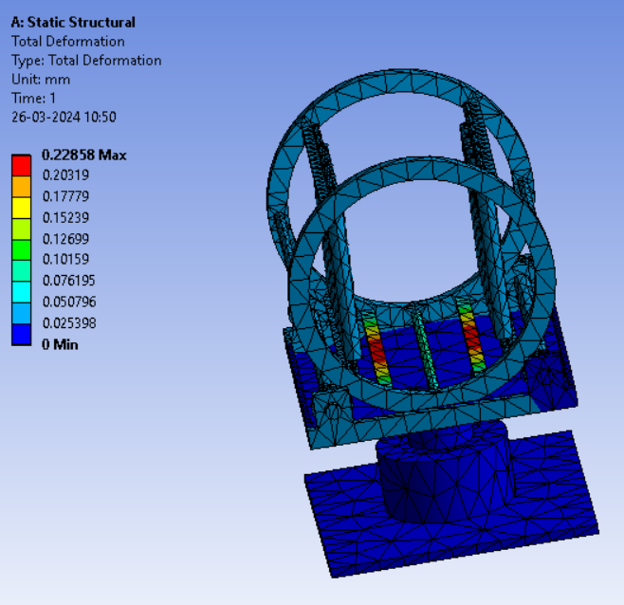

Fig.6.3.3. Total Deformation of Indexer

**7. Results and Discission**

|  |  |  |  |  |
| --- | --- | --- | --- | --- |
| **Sr.**  **NO.** | **Applied Load (Kg)** | **Equivalent Stress (MPa)** | **Equivalent Elastic Strain** | **Total Deformation (mm)** |
| 1. | 190 | 7.9335e6 | 7.3195e-5 | 0.19293 |
| 2. | 150 | 6.2663e6 | 5.7813e-5 | 0.15239 |
| 3. | 225 | 9.3994 | 8.672e-5 | 0.22858 |

Table 7.1 – Result

The above table show result and discission of Design Modification of Indexer in these four columns like Applied load, Equivalent Elastic Strain and Total Deformation. The analysis of the indexer under various conditions yielded insightful results regarding stress distribution, elastic strain, and total deformation, providing valuable insights into its performance and structural integrity across different workpiece weights. In addition, the analysis was limited to stress, strain, and deformation, which allowed for a thorough comprehension of the indexer's response to various loads. The study identified areas of concern and possible improvement by examining these metrics for three distinct load scenarios (190 kg, 150 kg, and 225 kg). These analyses showed changes in stress levels, strain magnitudes, and deformation patterns. The results aid in improving the indexer's design for improved dependability and performance during machining operations.

**8. Conclusion**

This research successfully developed a multi-purpose indexer design capable of precise positioning and indexing workpieces on both horizontal and vertical axes. This versatility eliminates the need for dedicated machines for different workpiece orientations, promoting space and cost savings in production environments. The design prioritizes modularity and automation, allowing for integration into automated lines or standalone use. Automation minimizes human error and improves machining precision, while reducing setup times and boosting overall productivity.

Finite element analysis (FEA) evaluated the indexer's performance under varying loads considering different workpiece weights (190 kg, 150 kg, and 225 kg). The analysis focused on stress distribution, elastic strain, and total deformation to assess the indexer's structural integrity and identify potential areas for improvement.

This research demonstrates the potential of the multi-purpose indexer design to contribute to improved product quality, reduced production costs, and a competitive edge in modern manufacturing. Future work may involve incorporating the FEA results into design optimization for enhanced performance and durability under diverse machining applications.

**9. REFERENCES**

1. Zheng, H., Dornfeld, D., &Lee, P., “A review on the design and development and of a reconfigurable indexing spindle for multi-task machine tool applications”, The International Journal of Advanced Manufacturing Technology, 2018.
2. Kumar, P., Patel, A., Sharma, N., & Suthar, P., “Indexing head for multi-purpose machine tool” , LDRP Institute of Technology and Research, 2017
3. Park, S.J., Lee, J., & Shin, S.J., “ Development of a novel indexing system for multi-tasking machine tool”, International Journal of Precision Engineering and Manufacturing, 2016.
4. Ghoreishi M., Ghadimi P., & Rahmani R., “Design and development of a reconfigurable indexing fixture for multi-purpose machine tool.”, Iran University of Science and Technology, 2015.
5. Lu, C.C., & Chang, Y.C., “Multi-function indexing head for CNC machine tools” , Journal of Mechanical Science and Technology, 2014.
6. Xu & Chen, “Structural Design Optimization of Multi-Axis Indexers: A Finite Element Analysis Approach for Enhanced Performance and Reliability in Precision Machining.” International Journal of Mechanical Sciences, 2021.
7. Fangyan Zheng a, Lin Hua a, Xinghui Han a, Bo Li b, Dingfang Chen b. “Synthesis of indexing mechanisms with non-circular gears”, Mechanism and Machine Theory Volume 105, November 2016, Pages 108-128.
8. Giorgio Figliolini a, Pierluigi Rea a, Jorge Angeles b, “The pure-rolling cam-equivalent of the Geneva mechanism”, Mechanism and Machine Theory Volume 41, Issue 11, November 2006, Pages 1320-1335.
9. Liu, "Analysis of Materials for Improved Stiffness and Thermal Stability of Indexer Components in Precision Machining" in 2020.
10. Lee & Kim, "Development of a Hybrid Indexer for Enhanced Machining Capabilities in Five-Axis Operations" , International Journal of Advanced Manufacturing Technology, 2019.