**CRACK DIAGNOSIS IN I SECTION BY USING VIBRATION TECHNIQUE**

**Mr. Awari Amol1, Prof. B. M. Randhavan2**

1Student, M.E., Mechanical Engineering, SVCOET, Junnar, Pune, Maharashtra, India

2Professor, Mechanical Engineering, SVCOET, Junnar, Pune, Maharashtra, India

**ABSTRACT**

This paper explores crack diagnosis in I-section beams using vibration analysis techniques. Structural health monitoring is crucial for ensuring the integrity and safety of engineering structures. Vibration-based methods have emerged as effective tools for detecting and characterizing defects like cracks. The study focuses on the development of a reliable diagnostic approach specifically tailored for I-section beams. Experimental modal analysis is employed to extract modal parameters, and changes in these parameters due to crack presence are analyzed. Various crack scenarios are simulated, and the effectiveness of vibration-based crack detection is evaluated. The results demonstrate the potential of vibration techniques in accurately identifying and assessing cracks in I-section beams, thereby contributing to enhanced structural health monitoring practices. The findings underscore the importance of proactive maintenance strategies based on advanced diagnostic tools for ensuring the longevity and safety of critical infrastructure.

**Keywords:** Finite Element Analysis, Natural frequency, FFT Analyzer, Experimental Analysis.

1. **INTRODUCTION**

All things are vibrating. Consider different instruments of music, riding on various vehicles, we feel the vibration when train passes away nearby us. Almost always, nonetheless, vibration is undesirable and in general unavoidable. It will motive continuously weakening of structures as well as the deterioration of metals in that machine. Vibration is mainly concerned with the frequencies. Vibration involves perpetual kineticism. Each occurrence of a consummate kineticism sequence is called a cycle. Frequency is defined as number of cycles in a given duration. One cycle per second is identically tantamount to one Hertz. The swing of pendulum is a mundane illustration of vibration.

The conception of vibration offers with study of oscillatory forms of kineticism of our bodies and the forces associated with them. A vibration can caused as a result of outside unbalanced drive supplementally. A vibratory method, probably involves, potential energy is stored by elastic member, kinetic energy is stored by mass as well as inertia member and damper by which gradual loss takes place

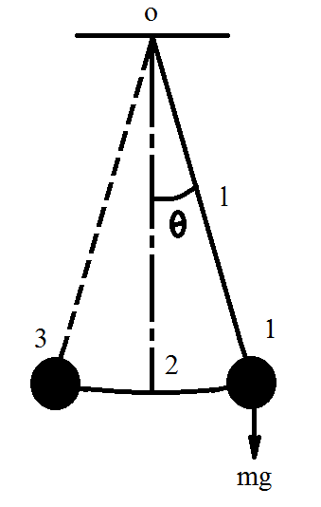

Fig. 1.1Free Vibrations of Simple Pendulum

1. **OBJECTIVES**

• To measure the herbal frequencies of quite a number beam models by using Finite Element Method (FEM). ANSYS workbench 15.0 is used to find herbal frequencies of all beams of unique crack sizes and pass section.• To measure the herbal frequencies of a number of beam models via using Experimentation (FFT analyzer). The FFT Analyzer is used to lift out experimentation on beam fashions for validation of proposed theory.• To evaluate the herbal frequencies of models by way of above two methods. A evaluation is made at the cease of document to locate the errors in the above methodologies.

1. **METHODOLOGY**
2. Experimental calculations for first three natural frequencies of all beam models by using Finite Element Analysis (ANSYS).
3. To experimentally validate the three natural frequencies of cracked and healthy beam, experimental modal analysis will be done using FFT analyzer.
4. With the help of above mentioned two methods the three natural frequencies for cracked & uncracked beam will be compared with each other.
5. Comparison of outputs with theoretical ones.
6. **MATERIAL SELECTION AND DIEMENSIONS**

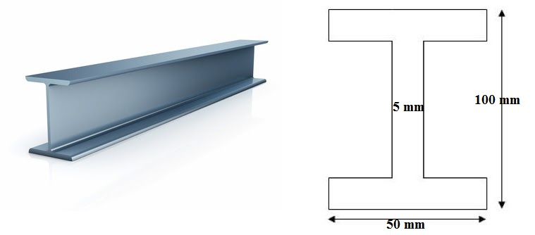

**Fig.4.1 Beam Models & Their Dimensions**

**Table 4.1 Different Beam models and their dimensions**

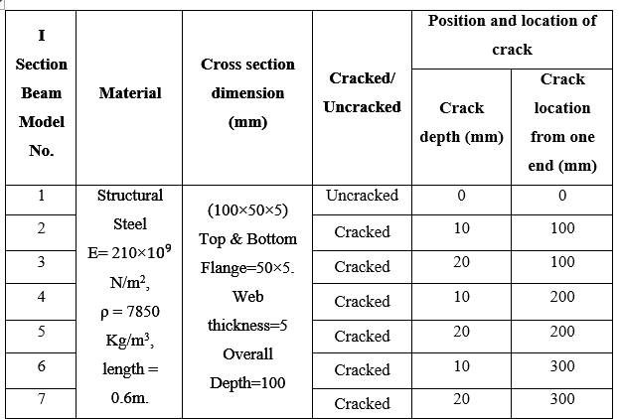

**5. FINITE ELEMENT ANALYSIS**

It is found that cracked beam model has lower frequencies than uncracked beam. After determination of natural frequencies we can easily find out at each frequency how much deformation every part of the beam model. All the data obtained by this method is summarized in following table:

**Table 5.1 Natural frequencies of beam model in Hz by using Finite Element Method**

|  |  |  |  |  |  |
| --- | --- | --- | --- | --- | --- |
| **Beam model no.** | **RCD** | **RCL** | **FNF** | **SNF** | **TNF** |
| 1 | 0 | 0 | 1171.1 | 1686.8 | 1720.5 |
| 2 | 0.1 | 0.167 | 1153.9 | 1549.2 | 1704.4 |
| 3 | 0.2 | 0.167 | 1126.4 | 1385.2 | 1699.6 |
| 4 | 0.1 | 0.333 | 1158.7 | 1665.1 | 1712.7 |
| 5 | 0.2 | 0.333 | 1152.2 | 1604.5 | 1711.9 |
| 6 | 0.1 | 0.50 | 1170.4 | 1664.1 | 1685.7 |
| 7 | 0.2 | 0.50 | 1169.3 | 1656.9 | 1685.6 |

**5.1 Post-processing**

Finite Element Method is a numerical procedure for solving continuum mechanics of problem with accuracy acceptable to engineers.

**5.1.1 Beam models obtained in ANSYS**

For all the beam models, first three natural frequencies are considered. Here we are presenting some sample of the beam model, all beam models in ANSYS are presented under Annexure I for first three natural frequencies with its total deformation.

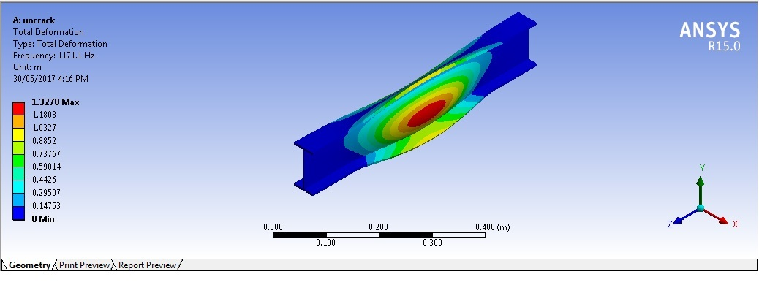

Fig.5.1 First mode of vibration of beam model 1

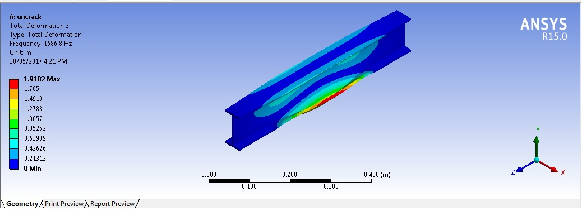

Fig.5.2 Second mode of vibration of beam model 1

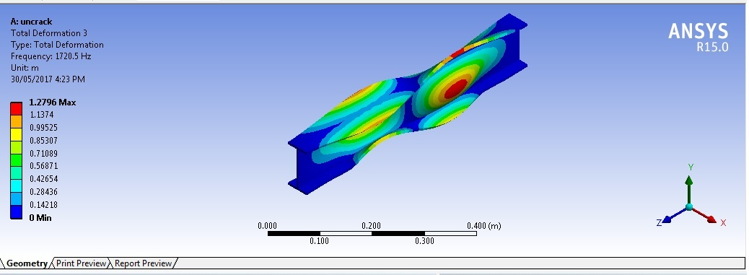

Fig.5.3 Third mode of vibration of beam model 1

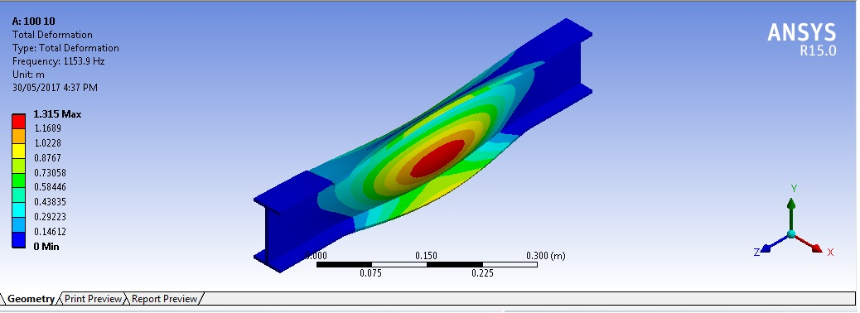

Fig.5.4 first mode of vibration of beam model 2

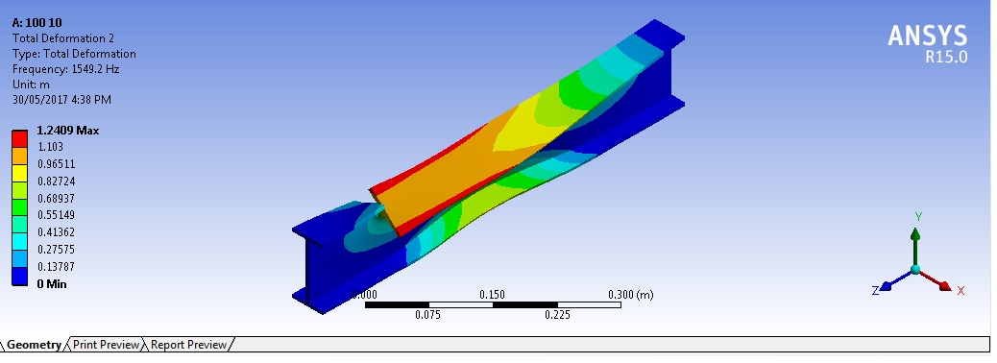

Fig.5.5 Second mode of vibration of beam model 2

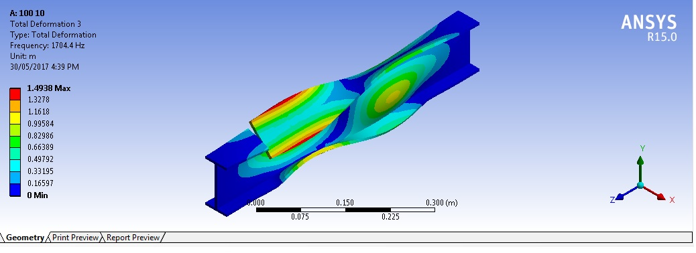

Fig.5.6 Third mode of vibration of beam model 2

1. **EXPERIMENTATION**

This consists of determining the first three transverse natural frequencies of all beam models. Experimental setup mainly consists of following different components:

All the components as explained above are connected neatly having laptop with software which is used for modal analysis.

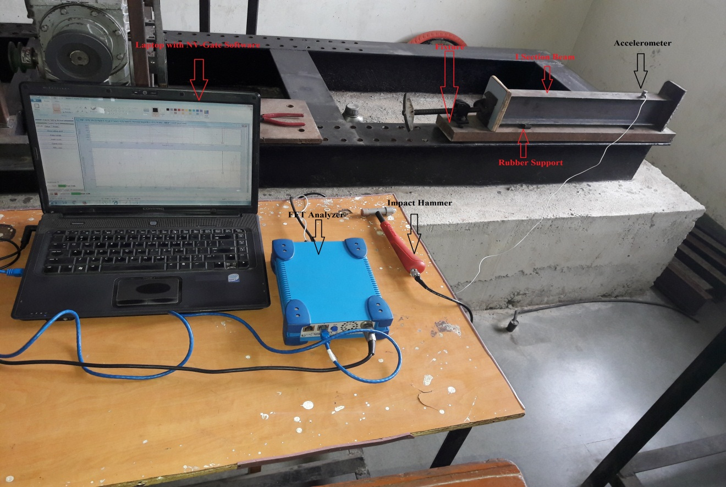

Fig.6.1 Experimental Setup

For all beam, first three natural frequencies are measured by using above same procedure.

Natural frequencies obtained by FFT Analyzer are listed below:

**Table 6.1 Natural frequencies of beam model in Hz by using FFT Analyzer**

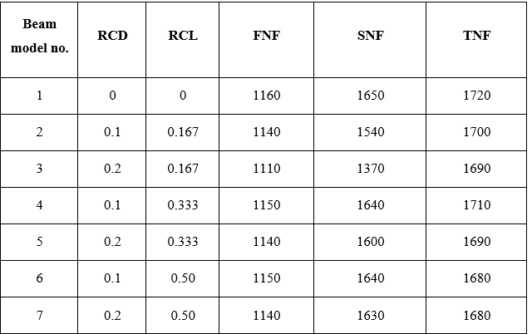

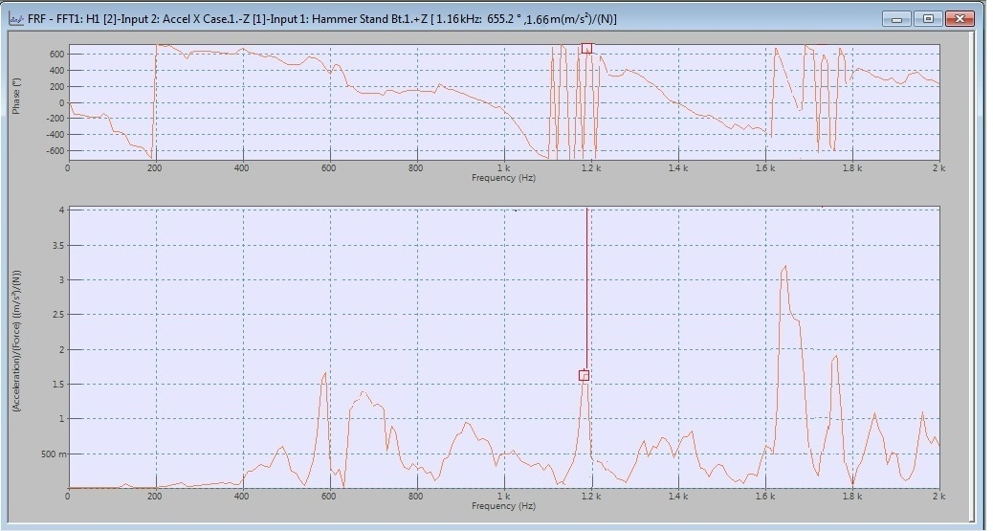

Fig 6.2 First Natural frequency of beam model 1 (Healthy beam)

Above graph is for first natural frequency of healthy i.e.uncracked beam. Graph shows that first natural frequency is 11160 Hertz with phase angle 655.2°.

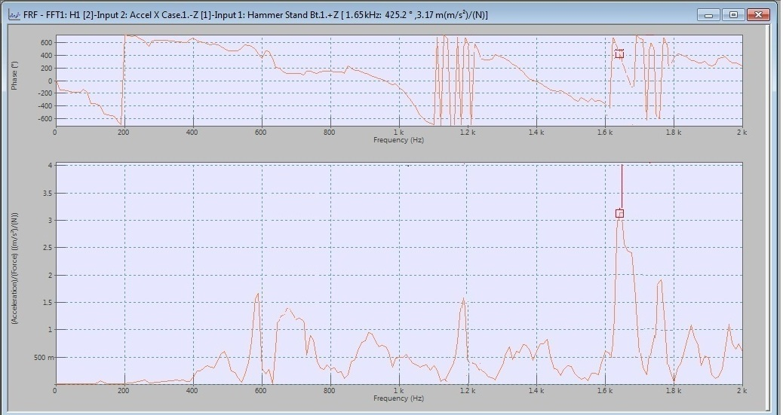

Fig.6.3 Second Natural frequency of beam model 1(Healthy beam)

The above graph is about second natural frequency of Healthy i.e. uncracked beam. Graph shows that second natural frequency is 1650 Hertz with phase angle 425.2°.

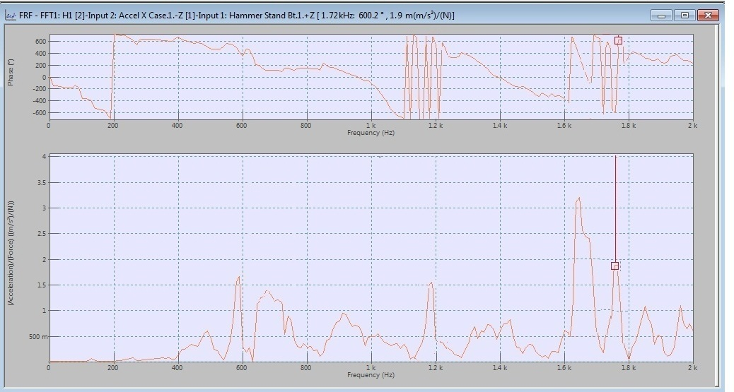

Fig.6.4 Third Natural frequency of beam model 1 (Healthy beam)

The above graph is about third natural frequency of Healthy i.e. uncracked beam. Graph

shows that third natural frequency is 1720 Hertz with phase angle 600.2°.

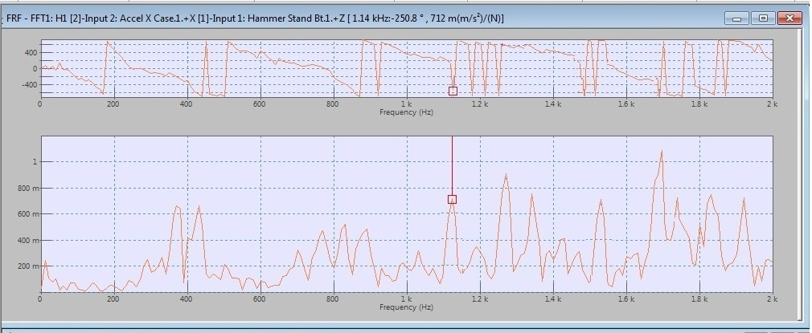

Fig.6.5 First Natural frequency of beam model (Crack length 100mm, Crack Depth 10mm)

The above graph is about first natural frequency of cracked beam. Graph shows that first natural frequency is 1140 Hertz with phase angle 250.8°. This first natural frequency is lower than first natural frequency of healthy beam.

**Table 6.2 Comparison of Natural frequencies in Hertz obtained by finite element method and experimentation**

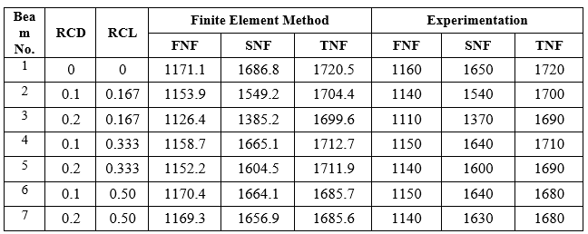

Above table shows that natural frequencies obtained by these three methods are close to each other with acceptable error. Finite element method and experimentation shows the effect of different crack depth and different crack location on the natural frequencies

**Table 6.3 Comparison of Natural frequencies in Hertz with percentage error (% error)**

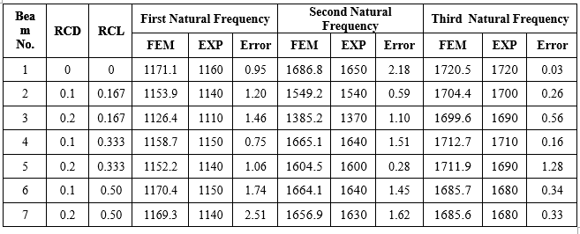

1. **CONCLUSION**

The present work is consists of finite element analysis and experimentation with FFT Analyzer for the frequency measurement. Fuzzy logic is used for the detection of crack with its location and depth. Considering all the investigations, following conclusion are drawn:

1. Natural frequencies calculated by the finite element method and experimentation are close to each other.
2. For the same crack location as the crack depth increases, first three natural frequencies are gradually decreases.
3. For the same crack depth as the crack location shift towards the Center, all natural frequency is gradually increases.
4. The effect of the crack near the fixed end is more than the crack away from the fixed end.
5. Small change in first three natural frequencies represents the existence of the crack.
6. Gaussian membership function for input and trapezoidal membership function for output have a good correlation to find out the exact location and depth of crack.
7. **REFERENCES**
8. Divine M. Ashigbi, Michael N. Sackey, YesuenyeagbeA.K. Fiagbe, Jonathan Quaye-Ballard, November 2021, -Structural health monitoring Beam Fuzzy logic Natural frequency Kurtosis.
9. Runjian Wang1 1Beijing Gongke Solid Bridge Technology Co., Ltd, Beijing, China 2021- Research on Construction Crack Diagnosis and Treatment Technology of Double-Column Large Cantilever Pre-Stressed Bent Cap .
10. Praseed Kumar, Aqleem Siddiqui, Ashay Ghadi*, Denisa Tony, Stephen Rhenius, and Saleel Rane 2021- Damage Detection in beams using Vibration analysis and Artificial Neural Network.
11. M Seguini, [S Khatir](https://scholar.google.com/citations?user=LZ0euWMAAAAJ&hl=en&oi=sra), [D Boutchicha](https://scholar.google.com/citations?user=Q2Y-hUYAAAAJ&hl=en&oi=sra), D Nedjar, [M Abdel Wahab](https://scholar.google.com/citations?user=xoZMzPkAAAAJ&hl=en&oi=sra) -Smart Structures and Systems, 2021 Crack prediction in pipeline using ANN-PSO based on numerical and experimental modal analysis.
12. Mehmet Haskula and Murat Kisab (13 January 2021) - Free vibration of the double tapered cracked beam.
13. Rasheed Majeed Jorani, Maroua Haddar , Fakher Chaari and Mohamed Haddar (20 February 2023)-Gear Crack Detection Based on Vibration Analysis Techniques and Statistical Process Control Charts (SPCC).
14. Mohamad Hazwan Mohd Ghazali and Wan Rahiman (11 September 2021)- Vibration Analysis for Machine Monitoring and Diagnosis: A Systematic Review.