**A History of the Caste System in Ancient, Medieval, and Modern India**

**Beginnings**

**viewpoint**

There are something like two viewpoints on the beginning stages of the railroad station framework in antiquated and middle age India. One view stresses philosophical factors while the other underlines monetary components.

The hidden philosophy centers around the philosophical components that are viewed as the principal hub behind the extremely durable structure and affirms that the season starts in the four varnas. This point of view, pervasive among researchers of the English common period and supported by Dumont, expects that the system was laid out logically hundreds of years sooner and went on as an otherworldly social development. This view depends primarily on references to the genuine and obsolete message of Manusmriti and rejects financial, political or certain proof.

The accompanying viewpoint centers around monetary factors and shows that these factors are the principal drivers of the situating system. This recommends that the reach is well established in India's financial, political and material past. This point of view, broadly divided between researchers of the post-common time frame like Berreman, Marriott, and Dirks, depicts the progressive structure as a consistently changing social develop that should be completely seen by looking at certain proof of legitimate practices and assessing apparent circumstances. inside them it becomes India. Money related, political and material history. This approach zeroed in unequivocally on true proof of old-fashioned and obsolete Indian social orders, the time of Muslim rule from the twelfth to the eighteenth 100 years, and the procedures of English common rule from the eighteenth 100 years to the mid-twentieth 100 years.

The fundamental system zeroed in on the thorough humanities, zeroing in on these and not other valid proof, and thinking of them as fundamental or pivotal to grasping the beginning stages of the positional structure. Then again, the accompanying philosophy zeroed in on humanistic proof and endeavored to catch the credible settings encompassing the job.

structure. Scientists following this perspective have reprimanded the past school for its station starting speculation, fighting that it has dehistoricized and decontextualized Indian culture by excusing greater credible circumstances.

Custom Authority Model

**Vedic *Varnas***

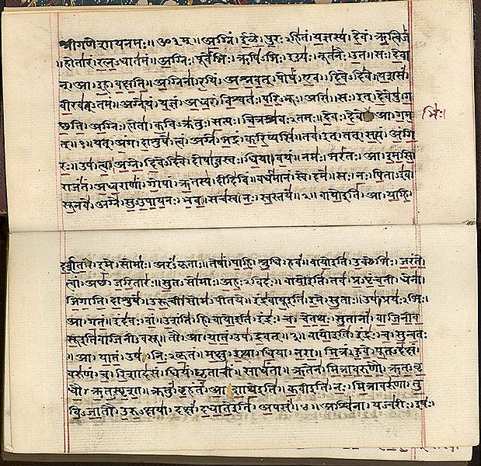

A section from The Vedas (expressly the Contraption Veda) made in Sanskrit around the mid nineteenth century CE.

The varnas follow their beginning stages to Vedic culture, crossing by and large from 1500 to 500 BCE. The underlying three get-togethers — Brahmins, Kshatriyas, and Vaishyas — share similarities with other Indo-European social orders, while the joining of the Shudras is acknowledged to be a Brahmanical creation from northern India.

The varna system finds its reason in cherished Hindu consecrated texts, conceptualized as romanticized human purposes for living. Key texts, for instance, the Purusha Sukta in the Rigveda and Manusmriti's examination on it are generally speaking alluded to in this particular situation. In any case, rather than these printed courses of action, many respected Hindu texts and statutes raise issues and express struggle with this game plan of social request.

The verse from the Purusha Sukta is as of now for the most part acknowledged to have been added to the Rigveda soon, possibly as a basic dream. Educators Stephanie Jamison and Joel Brereton, experts in Sanskrit and Severe Assessments, affirm that "there is no Rigvedic confirmation supporting a complex, broadly parceled rank structure."

The possibility of the varna system has every one of the reserves of being in its starting stages in the Rigveda and is considered more to be an ideal rather than a veritable social development, as communicated by Stephanie Jamison and Joel Brereton, who imply it as a "contract legend" implanted into the Rigveda soon. Susan Bayly similarly saw that while the Manusmriti offers a muddled publication on the varna system, it presents "models rather than depictions," showing a romanticized vision instead of an impression of this present reality.

In any case, she focuses on that these texts didn't clearly make the position idiosyncrasy in India.

Jeaneane Fowler, an educator having a few skill in perspective and severe assessments, fights that the starting points and clarifications behind the ascent of jatis are indeterminable. On the other hand, Susan Bayly places that the jati system arose as a method for gaining benefits in a period put aside by pre-Opportunity dejection, nonappearance of institutional essential freedoms, political flimsiness, and financial weakness.

Social anthropologist Dipankar Gupta suggests that associations at first outlined during the Mauryan time and progressed into jatis during the post-Mauryan period, concurring with the climb of feudalism in India. This cycle wrapped up during the seventh to twelfth many years. Regardless, there are clashes among specialists as for the schedule and headway of jatis in Indian history. Educators Barbara Metcalf and Thomas Metcalf, work ever, present an elective view considering late award and contemporaneous evidence. They fight that until modestly continuous times, social relationship in a huge piece of the subcontinent was unimportantly affected by the four varnas, and jatis were not the focal units of society.

Basham saw that old Indian composition as frequently as potential notification varnas anyway, truth be told, very only sometimes indicates jatis as specific social affairs inside the varnas. That is the thing he reasons if rank is portrayed as a course of action of get-togethers inside classes that are typically endogamous, share meals, and are tip top to express fortes, then there is minimal evidence of its presence until for the most part late periods.

# Disconnected Untouchables and the Varna System

The Vedic texts genuinely reject the possibility of disengaged people or any references to unavailability as a planning. In Vedic administrations, there are occasions where persons of nobility or bosses are urged to give functions to plebeians utilizing a near vessel. While later Vedic messages could affront express purposes for living, they don't present distance.

The post-Vedic texts, especially Manusmriti, notice outcastes and propose their estrangement. Regardless, late award includes a capability between the portrayal of outcastes in post-Vedic texts and the system generally analyzed in pioneer time Indian composition, as well as in Dumont's fundamental speculation of the position structure in India. Patrick Olivelle, a famous educator work in Sanskrit and Indian Religions and known for present day understandings of Vedic composition, Dharma-sutras, and Dharma-shastras, battles that old and middle age Indian messages don't uphold the possibility of custom pollution and faultlessness degradation fundamental to Dumont's speculation.

Olivelle battles that discussions about perfection and degradation in the Dharma-shastra texts depend on a solitary's moral, custom, and natural defilement, similar to dietary choices (e.g., eating specific sorts of food like meat) and actual cycles (e.g., going to the washroom). In his assessment of post-Vedic Sutra and Shastra texts, Olivelle observes that there is no event where the articulations "pure" or "polluted" are used concerning a get-together of individuals, varnas, or positions.

He points out that in the Shastra texts from the initial thousand years, the primary notification of contamination associates with individuals who commit serious sins and thusly exit their varna. These individuals, named "fallen people" by Olivelle, are considered messy according to middle age Indian texts, which propose disregarding them. Olivelle highlights that discussions on faultlessness and degradation in the Dharma-shastra texts basically turn around individuals regardless of what their varna partnership.

The flawlessness or poison of the four not completely firmly established by factors like their character, moral objectives, exercises, trustworthiness or carelessness (especially by virtue of children), assumptions, and formal approaches to acting.

In his later works, Dumont yielded that the old varna moderate framework didn't rely upon a situating rule considering righteousness or toxin. Besides, he saw that the possibility of disconnection is absent in Vedic composition.

**Vedic Period (1500-1000 BCE)**

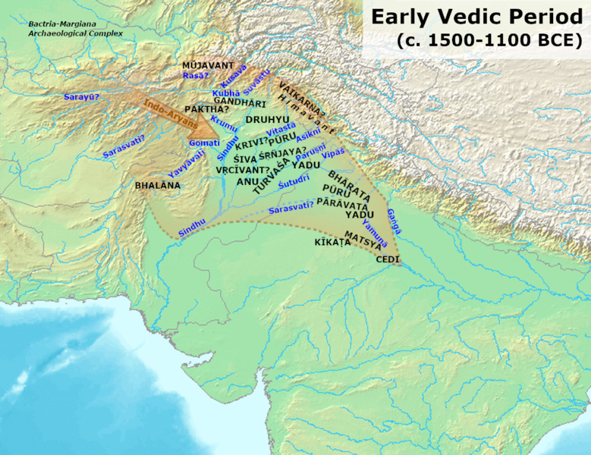

In the Rigvedic time, there were two varnas: arya varna and dasa varna, at first coming from tribal divisions. The dasas regularly lined up with Aryan groups and were plausible consumed into Aryan culture, provoking a class detachment. Regardless, various dasas stood firm on compliant circumstances, which finally progressed dasa to mean laborer or slave.

In the Rigvedic culture, occupations were not an important quality. Various farmers and specialists took part in various trades. Purposes for living like chariot-creation (rathakara) and metalworking (karmara) stood firm on respected tractions with close to no connected disgrace. A comparative ideal regard applied to carpenters, calfskin treaters, weavers, and various trained professionals.

Toward the completion of the Atharvaveda time, new class detachments began to surface. The past dasas were rebranded as Shudras, inclined to detach them from the changed significance of dasa as a slave. The aryas were redesignated as vis or Vaishya (meaning people from the group), and the ascent of new selective classes occurred.

Later Vedic Period (1000-600 BCE)

In an early Upanishad, Shudras are suggested as Pūşan or nourishers, suggesting their occupation as cultivators of the land. Regardless, not long later, Shudras are avoided among the residents, and they are referred to as being given close by the landscapes in case of giving. Various craftsmans moreover end up named Shudras, yet there is no indication of contempt for their work.

The Brahmins and Kshatriyas stand firm on a leaned toward balance in functions, isolating them from both Vaishyas and Shudras. The Vaishya is noted to be "mistreated unreservedly," while the Shudra is depicted as "beaten intentionally."

How we could decipher this time is improved by Pali Buddhist sacrosanct compositions. While Brahmanical texts inspect the four-cross-over varna structure, Buddhist consecrated works depict society coordinated around jati, kula, and occupation. It is conceivable that yet the varna structure was significant for Brahmanical reasoning, it wasn't totally utilitarian eventually. In Buddhist messages, Brahmins and Kshatriyas are organized as jatis rather than varnas, tending to high-situating jatis. Lower-situating jatis are referred to as chandala, close by word related social affairs like bamboo weavers, trackers, chariot-makers, and sweepers.ond Urbanization (500-200 BCE)

The possibility of kulas was all around comparative. Despite Brahmins and Kshatriyas, a social event known as gahapatis (meaning householders, yet fundamentally insinuating the propertied classes) was in like manner saw as a part of the extraordinary kulas. Individuals from high kulas were locked in with grand occupations like agribusiness and trade.

The occupations of high kulas included dairy steers keeping, enrolling, accounting, and making, while those of low kulas were locked in with less respected positions, for instance, holder twisting around and clearing.

Regardless of the way that there was a relationship among's kulas and occupations, particularly at the upper and lower limits, there was unquestionably not a rigid relationship between cordial class or standing and occupation, especially for those in the middle reach. Various purposes for living like accounting and creating were not limited to unequivocal jatis. In his evaluation of position in India, Peter Masefield observes that on a basic level, anyone could practice any calling. The texts show that Brahmins recognized food from anyone, exhibiting that extreme dietary guidelines were not yet settled. The Nikaya texts similarly suggest that endogamy (wedding inside one's social affair) was not necessary.

The conversations of that time are clear in the texts organizing conversations among Buddha and the Brahmins. The Brahmins keep up with their clear glorious pervasiveness and assurance the straight over get organization from lower social orders. Appropriately, Buddha includes the overall reality of regular birth shared by all individuals and emphasizes that the ability to get organization isn't natural yet can change — the people who are correct now laborers could climb in status, as well as the opposite way around. Buddha embraced this kind of friendly flexibility.

Traditional Period (320-650 CE)

Unique duplicate outline from the Mahabharata of the Conflict of Kurukshetra

The Mahabharata, acknowledged to have been done around the completion of the fourth hundred years, addresses the varna structure in section 12.181, presenting two specific models. The essential model portrays varna as a

assortment based structure, as portrayed by an individual named Bhrigu. According to this model, "Brahmins varna was The Mahabharata, dated to its last design around the completion of the fourth 100 years, discusses the varna structure in region 12.181, presenting two perspectives. The primary model, voiced by Bhrigu, accomplices varnas with colors: Brahmins as white, Kshatriyas as red, Vaishyas as yellow, and Shudras as dim. Bharadvaja, anyway, questions this thought, raising that tones are recognizable in all varnas, and typical human experiences like yearning, shock, fear, and others are general. He asks what truly perceives the varnas. As needs be, the Mahabharata states, "There is no capability of varnas. This entire universe is Brahman, made by Brahma and characterized considering deeds."

The unbelievable then presents a lead model for the varna structure, figuring out that those inclined towards shock, delights, and coarseness achieved the Kshatriya varna; those inclined towards cows raising and cultivation achieved the Vaishya varna; and those with penchants towards viciousness, energy, and contamination were set in the Shudra varna. The Brahmin class is depicted in the epic as the best depiction of humanity, committed to truth, dreariness, and pure direct.

In the Mahabharata and earlier Hindu texts, as Hiltebeitel points out, it's essential to appreciate that varna is non-genealogical on a basic level. The four varnas are not considering lineages but instead are fairly groupings.

The Adipurana text also dives into the relationship among varna and jati. According to Padmanabh Jaini, an expert in Indic studies, the Adi Purana text in Jainism and that is the very thing buddhism communicates "there is only a solitary jati called manusyajati or the human station, but divisions arise considering their various purposes for living." Jainism texts recommend that the Kshatriya rank emerged when Rishabha acquired weapons to serve society and anticipated supreme powers, while the Vaishya and Shudra standings started from their specific explicit livelihoods.

Late Traditional and Early Archaic Period (650-1400 CE)

Archeological Exhibitions guide of Andhra Pradesh/Adityamadhav83k,

Researchers have attempted to uncover obvious proof with respect to the presence and characteristics of varna and jati in middle age Indian records and etchings. Regardless, significant evidence supporting the presence of varna and jati systems during this period has been attempting to find, with conflicting confirmation surfacing taking everything into account.

In the expansive records of old fashioned Andhra Pradesh, notification of varna are sparse. References to jati are considerably more uncommon, especially up to the thirteenth hundred years. There are two unprecedented safe-haven donor records from contender families in the fourteenth century that case to be Shudras. One avows that Shudras are the most bold, while various cases they are the absolute best. Richard Eaton, a Bunch of encounters educator, saw that "anyone could transform into a legend paying little psyche to social establishment, and neither do Jati, which is seen as another significant piece of standard Indian culture, expected a section in embellishment people's characters. Eaton highlights that occupations were not fixed and suggests that Shudras were associated with the decency. He similarly points out that numerous father kid matches sought after different reasons for living, exhibiting that monetary prosperity was achieved rather than obtained among the Hindu Kakatiya people in the Deccan locale from the 11th to the fourteenth many years.

Leslie Orr, an educator of Religion, has focused on the Tamil Nadu locale of India. That's what she observes "Chola period etchings challenge our doubts about the relationship of (south Indian) culture by and large." rather than what Brahmanical legal messages could suggest, there is no undeniable evidence that position fills in as the fundamental straightening out rule of society, nor are the cutoff points between various get-togethers strongly portrayed

Susan Bayly observes that until the pioneer time, various districts in northern India had peoples where formal standing capabilities held limited significance. For sure, even in areas like the Gangetic fields, every now and again remembered to be the Hindu heartland, the foundations and convictions related with standard standing were still in the first place periods of progress as late as the mid eighteenth hundred years. This period agreed with the destruction of the Mughal Domain and the rising effect of Western powers in the Indian subcontinent.

According to Dirk Kolff, an educator of Humanities, open-status get-togethers expected a tremendous part in Rajput history during the middle age time span in western India.

**Medieval era, Islamic Sultanates and Mughal Period (1000-1750)**

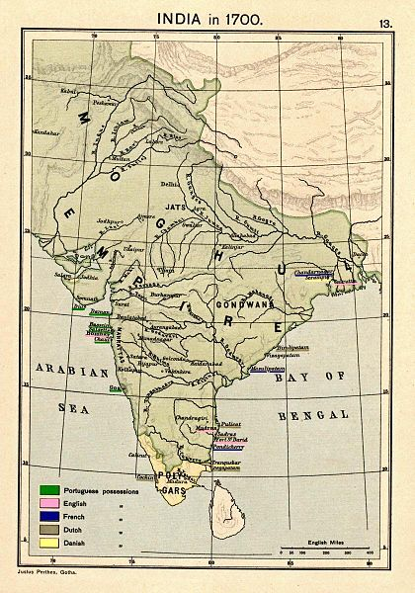

Later Mughal Period (1700-1850)

Susan Bayly, an anthropologist, sees that "position has not been and is positively not a static piece of Indian culture." She figures out that the position system, alluded to right now as a "ritualized plan of social arranged movement," created in two phases during the post-Mughal period, unequivocally in the eighteenth and mid nineteenth many years. Bayly highlights three key characteristics that basically impacted this headway: the arranged movement inside the association, the possibility of greatness, and the presence of outfitted priests.

As genuine frameworks and managerial plans were making in India nearby the rising effect of trailblazer Europeans, Dirks points out that late eighteenth century English writing with respect to India essentially revolves around subjects like local turn of events, organizations, battling, and placating relations inside the area. Despite this season of canny development, Colin Mackenzie, an English social understudy of history, amassed a basic collection of texts associated with Indian religions, culture, customs, and neighborhood narratives from southern India and the Deccan region. Regardless, there is small notification of the standing system in his arrangement and works connecting with eighteenth century India.

During English Rule (1857-1947)

While the varnas and jatis have obsolete beginning stages, the contemporary position system has progressed generally during the post-Mughal time and the English commonplace rule. These periods saw enhancements that changed the position structure into a central various leveled gadget for association.

During the English commonplace time, jatis filled in as the supporting of station ethnology. Starting from the 1881 enrollment and continuing consequently, trailblazer ethnographers utilized station (jati) plans to include and group individuals in what was then English India (as of now containing India, Pakistan, Bangladesh, and Burma). The 1891 identification introduced 60 sub-social occasions, each further isolated into six word related and racial classes, and this number filled in coming about censuses. According to Susan Bayly, the station tables in the English outskirts time enrollment "purposely organized, standardized, and cross-alluded to jati postings for Indians using principles compared to those in zoological and," not entirely settled to conclude moderate rankings considering contemplations of righteousness, word related beginning stages, and total moral standing.

While regulatory English specialists persistently collected reports considering their zoological request of Indian people, a piece of their accomplices rebuked these endeavors as basic distortions that didn't definitively address the complexities of the position system in India. The English boondocks chiefs utilized the jatis recognized in the measurements to sort out which individuals were equipped for explicit circumstances inside the trailblazer government, while similarly excepting explicit jatis as hazardous. According to Gloria Raheja, an educator of Human sciences, these specification decided position orders were similarly instrumental in setting land charge rates during the late nineteenth and mid 20th many years. In addition, they were routinely used by English specialists to name explicit social occasions as "criminal" standings and perceive positions leaned to "disobedience."

Around then, at that point, the general population amounted to around 200 million individuals, following five critical religions, staying in more than 500,000 agrarian towns. These towns typically went in people from 100 to 1,000 people, wrapping grouped age social occasions and divided into different standings.

Further Turn of events

During the round table gathering held in August 1932, in accordance with Ambedkar, the Top of the territory of Britain around then, at that point, Ramsay MacDonald, introduced a Common Honor. This award obliged separate depiction for various social events, including Muslims, Sikhs, Christians, Early English Indians, Europeans, and Dalits. Specifically, the deterred classes were apportioned a particular number of seats to be filled through races from extraordinary electorates where just residents having a spot with the deterred classes could participate.

Considering this game plan, Gandhi began a hankering strike, fighting that such a strategy would disengage the Hindu social class. Years sometime later, Ambedkar communicated that Gandhi's fast amounted to pressure. Over the long haul, a comprehension was reached known as the Poona Settlement, wherein Gandhi completed his speedy and Ambedkar took out his advantage for an alternate electorate.

Various Speculations and Discernments

In their assessment of Hutton's focus on the position structure in wilderness India, Smelser and Lipset propose a speculation concerning individual flexibility across station lines. They suggest that such adaptability might have been confined in English India in light of the proper thought of the standing system. They fight that this limitation could be attributed to the way that pioneer social depiction worked inside the construction of the past custom standing system.

The groundwork of a state of the art station system during the early English boondocks rule in the eighteenth and nineteenth many years was not consistent across South Asia. Claude Markovits, a French understudy of history acquiring reasonable involvement with wilderness India, observes that Hindu society in North and West India (counting Sindh) during the late eighteenth 100 years and a critical piece of the nineteenth century didn't have an obvious position structure. Taking everything into account, their severe characters were fluid, including Saivism, Vaisnavism, and Sikhism. Likewise, Brahmins were not the staggering strict social affair; taking everything into account, it was the Bawas who held more effect.

Markovits fights that among the Hindu vendor neighborhood northwest India, neither religion nor rank played an immense getting sorted out work during this period.

**Contemporary**

**Caste Politics**

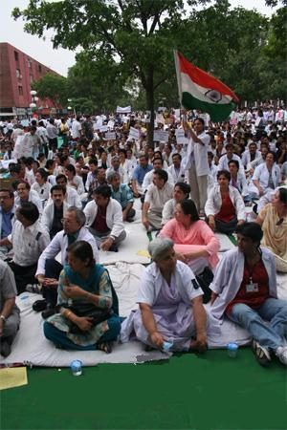

The immense 2006 Indian adversary of reservation battles

India continues to grapple with social depiction and the resulting awkwardness, which has gone up against tremendous investigation. Government methodologies have been executed to address this unevenness, incorporating reservation segments for in switch classes. Regardless, these methodologies have in like manner unintentionally made inspirations to support social outline. The Indian government officially recognizes commonly isolated networks in India, similar to the untouchables, relegated as Arranged Positions, and certain monetarily troubled stations as Other In turn around Class.

Relaxing of the Position Framework

Leonard and Weller drove a survey using marriage and genealogical records to look at the examples of exogamous among station and endogamous intra-rank connections inside a regional people of India from 1900 to 1975. Their revelations highlight a discernible development in exogamous connections across position limits, especially from the 1970s onwards. They suggest that components like preparation, financial progression, extended versatility, and more conspicuous correspondence among the more young age could add to this rising in exogamous connections.

According to a 2003 article in The Message, between rank marriage and dating have become transcendent in metropolitan India. The components of Indian culture and family associations are going through immense changes as a result of factors like extended female capability and preparing, women's dynamic help in the workforce, urbanization, the need of twofold compensation families, and overall effects through media like television. Female genuine models in various fields like legislative issues, the insightful world, revealing, business, and India's ladies' extremist improvement play had a fundamental effect in accelerating these changes.

# REFERENCES

Maddison, Angus (2007). Shapes of the World Economy 1-2030 Promotion: Expositions in Full scale Monetary History. Oxford College Press. p. 379. ISBN 978-0-191-64758-1.

^ Hop up to:a b Maddison, Angus (2003): Advancement Center Examinations The World Economy Verifiable Insights: Authentic Measurements, OECD Distributing, ISBN 9264104143, p. 261

^ Paul Bairoch (1995). Financial aspects and World History: Fantasies and Oddities. College of Chicago Press. p. 95. ISBN 978-0-226-03463-8.

^ "Force of Information Perception".

1. ^ "The World Economy (Gross domestic product) : Authentic Insights by Teacher Angus Maddison" (PDF). World Economy. Recovered 21 May 2013.

2. ^ Leap up to:a b c d Om Prakash, "Realm, Mughal", History of World Exchange Starting around 1450, altered by John J. McCusker, vol. 1, Macmillan Reference US, 2006, pp. 237-40, World History in Setting, got to 3 August 2017

3. ^ József Böröcz (10 September 2009). The European Association and Worldwide Social Change. Routledge. p. 21. ISBN 9781135255800. Recovered 26 June 2017.

4. ^ Sanjay Subrahmanyam (1998). Cash and the Market in India, 1100-1700. Oxford College Press. ISBN 9780521257589.

5. ^ Parthasarathi, Prasannan (2011), Why Europe Developed Rich and Asia Didn't: Worldwide Financial Uniqueness, 1600-1850, Cambridge College Press, p. 45, ISBN 978-1-139-49889-0

6. ^ S. A. A. Rizvi, p. 263 of A Social History of India (1975), altered by A. L. Basham

7. ^ Leap up to:a b c d e f g h I Jeffrey G. Williamson, David Clingingsmith (August 2005). "India's Deindustrialization in the eighteenth and nineteenth Hundreds of years" (PDF). Harvard College. Recovered 18 May 2017.

8.Maddison 2003, p. 261.

9. Baten, Jörg (2016). A Past filled with the Worldwide Economy. From 1500 to the Present. Cambridge College Press. p. 250. ISBN 9781107507180.

10. ^ Leap up to:a b "Monetary review of India 2007: Strategy Brief" (PDF). OECD. Chronicled from the first (PDF) on 6 June 2011.

11. ^ "Industry going through period of progress". The Tribune. Chronicled from the first on 24 Walk 2014.

12. ^ Marshall, John (1996). Mohenjo-Daro and the Indus Civilization: Being an Authority Record of Archeological Unearthings at Mohenjo-Daro Completed by the Public authority of India Between the Years 1922 and 1927. Asian Instructive Administrations. p. 481. ISBN 9788120611795.

In post-autonomy India, occurrences of station related brutality have happened. A 2005 UN report recorded around 31,440 detailed instances of rough demonstrations focusing on Dalits in 1996, adding up to 1.33 cases per 10,000 Dalit people. To give setting, the UN detailed somewhere in the range of 40 and 55 fierce cases for every 10,000 individuals in created nations in 2005. One striking occurrence of such savagery is the Khairlanji slaughter that occurred in 2006.Top of Form