DECENTRALIZED POLLING SYSTEM USING BLOCKCHAIN

*Karishma Shambharkar*1, Shivaji Phatak*2, Prathamesh Sarnaik*3, Shreya Wani*4, Sayali Karmode*5.*

*\*1,2,3,4 Student of Department of Information Technology, MGM College of Engineering and Technology, Navi Mumbai, Maharashtra.*

*\*5Faculty of Department of Information Technology, MGM College of Engineering and Technology, Navi Mumbai, Maharashtra.*

***Abstract: Voting is a primary right of every citizen living in a country. Traditional methods used for voting includes paper ballot system, EVMs (Electronic Voting Machines), etc. which are still followed and trusted by every voter or citizen blindly. The polling systems can have ambiguity as the data is maintained under a centralized environment whether it is counting the paper ballots or storing the vote caste on a computer server. This use of a centralized database for the polling system has some security issues such as Data modification through the third party in the network due to the use of the central database system as well as the result of the polling is not shown in real-time, or manipulation with the data which can hamper the result and thus have an impact on not only system integrity but also lose faith in democracy, government, nation, etc. Thpolling methods used in an election should be legal, accurate, safe, and convenient.***

***Keywords: Blockchain Technology, EVM(Electronic Voting System), Smart Contracts, Ethereum, Solidity, etc.***

# INTRODUCTION

The most fundamental aspect of a democracy is the avail- ability for citizens to not only share ideas, opinions, and beliefs but to make their individual voices heard by deciding the collective future by vote. However, for the polling to proceed as intended, there needs to be a transparent and secure process where also the voters knowingly keep their privacy. The challenge is to find a solution that prevents unlawful manipulation of the collected data and achieve desired transparency in the security measures, taken to protect voter privacy and the collected results and therefore democracy itself. By using blockchain our proposed system has the features like security, privacy, and integrity. In blockchain every node or user is anonymous, and every action performed is a transaction which is hashed and then stored into the network. To test our protocol, we put it on Ethereum a blockchain platform that uses Solidity as a programming language to create smart contracts. Smart Contracts are backbone of Blockchain System. The usage of smart contracts ensures a safe means for performing voter verification, ensuring the correctness of voting results, making the counting system public, and protecting against fraudulent activities. Blockchain Technology eliminates the risk of single point of failure, which is usually seen in traditional approaches as discussed above, making our voting system tamperproof and trustworthy which not only provides integrity to voters or citizens, but also supports transparency among voters and candidates and it also strengthens the actual meaning of democracy and create a sense of belief among them and thus making the system more secured and reducing the cost for infrastructure management as well. Votingis a process which is defined as the right of people to choose their leaders. Voting is a important process that enables people to handpick their government leader. The polling system should be democratic, independent, and unprejudiced. As a result, it must be a transparent and secure procedure that allows everyone to partake their standpoint freely. A lot of people in the world do not keep faith in the election system. The Traditional voting is controlled and full of mediators. Furthermore, people are dealing with a variety of issues, such as booth capture, dummy voting and the problem of proper monitoring, a massive line of people in front of the polling booths, false polling, pre-vote casting, redundant vote, lack of awareness, polling booths are located a long .

# PROBLEM STATEMENT

In traditional polling systems, centralization poses significant challenges such as security risks, lack of transparency, and potential manipulation. A decentralized polling system utilizing blockchain technology can address these issues by providing a secure, transparent, and tamper-resistant platform for conducting polls. However, developing such a system requires overcoming challenges related to scalability, user adoption, and ensuring the integrity of the voting process. This project aims to design and implement a decentralized polling system that leverages blockchain technology to create a more secure and trustworthy platform for conducting polls."

# OBJECTIVE

The objective of this project is to develop a decentralized polling system that utilizes blockchain technology to ensure security, transparency, and integrity in the polling process. This system aims to provide a reliable platform for conducting polls that are resistant to manipulation, censorship, and fraud. By leveraging the decentralized nature of blockchain, the objective is to create a system that enables trustless and verifiable polling, thereby increasing confidence in the democratic process.

# LITERATURE SURVEY

1. *Related Works*

BLOCKCHAIN TECHNOLOGY SECURITY ISSUES AND CONCERNS. In this paper, we will review the concept of blockchain and various blockchain attacks with solutions.

[1] Forensic analysis of Blockchain data is a new field in police work. It's now one of the largest problems facing law enforcement. The paper discussed the worldwide need for digital forensics in law enforcement and Blockchain forensics to counteract crimes committed using Blockchain technology.

[2] Security Challenges for IoT Based Applications & Solutions Using Fog Computing In this study, we surveyed about the integration of fog computing with IoT and its implications.

[3] Blockchain based Voting system in Local Network (2021) This research paper investigates the implementation of a blockchain-based voting system within a local network environment.

[4]Decentralized E-Voting Portal Using Blockchain. Kriti Patidar, Dr. Swapnil Jain. In this paper, an e-voting system based on blockchain that eliminates some of the limitations in existing voting systems. The paper also presents state of art of some blockchain frameworks for e-voting. The presented implementation is suitable for small scale elections like inside corporate houses, board rooms etc.

[5] Decentralized E-voting system based on Smart Contractby using Blockchain Technology. Ali Mansour Al-madani, Dr.Ashok T. Gaikwad, Vivek Mahale, Zeyad A.T.Ahmed. This paper aims to provide an E-voting system with high security by using blockchain. Blockchain provides a decentralized model that makes the network Reliable, safe, flexible, and able to support real-time services.

[6]DVT Chain: A blockchain-based decentralized mechanism to ensure the security of digital voting system voting system. Syada Tasmia Alvi, Mohammed Nasir Uddin, Linta Islam, Sajib Ahamed. The system in this paper provides voter anonymity by keeping the voter information as a hash in the blockchain.

[7] Decentralized E-Voting Systems Based on the

Blockchain Technology. Jen-Ho Hsiao1, Raylin Tso1, Chien-Ming Chen2and Mu-En Wu. This paper is aimed to design a decentralized e-voting system.

[8] Decentralized E-Voting System Using Blockchain. Dr S.Salekar The purpose of this paper is to overcome the limitation of existing e-voting system by implementing voter validation using Biometric, Dynamic Ballot loading and Acknowledgement after casting votes with the help of Blockchain technology.

1. **PROPOSED SYSTEM ARCHITECTURE**

The system architecture comprises of Client side, Blockchain network and Middleware edge technology by removing the barrier of dependency, which will be adopted by the tech industry very soon and then further by customers.

1. *Client Side Application:* The client side application is build using HTML,CSS, React.js Library.
2. *Blockchain Network:* The Smart Contracts are written using the Solidity programming language. Ganache is used as Ethereum client for testing. Truffle framework is used for development, testing and deploying smart contracts.

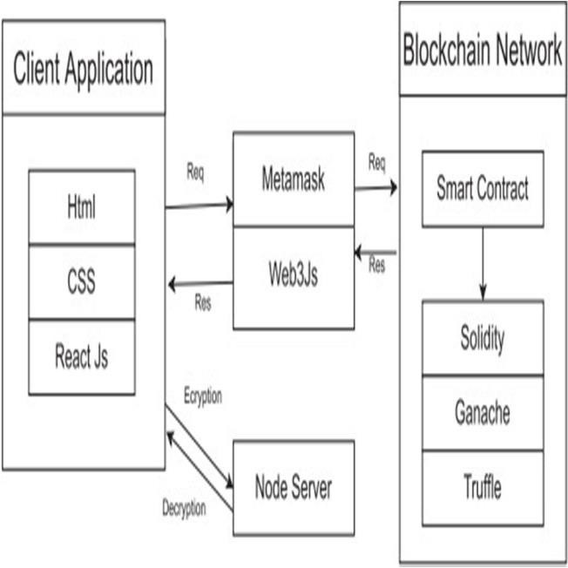

1. *Middleware:* Meta-mask is used as browser wallet. Web3.js a collection of libraries is used for connection between user interface and blockchain database(network), and A small node server is used in our system. It acts as a cryptographic server which is named as a crypto server. This server is used for storing the public private keys for encryption and decryption, respectively.

(Fig. 5.1 System Architecture)

# SYSTEM IMPLEMENTATION

# (Fig 6.1 home page)

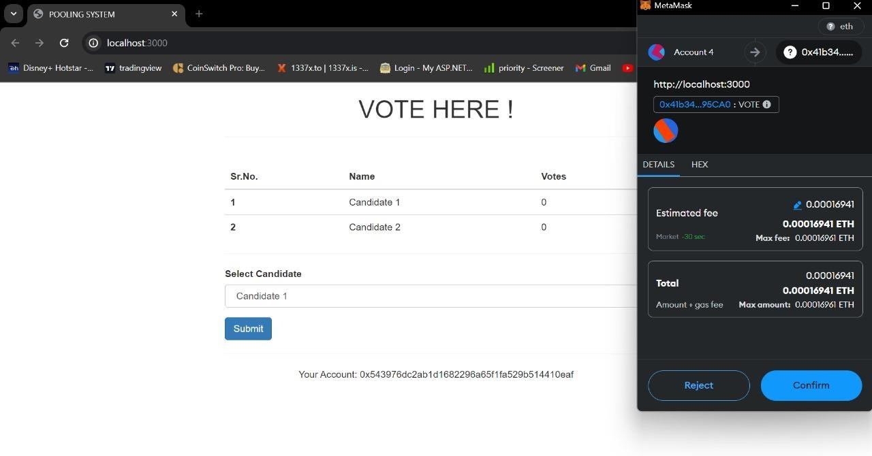

(Fig. 6.2 E-pooling using metamask wallet )

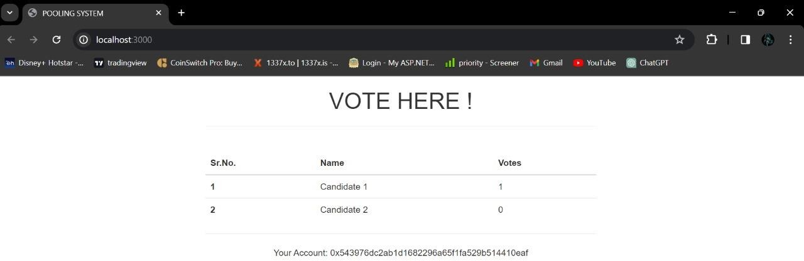

(Fig 6.3 Voting done)

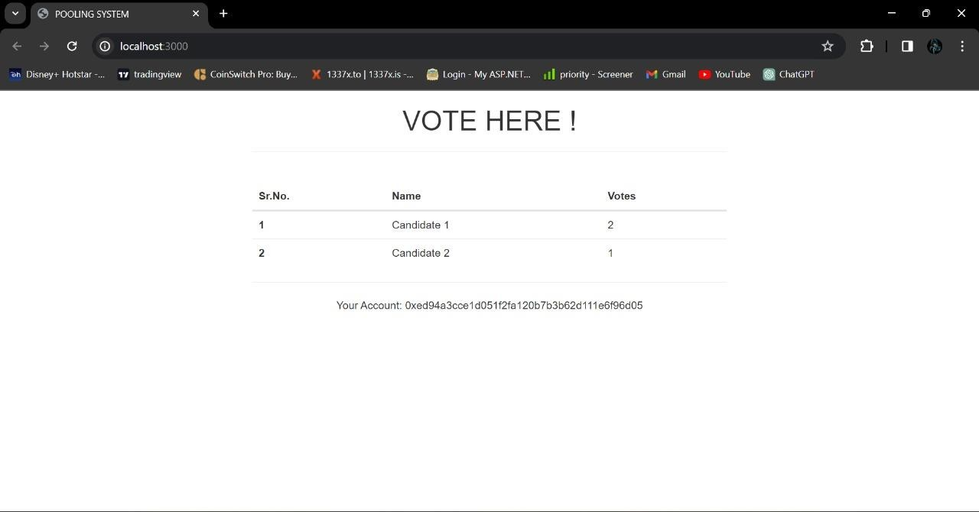

(Fig 6.4 Total vote count )

1. **RESULT ANALYSIS**

The decentralized polling system produces a verifiable outcome, ensuring the integrity of the voting process. Results are stored on the blockchain and can be independently verified. The system provides a secure and transparent method for conducting polls, reducing the risk of fraud and manipulation. It also offers scalability to accommodate a large number of voters and can potentially reduce costs associated with traditional polling methods. However, it requires compliance with legal and regulatory frameworks and may require user education for widespread adoption.

# CONCLUSION

This paper presents a blockchain based e-voting system that runs on Ethereum. It shows that blockchain technology can overcome limitations of centralized voting systems. This implementation uses Ethereum blockchain as a network as well as database for storing voter’s accounts, candidate de- tails and votes. This implementation makes use of smart contracts. Blockchain as a technology carries a great future ahead where many real-world problems of depending on third party centralized authority in day- to-day life can be resolved, people want an less ambiguous system where everything is crystal clear and at the same time making sure that their(users) data is safe and secure. Voting system using Blockchain will for sure solve all these circumstances faced by people or citizens of a country and will provide them with a system where we are no longer, they need to depend and follow on to these old aged traditional approaches. World is moving faster, and it will move faster in terms of Technology, when we noticed a boom inWeb 2 Era that is the dot com era every- thing was digitalized but centralized at the same time, but this revolution of Web3 Era brings a lot of exciting and one step ahead cutting.

# REFERENCES

1. Sayali Karmode, *Security Challenges for IoT Based Applications & Solutions Using Fog Computing: A Survey,* Journal of Journal of Cybersecurity and Information Management, Vol. 3 , No. 1 , (2020) : 21-28(Doi : <https://doi.org/10.54216/JCIM.030103>)
2. M. S. K. Yelpale, “Security and privacy challenges in cloud computing: a review,” *Journal of Cybersecurity and Information Management*, vol. 4, no. 1, pp. 36–45, 2020.View at: [Google Scholar](https://scholar.google.com/scholar_lookup?title=Security%20and%20privacy%20challenges%20in%20cloud%20computing%3A%20a%20review&author=M.%20S.%20K.%20Yelpale&publication_year=2020)
3. Sayali Karmode Yelpale, “IOT Technology for Pandemic Situation”, NJITM, vol. 4, no. 2, pp. 25–27, Jan. 2022 <https://mbajournals.in/index.php/JoITM/article/view/806>.
4. Karmode, S. S., & Bhagat, V. B. (2017). DETECTION AND BLOCKING SOCIAL MEDIA MALICIOUS POSTS. International journal of modern trends in engineering and research, 4(5).
5. Kermode, S. S., & Bhagat, V. B. (2016). A Review: Detection and Blocking Social Media Malicious Posts. Int. J. Mod. Trends Eng. Res, 3(11), 130-136. doi: [10.21884/IJMTER.2016.3133.Q4M8O](https://doi.org/10.21884/IJMTER.2016.3133.Q4M8O)
6. Sayali Karmode, “Blockchain Technology Security Issues and Concerns: A Review”, International Research Journal of Modernization in Engineering Technology and Science, Vol 6, Issue 03, March 2024 DOI: <https://www.doi.org/10.56726/IRJMETS50249>
7. Pranav Chavan, Harshraj Deshmukh, Aakash Dhotre, Aditya Gharat, Sayali Karmode, “Blockchain Democracy : Evaluating a Secure Voting System”, International Research Journal of Modernization in Engineering Technology and Science, Vol 6, Issue 03, March 2024 DOI : <https://www.doi.org/10.56726/IRJMETS50478>
8. B. J. Dange, Kaustubh Manikrao Gaikwad, H. E. Khodke, Santosh Gore, S. N. Gunjal, Kalyani Kadam, Sayali Karmode, “Machine Learning for Quantum Computing Bridging the Gap between AI and Quantum Algorithms”, *Int J Intell Syst Appl Eng*, vol. 12, no. 21s, pp. 600–605, Mar. 2024.
9. N Kumar, E Howard, S Karmode, “[Reinforcement Learning for Optimal Treatment Planning in Radiation Therapy](https://scholar.google.com/scholar?oi=bibs&cluster=12796027889473991021&btnI=1&hl=en)”, NATURALISTA CAMPANO, Vol 28, Issue 1, 2024<https://museonaturalistico.it/index.php/journal/article/view/355>
10. M.D. Castillo, “Russia Is Leading the Push for Blockchain Democracy,”Coin Desk, 2018; https://www .coindesk.com/Russia s capital - leading-charge-blockchain– democracy, 2018.
11. Bayu Adhi Tama, Bruno Joachim Kweka, Youngho Park, and Kyung- Hyune Rhee, ”A Critical Review of Blockchain and Its Current Applications,” in IEEE International Conference on Electrical Engineering and Computer Science (ICECOS) 2017, pp. 109- 113, 2017.
12. Andrew Barnes, Christopher Brake and Thomas Perry, “Digital Voting with the use of Blockchain Technology”,https://[www.economist.com/site](http://www.economist.com/sites/default/files/plymouth.pdf) [s/default/files/plymouth.pdf,](http://www.economist.com/sites/default/files/plymouth.pdf) 2016.
13. Friorik P. Hjalmarsson, Gunnlaugur K.Hreioarsson, Mohammad Ham- daqa, and Gisli Hjalmtysson, ”Blockchain-Based E- VotingSystem,” in IEEE 11th International Conference on Cloud Computing, pp. 983-986, 2018.
14. Patrick McCorry, Siamak F. Shahandashti and Feng Hao, “A Smart Con- tract for Boardroom Voting with Maximum Voter Privacy”, Published in: Financial Cryptography and Data Security, Springer, 2017.
15. Jonathan Alexander, Steven Landers and Ben How-erton, “Netvote: A Decentralized Voting Network”,https://netvote.io/wpcontent/uploads/2018/02/Netvote- White-Paper- v7.pdf, 2018.
16. D. Khader, B. Smyth, P. Y. Ryan, and F. Hao, “A fair and robust votingsystem by broadcast”, in 5th InternationalYiyun Zhou, Meng Han, Liyuan Liu, and Wang Yan, ”Improving IoT Services in Smart- Home Using Blockchain Smart Contract,” in IEEE Confs. on Internet of Things, Green Computing and Communications, Cyber, Physical and Social Computing, Smart Data, Blockchain, Com- puter and Information Technology, Congress on Cybermatics, pp. 81- 87,2018.
17. Sayali Karmode Yelpale, “IOT Technology for Pandemic Situation”, NJITM, vol. 4, no. 2, pp. 25–27, Jan. 2022 <https://mbajournals.in/index.php/JoITM/article/view/806>.
18. Layth Almahadeen, Renzon Daniel Cosme Pecho, Murugananth Gopal Raj, Nichenametla Rajesh, Zainab Mohammed Imneef, Sayali Karmode Yelpale, “Digital Investigation Forensic Model with P2P Timestamp Blockchain for Monitoring and Analysis” , Journal of Electrical System, Vol. 1, No 1, (2024): 09-17 ( DOI : https://doi.org/10.52783/jes.656)