Application of the Integrated QFD Technique in the Design And Development of Automated Viscous Fluid Filling System
Mr. S. V. Patil¹,Mr. R. R. Adsul ², Mr. S. S. Babale³, Mr. V. V. Bhosale⁴, Mr. K. D. Chavan⁵,Mr. S. S. Jadhav⁶
1 Project Guide, 2,3,4,5,6 Engineering students
Department of Mechanical Engineering, Annasaheb Dange College of Engineering & Technology, Ashta, Maharashtra, India
---------------------------------------------------------------------***--------------------------------------------------------------------

Abstract
An automated viscous fluid filling machine is a device in the food packaging industries that is beneficial for health and fatigue relief. Consumer demand for products that have a good impact on health is increasing due to high public awareness of the importance of health. One effective method for determining the needs and desires of consumers is Quality Function Deployment (QFD). This method starts from the House of Quality Matrix, also the process planning matrix, and the planning of production matrix. For the accuracy of the QFD analysis, it is necessary to improvise the planning process of the Automated viscus fluid filling machine, then realize using the strategy formulation implementation strategy based on the Kano model the important needs and performance to be achieved. With the help of the QFD approach, is expected to help businesspeople formulate process priorities to be improved to satisfy customer requirements.
Keywords: automation, fatigue, operation, engineering attributes, automated viscous fluid filling machine
INTRODUCTION
Customer satisfaction for enhanced service and product quality is a core focus of business achievements. To reach customers' responsive behaviours, one has set out to understand the major leads to fulfil the requirements. For capturing the customer’s voices the tool used is quality function deployment. This tool translates customer expectations in systematic fictional requirements for creating products and services.
The project's overall implementation is to create a system wherein the fluid is taken into consideration. Due to the viscosity of the fluid, there is difficulty in filling it in the container with a predefined value. The fatigue strength utilization in various industries for the filling is been also seen nowadays. The project creates a system that will be cost-effective as well as a fatigue system. The automation with utilization of software applications is the present view of the market. To moralize this process the method of pouring and settling system has been undertaken to work

in progress in the form of a line process in any firm and packaging industry. A new method has been utilized for the proper settling of the viscous fluid in a predefined container. It is termed as “shackling” which will showcase a back and through motion to settle the fluid in the container. Vibratory motion has been given to the table created for the settling station. The overall motivation for the project is to reduce the human fatigue of material handling and timing saving process will be achieved. The use of technology, as well as electrical components along with Arduino, will also be done in this rigorous systematic method.
LITERATURE REVIEW
In the pursuit of enhancing customer satisfaction and product quality, businesses are increasingly turning to automated systems for filling viscous fluids. Quality Function Deployment (QFD) emerges as a vital tool for understanding and translating customer expectations into actionable requirements, ensuring alignment between product offerings and consumer needs. Filling viscous fluids presents unique challenges due to viscosity, impacting flow dynamics and precision in achieving predefined filling levels. This necessitates innovative solutions to optimize fluid-filling processes and mitigate operational inefficiencies. Automated systems offer a promising avenue for addressing these challenges, providing enhanced precision, repeatability, and efficiency compared to manual methods (Hauser & Clausing, 1988).
Technology integration plays a pivotal role in modern fluid-filling systems, with a focus on leveraging advancements such as software applications, electrical components, and Arduino-based systems. These technologies enable real-time monitoring, control, and data analysis, facilitating improved process visibility and performance. Moreover, novel methods like "shackling" have emerged to address the challenge of settling viscous fluids in containers. By employing a combination of back-and-forth and vibratory motions, these approaches aim to enhance filling accuracy and consistency while reducing human fatigue and handling issues (Kumar et al., 2018; Kumar & Singh, 2019).
The literature reviewed encompasses a diverse array of studies focusing on the integration and application of Quality Function Deployment (QFD) methodology across various industries and contexts. Zarei et al. (2011) explores the integration of QFD within the food supply chain, emphasizing its role in enhancing efficiency, quality, and customer satisfaction. Rujito et al. (2020) investigate the application of QFD in product design, specifically within the context of developing the Kolang Kaling grass jelly drink, showcasing its effectiveness in aligning customer preferences and market demands. Miguel (2016) provides a comparative analysis of QFD implementation in packaging product development between Italian and Brazilian companies, highlighting cultural and organisational differences. Desai et al. (2017) delves into the application of QFD in designing assistive technology, particularly in developing a new wheelchair, underscoring its importance in bridging the gap between user needs and engineering specifications. Kelesbayev et al. (2016) discuss the adaptation of QFD in higher education, illustrating its effectiveness in enhancing the quality of education and services provided by academic institutions. Lastly, Liu et al. (2011) present a practical application of QFD in developing an automatic liquid filling machine, emphasizing its affordability, ease of operation, and user-friendliness. Collectively, these studies demonstrate the versatility and effectiveness of QFD in addressing diverse challenges and improving processes across different industries and domains.
In conclusion, the literature underscores the importance of automated viscous fluid filling systems in meeting customer demands for enhanced product quality and service. Through the integration of technology and innovative methodologies such as QFD, businesses can optimize fluid-filling processes across various industries, improving operational efficiency and customer satisfaction. Future research may explore further advancements in automation, technology integration, and innovative techniques to address evolving challenges in fluid-filling applications. This review provides industry heads of packaging with a piece of relevant packaging machinery that will be fully automated and can be beneficial to grow businesses and increase the productivity of the fluid-filling. Moreover, to capture the unexpected vagueness related to the product design, a fuzzy approach was introduced to QFD.
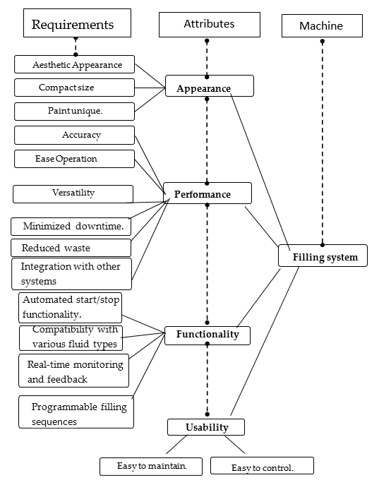

Figure 1. Tree diagram of the specific requirements for a new machine

METHODOLOGY
SURVEY
Quality Function Deployment (QFD) serves as an invaluable methodology in bridging the gap between customer expectations and product development. The initial survey phase plays a pivotal role, with carefully crafted questions aiming to uncover the nuanced needs and preferences of the target audience. Through this systematic inquiry, the importance of each identified need is quantified, offering a foundation for subsequent decision-making. Additionally, insights into the competitive landscape provide valuable context, allowing businesses to understand the features that resonate with customers in rival products or services.
The subsequent visits component of QFD, characterized by product demonstrations and showcase events, fosters a dynamic interaction between developers and customers. These sessions serve as a crucible for gathering real-time feedback, enabling developers to witness first-hand how users engage with prototypes and existing features. The observational element during these events adds depth to the understanding of user behaviours, preferences, and potential challenges. The conclusion phase, marked by meticulous data analysis and prioritization matrices, synthesizes the collected information into actionable insights. The iterative feedback loop ensures that the development process remains agile, adapting to evolving customer needs. Transparent communication channels further strengthen the customer-developer relationship, establishing a foundation for continuous improvement and innovation in the product development lifecycle. In essence, QFD offers a structured and customer-centric approach, transforming user feedback into tangible enhancements that drive product excellence.

Table 1. Required specifications for participation in the study.
Backend Data | Pouring Station Specifications
Weight | 8 kg
Area | 1 ft * 3.5ft
Operation | Semi-Automated
Battery Power | 12V
Arduino type | Arduino UNO
Backend Data | Settling Station Specifications
Weight | 10 kg
Height | 2ft * 2 ft
Operation | Automated
Battery Power | 6V
Arduino type | Arduino UNO

DATA COLLECTION
For the study of the QFD analysis, there were taken interviews of conducted with various industry heads to specify the market value and need to reach out to the customers. The packaging industry of food was a major target for gaining the required specification of the setup indulge and required. The questions were framed in two open-ended questions to investigate the immense experiences and expectations of the pouring and settling station user. The information gathered for the questions was then depicted in Table 3.
Table 2. The open-ended questions were asked during the interview.
Question No. | Open Ended Question
1 | What are the challenges you encounter while using your manually operated filling station?
1.1 | What problems do you face while using this type of pouring station?
1.2 | What effect do you face on the fatigue while using the operation?
2 | What are your Expectations forming the Automated Viscous Filling Station?
2.1 | What additional functionalities do you expect from the new Automatic mechanism?
2.2 | Which are the design modifications required for the new station?

Table 3: Information adapted through the questions.
Details Required | Explanation
Current pouring and setting station | Type, cost, make, specifications
Performance rating | A rating scale (1 to 10) used to examine
Limitation Recent Station | Limitations of the station based on the industry users and experiences
Expected features in the new Automation station | Expectations of user from new design

DATA ANALYSIS
The utilization of the framework method for the systemic analysis of the Automated Viscous fluid stations. The investigation of the needs and preferences of the pouring and settling station from the industry head will add valuable qualitative and quantitative data. Several Interviews were noted and recorded to gain accuracy of the collective content.
Qualitative Analysis for the data by making various sections and categories to get better tendency and emerging operation. Tools like excel can also be used for investigation or analysis purposes.

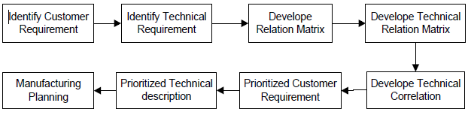Fig 1. Qualitative methodology used in study.

RESULTS
Study Participants:
A total of 25 packaging industries participated in this study (including Sangli and Kolhapur district industries) with different majorly related to food packing industries. These industries delivered different kinds of difficulties and that is been listed and analysed on the number of industry having common issues regarding the filling and settling stations in the Table 4. That is also displayed with the number-related graph showing the proper chart show casing the difficulties.
Table 4: List of Difficulties with some packaging industry reported.
Difficulty Number | Difficulties Faced by Manual operated filling station | Number of Industries Reported (Out of 25)
1 | Difficulties in operating | 20
2 | Operating In Standing | 23
3 | Uncomfortable to settle the quantity | 17
4 | Increased error rates | 22
5 | Heavy and large equipment | 15
6 | No safety measures | 11
7 | More Fatigue issues | 24
8 | High cost | 9
9 | More Maintenances required | 18
10 | More mechanical Breakdown | 14
11 | Technology implementation | 24
12 | Data retrieval | 19

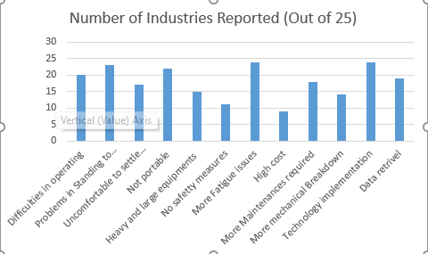
Fig 2: Difficulties vs number of industries chart
KEY DIFFICULTIES ENLISTED
The four key difficulties enlisted were the following: Problems in standing to do the operation; Difficulties in operating the machine; There is no portability to the machine; Difficulties in technology implementation and data retrieval. List of difficulties with number of packaging industries is detailed in Table 4 and Fig 2.
Problems in standing to do the operation.
While using the manually operated filling station, people were facing problems while operating the station of filling having recurring leg pain because they had to operate the machine standing. In response to the questions posed related to transfer, 23 (92%) users suggested the problem with standing and operating the machine. Twenty (80%) users gave a 10/10 rating for the sit-and-operate machine design feature which received a 9.25/10 overall rating.
The problems faced by the worker have been a pain in the legs due to constantly standing at the place of work. Due to the constant standing there leads to laziness.

Problem in operating machine
While operating the manually operated machine for the work of filling the predefined quantity of viscous fluid there are problems faced for operating the machine to be using the manpower at an appropriate stage. There is a to-and-fro motion of the lever to suction and extract. In response to the question related to this issue, 20 (80%) users denoted the issue in operating the machine as it ventures to fatigue. 17(68%) users provide a 10/10 rating for making the guidance posters or bringing automation in the operation with features to a 9.15/10 overall rating.
The problems faced by the workers to indulge their entire body strength for the procedures for the filling of viscous fluid. Automation may reduce fatigue it may also add to the productivity of the filling.

Problem faced due to no portability of the machine.
The entire setup of the packaging by filling the viscous fluid with the machine is manually operated and at various industries, the entire setup was very bulky, and it was not easy to change position, or it could be travelled to the required location. In response to the questions related to this issue, 22 (88%) users emphasised the issue of the portability of the station of operation to position. 16 (64%) users provide 10/10 rating for making the base roller to the station or compact the size the automated machine in order it would be easy to moved anywhere required with features to 7.85/10 overall rating.
The problem faced for no portability can be back pain issue for always shifting the machine wherever required and it also might require the involvement of more worker. So reducing the size of the automated machine with limited weight and rollers at base will be good solution.
Difficulties in technology implementation and data retrieval
The manually operated filling station doesn’t have any measuring of the quantity and as it uses mane power so there is not designed to implement for the technologies like data retrieval device, Load cell to measure quantity in container and not use of Bluetooth module in order to operate it with automation model with the inputs given by the mobile device for remote controller. In response to the question for this problem, 24 (96 %) users for technology implementation and 19 (76%) for the data retrieval users showed their approach in the issues. 18 (72%) users shoed 10/10 rating for the implementation of Bluetooth operation and creating the excel database of the filling in the container with features 9.27/10 overall rating.
The problem faced by industries to data retrieval is that they don’t know how much quantity is been dispatched by the filling inside the container. This may lead to lack of productivity measurement.

QFD DESIGN
Industry Importance ratings
Understanding the industry requirements was performed by visiting the 25 industries was step taken in for the study. The answers from heads were weighted to get the measured value. The relevant data from the industries was then used in the QFD analysis to convert the industry requirements straight to design parameters. Table 5 displays the industry importance rating and industry requirements.
Table 5. 25 industry requirements received from data analysis.
Industry Requirements no. | Industry Requirements | Industry Importance Ratings (Out of 10)
1 | Creating the sitting Arrangement | 9.25
2 | Reduce size of setup of automation | 8.76
3 | Low cost | 9.65
4 | Low service and Maintenance | 9.43
5 | Add base roller for easy movement | 7.85
6 | Hygiene consideration | 8.76
7 | Bluetooth operating system | 9.27
8 | Use of Load cell for measuring Quantity | 7.98
9 | Low weight | 7.96
10 | Easy operation | 9.15
Priority of Design parameters
According to the information gathered from the respective industries and after one-to-one interview it understood the required parameters that is been concerned with the user of the station of filling and settling. Table 6 shows the satisfied design parameters that is predicting the user’s requirements. The weight is taken based on the overall importance of the design parameters from the industries.
Table 6. Six design parameters deployed in the QFD Study
Design Parameters (DP)  Number | Design Parameters identified to Resolve issue in the manually operated viscous fluid filling station |  | Relative Weighting  (Out of 10)
1 | Adjustable sitting arrangements on machine | 8.4
2 | Use Arduino to operate with Bluetooth controller | 7.9
3 | Attach the pouring and settling stations besides to get smooth operation | 9.3
4 | Attach the load cell below the vibrating table. | 8.1
5 | Selecting low weight material | 7.5
6 | Make available for different viscous fluids like oil, paste, sauces | 8.7

HOUSE OF QUALITY
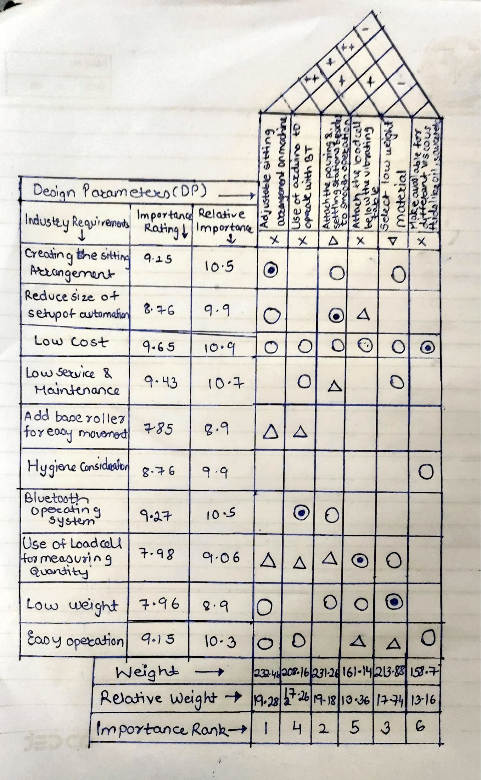Figure 4. House of Quality (HOQ) diagram for the automated viscous fluid filling machine.
The house of quality emphasises on the importance of the work to done on the best priority. In this there are many correlations and relationship matrix which are been calculated on the basis of various relationships symbols and a positive and negative symbol are being mentioned in figure 5 about the correlation between the industry requirements and design parameters. And figure 6 indicates the relationship among the design parameters.
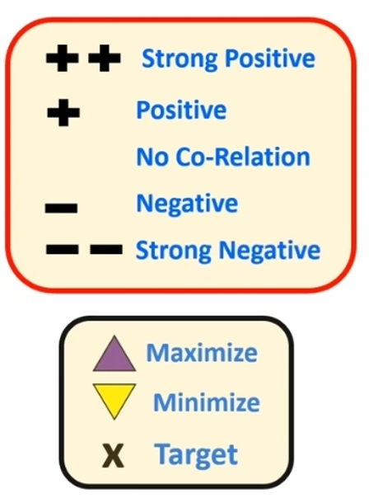
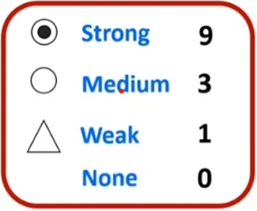

Figure 5. Correlation between industry requirements and design parameters

Figure 6. Relationship among the design parameters

CALCULATIONS FOR PRIORITY ESTIMATION OF DESIGN PARAMETERS
- The value of the absolute weight has been measured by using formula,
It is also used for other design parameters separately for weights.
- The value of Relative weight has been measured by using formula.
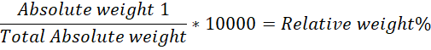
It is also used for other design parameters separately for relative weights in percentage.
- To measure relative importance of the rating by industry use formula.
It is also used for other design parameters separately for relative importance in percentage.
THE DESIGN OF AUTOMATED VISCOUS FLUID FILLING MACHINE
After obtaining results from the goal program, the automatic filling machine was designed.
A description of the final model is presented in Table 7 and Figure 7. The design
expressed in form, fit, or function, as shown in Table 7. For the draft design in Figure 7, the proposed machine can fill the bottle at a rate of up to 62.5 mL/s and is suitable to use for filling bottles of 100 mL up to 750 mL in size.
The machine has a pneumatics cylinder operating system. This function enables the user to precisely adjust the expected fluid level. The machine can be equipped with a conveyor machine for higher productivity. Thus, these attributes mean the proposed system can be used relevant to the industrial application of filling the container for more productivity. Fulfillment level and cost function.
obtaining results from the goal program, the automatic viscous fluid filling machine was
designed. A description of the final model is presented in Table 7 and engineers have tried to combine the concepts of the filling single bottle and multi-head, filling machine. Price, function, and size are key components in the design of a structural platform of an automatic filling machine that can effectively support it.

Table 7: Product Characteristics after QFD analysis.
Product Characteristics | Definition
Automatic system | The mechanism is high-tech. A “less-human labor required” concept is applied to the entire process of filling system.
Mission complete within just a few seconds | The proper “Liquid Filling Equipment” and “Water flow rate”  conditions are provided to assist with fast filling.
Smaller Size | Filling machine can be easily moved and relocated.
Easy to access | The universal design has been implemented having “Discharge unit” to fill the Viscous fluid in Bottle or container and “Vibrating table” to settle the fluid inside the container.
Easy to control | The controlling program and equipment immediately send the command and retrieve the feedback, with less error.
Providing more than one level of filling volume | Different volumes of water and oil are available (e.g. 100 mL, 250 mL, 500 mL, 750 mL).

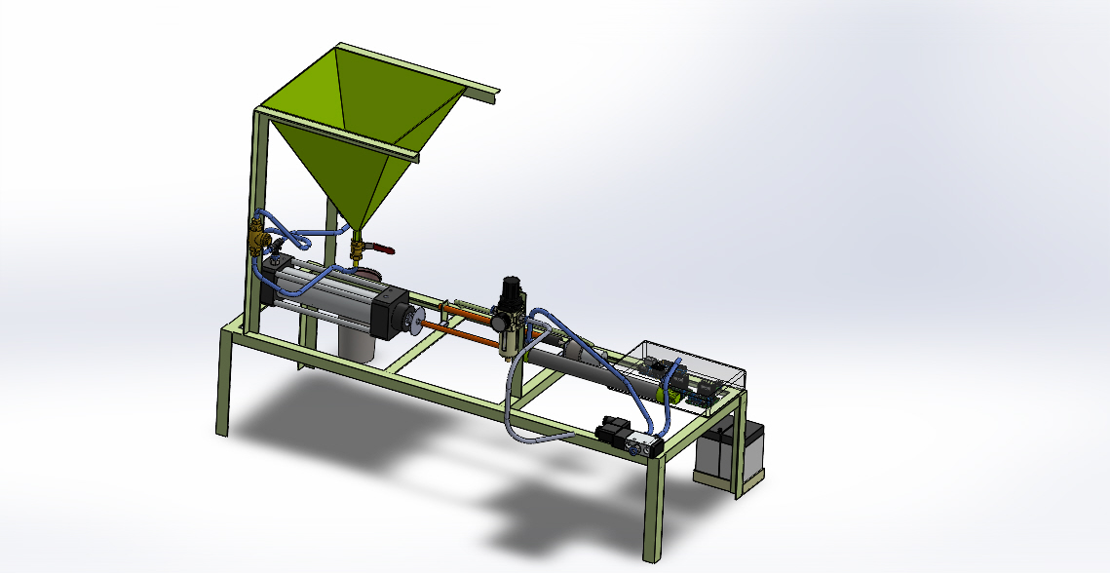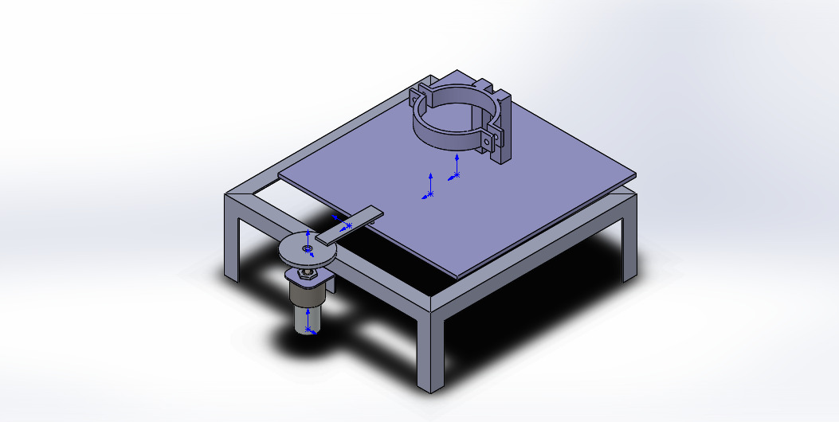
Fig 7. Model of automatic viscous fluid filling machine
For the draft design in Figure 7, the proposed machine can fill the bottle at a rate of up to 62.5 mL/s and is suitable to use for filling bottles of 100 mL up to 750 mL in size. The machine has an automatic pneumatic mechanism for suction and extraction of the fluid in the bottle or container. Also, it has an additional settling table which is used as a vibrating table to do the shackling of the bottle, a gripper to grip the bottle is also attached to the system as shown in Figure 7. The vibrating table is enabled with a load cell to weigh the volume of the fluid inside the unit. The display of the volume weighed has been delivered via. an android application

DISCUSSION
The assessment study is to elaborate the majorly needed requirements to implement in the new machine by having the importance rating from figure 5. For key themes emerged: 1. Problems in standing to do the operation; 2. Difficulties in operating the machine; 3. There is no portability to the machine; 4. Difficulties in technology implementation and data retrieval. After all, OFD analysis revealed that out of 6 design parameters the highest technical importance: 1. Adjustable sitting arrangements on machine (19.28%); 2. Attach the pouring and settling stations besides to get smooth operation (19.18%); 3. Selecting low weight material (17.74%); 4. Use Arduino to operate with Bluetooth controller (17.26%);
Figure 4 depicts the association of 10 industry requirements and 6 design parameters with their importance in terms of absolute weight and relative weight importance. Low cost and fatigue relief was majorly taken into consideration for as the medium for the design of the machine.

CONCLUSION
The study displays the perspective of automation in the packing of food items with a proper report on the QFD analysis to get proper design parameters to create the overall analysed device to bring great productivity to the filling and settling station. The analysis can bring unique techniques onto the stations to make the operation easy and precise. The issues provided by the industries were studied properly and implementation of the design parameters was made as per their requirements. This project was an industry-based solution given and provided to various industries for their filling and settling of the viscous fluid in predefined quantities by projecting automation to the project. The data of the quantity settled in the container was also collected and stored to get the data retrieval whenever required. The size is reduced so the machine is also got lesser weight, so it is portable in use. The industry review was positive for the design parameters implemented and presented well.

REFERENCES
Kumar, R., et al. (2018). Automation of fluid filling system using PLC and SCADA. International Journal of Advanced Research in Computer Engineering & Technology, 7(5), 1320-1325.
Hauser, J. R., & Clausing, D. (1988). The house of quality. Harvard Business Review, 66(3), 63-73.
Zarei, M., Fakhrzad, M.B., & Jamali Paghaleh, M. (2011): Explores QFD integration within the food supply chain, emphasizing its role in enhancing efficiency, quality, and customer satisfaction.
Rujito, H., Utami, M.M.D., Rishkiawan, H.Y., Hermanuadi, D., & Retnowati, N. (2020): Investigates QFD application in product design, specifically in developing Kolang Kaling grass jelly drink, demonstrating its effectiveness in aligning customer preferences and market demands.
Miguel, P.A.C. (2016): Provides a comparative analysis of QFD implementation in packaging product development between Italian and Brazilian companies, highlighting cultural and organizational differences.
Desai, S., Mantha, S., & Phalle, V. (2017): Delves into QFD application in designing assistive technology, particularly in the development of a new wheelchair, emphasizing its role in bridging the gap between user needs and engineering specifications.
Kelesbayev, D., Kalkulov, K., Yertayev, Y., Turlybekova, A., & Kamalov, A. (2016): Discusses the adaptation of QFD in higher education, illustrating its effectiveness in enhancing the quality of education and services provided by academic institutions.
Liu, H.-b., Wang, L.-z., & Hou, Z.-y. (2011): Presents a practical application of QFD in developing an automatic liquid filling machine, highlighting its affordab

