**PLANNING, ANALYSIS AND DESIGN OF HOSPITAL**

**BUILDING BY USING ETABS**

**Raavi Pavan Siva Sai Ganesh* ,Morampudi Navya* , Mullangi Komali* ,Mynam Siva Gopi Krishna*,**

**P. Narendra Babu1 and N A G K Manikanta Kopuri2**

**UGStudents-Final Year, 1Associate Professor & HOD, 2Assistant Professor Department of Civil Engineering,**

NRI Institute of Technology, Agiripalli,

# ABSTRACT

In every aspect of human civilization we need building structures to live in or to get what we need. But it is not only building structures but to build efficient structures so that it can fulfil the main purpose for what it is made for. Here comes the role of civil engineering and more precisely the role of analysis of structure. The present design consists of G+5 commercial building. The floor to floor distance is 3m. There are many classical methods to solve the design problems and with time new software’s are also coming into play. Here in this project work based on software named “ETABS”, design and analysis of multistoried G+6 building using RCC structure are carried out. ETABS are the effective software’s which are used for the purpose of analysis and design of structure by the structural engineers. These software’s give more precise and accurate results than manual techniques. ETABS was used to create the mathematical model of the Burj Khalifa (UAE). The input, output and numerical solution techniques of ETABS are specifically designed to take advantage of the unique physical and numerical characteristics associated with building type structures. ETABS provides both static and dynamic analysis for wide range of gravity, thermal and lateral loads. In this project I analyze and design the multi-storey building using ETABS. Comparing results obtained by software’s and justifying economical one or to decide best software to adopt for design and to increase the number of storey of the structure.

Keywords -Auto CAD, Code, Etabs

# I. INTRODUCTION

India is a developing country and has developed in every sense since its independence. The most important are the infrastructural development which is to be provided in order to generate an efficient way to work. Infrastructure has become very important in today’s era, since it has been the key factor in the growth of a country, be it in information technology, logistics or any other senses. The presence of high rise buildings in a country displays its economic strength. Now in India in cities like Mumbai, the government is sanctioning the construction of highrise buildings. As of next year, Mumbai will be the city having the world’s tallest residential building named World one. Building these mega structures has become common in today’s world since it is the only way in which humans can make the maximum use of the piece of land. But the main concern is when the designing part of these high rise structure comes into play. Unlike the old times, the designing of the building was done manually. Until the innovation into civil engineering field which started the use of computer-oriented design software into the process of designing of a structure or a high rise building. Today there are hundreds of software which consult into the designing of the civil related structures and also managerial software which deals with the management of the construction activities on the site. The various software in the field of designing are namely E-Tabs, STAAD.pro, SAFE etc. These are most widely used software around the world. The main focus being on E-Tabs software. Since in India, it is been used from recent past even though it has been existing since last three decades.

The software ETABS has an ultimate integrated system which helps in computing the values required for the designing and analysis of the building. It has been used in some of the most renowned building projects the mankind has known. E-tabs was used to create the mathematical modelling of the Burj Khalifa, currently the tallest building the world, designed by Chicago, Illinois-based Skidmore, Owings and Merrill (SOM). Various factors like gravity, wind and seismic response were all characterized using ETABS. ETABS is commonly used to analyse skyscrapers, parking garages, steel and concrete structures, low-rise buildings, portal frame structures, and high rise buildings. Concrete structures provide a vast availability in the field of civil engineering. It has redefined the construction methods and building high-rise structures at easy. Concrete structures also include various structures like Dams, retaining walls, bridges and skyscrapers. After the introduction of concrete cement in before Christ era, it has been in the construction field since then. It is the basic requirement for the building of any structure which is of vital importance. In India concrete structures are used almost everywhere, even the simple residential blocks are concrete made unlike in western countries where the houses are made of wood. Concrete has been the most favourable material in the field of construction because of its properties as it is durable, strong, resistant and reliable. It is used under various types of Reinforced Cement Concrete, plain cement concrete, and various under the same categories. The necessity and importance of concrete are immense. To analyse the structural details of the structure.

# II.LITERATURE REVIEW

**Varalakshmi V et.al** (2014) [1] built the skeleton of a G+5 home from the ground up. IS 875(Part I & II)-1987 dead and live loads and IS 1986-1985 HYSD bars were employed in this study. They observed that a reinforced concrete structure's safety depends on its structural analysis, design, and reinforcing characteristics.

**Chandrashekar et.al** (2015) [2] ETABS was used for both the assessment and planning of the multi-story structure. A G+5 building's response to lateral wind and seismic loads was analysed in ETABS. They considered fire spread and the best fireproof material. They offered the innovative and user-friendly ETABS application for high-rise structures to save design time.

**Balaji.U and Selvarasan M.E** (2016) [3] multi-story structures' static and dynamic loads were analysed and designed using ETABS. The effects of an earthquake on a G+13 house were analysed using ETABS. For both static and dynamic analyses, linear material characteristics were used. Behaviour in areas of high seismicity and soil type II was analysed using a non-linear model. Base shear and displacements were charted and analysed.

**Geethu et.al** (2016) [4] compared STAAD.Pro with ETABS multi-story building analysis and design. They designed residential and commercial buildings. The Auto CAD-drafted plan followed the national construction code. ETABS software had greater bending moment and axial force readings.

**Nagaratna et.al** Multi-storey structural analysis and design project RCC building analyses multistorey buildings using structural analysis methodologies and software (ETABS). E-TABS software analyses beams and columns, while IS: 456-2000's "LIMIT STATE METHOD" designs slabs and footings. Uses M-25 concrete and Fe-415 steel.

**Maruthi T et.al** In Civil Engineering, a building is a structure with many parts such a base, ETABS' input, output, and Building-type structures' physical and numerical properties are used to solve numerical problems. Architectural features include walls, columns, floors, roofs, doors, windows, ventilators, stairlifts, surface treatments, etc. Structural studies and design create a structure that can withstand all loads.

**B. Anusha et.al.** We understand the housing issues in this era of diminishing space, time, and expectation. Any institution now offers student hostels. G+4 building with stairs and elevator accommodates 120 students. The model is being prepared by ETABS. It is capable of handling complex structures as well as high-rise skyscrapers. It performs assessments on beams, columns, slabs, shear walls, and other structural elements. We are able to quickly analyse a wide variety of materials using ETABS, including concrete, steel, reinforced concrete, and others. Produce gravitational, lateral, and self-weights on its own automatically. (Varalakshmi V et al-2014).

**Chandrakala V B et.al ,** Civil engineering constructions have foundations, walls, columns, floors, roofs, doors, windows, ventilators, stairs lifts, and surface treatments. Design and analysis create load-bearing structures. Structural analysis and design need geotechnical study. Geotechnical site investigations design and install foundations. Structural engineers must carefully design the most cost-effective and functional building for its intended application.

**Nilendu Chakrabortty et.al,** The successful plan and development of seismic tremor safe structures have a lot more significance worldwide, so designs are trying to use various materials to their best advantage, keeping in mind the unique properties of each material. Combining the most desirable qualities of a single material with the functional and aesthetic requirements of the project results in the construction of the most robust and aesthetically pleasing buildings.

**Nirmal S. et.al** ETABS engineering software analyses and designs multi-storey buildings. Extended Three- Dimensional Building System Analysis is ETABS. CAD drawings may be used to create ETABS models or as templates for ETABS items. Software generates full reinforcement report. Building floor levels are identical, reducing modelling and design time. Similar storey model creation for speed. Structural components might be steel, RCC, composite, or user defined.

**Shah H. J. and Jain S. K. et.al,** Have examined building earthquake performance utilising various load combinations. They also examined high-wind building performance. They also detailed structural components utilising Indian Standard Code. Restoring force depends on shear wall location.

**Uma M and Nagarajan (2016) et.al ,** Changed the shear wall placement to get the best multistorey building structural layout. The shear wall at the building corner has minimal displacement and drifts, making it the best site. Shear wall material also affects building performance.

## III.METHODOLOGY

Stilt, 1st, 2nd, and one more level are planned for the residential construction. RCC beams and slabs support the structural framework. Columns are spaced for stability and utility with

RCC shear walls.

Architectural planning and serviceability determine beam planning. Secondary beams are required.

The system resists the entire design force according to their lateral stiffness considering floor level interaction. IS:1893(Part1)-2016 classifies the building as an SMRF.

Horizontal diaphragms are floor slabs.

3-D ETAB Software will be utilised for structural system analysis and design/detail. All designs must adhere to Indian requirements.

PLAN OF THE PROJECT

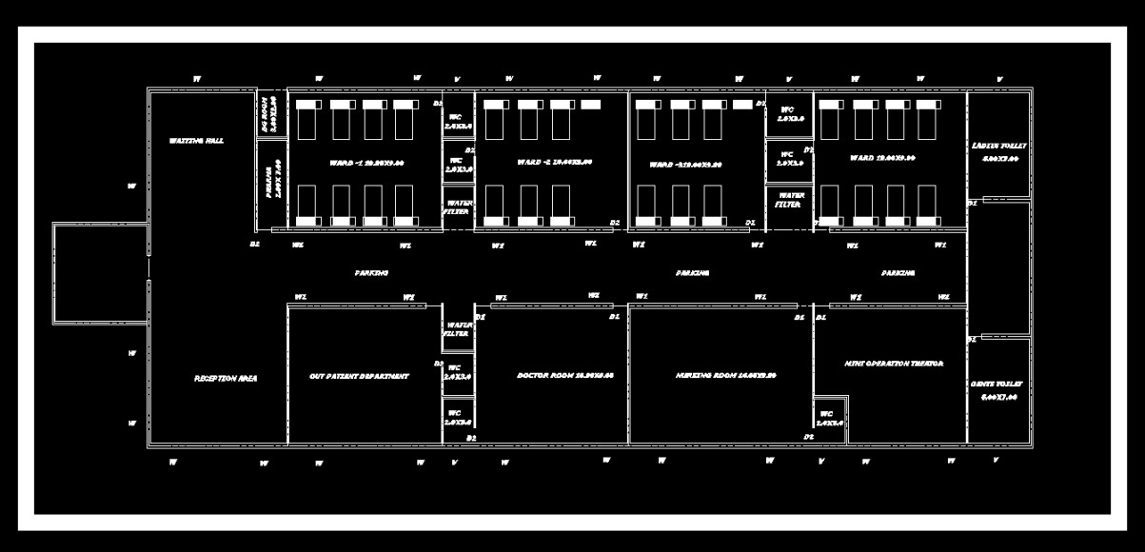

### A black grid with red lines Description automatically generatedLINE DIAGRAM

**DETAILS OF THE PROJECT**

* Structure: G+5
* Floor height(First Floor to Fifth Floor) : 4.0m
* Grade of Concrete : M-25
* Unit weight of Concrete : 25 KN/M3
* Rebar material grade : HYSD500
* Beam sizes :B1(300x230)mm
* B2(300X450)mm
* B3(300X600)mm
* Column sizes : C1(350x350)mm
* C2(450X450)mm
* C3(500x500)mm
* PLOT AREA:- 2404 sqm
* CARPET AREA :-1416 sqm
* SUPER BUILT UP AREA :-1422 sqm
* DEAD LOAD (IS875-part-1) Unit weight of building materials.
* LIVE LOAD (IS875- PART-2)
* WIND LOAD(IS875-part-3)
* SEISMIC LOAD(IS1893-part-1)
* LOAD COMBINATIONS

#### A computer screen shot of a blueprint Description automatically generated3D VIEW

#### ANALYSIS AND RESULTS

The present structure is modelled and analyzed and analysis using ETABS. For the analysis of gravity load and seismic loads. The live load of the structure is considered 2 kN/m2. For the lateral load analysis (earthquake) parameter are considered as per Indian code basis.

**For area of longitudinal reinforcement, go to design menu in ETAB, concrete frame design and start design check.**

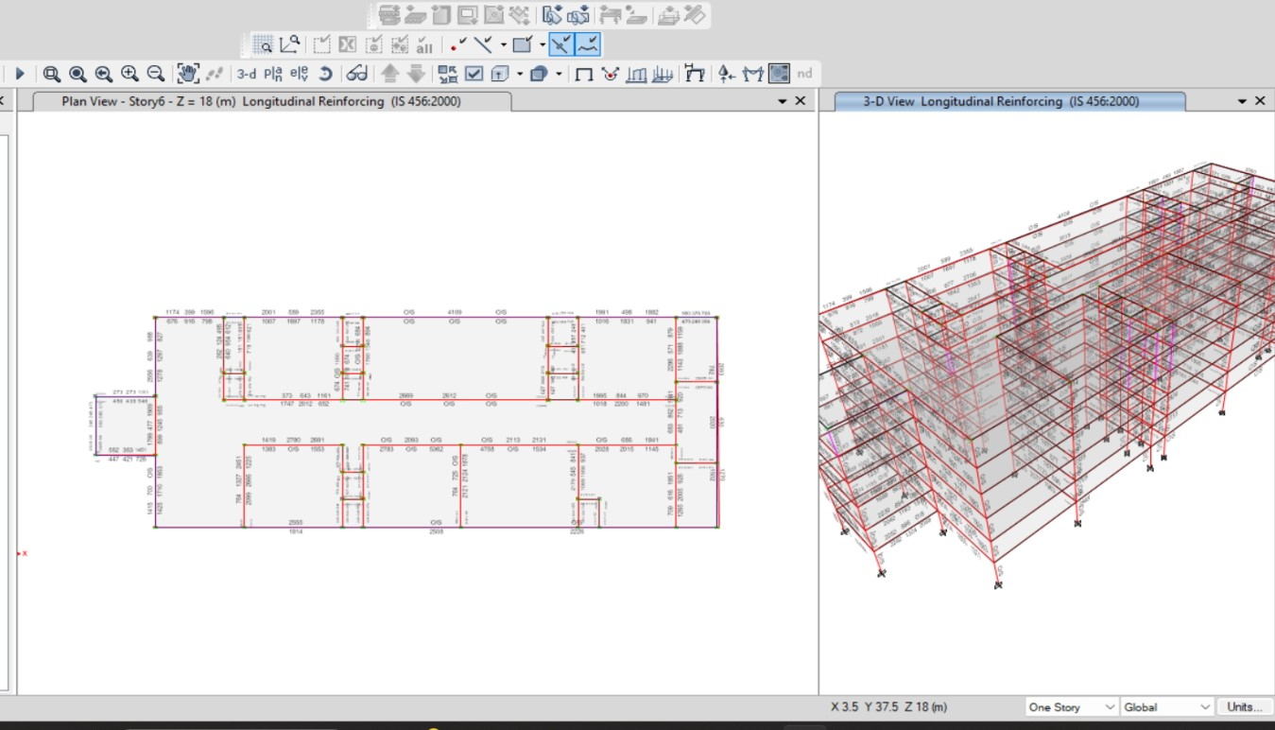

SHEAR FORCE

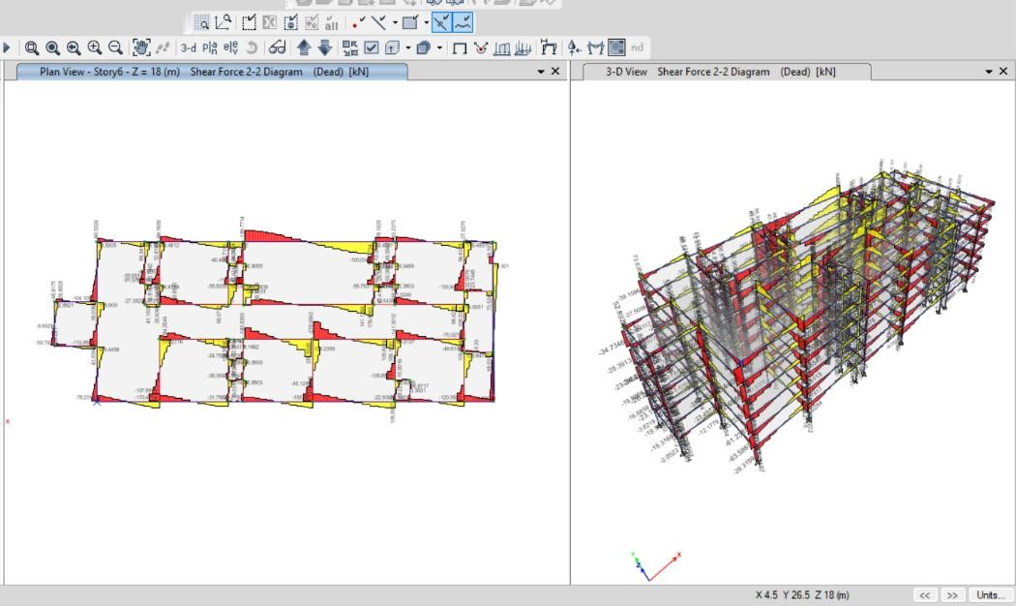

BENDING MOMENT

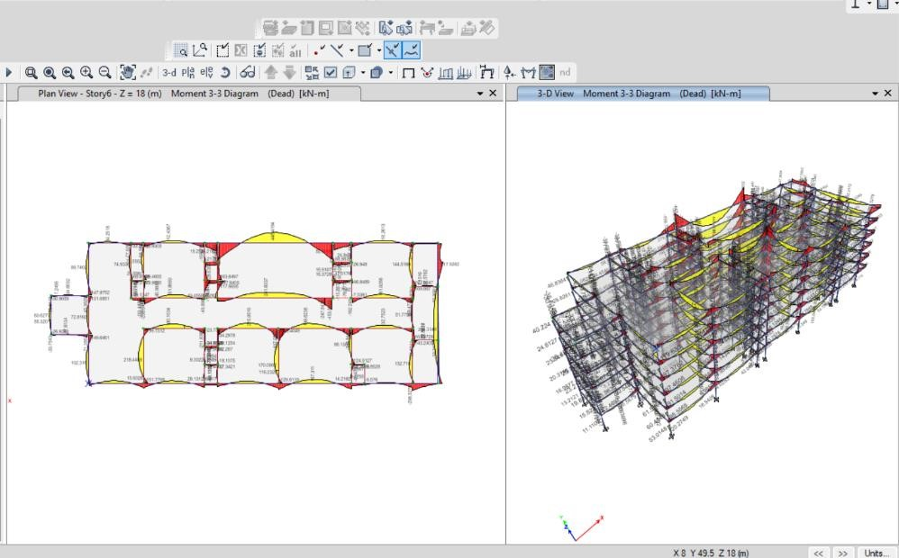

Design > Concrete Frame Design > Display Design Information shows steel percentages and column beam steel areas.

# BEAM-1

## ETABS Concrete Frame Design

**IS 456:2000 + IS 13920:2016 Beam Section Design**

Beam Element Details Type: Ductile Frame (Summary)

|  |  |  |  |  |  |  |  |
| --- | --- | --- | --- | --- | --- | --- | --- |
| **Level** | **Element** | **Unique Name** | **Section ID** | **Combo ID** | **Station Loc** | **Length (mm)** | **LLRF** |
| Story6 | B61 | 26 | BEAM | DCon19 | 3200 | 3375 | 1 |

Section Properties

|  |  |  |  |  |  |
| --- | --- | --- | --- | --- | --- |
| **b (mm)** | **h (mm)** | **b** f **(mm)** | **d** s **(mm)** | **d** ct **(mm)** | **d** cb **(mm)** |
| 230 | 350 | 230 | 0 | 35 | 35 |

Material Properties

|  |  |  |  |  |
| --- | --- | --- | --- | --- |
| **E** c **(MPa)** | **f** ck **(MPa)** | **Lt.Wt Factor (Unitless)** | **f** y **(MPa)** | **f** ys **(MPa)** |
| 25000 | 25 | 1 | 500 | 500 |

Design Code Parameters

|  |  |
| --- | --- |
| **ɣ** C | **ɣ**    S |
|  |  |

Factored Forces and Moments

|  |  |  |  |
| --- | --- | --- | --- |
| **Factored**  **M** u3  **kN-m** | **Factored**  **T** u  **kN-m** | **Factored**  **V** u2  **kN** | **Factored**  **P** u **kN** |
| -28.2484 | 2.7973 | 30.0286 | 5.734 |

Design Moments, M u3 & M t

|  |  |  |  |
| --- | --- | --- | --- |
| **Factored**  **Moment kN-m** | **Factored**  **M** t  **kN-m** | **Positive**  **Moment kN-m** | **Negative**  **Moment kN-m** |
| -28.2484 | 4.1495 | 0 | -32.3979 |

Design Moment and Flexural Reinforcement for Moment, M u3 & T u

|  |  |  |  |  |  |  |
| --- | --- | --- | --- | --- | --- | --- |
|  | **Design**  **-Moment kN-m** | **Design**  **+Moment kN-m** | **-Moment**  **Rebar mm²** | **+Moment**  **Rebar mm²** | **Minimum**  **Rebar mm²** | **Required**  **Rebar mm²** |
| Top (+2 Axis) | -32.3979 |  | 241 | 0 | 241 | 174 |
| Bottom (-2 Axis) |  | 0 | 121 | 0 | 0 | 121 |

Shear Force and Reinforcement for Shear, V u2 & T u

|  |  |  |  |  |
| --- | --- | --- | --- | --- |
| **Shear V** e **kN** | **Shear V** c **kN** | **Shear V** s **kN** | **Shear V** p **kN** | **Rebar A**sv **/s mm²/m** |
| 42.8968 | 0 | 62.3563 | 23.8886 | 548.55 |

Torsion Force and Torsion Reinforcement for Torsion, Tu & V U2

|  |  |  |  |  |
| --- | --- | --- | --- | --- |
| **T** u  **kN-m** | **V** u **kN** | **Core b** 1 **mm** | **Core d** 1 **mm** | **Rebar A**svt **/s mm²/m** |
| 2.7973 | 30.0286 | 180 | 300 | 254.5 |

# BEAM -2

## ETABS Concrete Frame Design

**IS 456:2000 + IS 13920:2016 Beam Section Design**

Beam Element Details Type: Ductile Frame (Summary)

|  |  |  |  |  |  |  |  |
| --- | --- | --- | --- | --- | --- | --- | --- |
| **Level** | **Element** | **Unique Name** | **Section ID** | **Combo ID** | **Station Loc** | **Length (mm)** | **LLRF** |
| Story6 | B27 | 157 | FSec2 | DCon21 | 8080 | 23360 | 1 |

Section Properties

|  |  |  |  |  |  |
| --- | --- | --- | --- | --- | --- |
| **b (mm)** | **h (mm)** | **b** f **(mm)** | **d** s **(mm)** | **d** ct **(mm)** | **d** cb **(mm)** |
| 300 | 450 | 300 | 0 | 30 | 30 |

Material Properties

|  |  |  |  |  |
| --- | --- | --- | --- | --- |
| **E** c **(MPa)** | **f** ck **(MPa)** | **Lt.Wt Factor (Unitless)** | **f** y **(MPa)** | **f** ys **(MPa)** |
| 27386.13 | 30 | 1 | 500 | 500 |

Design Code Parameters

|  |  |
| --- | --- |
| **ɣ** C | **ɣ**    S |
|  |  |

Factored Forces and Moments

|  |  |  |  |
| --- | --- | --- | --- |
| **Factored**  **M** u3  **kN-m** | **Factored**  **T** u  **kN-m** | **Factored**  **V** u2  **kN** | **Factored**  **P** u **kN** |
| -180.3254 | 84.196 | 119.4508 | 28.2329 |

Design Moments, M u3 & M t

|  |  |  |  |
| --- | --- | --- | --- |
| **Factored**  **Moment kN-m** | **Factored**  **M** t  **kN-m** | **Positive**  **Moment kN-m** | **Negative**  **Moment kN-m** |
| -180.3254 | 123.8176 | 0 | -304.143 |

Design Moment and Flexural Reinforcement for Moment, M u3 & T u

|  |  |  |  |  |  |  |
| --- | --- | --- | --- | --- | --- | --- |
|  | **Design**  **-Moment kN-m** | **Design**  **+Moment kN-m** | **-Moment**  **Rebar mm²** | **+Moment**  **Rebar mm²** | **Minimum**  **Rebar mm²** | **Required**  **Rebar mm²** |
| Top (+2 Axis) | -304.143 |  | 2019 | 0 | 2019 | 648 |
| Bottom (-2 Axis) |  | 0 | 648 | 0 | 0 | 648 |

Shear Force and Reinforcement for Shear, V u2 & T u

|  |  |  |  |  |
| --- | --- | --- | --- | --- |
| **Shear V** e **kN** | **Shear V** c **kN** | **Shear V** s **kN** | **Shear V** p **kN** | **Rebar A**sv **/s mm²/m** |
| O/S #45 | 0 | 0 | 63.7662 | 0 |

Torsion Force and Torsion Reinforcement for Torsion, Tu & V U2

|  |  |  |  |  |
| --- | --- | --- | --- | --- |
| **T** u  **kN-m** | **V** u **kN** | **Core b** 1 **mm** | **Core d** 1 **mm** | **Rebar A**svt **/s mm²/m** |
| 84.196 | 119.4508 | 260 | 410 | 3030.07 |

**O/S #45 Shear stress due to shear force and torsion together exceeds maximum allowed**

# BEAM-3

## ETABS Concrete Frame Design

**IS 456:2000 + IS 13920:2016 Beam Section Design**

Beam Element Details Type: Ductile Frame (Summary)

|  |  |  |  |  |  |  |  |
| --- | --- | --- | --- | --- | --- | --- | --- |
| **Level** | **Element** | **Unique Name** | **Section ID** | **Combo ID** | **Station Loc** | **Length (mm)** | **LLRF** |
| Story6 | B29 | 169 | FSec3 | DCon2 | 43660 | 57970 | 1 |

Section Properties

|  |  |  |  |  |  |
| --- | --- | --- | --- | --- | --- |
| **b (mm)** | **h (mm)** | **b** f **(mm)** | **d** s **(mm)** | **d** ct **(mm)** | **d** cb **(mm)** |
| 300 | 600 | 300 | 0 | 30 | 30 |

Material Properties

|  |  |  |  |  |
| --- | --- | --- | --- | --- |
| **E** c **(MPa)** | **f** ck **(MPa)** | **Lt.Wt Factor (Unitless)** | **f** y **(MPa)** | **f** ys **(MPa)** |
| 27386.13 | 30 | 1 | 500 | 500 |

Design Code Parameters



**ɣ**

C



**ɣ**

S

Factored Forces and Moments

|  |  |  |  |
| --- | --- | --- | --- |
| **Factored**  **M** u3  **kN-m** | **Factored**  **T** u  **kN-m** | **Factored**  **V** u2  **kN** | **Factored**  **P** u **kN** |
| -348.4219 | 66.3015 | 155.4774 | 32.622 |

**Design Moments, M** u3 **& M** t

|  |  |  |  |
| --- | --- | --- | --- |
| **Factored**  **Moment kN-m** | **Factored**  **M** t  **kN-m** | **Positive**  **Moment kN-m** | **Negative**  **Moment kN-m** |
| -348.4219 | 117.0027 | 0 | -465.4246 |

Design Moment and Flexural Reinforcement for Moment, M u3 & T u

|  |  |  |  |  |  |  |
| --- | --- | --- | --- | --- | --- | --- |
|  | **Design**  **-Moment kN-m** | **Design**  **+Moment kN-m** | **-Moment**  **Rebar mm²** | **+Moment**  **Rebar mm²** | **Minimum**  **Rebar mm²** | **Required**  **Rebar mm²** |
| Top (+2 Axis) | -465.4246 |  | 2171 | 0 | 2171 | 543 |
| Bottom (-2 Axis) |  | 0 | 543 | 0 | 0 | 543 |

Shear Force and Reinforcement for Shear, V u2 & T u

|  |  |  |  |  |
| --- | --- | --- | --- | --- |
| **Shear V** e **kN** | **Shear V** c **kN** | **Shear V** s **kN** | **Shear V** p **kN** | **Rebar A**sv **/s mm²/m** |
| 155.4774 | 124.2947 | 384.7908 | 37.4705 | 1870.68 |

Torsion Force and Torsion Reinforcement for Torsion, Tu & V U2

|  |  |  |  |  |
| --- | --- | --- | --- | --- |
| **T** u  **kN-m** | **V** u **kN** | **Core b** 1 **mm** | **Core d** 1 **mm** | **Rebar A**svt **/s mm²/m** |
| 66.3015 | 155.4774 | 260 | 560 | 1870.68 |

## COLUMN-1

### ETABS Concrete Frame Design

**IS 456:2000 + IS 13920:2016 Column Section Design**

Column Element Details Type: Ductile Frame (Summary)

|  |  |  |  |  |  |  |  |
| --- | --- | --- | --- | --- | --- | --- | --- |
| **Level** | **Element** | **Unique Name** | **Section ID** | **Combo ID** | **Station Loc** | **Length (mm)** | **LLRF** |
| Story1 | C40 | 608 | COLUMN | DCon21 | 0 | 3000 | 0.851 |

Section Properties

|  |  |  |  |
| --- | --- | --- | --- |
| **b (mm)** | **h (mm)** | **dc (mm)** | **Cover (Torsion) (mm)** |
| 230 | 350 | 55 | 25 |

Material Properties

**E** c **(MPa) f** ck **(MPa) Lt.Wt Factor (Unitless) f** y **(MPa) f** ys **(MPa)**

25000

25

1

500

500

Design Code Parameters

|  |  |
| --- | --- |
| **ɣ** C | **ɣ**    S |
|  |  |

Axial Force and Biaxial Moment Design For P u , M u2 , M u3

|  |  |  |  |  |  |  |
| --- | --- | --- | --- | --- | --- | --- |
| **Design P** u **kN** | **Design M** u2 **kN-m** | **Design M** u3 **kN-m** | **Minimum M** 2 **kN-m** | **Minimum M** 3 **kN-m** | **Rebar Area mm²** | **Rebar % %** |
| -67.1618 | 74.2438 | 22.2888 | 1.3432 | 1.3432 | 3481 | 4.32 |

Axial Force and Biaxial Moment Factors

|  |  |  |  |  |  |
| --- | --- | --- | --- | --- | --- |
|  | **K Factor Unitless** | **Length mm** | **Initial Moment kN-m** | **Additional Moment kN-m** | **Minimum Moment kN-m** |
| Major Bend(M3) | 1 | 2500 | 8.9155 | 0 | 1.3432 |
| Minor Bend(M2) | 0.641691 | 2500 | 29.6975 | 0 | 1.3432 |

Shear Design for V u2 , V u3

|  |  |  |  |  |  |
| --- | --- | --- | --- | --- | --- |
|  | **Shear V** u **kN** | **Shear V** c **kN** | **Shear V** s **kN** | **Shear V** p **kN** | **Rebar A**sv **/s mm²/m** |
| Major, Vu2 | 14.4302 | 60.0621 | 27.1402 | 0 | 254.94 |
| Minor, V u3 | 47.4888 | 55.5742 | 24.5003 | 46.6095 | 387.95 |

Joint Shear Check/Design

|  |  |  |  |  |  |  |
| --- | --- | --- | --- | --- | --- | --- |
|  | **Joint Shear**  **Force kN** | **Shear**  **V** Top  **kN** | **Shear**  **V** u,Tot  **kN** | **Shear**  **V** c  **kN** | **Joint Area cm²** | **Shear**  **Ratio**  **Unitless** |
| Major Shear, Vu2 | N/A | N/A | N/A | N/A | N/A | N/A |
| Minor Shear, Vu3 | N/A | N/A | N/A | N/A | N/A | N/A |

(1.4) Beam/Column Capacity Ratio

|  |  |
| --- | --- |
| **Major Ratio** | **Minor Ratio** |
| N/A | N/A |

Additional Moment Reduction Factor k (IS 39.7.1.1)

|  |  |  |  |  |  |
| --- | --- | --- | --- | --- | --- |
| **A** g  **cm²** | **A** sc  **cm²** | **P** uz **kN** | **P** b **kN** | **P** u **kN** | **k**  **Unitless** |
| 805 | 34.8 | 2210.9778 | 301.1202 | -67.1618 | 1 |

Additional Moment (IS 39.7.1)

|  |  |  |  |  |  |  |  |
| --- | --- | --- | --- | --- | --- | --- | --- |
|  | **Consider**  **M** a | **Length Factor** | **Section Depth (mm)** | **KL/Depth Ratio** | **KL/Depth Limit** | **KL/Depth Exceeded** | **M** a  **Moment (kN-m)** |
| Major Bending (M 3 ) | Yes | 0.833 | 350 | 7.143 | 12 | No | 0 |
| Minor Bending (M 2 ) | Yes | 0.833 | 230 | 6.975 | 12 | No | 0 |

# COLUMN-2

## ETABS Concrete Frame Design

**IS 456:2000 + IS 13920:2016 Column Section Design**

Column Element Details Type: Ductile Frame(Summary)

|  |  |  |  |  |  |  |  |
| --- | --- | --- | --- | --- | --- | --- | --- |
| **Level** | **Element** | **Unique Name** | **Section ID** | **Combo ID** | **Station Loc** | **Length (mm)** | **LLRF** |
| Story6 | C1 | 205 | COL 2 | DCon21 | 0 | 3000 | 0.888 |

Section Propertie

|  |  |  |  |
| --- | --- | --- | --- |
| **b (mm)** | **h (mm)** | **dc (mm)** | **Cover (Torsion) (mm)** |
| 450 | 450 | 60 | 30 |

Material Properties

|  |  |  |  |  |
| --- | --- | --- | --- | --- |
| **E** c **(MPa)** | **f** ck **(MPa)** | **Lt.Wt Factor (Unitless)** | **f** y **(MPa)** | **f** ys **(MPa)** |
| 27386.13 | 30 | 1 | 500 | 500 |

Design Code Parameters



**ɣ**

C



**ɣ**

S

Axial Force and Biaxial Moment Design For P u , M u2 , M u3

|  |  |  |  |  |  |  |
| --- | --- | --- | --- | --- | --- | --- |
| **Design P** u **kN** | **Design M** u2 **kN-m** | **Design M** u3 **kN-m** | **Minimum M** 2 **kN-m** | **Minimum M** 3 **kN-m** | **Rebar Area mm²** | **Rebar % %** |
| 151.2296 | 152.4941 | -37.4958 | 3.0246 | 3.0246 | 1806 | 0.89 |

Axial Force and Biaxial Moment Factors

|  |  |  |  |  |  |
| --- | --- | --- | --- | --- | --- |
|  | **K Factor Unitless** | **Length mm** | **Initial Moment kN-m** | **Additional Moment kN-m** | **Minimum Moment kN-m** |
| Major Bend(M3) | 0.936723 | 2500 | 15.3278 | 0 | 3.0246 |

Minor

Bend(M2)

0.915942

2500

60.9976

0

3.0246

**Shear Design for V** u2 **, V** u3

|  |  |  |  |  |  |
| --- | --- | --- | --- | --- | --- |
|  | **Shear V** u **kN** | **Shear V** c **kN** | **Shear V** s **kN** | **Shear V** p **kN** | **Rebar A**sv **/s mm²/m** |
| Major, Vu2 | 30.3261 | 95.2886 | 70.2003 | 0 | 498.8 |
| Minor, V u3 | 106.9116 | 95.2886 | 70.2003 | 0 | 498.8 |

Joint Shear Check/Design

|  |  |  |  |  |  |  |
| --- | --- | --- | --- | --- | --- | --- |
|  | **Joint Shear**  **Force kN** | **Shear**  **V** Top  **kN** | **Shear**  **V** u,Tot  **kN** | **Shear**  **V** c **kN** | **Joint Area cm²** | **Shear**  **Ratio**  **Unitless** |
| Major Shear, Vu2 | N/A | N/A | N/A | N/A | N/A | N/A |
| Minor Shear, Vu3 | N/A | N/A | N/A | N/A | N/A | N/A |

(1.4) Beam/Column Capacity Ratio

|  |  |
| --- | --- |
| **Major Ratio** | **Minor Ratio** |
| N/A | N/A |

Additional Moment Reduction Factor k (IS 39.7.1.1)

|  |  |  |  |  |  |
| --- | --- | --- | --- | --- | --- |
| **A** g  **cm²** | **A** sc  **cm²** | **P** uz **kN** | **P** b **kN** | **P** u **kN** | **k**  **Unitless** |
| 2025 | 18.1 | 3410.9703 | 1161.6527 | 151.2296 | 1 |

Additional Moment (IS 39.7.1)

|  |  |  |  |  |  |  |  |
| --- | --- | --- | --- | --- | --- | --- | --- |
|  | **Consider**  **M** a | **Length Factor** | **Section Depth (mm)** | **KL/Depth Ratio** | **KL/Depth Limit** | **KL/Depth Exceeded** | **M** a  **Moment (kN-m)** |
| Major Bending (M 3 ) | Yes | 0.833 | 450 | 5.204 | 12 | No | 0 |
| Minor Bending (M 2 ) | Yes | 0.833 | 450 | 5.089 | 12 | No | 0 |

# COLUMN-3

ETABS Concrete Frame Design

**IS 456:2000 + IS 13920:2016 Column Section Design**

Column Element Details Type: Ductile Frame (Summary)

|  |  |  |  |  |  |  |  |
| --- | --- | --- | --- | --- | --- | --- | --- |
| **Level** | **Element** | **Unique Name** | **Section ID** | **Combo ID** | **Station Loc** | **Length (mm)** | **LLRF** |
| Story2 | C9 | 535 | COL 3 | DCon19 | 0 | 3000 | 1 |

Section Properties

|  |  |  |  |
| --- | --- | --- | --- |
| **b (mm)** | **h (mm)** | **dc (mm)** | **Cover (Torsion) (mm)** |
| 550 | 550 | 60 | 30 |

Material Properties

|  |  |  |  |  |
| --- | --- | --- | --- | --- |
| **E** c **(MPa)** | **f** ck **(MPa)** | **Lt.Wt Factor (Unitless)** | **f** y **(MPa)** | **f** ys **(MPa)** |
| 27386.13 | 30 | 1 | 500 | 500 |

Design Code Parameters



**ɣ**

C



**ɣ**

S

Axial Force and Biaxial Moment Design For P u , M u2 , M u3

|  |  |  |  |  |  |  |
| --- | --- | --- | --- | --- | --- | --- |
| **Design P** u **kN** | **Design M** u2 **kN-m** | **Design M** u3 **kN-m** | **Minimum M** 2 **kN-m** | **Minimum M** 3 **kN-m** | **Rebar Area mm²** | **Rebar % %** |
| 86.8263 | 26.562 | 237.5714 | 2.0259 | 2.0259 | 2632 | 0.87 |

Axial Force and Biaxial Moment Factors

|  |  |  |  |  |  |
| --- | --- | --- | --- | --- | --- |
|  | **K Factor Unitless** | **Length mm** | **Initial Moment kN-m** | **Additional Moment kN-m** | **Minimum Moment kN-m** |
| Major Bend(M3) | 0.794273 | 2500 | 104.6556 | 0 | 2.0259 |
| Minor Bend(M2) | 0.772917 | 2500 | 19.9968 | 0 | 2.0259 |

Shear Design for V u2 , V u3

|  |  |  |  |  |  |
| --- | --- | --- | --- | --- | --- |
|  | **Shear V** u **kN** | **Shear V** c **kN** | **Shear V** s **kN** | **Shear V** p **kN** | **Rebar A**sv **/s mm²/m** |
| Major, Vu2 | 132.9159 | 136.9317 | 107.8004 | 0 | 609.64 |
| Minor, V u3 | 6.5652 | 136.9317 | 107.8004 | 0 | 609.64 |

Joint Shear Check/Design

|  |  |  |  |  |  |  |
| --- | --- | --- | --- | --- | --- | --- |
|  | **Joint Shear**  **Force kN** | **Shear**  **V** Top  **kN** | **Shear**  **V** u,Tot  **kN** | **Shear**  **V** c  **kN** | **Joint Area cm²** | **Shear**  **Ratio**  **Unitless** |
| Major Shear, Vu2 | N/A | N/A | N/A | N/A | N/A | N/A |
| Minor Shear, Vu3 | N/A | N/A | N/A | N/A | N/A | N/A |

(1.4) Beam/Column Capacity Ratio

|  |  |
| --- | --- |
| **Major Ratio** | **Minor Ratio** |
| N/A | N/A |

Additional Moment Reduction Factor k (IS 39.7.1.1)

|  |  |  |  |  |  |
| --- | --- | --- | --- | --- | --- |
| **A** g  **cm²** | **A** sc  **cm²** | **P** uz **kN** | **P** b **kN** | **P** u **kN** | **k**  **Unitless** |
| 3025 | 26.3 | 5070.7326 | 1833.9532 | 86.8263 | 1 |

Additional Moment (IS 39.7.1)

|  |  |  |  |  |  |  |  |
| --- | --- | --- | --- | --- | --- | --- | --- |
|  | **Consider**  **M** a | **Length Factor** | **Section Depth (mm)** | **KL/Depth Ratio** | **KL/Depth Limit** | **KL/Depth Exceeded** | **M** a  **Moment (kN-m)** |
| Major Bending (M 3 ) | Yes | 0.833 | 550 | 3.61 | 12 | No | 0 |
| Minor Bending (M 2 ) | Yes | 0.833 | 550 | 3.513 | 12 | No | 0 |

RESULT AND CONCLUSION:

G+3-storey apartment building analysis and design. ETABS V13.2, a premium section analysis and design programme, is used. RCC frame, shear wall, and retaining walls. The soil investigation report gives an isolated footing. ETABS developed RCC beams and columns. Analysis and design were as conventional as possible. Recognized were the structural engineer's design problems.

Manual design and software analysis data for structures **Following conclusions are drawn:**

1.ETABS was used to analyse and manually verify IS456.

REFERENCES

We have used a number of books and code as a reference for carrying out this project work. Some of the books (s) that we refer are mentioned below.

Indian Standard Code:

* IS CODE 456-2000
* IS CODE 875-1987 PART I
* IS CODE 875-1987 PART II
* IS CODE 875-1987 PART III
* DESIGN AIDS TO IS -456-2000 ( SP 16 )
* ARRANGEMENT OF REINFORCEMENT USING SP 34REFFERENCES:

JOURNALS

[1]. Varalakshmi V,G Sivakumar and R S Sarma (2014) “Designed and d G+5 residential building by ETABS”, International Conference on Advance in Engineering and Technology.

[2]. Chandrashekar and Rajashekar (2015), “Analysis and Design of Multi Storied Building by Using ETABS Software”, International journals of scientific and research vol.4: issue.7: ISSN no. 2277-8179.

[3]. Balaji and Selvarasan (2016), “Design and Analysis of multistoried building under static and dynamic loading conditions using ETABS”, International Journal of Technical Research and Applications e-ISSN: 2320-8163, www.ijtra.com Volume 4, Issue 4, PP. 1-5

[4]. Geethu S N, Deepthi M, Abdul Nasir N A and Izzedine K M(2016) “Comparative study on design and analysis of multi storied building by STAAD. Pro and ETABS software’s”.

[5]. Aman, Manjunath Nalwadgi, Vishal, Gajendra Analysis And Design Of Multi-Storey Building

By Using STAAD Pro international Research Journal of Engineering and Technology (IRJET) eISSN: 2395 -0056 Volume: 03 Issue: 06 | June-2016

[6]. C.V.S. Lavanya, Emily.P.Pailey, Md. Mansha Sabreen and U.P.B.C. Sekhar, Analysis and Design of G+4 Residential Building Using ETABS. International Journal of Civil Engineering and Technology, 8(4), 2017, pp. 1845-1850.

[7]. Mounika.Pallapolu, Aquila Angel. Pilli and K. Prasanthi, Analysis and Design of Commercial Building. International Journal of Civil Engineering and Technology, 8(4), 2017, pp. 1445–1451. [8]. IS: 1893-2002, Part 1, “Criteria for Earthquake Resistant Design of Structures –General Provisions and Buildings”, Bureau of Indian Standards, New Delhi, India.

[9]. IS: 875 (Part 1), “Indian Standard Code of Practice for design loads for building and structures, Dead Loads” Bureau of Indian Standards, New Delhi.

[10]. IS: 875 (Part 2), “Indian Standard Code of Practice for design loads for building and structures, Live Loads” Bureau of Indian Standards, New Delhi.

[11]. IS: 875 (Part 3), “Indian Standard Code of Practice for design loads (Other than earthquake) for building and structures, Wind Loads” Bureau of Indian Standards, New Delhi.

[12]. IS 456:2000, “Indian Standard plain and reinforced concrete-Code of Practice”, Bureau of Indian Standards, New Delhi, 2000. [13]. Indian standards code of practice for design SP-16 and detailing SP-34. ss