AERIATION SYSTEM

# Mr. S. K. Aher1, Mr. Vishal shantaram Bachchav2, Mr. Vishnu Appa Shinde 3, Mr. Sudarshan Shankar Gadag4, Mr. Yogesh krushna Gadag5

1Professor, Mechanical Engineering, Sandip Foundation's Sandip Polytechnic, Nashik, Maharashtra, India. 2,3,4,5Student, Mechanical Engineering, Sandip Foundation's Sandip Polytechnic, Nashik, Maharashtra, India.

# ABSTRACT

The availability of oxygen depended on all livelihoods and lives. In the body, oxygen was needed to keep several processes ongoing for growth. The amount of oxygen dissolved in water was important for the survival of aquatic organisms; it also indicated aquatic health. Decrease in the amount of dissolved oxygen in water corresponded to the pollution of water. Thus, an aerator could be employed towards increasing the concentration of oxygen by hypoglycemia in this case. It had always been powered by electricity that is why it is typically such like aerators.. Nonetheless, that project is solar power aeration system design and development. An aerator using solar generated electricity as its source of energy .For example, according to solar cell, the aerator was able to produce electric power which drove a water pump and at the same time charged a battery making sure that there was no interruption during its delivery even when there was no sunlight… The solar cell gave out an output of 6-8 hours per day whilst providing power for itself around this period.. Within moments, an aerator’s job as a catalyst for adding additional levels of oxygen inside a liquid came into play when it began running with air supplied from a solar panel

1. **INTRODUCTION**

T Biological treatment of natural material and ammonia requires ample oxygen to facilitate degradation and elimination. However, minimum Dissolved Oxygen (DO) is commonly found in raw wastewater, and ought to be introduced to the treatment procedure to decorate and facilitate biological removal of soluble natural cloth and ammonia. Water Resource Recovery Facilities (WRRFs) depend upon aeration systems to switch oxygen from a gaseous state to a dissolved liquid shape that is available to guide organic remedy. Aeration may be furnished through mechanical agitation of the liquid floor to entrain DO within the aeration tanks (mechanical aeration) or via introducing oxygen into the aeration tanks through porous devices (diffused aeration).Aeration structures are designed to boom the air-water interface inside a manner liquid, taking into account enough oxygen transfer required to guide the biological processes. Mechanical aeration consists of motor-pushed impellers, propeller aspirators, or rotors that generally function on the liquid surface to provide DO inside the aeration tanks. The impeller and rotor switch oxygen via blending the liquid surface whilst the propeller aspirator injects atmospheric air into the liquid. The gadget used relies upon on which configuration turned into utilized for the remedy technique. There are 4 well known configurations for mechanical aeration systems: radial glide low velocity, axial float excessive pace, horizontal rotors, and aspirating gadgets. Radial flow low pace and axial float high velocity makes use of impellers that can be designed at the liquid surface or submerged at various depths. Horizontal rotors utilize horizontal impellers (rotors) to agitate the liquid floor and supply oxygen to the aeration tanks. Aspirating gadgets make use of a propeller aspirator which can be positioned at various angles to reach wonderful degrees for aeration mixing. The Standard Aeration Efficiency (SAE) of each configuration relies upon the layout of the device used (impeller, rotor, or propeller aspirator), tank geometry, results of adjoining walls, enter electricity to tank extent, and numerous other elements. Oxygen became critical to livelihoods and lives as oxygen empowered all frame tactics for existence boom. Provided that there was inadequate quantity of oxygen, lives could not live to tell the tale. Likewise, aquatic animals were in need of dissolved oxygen (DO) in water. In fashionable, it was derived through environment and photosynthesis achieved via aqua vegetation. The quantity of dissolved oxygen was inverse with temperature and depth of minerals dissolved in the water. The higher the temperature and the more intensity of the minerals in the water, the lesser the dissolved oxygen. Furthermore, the dissolved oxygen degree became inverse with air pressure. The higher the water, the lesser the dissolved oxygen inside. Water in nature came with dissolved oxygen value of 5-7 mg/L. If it turned into decrease than 3 mg/L, the water was taken into consideration polluted. As talked about above, the researcher planned the studies guideline via inventing a prototype sun power aerator. Electricity from the sun energy became introduced into use to power the functionality of the aerator and this became used within the pond. Such practice turned into aimed to mitigate the strength invoice cost and also changed into to deploy the solar power which was herbal renewable resource

# METHODOLOGY

The below flow chart shows the sequential operation/steps that will be performed during the project process.

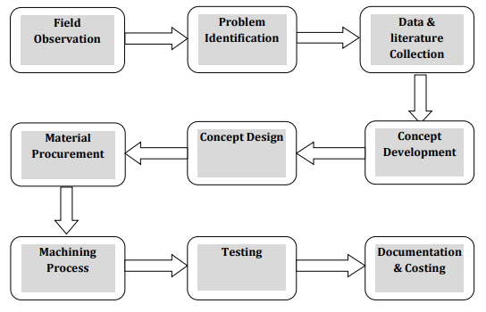

In this chapter creation of the undertaking in addition to the trouble definition are discussed. To clear up all the issues mentioned above we're generating a newmachine, as our assignment below this subject matter in our educational yr 2023 – 2024, we're getting ready a working scale model of this machine. We have proposed a technique to clear up the issues. Our method is split in exclusive components, below special titles. Sequence of proposed methodology is as follows –

1. Proposed Methodology 1 – Basic Information & Literature survey.

2. Proposed Methodology 2 – Design of Machine Components.

3. Proposed Methodology three - Selection of Components for Machine.

4. Proposed Methodology four – CAD modelling & Fabrication of Machine elements.

5. Proposed Methodology 5 – Assembly, Testing & Documentation of Machine.

# MODELING AND ANALYSIS

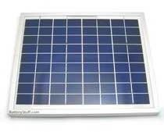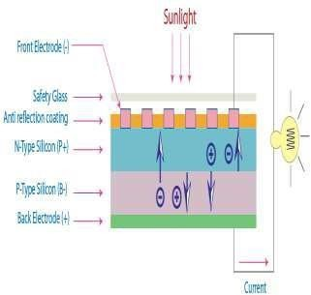

**Fig.1.** Solar panel. **Fig.2.** Photovoltaic Effect.

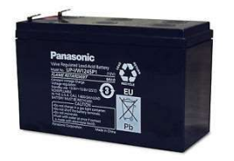 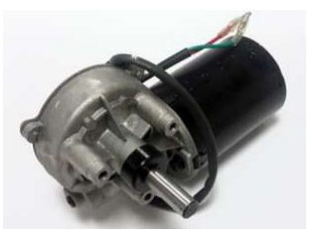

**Fig.3.** Battery. **Fig.4.** DC Motors.

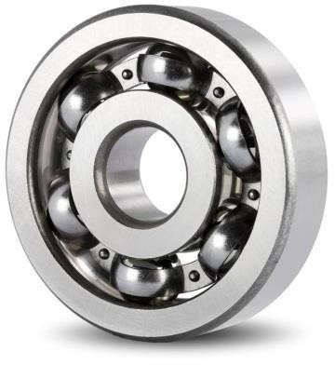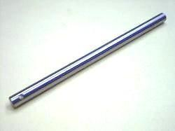

**Fig.5.** Pedestal bearing. **Fig.6.** Shaft

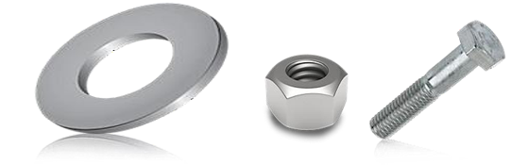

**Fig.7.** Washer. **Fig.8.** Nut and Bolt

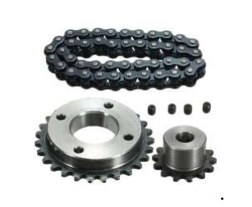 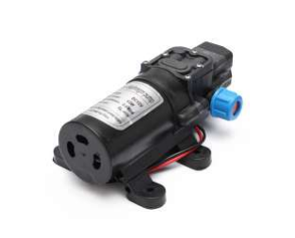

**Fig.9.** Chain, Pinion & Sprocket Wheel. **Fig.10.** DC Pump.

Material Selection for put together any gadget component, the sort of material should be nicely decided on considering design safety. The choice of the material for engineering utility is given by means of the subsequent thing,

1) Availability of materials & Cost of the substances.

2) Suitability of the material for the desired components.

The machine shape is largely made of slight steel. The motives for the selection are mild steel is effortlessly available in market .It's miles reasonably priced to apply and is to be had in fashionable sizes. It has right mechanical properties. Easily machinable. It has mild thing of safety, because it results in unnecessary wastage of cloth and heavy selection, low component of safety outcomes in pointless risk of failure. It has high power, low coefficient of thermal expansion. The fabric of the plates to be reduce and drill are taken as copper and plastic as they're changing many metals within the present scenario because of their prominent homes andf eatures.

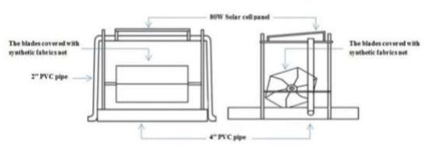

**Concept of solar power aeration system**.

The wheel structure consisted of two main components i.e. stationary and rotary component. Stationary component consisted of frame structure, solar PV system, battery, DC pump & motor. Rotary component consisted of a rotary rim, bearings and chain transmission

# RESULTS AND DISCUSSION

# 

**Advantages:**

The advantages covered by using the suggest aeration device are indexed as,

1) Overcoming hazards of conventional system through the usage of standalone renewable electric strength generation for going for walks aeration machine.

2) Since, the device doesn’t complexity of system checking out and know-how became easy in phrases of difficulties.

3) Aeration System continues is remarkably reduced and becomes clean.

4) Renewable electricity resources are applied so, no waste production.

5) Once the machine is designed and evolved or manufactured, the setup of gadget is easy.

6) Within certain term the installation fee receives protected.

7) Improves the aesthetics and common fitness of ponds and lakes.

8) Eliminates the need for harmful chemicals.

9) Reduces protection, saving your time and money.

10) Improves Water Quality and Clarity.

11) Improves Fish and Water chicken habitat.

**Applications:**

1) For aquatic environments ranging in size from small decorative ponds to lakes up for filtration.

2) Remote regions set up

3) Environmentally beneficial landscaping / aqua scaping.

# CONCLUSION

While concluding this record, we sense quite fulfil in having finished the task undertaking nicely on time, we had massive practical enjoy on fulfilment of the producing schedules of the running challenge model. We are consequently, satisfied to state that the in calculation of mechanical flair proved to be a completely beneficial purpose.

Although the layout criterions imposed challenging troubles which, but have been conquer by means of us because of availability of true reference books. The choice of desire uncooked materials helped us in machining of the various additives to very near tolerance and thereby minimizing the extent of balancing problem. Needless to emphasis here that we had raise no stone unturned in our potential efforts at some stage in machining, fabrication, and assembly paintings of the venture model to our whole pride.

# REFERENCES

1. Mohammad Tanveer, Subha M Roy, M Vikneswaran, P Renganathan and S Balasubramanian, Surface aeration systems for application in aquaculture: A review, International Journal of Fisheries and Aquatic Studies 2018; 6(5): pp.342- 347.
2. L.B. Bhuyar, S.B. Thakre1, N.W. Ingole, Design characteristics of Curved Blade Aerator w.r.t. aeration efficiency and overall oxygen transfer coefficient and comparison with CFD modeling, International Journal of Engineering, Science and Technology, Vol. 1, No. 1, 2009, pp. 1-15.
3. Joseph E. Shigley , Mechanical engineering design, sixth edition, Tata Mcgraw hill ,2005.
4. Khurmi R. S.,Gupta J.K., Atextbook of machine design, first edition, S. Chand Publication,1979.
5. Ballany P. L.,Thory of machines & mechanisms,Twenty forth edition, Khanna publishers,2005.
6. Bhandari V.B.,Design of machine elements,eighteenth edition, MC graw-hill companies,2003.
7. PSG college of Technology,Coimbatore design data, first edition Kalaikaikathir Achchagam,2003.
8. <http://www.ijetsr.com/images/short_pdf/1503912420_1203-1208-mccia967_ijetsr.pdf>
9. <https://www.ijitee.org/wp-content/uploads/papers/v8i11/J99290881019.pdf>
10. <https://www.cheric.org/PDF/KJChE/KC25/KC25-6-1338.pdf>
11. <https://www.fisheriesjournal.com/archives/2018/vol6issue5/PartE/6-5-23-591.pdf>
12. <https://www.ijrrjournal.com/IJRR_Vol.4_Issue.4_April2017/IJRR0010.pdf>
13. <http://www.iraj.in/journal/journal_file/journal_pdf/11-346-149199001823-26.pdf>