Retail Bank Management

# Sabari M, Dr. D. Swamydoss, MCA., M.Tech., Ph.D.,

## *1Student, Department Of Computer Applications, Adhiyamaan College Of Engineering (Autonomous), Hosur, Tamil Nadu, India.*

*2Assistant Professor, Department Of Computer Applications, Adhiyamaan College Of Engineering (Autonomous), Hosur, Tamil Nadu, India.*

------------------------------------------------------------------------------- ******* ----------------------------------------------------------------------------

## Abstract - In Retail Bank Management developed using Java/J2EE The Bank Account Management System is an application for maintaining a person's account in a bank. In this project I tried to show the working of a banking account system and cover the basic functionality of a Bank Account Management System. To develop a project for solving financial applications of a customer in banking environment in order to nurture the needs of an end banking user by providing various ways to perform banking tasks.

## Also to enable the user’s work space to have additional functionalities which are not provided under a conventional banking project. The Bank Account Management System undertaken as a project is based on relevant technologies. The main aim of this project is to develop software for Bank Account Management System. This project has been developed to carry out the processes easily and quickly, which is not possible with the manuals systems, which are overcome by this software.

## This project is developed using JAVA/J2EE, HTML, JAVASCRIPT ,CSS and MYSQL use for database connection. Creating and managing requirements is a challenge of IT, systems and product development projects or indeed for any activity where you have to manage a contractual relationship. Organization need to effectively define and manage requirements to ensure they are meeting needs of the customer, while proving compliance and staying on the schedule and within budget.

## The system is then designed in accordance with specifications to satisfy the requirements. The system design is then implemented with MYSQL, JAVA/J2EE and HTML. The system is designed as an interactive and content management system. The content management system deals with data entry, validation confirm and updating whiles the interactive system deals with system interaction with the administration and users.

1. **INTRODUCTION**

This Application mainly focuses on developing an Online Banking System. The main objective of the Online Banking System is to manage the details of Accounts, Internet Banking, Transactions, Balance, It manages all the information about Accounts, Customers, Statements, and Accounts. Although banks do many things, their primary role is to take in funds-called deposits- from those with money ,pool them and lend them to those who need funds. Intermediaries between depositors(who lend money to the bank )and borrower lends money.

There are plenty of job opportunities in Banking, such as Bank Manager, Probationary officer, Investment Banker, Loan Officer, Bank Teller, Financial Accountant, Chartered Public Accountant. Financial analysts are responsible for analyzing the performance of different investment operations, such as stocks and bonds, to help banks/investors decide where to invest their money.

An organization hires a financial examiner (also known as a compliance officer) to make sure that it meets all financial requirements. Both governmental and private institutions can hire financial analysts.

Their core duties include risk assessment, monitoring credit, and monetary transactions, as well as emergency response. CRM (Customer Relationship Management) is a tool that is used by approximately every customer-centric industry.

Well, in banking, it helps to deliver more personalized customer experiences due to its amazing features of storing and managing the details of the customers.

**2PROJECT OBJECTIVE**

A regression is made for the usefulness of data collection, data analysis and data integration. The larger areas such as information technology which are developing tons of data will obtain the aid of regression to every element of data operations like data labeling, segmenting and analyzing. The fusion of regression with massive data is a never-ending loop encountering the requirements of the client is the most critical element for a profitable business. Regression analyzes the hierarchy and helps the team to complete the project on time to benefit their clients.

The massive data allows information technology to calculate the probability of different outcomes and decisions. Predictive analysis helps then by providing resources for the right team. The input of regression is the information extracted for massive data. Hereby making a regression of finding the hierarchy for the allocating the resource in the enormous team of employees, makes the information technology advances in their business by providing a good service to the clients.

all types of trade, including intert emporal exchange. That sounds mundane, even boring, but it isn’t once you understand how important it is to human welfare. The material progress

**3.** PROPOSED SYSTEM

1.Login

Customerlogins by entering customer Username and password enter login Security.

2.Account Registration

## Customer registration personal information registering in document then User name and password create in Customer Also to enable the user’s work space to have additional functionalities which are not provided under a conventional The Bank Management System undertaken as a project is based on relevant technologies.

## 3.Withdraw Amount:

## A customer is withdraw Amount/money enter the amount which he/she also wishes to withdraw. If the entered amount is less then the available balance and if after withdraw if the minimum required balance is maintained then bank balance withdraw.

## 4.Modify Account:

## Customer is create a Account modify information details check and modify Bank details How to change bank account number. Unfortunately, you can't change the account number for your bank, as that number tells payers and payees where to withdraw or deposit money in your name. But if your account has been compromised, you can open a new bank account.

## 5.Deposit Amount:

## A customer can be Deposit amount/money enter the amount which he/she also wishes to Deposit amount. If the entered amount is greater then the bank balance will be checker transition money inset bank account verify balance. After Deposit money current/saving account number enter the amount balance check.

## 6.Close Account:

## Cancel your bank account. Although financial institutions allow you to do this online, they may require you to make a phone call to customer service or a visit to a local bank branch. Some banks and credit unions may require you to fill out an account closure request form or submit a written request.

## 7.View Transactions:

Customers should be able to keep track of transactions taking place in their accounts.

The Statement feature enables customers to view the details of all transactions performed in their accounts. All the debit and credit entries along with each transaction amount and reference details are displayed. By subscribing to e-statements, the user receives statements on his registered email address. The access to your e-Statements is through a password. The Download Pre-generated option, allows the customer to view, download and print the pre-generated e-statements by selecting the desired period.

8.ER Digram:

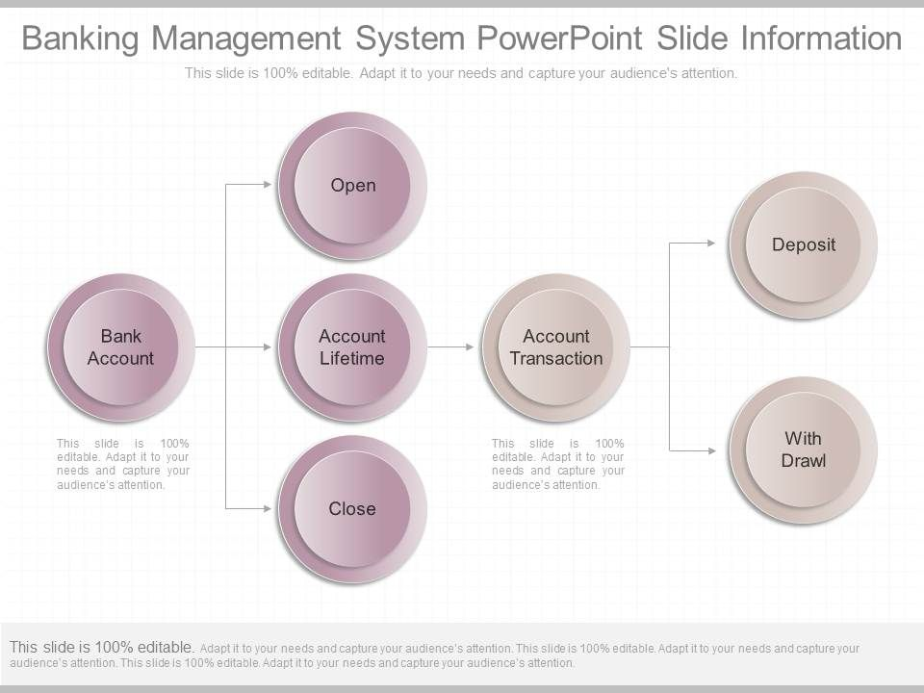

**4.WORKING**

1.User Registration and Authentication:

Users register for an account by providing personal information such as name, email address, and phone number.They create login credentials (username/password) or may use other authentication methods such as biometrics (fingerprint, face recognition) or two-factor authentication (SMS verification, authenticator apps).

2.Account Management:

After logging in, users can view information about their accounts, including balances, transaction history, and account details.

They may have the option to open new accounts, apply for loans or credit cards, and manage existing accounts (e.g., update personal information, set up alerts).

3.Transactions:

Users can initiate various types of transactions, such as fund transfers between their own accounts, transfers to other accounts within the same bank, and external transfers to accounts at other financial institutions.

They can also pay bills, set up recurring payments, deposit checks remotely using mobile check deposit, and view pending transactions.

4.Security Features:

Banking applications implement various security measures to protect user data and transactions. This includes encryption to secure data in transit and at rest, multi-factor authentication to prevent unauthorized access, and fraud detection systems to monitor for suspicious activity.

Users may have the option to set up additional security features such as transaction alerts, biometric authentication, and device authorization.

5.Customer Support:

Banking applications often provide access to customer support services such as live chat, phone support, and help articles.Users can report issues, ask questions about their accounts, and receive assistance with transactions or account management.

6.Additional Features:

Many banking applications offer additional features to enhance the user experience, such as budgeting tools, financial planning calculators, spending analytics, and integration with third-party services (e.g., payment apps, personal finance management tools).

Some applications may also offer features for investment management, loan applications, insurance services, and more.

7.Regulatory Compliance:

Banking applications must comply with regulatory requirements related to data protection, privacy, anti-money laundering (AML), know your customer (KYC), and other regulations specific to the banking industry.

Compliance features may include identity verification processes for account opening, transaction monitoring for suspicious activity, and adherence to data security standards.

**5.CONCLUSION**

Bank management system is a virtualization of transactions in banking system. The banking system are used manual working but when we used online banking system it is totally virtualization process which avoid manual process and converts it in automatic process Bank management system is a virtualization of transactions in banking system. The banking system are used manual working but when we used online banking system it is totally virtualization process which avoid manual process and converts it in automatic process .

If user can make a transaction in bank management system it is available in any were also user can link aadhaar with account, change branch location easily. Bank management system is saving the time with accuracy than bank manual system.

**6.REFERENCES**

1. Smith, Alan D. "Internet retail banking." Information Management & Computer Security 17, no. 2 (June 5, 2009): 127–50.
2. Kohlleppel, Laurenz. "Erfolgreiches Marketing im Retail-Banking." Zeitschrift für das gesamte Genossenschaftswesen 57, no. 2 (June 1, 2007): 106–15.
3. Valenzuela, Fredy. "Switching barriers used to retain retail banking customers." Management Research Review 33, no. 7 (June 18, 2010): 749–66.
4. Barry Howcroft, J., and John C. Lavis. "Pricing in Retail Banking." International Journal of Bank Marketing 7, no. 1 (January 1989): 3–7.
5. Pandit, Richa, and Dr Ram Kumar Balyan. "Measuring Service Quality in Retail Banking." Indian Journal of Applied Research 3, no. 8 (October 1, 2011): 380–81.
6. Klein, Edgar. "Megatrends im Retail Banking." Bankmagazin 48, no. 2 (February 1999): 10–13