“Digital Gram Panchayat”

Mr. Arif Siddiqui1 [aarifsiddiqui343@gmail.com](mailto:aarifsiddiqui343@gmail.com) Mr. Tushar Hiwarkar4

[tusharhiwarkar61@gmail.com](mailto:tusharhiwarkar61@gmail.com)

Mr. Piyush Lingayat2 [lingayatpiyush7@gmail.com](mailto:lingayatpiyush7@gmail.com) Mr. Sagar chourasiya5

[sagar.chourasiya2002@gmail.com](mailto:sagar.chourasiya2002@gmail.com)

Mr.Ayush Nighot3 [ayushnighot29@gmail.com](mailto:ayushnighot29@gmail.com)

Miss. Snehal Bagde6 [snehalb.it@gmail.com](mailto:narendra.cse@tgpcetgmail.com)

Student (1 to 5), Department of Information And Technology, TGPCET, Nagpur, India Professor6, Department of Information And Technology, TGPCET, Nagpur, India

**Abstract**— Through the use of digital Gram Panchayat services, villagers can conveniently access information about government services provided for their well-being. The platform, where all panchayat work will be conducted online, allows users to review all relevant information,The Digital Gram Panchayat Service is a technology designed to help government employees alleviate workloads for both citizens and officials.. The primary goal of this project is to establish a digital gram panchayat. Its main focus is on individuals who visit the Gram for documentation,Applicants can apply for panchayat services online or through an Android app. The primary advantage is that workers can avoid losing income for that specific day and don't have to take time off

**Keyword: -** E-Government, User-Friendly, Secured, Centralized Approach,Government- Citizen Relationships, Android Application.

# Introduction

The main motive of project is to digitalize services provided by the government. Through this online service, the public can access a catalog of government services on devices, gather information about registering calls, documents, and apply for online services. The project aims to improve communication between government service providers and the public, facilitating the distribution of information. Panchayat staff will accept, verify, and forward applications to the head office for approval. Users can track the status of their applications through the application status option, The primary objective of this project is to digitize government services.

In this online service, the public can access a list of government services on their mobile phones and obtain information about registering calls, documents, and apply for online services. This project seeks to improve communication between government service providers and the public, streamlining the distribution of information. Panchayat staff will receive, verify, and forward applications to the head office for approval.

Users can monitor the status of their applications through the application. Presently, all services are carried out offline or through paper-based methods, necessitating villagers to visit the Panchayat office and encounter various challenges. The current approach fails to give users a clear understanding of the application status This project is an Android-based application linked to a web application. End-users (local people) use the Android application to send or apply for online documents from Gram Panchayat, view various scheme lists, candidates appearing for those schemes, voting lists, committees, village history, and current affairs, all accessible on their devices.

When a user needs a document, they fill out the application form and submit it. The application goes to the application admin panel where the admin checks the user's application form, copies the Aadhar number, and checks for any outstanding balances (home tax, water tax, other taxes)

The project uses Firebase for sending and receiving notifications between admin and users. Digital Gram Panchayat services eliminate difficulties, allowing users to fill out forms online and easily check the status of their applications on their mobiles. Users receive instant information about the approval or rejection of their applications, eliminating the need for frequent visits to the Panchayat office. This streamlined process benefits Panchayat offices by reducing paperwork and file management The website shares details of all schemes, and users can fill out forms by clicking on the respective scheme. E-Panchayat addresses challenges in the current panchayat system by providing digital solutions. It saves time for rural residents who would otherwise have to visit the Panchayat office, enhances data security, and resolves issues related to manual data entry and response delays from ward members in the current panchayat system In this digital age, everyone uses the internet on both computers and mobile devices. Farmers and employees now work in rural areas, engaging in daily farm activities to earn a living. When these individuals need paperwork related to a certificate for any reason, they typically visit the gram panchayat. In the past, they had to take time off from work to attend the gram panchayat and collect the required document, resulting in a loss of working payment for that day. To address this issue, we have developed a software program and an Android application.Information technology plays a crucial role in all government transactions aiding in reducing bureaucracy, preventing corruption, and facilitating direct communication with the public. These programs are designed to help residents understand the various policies, procedures, and services provided by the government. The daily transactions in the Gram Panchayat can be efficiently managed with the help of this application. The introduction of e- services will lead to a reduction in paperwork at Gram Panchayat, and this initiative serves as a solution to streamline these processes.

# Literature Review

**"Digital Gram Panchayat Service"** Manikanta Sahu1, Heena Pradhan2, Tara Netam3 1,2,3Computer Science & Engineering, New Government Engineering College Sejbahar Raipur (C.G), Chhattisgarh Swami Vivekanand Technical University Bhilai. The advent of Digital Gram Panchayat services in India marks a significant stride towards modernizing grassroots governance, prioritizing efficiency, accessibility, and transparency. This transformative initiative benefits both government officials and villagers, ushering in a more streamlined and citizen-centric approach to public service delivery.

**"Smart e-Governance for Gram Panchayat"** Reethikha R M1, Mrs. V. Bakyalakshmi2 PG Student1, Assistant Professor2 PG & Research, Department of Computer Applications, Hindusthan College of Arts and Science, Coimbatore, India The "Digital e-Gram Panchayat Service" aims to empower villagers with easy access to government services provided for their benefit through digital platforms. This initiative revolutionizes the traditional panchayat operations by digitizing all activities on a dedicated website, ensuring seamless access to information for users. The Digital Gram Panchayat Service leverages technology to enhance citizen engagement and efficiency in governance processes, thereby benefiting the community as a whole.

**"E-Gram Panchayat using ICT"** Prof. M. S. Sawane1, Prashik S. Awachar2, Saurabh S. Shah3, Sushant C. Waghole4 1Assistant Professor, 2,3,4UG Scholars Department of Information Technology, Bhivarabai Sawant Institute of Technology and Research, Warhol, Pune, India-412207 In today's technology-driven era, internet usage has become ubiquitous, with people accessing it via mobile phones and computers alike. Particularly in rural areas, farmers and laborers are predominantly engaged in agricultural activities to sustain their livelihoods. However, obtaining essential documents such as certificates (Dakhala) from the gram panchayat often entails taking time off from work, resulting in a loss of income for the day.

**"Role of ICT in Grassroots: A Review on Gram Panchayats of District Hisar in Haryana"** Suresh Kumar1 *, Vijay Athavale2 Dept. of Computer Science, School of Science & Technology, Dravidian University, Kuppam, Andhra Pradesh, INDIA Gulzar Group of Institutions, Khanna, Punjab, INDIA The statement highlights the transformative role of Information and Communication Technology (ICT) in grassroots governance, with a specific focus on gram panchayats in District Hisar, Haryana. It underscores the evolution of communication technologies over the years and emphasizes the importance of promoting computer literacy to enable broader participation in the digital era.

**"Smart Gram Panchayat"** Suksham Gupta1, David2, Nishchal Kumar3, Vicky Kumar Verma4, Aditya Kumar5, Akshar Kumar Kashyap6 1Assistant Professor, 2,3,4,5,6Students Department of Computer Science and Engineering, Lovely Professional University, Jalandhar, India The statement reflects on the profound changes in communication over time, highlighting the evolution from traditional postal and telegram services to modern communication mediums such as radio, TV, and telephones. It acknowledges the pivotal role of satellite communication in enabling globalization and connectivity on a global scale.

.

# Block Diagram

**Admin**

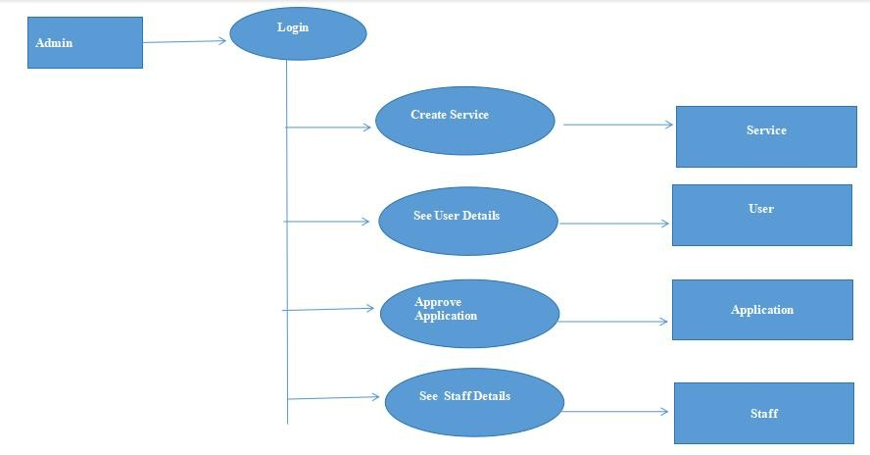

**Fig: Flow Chart**

## Block Diagram Description:

The data flow diagram for the admin illustrates the functioning of the admin system. The admin has their own ID and password, and upon entering the system, the admin can add schemes along with all the relevant information. This scheme information is then displayed on the user's Application and the Gravamen's Application, allowing them to access details about the scheme and related documents. The admin can update scheme details as required and has the ability to view user and staff details, enabling control over staff activities Requests processed by the Gram sevak are visible in the admin window. After reviewing the documents and receiving the ground-level report from the officer, the admin approves the application. In the event of any mistakes, the admin has the authority to reject the application or request. villager needs any archives and any data related to government conspire since for these data villagers ought to reach gram panchayat and ask to gram sevak. Government gives diverse plans /administrations to back villagers beneath which villagers get cash or hardware the data which is given by gram sevak to the villagers there is no affirmation that data is redress.villagers do not know whether plot cash or any other gram panchayat related cash exchanges his account or not.

## User

Client id concept is exceptionally valuable. Clients or villagers will get its id by enlisting title and individual information at the framework after enrolling the data client id and secret word created. Through this id and secret word clients can login in the client window and see all plans or benefit records given by the government to them. In this window they can see the data of required archives and points of interest which will be submitted. By this they were educated that they are qualified or not for given administrations. If a client is qualified for the benefit they can apply in a computerized way without any burden and transfer required archives. This way is more secure than the offline prepare of applying for any benefit.

## Conclusion

It has been an enriching experience working on this design, which has handed me with precious perceptivity and practical knowledge in the field of software development. Through the development of this operation using Java and Spring Boot, coupled with Firebase database integration, I've gained hands- on experience in ultramodern technologies and fabrics that are largely applicable in moment’s software assiduity. This design has not only enhanced my proficiency in programming but has also strengthened my understanding of the complications involved in handling digital results, particularly in the environment of a" Digital Gram Panchayat” terrain. By using the rearmost advancements in web- enabled operation development and customer- garcon technology, I've been suitable to produce a robust and effective system that meets the requirements and conditions of the end- druggies effectively.

## Reference

1. **“**Digital gram panchayat servic**e”**Manikanta Sahu*1, Heena Pradhan*2, Tara Netam*31,2,3computer Science & Engineering, New Government Engineering College Sejbahar Raipur (C.G) Chhattisgarh Swami Vivekanand Technical University Bhilai(2021)
2. “Smart e-governance for gram panchayat”Reethikha r m1 mrs. V. Bakyalakshmi2Pg student 1 , assistant professor2 , pg & research , department of computer applications hindusthan college of arts and science Coimbatore(2023)
3. “E-Gram Panchayat using ICT” Prof. M. S. Sawane, 2Prashik S. Awachar, 3Saurabh S. Shah, 4 Sushant C. Waghole 1Assistant Professor, 2,3,4UG Scholars Department of Information Technology Bhivarabai Sawant Institute of Technology and Research Warhol, Pune,(2019)
4. ”Role of ICT in Grassroots” A Review on Gram Panchayats of District Hisar in Haryana ” Suresh Kumar1 *, Vijay Athavale2Dept. of Computer Science, School of Science & Technology, Dravidian University, Kuppam, Andhra Pradesh-INDIA, 2Gulzar Group of institutions, Khanna, Punjab(2021)
5. “Smart gram panchayat”Suksham Gupta, 2David, 3Nishchal Kumar, 4Vicky Kumar Verma, 5Aditya Kumar, 6Akshar Kumar Kashyap 1Assistant Professor, 2,3,4,5,6Student Department of Computer Science and Engineering Lovely Professional University, Jalandhar